E-LEARNING
Software Requirements Specification
Version 1
3/11/2024

MADE BY:
- AMINA AHMED
- SONDOS ASHRAF
- AMIRA TAMER
- BASMALA EHAP
- AYA EZZAT
- NADA ABDLATEF
- MARIAM NAGAH

Prepared for
Table of Contents

Revision History Error! Bookmark not defined.
Document Approval Error! Bookmark not defined.
1. Introduction 1
1.1 Purpose 1
1.2 Scope 1
1.3 Definitions, Acronyms, and Abbreviations Error! Bookmark not defined.
1.4 References Error! Bookmark not defined.
1.5 Overview 1
2. General Description 1
2.1 Product Perspective 1
2.2 Product Functions 1
2.3 User Characteristics 2
2.4 General Constraints 2
2.5 Assumptions and Dependencies Error! Bookmark not defined.
3. Specific Requirements 3
3.1 External Interface Requirements 3
3.1.1 User Interfaces Error! Bookmark not defined.
3.1.2 Hardware Interfaces Error! Bookmark not defined.
3.1.3 Software Interfaces Error! Bookmark not defined.
3.1.4 Communications Interfaces Error! Bookmark not defined.
3.2 Functional Requirements Error! Bookmark not defined.
3.2.1 <Functional Requirement or Feature #1> Error! Bookmark not defined.
3.2.2 <Functional Requirement or Feature #2> Error! Bookmark not defined.
3.3 Use Cases Error! Bookmark not defined.
3.3.1 Use Case #1 Error! Bookmark not defined.
3.3.2 Use Case #2 Error! Bookmark not defined.
3.4 Classes / Objects Error! Bookmark not defined.
3.4.1 <Class / Object #1> Error! Bookmark not defined.
3.4.2 <Class / Object #2> Error! Bookmark not defined.
3.5 Non-Functional Requirements Error! Bookmark not defined.
3.5.1 Performance Error! Bookmark not defined.
3.5.2 Reliability Error! Bookmark not defined.
3.5.3 Availability Error! Bookmark not defined.
3.5.4 Security Error! Bookmark not defined.
3.5.5 Maintainability Error! Bookmark not defined.
3.5.6 Portability Error! Bookmark not defined.
3.6 Inverse Requirements 7
3.7 Design Constraints Error! Bookmark not defined.
3.8 Logical Database Requirements Error! Bookmark not defined.
3.9 Other Requirements Error! Bookmark not defined.
4. Analysis Models Error! Bookmark not defined.
4.1 Sequence Diagrams Error! Bookmark not defined.
4.3 Data Flow Diagrams (DFD) Error! Bookmark not defined.
4.2 State-Transition Diagrams (STD) Error! Bookmark not defined.
5. Change Management Process Error! Bookmark not defined.
A. Appendices Error! Bookmark not defined.
A.1 Appendix 1 Error! Bookmark not defined.
A.2 Appendix 2 Error! Bookmark not defined.

1. Introduction

1.1 Purpose
- The purpose of this SRS documentation is to carry the project’s analysis which will provide a detailed and clear description of the project’s functionality, features, and constraints

1.2 Scope
- MINDBLOOM

- This project aim to achieve educational access globally by providing online courses with versed instructors which will provide the ability to cater to diverse learning styles in a one reachable platform.

- This project aims to provide scientific content, some of which is free and some of which is paid. Instructors have the ability to create their own courses or explain the courses on the site.

1.3 Overview

This subsection should include (General Description _ Specific Requirements) which define and identify the needed requirements for our E-Learning project to ensure its compatibility and to lead us to the implementation process safely

2. General Description

2.1 Product Perspective
- This system receives user data, whether the user is a student or an instructor. If the user is a student, it will show him the courses available for registration. If he is an instructor, it will allow him to upload his own course.

2.2 Product Functions
- For student:
This platform displays different types of courses. When browsing the course, you will be shown a description of the course, the instructor who explains this course, the duration of the course, and its price if it is paid.

- For instructor:
Each instructor has his own account and can display his qualifications, skills, the courses he offers, and the materials of these courses.

- For administrator:
His role here is to go in and see the instructors who are presenting and accept on who is qualified, and publish courses.

2.3 User Characteristics

The users of the E-learning system should be from different age stages as the courses are open for different people who are interested in the given course where the system user should be able to enroll in needed courses and the system admin should be able to maintain the system for the system user

2.4 General Constrains
- Compatibility: The platform should support multiple devices (e.g., desktops, tablets, and smartphones)

- Security: Protection of sensitive data (user information, payment details, etc.) is essential, requiring encryption and secure authentication methods.

- User Interface (UI)/User Experience (UX): The platform should be intuitive and easy to navigate for users with varying levels of technical skill. Accessibility features, like text-to-speech and screen reader compatibility, are essential.

- Content Format Compatibility: The platform should support various types of content, including text, video, quizzes, simulations, and interactive elements.

3. Specific Requirements
3.1 User requirements:

Functional:

1- Home page (market place)
(Profile icon - basket icon -pages list- course list –home link - search engine –logo- featured courses)
2- Contact page (has form for questions and complaints)
3- About us page (has information about authors and website)
4- Course page
5- Quiz page (attached with each course)
6- profile (has dashboard – wishlist – enrolled courses – my profile – my quiz – order history – discussion section-my courses – withdrawals – quiz attempts-announcements)
7- Cart page (for checkout)
8- Login page (contains form)

Nonfunctional:

1- User should be able to navigate easily through courses
2- System should be fully responsive
3- Data should be secure
4- Quiz duration
5- Forgotten password issue
6- Profit percentage for both the platform and the instructor
7- Admin permissions
8-The user must have an email to access courses
9-Copoun and Discounts

3.2 System requirements:

Functional:

1.1 by hovering the cursor on profile icon, the (Dashboard – My Profile – Account Setting – logout )

1.2 When a student enroll in a specific(non free ) course, this course will be added to the cart

1.3 pages list contains (about us -blog – instructors registration – instructors - student registeration – contact) pages user choose page and browse it

1.4 course list linked to all courses

1.5 home link the user to return to the home page

1.6 search engine helps user to know every thing about the topic he search about it

1.7 featured courses (every course has its image which can be rated by stars and numbers ,instructor name , price if exist , add to cart button ,wish list button ,level of user and number of enrolled users)

2.1 Contact page (it has phone numbers- email links-company address-form (has fields: - user name – email –subject –massage) for questions and complaints-emails )

4.1 Course page in this page show the courses are exist – content information – review – course restart-automatic loading for the next lesson –the aim of the course ( what the student will learn)-comment and discussion –tags to search easily – requirements - every course has its image which can be rated by stars and numbers ,instructor name , price if exist , add to cart button ,wish list button ,level of user and number of enrolled users – audience – enroll now button for buying course – quizzes .

5.1 Quiz in different forms(multiple choice-true or false- etc… )

5.2 Automatic correction then show correct answers

6.1 Dashboard shows (enrolled courses – active courses – completed courses – total students – total courses – total earnings)

6.2 Wish list shows saved courses without payment

6.3 My profile (registration date - first name - last name -user name - email - phone number - skill - biography )

6.4 My courses contains published courses (accepted by administrator)
Pending courses (courses waiting admin acceptation)
Draft courses (course in progress)

6.5 Withdrawals (shows instructor’s balance note: - minimum withdrawal amount)

7.1 Cart page contains all enrolled non free courses by the student and payment process (different payment methods) on click on checkout button

7.2 Confirm purchase contains the order and student details to confirm the payment process and coupon if exist

8.1 Login form (contains username field – password field – sign in button – registration link)

Nonfunctional:

1.1 System must have a user friendly interface for both students and instructors

1.2 there are many buttons that help the user to reach different pages easily

3.1 Security: Protection of sensitive data (user information, payment details, etc.) is essential, requiring encryption and secure authentication methods.

4.1 Quiz with duration if quiz ended but student didn’t finish system will auto submit

5.1 If user forget password press (forget password link) to open change password page

6.1 If the instructor upload his course, he will get 90% of the profits, and the administrator will get 10%.

7.1 The admin must agree that this student has paid in order for the course to be activated.

8.1 You must log in before you can enroll the course if user is student or add one if user is instructor.

9.1 If the user wants a discount, he must have the discount code (coupon)

9.2 The coupon must be valid to be accepted (there are several types of coupons)

3.5 Inverse Requirements
- The system should not violate copyright or trademark laws.
- The system should not have confusing or inconsistent navigation.
- The system should not show the wrong test results
- We shouldn't use inappropriate themes and plugging that won't match the system design and idea

3.6 Validation process:

- Completeness Check :
Ensured all functional and non-functional requirements are documented, including Account Management, Course Management, Tracking Progress, Assessments, Communication Tools, Usability, Performance, Security, and Accessibility.

- Variability Check :
Verified that all requirements are measurable. For example, specified load time for Performance and data encryption methods for Security.

- Clarity Check :
Clarified ambiguous requirements such as Usability and Performance by adding specific metrics.

- Consistency Check :
Confirmed no conflicting requirements. Ensured that Security requirements do not negatively impact Performance.

- Feasibility Check :
Technically feasible with tools like AWS or AZUR for cloud services. Financial feasibility reviewed based on projected monthly costs.

- Stakeholder Review :
Presented requirements to stakeholders (Learners, Instructors, Administrators, Technical Team) for feedback and necessary revisions.

- Final Documentation :
Documented the finalized version of requirements as a reference for the development team.

- After discussing the validation process we conclude the project is valid.

Use case diagram
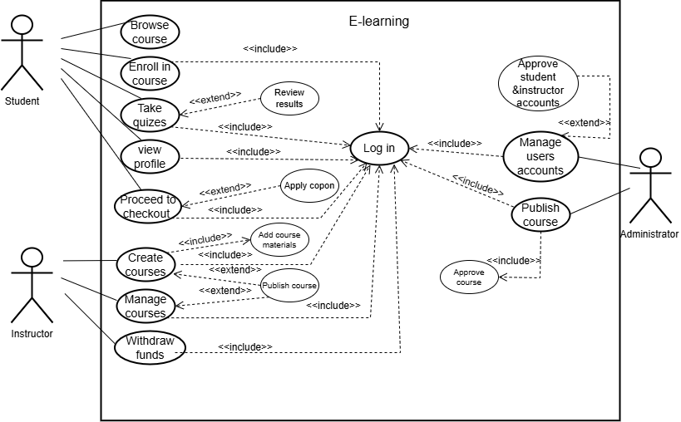
Browse course
Goal | Allow users to explore available courses on the platform
Primary actor | Student
Scope | E-learning system
level | Student
Precondition | ----------
Success End Condition | User successfully views a list of available courses.
Failure End Condition | System fails to retrieve the list of courses.
Trigger | When student scroll the home badge
Main Success Scenario | 1- student enter the website and scroll to watch the courses  2-System display a list of available courses with details
Extensions(Error  scenarios ) | 1-Course database is unavailable  System shows an error message  2-No courses are available  System displays a message indicating no courses are listed
Variation(Alternative  scenarios) | ------------

Enroll in Course
Goal | Allow users to enroll in a course
Primary actor | Student
Scope | E-learning system
Precondition | Student has an active account and is logged in
Success End Condition | Student is successfully enrolled in the selected course
Failure End Condition | Enrollment fails due to insufficient funds or course unavailability
Trigger | Student clicks on “Enroll in Course”
Main Success Scenario | -1Student selects a course to enroll in  - The system will show payment methods  - Student will pay for the course  4-Student receives confirmation of enrollment
Extensions(Error  scenarios ) | 1-Student does not meet prerequisites.  System shows a message indicating unmet requirements.  2-payment fails  System shows an error and prompts for retry
Variation(Alternative  scenarios) | -Student applies a coupon for discount  -System validates the coupon and applies it

Take quizzes
Goal | Allow users to take quizzes for a course
Primary actor | Student
Scope | E-learning system
Precondition | Student is enrolled in the course and logged in
Success End Condition | Student successfully completes the quiz and receives results
Failure End Condition | Quiz submission fails or the quiz is unavailable
Trigger | Student selects “take Quiz”
Main Success Scenario | 1-Student selects the quiz to take  2-System loads quiz questions  3-Student answers all questions  4-Student submits the quiz  5-System evaluates answers and displays results
Extensions(Error  scenarios ) | 1-Quiz fails to load  System shows an error message  2-Internet connection is lost during submission  System prompts user to retry submission
Variation(Alternative  scenarios) | ___________

View Profile
Goal | Allow users to view and manage their profile information
Primary actor | Student
Scope | E-learning system
Precondition | Student is logged in
Success End Condition | Student successfully views or updates profile information.
Failure End Condition | System fails to load profile details
Trigger | Student selects “View Profile”
Main Success Scenario | 1-Student selects “View Profile”  2-System retrieves user profile details  3-Student views or updates the information
Extensions(Error  scenarios ) | 1-System cannot retrieve user data  System displays an error message
Variation(Alternative  scenarios) | _______________

Proceed to Checkout
Goal | Allow Students to complete payment for course enrollment
Primary actor | Student
Scope | E-learning system
Precondition | Student has selected a course to enroll in.
Success End Condition | Payment is successfully processed, and the Student is enrolled.
Failure End Condition | Payment fails or is declined.
Trigger | Student clicks “Proceed to Check out”
Main Success Scenario | 1-Student clicks “Proceed to Checkout”  2-System calculates total cost  3-Student enters payment details  4-System processes the payment  5-Student receives confirmation
Extensions(Error  scenarios ) | 1-Student cancels the payment process.  System redirects to the course list.
Variation(Alternative  scenarios) | 1-Student applies a discount coupon before payment  2- System recalculates the total

Create courses
Goal | Allow instructors to create new courses
Primary actor | Instructor
Scope | E-learning system
Precondition | Instructor is logged in
Success End Condition | Course is created successfully
Failure End Condition | Course creation fails due to missing data
Trigger | Instructor selects “Create Courses”
Main Success Scenario | 1-Instructor selects “Create Courses”  2- System provides a form for entering course details  3- Instructor fills in the form and submits it  4-System saves the course
Extensions(Error  scenarios ) | 1-Required fields are missing  System prompts the instructor to fill them
Variation(Alternative  scenarios) | ______________________

Manage courses
Goal | Allow instructors to manage the courses they created, including editing course content, adding materials, or deactivating their courses
Primary actor | Instructor
Scope | E-learning system
Precondition | The instructor is logged in and has at least one course created in the system
Success End Condition | The instructor successfully updates, adds , or deactivates their courses
Failure End Condition | Updates fail due to system errors or invalid input
Trigger | Instructor selects “Manage Courses”
Main Success Scenario | 1-Instructor logs into the system  2-Instructor navigates to the “Manage Courses" 3-System displays a list of courses created by the instructor  4-Instructor selects a course to edit or deactivate  5-System processes the requested changes and updates the course
Extensions(Error  scenarios ) | 1-System fails to save course updates  System prompts the instructor to retry or report the issue
Variation(Alternative  scenarios) | ___________

Withdraw funds
Goal | The instructor takes money for the course has published
Primary actor | Instructor
Scope | E-learning system
Precondition | The instructor is logged in and withdraw money when the minimum limit is reached
Success End Condition | The instructor successfully get 90% of the profits, and the administrator will get 10%.
Failure End Condition | Failed to withdraw funds because there was less than the limit amount in his account
Trigger | Instructor selects “Withdraw funds”
Main Success Scenario | 1-Instructor logs into the system  2-Instructor selects to the “Withdraw”  3-System displays how much money in his account  4-Instructor can withdraw money if his account has greater than the limit amount .
Extensions(Error  scenarios ) | - System encounters an error while loading withdrawal data.  2-System shows an error message and prompts the instructor to retry
Variation(Alternative  scenarios) | ____________________

Manage User Accounts
Goal | Allow administrator to manage user accounts (e.g., add, update, delete)
Primary actor | Administrator
Scope | E-learning system
Precondition | Admin is logged in
Success End Condition | User accounts are successfully managed
Failure End Condition | Action fails due to system error
Trigger | Admin selects “Manage User Accounts”
Main Success Scenario | 1-Admin logs into the system  2-Admin selects "Manage User Accounts"  3-Admin views a list of user accounts  4-Admin adds, updates, or deletes accounts
Extensions(Error  scenarios ) | 1-Admin tries to delete a non-existent account
Variation(Alternative  scenarios) | ___________________

Publish courses
Goal | Allow the administrator to review and publish courses created by instructors
Primary actor | Administrator
Scope | E-learning system
Precondition | A course has been submitted by an instructor and is ready for review
Success End Condition | The course is published and become available to students
Failure End Condition | Action fails due to system error .The course fails to meet publishing criteria or is rejected by the administrator
Trigger | Admin selects “Publish Course”
Main Success Scenario | 1-Admin logs into the system.  2-Admin navigates to the "Publish Course" section.  3-Admin reviews the submitted course details.  4-Admin approves and publishes the course.  5-System updates the course status to "Published" and makes it visible to students.
Extensions(Error  scenarios ) | 1-Course fails to meet publishing requirements.  2-Admin rejects the course
Variation(Alternative scenarios) | ------------------------

Seq: Browse course

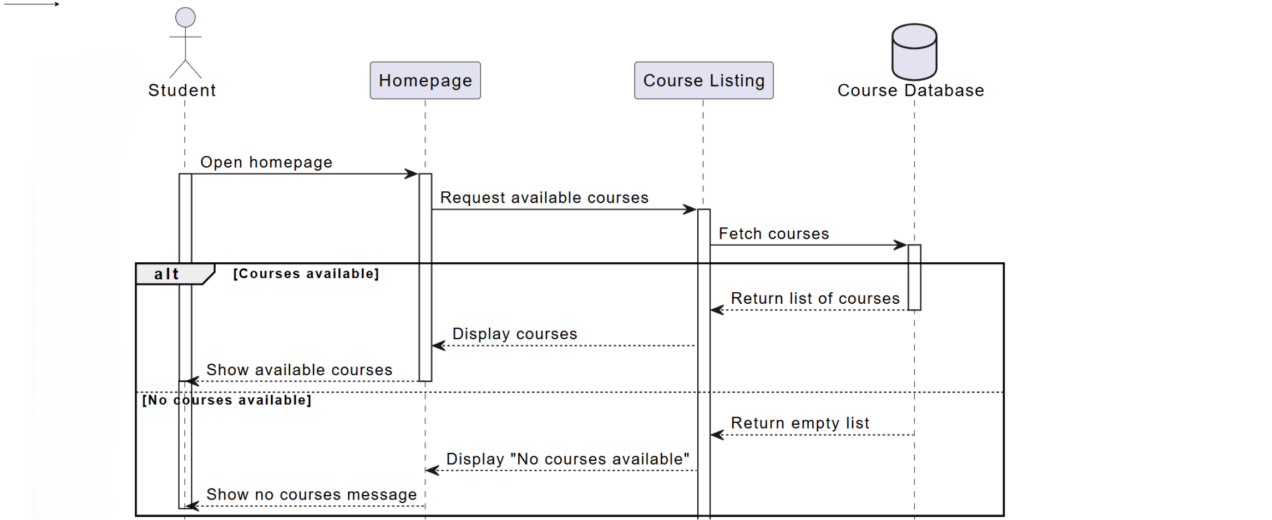
Seq: Enroll in course
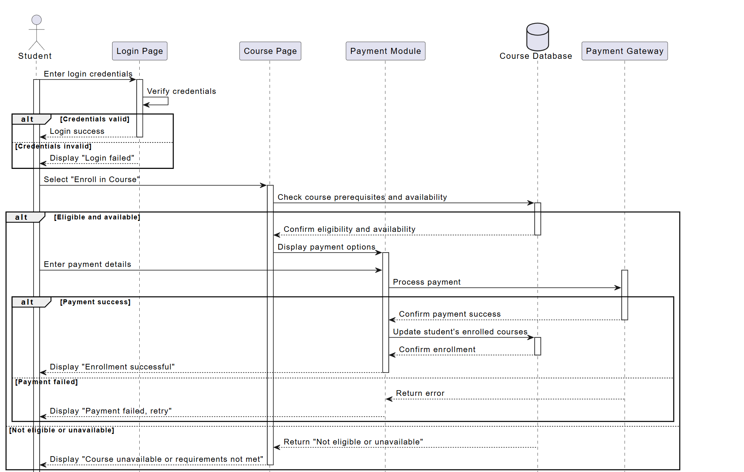
Seq: Take quiz

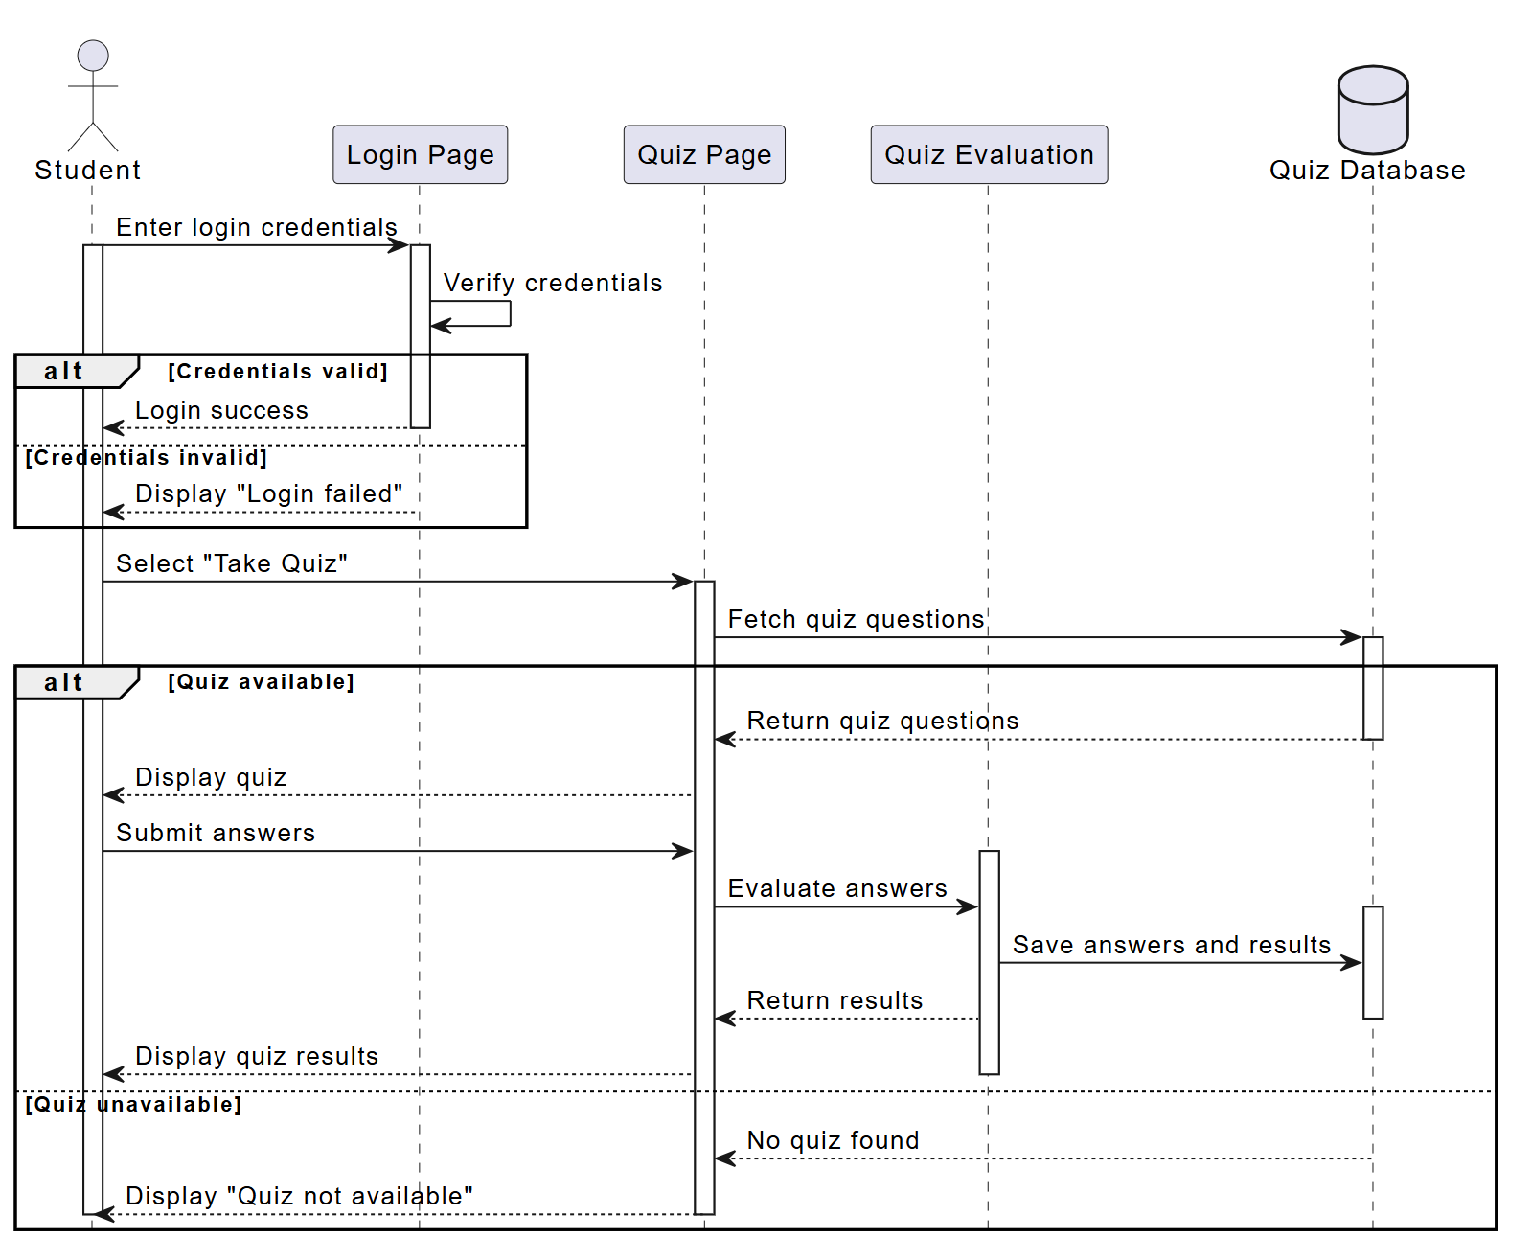
Seq: View profile

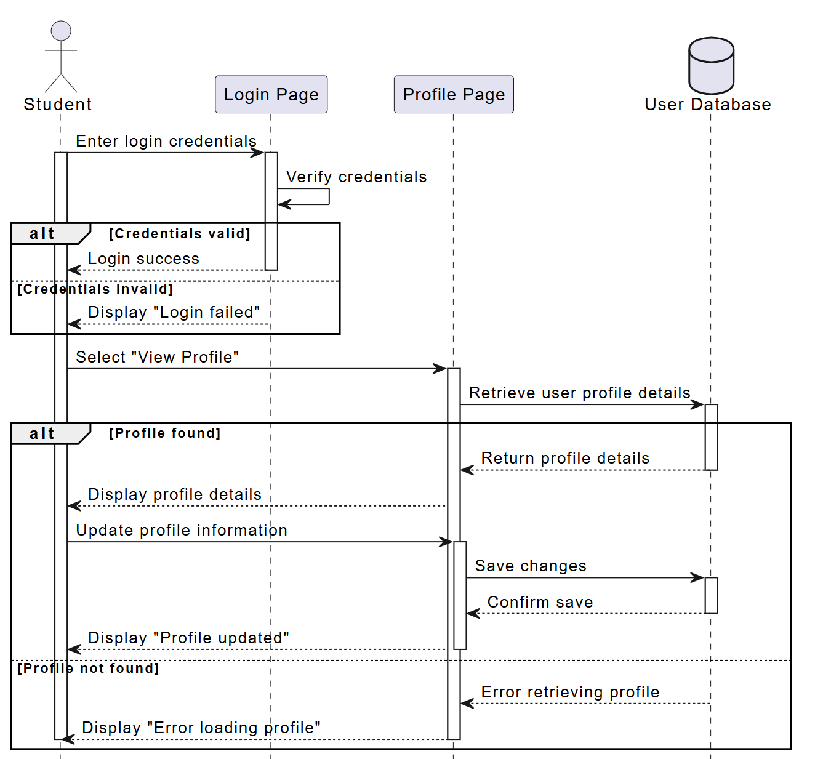
Seq: Proceed to checkout
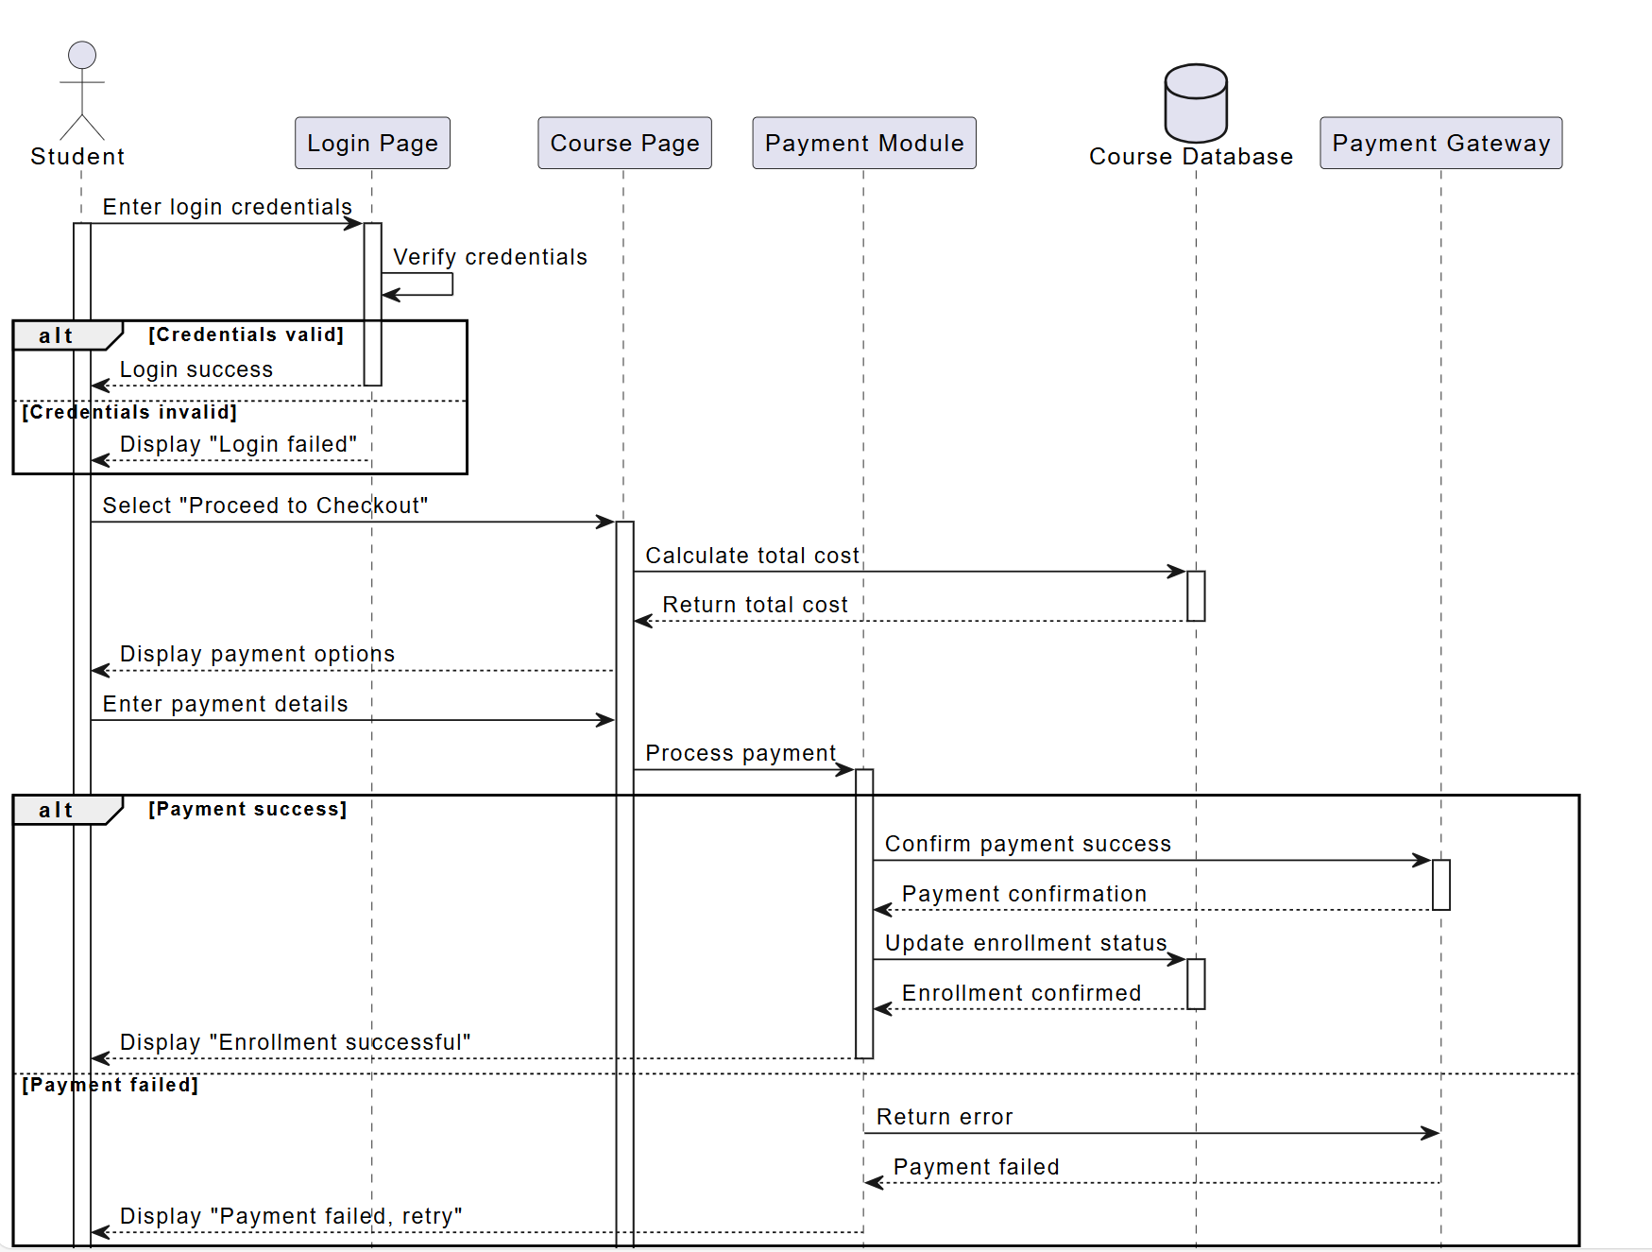
Seq: Create course
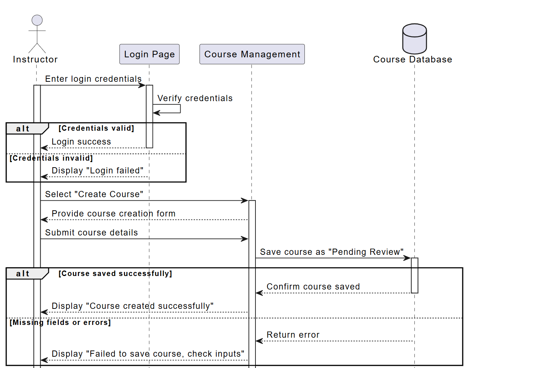
Seq: Manage course
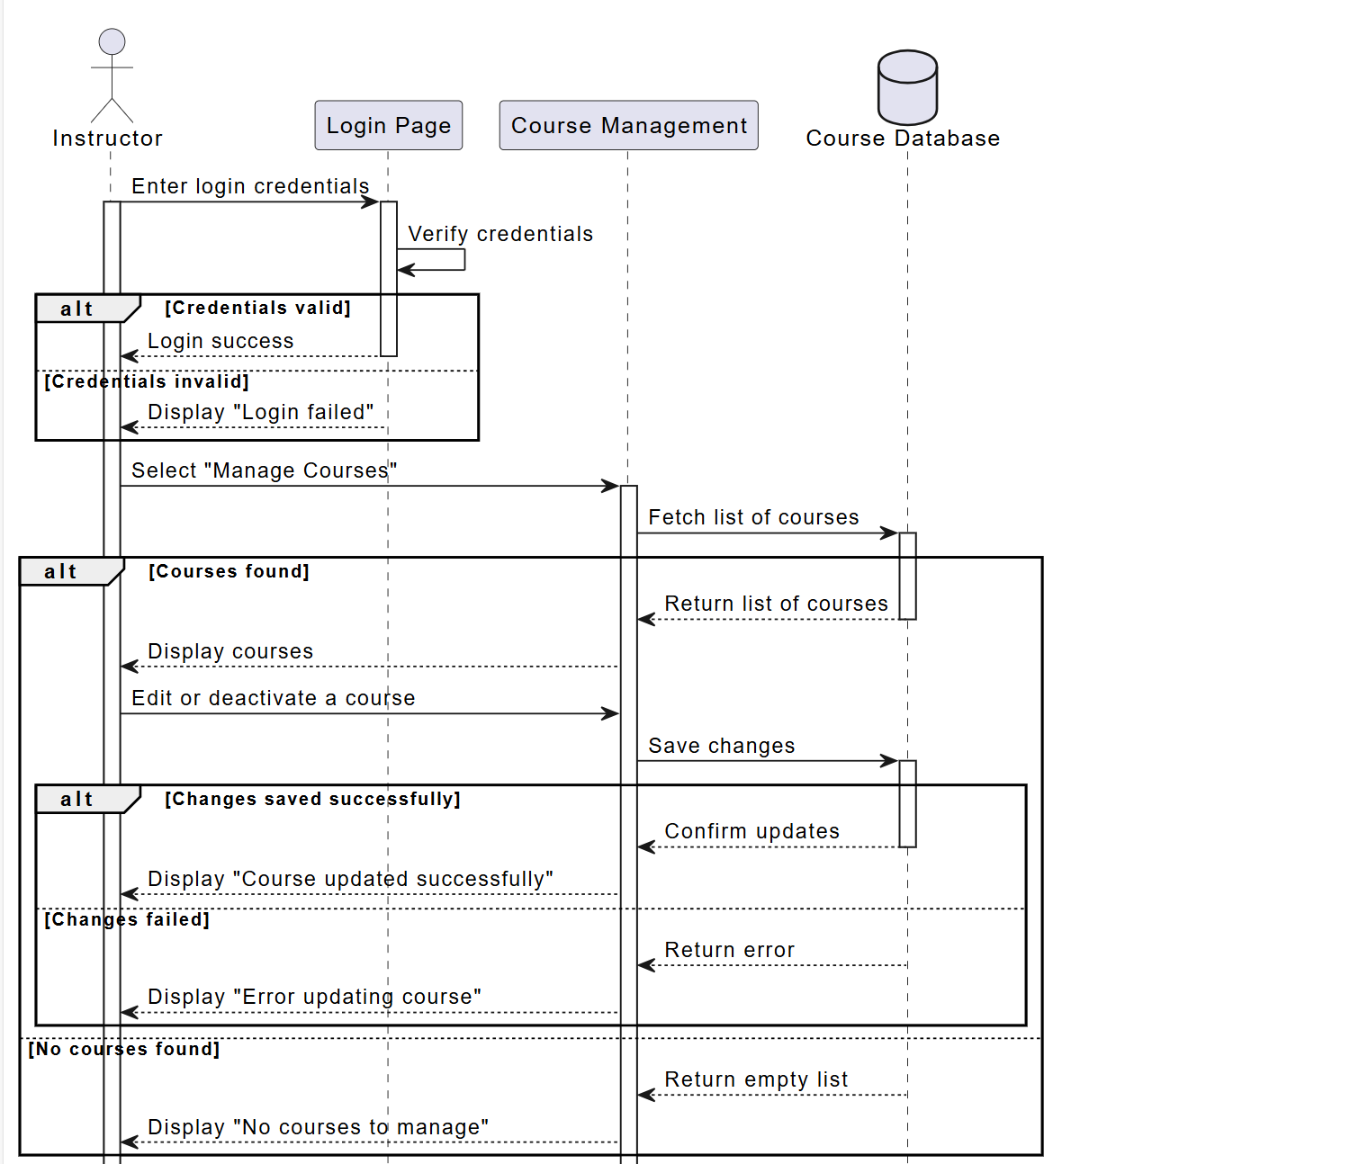
Seq: Withdrawal funds
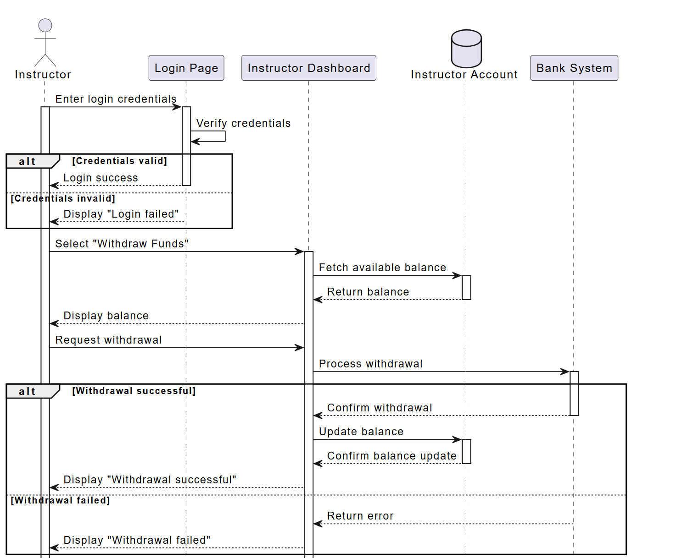
Seq: Manage user accounts
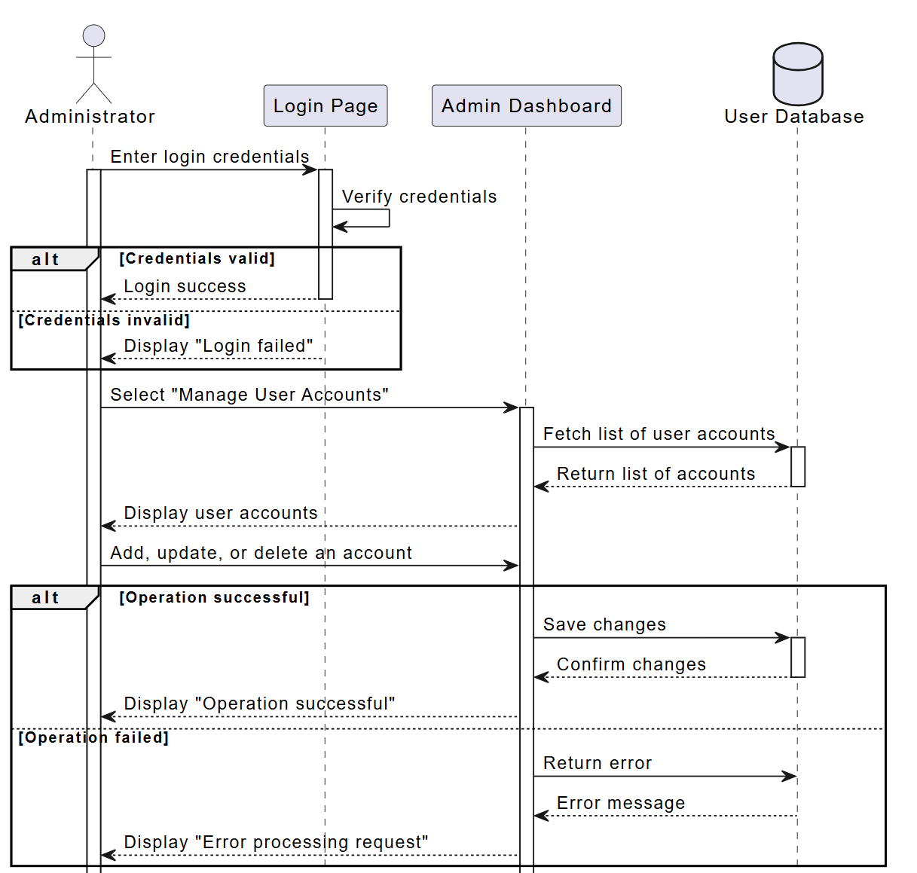
Seq: Publish course
