# Plot and Scatter plot

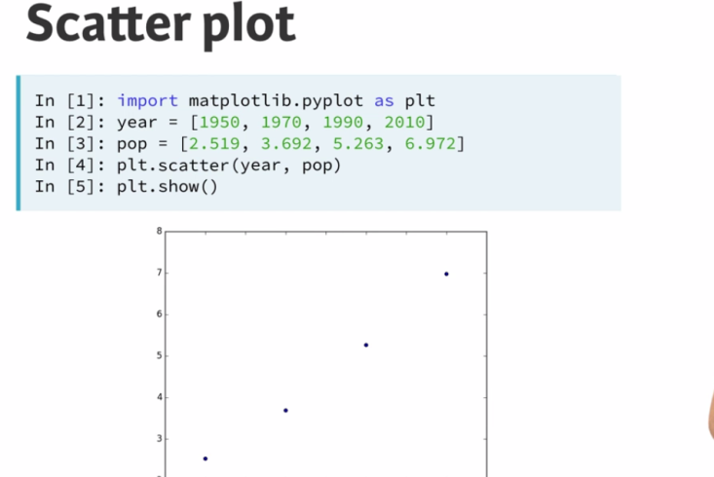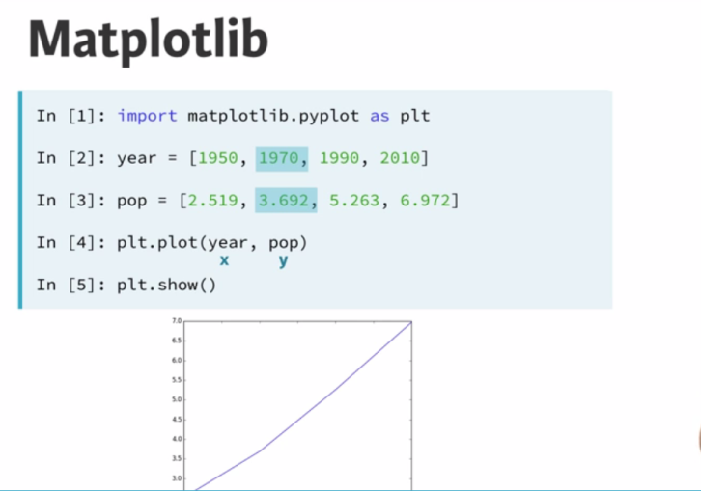

When you have a time scale along the horizontal axis, the line plot is your friend.

But in many other cases, when you're trying to assess if there's a correlation between two variables, for example, the scatter plot is the better choice. Below is an example of how to build a scatter plot.

# Histogram

