Neural Networks and Deep Learning

# CSCI 5922 – Assignment 6 (Fall 2017) by **Akshit Arora (108631342)**

As per guideline on piazza, here is the code I started working with: <https://github.com/aymericdamien/TensorFlow-Examples/blob/master/notebooks/3_NeuralNetworks/dynamic_rnn.ipynb>. Due to long training time, I used the Summit super-computing cluster (with GPUs) by research computing of CU that took much less time in executing the training process. (<https://www.rc.colorado.edu/resources/compute/summit>) I wrote a small code to submit the code as a job to the GPU cluster. I saved the numpy arrays as ‘.npy’ extension and then plotted them in my local Jupyter notebook.

Part 1:

Legend for the upcoming plots:

|  |  |
| --- | --- |
| # | Architecture [sequence length, hidden units] |
| 0 | 2,5 |
| 1 | 10,5 |
| 2 | 25,5 |
| 3 | 50,5 |
| 4 | 2,25 |
| 5 | 10,25 |
| 6 | 25,25 |
| 7 | 50,25 |

Mean fraction correct on test set for RNN (100 epochs):

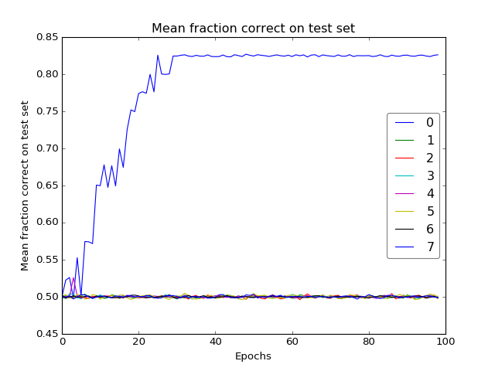Only model 0 (with sequence length = 2 and hidden units = 5) gives good result. Rest every model gives baseline accuracy of 50%

Here’s what the standard error of the mean looks like: A screenshot of a computer screen

Description generated with very high confidence

Here are the plots for 1500 epochs:

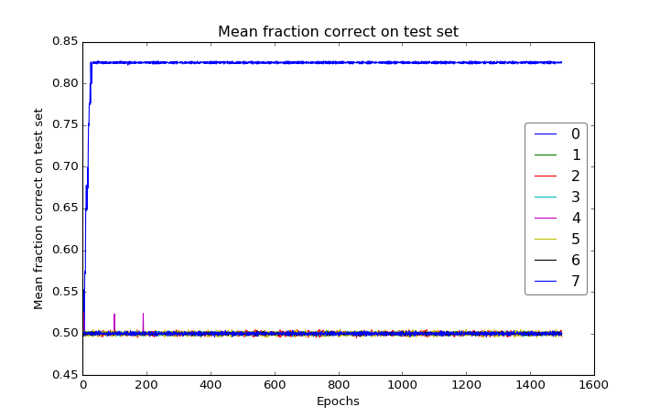

For 1500 epochs, the standard deviation looks like:

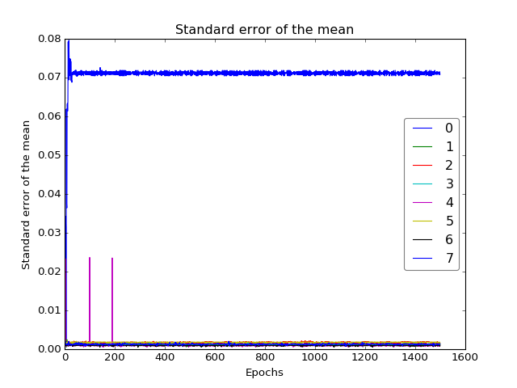

## Part 2:

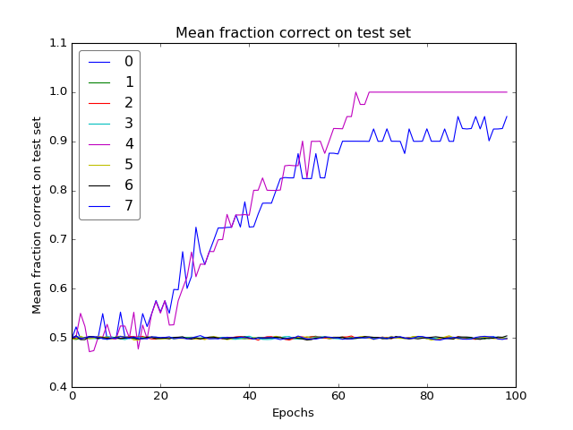For LSTM, we have not only model 0 (with sequence length = 2 and hidden units = 5) stands out but also, model 4 (with sequence length = 2 and hidden units = 25).

Here’s what the standard error of the mean looks like:

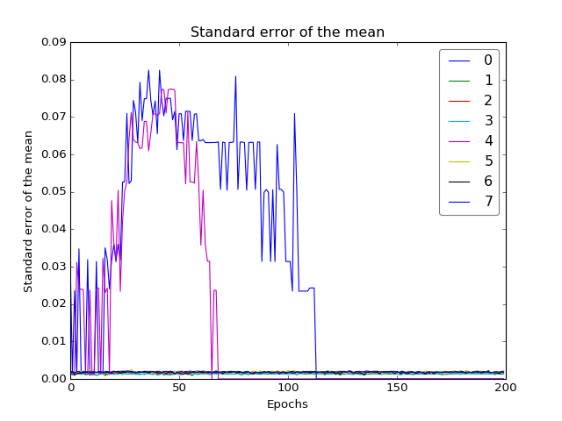

Here are the plots for 1500 epochs for LSTM:

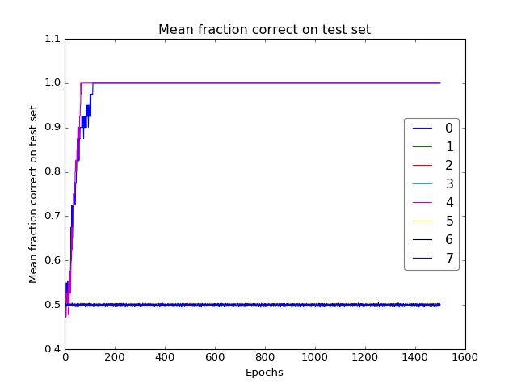

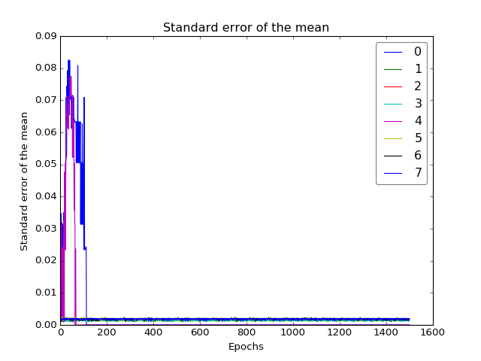

Please note that in the code submitted, Tensorflow version 0.12 has been used instead of the latest 1.4. It is because CUDA, CUDNN have been setup with python 3.5.1 and I didn’t have the rights to upgrade any of those modules on, Research Computing’s supercomputer, Summit.