1. Introduction
Modern machine learning systems require structured pipelines to automate data processing, model training, evaluation, and deployment. MLOps combines machine learning with DevOps practices to ensure reproducibility, scalability, and reliability of ML systems.
In this assignment, an end-to-end machine learning pipeline was developed using Apache Airflow for workflow orchestration and MLflow for experiment tracking and model registry. The pipeline predicts passenger survival using the Titanic dataset.
The pipeline automates the following stages:
- Data ingestion
- Data validation
- Parallel preprocessing
- Feature engineering
- Data encoding
- Model training
- Model evaluation
- Model registration or rejection
- Experiment comparison
This pipeline demonstrates how Airflow and MLflow work together to manage machine learning workflows efficiently.

2. System Architecture (Airflow + MLflow Interaction)
The architecture consists of two main components:
Apache Airflow
Airflow orchestrates the entire machine learning workflow using a Directed Acyclic Graph (DAG). Each step of the pipeline is defined as a task and executed in a controlled order.
Airflow manages:
- task scheduling
- dependency management
- retry mechanisms
- parallel task execution
- conditional branching
MLflow
MLflow is used for experiment tracking and model lifecycle management. It records parameters, metrics, artifacts, and trained models.
MLflow provides:
- experiment tracking
- model artifact storage
- hyperparameter comparison
- model registry
The interaction between Airflow and MLflow occurs during the model training stage, where MLflow logs model parameters, evaluation metrics, and artifacts generated during training.

3. DAG Structure and Task Dependencies
The pipeline is defined using an Airflow DAG (Directed Acyclic Graph). Each node represents a task and edges represent dependencies between tasks.

The pipeline follows this sequence:
- Start
- Data Ingestion
- Data Validation
- Parallel Processing
  - Handle Missing Values
  - Feature Engineering
- Data Encoding
- Model Training
- Model Evaluation
- Branching Decision
- Model Registration or Rejection
- End
Parallel processing is implemented using two independent tasks that execute simultaneously after validation. 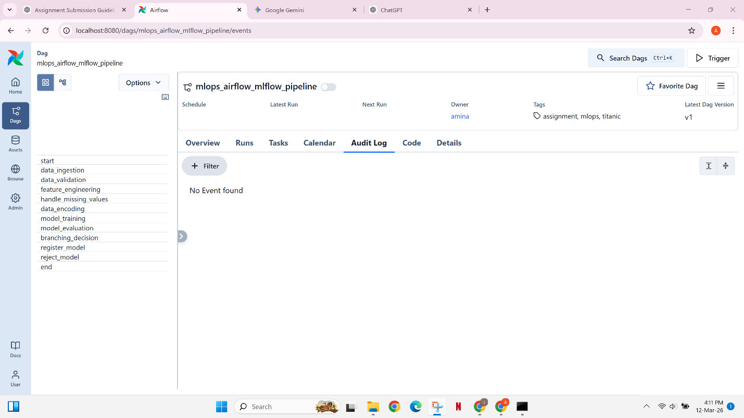
Branching logic is implemented using BranchPythonOperator which directs the workflow based on model accuracy. 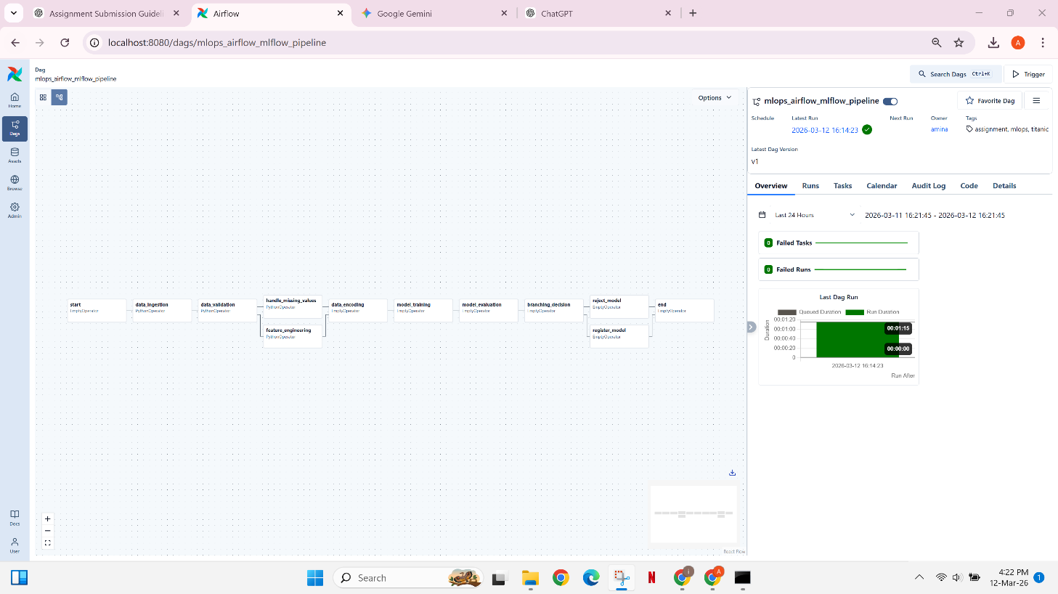

4. Data Ingestion
The pipeline begins by loading the Titanic dataset from a CSV file.
The following actions occur during ingestion:
- The dataset is loaded using pandas
- The dataset shape is printed
- Missing values in each column are logged
- The dataset path is passed to downstream tasks using Airflow XCom
This step ensures that the pipeline can dynamically pass dataset information to later tasks.
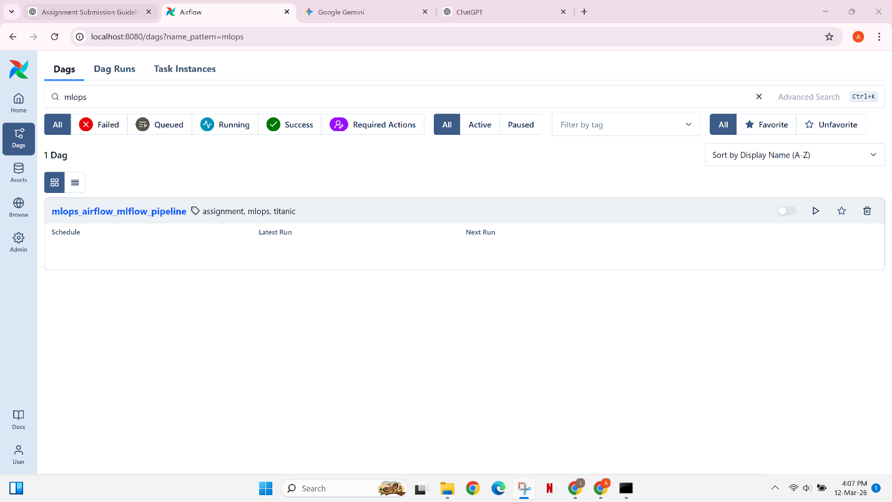

5. Data Validation and Retry Mechanism
Data validation checks the quality of the dataset before further processing.
The pipeline checks the missing value percentage in two columns:
- Age
- Embarked
If the missing percentage exceeds 30%, an exception is raised and the pipeline stops.
To demonstrate Airflow's retry mechanism, the validation task intentionally fails once before succeeding on the retry attempt.
This demonstrates Airflow's ability to recover from temporary failures automatically.
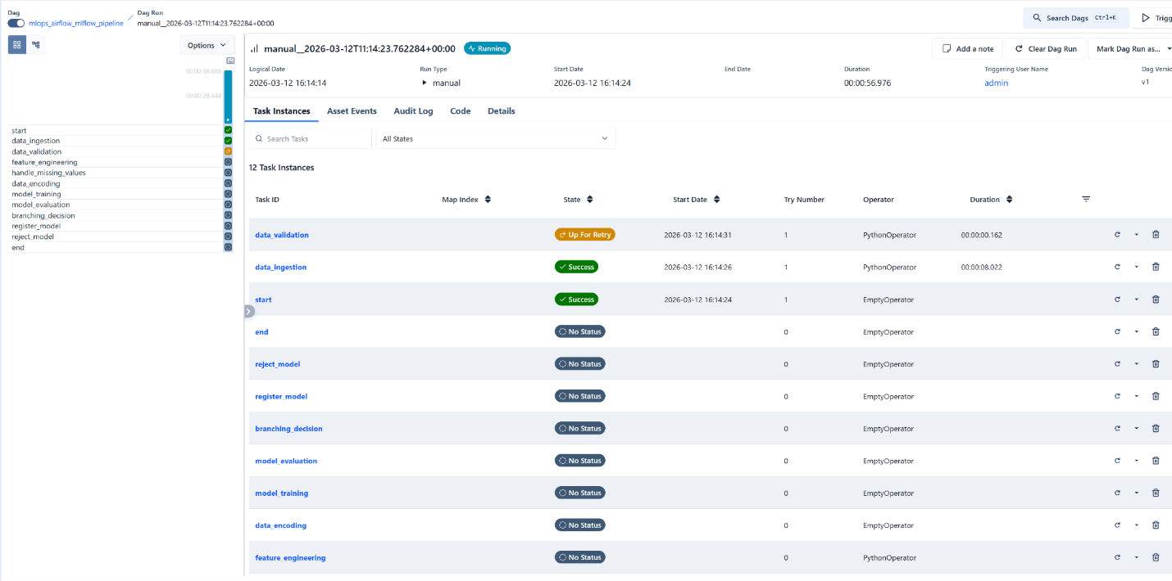
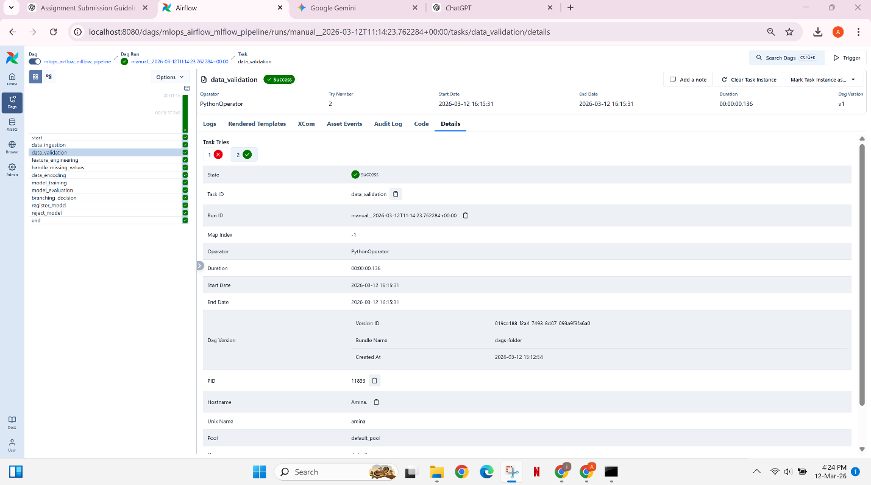

6. Parallel Data Processing
After validation, two preprocessing tasks run in parallel:
Handle Missing Values
Missing values are handled using:
- Median imputation for Age
- Mode imputation for Embarked
Feature Engineering
Two new features are created:
- FamilySize = SibSp + Parch + 1
- IsAlone (binary feature)
These tasks run simultaneously to improve pipeline efficiency.

7. Data Encoding
Categorical variables must be converted into numeric form before training.
The following encoding was applied:
Sex:
- male → 0
- female → 1
Embarked:
- S → 0
- C → 1
- Q → 2
Irrelevant columns were removed:
- PassengerId
- Name
- Ticket
- Cabin
This produces a clean dataset suitable for machine learning training.
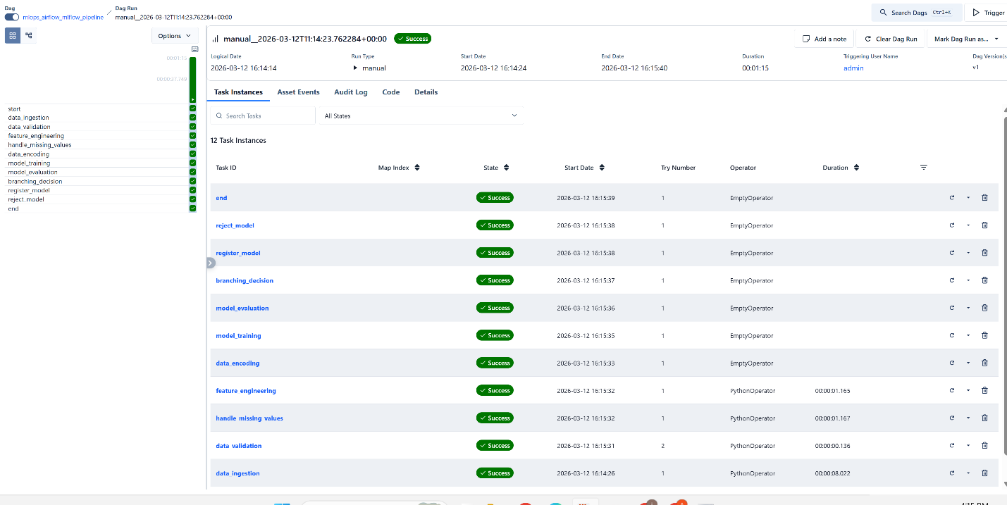

8. Model Training with MLflow
The model training stage trains a Logistic Regression classifier.
MLflow is used to track the experiment by logging:
- model type
- hyperparameters
- dataset size
- model artifact
Example hyperparameters logged:
- C (regularization strength)
- max_iter
MLflow also stores the trained model artifact for later retrieval.
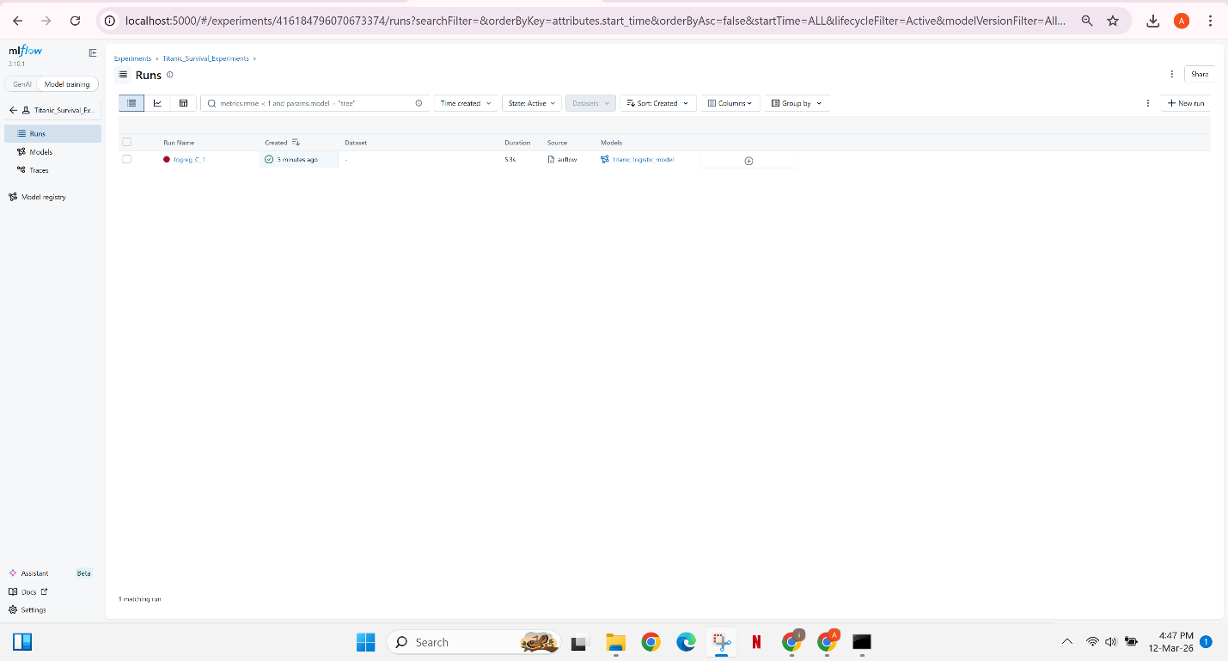

9. Model Evaluation
After training, the model is evaluated using the following metrics:
- Accuracy
- Precision
- Recall
- F1-Score
All evaluation metrics are logged to MLflow for experiment comparison.
The accuracy value is also passed using XCom to the branching task which determines whether the model should be registered or rejected.
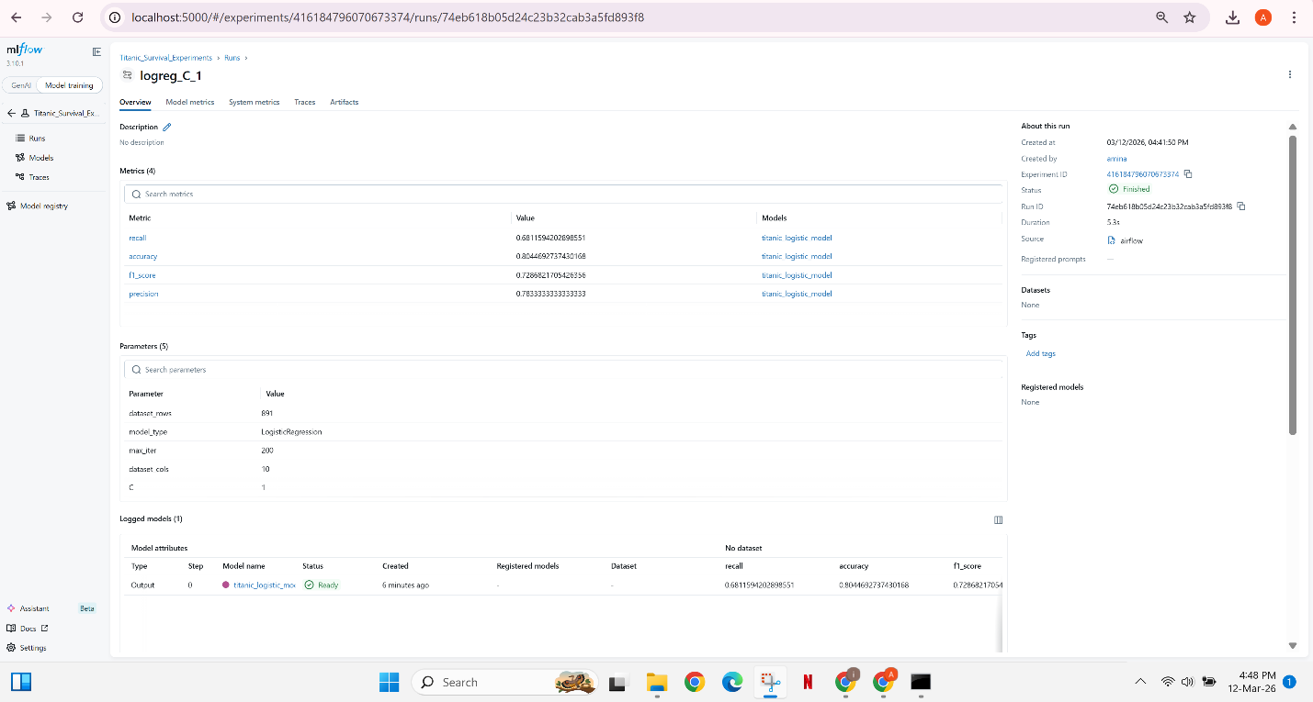

10. Branching Logic and Model Registration
Branching logic determines the next step based on model performance.
Decision rule:
Accuracy ≥ 0.80 → Register model
Accuracy < 0.80 → Reject model
This logic is implemented using BranchPythonOperator.
When the model meets the performance threshold, it is registered in the MLflow Model Registry.
The registry stores versioned models and enables model lifecycle management.
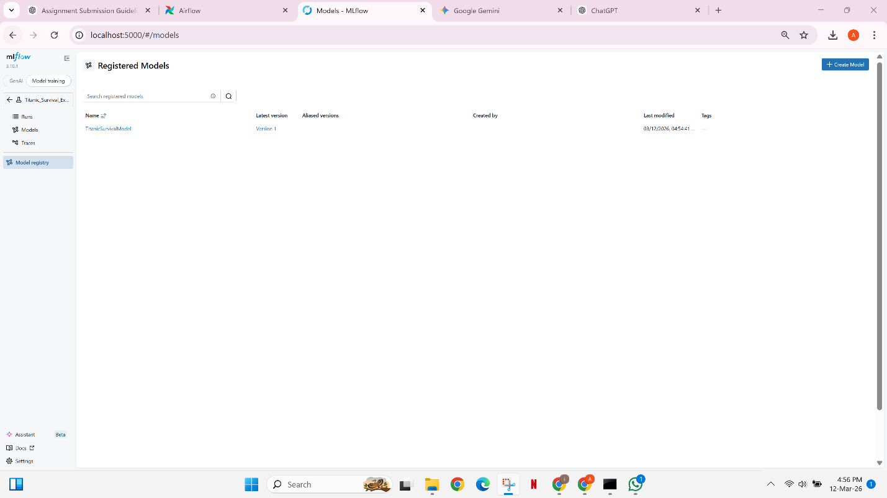

11. Experiment Comparison
To analyze model performance, the DAG pipeline was executed multiple times with different hyperparameters for the Logistic Regression model. The main hyperparameter adjusted during the experiments was the regularization parameter C. The following configurations were tested:
- C = 0.5
- C = 1.0
- C = 2.0
Each run was automatically logged in MLflow, which recorded parameters, evaluation metrics, and model artifacts. The MLflow interface allows easy comparison between multiple runs.
The comparison shows that the evaluation metrics remained almost identical across the different hyperparameter values. In all experimental runs, the model accuracy remained above the threshold of 0.80. Because of this, the branching condition in the Airflow DAG always directed the pipeline to the model registration path rather than the rejection path.
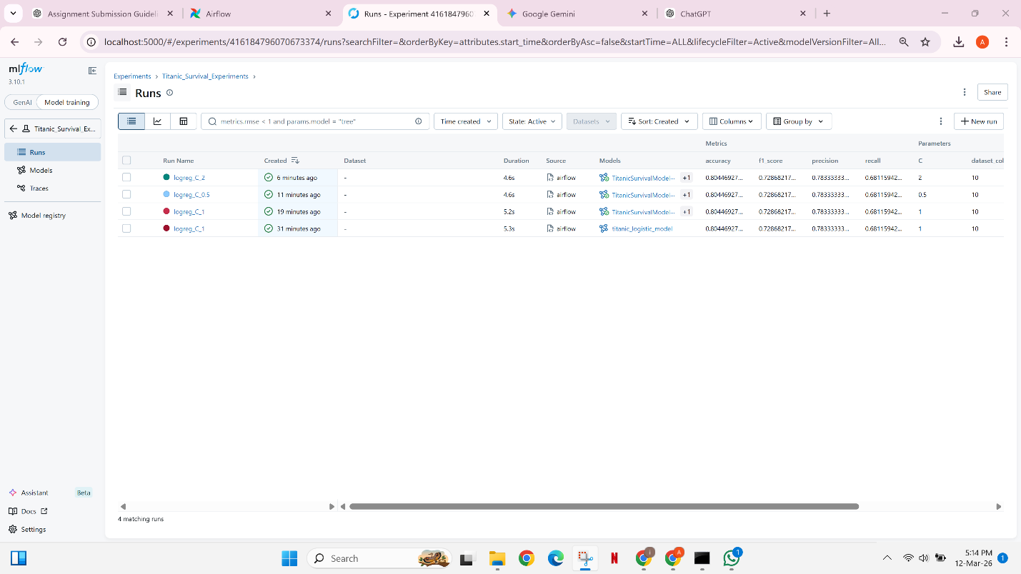
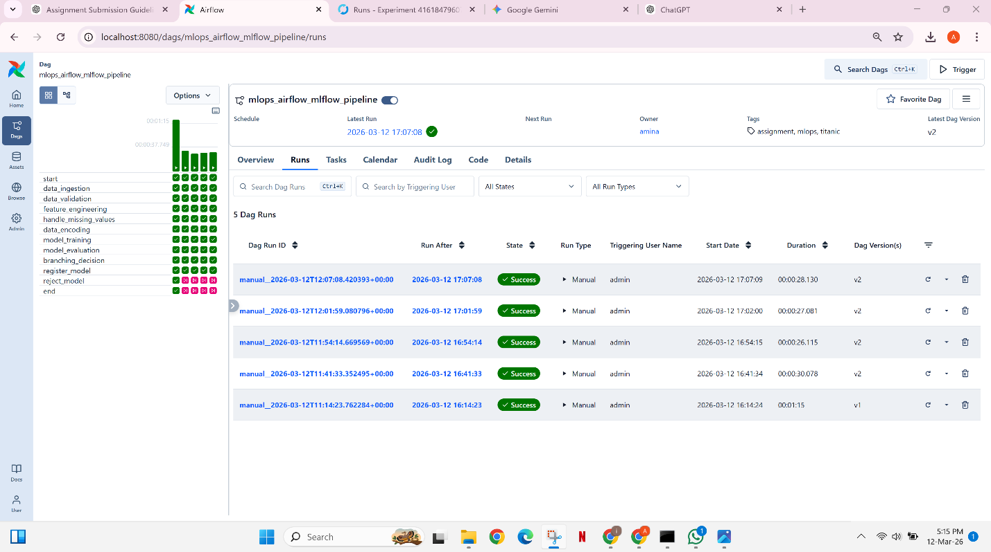
As a result, the rejection branch was not triggered during these experiments. However, the rejection logic is fully implemented in the DAG and would automatically activate if a model produced an accuracy lower than 0.80.
Since all models produced very similar performance results, the configuration with C = 1.0 was selected as the best-performing model because it provides stable performance while maintaining balanced regularization.

12. Conclusion
This assignment demonstrates the implementation of an end-to-end MLOps pipeline integrating Apache Airflow and MLflow.
The pipeline automates data ingestion, preprocessing, training, evaluation, and model registration while ensuring reproducibility through experiment tracking.
Airflow provides robust workflow orchestration through DAGs, retry mechanisms, and branching logic. MLflow complements this by enabling experiment tracking and model lifecycle management.
Such pipelines are essential in production machine learning systems where automation, monitoring, and reproducibility are critical.

