THE ISLAMIA UNIVERSITY OF BAHAWALPUR
Department of Artificial Intelligence
Bahawalpur, Punjab, Pakistan
DATA MINING — PROJECT REPORT
Multi-Model Ensemble and Computer Vision Approach for Crop Yield Prediction in Punjab, Pakistan: Towards Climate-Resilient Agriculture
Item | Details
Subject | Data Mining
Submitted By | Amina Asif, Kasa e Fatima
Supervisor | Miss Maryam Aslam
University | The Islamia University of Bahawalpur
Session | 2023 - 2027
Original Submission | May 2026
This Version | Extended edition with Computer Vision (CV) leaf-health module

Abstract
Accurate crop yield forecasting is essential for food security in Punjab, Pakistan, where climate variability, soil nutrient depletion and unpredictable weather threaten wheat and maize production. This project builds a multi-model machine learning system that predicts crop yield (Ton/Ha) from climate, pesticide and soil features using Random Forest, XGBoost and Support Vector Regression, combined through a Ridge-based Stacking Ensemble. The baseline tabular models are independently cross-checked in Orange Data Mining (the CV module and the later feature sets were evaluated in Python only).
In this extended edition, a Computer Vision (CV) module is added. A MobileNetV2 transfer-learning classifier is trained on the PlantVillage maize-leaf images to separate healthy from diseased leaves, and its output probability is exposed to the yield models as a tenth feature, health_score. The complete system, including leaf-image upload, model comparison charts and SHAP explanations, is deployed as a Gradio web application.
On the final 10-feature configuration the Stacking Ensemble achieves R² = 0.9906 (MAE 0.0462, RMSE 0.0780 Ton/Ha) and XGBoost R² = 0.9894, while SVR reaches only R² = 0.224. The report also presents an honest critical evaluation: the health_score feature produced no measurable change in accuracy, and a group-aware validation test shows that random-split scores overstate real-world generalisation. These findings are documented together with recommendations for a stronger second iteration.
Keywords: crop yield prediction, stacking ensemble, XGBoost, MobileNetV2, PlantVillage, SHAP, Punjab, Gradio.

1. Introduction
Agriculture is the backbone of Pakistan's economy, employing nearly 40% of the labour force and contributing approximately 23% to national GDP. Punjab, the most populous and agriculturally productive province, is responsible for the majority of Pakistan's wheat, rice, cotton, maize and sugarcane production. The Bahawalpur region in South Punjab is especially significant for wheat and cotton cultivation, serving as a breadbasket for millions of people.
Crop yield in Punjab is increasingly threatened by climate variability, including erratic rainfall, rising average temperatures, soil nutrient depletion and unpredictable weather events. These factors make it difficult for farmers, agricultural extension workers and policymakers to forecast output accurately. Poor yield predictions lead to inadequate resource planning, price instability, food insecurity and economic hardship for smallholder farmers.
Machine learning and data mining offer a practical answer. By analysing historical agricultural, climate and soil data, predictive models can forecast yields and support decisions on irrigation, fertiliser application, pest management and risk mitigation. This project develops a Multi-Model Ensemble of three diverse algorithms (Random Forest, XGBoost and SVR) combined into a Stacking Ensemble.
A second, complementary information source is the visible condition of the crop itself. Leaf diseases such as common rust and blight reduce photosynthetic area and, ultimately, yield. The extended edition therefore adds a Computer Vision module that reads a leaf photograph and returns a health probability, bringing image evidence into a pipeline that was previously purely tabular.
The workflow is implemented in Python (Google Colab), validated with Orange Data Mining, and deployed as an interactive web application on Hugging Face Spaces.

2. Problem Statement
The core problem is the accurate prediction of crop yield (Tons per Hectare) for wheat and maize in Punjab, Pakistan, using weather conditions, soil nutrients, pesticide usage and, in this edition, leaf-health evidence extracted from images. Specific challenges addressed:
- Unpredictable climate variability affecting rainfall and temperature patterns in Punjab
- Lack of accessible, data-driven tools for smallholder farmers to estimate yield before harvest
- Absence of multi-model comparison studies tailored to Punjab's agricultural context
- Need for interpretable AI models that explain which factors most influence yield
- Gap between academic machine learning research and practical field-level decision support
- No link between visual crop-health evidence (leaf images) and numeric yield forecasts
The task is framed as supervised regression: given input features, predict the continuous target yield_ton_ha. A second, image-based task is framed as binary classification: given a maize-leaf photograph, predict healthy (1) or diseased (0).

3. Datasets
Four datasets, all sourced from Kaggle, were used. Together they cover crop production, climate, soil health and leaf imagery.

3.1 Dataset 1: Wheat Data of Punjab Pakistan (12 Years)
Source: Kaggle (mhaiderali37) | Format: Excel | Rows: 12 | Variables: 5. Annual wheat statistics for Punjab from 2014/2015 to 2023/2024 (market year, area in 1000 Ha, production in 1000 Tons, yield in Ton/Ha). Used for trend analysis and visualisation, showing a steady improvement from 2.7 Ton/Ha in 2015/2016 to 3.0 Ton/Ha in 2023/2024.

3.2 Dataset 2: Crop Yield Prediction Dataset
Source: Kaggle (patelris) | Format: CSV | Rows: 28,242 global, 1,449 after the Pakistan filter | Variables: 8. The primary modelling dataset, combining FAO crop production data with World Bank climate indicators. After filtering for Pakistan it covers seven crops from 1990 to 2013. Key variables are yield (hg/ha, converted to Ton/Ha), average rainfall (mm), pesticide usage (tonnes) and average temperature (°C).

3.3 Dataset 3: Crop District-Level Dataset (Punjab, Pakistan)
Source: Kaggle (talhanazir168) | Format: CSV | Rows: 2,200 | Variables: 9. District-level soil and climate data for Punjab covering 13 crop types: soil nutrients (N, P, K in mg/kg), soil temperature, humidity, pH and rainfall, including Bahawalpur, Rahim Yar Khan and Bahawalnagar. It was aggregated by crop type and merged with Dataset 2.

3.4 Dataset 4: PlantVillage Leaf Images (new in this edition)
Source: Kaggle (abdallahalidev/plantvillage-dataset), colour images | Used subset: the four maize (Corn) classes. Wheat leaf classes are not available in PlantVillage, so the CV module is trained on maize only. The three disease classes were merged into one 'diseased' label to form a binary problem.
Class (PlantVillage) | Binary label | Images
Corn (maize) healthy | healthy (1) | 1,162
Corn common rust | diseased (0) | 1,192
Corn northern leaf blight | diseased (0) | 985
Corn Cercospora / gray leaf spot | diseased (0) | 513
Total |  | 3,852
After the 80/20 split the validation set contains 772 images (539 diseased, 233 healthy) and the training set 3,080 images (2,151 diseased, 929 healthy). The class imbalance is roughly 70% diseased to 30% healthy.

3.5 Final Merged Dataset Summary
Property | Value | Details
Total rows | 414 | After merge and cleaning (207 wheat + 207 maize)
Total columns | 16 | Includes target; 15 in the original edition plus health_score
Missing values | 0 | Complete dataset
Crop types | 2 | Wheat, Maize
Time period | 1990 - 2013 | 23 distinct years (2003 absent); 46 crop-year combinations
Target variable | yield_ton_ha | Range 1.40 to 4.23 Ton/Ha
CV feature | health_score | Added in final_ml_dataset_cv.csv

4. Methodology and Workflow
The project follows a complete data-mining pipeline: Python (Google Colab) for processing and modelling, Orange Data Mining for visual EDA and independent validation, a TensorFlow/Keras transfer-learning pipeline for the CV module, and Gradio for deployment. Orange was used for the baseline tabular models only; the CV module and the Phase 2 and Phase 3 feature sets were not built in Orange.
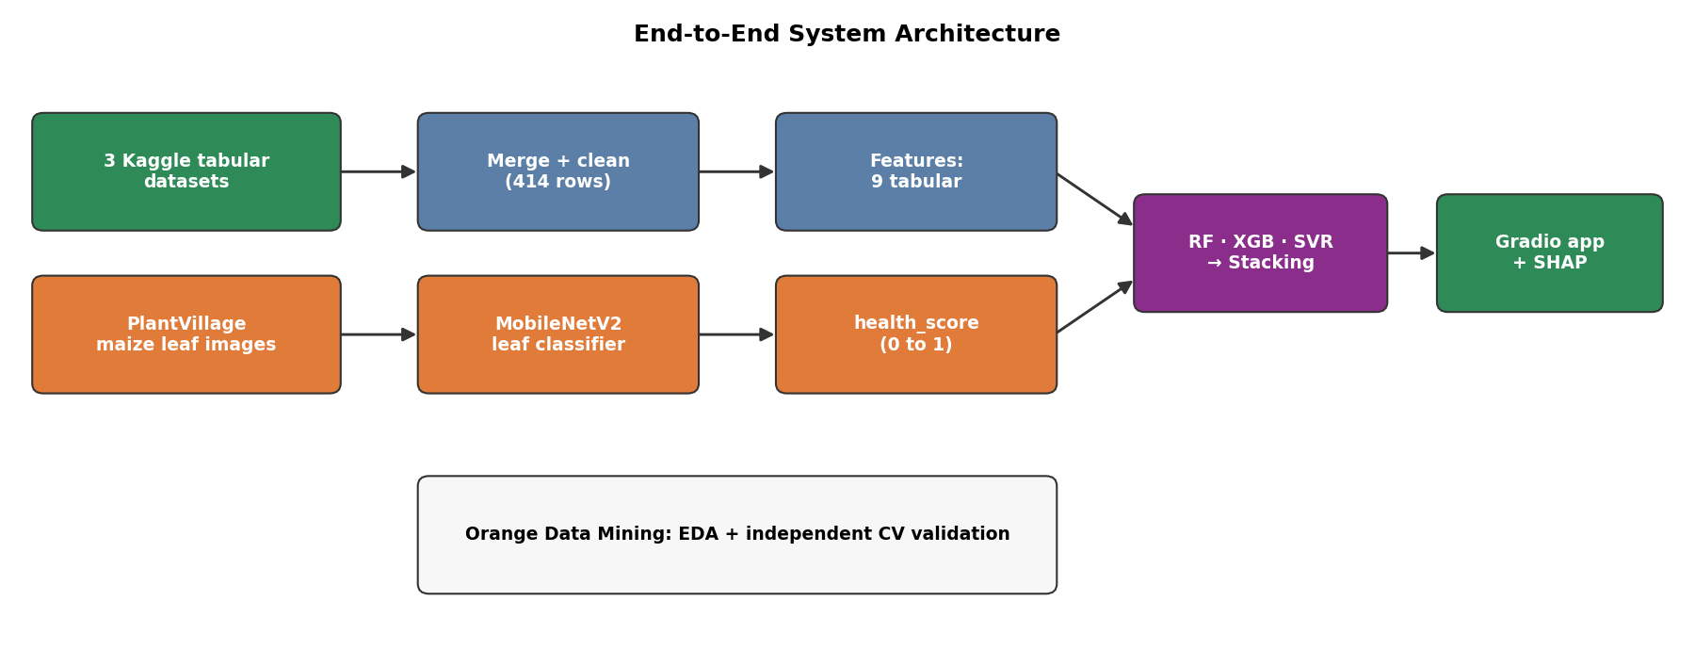
Figure 1: End-to-end system architecture: tabular pipeline, CV leaf-health pipeline, stacking ensemble and Gradio deployment
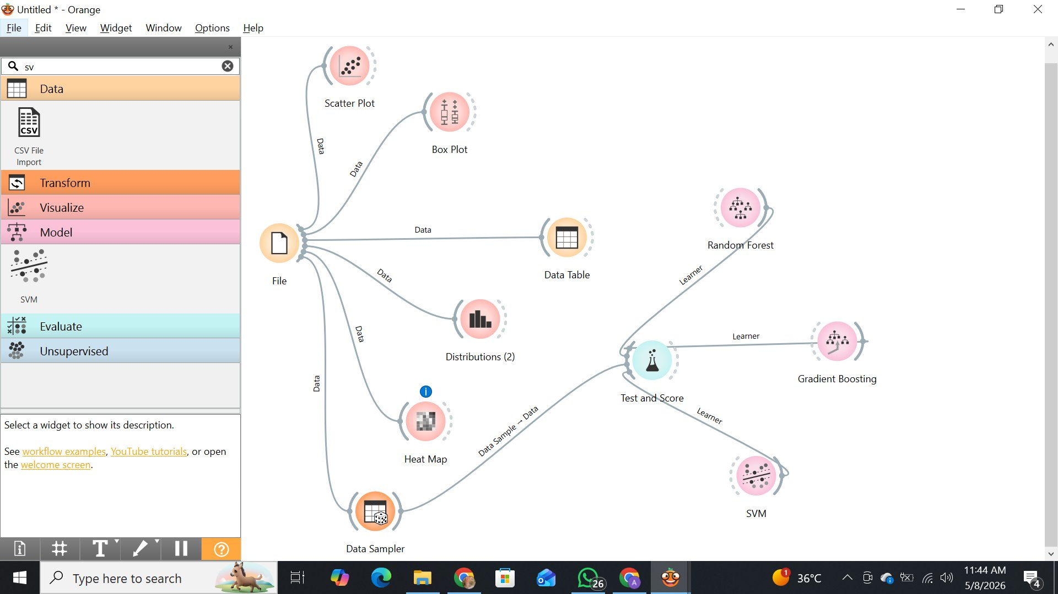
Figure 2: Orange Data Mining workflow: File widget connected to Data Table, Distributions, Heat Map, Data Sampler and Test and Score with three learners (Random Forest, Gradient Boosting, SVM)

4.1 Data Collection
All datasets were downloaded into Google Colab through the Kaggle API using a JSON credentials key. Google Drive was mounted at the start of each session for persistent storage; raw files were saved in CropYieldProject/data/raw/.

4.2 Data Preprocessing
- Dataset 1: fixed column headers and removed the summary-average row
- Dataset 2: filtered for Pakistan, reducing 28,242 global rows to 1,449
- Dataset 3: aggregated by crop type using group means for N, P, K, temperature, humidity, pH and rainfall
- Datasets 2 and 3 merged on crop type (inner join), giving 414 rows
- Missing-value check confirmed zero missing values
- StandardScaler applied for SVR only; tree models need no scaling

4.3 Feature Engineering and Feature-Set Evolution
The engineered features were temp_x_rainfall (interaction term), NPK_total (N + P + K) and crop_encoded (0 = maize, 1 = wheat); the target was converted from hg/ha to Ton/Ha by dividing by 10,000. The feature set was refined in three phases:
Phase | Features | Purpose
1 - Baseline | 13: year, rainfall_mm, pesticides_tonnes, avg_temp, N, P, K, temperature, humidity, ph, temp_x_rainfall, NPK_total, crop_encoded | Original submitted models
2 - Cleaned | 9: pesticides_tonnes, avg_temp, N, P, K, temperature, humidity, ph, NPK_total | Removed year, constant rainfall (494 mm for all rows), its interaction term and crop label
3 - With CV | 10: the 9 features above + health_score | Adds the CV leaf-health probability

4.4 Exploratory Data Analysis in Orange
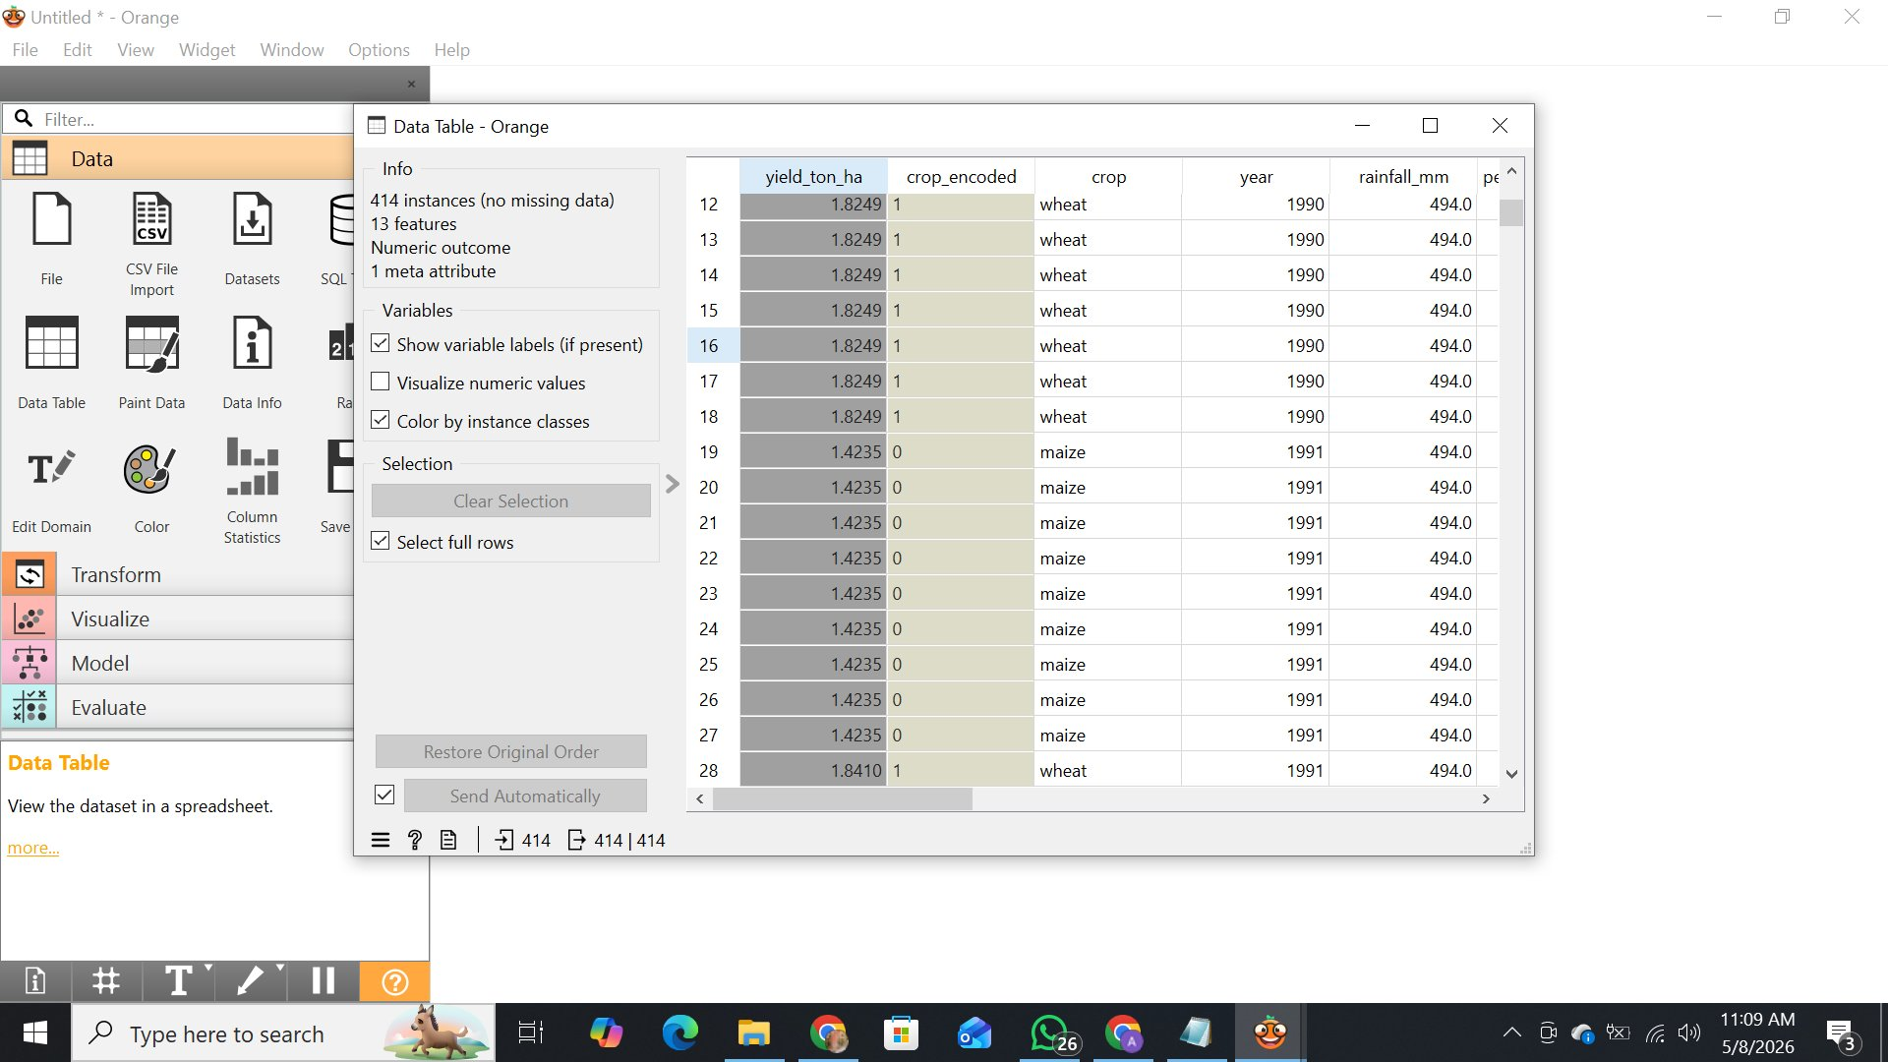
Figure 3: Orange Data Table: 414 instances, no missing data, 13 numeric features, yield_ton_ha as numeric target
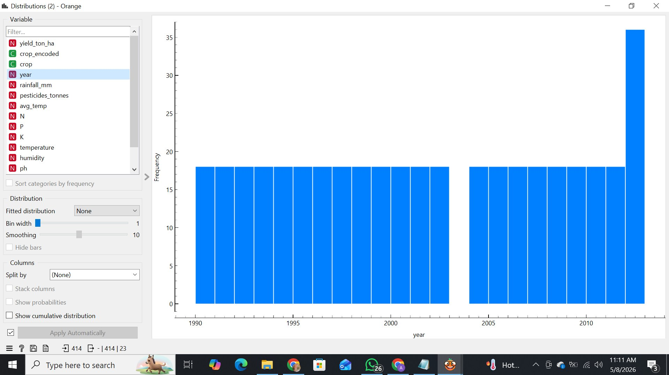
Figure 4: Distributions widget (Year): uniform records 1990 to 2013
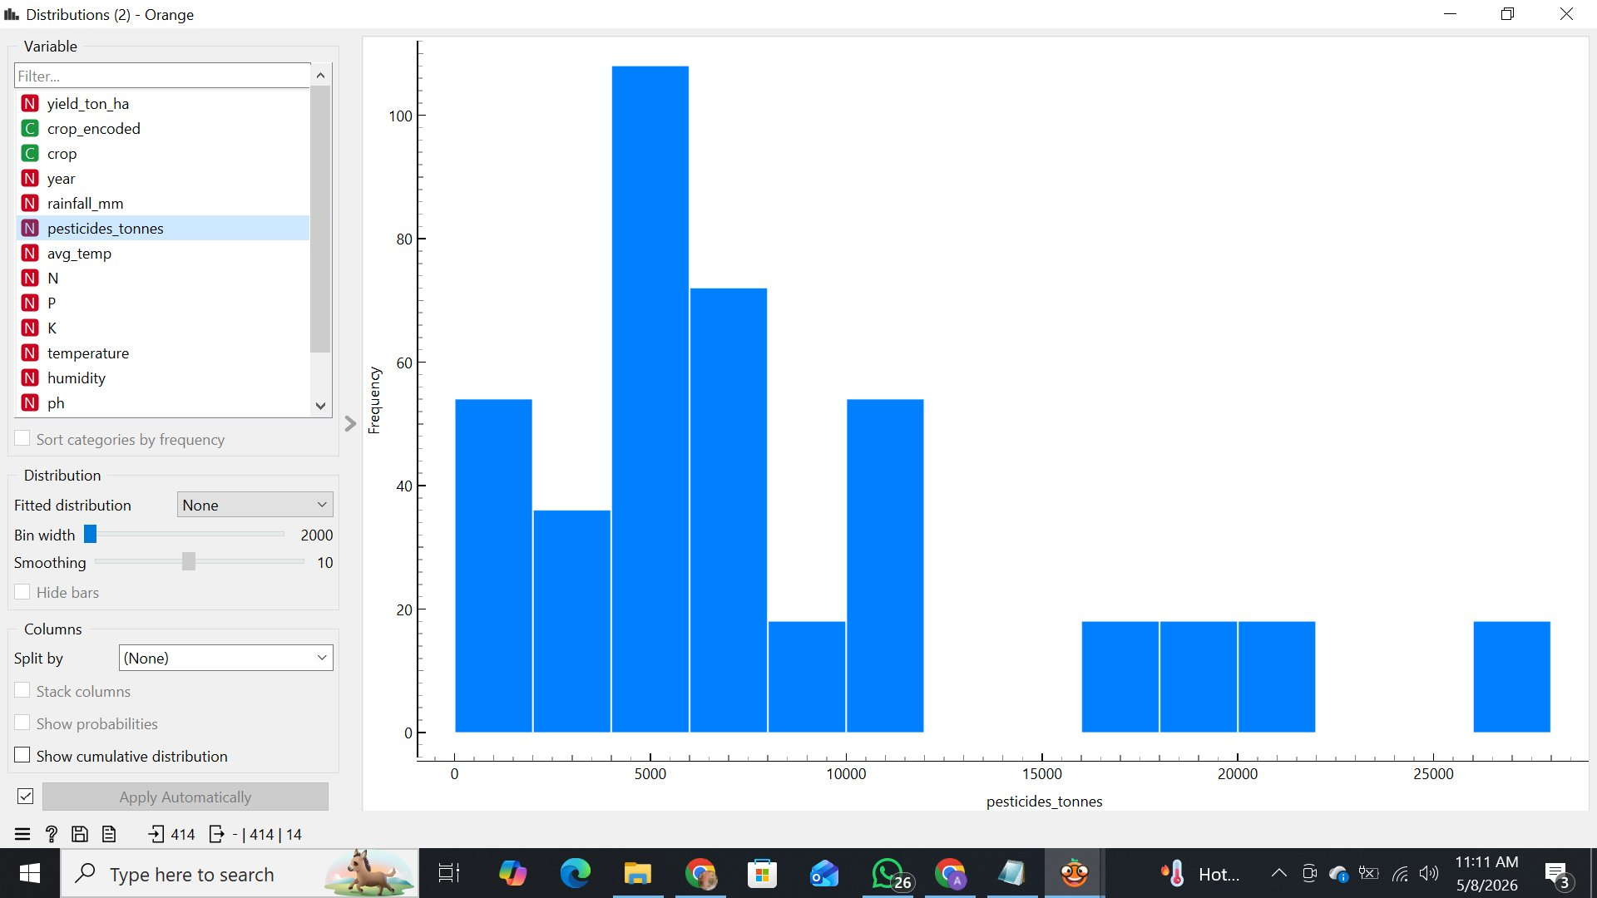
Figure 5: Distributions widget (Pesticides tonnes): right-skewed, most values between 0 and 10,000 tonnes
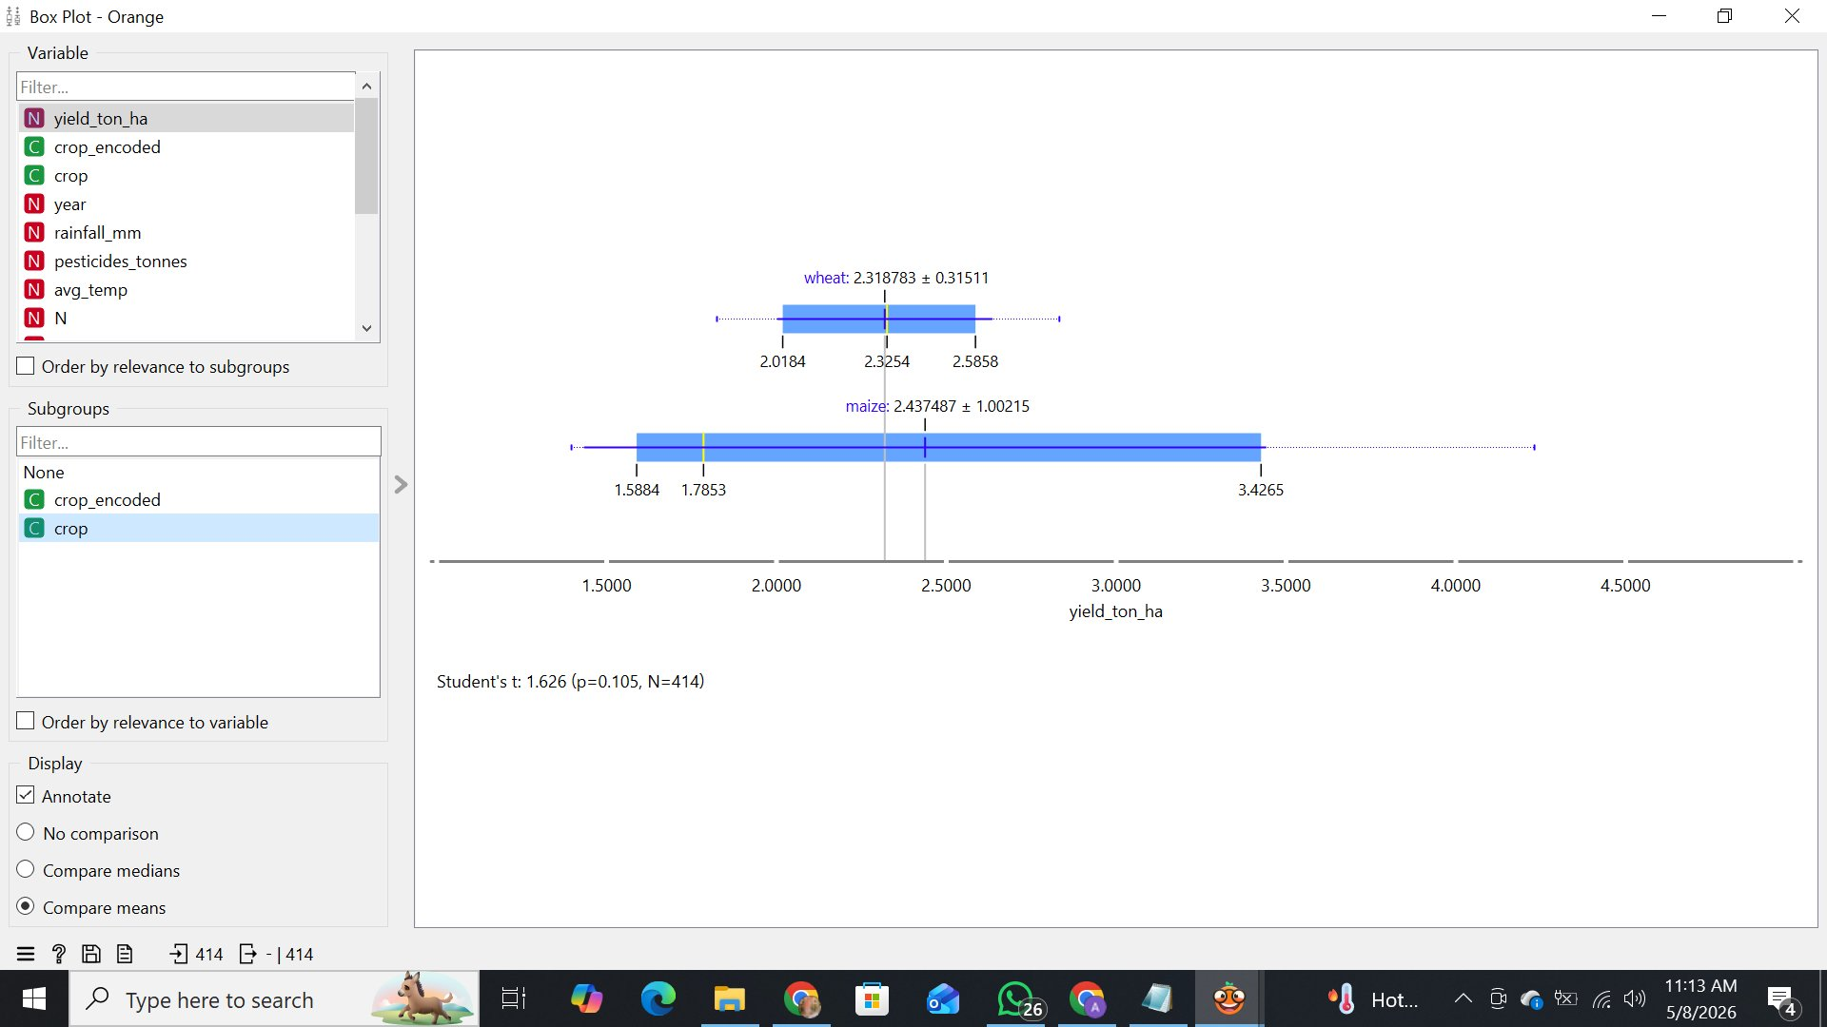
Figure 6: Box Plot of yield by crop. Wheat mean 2.32 Ton/Ha; maize mean 2.44 Ton/Ha (range 1.59 to 3.43); Student's t-test p = 0.105
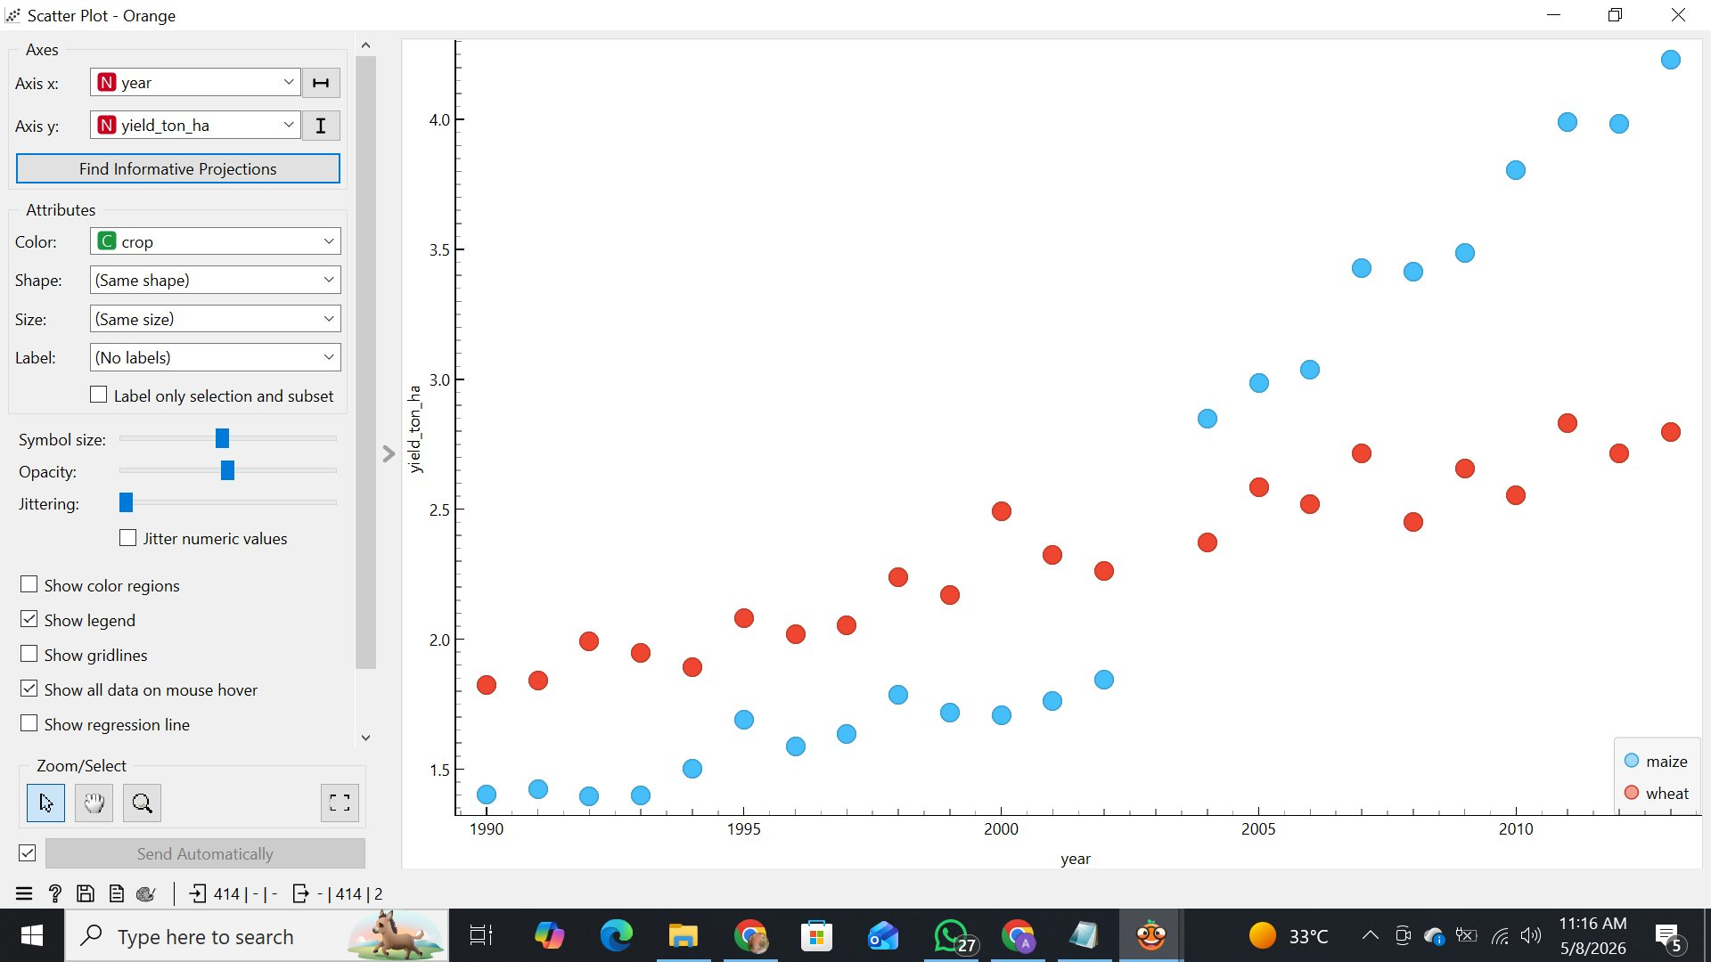
Figure 7: Scatter Plot of Year vs yield, coloured by crop: both crops trend upward from 1990 to 2013
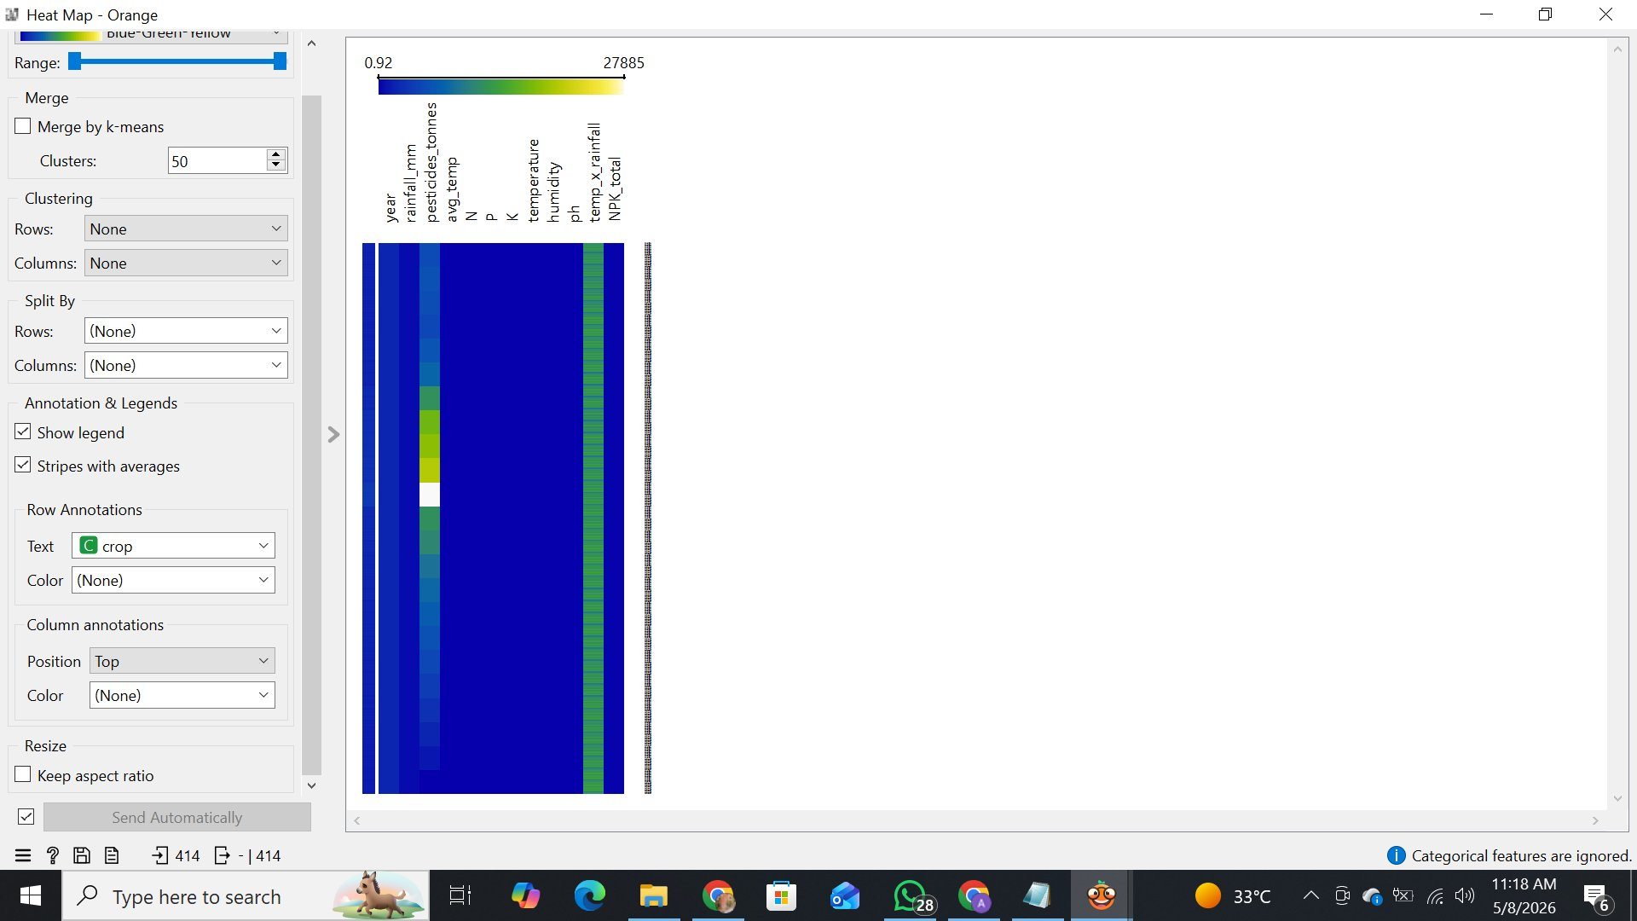
Figure 8: Heat Map across all 414 instances, annotated by crop

4.5 Additional EDA Outputs (Python)
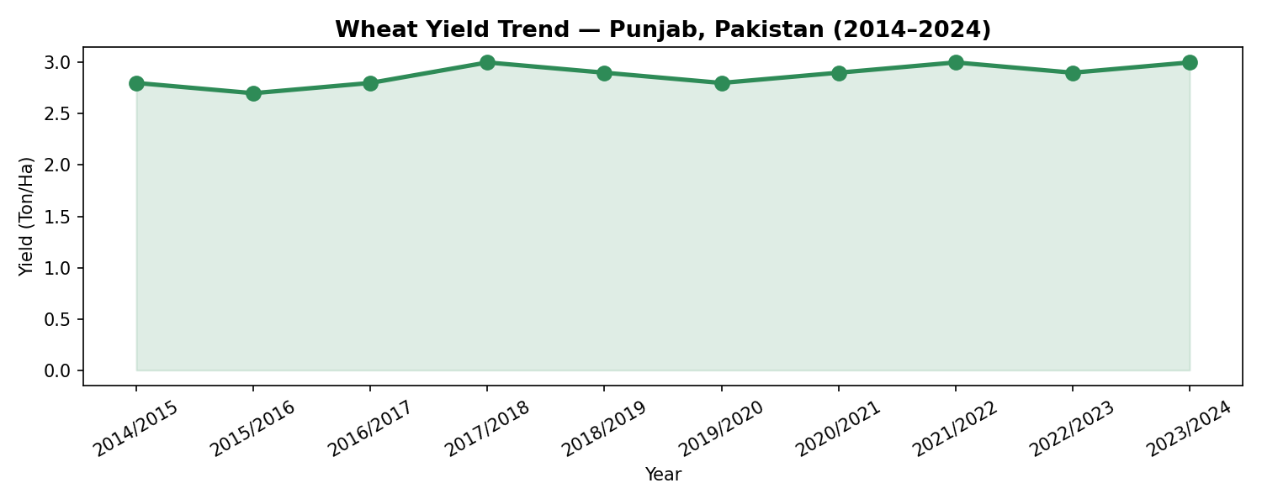
Figure 9: Wheat yield trend for Punjab (Dataset 1)
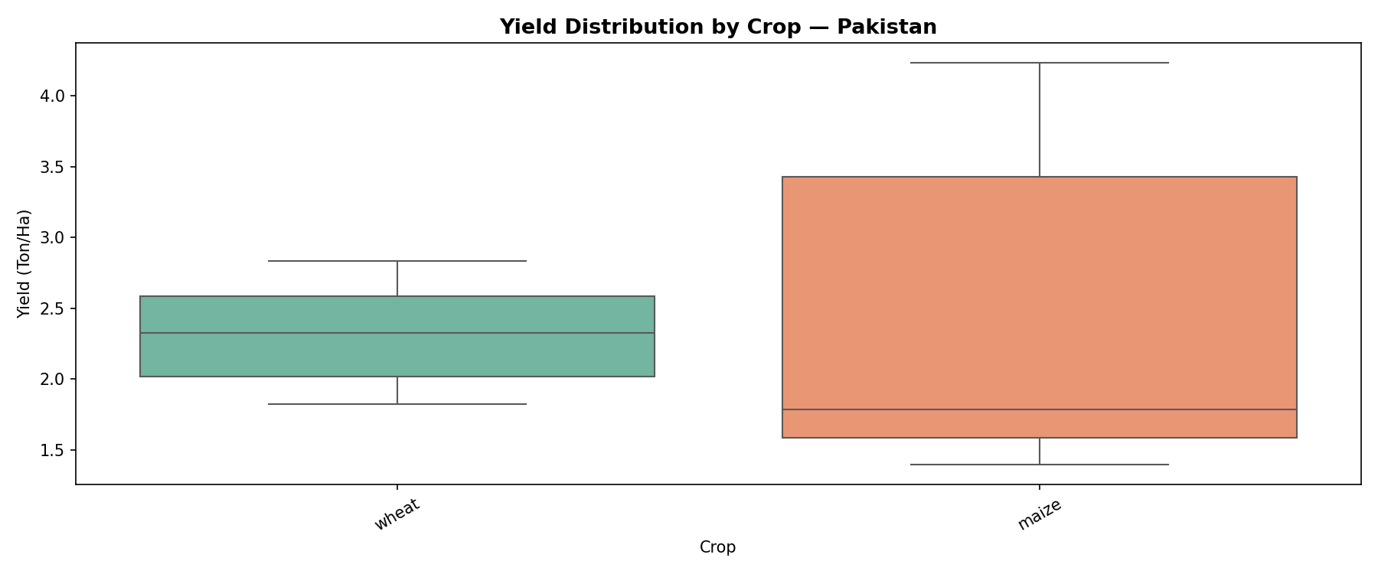
Figure 10: Yield distribution by crop type
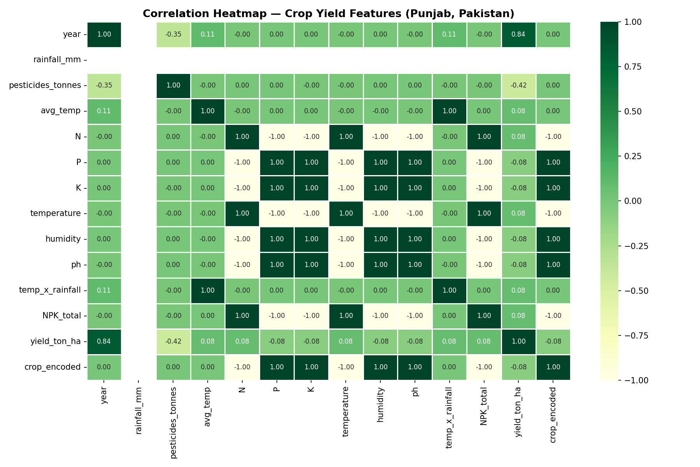
Figure 11: Correlation heatmap of the modelling features

5. Machine Learning Models
Three models from different paradigms were selected to give rich comparison and a strong ensemble foundation.

5.1 Random Forest Regressor
Paradigm: bagging | Library: scikit-learn | Parameters: 200 trees, random_state = 42, max_depth = 10 in Phase 1 and max_depth = 8 in Phases 2 and 3 (final models). Builds many decision trees on random subsets of rows and features and averages them, reducing variance. Selected because it handles mixed features, is robust to noise and outliers, offers built-in feature importance, needs no scaling and creates the diversity needed for stacking.

5.2 XGBoost Regressor
Paradigm: gradient boosting | Library: xgboost | Parameters: 200 estimators, learning_rate = 0.05, max_depth = 6 in Phase 1 and max_depth = 5 in Phases 2 and 3 (final models). Builds trees sequentially, each correcting the residuals of the previous ones, with L1/L2 regularisation. Selected for strong performance on tabular data, its ability to capture non-linear interactions, regularisation suited to a small dataset (414 rows) and full SHAP compatibility.

5.3 Support Vector Regression (SVR)
Paradigm: kernel-based margin optimisation | Library: scikit-learn | Parameters: RBF kernel, C = 100, gamma = 0.1, epsilon = 0.1. Fits a function within an epsilon margin in a kernel-induced feature space. Selected because it is fundamentally different from both bagging and boosting, adding diversity to the ensemble.

5.4 Justification for the Three-Model Selection
Random Forest (averaging), XGBoost (sequential boosting) and SVR (kernel/margin) make different kinds of errors, which is what a stacking ensemble exploits. Tree models capture threshold effects while SVR captures smooth non-linear boundaries.

5.5 Stacking Ensemble
A StackingRegressor uses the three models as level-1 learners (SVR wrapped in a StandardScaler pipeline) and Ridge Regression (alpha = 1.0) as the level-2 meta-learner. Five-fold cross-validation produces out-of-fold predictions to avoid leakage between levels. The final stacked model uses the Phase 2/3 base-learner settings above.

6. Computer Vision Module: Leaf Health Classification

6.1 Objective
The CV module reads a photograph of a maize leaf and outputs a probability that the leaf is healthy. This probability is the health_score feature passed to the yield models, and it is also displayed to the user as a 'Healthy' or 'Diseased' label with confidence.

6.2 Data Preparation
- Source images: PlantVillage colour folder, four maize classes (Section 3.4)
- Each class folder was split 80% train / 20% validation with random_state = 42, giving 3,080 training and 772 validation images
- Labels: diseased = 0 (three disease classes merged), healthy = 1
- Training augmentation: rotation up to 20 degrees, zoom 0.2, horizontal flip, brightness range 0.8 to 1.2; pixel values rescaled to [0, 1]
- Input size 224 x 224 pixels, batch size 32; validation images are rescaled only

6.3 Model Architecture
Transfer learning with MobileNetV2 pre-trained on ImageNet. MobileNetV2 uses depth-wise separable convolutions and inverted residual blocks, giving high accuracy at low computational cost, which suits a free-tier web deployment.
Component | Configuration
Backbone | MobileNetV2 (ImageNet weights, include_top = False), frozen
Pooling | GlobalAveragePooling2D
Dense layer | 128 units, ReLU
Regularisation | Dropout 0.3
Output | 1 unit, sigmoid (probability of healthy)
Loss / optimiser | Binary cross-entropy / Adam
Training | Up to 10 epochs; EarlyStopping on val_accuracy (patience 3, best weights restored); ModelCheckpoint saves leaf_classifier.h5

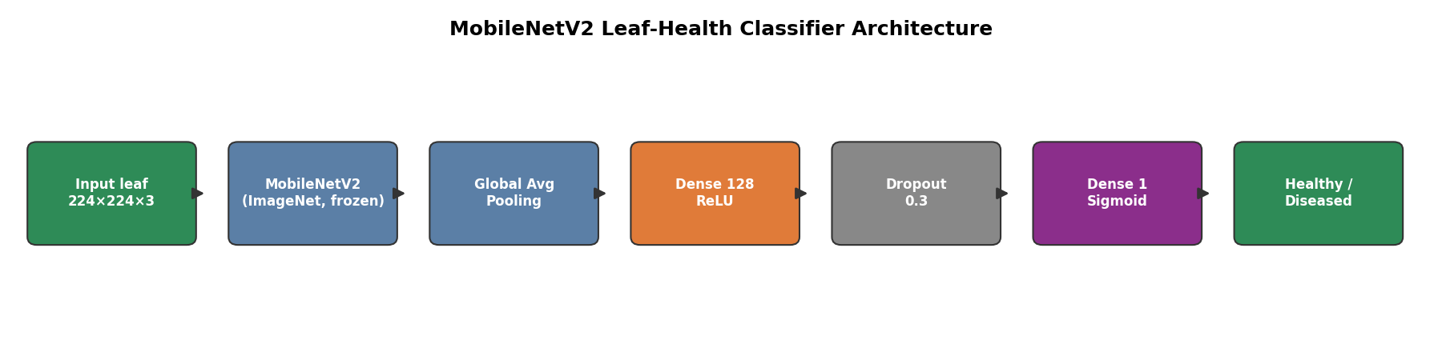
Figure 12: MobileNetV2 leaf-health classifier: layers from input image to healthy/diseased probability

6.4 CV Model Performance
Evaluated on the 772 held-out validation images, the classifier misclassified a single image. Overall accuracy is 771 / 772 = 99.87%: all 539 diseased leaves were identified correctly and 232 of 233 healthy leaves were identified correctly (one healthy leaf was predicted as diseased).
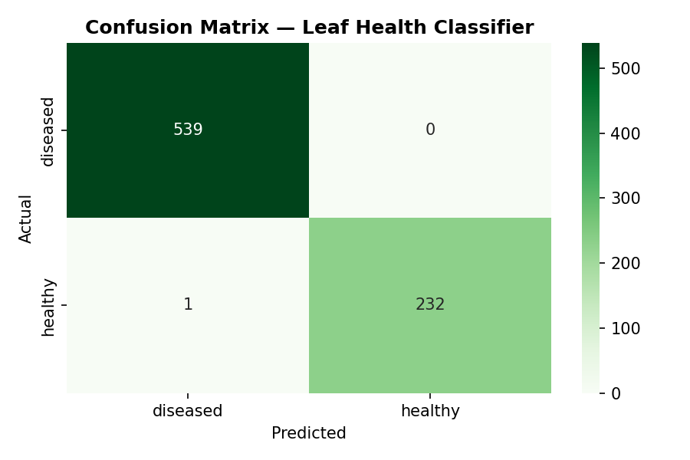
Figure 13: Confusion matrix of the leaf-health classifier on the validation set (539 diseased, 233 healthy)
Class | Precision | Recall | F1-score | Support
Diseased | 0.9981 | 1.0000 | 0.9991 | 539
Healthy | 1.0000 | 0.9957 | 0.9979 | 233
Accuracy |  |  | 0.9987 | 772
Macro average | 0.9991 | 0.9979 | 0.9985 | 772
Weighted average | 0.9987 | 0.9987 | 0.9987 | 772

Precision, recall and F1 were calculated directly from the confusion matrix. Training converged very quickly (Figure below): validation accuracy was already about 99.7% after the first epoch and reached 99.87% at the second epoch. Early stopping (patience 3) ended training after five epochs and the best-epoch weights were kept. Training accuracy is lower than validation accuracy in the first epochs because the training images are augmented and dropout is active; by the final epoch the two curves meet at about 99.9%. Training loss falls from about 0.045 to 0.004, while validation loss stays near 0.010 to 0.013 with one temporary rise (about 0.023) at the third epoch, which does not affect accuracy.
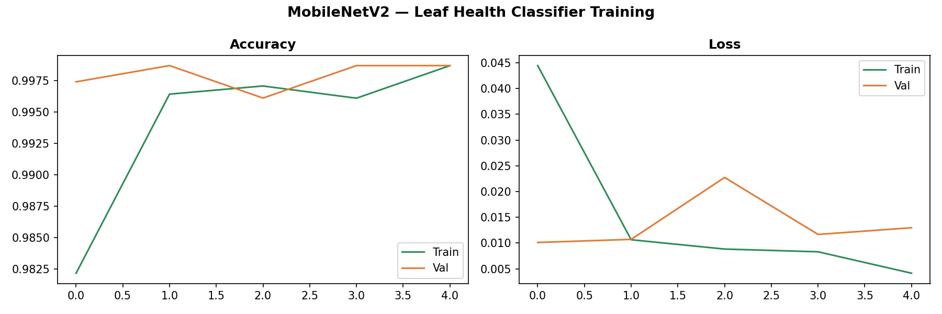
Figure 14: MobileNetV2 leaf-health classifier: training and validation accuracy (left) and loss (right) over five epochs
Interpretation note. PlantVillage photographs are taken against plain backgrounds under controlled lighting. High accuracy on this dataset does not guarantee equal accuracy on field photographs from Bahawalpur with complex backgrounds, shadows and mixed leaves. Two further cautions apply: (1) PlantVillage contains several photographs of the same leaves, so a random image-level split can place near-duplicate images in both training and validation sets; (2) the same validation set was used to choose the best epoch and to report accuracy, and no separate test set was held out. The 99.87% figure is therefore best read as an upper estimate. Validation on locally collected images and a separate test set are listed under Future Work.

6.5 Integration of the CV Output into the Yield Models
At inference time the integration is direct: the uploaded leaf image is resized to 224 x 224, scaled, passed through MobileNetV2, and the sigmoid output becomes health_score for that prediction. If no image is uploaded the app uses a neutral default of 0.5.
At training time the yield dataset contains no paired leaf images, so a health_score had to be constructed for each of the 414 rows. The procedure used in the notebook was:
- Compute the mean predicted probability on validation leaves of each class (healthy mean = 0.9921, diseased mean = 0.0007)
- Normalise NPK_total to the range 0 to 1 across the dataset
- Set health_score = diseased_mean + normalised_NPK x (healthy_mean - diseased_mean)
This makes health_score a rescaled copy of NPK_total. Because NPK_total is constant within each crop in the merged data, the resulting column takes only two values (0.9921 for maize rows and 0.0007 for wheat rows) and has a correlation of 1.00 with NPK_total. Note also that the wheat rows receive a score near 0 (the 'diseased' end) only because wheat has a slightly lower NPK_total than maize (159.63 vs 160.25); no wheat leaf images were used and this value does not mean wheat is diseased. Its consequences for the results are analysed in Sections 7.4 and 7.5.
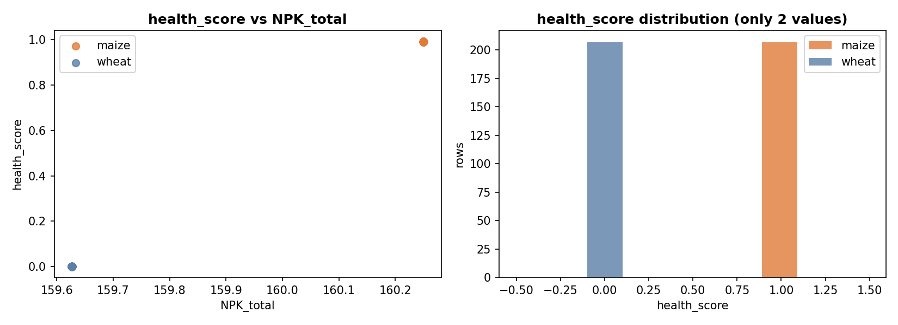
Figure 15: health_score versus NPK_total: the constructed feature takes only two values, one per crop, and mirrors NPK_total

7. Results and Evaluation
All tabular models use an 80/20 train-test split (random_state = 42) and 5-fold cross-validation on the training portion. Metrics are MAE and RMSE in Ton/Ha, and R².

7.1 Phase 1: Baseline Models (13 features, Python)
Model | MAE | RMSE | R² | CV R²
Random Forest | 0.0029 | 0.0071 | 0.9999 | 0.9997
XGBoost | 0.0009 | 0.0023 | 1.0000 | 1.0000
SVR | 0.0806 | 0.0933 | 0.9865 | 0.9730
Stacking Ensemble | 0.0070 | 0.0088 | 0.9999 | 0.9997

7.2 Orange Data Mining Validation (5-fold CV, baseline features)
Orange was used only for the baseline 13-feature tabular models. The CV module (MobileNetV2) and the Phase 2 and Phase 3 models were trained and evaluated in Python and were not replicated in Orange.
Model | MSE | RMSE | MAE | MAPE | R²
Random Forest | 0.001 | 0.024 | 0.010 | 0.389 | 0.999
Gradient Boosting | 0.001 | 0.030 | 0.024 | 1.085 | 0.998
SVM | 0.019 | 0.139 | 0.100 | 4.696 | 0.964
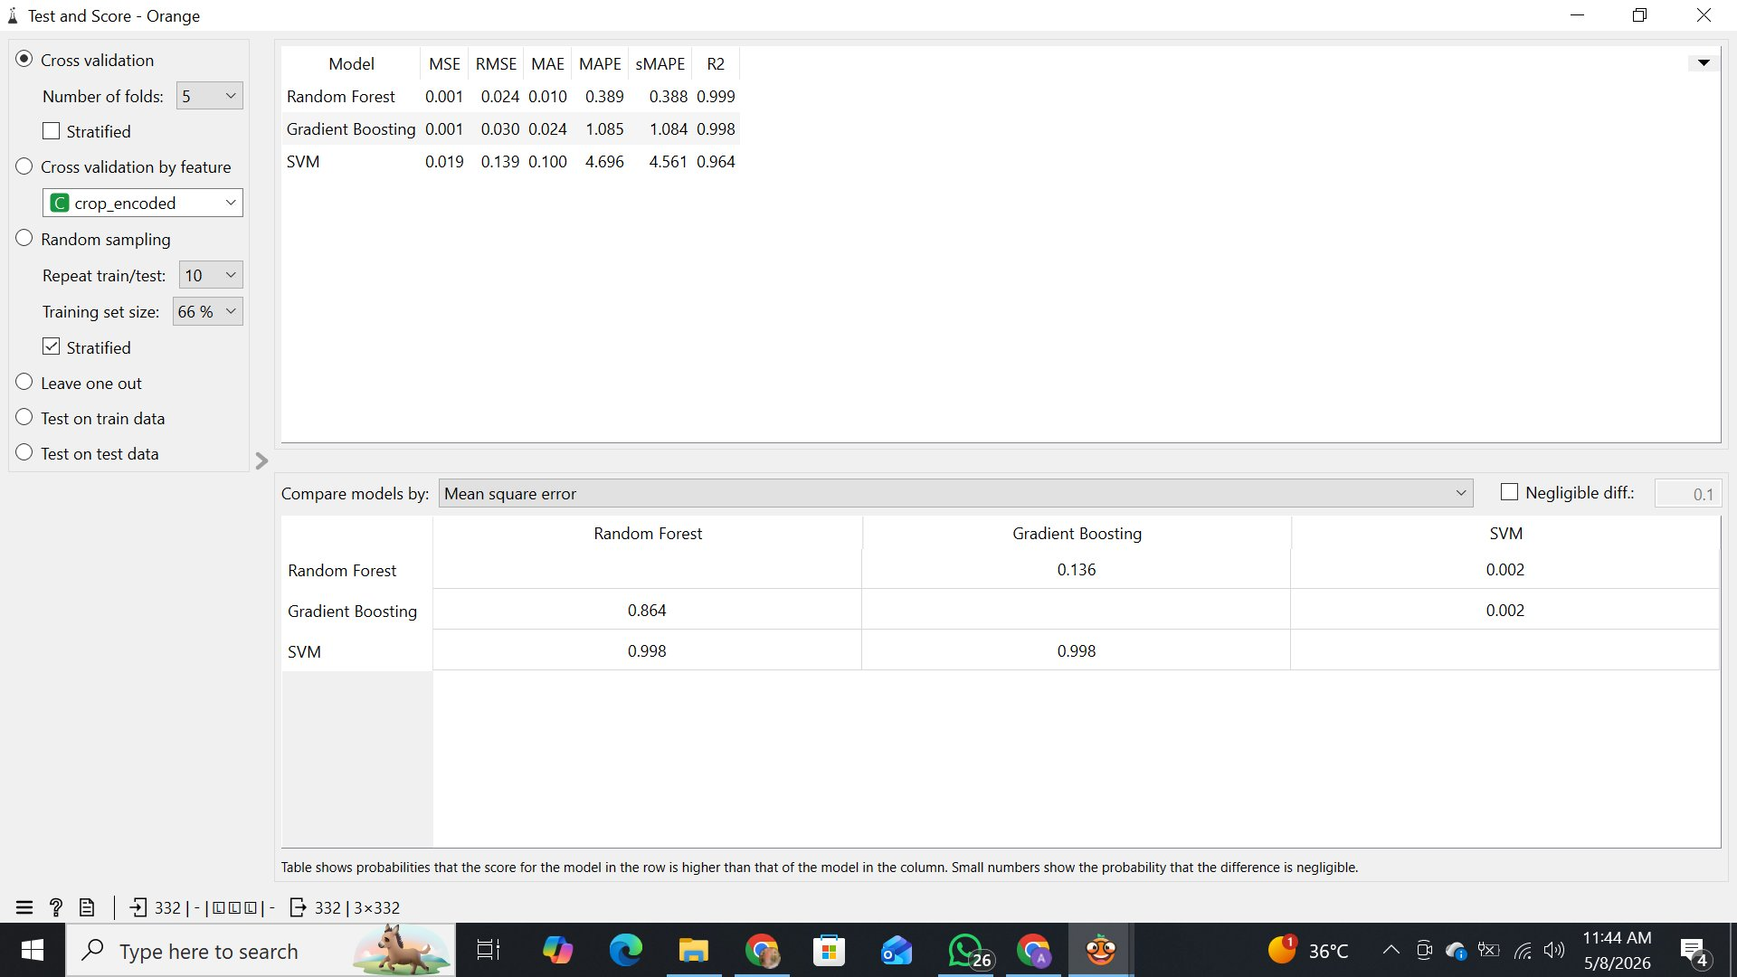
Figure 16: Orange Test and Score: RF R² = 0.999, Gradient Boosting R² = 0.998, SVM R² = 0.964

7.3 Phase 2 and Phase 3: Cleaned Features and CV Health Score
After removing year, rainfall, the interaction term and the crop label (Phase 2), and then adding health_score (Phase 3), the models were re-evaluated on the same split:
Model | Phase | MAE | RMSE | R² | CV R²
Random Forest | 2 (9 features) | 0.0717 | 0.1316 | 0.9732 | 0.9578
Random Forest | 3 (+ health_score) | 0.0715 | 0.1309 | 0.9735 | 0.9582
XGBoost | 2 (9 features) | 0.0509 | 0.0827 | 0.9894 | 0.9922
XGBoost | 3 (+ health_score) | 0.0509 | 0.0827 | 0.9894 | 0.9922
SVR | 2 (9 features) | 0.4637 | 0.7083 | 0.2245 | 0.3768
SVR | 3 (+ health_score) | 0.4639 | 0.7086 | 0.2240 | 0.3767
Stacking Ensemble | 2 (9 features) | 0.0462 | 0.0780 | 0.9906 | 0.9923
Stacking Ensemble | 3 (+ health_score) | 0.0462 | 0.0780 | 0.9906 | 0.9923

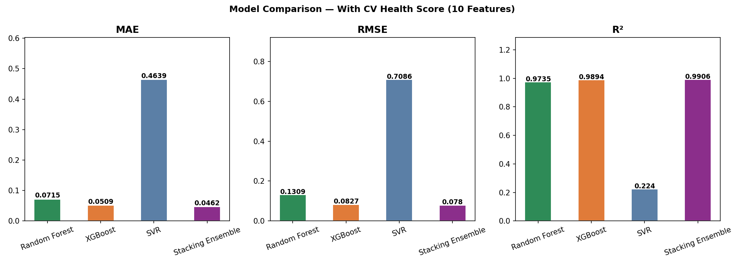
Figure 17: Model comparison with the CV health score (10 features): MAE, RMSE and R²
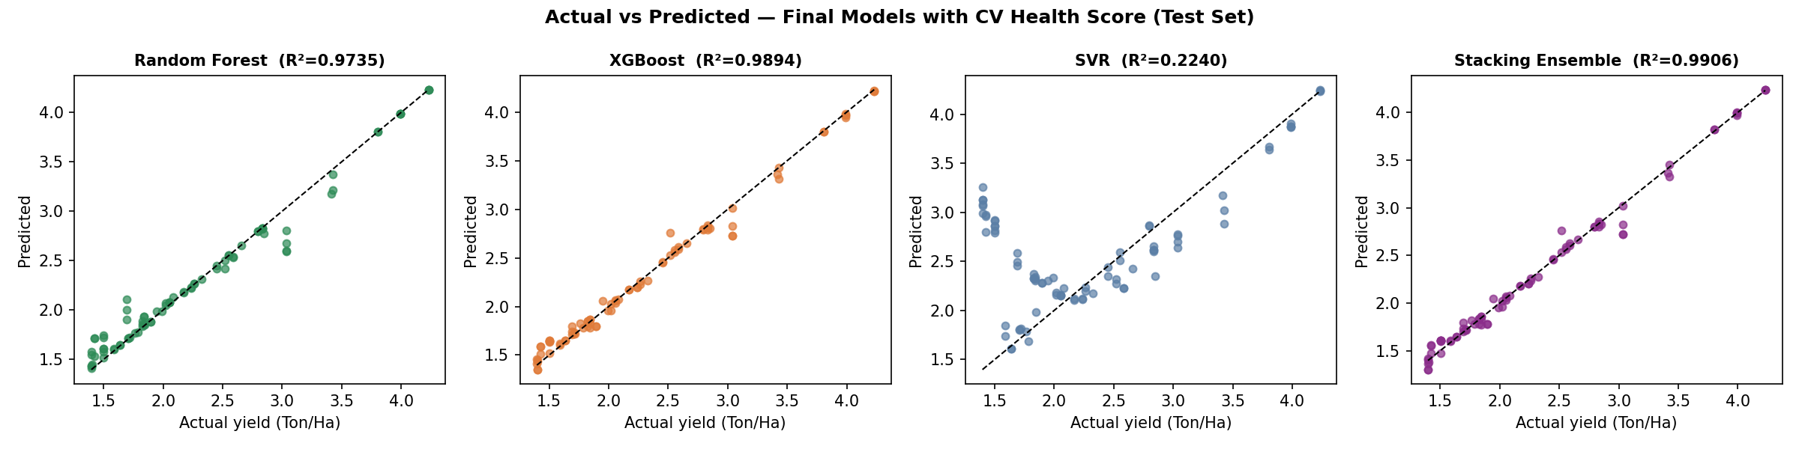
Figure 18: Actual vs predicted yield on the test set for the four final models (10 features). SVR shows the widest scatter
The Stacking Ensemble is the best model in the final configuration (R² = 0.9906, MAE = 0.0462 Ton/Ha), followed by XGBoost (R² = 0.9894). Random Forest is slightly lower (0.9735). SVR performs poorly (R² = 0.224). Once the year feature was removed, the yield depends on step-like crop-year identifiers that tree models can split on directly, while a smooth RBF surface with fixed settings (C = 100, gamma = 0.1, not re-tuned) cannot reproduce them. The learned weights of the Ridge meta-learner show that the Ensemble is effectively XGBoost: XGBoost 0.967, Random Forest 0.070, SVR -0.027 (intercept -0.021). This explains why the Ensemble and XGBoost scores are so close.

7.4 Effect of the CV Feature (Ablation)
Comparing Phase 2 with Phase 3 isolates the contribution of health_score. Changes are at most 0.0007 in RMSE and 0.0005 in R² and all are within numerical noise: the XGBoost and Stacking results are identical to four decimals. A permutation-importance test on the saved XGBoost model (20 repeats, held-out test set) confirms the same picture:
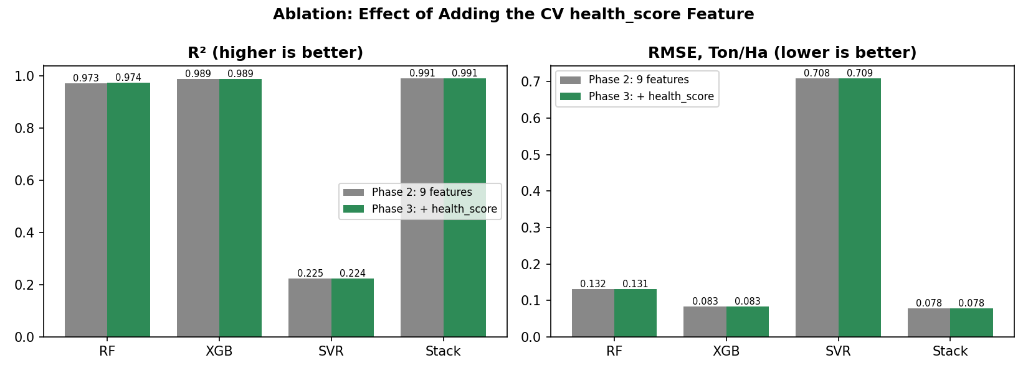
Figure 19: Ablation: Phase 2 (9 features) vs Phase 3 (with health_score). Bars are visually identical
Feature | Permutation importance (R² drop)
pesticides_tonnes | 1.894
N (nitrogen) | 0.391
avg_temp | 0.011
P, K, temperature, humidity, ph, NPK_total, health_score | 0.000

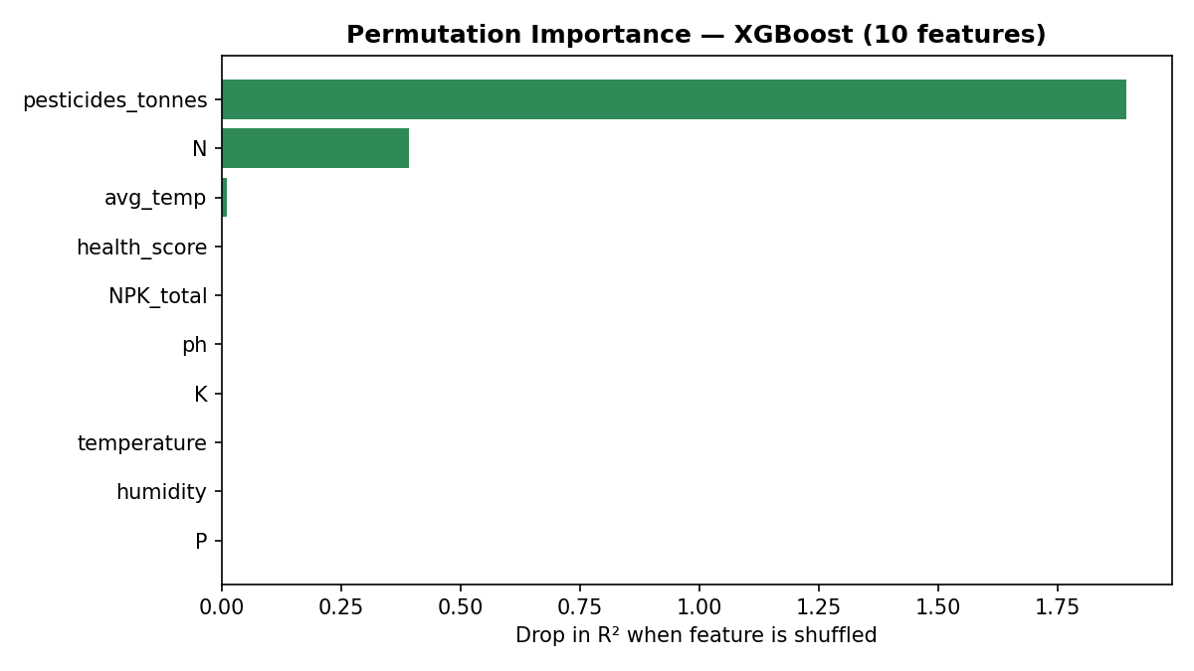
Figure 20: Permutation importance of the 10 features for the final XGBoost model
The models rely almost entirely on pesticides_tonnes and N. In this dataset pesticides_tonnes takes one value per year and N takes one value per crop, so together they act as identifiers of the crop-year, and the yield is a fixed number for each crop-year. health_score, being a rescaled NPK_total, carries the same crop identity that N already provides, so it adds no new information.
Sensitivity of the deployed app to the leaf image. The saved final models were queried with the default slider values (pesticides 6,000 t, temperature 24 °C, N 56, P 42, K 61, soil temperature 24 °C, humidity 86%, pH 6.4) while only health_score was changed to the value a healthy leaf, a diseased leaf or no image would produce:
Leaf input (health_score) | Random Forest | XGBoost | SVR | Ensemble
Healthy leaf (0.9921) | 1.660 | 1.854 | 2.352 | 1.824
No image (0.5) | 1.660 | 1.854 | 2.343 | 1.825
Diseased leaf (0.0007) | 1.703 | 1.854 | 2.326 | 1.828

Predictions are in Ton/Ha. Moving the leaf score across its whole range changes the Ensemble output by only 0.004 Ton/Ha, XGBoost not at all, and Random Forest by 0.043 Ton/Ha. At present the leaf image is displayed and passed to the models, but it has practically no influence on the predicted yield.

7.5 Validation Caveat: Random Split vs Group-Aware Split
The 414 rows consist of 46 crop-year combinations, each repeated exactly 9 times with the same yield value. A random 80/20 split therefore places near-identical rows in both training and test sets, so the high R² values partly measure memorisation. As a diagnostic, XGBoost with the Phase 3 features was retrained holding out entire crop-year groups (GroupShuffleSplit, 20% of groups). The held-out R² fell to -1.89, i.e. worse than predicting the mean.
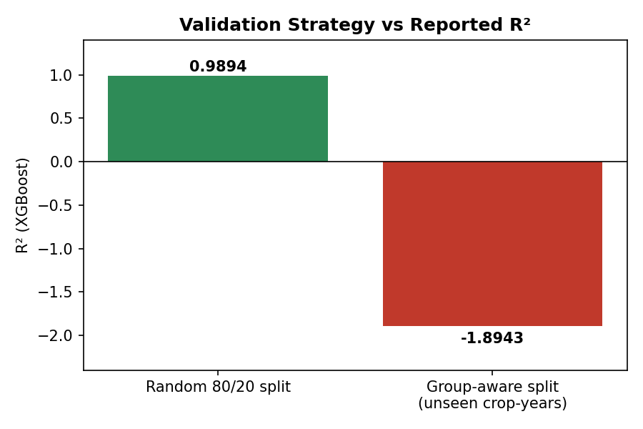
Figure 21: XGBoost R² under a random split versus a group-aware split that holds out whole crop-years
What this means. The reported R² values are valid for interpolation within crop-years already seen, but they should not be read as evidence that the model can forecast an unseen season. This does not invalidate the pipeline, the deployment or the CV classifier; it defines what the next iteration must fix (Section 10).

7.6 Feature Importance and Explainability (SHAP)
SHAP (TreeExplainer) explains each XGBoost prediction in the web application through a waterfall plot. In the original 13-feature version the SHAP analysis showed year (+0.79) and nitrogen (-0.39) as the largest contributors for a wheat prediction in 2025. In the CV version year is no longer a feature; the permutation results above indicate that pesticide level and nitrogen dominate. SHAP plots therefore highlight which inputs drive a prediction, but for this dataset should be read as dataset structure rather than agronomic causation.
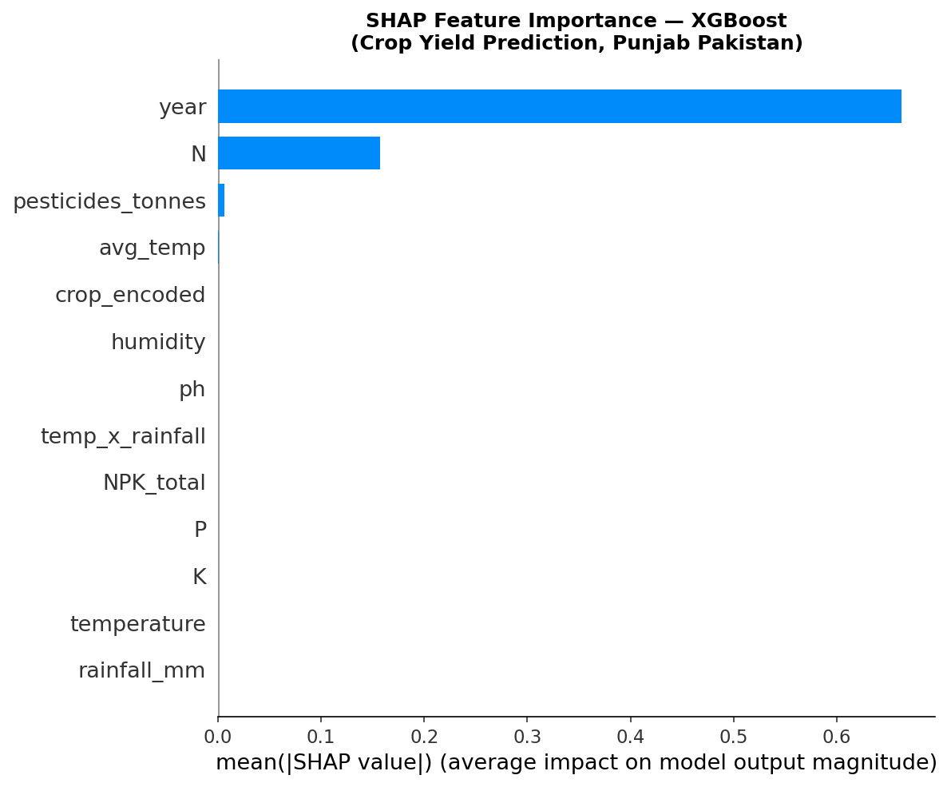
Figure 22: SHAP feature importance for the baseline 13-feature XGBoost model (year and nitrogen dominate)
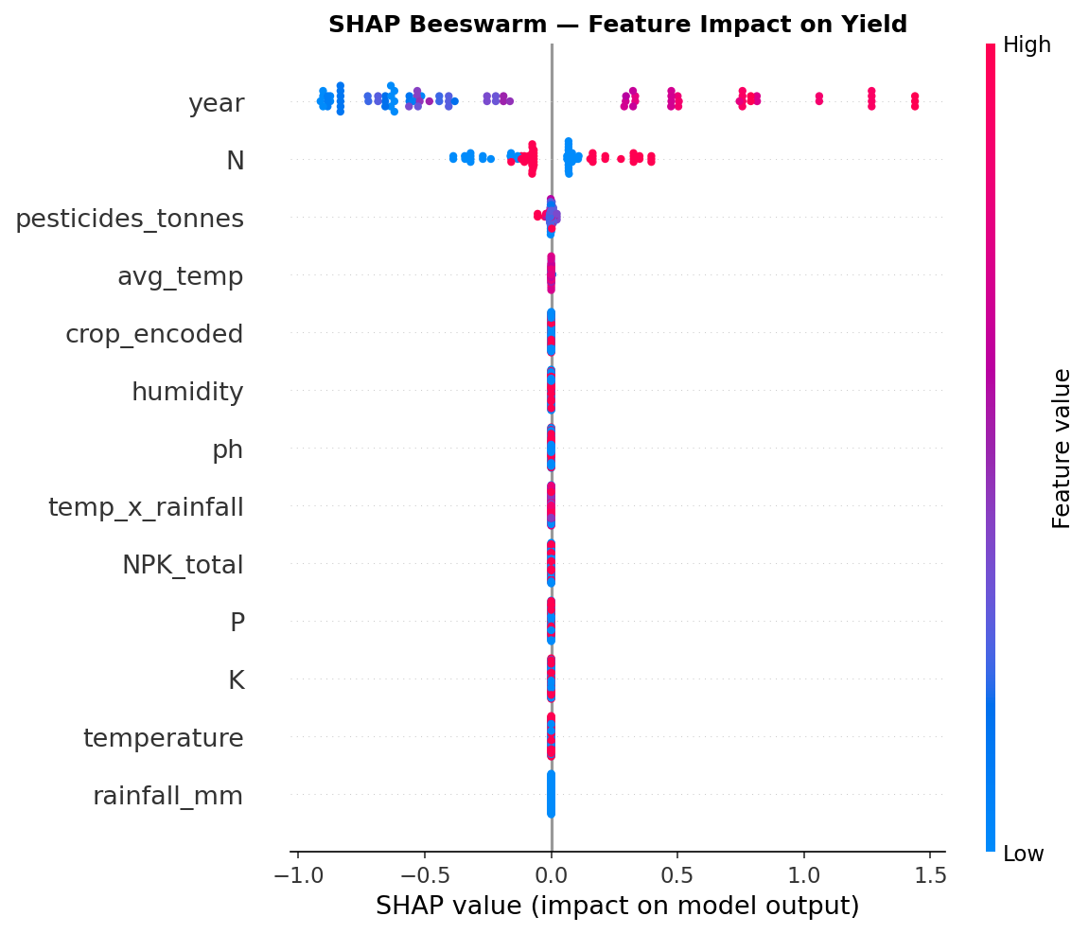
Figure 23: SHAP beeswarm for the baseline model: direction and spread of each feature's effect on yield
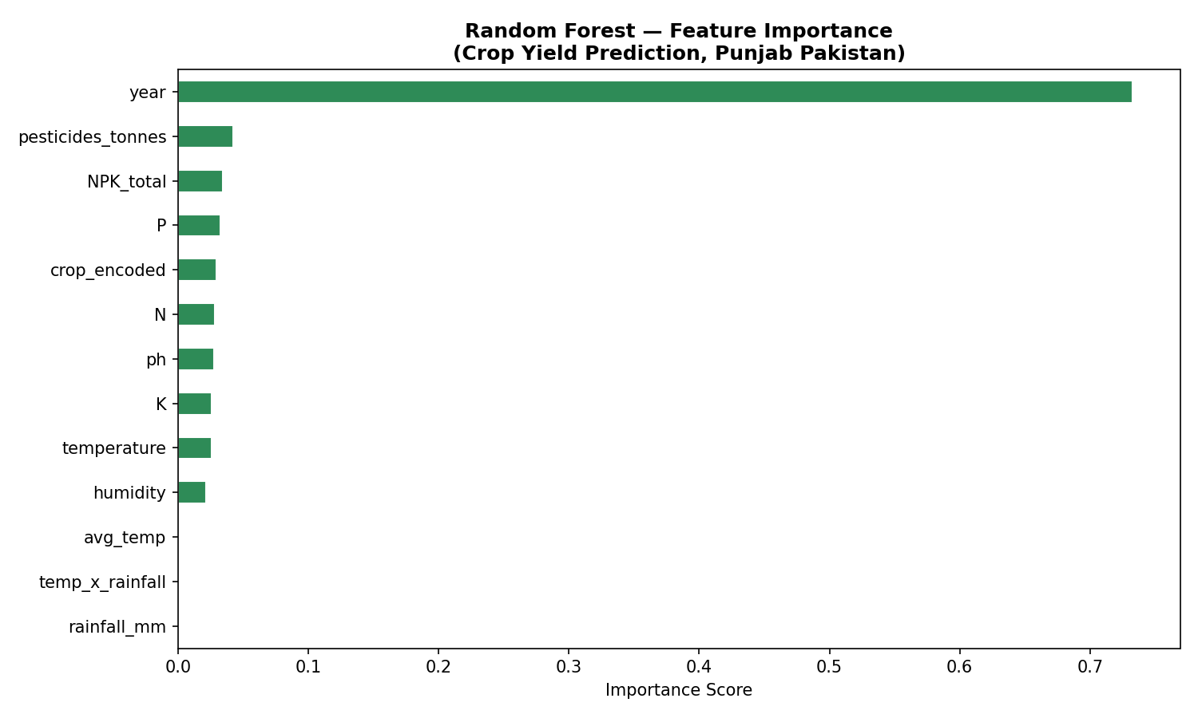
Figure 24: Random Forest feature importance for the baseline 13-feature model
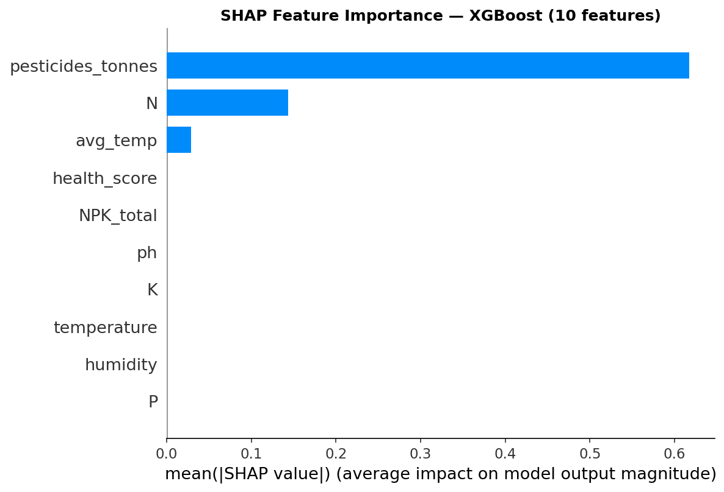
Figure 25: SHAP feature importance for the final 10-feature XGBoost model: pesticides_tonnes and N dominate, health_score contributes nothing

7.7 Key Findings
- The Stacking Ensemble achieved the best final scores: R² = 0.9906, CV R² = 0.9923, MAE = 0.0462 Ton/Ha
- XGBoost is the strongest single model (R² = 0.9894) and Random Forest is close behind (0.9735)
- SVR is unsuitable in its current configuration (R² = 0.224)
- Orange and Python agreed on model rankings for the baseline features
- The MobileNetV2 leaf classifier reaches 99.87% validation accuracy (771 / 772; one healthy leaf misclassified; precision and recall at least 0.996 for both classes)
- The Ensemble is effectively XGBoost (meta-learner weight 0.967)
- Changing the leaf score across its full range moves the Ensemble prediction by only 0.004 Ton/Ha
- Adding health_score produced no measurable improvement in the yield models, because it was derived from NPK_total rather than from real paired images
- Group-aware validation reveals that random-split scores overstate generalisation to unseen years

8. Web Application Deployment
The application is built with Gradio and deployed on Hugging Face Spaces: huggingface.co/spaces/AminahAsif/Crop-yield-punjab. It loads five tabular artefacts (rf_cv.pkl, xgb_cv.pkl, svr_cv.pkl, scaler_cv.pkl, stack_cv.pkl) and the CV model leaf_classifier.h5.

8.1 Application Flow
- The user optionally uploads a maize leaf image; MobileNetV2 returns health_score and a Healthy/Diseased label with confidence
- The user sets sliders: pesticides (0 to 30,000 t), average temperature (15 to 35 °C), N (0 to 140), P (0 to 100), K (0 to 120), soil temperature, humidity (50 to 100%) and pH (4 to 9)
- NPK_total is computed automatically and the ten-feature vector is built; SVR receives the scaled version
- Output: predicted yield from Random Forest, XGBoost, SVR and the Ensemble, a horizontal bar chart comparing them, and a SHAP waterfall plot for XGBoost
The app footer states: CV model MobileNetV2 (99.87% accuracy) and Ensemble R² 0.9906.

8.2 Screenshots
The first two screenshots are from the first (tabular-only) version of the app, which included crop type, year and rainfall inputs. The last screenshot is the final CV-enabled version.
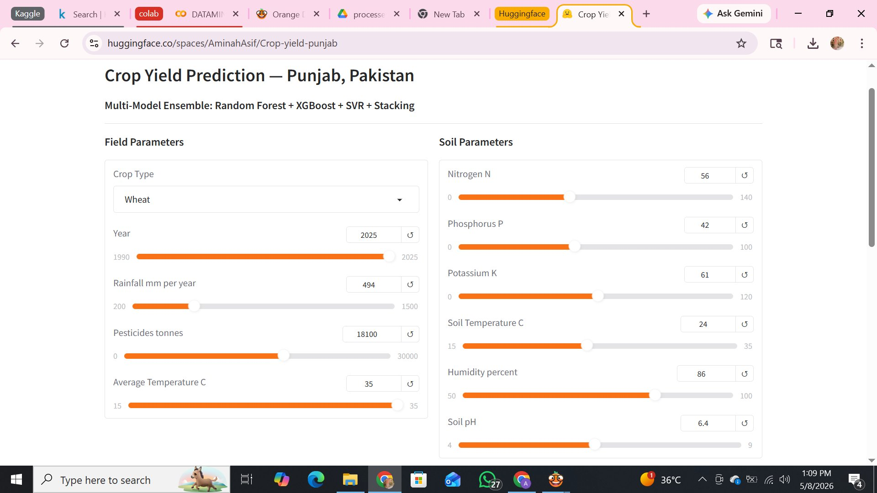
Figure 26: Version 1 web app, input panel with field and soil parameter sliders
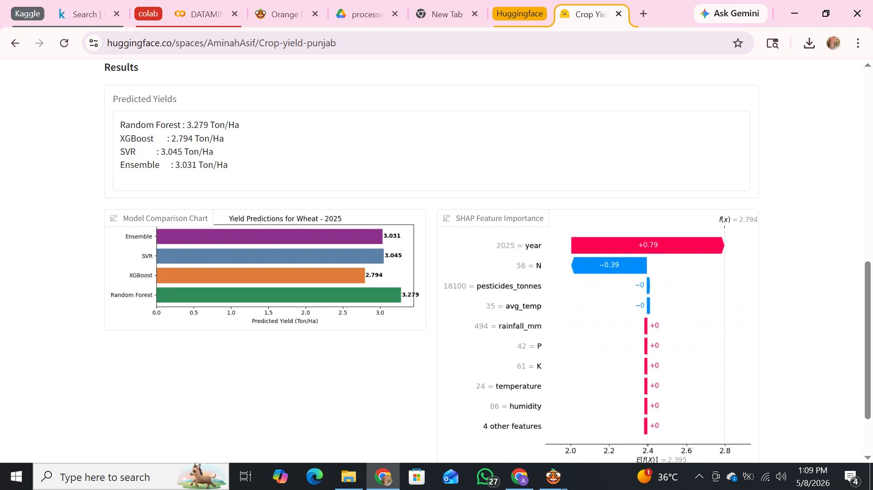
Figure 27: Version 1 web app, results: RF 3.279, XGBoost 2.794, SVR 3.045, Ensemble 3.031 Ton/Ha (wheat, 2025) with bar chart and SHAP waterfall
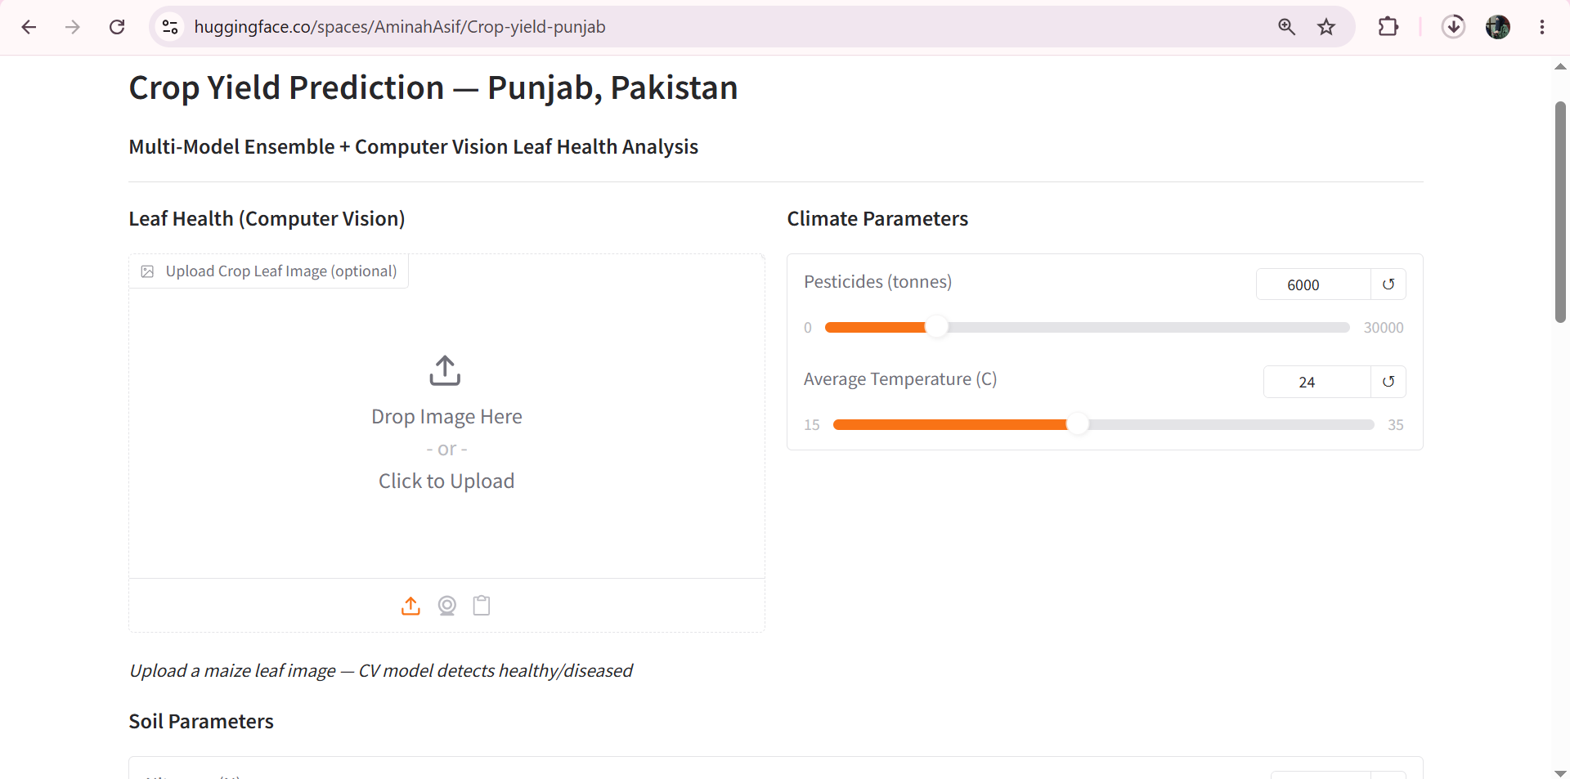
Figure 28: Final CV-enabled web app on Hugging Face Spaces: leaf-image upload panel (Leaf Health, Computer Vision) and climate parameter sliders

8.3 Software Environment
Python, Gradio, NumPy, pandas, scikit-learn, XGBoost, SHAP, matplotlib, joblib, TensorFlow/Keras and Pillow (see requirements_cv.txt).

9. Discussion
The project shows that a stacked ensemble of bagging, boosting and kernel models can fit crop-yield records for Punjab with very low error, and that a lightweight transfer-learning classifier can be trained to recognise diseased maize leaves with near-perfect accuracy on a benchmark dataset. Combining both in one interactive tool is a useful demonstration of a multimodal decision-support prototype.
The critical analysis in Sections 7.4 and 7.5 is equally important. The tabular data has very little independent variation: rainfall is constant, soil values are crop-level averages, and the yield is fixed per crop-year. In such data, powerful tree models can reach high R² by recognising crop-year identifiers. The CV feature, because it was constructed from NPK_total, could not add genuine visual information. Reporting these facts openly strengthens the work: it separates what the system demonstrably does (a working end-to-end pipeline with a working leaf classifier) from what still needs evidence (generalisation to unseen seasons and a measurable benefit from image features).

10. Conclusion
This project developed, validated and deployed a Multi-Model Ensemble with a Computer Vision leaf-health module for crop-yield prediction in Punjab, Pakistan. Three datasets covering the period 1990 to 2013 (23 distinct years) of agricultural, climate and soil data were merged, and Random Forest, XGBoost and SVR were compared and combined in a Stacking Ensemble that reached R² = 0.9906 in the final configuration. A MobileNetV2 classifier trained on PlantVillage maize leaves reports 99.87% validation accuracy and is integrated into a Gradio application that combines image upload, model comparison and SHAP explanations. Orange Data Mining independently confirmed the baseline model ranking.
Critical evaluation showed that the current health_score adds no measurable gain and that random-split metrics overstate forecasting ability for unseen years. These findings define a clear path for improvement rather than diminishing the contribution: the system is a complete, working prototype and a transparent baseline.

10.1 Limitations
- Only two crops (wheat and maize) after the merge; the CV classifier covers maize only
- Rainfall is a single national value (494 mm/year), and soil data are crop-level averages, not district or field measurements
- Training data ends in 2013; retraining with recent seasons is needed
- health_score in the training data is a rescaled NPK_total, not a per-sample image measurement
- Random-split evaluation with repeated crop-year rows overstates generalisation (group-split R² = -1.89)
- CV accuracy is measured on controlled PlantVillage images, not on field photographs
- The CV module and the Phase 2 and Phase 3 models were not replicated in Orange; Orange validation covers only the baseline 13-feature models
- The CV classifier was selected and evaluated on the same validation set, with no separate test set, and PlantVillage may contain near-duplicate images of the same leaf
- In the deployed app the leaf image barely changes the yield prediction (Section 7.4)

10.2 Future Work
- Evaluate with group-aware or leave-one-year-out cross-validation and report those scores as the headline metric
- Collect paired data: leaf images plus recorded yield for the same field and season, so health_score is measured rather than constructed
- Use district-level, season-specific weather and satellite indices (NDVI) instead of crop-level averages
- Add wheat, cotton and rice leaf datasets; fine-tune MobileNetV2 on locally captured Bahawalpur images
- Tune or replace SVR (or drop it from the ensemble) using cross-validated hyper-parameter search
- Integrate live weather APIs, build an Urdu-language mobile version, and test time-series models such as LSTM and Prophet

11. Reproducibility Summary
Artefact | Description
Crop_yield_Prediction_with_CV_module.ipynb | Full Colab notebook: preprocessing, models, stacking, SHAP, CV training, app export
final_ml_dataset.csv / final_ml_dataset_cv.csv | Merged dataset without / with health_score (414 rows)
rf_final, xgb_final, svr_final, scaler_final, stack_final (.pkl) | Phase 2 models (9 features)
rf_cv, xgb_cv, svr_cv, scaler_cv, stack_cv (.pkl) | Phase 3 models (10 features), used by the app
leaf_classifier.h5 | MobileNetV2 leaf-health classifier (from the Colab run)
app_cv.py, requirements_cv.txt | Gradio application and dependencies
outputs/*.csv, outputs/*.png | Result tables and figures

12. References
[1] Breiman, L. (2001). Random Forests. Machine Learning, 45(1), 5-32.
[2] Chen, T., & Guestrin, C. (2016). XGBoost: A Scalable Tree Boosting System. Proceedings of KDD 2016.
[3] Vapnik, V. (1995). The Nature of Statistical Learning Theory. Springer, New York.
[4] Lundberg, S. M., & Lee, S. I. (2017). A Unified Approach to Interpreting Model Predictions. NIPS 2017.
[5] Wolpert, D. H. (1992). Stacked Generalization. Neural Networks, 5(2), 241-259.
[6] Sandler, M., Howard, A., Zhu, M., Zhmoginov, A., & Chen, L.-C. (2018). MobileNetV2: Inverted Residuals and Linear Bottlenecks. CVPR 2018.
[7] Hughes, D. P., & Salathe, M. (2015). An open access repository of images on plant health to enable the development of mobile disease diagnostics. arXiv:1511.08060.
[8] Patel, R. (2022). Crop Yield Prediction Dataset. Kaggle. kaggle.com/datasets/patelris/crop-yield-prediction-dataset
[9] Ali, M. H. (2023). Wheat Data of Last 12 Years in Punjab Pakistan. Kaggle.
[10] Nazir, T. (2023). Crop District Level Dataset Punjab Pakistan. Kaggle.
[11] abdallahalidev. PlantVillage Dataset. Kaggle. kaggle.com/datasets/abdallahalidev/plantvillage-dataset
[12] Pakistan Economic Survey 2023-24. Ministry of Finance, Government of Pakistan, Islamabad.
[13] Aziz, M. et al. (2024). Sustainable Approach for Assessing Wheat Production in Pakistan Using Machine Learning. Agronomy, MDPI, 15(3), 654.

