COVID-19: Impact to and Response of Highmark Health.  
Analysis of Its Online Platform and Creation of Website with Interactive Chatbot

Amin-Erdene Otgonbold

Computer Science Senior at PSU

Highmark Health Summer Intern 2020

Table of Contents

**COVID-19: Impact to and Response of Highmark Health. Analysis of Its Online Platform and Creation of Website with Interactive Chatbot** 4

1. Project Background and Requirements 4

1.1 Highmark Health 4

1.1.1 Background 5

1.1.2 Task 5

1.1.3 Minimum Requirement 5

1.2 Penn State University 6

2. Covid-19: Analysis 6

2.1 Background on the progression of Covid-19 6

2.2 Impact to and Response of Highmark Health 7

2.3 Competitors 14

2.4 Possible Improvements 15

2.5 Conclusion 16

3. Submission 17

3.1 Chatbot 17

3.1.1 Feature 17

3.2 Full Stack Website 18

3.2.1 Feature 18

4. Sources 18

4.1 Acknowledgement 18

4.2 References 19

**COVID-19: Impact to and Response of Highmark Health.  
Analysis of Its Online Platform and Creation of Website with Interactive Chatbot**

This documentation is created to walk you through my three-week summer internship case study project at Highmark Health. This document includes analysis of Highmark Health’s Covid-19 web page along with its chatbot feature and the reasoning for the creation of a website and chatbot of my own. This document also entails the user instruction on how to and where to find the information. If you find any problems or have recommendation, please send an email to:

[mailto:aqo5219@psu.edu?subject=Internship Case Study Summer 2020](mailto:aqo5219@psu.edu?subject=Internship%20Case%20Study%20Summer%202020).

Or

[mailto:aminamary1@gmail.com?subject=Internship Case Study Summer 2020](mailto:aminamary1@gmail.com?subject=Internship%20Case%20Study%20Summer%202020).

# Project Background and Requirements

## Highmark Health

Covid-19 had been declared as pandemic before receiving the project details of my 12-week internship at Highmark Health. To adjust to the changes, Highmark Health has decided to shorten its summer internship into a three-week remote intern case study project. This case study project has increased my awareness to the pandemic, and its impact on the community.

Most often, all phases of the project planning are implemented and tested by the party that are already familiar with the product or the project. I wish to contribute to the value and the hard work of Highmark Health by giving personal analysis as an intern, which might provide a fresh perspective to the company.

### Background

Highmark Health is a national health and wellness organization whose mission is to create a remarkable health experience, freeing people to be their best. Highmark Health recognizes health care urgently needs breakthrough solutions and new visionaries to champion change. They’ve stepped up to be leaders in that quest and catalysts in that change. Highmark Health and the Allegheny Health Network have been monitoring the coronavirus situation closely and had been preparing accordingly since the onset of the activity.

### Task

I was provided with the reference material in chronological order on the actions taken by the organization and had to create an assessment of how I think Highmark Health has handled the Covid-19 pandemic. I had a freedom in choosing the format that details my evaluation. I have focused my analysis on the Covid-19 update webpage of Highmark, and the interactive chatbot function that the site provides. I have further created a website without using preset platform with interactive chatbot which illustrates the improvement points from the analysis of current Highmark Health’s chatbot.

### Minimum Requirement

Following is the project requirement provided by the Highmark Health.

* Evaluation of how Highmark Health handled the situation, with supporting facts.
* A clear point of view.
* At least one comparative example that supports the conclusion.
* At least one academic reference.
* Viewpoint on if I were a member of the Highmark Health leadership team, what I would have done differently.
* What risks there are to consider and how I would mitigate them.
* Detail on how I would define success for navigating the outcomes of coronavirus as a leader in the health and wellness industry.

## Penn State University

I am an international student at Penn State University and am required to obtain a CPT work permit in order to work for a company in the United States. The process of obtaining a CPT work permit includes an enrollment to an internship course. Penn State University requires at least 150 hours of internship experience to accept an enrollment for the course, however it was originally difficult for me to accept the renewed three-week option because my internship at Highmark Health has been shortened from 480 hours into 120 hours. I was able to enroll for the course by making an adjustment to work extra 30 hours in additional to my given 120 hours at Highmark Health. I have decided to work further on the web development and created a full stack website without using any given platforms.

# Covid-19: Analysis

## Background on the progression of Covid-19

Covid-19 pandemic is caused by a novel coronavirus strain called SARS-CoV-2. The outbreak began in China when the virus began to infect among human, and now has spread around the world. According to CDC[1], there are in total of 2,104,346 confirmed cases and 116,140 deaths caused by Coronavirus as of June 16th of 2020 in the United States. In Pennsylvania[2] , there are 79,483 total confirmed cases and 6,276 deaths. According to U.S. Census Bureau[3], estimated population of Pennsylvania is 12,801,989 as of July of 2019, which makes us realize how quickly the coronavirus is spreading and how many people are getting affected by this pandemic. There have been social restrictions such as stay at home order, prohibiting large gathering more than 25 people, requiring masks when entering a business, closure of indoor recreation and all entertainment and many more depending on the county and the state.

## Impact to and Response of Highmark Health

The user-friendly and well-designed web page interface could mitigate some of the possible risks of costumer dissatisfaction and interruption in service provided. When the user interface is not friendly enough, the interface frustrates the customers, and increases the demand for direct help over the phone and complaints, which slows the progress of the service. As a tester, I have never used the Highmark Health’s web page before, and it was easy for me to find the information that I needed. The contents were divided nicely depending on their category, and navigation bars were helpful to guide to a different content.

Having a chatbot[4] on the web page that can provide answers to commonly asked questions is a great advantage. Inbenta[5], an AI company based in California mentioned that their demand for chatbot increased at least 150%, up to 300% during the Covid-19 pandemic. This shows that the companies and organizations are developing their website more communicative and easier to find necessary information by adding a chatbot. After testing the chatbot on Highmark Coronavirus Update web page, I gained more knowledge about Covid-19 pandemic and its response of Highmark Health.

The chatbot is located on the right bottom side of the website as shown in *figure 1.* The name of the chatbot on the Highmark Coronavirus Update web page is “Covid-19 Answers Virtual Assistant”, which is a targeted response to the Covid-19 pandemic. The chatbot is not easily noticeable for 2 reasons which leads to not acknowledging the existence of a chatbot. First, the color of the footer and the color of the chatbot icon is similar blue shade which makes it hard to distinguish. Second, the chatbot does not have animated movement or starter sentence to catch the user’s attention.

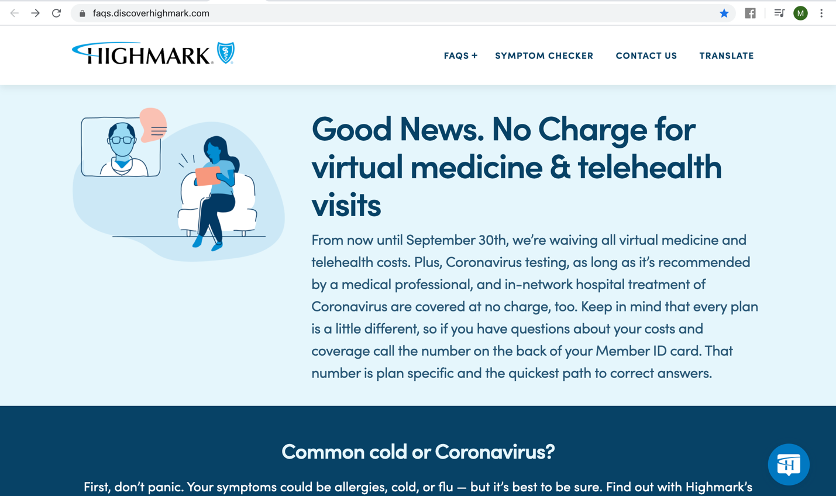

*Figure 1. User interface of Highmark Coronavirus Update Web page.*

There was a minor inconvenience when I first tested the chatbot. If you see in *figure 2,* the chatbot asks for a consent before starting the conversation. I couldn’t find “Yes, I accept” button which is in *figure 3.* The idea of scrolling down and clicking the accept button is simple, but because there is no visible scroll bar, I personally struggled finding it. I asked my colleagues how long it took for them to find the “Yes, I accept” button, and 3 out of 5 people answered it took more than 5 seconds. As a developer the idea of scrolling down is simple, but as a user people could struggle finding it if it is not visible to them which could hinder their ability to use the chat function altogether.

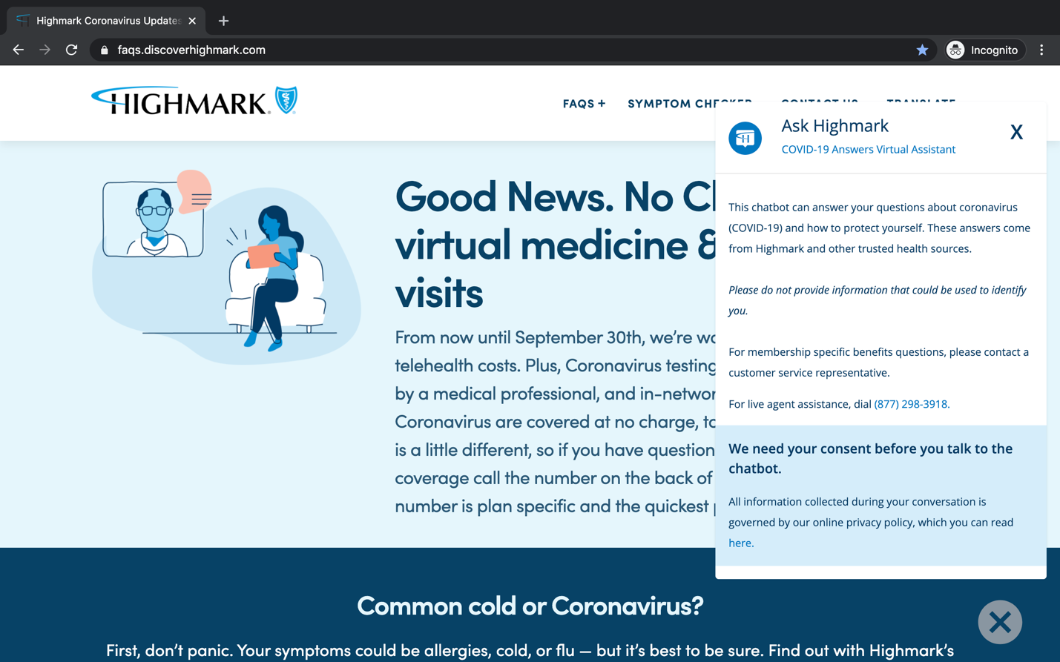*Figure 2. Chatbot asking for a consent before starting a conversation.*

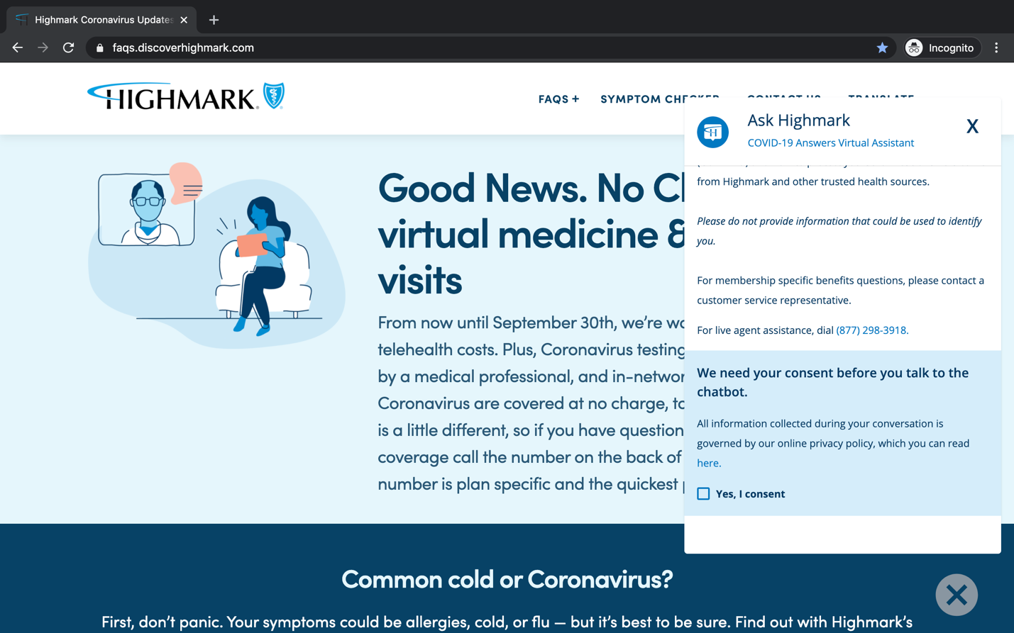

*Figure 3. Screen shot of “Yes, I consent” button after scrolling down.*

The chatbot eases the communication and saves time by providing sample questions which you can see in *figure 4*. Each time the chatbot provides 2 to 3 sample questions that are commonly asked. The user can simply click the choice rather than typing the whole sentence. It becomes harder to predict when the user has a power to type the question, because there is almost an infinite case of scenarios that the user can go for. Sometimes the user can type questions that are too long, too wordy, or just simply misworded. I think Covid-19 Answers Virtual Assistant Chatbot is easy to use because it provides different choices of sample questions as the conversation continues.

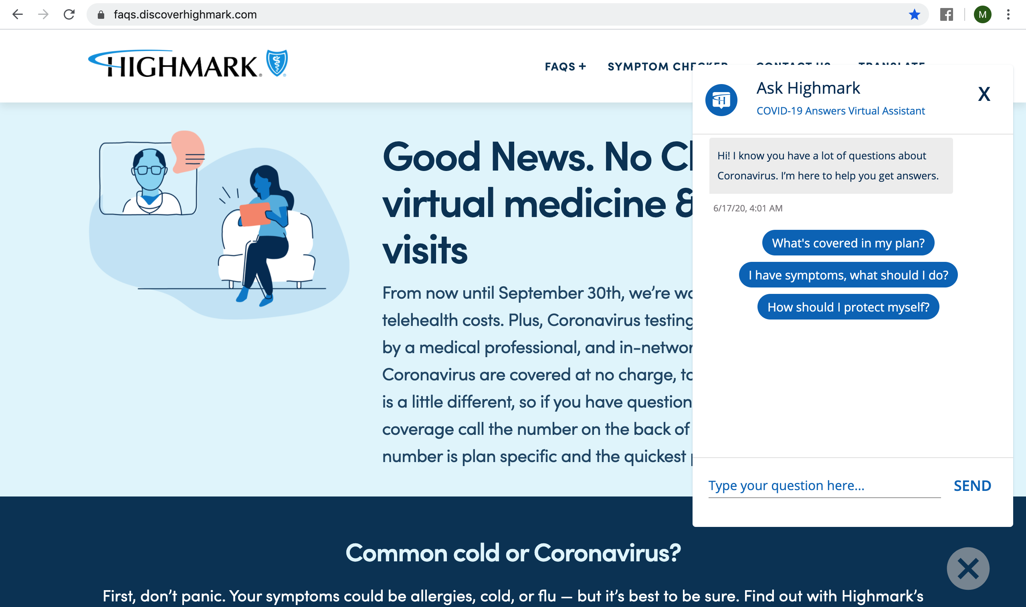

*Figure 4. Covid-19 Answers Virtual Assistant providing sample questions to the user.*

Below *figure* 5 illustrates a flow chart that I created after testing the chatbot. I extracted the information using sample questions provided by the chatbot. 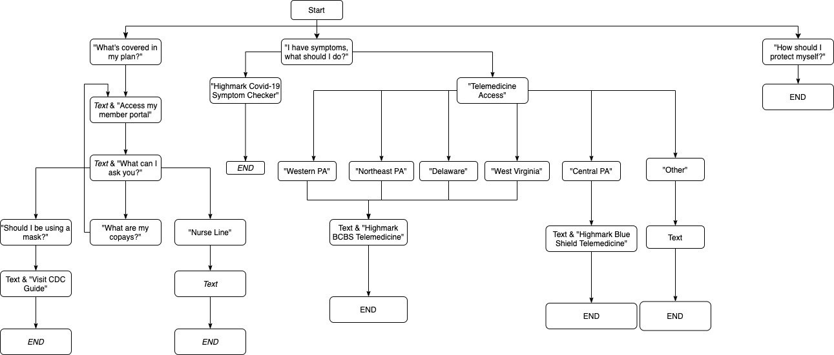

*Figure 5. Flow chart of Highmark Coronavirus Update web page’s Chatbot Intent.*

I found two crucial errors in the chatbot. First, there is an infinite loop after choosing “What are my copays?”. It creates an infinite loop because “Access my member portal” is not functioning properly. As a tester and a user, I would expect choosing “Access my member portal” would lead to a log-in portal or a member portal. However, the chatbot guides me through an infinite loop of choices rather than an action. Second, the chatbot doesn’t respond when I choose “How should I protect myself?”. Interestingly, the chatbot provides an answer when I type the question, rather than clicking the sample question. You can see in *figure 6,*I clicked on the provided sample question and there is no response from the chatbot.After waiting for 5 minutes,I typed the same question and the chatbot provided me an answer within a second as you can see in *figure 7*. This is odd because for all the other cases, the chatbot automatically responded within a second as soon as I clicked on the sample question.

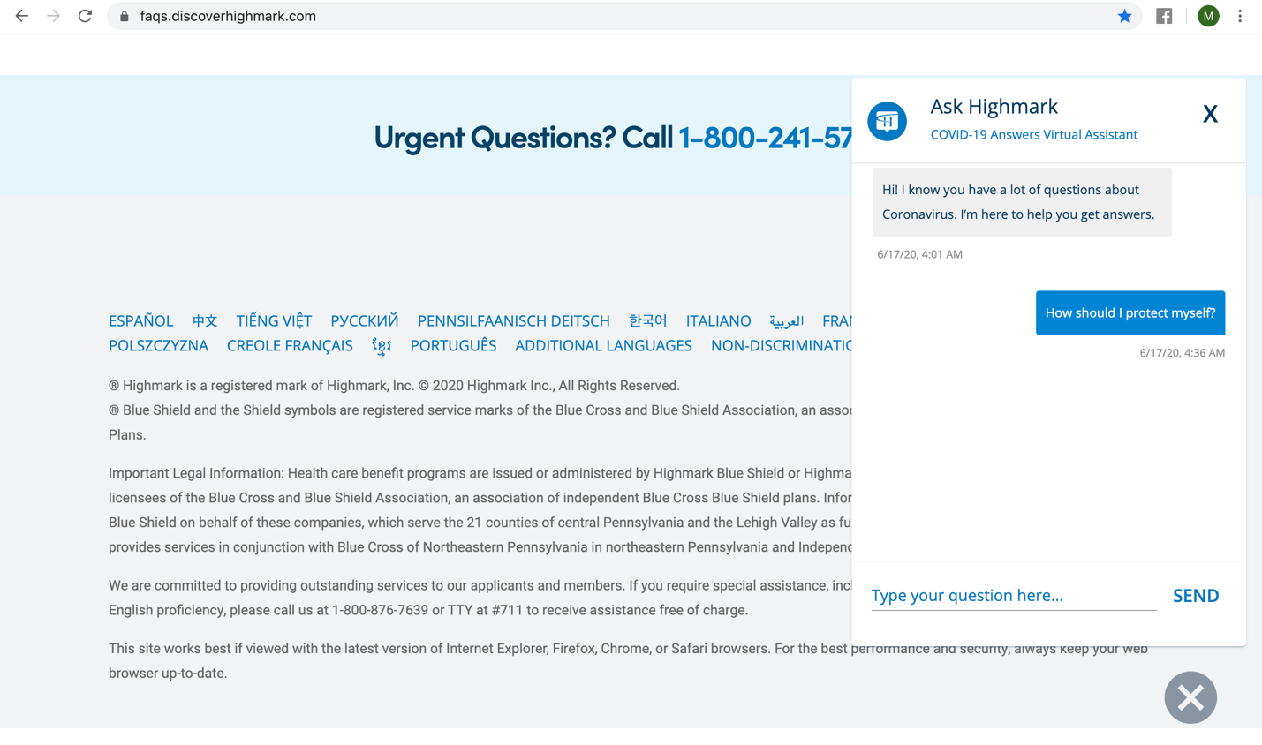

*Figure 6. Chatbot not responding to a clicked question that provided by the chatbot.*

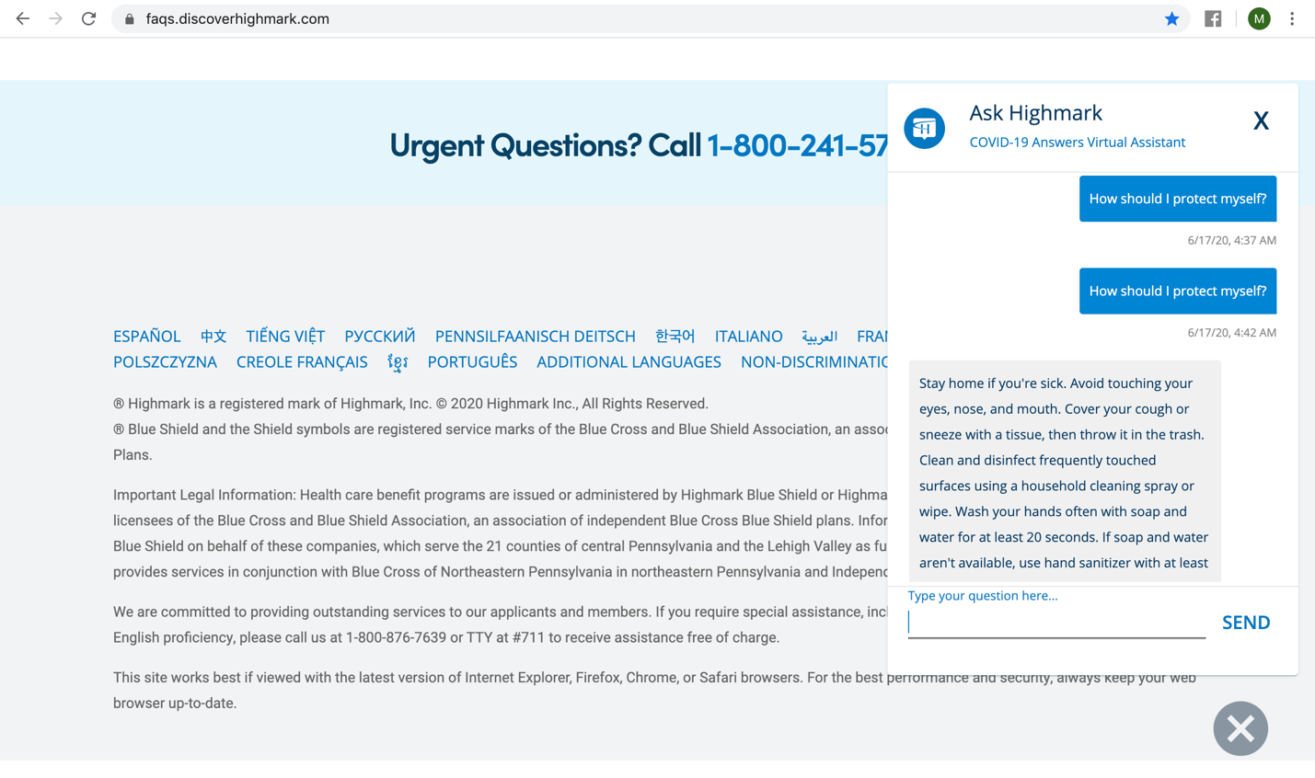

*Figure 7. Chatbot immediately responding after typing the same question as in figure 6.*

## Competitors

I chose two competitors of Highmark Health to see the difference in their response to Covid-19 pandemic. I will be comparing UnitedHealthCare[6] and Anthem[7], but since both of them does not have a chatbot as you can see in *figure 8,* I added more focus points to analyze. The importance of telehealth has been greatly emphasized, especially after the emergence of the Covid-19 pandemic. As stated by Keshvardoost S. et al[8]., many nations have implemented the telehealth as healthcare option utilizing the new technological advances.

All three companies offer telehealth services and waived their telehealth cost during the Covid-19 pandemic, but the valid dates differ. Highmark Health and Anthem both are cost free until September 30th of 2020, but UnitedHealthCare is cost free until June 18th of 2020. As a customer, I feel safer and satisfied having a longer duration of free telehealth coverage. All three companies had symptom checker that was available to user at no cost. I’ve evaluated the accessibility of the three company during the pandemic on five-point categories. These categories include the existence of a chatbot (1 point), cost of telehealth (1 point), duration of free telehealth services (1 point), existence of a symptom checker (1 point), friendly user interface (1 point). Summarized analysis and comparison are provided in the *figure 8*.

|  |  |  |  |
| --- | --- | --- | --- |
|  | Highmark Health | United Health Care | Anthem |
| Presence of a chatbot | [yes](https://faqs.discoverhighmark.com/) | no | no |
| Free telehealth termination date | [Sept. 30, 2020](https://faqs.discoverhighmark.com/) | [June 18, 2020](https://www.uhc.com/health-and-wellness/health-topics/covid-19/telehealth-options) | [Sept. 30, 2020](https://providernews.anthem.com/georgia/article/information-from-anthem-for-care-providers-about-covid-19-4) |
| Presence of symptom checker | [yes](https://faqs.discoverhighmark.com/covid-19-symptom-checker/) | [yes](https://www.buoyhealth.com/symptom-checker/?configuration=uhc&concern=coronavirus) | [yes](https://www.anthem.com/microsites/covid19-assessment/index.html) |
| Overall grading based on 5-point grading system  (1 being poor 5 being excellent) | 5 | 3 | 4 |

*Figure 8. Table comparing the three companies depending on the focus point.*

## Possible Improvements

There are few recommendations that I would like to suggest for the chatbot on Highmark Coronavirus Update website.

There are five possible improvement points, which includes the two errors in chatbot flow and visual interfaces. As I mentioned in 2.2 and fixing them by making “Access my member portal” question functional and adding an answer to “How should I protect myself” could improve the completeness of the chatbot. Additionally, implementing a starter question could help increase the awareness of the chatbot. The chatbot could have an animated motion of sending a starter message when the user enters the web page like in *figure 9* that I implemented on my sample chatbot. Further, changing the color of the chatbot icon can ease the user in locating the presence of a chatbot function. Last but not least, adjusting the location of the “Yes, I consent” button as I mentioned in 2.2 could ease the communication and increase the usage of the chatbot.

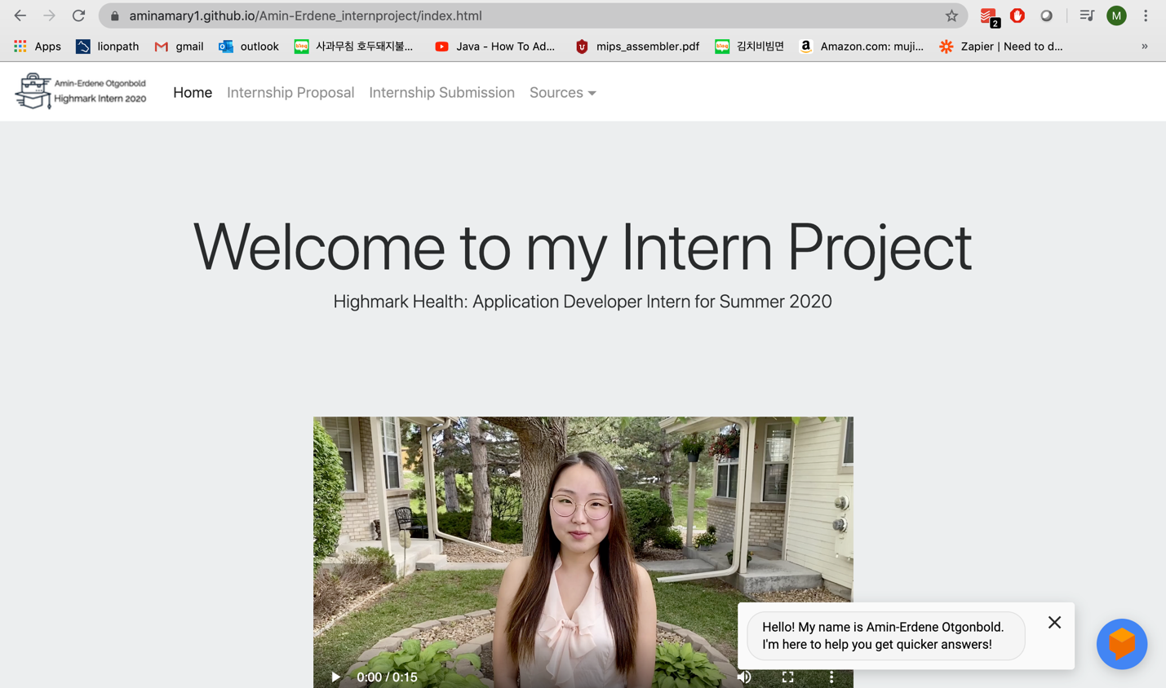

*Figure 9. Capture of my sample chatbot that starts the conversation when user enters web page.*

## Conclusion

I focused the intern case study project “Covid-19: Impact to and Response of Highmark Health” on chatbot. Thus, I analyzed the response of Highmark Health to Covid-19 pandemic in the existence of a chatbot and its minor details. I found two errors including an infinite loop and the case that the chatbot does not respond to a user even though the question is provided by the chatbot. I also had two suggestions mentioned above in 2.2 as well, which was to make the “Yes, I accept” button visible when the user gives a consent before using the chatbot. Another suggestion was to add a starter sentence, so the user can notice the existence of a chatbot. In my opinion, in the health and wellness industry, the crucial outcome of success is measured in how many lives has been saved and whether or not full measures were taken to prevent any possible harms. In that sense, Highmark has provided the relevant information online with easy to access interface. It further enabled free telehealth service which allowed its customers to utilize the technological advancement in healthcare to seek the necessary care.

# Submission

## Chatbot

I created a sample chatbot for the simulation. I used dialogflow as an AI engine, and Nodejs to implement the rich messages to build a user interactive virtual assistant called Amin-Erdene. This chatbot is embedded into the website to help the website user to find information more easily. I created the below *figure 10* flowchart to show the bigger picture of the chatbot intent. In addition to the sample questions provided in *figure 10*, the chatbot can have a casual conversation with user such as “how are you today”.

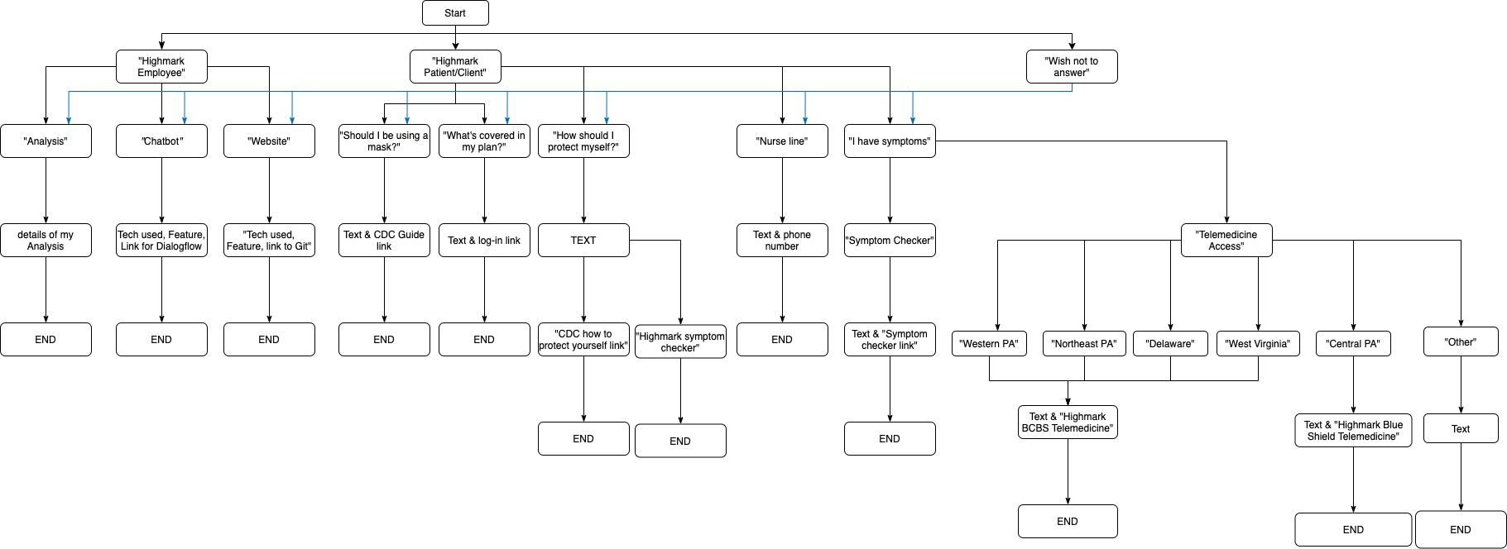

*Figure 1. Flow chart of Amin-Erdene Chatbot Intent.*

### Feature

* Able to start a conversation as soon as the user enters the website.
* Able to provide different information depending on the user type such as Highmark Employee, Highmark Customer, and guide the user through the user-friendly conversation.
* Able to display image, link, video, button for the rich user interaction.
* Able to have casual conversations like “where is your favorite place to go?”, “you’re funny”, “are you bored?”, “wow”, etc.

## Full Stack Website

I created a full stack website to showcase and hold all the information about the intern case study project. I used HTML5, CSS, bootstrap4, NodeJs, Javascript to build the website, and the source code is available in my personal github account (aminamray1@gmail.com). The website has a navigation bar to guide the user between major contents and has a chatbot on the right bottom corner to provide an instant support for the user. The website can be accessed at: <https://aminamary1.github.io/Amin-Erdene_internproject/index.html>

### Feature

* Able to display Static information such as project proposal, submission, acknowledgement.
* Able to display the chatbot and connect to dialogflow.
* Able to display user interactive AI assistant, pdf, jpg, mp4, social media links.
* Able to adjust the placement on different screen sizes such as laptop and handheld devices.

# Sources

## Acknowledgement

I wish to express my sincere thanks to Ms. Jackie Baker, Talent Acquisition Program Manager at Highmark Health, for her constant encouragement and help throughout the whole internship program.

I would like to thank Professor J. Brian Adams, Ph.D, PE, my academic & internship course advisor at Penn State - Harrisburg. I am grateful to him for his expert, sincere and valuable guidance and encouragement extended to me.

I also thank Mr. Brian Utz, Director of Digital at HM Health Solutions, for trusting in me and hiring me for the Summer 2020 intern. Even though I couldn’t get to work directly due to the Covid-19 pandemic, I sincerely thank you for giving me an opportunity to become part of this amazing community.

## References

1. “Cases in the U.S.” *Centers for Disease Control and Prevention*, Centers for Disease Control and Prevention, 11 June 2020, [www.cdc.gov/coronavirus/2019-ncov/cases-updates/cases-in-us.html](http://www.cdc.gov/coronavirus/2019-ncov/cases-updates/cases-in-us.html).

2. “Guide: Responding to COVID-19 in Pennsylvania.” *PA.Gov*, [www.pa.gov/guides/responding-to-covid-19/](http://www.pa.gov/guides/responding-to-covid-19/).

3. “U.S. Census Bureau QuickFacts: Pennsylvania.” *Census Bureau QuickFacts*, [www.census.gov/quickfacts/PA](http://www.census.gov/quickfacts/PA).

4. “Highmark Coronavirus Updates.” *Highmark Answers*, faqs.discoverhighmark.com/.

5. Verani, Estelle. “Coronavirus Crisis Generates a Rise in Chatbot Inquiries.” *Inbenta*, 29 Apr. 2020, www.inbenta.com/en/blog/chatbot-and-coronavirus-pandemic/.

6. “Telehealth.” *UnitedHealthcare Provider*, [www.uhcprovider.com/en/resource-library/news/Novel-Coronavirus-COVID-19/covid19-telehealth-services/covid19-telehealth-services-telehealth.html](http://www.uhcprovider.com/en/resource-library/news/Novel-Coronavirus-COVID-19/covid19-telehealth-services/covid19-telehealth-services-telehealth.html).

7. “Coronavirus (COVID-19) Resource Center.” *Coronavirus (COVID-19) Resource Center | Anthem Blue Cross*, www.anthem.com/ca/coronavirus/.

8. Keshvardoost S, Bahaadinbeigy K, Fatehi F. Role of Telehealth in the Management of COVID-19: Lessons Learned from Previous SARS, MERS, and Ebola Outbreaks [published online ahead of print, 2020 Apr 23]. *Telemed J E Health*. 2020;10.1089/tmj.2020.0105. doi:10.1089/tmj.2020.0105

1. “Cases in the U.S.” *Centers for Disease Control and Prevention*, Centers for Disease Control and Prevention, 11 June 2020, [www.cdc.gov/coronavirus/2019-ncov/cases-updates/cases-in-us.html](http://www.cdc.gov/coronavirus/2019-ncov/cases-updates/cases-in-us.html).
2. “Guide: Responding to COVID-19 in Pennsylvania.” *PA.Gov*, [www.pa.gov/guides/responding-to-covid-19/](http://www.pa.gov/guides/responding-to-covid-19/).
3. “U.S. Census Bureau QuickFacts: Pennsylvania.” *Census Bureau QuickFacts*, [www.census.gov/quickfacts/PA](http://www.census.gov/quickfacts/PA).
4. “Highmark Coronavirus Updates.” *Highmark Answers*, faqs.discoverhighmark.com/.
5. Verani, Estelle. “Coronavirus Crisis Generates a Rise in Chatbot Inquiries.” *Inbenta*, 29 Apr. 2020, www.inbenta.com/en/blog/chatbot-and-coronavirus-pandemic/.
6. “Telehealth.” *UnitedHealthcare Provider*, [www.uhcprovider.com/en/resource-library/news/Novel-Coronavirus-COVID-19/covid19-telehealth-services/covid19-telehealth-services-telehealth.html](http://www.uhcprovider.com/en/resource-library/news/Novel-Coronavirus-COVID-19/covid19-telehealth-services/covid19-telehealth-services-telehealth.html).
7. “Coronavirus (COVID-19) Resource Center.” *Coronavirus (COVID-19) Resource Center | Anthem Blue Cross*, www.anthem.com/ca/coronavirus/.
8. Keshvardoost S, Bahaadinbeigy K, Fatehi F. Role of Telehealth in the Management of COVID-19: Lessons Learned from Previous SARS, MERS, and Ebola Outbreaks [published online ahead of print, 2020 Apr 23]. *Telemed J E Health*. 2020;10.1089/tmj.2020.0105. doi:10.1089/tmj.2020.0105