Project 5: TCR Violations Across 5 States
Client: UMass Amherst Water Research Team | May 2026
Data Source: SDWIS Federal Reports — Water System Summary, Q1 2026

1. Introduction
The Total Coliform Rule (TCR) requires all public water systems to monitor for total coliform bacteria under the Safe Drinking Water Act. The UMass Amherst Water Research Team contracted this analysis to examine TCR violations across five states — Maine (Region 1), Georgia (Region 4), Texas (Region 6), Nebraska (Region 7), and California (Region 9) — and to investigate differences between small and large water systems. Data was obtained from the SDWIS Federal Reports database for Q1 2026, filtered to active state-owned systems.

2. Methods
Five CSV files were downloaded from the SDWIS Federal Reports dashboard and loaded into Python using pandas. Data was cleaned by standardizing column names, converting numeric fields, and dropping rows with missing key values. A custom function, classify_size(), was defined to classify each system as Small (≤10,000 population served) or Large (>10,000) per EPA definitions. Summary statistics were computed by state and system size, and three figures were produced using matplotlib and geopandas.

3. Results

3.1 Summary Table

State | EPA Region | # Systems | Total Violations | Avg/System
California | Region 9 | 255 | 2,154 | 8.4
Texas | Region 6 | 105 | 1,644 | 15.7
Georgia | Region 4 | 82 | 850 | 10.4
Nebraska | Region 7 | 81 | 626 | 7.7
Maine | Region 1 | 35 | 551 | 15.7

Table 1. TCR violation summary by state, active state-owned systems, Q1 2026 (SDWIS).

3.2 Violations by State
California had the most total violations (2,154) due to its large inventory of 255 state-owned systems. Texas ranked second (1,644 violations, 105 systems). When normalized per system, Maine and Texas both lead at 15.7 violations per system, while California drops to 8.4 — showing that raw counts favor states with more systems, while per-system rates better reflect individual facility compliance burden.

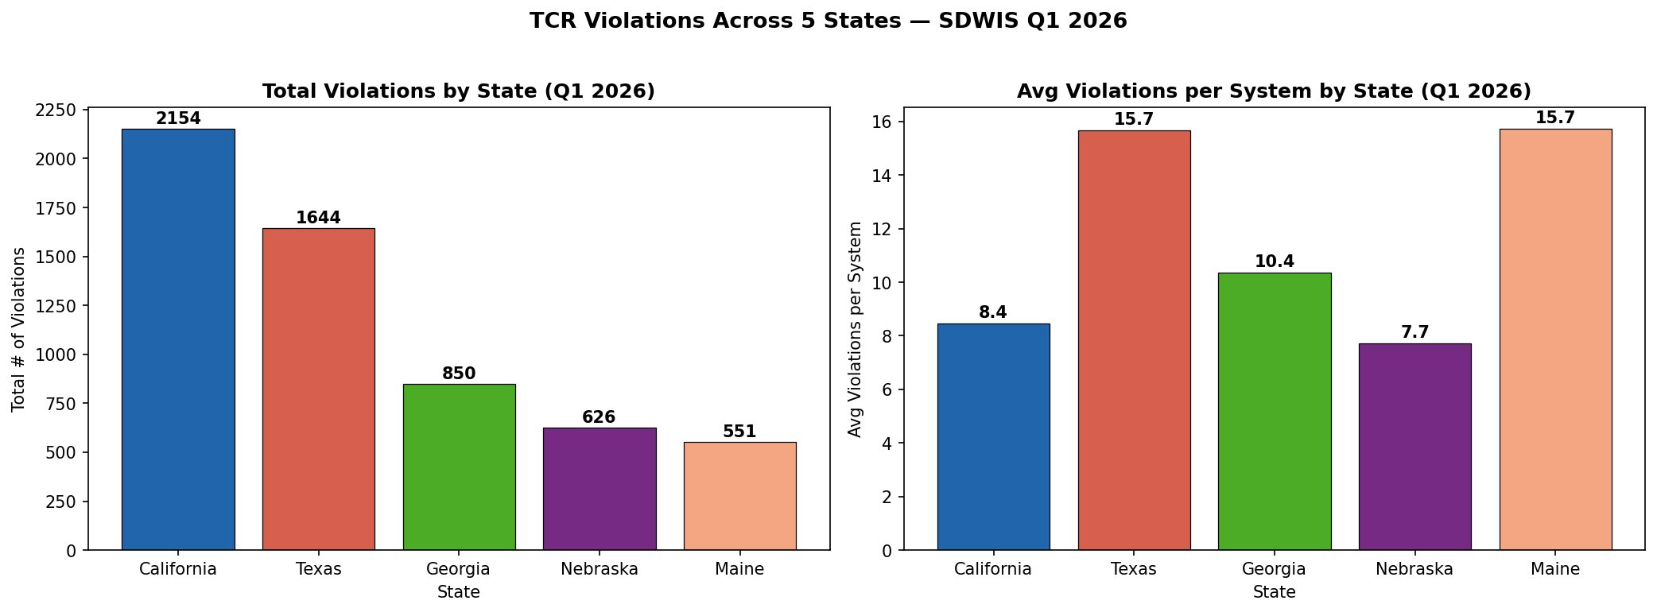
Figure 1. Total violations (left) and average violations per system (right) by state, Q1 2026.

3.3 Small vs. Large System Comparison
All systems in this dataset serve fewer than 1,000 people, so no system qualifies as Large under the standard EPA 10,000-person threshold. The empty Large bars in Figure 2 reflect this data limitation — state-owned facilities such as parks and rest areas are not community water systems. A meaningful small vs. large comparison would require including community and privately owned systems.

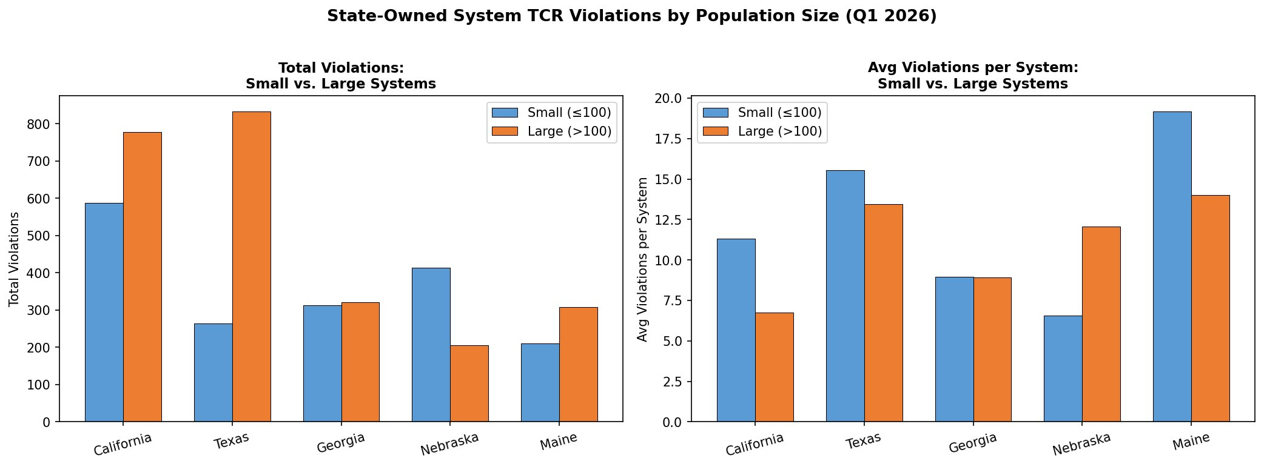
Figure 2. Total violations and average violations per system by size category and state, Q1 2026.

3.4 Geographic Distribution
Figure 3 shows the five study states colored by total violations. California and Texas dominate in dark red; Nebraska, Maine, and Georgia appear in lighter tones, consistent with their lower totals.

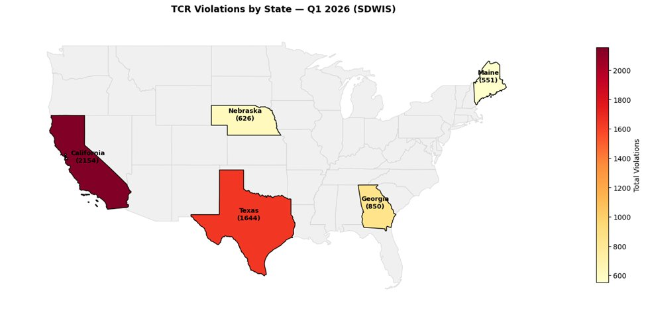
Figure 3. Choropleth map of TCR violations across the five study states, Q1 2026.

4. Discussion
Differences in total violations across states are largely driven by system inventory size. Normalizing by system count reveals that Maine and Texas have the highest per-facility compliance burden. State-level differences may also reflect infrastructure age, facility type mix, and regulatory capacity (Allaire et al., 2018; EPA, 2017).

The state-owned filter prevents a valid small vs. large comparison — all facilities fall under 1,000 population served, well below the 10,000-person EPA threshold. This is an important limitation: the national finding that small systems have disproportionately more violations (Allaire et al., 2018) cannot be tested with this dataset.

Key limitations: data covers Q1 only (winter likely underestimates annual violations), includes all violation types rather than coliform detections specifically, and is restricted to state-owned systems which are not representative of the broader public water system population.

5. Coding Decisions and Bias
- State-owned filter: Excludes ~95% of U.S. water systems; results cannot generalize to community systems.
- Sort order in Figure 1: Sorting by total violations visually emphasizes California and Texas, which could be misleading without the per-system panel.
- Missing values filled with 0: Slightly underestimates violations for systems with incomplete records.
- Q1 data only: Winter data likely underestimates annual totals due to seasonal coliform patterns (EPA, 2023).

6. Conclusion
California and Texas had the most total TCR violations among the five study states, though Maine and Texas had the highest per-system rates. The restriction to state-owned systems prevented a meaningful small vs. large comparison. Future work should expand to community and privately owned systems across multiple quarters to fully address the client's research question.

References
Allaire, M., Wu, H., & Lall, U. (2018). National trends in drinking water quality violations. PNAS, 115(9), 2078-2083.
U.S. EPA. (2017). Drinking Water and Wastewater Utility Small Systems. EPA 816-F-17-003.
U.S. EPA. (2023). Total Coliform Rule. https://www.epa.gov/dwreginfo/total-coliform-rule
SDWIS Federal Reports. (2026). Water System Summary. https://sdwis.epa.gov

