AgeX Shipping Company
Capstone Project Report
Data Analysis Using SQL

Prepared by: [Aminat Aminu]
Date: [August 2025]

Introduction
This report presents the findings of a data analysis project conducted for AgeX Shipping Company, a global logistics firm operating between the USA, Canada, and Nigeria since February 2020. The company provided shipping and customer data in SQL format, and the goal of this project was to analyze the data and generate insights into customer behavior, sales performance, and shipping trends.
The analysis was carried out using SQL queries in MySQL Workbench. Each query addresses a specific business question, and the results are presented along with explanations of the approach.

Database Design

Below is the ERD (Entity Relationship Diagram) of the database.
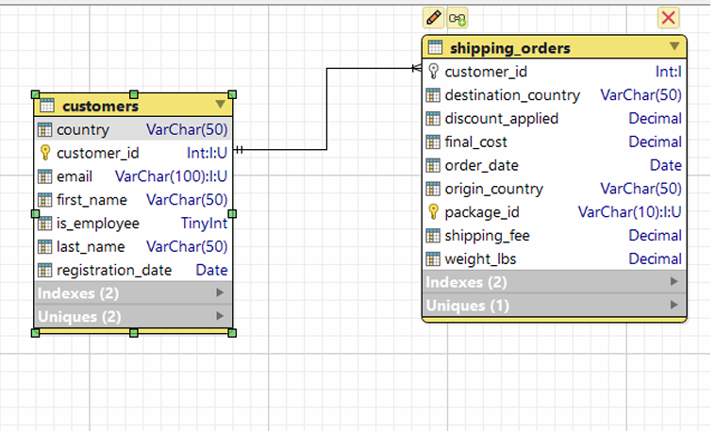
Figure 1: Entity-Relationship Diagram for AgeX Shipping Database

Q1. Total Customers
Explanation: I use the COUNT(customer-id) to count all registered customers in the database. The query counts all row in the customers table, to return the total number of customers on AgeX database.

SQL Query:
--Q1 find the total number of customers registered in AgeX
-- to count all customer_id values

SELECT COUNT(customer_id) AS total_customers
FROM customers;

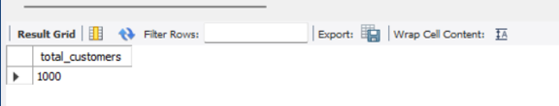
Result:

Q2. Customers Who Have Shipped
Explanation: I use the COUNT(DISTINCT) aggregate function from the shipping table to know how many customers have shipped. Here DISTINCT ensures that each customer is counted once even when they appear many times

SQL Query:
--Q2 find the number of unique customers who have placed at least one order
-- count unique customers who have placed at least one order

SELECT COUNT(DISTINCT customer_id) AS customers_with_orders
FROM shipping_orders;

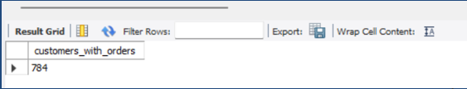
Result:

Q3. Customers Without Orders
Explanation: To identify customers who have not made any orders but are registered, I use LEFT JOIN to connect customers with shipping_orders. If a customer has no order, the s.customer_id will be NULL, it will filter for those to list the customers without orders.

SQL Query:
--Q3 name of customers who have registered but have not placed order
-- LEFT JOIN customers with shipping_orders
-- select those where no matching orders exist (NULL)

SELECT c.first_name, c.last_name
FROM customers as c
LEFT JOIN shipping_orders as s ON c.customers_id=s.customer_id
WHERE c.customer_id is NULL;

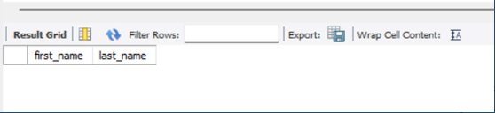
Result:

Q4. Employee Discounts
Explanation: I use INNER JOIN to connect shipping_orders with customers because the is_employee column is in the customer table. I WHERE c.is_employee=1 to filter only employee orders. Then I SUM() the discount cost to know how much in total AgeX gave out in discount to employees.

SQL Query:
--Q4. total employee discount
-- I SUM up discount_applied for employee (is_employee=1)

SELECT SUM(discounts_applied)
FROM shipping_orders as s
INNER JOIN customers as c ON c.customer_id=s.customer_id
WHERE is_employee=1;

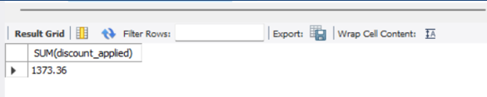
Result:

Q5. Customers by Region
Explanation: This query counts the number of registered customers in each country. The GROUP BY clause groups the records by country, and COUNT(*) gives the total for each group.

SQL Query:
--Q5. show the total number of customer located region
-- I use COUNT(*) grouped by country to get totals
SELECT country COUNT(*) as total_customers
FROM customers
GROUP BY country

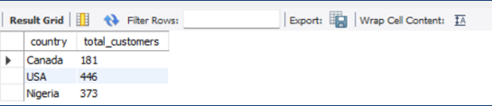
Result:

Q6. Sales by Region
Explanation: I use SUM(final_cost) to add up all sales from shipping_orders originating in each country. The results are GROUP BY the origin_country.

SQL Query:
--Q6. calculate total sales (final_cost) from each origin_country
-- I use grouped by country to get totals

SELECT origin_country, SUM(final_cost) as total_sales
FROM shipping_orders
GROUP BY origin_country;

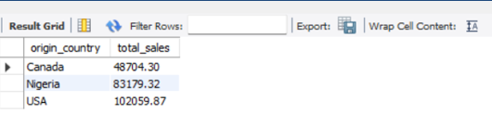
Result:

Q7. Sales by Destination
Explanation: This query adds up SUM(final_cost) for each package shipped and delivered to a destination_country, then GROUP BY the destination country

SQL Query:
--Q7 calculate final_cost for packages shipped to each destination_country
-- I use GROUP BY the destination_country

SELECT destination_country, SUM(final_cost) as sales_by_destination
FROM shipping_orders
GROUP BY destination_country;

Result:
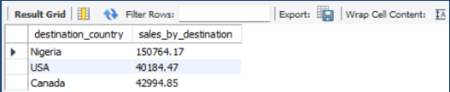

Q8. Sales Over Time
Explanation: I extract the year from order_date, using the YEAR() function, then calculate total sales per year using the SUM(final_cost). The GROUP BY YEAR(order_date) ensures I get the result for total sales for each year.

SQL Query:
-- Q8. find total sales for each year since company started
-- use GROUP BY YEAR() function to extract each year from order_date

SELECT YEAR(order_date) AS year, SUM(final_cost)AS total_sales
FROM shipping_orders
GROUP BY YEAR (order_date);

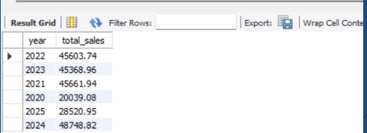
Result:

Q9. Average Shipping Cost per Pound
Explanation: The average shipping cost per pond is found by dividing total shipping cost by the total light_lbs for each origin_country.

SQL Query:
-- Q9. find average shipping cost per pound for each origin_country
-- divide final_cost by Iight_lb to get the cost per pound

SELECT origin_country, AVG(final_cost/Iight_lbs) AS avg_cos_per_lb
FROM shipping_orders
GROUP BY origin_country;

Result:
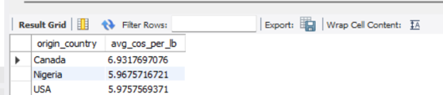

Q10. Most Expensive Order
Explanation: The query sorts all orders by final_cost and packaging_id in descending order and select the top one with the highest value, I used WHERE final_cost IS NOT NULL to remove incomplete or missing cost records.
The final query finds the most expensive order by checking the highest value in the final_cost, results show packaging_id along with its maximum cost. In the final result, there is also a NULL value which means that at least one order final_cost do not have a recorded final_cost in the database.

SQL Query:
-- Q10. find the most expensive order (excluding NULL values)

SELECT package_id, final_cost
FROM shipping_orders
WHERE final_cost IS NOT NULL
ORDER BY final_cost DESC
LIMIT 1;

Result:
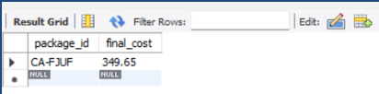

Q11. High-Value Customers
Explanation: Calculate the total spending per customer, then use the HAVING clause to keep only those above $500. Finally, ORDER BY from highest to lowest spender.

SQL Query:
-- Q11. find the customers who have spent more than $500 in total
-- I SUM the final_cost per customer then use the HAVING clause to filter
SELECT customer_id, SUM(final_cost) AS total_spent
FROM shipping_orders
GROUP BY customer_id
HAVING SUM(final_cost) > 500
ORDER BY total_spent DESC;

Result:
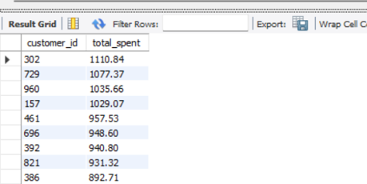

Q12. Sales from Specific Region (Nigeria to Canada)
Explanation: I filter shipment by origin (Nigeria) and destination (Canada) and then sum of their final_cost to get the total revenue.

SQL Query:
-- Q12. total revenue from shipments originating in Nigeria destined Canada
-- apply WHERE filter for both origin and destination

SELECT SUM(final_cost) AS total_revenue
FROM shipping_orders
WHERE origin_country=‘Nigeria’
AND Destination_country=‘Canada’;

Result:
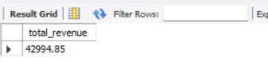

Q13. Employee's Sales (Orders > 30 lbs)
Explanation: I JOIN customers with shipping orders to identify employee shipments. And is_employee=1 only count those where Iight_lbs is equal to 30lbs

SQL Query:
-- Q13. find total sales generated by employee shipment
-- JOIN customers (to check is_employee) with shipping_orders
-- only include shipments greater then 30lbs

SELECT SUM(s.final_cost) AS total_employee_sales
FROM shipping_orders as s
INNER JOIN customers as c
ON c.customer_id=s.customer_id
WHERE c.is_employee=1
AND s.Iight_lbs > 30;

Result:
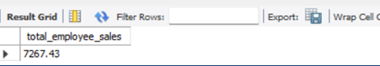

Q14. Popular Routes
Explanation: I group shipments by routes (Origin → Destination), count the number of packages, sort them in descending order and take the top 3.

SQL Query:
-- Q13. find the top 3 most popular shipping routes (from origin_country to destination_country)
--GROUP BY origin_country and destination_country
-- ORDER BY package_count

SELECT origin_country, destination_country, COUNT(*) As package_count
FROM shipping_orders
GROUP BY origin_country, destination_country
ORDER BY package_count DESC
LIMIT 3;

Result:
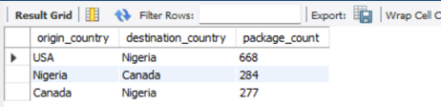

Q15. Customers with Last Name Starting with 'O'
Explanation: I use LIKE’O%’ conditions to filter customers whose last name begins with “O”

SQL Query:
-- Q15. find all customers whose last_name LIKE'O'
-- use LIKE with a wildcard
SELECT first_name, last_name
FROM customers
WHERE last_name LIKE 'O%';

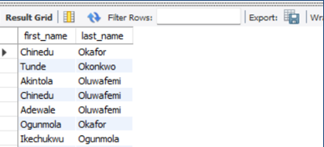
Result:

Q16. Package Tracking String
Explanation: I use CONCAT to merge the package ID, origin country and destination country into a readable sentence for tracking.

SQL Query:
-- Q16. create a readable tracking strings
-- use CONCAT to combine packaging_id, origin_country, destination_country
SELECT CONCAT('package',' ',package_id,' ','from',' ',origin_country,' ','to',' ',destination_country) AS tracking_info
FROM shipping_orders;

Result:
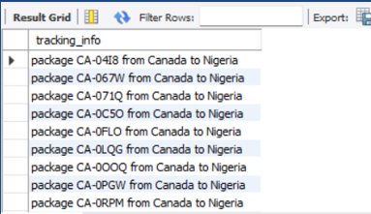

Q17. Top Spenders by country ‘USA’
Explanation: I JOIN customers and orders, filter for costumers in the USA, calculate their total spending and list the top 5 spenders ordered by total spent.

SQL Query:
-- Q16. create a readable tracking strings
-- use CONCAT to combine packaging_id, origin_country, destination_country
SELECT CONCAT(c.first_name,' ',c.last_name,' ',c. country) AS full_name, SUM(s.final_cost) AS total_spent
FROM customers as c
JOIN shipping_orders as s ON c.customer_id=s.customer_id
WHERE c.country= 'usa'
GROUP BY c.customer_id, first_name, last_name
ORDER BY total_spent DESC LIMIT 5;

Result:

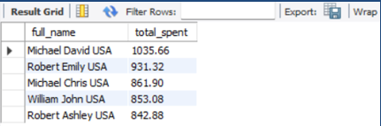
Conclusion
This analysis provided insights into:
- Customer demographics
- Revenue trends
- Shipping patterns
- Employee discounts impact
The findings can help AgeX Shipping improve decision-making and optimize operations.

