**Blogies**

**Subtitle: Comprehensive Guide to Blogies**

**Team members :**

***Mohamed Amine Ben Omar   
Mohamed Yassine Asnus***

**Date: June 19, 2024**

***Purpose:***

**This document provides a detailed overview of Blogies, a web application designed to share blogs and interact with users' blogs.**

***Scope:***

**Blogies allows users to share and delete posts, chat with other users, create chat groups, and receive notifications about any changes related to user account. The application aims to facilitate communication and content sharing among users.**

***Description:***

**Blogies is a social platform where users can create, share, and delete posts on their profiles. Users can also chat with other users in real-time and create groups for collective conversations.**

***Technologies Used:***

***- Frontend*: HTML, CSS, JavaScript, React**

***- Backend*: Node.js, Express.js**

***- Database*: MongoDB**

***Figma link :***

***https://www.figma.com/design/PLPtz3sZTRv0KZVxWZHYWg/Blogies?node-id=0-1&t=9TnEBpoVM3bPszQt-1***

***ser Interface (UI) Design***

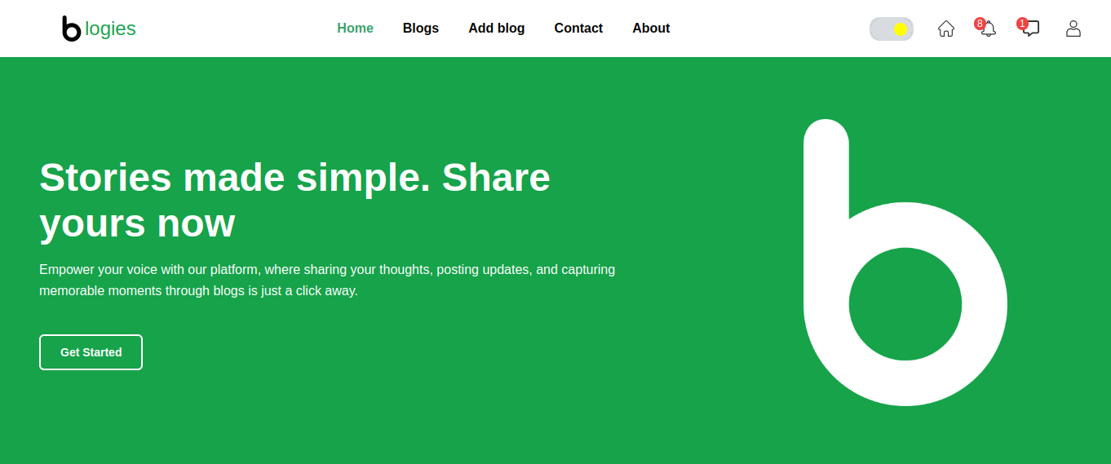

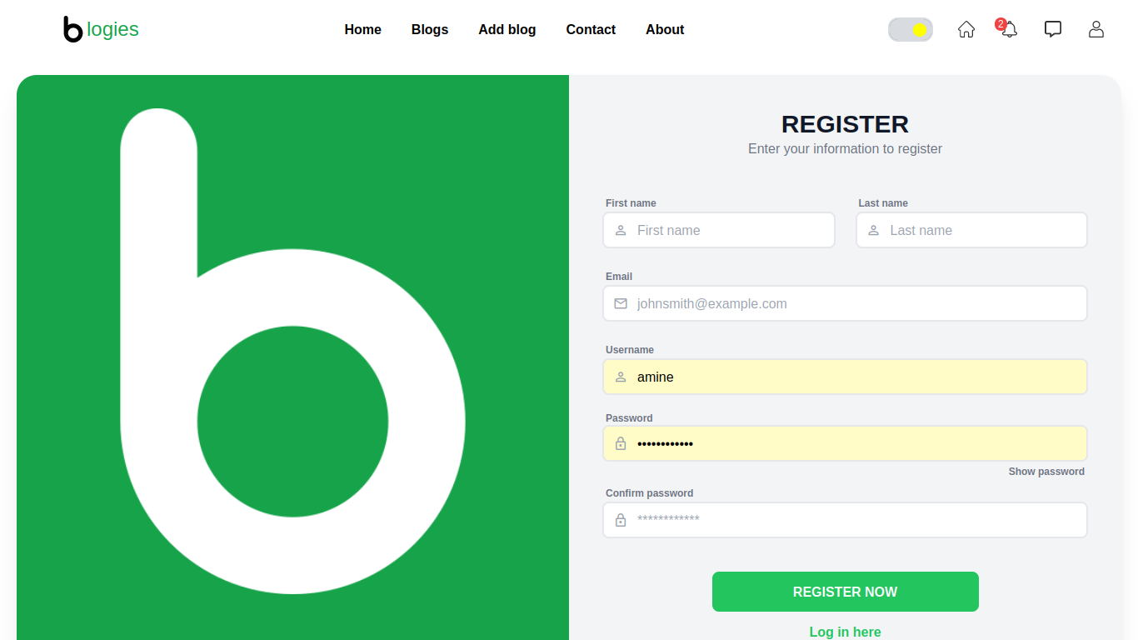

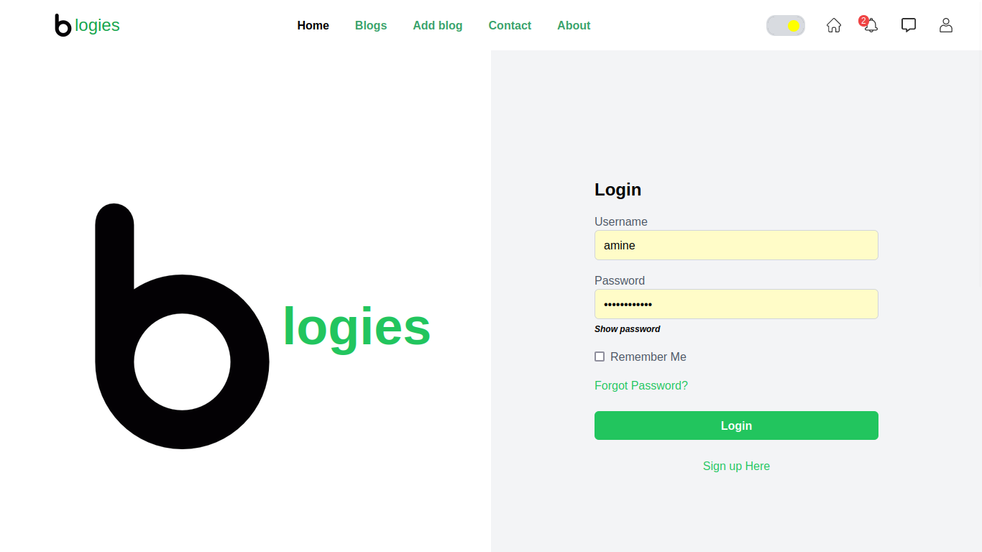

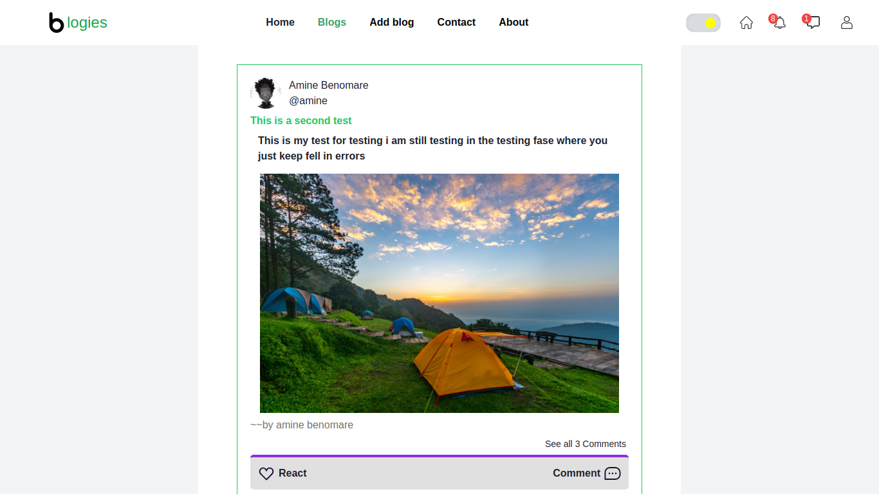

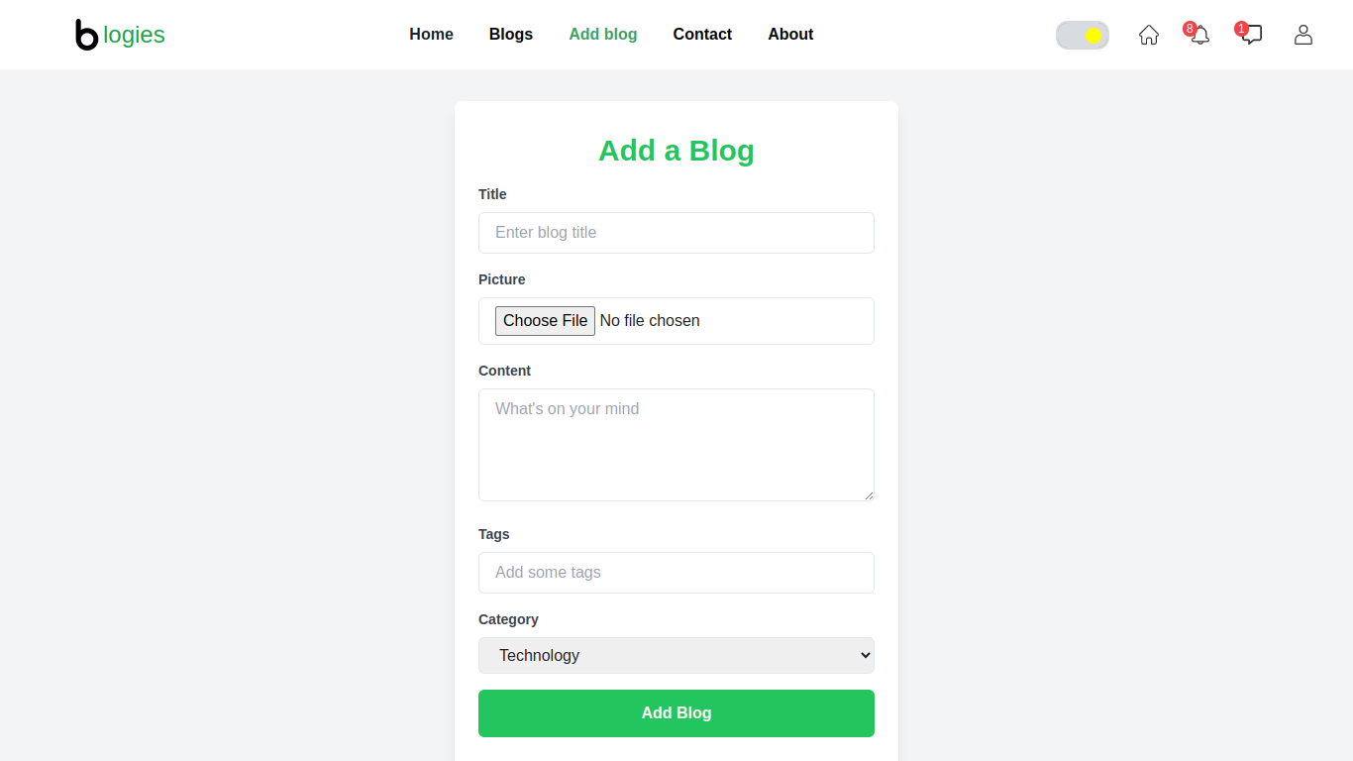

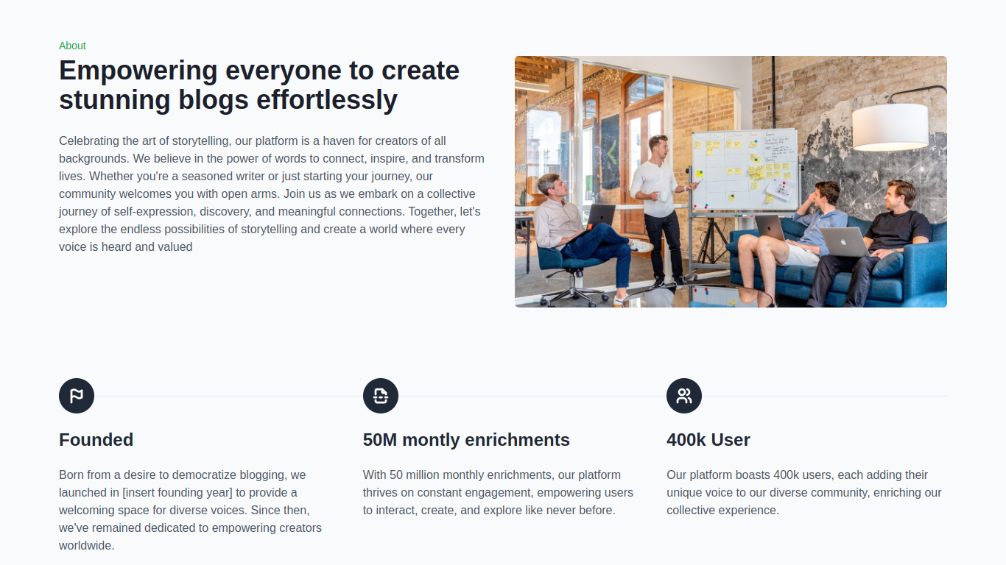

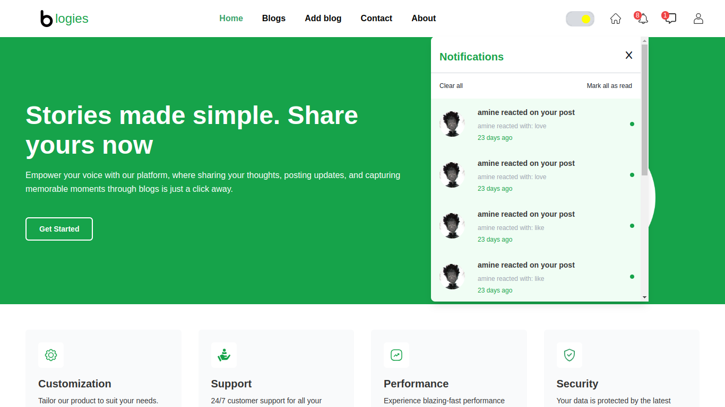

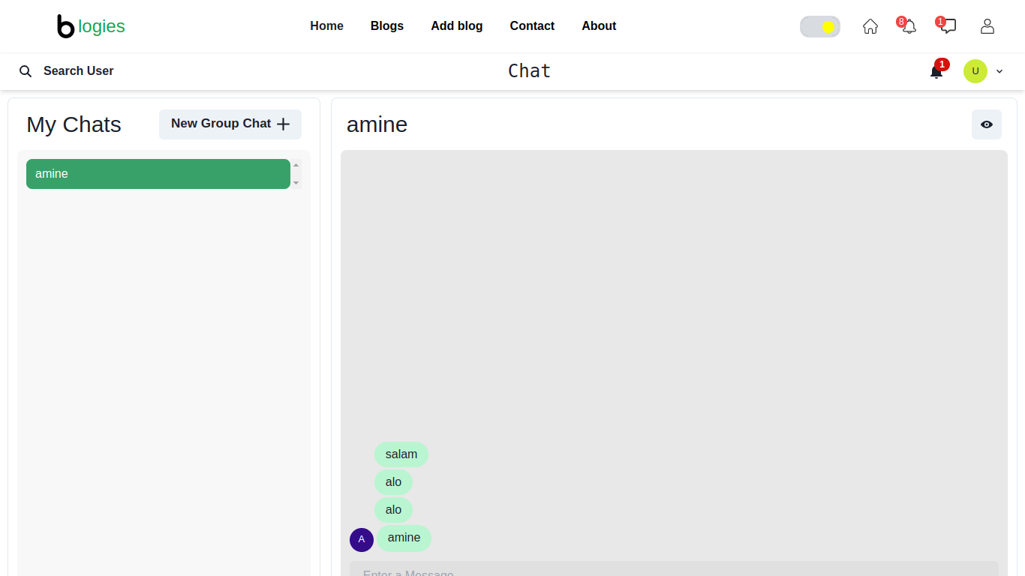

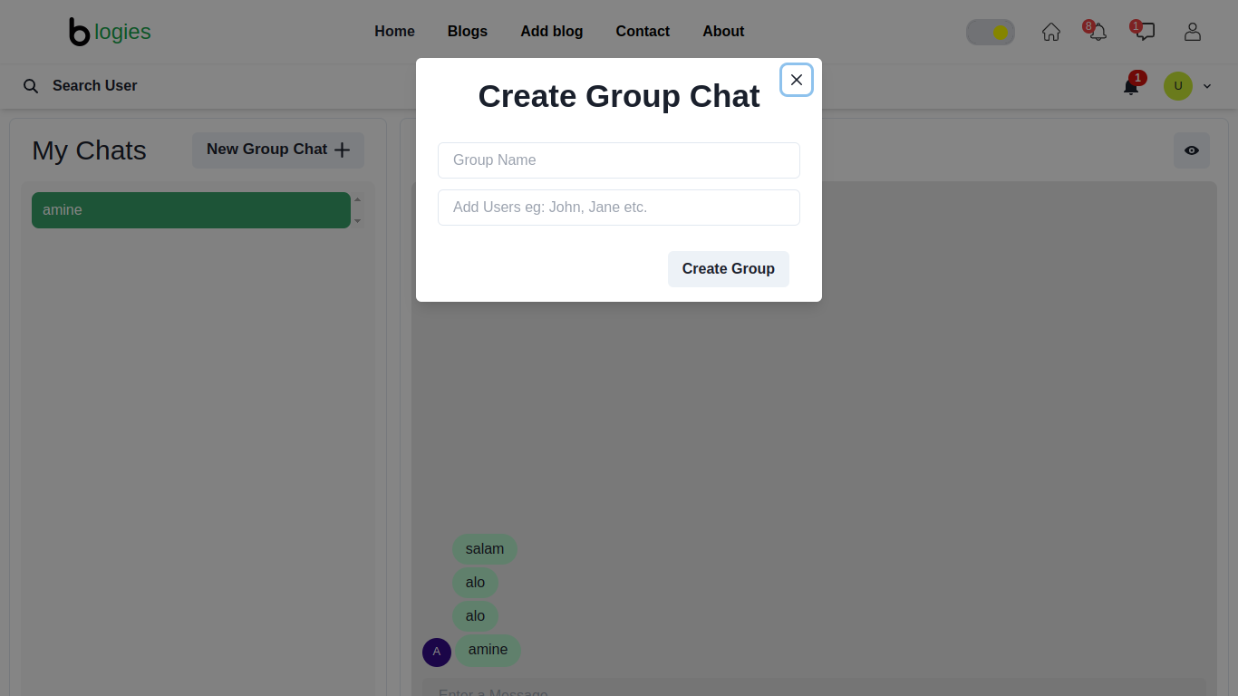

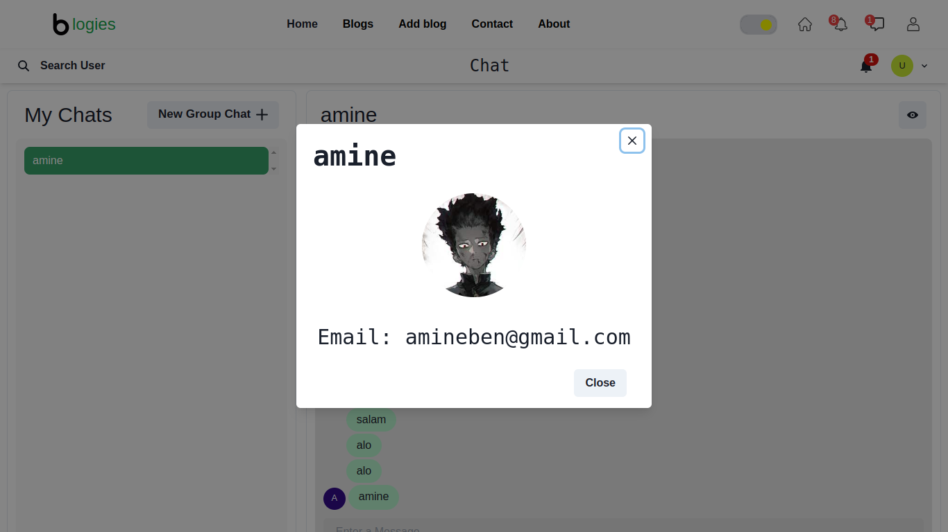

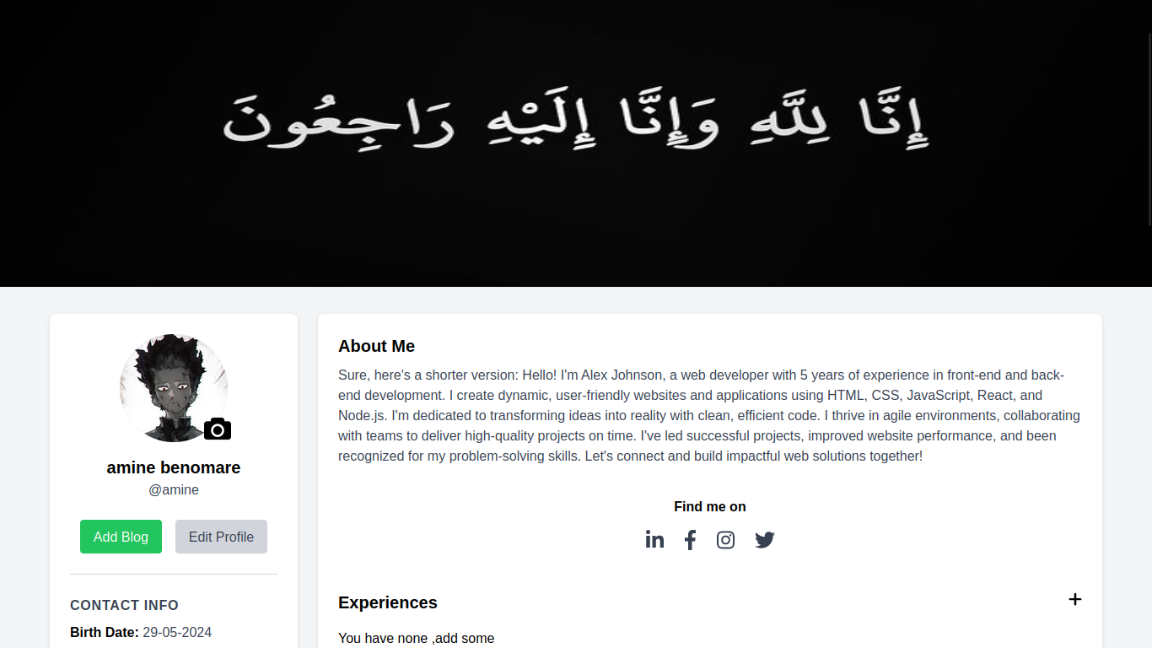

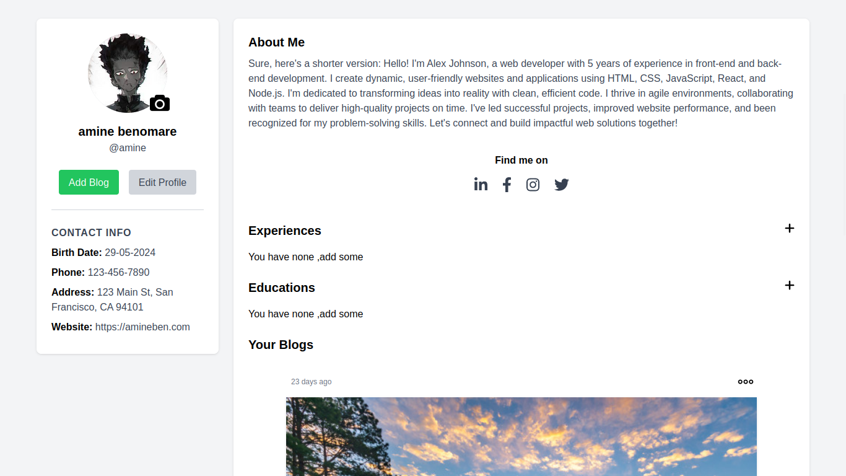

***UML Diagrams :***

**Use Case Diagram :**

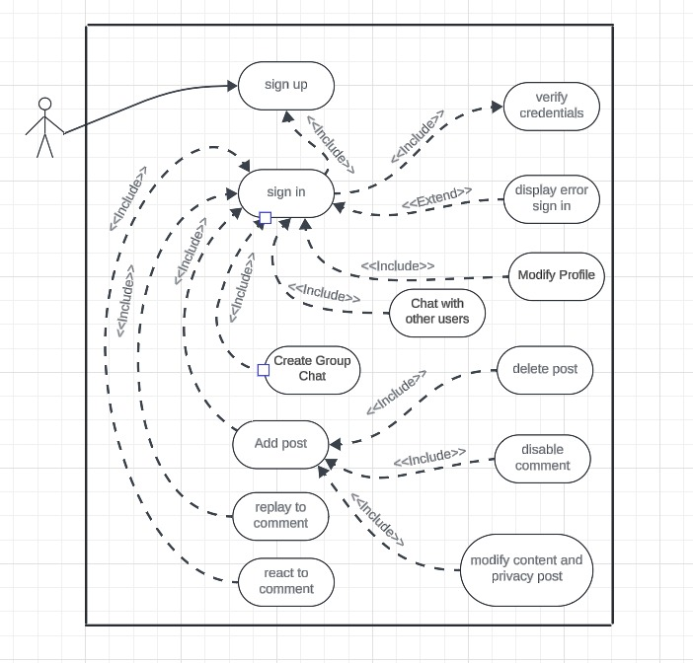

***Class Diagram :***

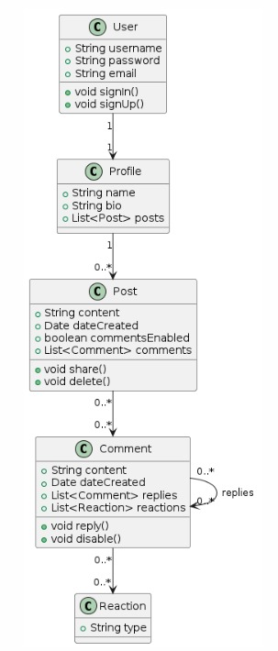

***Sequence Diagrams :***

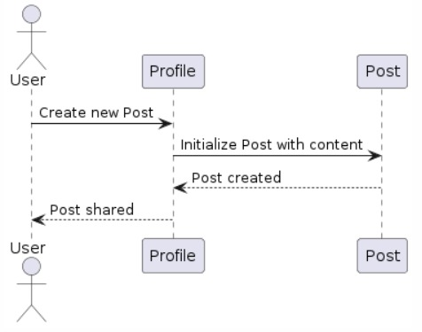

The image represent a sequence diagram that shows the process of creating a new post on a blog

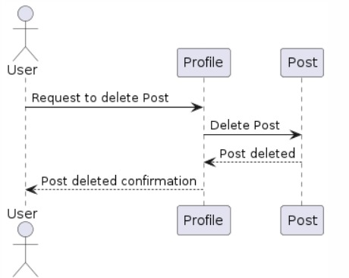

The image represent actually a sequence diagram showing the process of deleting a post on ***Blogies***

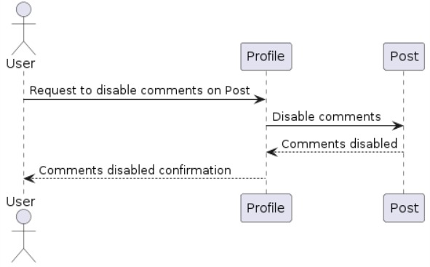

The image represent a sequence diagram showing the process of disabling comments on a post

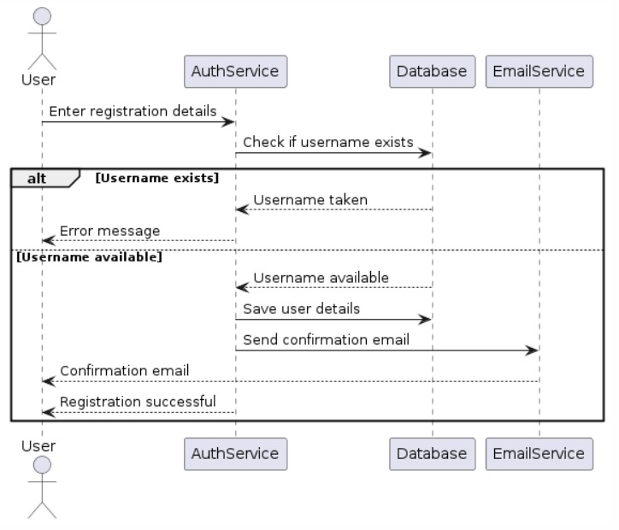

The image represent a sequence diagram that shows the user registration process on ***Blogies***

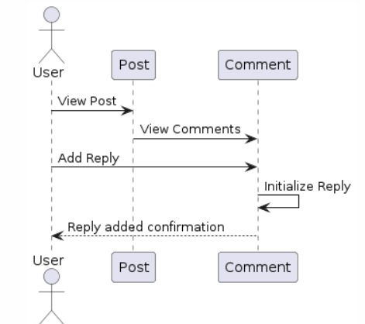

The image represent a sequence diagram that shows the steps involved in a user adding a reply to comments on a blog post.

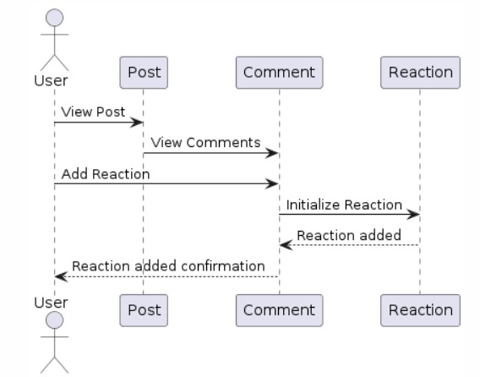

The image represent a sequence diagram that shows the steps involved in a user adding a reaction to comments on a blog post.

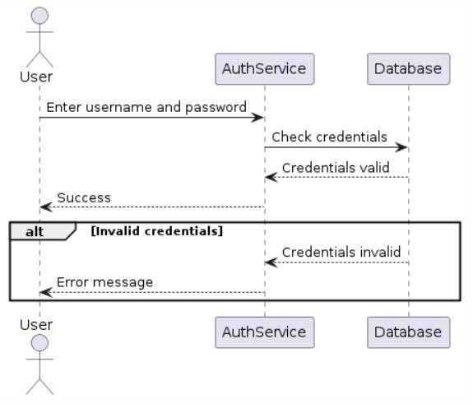

**The image represent a sequence diagram of a login process.**

**Summary:**

This document provides a detailed overview of ***Blogies***, including its features, technical architecture, and user interface. Blogies offers a comprehensive platform for sharing posts and real-time communication.

**Future Enhancements:**

- **\*\*Advanced Search**:** Add a search feature to find posts and users more efficiently.