**The Battle of the Neighborhoods (New York Vs Toronto)**

**Applied Data Science Capstone by IBM/Coursera**

## **Introduction (Business Problem):**

Toronto and New York are the famous places in the world. They are diverse in many ways. We want to explore how much they are similar or dissimilar in aspects from a tourist point of view regarding food, accommodation, beautiful places, and many more. Both are multicultural as well as the financial hubs of their respective countries.

## **Data:**

For this problem, we will get the services of Foursquare API to explore the data of two cities, in terms of their neighborhoods. The data also include the information about the places around each neighborhood like restaurants, hotels, coffee shops, parks, theaters, art galleries, museums ... . We selected one Borough from each city to analyze their neighborhoods. Brooklyn from New York and Central Toronto from Toronto. We will use “Clustering” to segment the neighborhoods with similar objects based on each neighborhood data. This will help to locate the tourist’s areas and hubs, and then we can judge the similarity or dissimilarity between two cities on that basis.

## **Methodology:**

As we have selected two cities Borough to explore their neighborhoods. The data exploration, analysis and visualization for both boroughs are done in the same way but separately.

## **EXPLORATION:**

For Central Toronto case, we have extracted table of Toronto’s Borough from Wikipedia page. Then we arrange the data according to our requirements. In the arrangement phase, which applied multiple steps including but not limited to, eliminating “Not assigned” values, combine neighborhoods that have same geographical coordinates at each borough and sorted against the concerned borough. For data verification and further exploration, we use Foursquare API to get the coordinates of Central Toronto and explore its neighborhoods.

The neighborhoods are further characterized as venues and venue categories. For Brooklyn, we used a saved data file, which is already explored through foursquare API in which we have extracted all the boroughs of New York and then sorted against the concerned borough. Then we explored the Brooklyn neighborhoods as venues and venue categories

### VISUALIZATION:

#### **Central Toronto**

##### ***Before Clustering***

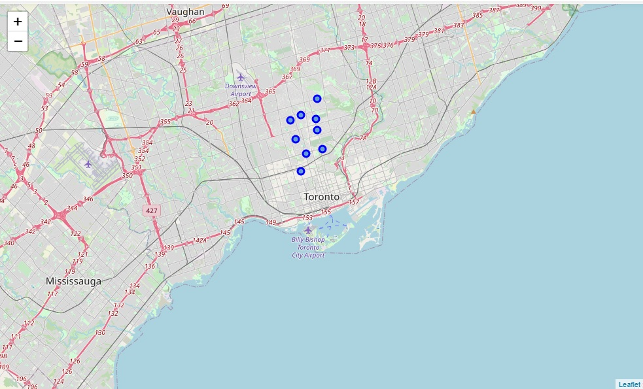

##### ***After Clustering***

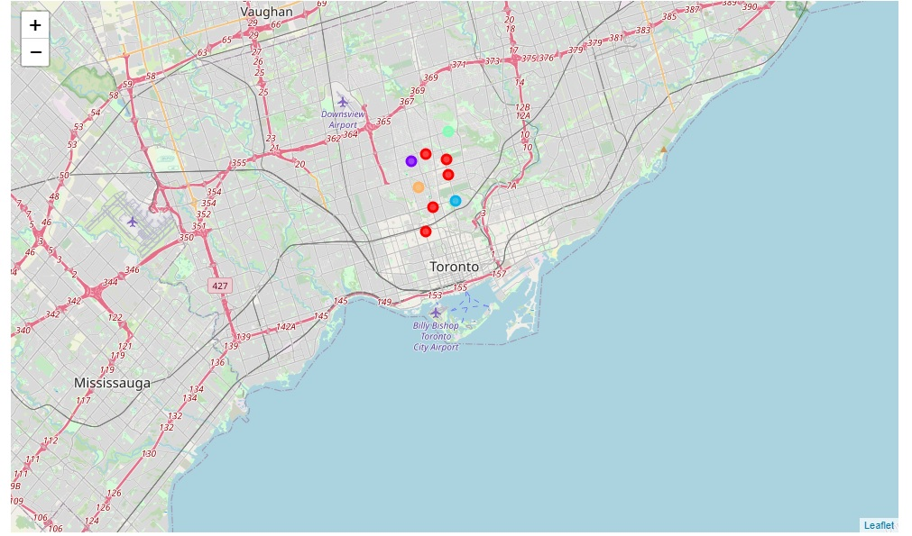

**Brooklyn**

##### ***Before Clustering***

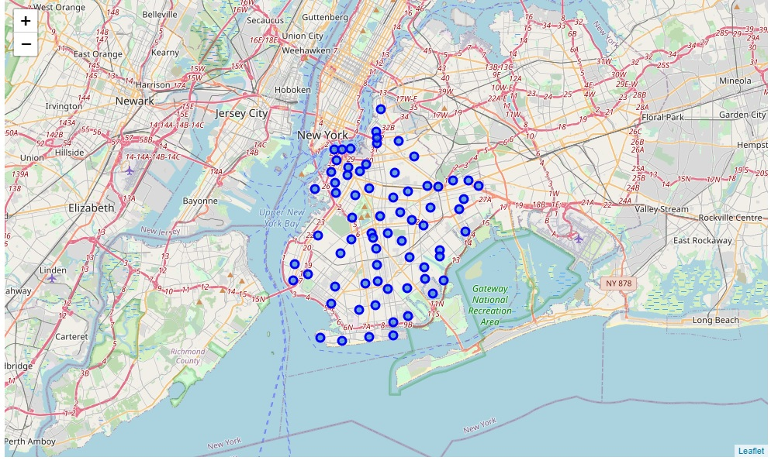

##### ***After Clustering***

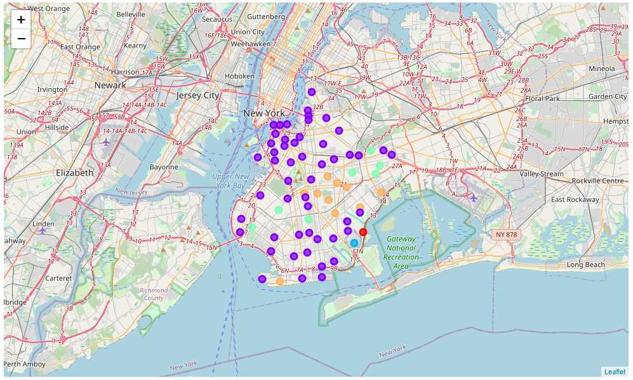

## **Results and Discussion:**

After clustering the data of the respective neighborhoods, both cities (Boroughs) have venues which can be explored and attract the Tourists. The neighborhoods are much similar in features like Theaters, opera houses, food places, clubs, museums, parks etc. As far as concern to dissimilarity, it differs in terms of some unique places like historical places and monuments. When we compare the tourist places, we observe that the park place is only situated in Central Toronto and the Monument or landmark venue is in Brooklyn neighborhoods. Similarly, Airport facility, Harbor, Sculpture garden and Boat or ferry services are also available in central Toronto while venues like Nightlife, Climbing gym and Museums are present in Brooklyn. As far as concern to recommendations, we recommend Brooklyn Neighborhoods will be considered first to visit for more nightlife and fun.

## **Conclusion:**

The Central Toronto and Brooklyn neighborhoods have more like similar venues. As we know that, every place is unique in its own way, so this argument is present in both neighborhoods. The dissimilarity exists in terms of some different venues and facilities but not on a larger extent