The Kanzius effect

Peter Walsh
Peter.Walsh@MakeitLabs.com

Abstract
Results from experiments done by the Amine Group at MakeitLabs.

This document contains the distilled results and conclusions, and is updated as needed, unlike laboratory notebooks which contain everything and anything and are never edited or updated.

Table of Contents
Illustration Index IV
Index of Tables IV
Heading w/o numbering, in TOC IV
I Heading w/ Roman Numbering IV
1 Preface 1
2 Talley's circuit 2
2.1 Initial analysis of Talley's circuit 2
2.2 Simulation of Talley's circuits 3
3 The Kanzius circuit 4
3.1 RC voltage divider 5
3.2 LC voltage divider 6
3.3 The Kanzius circuit 7
4 Dummy chapter 10
4.1 Dummy Subheading 10
4.1.1 Dummy Subsubheading 10
4.1.2 Dummy Subsubheading 2 10
4.2 Dummy Subheading 2 11
5 Bibliography 12

Illustration Index
Figure 1: Talley's circuit VI
Figure 2: Simulation of Talley's experiment VII
Figure 3: The Kanzius circuit VIII
Figure 4: RC Voltage divider 9
Figure 5: LC Voltage divider 10
Figure 6: Kanzius circuit 11

Preface
Lorem ipsum

Talley's circuit
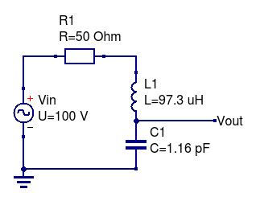Figure 1: Talley's circuit
Talley's circuit is shown above. The values shown have been adjusted for a resonant frequency of 15.0 MHz, the actual experiment was run at resonance to account for slight deviations from the nominal values. R1 represents the Vin internal resistance of the power source.
The system was assembled and Vin was adjusted to provide at 200 watts power.

Initial analysis of Talley's circuit
At resonance, the voltage across L1 and C1 vanishes, leaving R1 to dissipate the full power supplied by Vin. Since the supplied power was 200 watts, Vin supplies 100 volts to push 2 amps through R1.
At resonance, the impedance of L1 and C1 are equal, and given by:

The circuit resistance is negligible compared to the 50 ohms impedance of Vin, so the Quality factor of the circuit is:

At resonance, the voltage across L1 and C1 is zero, but the voltage across either component is:

Talley's capacitor plates were 22,275 mm apart, resulting in an electric field strength of:

Simulation of Talley's circuits
Typing Talley's circuit into Qucs (open source circuit simulator) shows a peak voltage a little over 18000 volts, as expected.
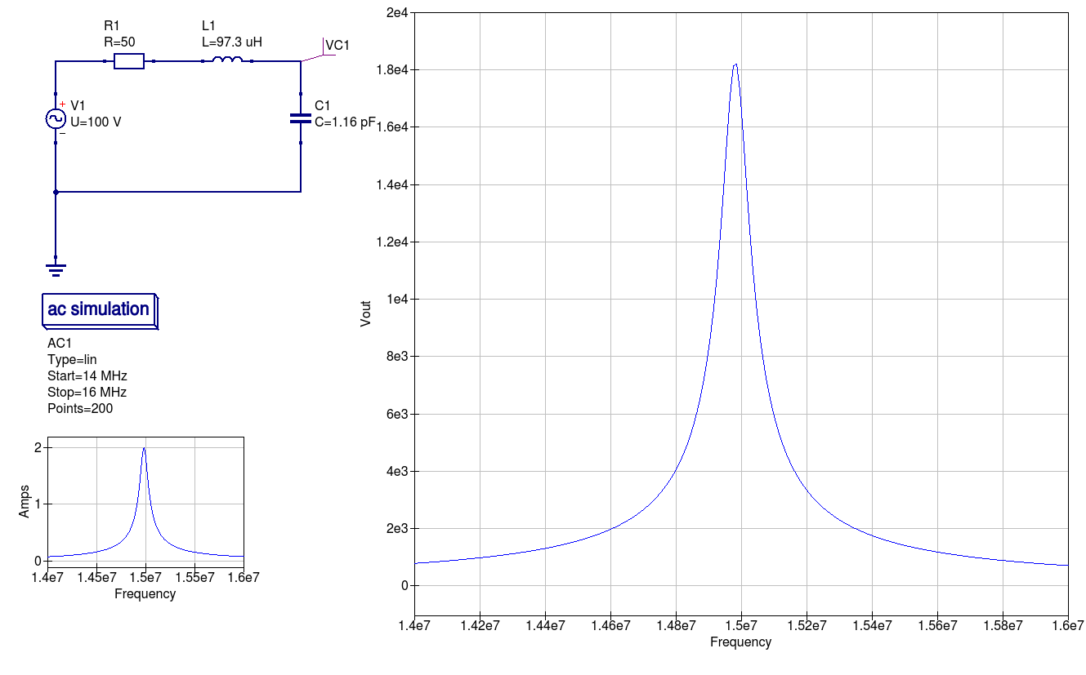Figure 2: Simulation of Talley's experiment

Power calculations for Talley's circuits
Since the voltage dropped across L1 and C1 is zero at resonance, no power will be dissipated in these components.
This is only true for ideal components. In reality, L1 always has a little resistance (estimated at 0.01 ohms in Talley's experiment), and C1 will have a resistance corresponding to the dielectric loss. It is this dielectric loss that is of interest.
The Penn State researchers reproduced the Kanzius effect at 300 watts. Assuming a dielectric power factor of 0.05 and knowing their RF generator has an output impedance of 50 ohms leads to an estimated 0.6 ohms of resistance due to the salt water dielectric in their system. This dissipates 15 watts of energy in the Penn State setup.
From the simulation below, the capacitor dielectric resistor drops 1 volt and dissipates 2.4 watts of power. I believe that this power level is unlikely to reproduce the Kanzius effect, and is why Talley's experiment had no results.
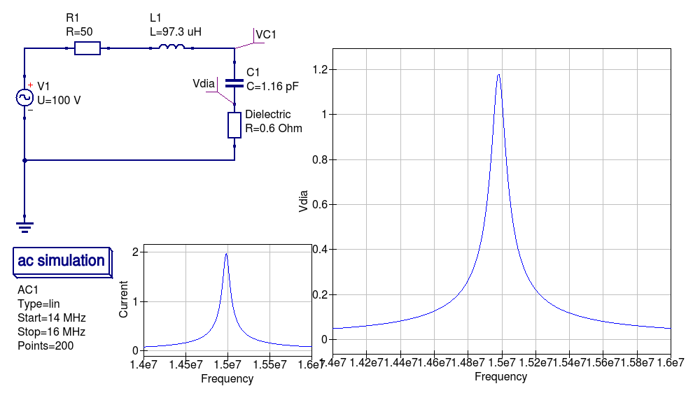

The Kanzius circuit
The circuit from John Kanzius' patent is more complex
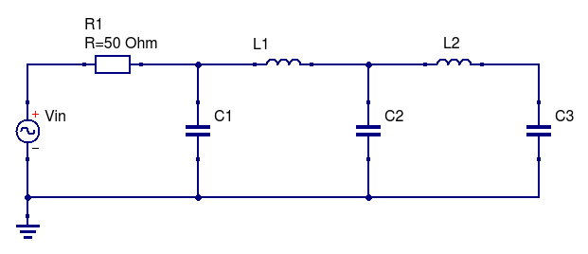Figure 3: The Kanzius circuit
Appendix A: Derivation of Kanzius transfer function

RC voltage divider
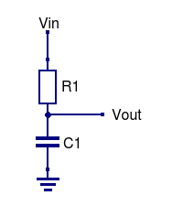Figure 4: RC Voltage divider
When considered as a voltage divider, the transfer function for the circuit shown above is:

Dividing top and bottom by XC1:

Using S as shorthand for 2×π×F, and replacing XC with 1/(S×i×C):

This equation has no poles; ie – no value of S will cause a divide by zero.
This equation has one zero when S = ∞.
Vout→0 as S→∞ as the capacitor is a short to ground at high frequencies.
Vout→1 as S→0 as the capacitor is open at low frequencies.

LC voltage divider
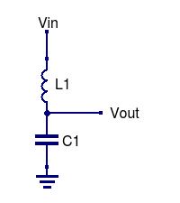Figure 5: LC Voltage divider
When considered as a voltage divider, the transfer function for the circuit shown above is:

Dividing top and bottom by XC1:

Using S as shorthand for 2×π×F, and replacing XC with 1/(S×i×C):

(Where i x i = -1). The quadratic equation on the bottom can then be replaced by its two solutions:

This equation has two poles (frequencies that divide by zero) at S = +/- √L₁C_{1.}
Vout→0 as S→∞ as the capacitor is a short to ground and the inductor is open at high frequencies.
Vout→1 as S→0 as the capacitor is open and the inductor is a short at low frequencies.

The Kanzius circuit
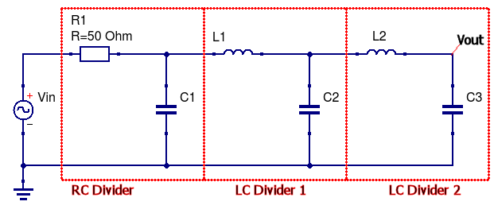Figure 6: Kanzius circuit
The transfer function for the Kanzius circuit is formed by concatenating the transfer functions of the RC divider, followed by the LC and a second LC voltage divider:

Appendix
My whiteboard after figuring all this out:
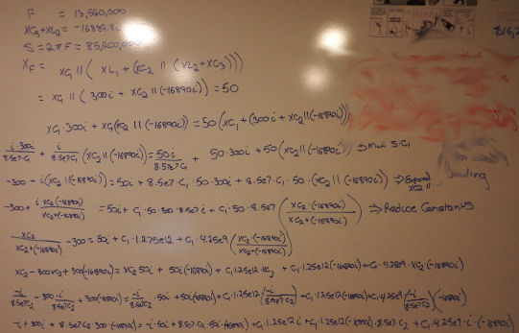

Observations of polarised RF radiation catalysis of dissociation of H 2 O–NaCl solutions, R. Roy* 1,2 , M. L. Rao 1 and J. Kanzius 3, 2008
Wild-assed guess, consistent with known loss tangents of some materials

