Reproducing the
Kanzius effect

Peter Walsh
Peter.Walsh@ToolChainGang.com

Abstract
Attempts to reproduce the Kanzius effect have produced no results. Comparing the transfer function of the circuits used in our initial attempts with the circuit actually used by John Kanzius implies that the Kanzius effect requires extremely high electric fields which were not reproduced in our experimental setup. The electric field field to reproduce the effect must therefore be higher than 20,000 volts/inch.

Table of Contents
Illustration Index IV
Index of Tables IV
Heading w/o numbering, in TOC IV
I Heading w/ Roman Numbering IV
1 Preface 1
2 Talley's circuit 2
2.1 Initial analysis of Talley's circuit 2
2.2 Simulation of Talley's circuits 3
3 The Kanzius circuit 4
3.1 RC voltage divider 5
3.2 LC voltage divider 6
3.3 The Kanzius circuit 7
4 Dummy chapter 10
4.1 Dummy Subheading 10
4.1.1 Dummy Subsubheading 10
4.1.2 Dummy Subsubheading 2 10
4.2 Dummy Subheading 2 11
5 Bibliography 12

Illustration Index
Figure 1: Talley's circuit VI
Figure 2: Simulation of Talley's experiment VII
Figure 3: The Kanzius circuit VIII
Figure 4: RC Voltage divider 9
Figure 5: LC Voltage divider 10
Figure 6: Kanzius circuit 11

Preface
Thank you for looking at this template. I hope this makes it easier for you to successfully write your paper. In my case, it does. This is not meant to be a manual or that sort of thing. If you have specific questions, read the documentation or ask the (great!) community. They have taught me so much, I feel that I have to contribute now, too.
This is a collection of various hints I have collected over the past years. Having studied at three international universities, I found this layout to be the minimum working example of writing. Now, some of you may argue to use LaTeX. Well, for serious typesetting, I prefer TeX over Writer, too. As the title suggests, this is a “quick and dirty” example. For sure, you can achieve things on a more elegant way. But since you are reading this, I assume you are rather a beginner. Let's focus on not making the learning curve too steep.
Feel free to modify anything according to your desires. But please, do not post this template nor parts of it somewhere else and claim it to be yours. If you have suggestions for improving this file, feel free to share your ideas at

Talley's circuit
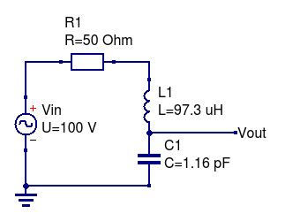Figure 1: Talley's circuit
Talley's circuit is shown above. The values shown have been adjusted for a resonant frequency of 15.0 MHz, the actual experiment was run at resonance to account for slight deviations from the nominal values. R1 represents the Vin internal resistance of the power source.
The system was assembled and Vin was adjusted to provide at 200 watts power.

Initial analysis of Talley's circuit
At resonance, the voltage across L1 and C1 vanishes, leaving R1 to dissipate the full power supplied by Vin. Since the supplied power was 200 watts, Vin supplies 100 volts to push 2 amps through R1.
At resonance, the impedance of L1 and C1 are equal, and given by:

The circuit resistance is negligible compared to the 50 ohms impedance of Vin, so the Quality factor of the circuit is:

At resonance, the voltage across L1 and C1 is zero, but the voltage across either component is:

Talley's capacitor plates were 22,275 mm apart, resulting in an electric field strength of:

Simulation of Talley's circuits
Typing Talley's circuit into Qucs (open source circuit simulator) shows a peak voltage a little over 18000 volts, as expected.
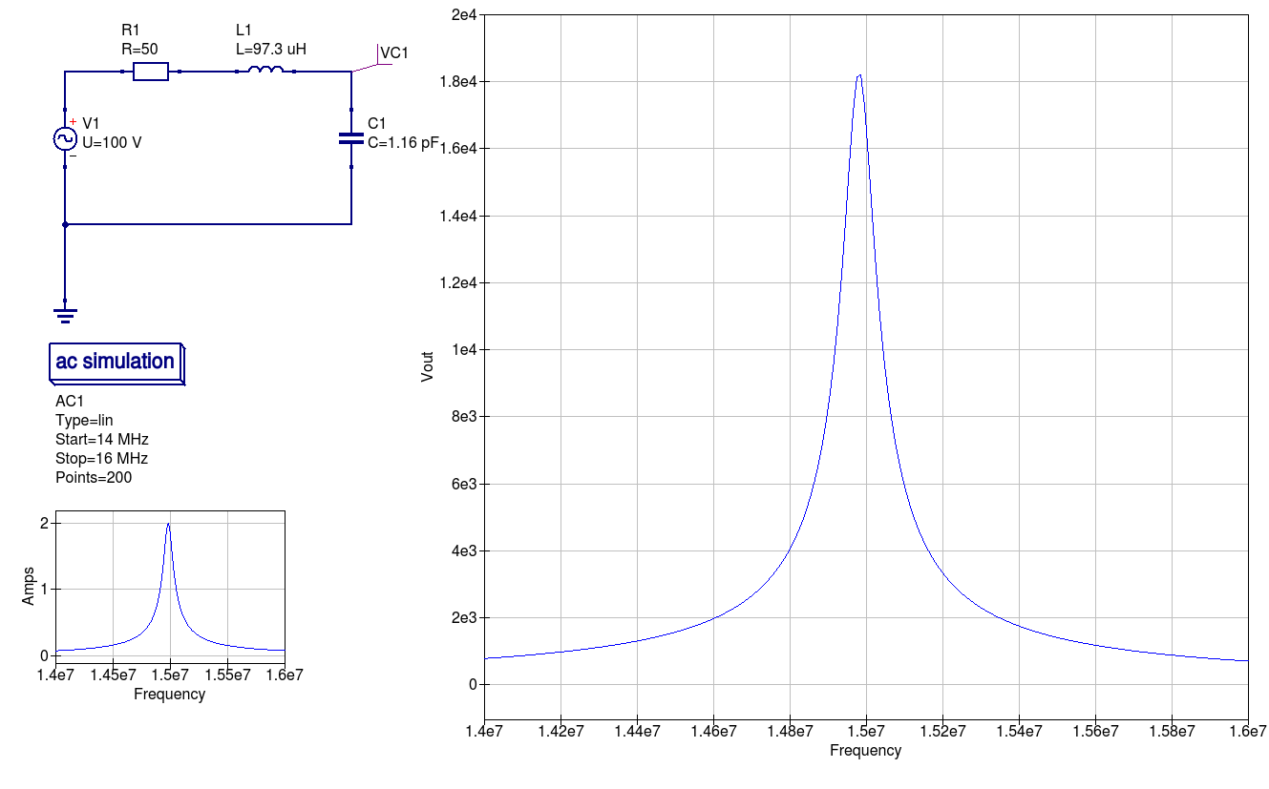Figure 2: Simulation of Talley's experiment

The Kanzius circuit
The circuit from John Kanzius' patent is more complex
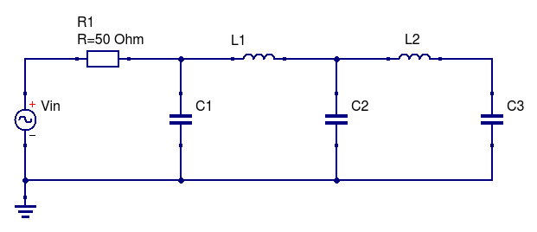Figure 3: The Kanzius circuit
Appendix A: Derivation of Kanzius transfer function

RC voltage divider
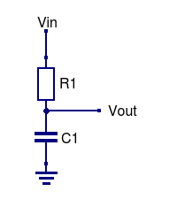Figure 4: RC Voltage divider
When considered as a voltage divider, the transfer function for the circuit shown above is:

Dividing top and bottom by XC1:

Using S as shorthand for 2×π×F, and replacing XC with 1/(S×i×C):

This equation has no poles; ie – no value of S will cause a divide by zero.
This equation has one zero when S = ∞.
Vout→0 as S→∞ as the capacitor is a short to ground at high frequencies.
Vout→1 as S→0 as the capacitor is open at low frequencies.

LC voltage divider
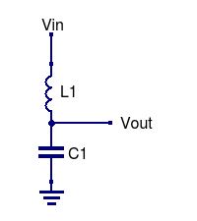Figure 5: LC Voltage divider
When considered as a voltage divider, the transfer function for the circuit shown above is:

Dividing top and bottom by XC1:

Using S as shorthand for 2×π×F, and replacing XC with 1/(S×i×C):

(Where i x i = -1). The quadratic equation on the bottom can then be replaced by its two solutions:

This equation has two poles (frequencies that divide by zero) at S = +/- √L₁C_{1.}
Vout→0 as S→∞ as the capacitor is a short to ground and the inductor is open at high frequencies.
Vout→1 as S→0 as the capacitor is open and the inductor is a short at low frequencies.

The Kanzius circuit
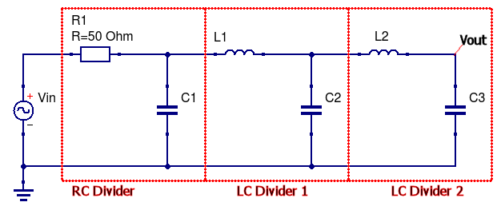Figure 6: Kanzius circuit
The transfer function for the Kanzius circuit is formed by concatenating the transfer functions of the RC divider, followed by the LC and a second LC voltage divider:

Appendix
My whiteboard after figuring all this out:
