TECHNICAL PROJECT REPORT
CUDA p-Bit Route Planner
for Digital Asimov
Direct Ising optimization, population annealing, and PPO robot locomotion
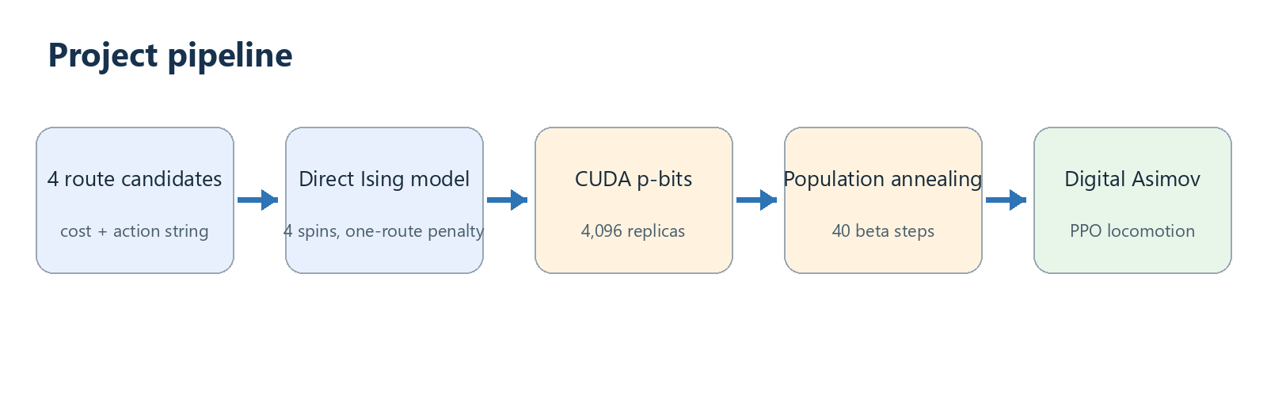
Prepared by Mohammadamin Jahanimajd
August 2026

Abstract
This project demonstrates a simple connection between GPU probabilistic optimization and a humanoid digital twin. Four fixed routes are encoded directly as a four-spin Ising model. A CUDA p-bit kernel updates 4,096 replicas in parallel, while population annealing progressively favors low-energy solutions. The decoded route is converted into forward and turning commands for Digital Asimov, whose locomotion is produced by Menlo's existing PPO-trained neural controller. The implementation intentionally avoids QUBO construction, quantum hardware, perception, and new reinforcement-learning training.

1. Objective and project scope
The objective is to give a simple task to a robot digital twin while making CUDA a real computational component. The task is route choice around a predefined obstacle. CUDA chooses the route; Digital Asimov performs the motion.
- Included: direct Ising model, stochastic p-bits, CUDA parallelism, population annealing, route decoding, and Digital Asimov motion commands.
- Reused component: Menlo's already-trained PPO locomotion policy converts velocity commands into whole-body walking.
- Excluded: QUBO, D-Wave embedding, inverse kinematics, new PPO training, visual obstacle detection, and global closed-loop navigation.

2. System design
Figure 1. End-to-end project pipeline.

2.1 Route candidates
Each candidate contains a cost and a short action string. F means forward, L means turn left, and R means turn right. The direct path has the highest cost because it crosses the modeled obstacle.
Route | Cost | Action string | Meaning
Direct | 22.0 | FF | Blocked by obstacle penalty
Left detour | 5.0 | LFRFFRFL | Shortest safe route
Right detour | 5.4 | RFLFFLFR | Small terrain penalty
Long detour | 7.0 | LFFRFFRFFL | Safe but longer

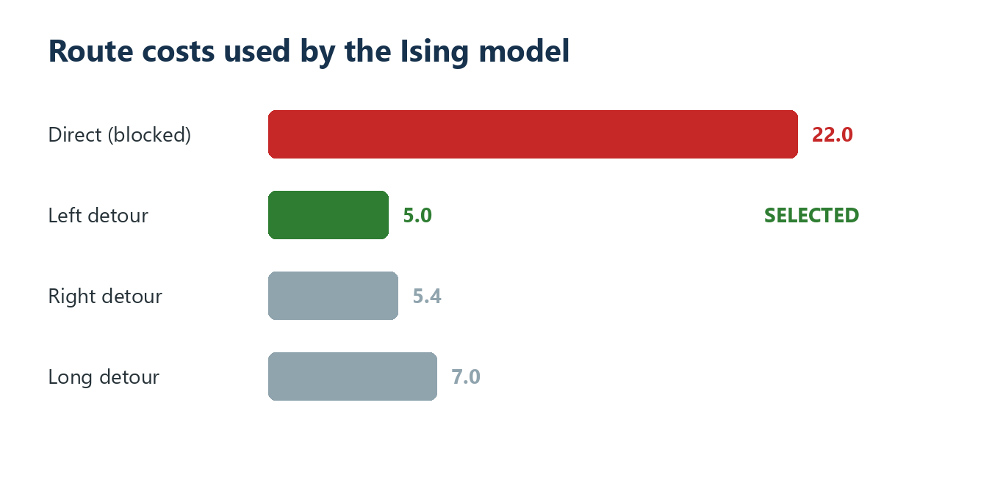
Figure 2. Route costs and the expected minimum-energy selection.

2.2 Direct Ising formulation
One spin represents each route. A spin value of +1 means selected and -1 means not selected. The code uses x=(s+1)/2 and directly creates Ising fields h and couplings J for the following energy:
E = sum(cost_i * x_i) + A * (sum(x_i) - 1)^2
A = 30
The first term prefers low-cost routes. The penalty term makes every state selecting zero or multiple routes expensive. No QUBO matrix is generated and no quantum processor is used.

3. Code-based implementation

3.1 CUDA probabilistic p-bit update
The RawKernel is ordinary CUDA C embedded in Python. One thread processes one replica. It computes the local Ising field and samples the new spin from a sigmoid probability.
float local = h[bit];
for (int j = 0; j < n; j++)
local += J[bit*n + j] * s[r*n + j];
float p_plus = 1.0f / (1.0f + expf(2.0f*beta*local));
s[r*n + bit] = rnd[r] < p_plus ? 1 : -1;

3.2 Population annealing
The solver starts with random spins and increases inverse temperature beta from 0.1 to 5.0 in 40 steps. At each step it performs two p-bit sweeps. Low-energy replicas receive larger Boltzmann weights and are more likely to be copied into the next population. This combines local probabilistic spin updates with population selection.
weights = exp(-(beta - old_beta) * (energy - minimum_energy))
spins = resample(spins, probability=weights)
# 4,096 replicas remain in the population

3.3 Route decoding and robot commands
The final valid replica must contain exactly one +1 spin. Its position selects the route dictionary. The corresponding action letters are translated into conservative velocity commands. The Python program creates a temporary asimov-v0 robot, prints the browser URL, waits for the simulator, executes the actions, sends zero velocity, disconnects, and deletes the temporary robot.
F -> vx=+0.3 m/s for 1.50 s
L -> vyaw=+0.5 rad/s for 3.15 s
R -> vyaw=-0.5 rad/s for 3.15 s
End -> vx=vy=vyaw=0

4. Execution evidence

4.1 Verified CUDA result
The CUDA solver was executed locally on 13 August 2026. The result below is the captured console output, reproduced without changing its values.
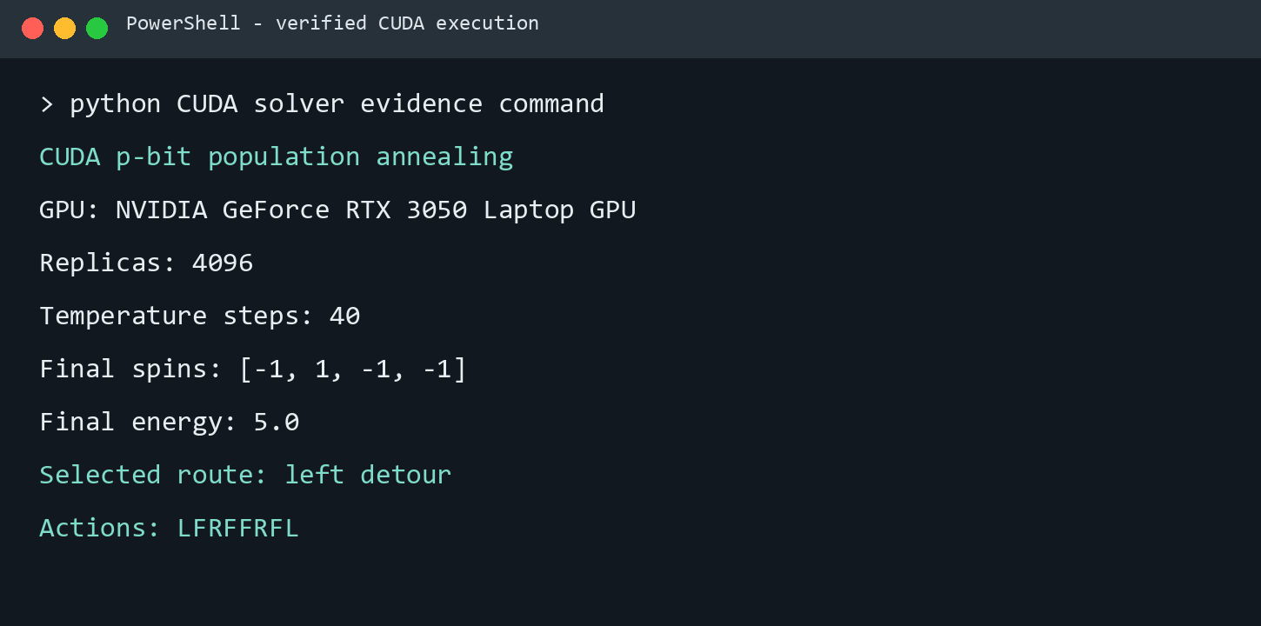
Figure 3. Verified local CUDA execution output.
Observed item | Value
GPU | NVIDIA GeForce RTX 3050 Laptop GPU
Population | 4,096 replicas
Annealing schedule | 40 beta steps, 0.1 to 5.0
Final spins | [-1, 1, -1, -1]
Energy | 5.0
Decoded route | Left detour: LFRFFRFL

4.2 Digital Asimov execution evidence
The decoded LFRFFRFL sequence was replayed in Menlo's live Penalty Shootout guest simulator. Fifty-eight frames were captured and combined into the companion MP4 file digital_asimov_left_detour.mp4. The simulator's command log recorded forward and yaw velocity commands, and live telemetry changed from the reset pose to approximately x=0.7 m, y=-0.1 m, heading=-41 degrees before the final stop command.
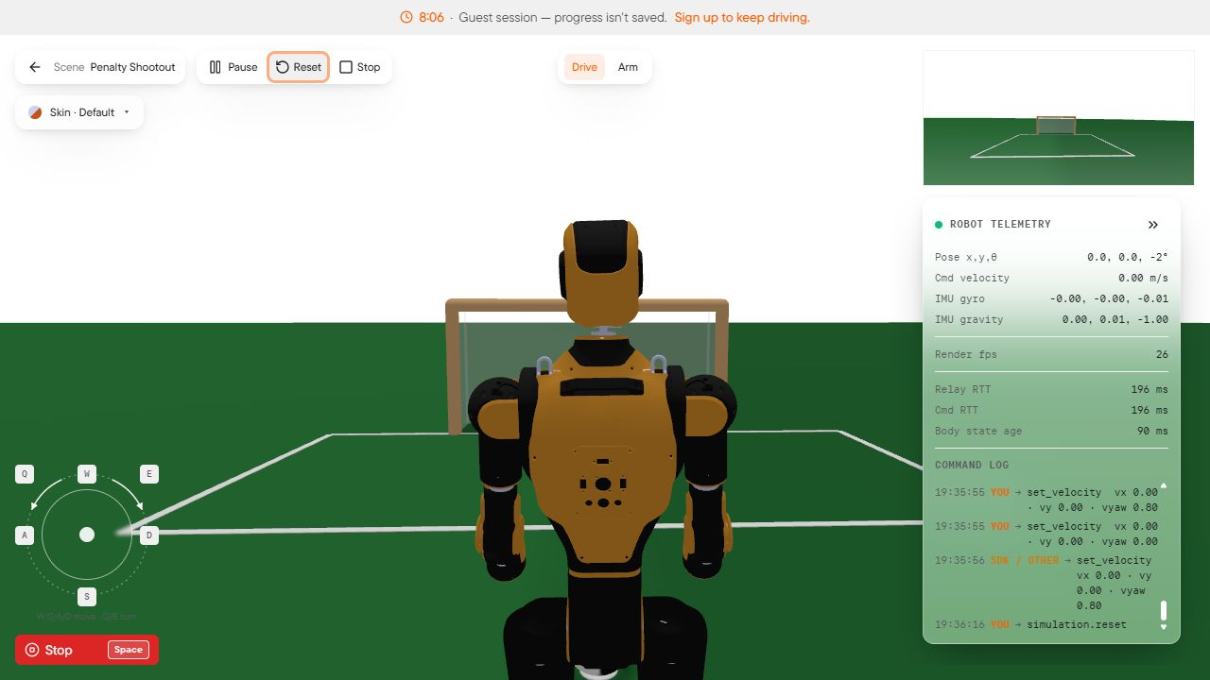 | 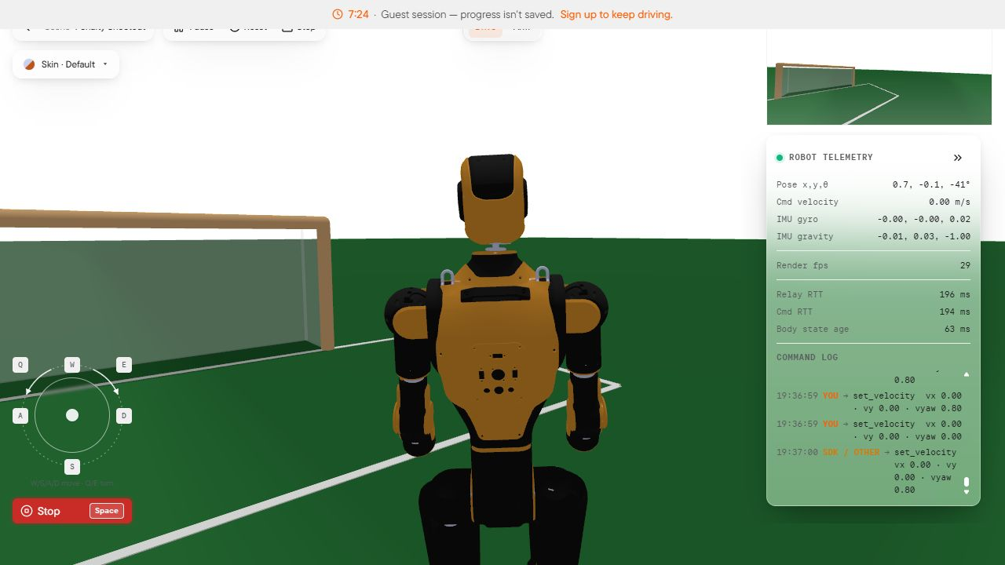
Figure 4. Digital Asimov at reset (left) and after the route replay and stop (right).
Evidence note. The CUDA computation is a verified local program run. The captured robot motion used Menlo's no-account guest controls to replay the same decoded action sequence because MENLO_API_KEY was not available in the execution environment. The supplied main.py performs the same replay through the SDK after the user sets that key.

5. How to run the complete project
- Open PowerShell in the project folder.
cd "C:\Users\SefroyeK\OneDrive\Documents\ChatGPT\CUDA Digital Twin"
- Create and activate a virtual environment, then install the two project dependencies.
python -m venv .venv
.\.venv\Scripts\Activate.ps1
python -m pip install --upgrade pip
python -m pip install -r requirements.txt
- Create a free Menlo API key and set it only in the current PowerShell window.
$env:MENLO_API_KEY="your-key-here"
$env:MENLO_RCS_URL="https://api.menlo.ai/rcs"
- Start the program.
python main.py
- Read the GPU, spins, energy, route, and action string printed in the terminal.
- Open the printed https://sim.menlo.ai/?key=... URL in Chrome within three minutes. The script waits for the simulator, executes the route, stops the robot, and cleans up the temporary robot.

6. Suggested professor demonstration
A short presentation can follow this sequence:
- Show Figure 1 and explain the division of work: CUDA plans; the PPO controller walks.
- Show the four route costs and explain why the direct route is penalized and the left route is preferred.
- Open main.py and point to ROUTES, the RawKernel, solve_route(), and run_robot().
- Run python main.py and point out the detected GPU, the one-hot spin result, energy 5.0, and LFRFFRFL action string.
- Open the generated Digital Asimov URL and let the robot execute. Keep the telemetry and command log visible.
- Finish by stating the limitation: this is open-loop route execution, not obstacle perception or a comparison against standard planners.
One-sentence summary: This project uses thousands of probabilistic Ising replicas on CUDA to select a route, then gives the decoded velocity sequence to a PPO-controlled humanoid digital twin.

7. Limitations and interpretation
- The obstacle is represented only by route cost; it is not rendered or detected by the robot camera.
- The route is open-loop, so accumulated motion error is not corrected with global position feedback.
- The four-route problem is deliberately small and educational; it does not establish a performance advantage over classical shortest-path algorithms.
- PPO locomotion is provided by Menlo. CUDA is used for route optimization, not for training the locomotion policy.
- The Ising model is built directly. QUBO conversion, quantum annealing, D-Wave embedding, and IK decoding are outside this implementation.

References
- Menlo Research, Digital Asimov overview
- Menlo Research, Python SDK quickstart
- Menlo Research, robot control and telemetry
- Menlo Research, reinforcement-learning simulation environment
- Salloum et al., Quantum annealing for inverse kinematics in robotics
- Bernaschi et al., How we are leading a 3-XORSAT challenge
- Barash et al., GPU accelerated population annealing algorithm
- CuPy installation documentation

