Aminudin

312310039

code 1

<!DOCTYPE html>

<html lang="en">

<head>

<meta charset="UTF-8">

<meta name="viewport" content="width=device-width, initial-scale=1.0">

<title>Mengenal JavaScript</title>

</head>

<body>

<h1>Pengenalan JavaScript</h1>

<h3>Contoh document.write dan console.log</h3>

<script>

document.write("Hello World"); console.log("Hello World");

</script>

</body>

</html>

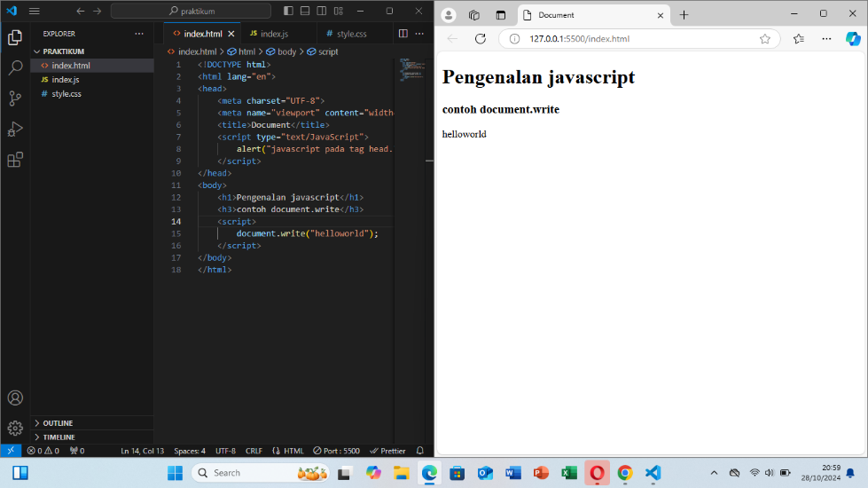

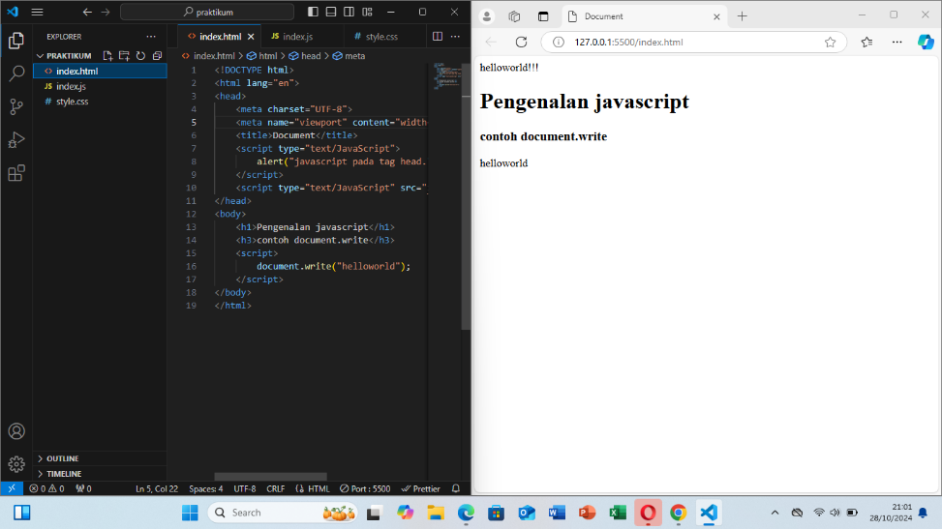

js dasar

pemakaian alert sebagai property window

<!DOCTYPE html>

<html>

<head>

<title>alert box</title>

</head>

<body>

<script language = "javascript">

window.alert("ini merupakan pesan untuk anda");

</script>

</body>

</html>

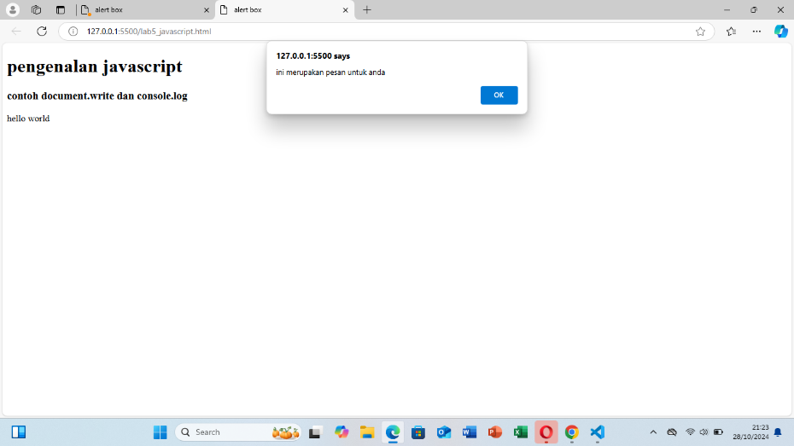

pemakaian method dalanm objek

<!DOCTYPE html>

<html>

<head>

<title>skrip javascript</title>

</head>

<body>

percobaan memakai javascript:<br>

<script language = "javascript">

document.write("selamat mencoba javascript<br>"); document.write("semoga sukses!");

</script>

</body>

</html>

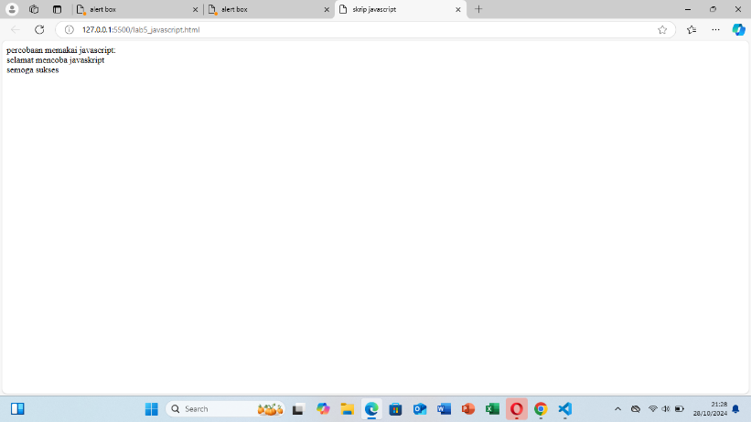

pemakaian prompt

<!DOCTYPE html>

<html>

<head>

<title>pemasukan data</title>

</head>

<body>

<script language = "javascript">

var nama = prompt("siapa nama anda?", "masukkan nama anda"); document.write("hai, " + nama);

</script>

</body>

</html>

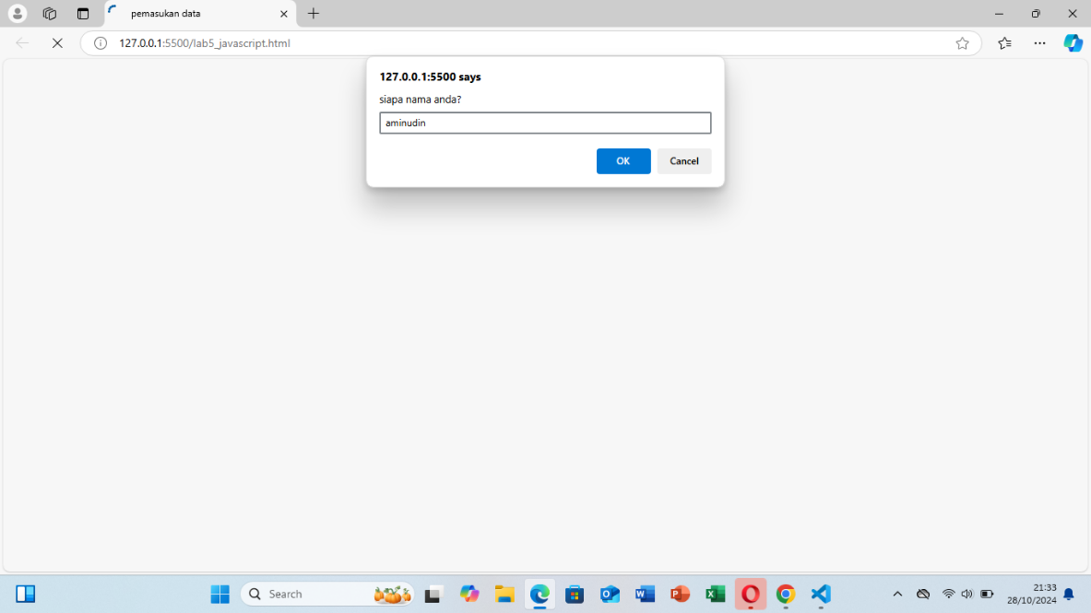

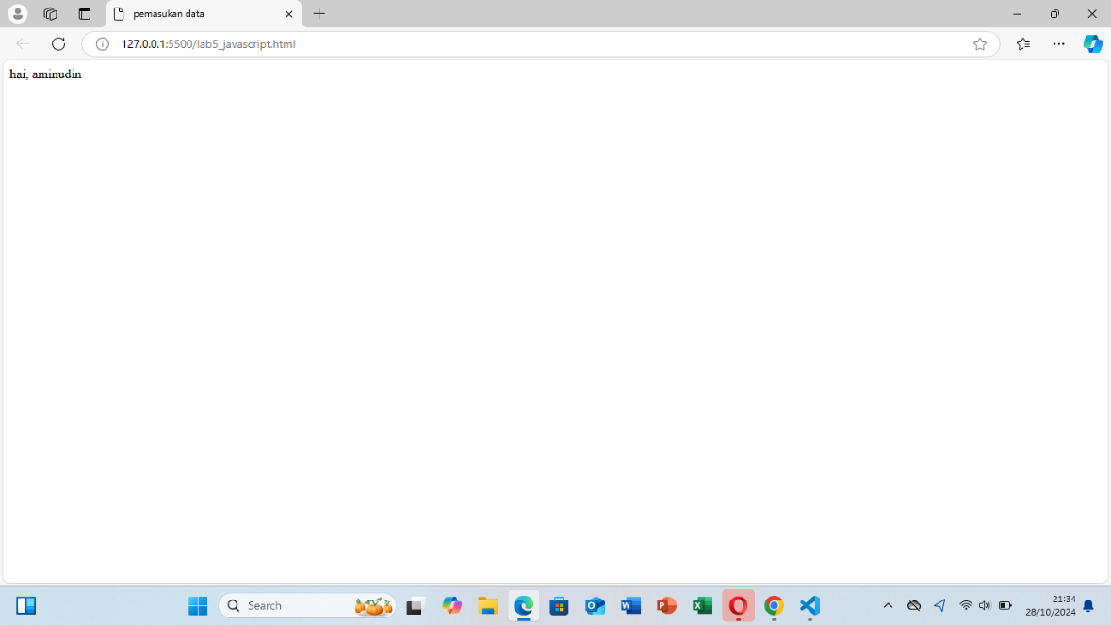

pembuatan fungsi dan cara pemanggilan

<!DOCTYPE html>

<html>

<head>

<title>contoh program Javascript</title>

<script language="javascript">

function pesan () {

alert ("memanggil javascript lewat body onload")

}

</script>

</head>

<body onload=pesan()>

</body>

</html>

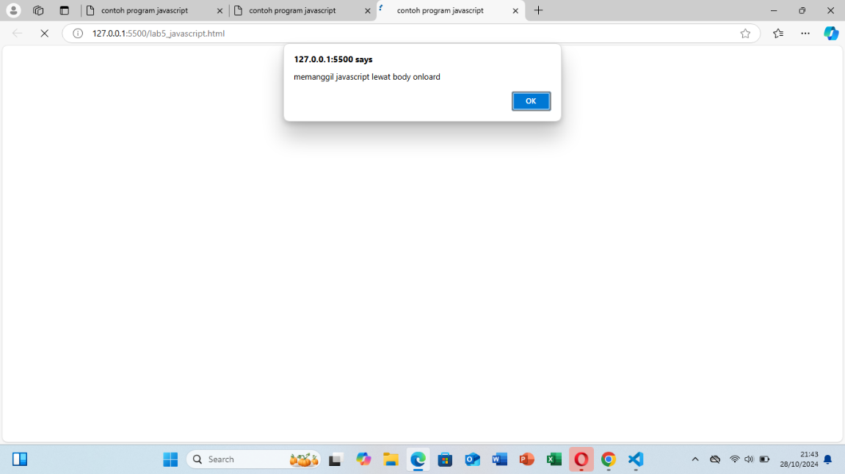

operasi dasar aritmatika

<html>

<head>

<title>contoh program javascript</title>

<script language="javascript"> function test (val1,val2)

{

document.write("<br>"+"perkalian : val1\*val2 "+"<br>")

document.write(val1\*val2)

document.write("<br>"+"pembagian : val1/val2 "+"<br>") document.write(val1/val2)

document.write("<br>"+"penjumlahan : val1+val2 "+"<br>") document.write(val1+val2)

document.write("<br>"+"pengurangan : val1-val2 "+"<br>") document.write(val1-val2)

document.write("<br>"+"modulus : val1%val2 "+"<br>") document.write(val1%val2)

}

</script>

</head>

<body>

<input type="button" name="button1" value="arithmetic" onclick=test(9,4)>

</body>

</html>

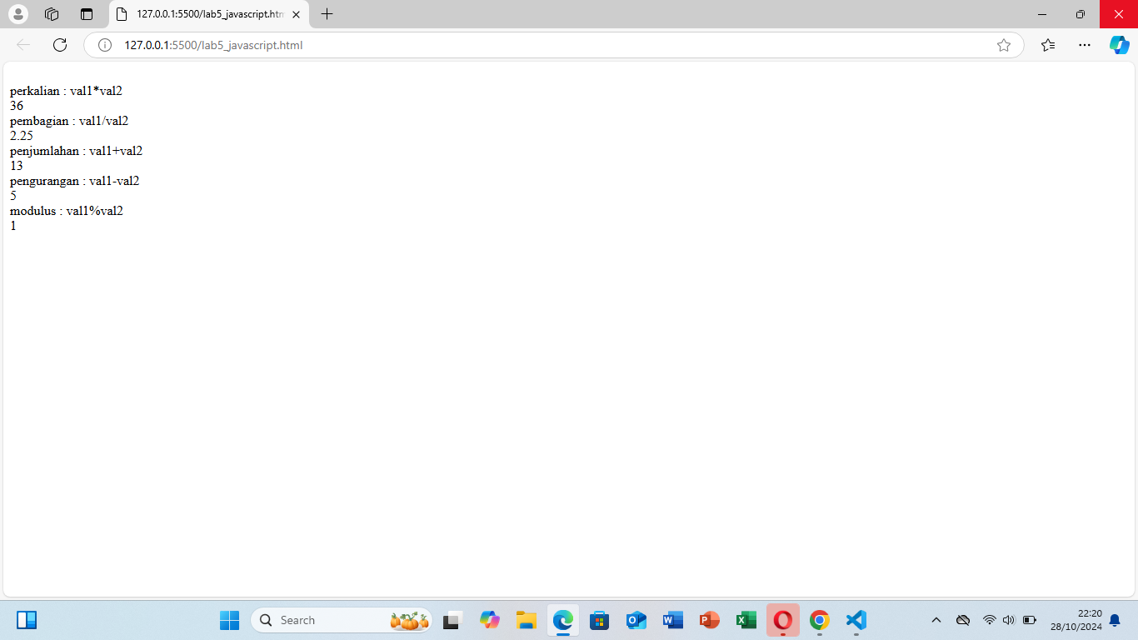

seleksi kondisi if.else

<html>

<head>

<title>contoh if-else</title>

</head>

<body>

<script language = "javascript">

var nilai = prompt("nilai (0-100): ", 0); var hasil = "";

if (nilai >= 60) hasil = "lulus"; else

hasil = "tidak lulus";

document.write("hasil: " + hasil);

</script>

</body>

</html>

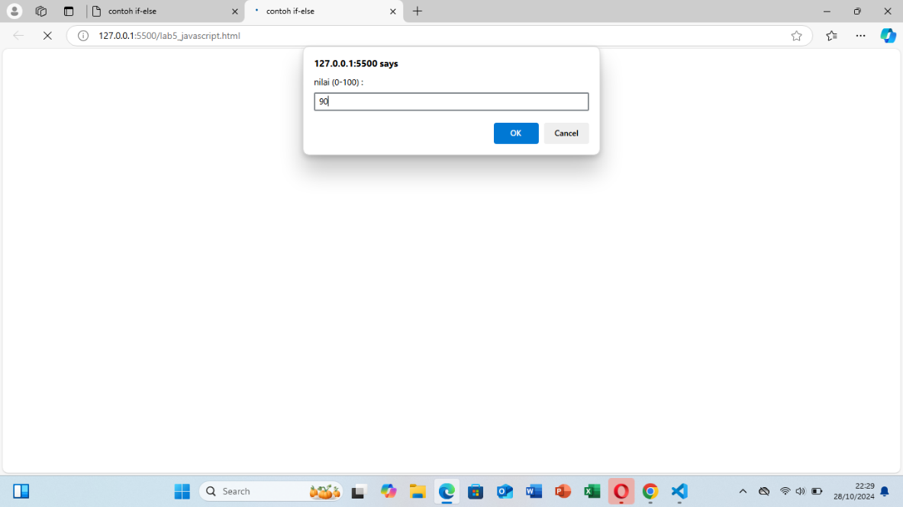

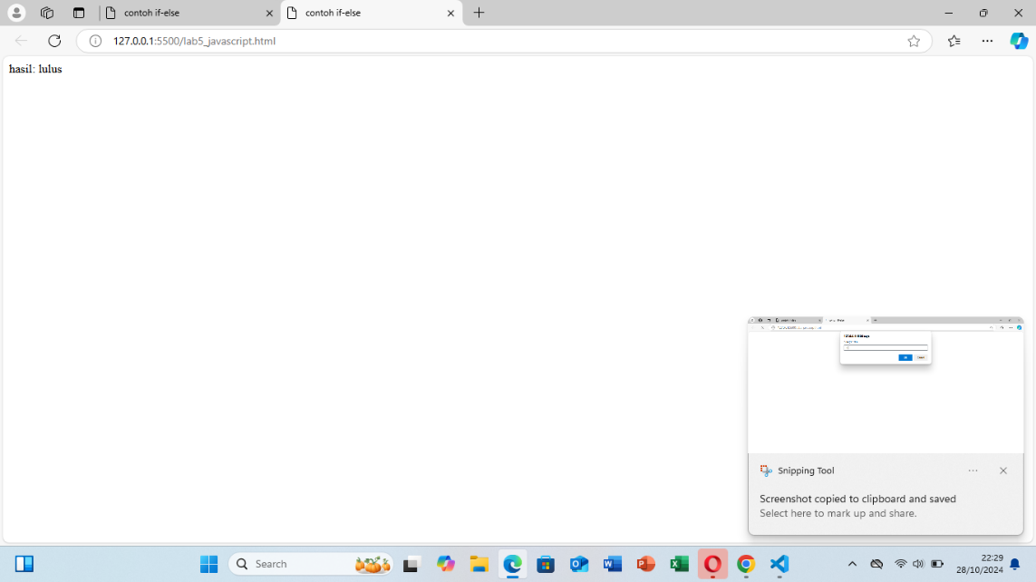

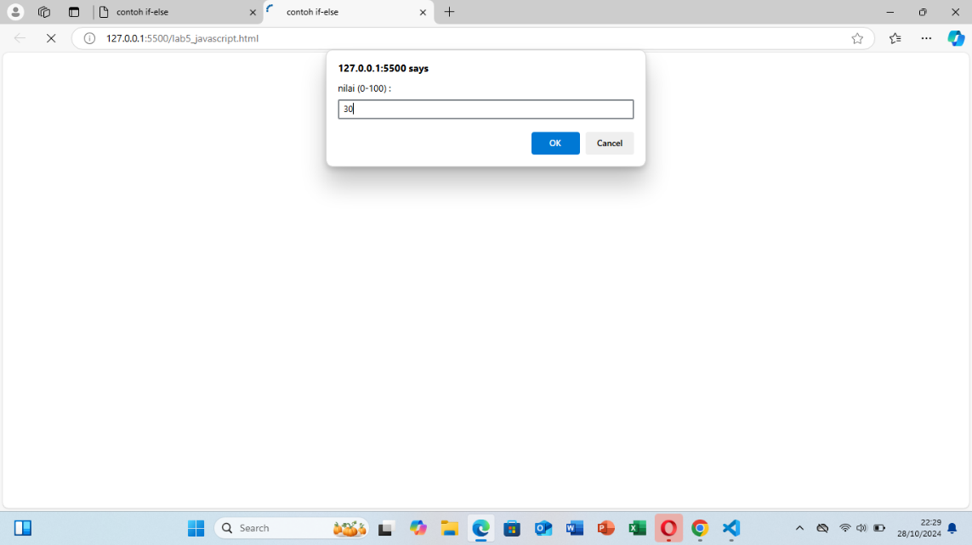

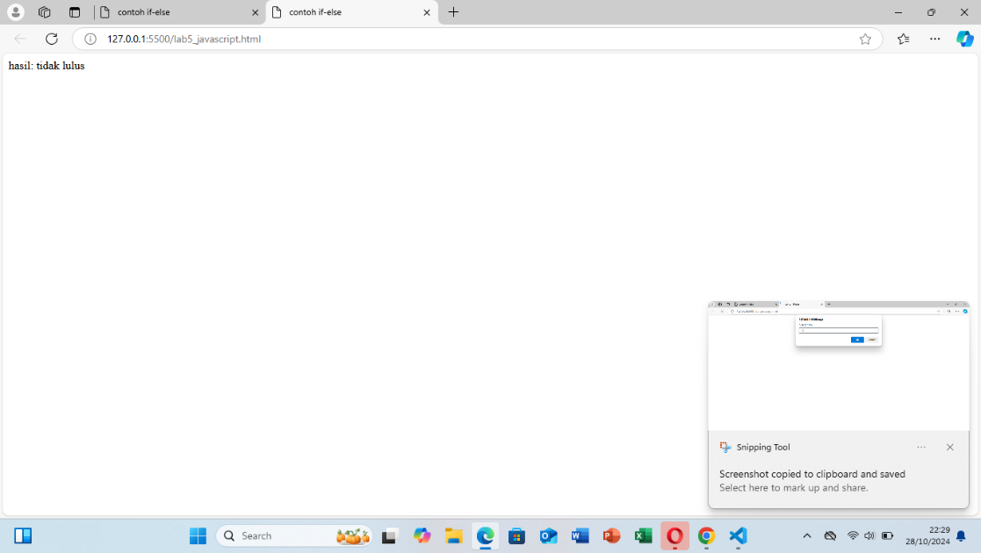

operasi switchutk seleksi kondisi

<html>

<head>

<title>contoh program javascript</title>

<script language="javascript">

function test ()

{

val1=window.prompt("input nilai (1-5): ") switch (val1)

{

case "1" :

document.write("bilangan satu") break

case "2" :

document.write("bilangan dua") break

case "3" :

document.write("bilangan tiga") break

case "4" :

document.write("bilangan empat") break

case "5" :

document.write("bilangan lima") break

default :

document.write("bilangan lainnya")

}

}

</script>

</head>

<body>

<input type="button" name="button1" value="switch" onclick=test()>

</body>

</html>

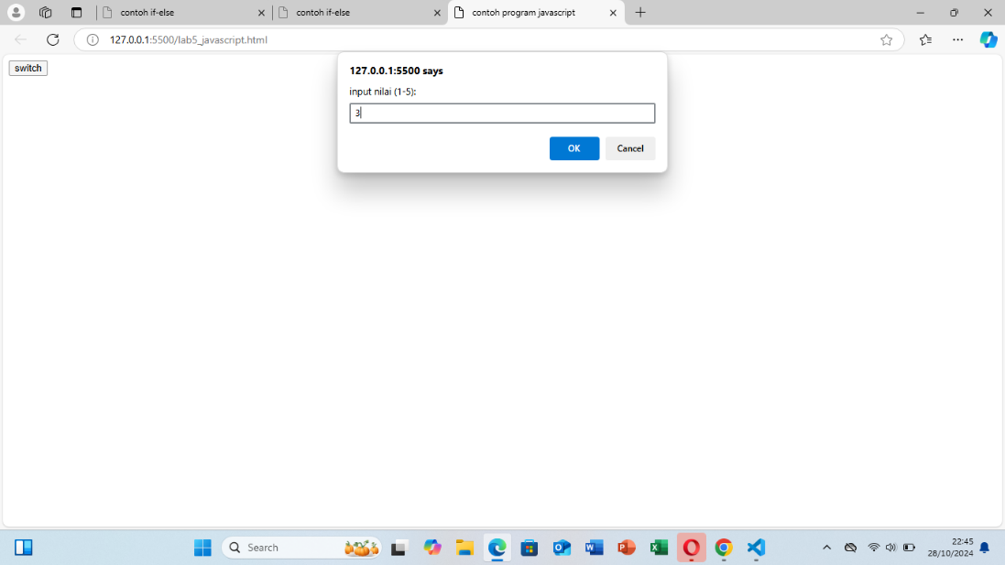

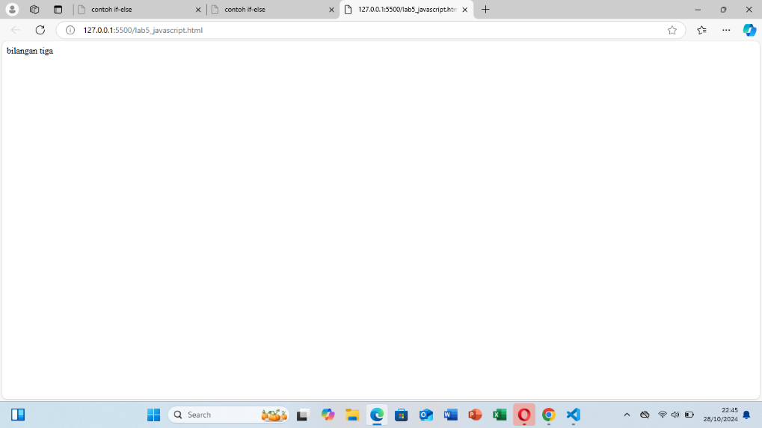

pembuatan form input

<html>

<head>

<script language="javascript"> function test () {

var val1=document.kirim.T1.value if (val1%2==0)

document.kirim.T2.value=" bilangan genap" else

document.kirim.T2.value="bilangan ganjil"

}

</script>

</head>

<body>

<form method="POST" name="kirim">

<p>BIL <input type="text" name="T1" size="20">

MERUPAKAN BIL <input type="text" name="T2" size="20"></p>

<p><input type="button" value="TEBAK" name="B1" onclick=test()></p>

</form>

</body>

</html>

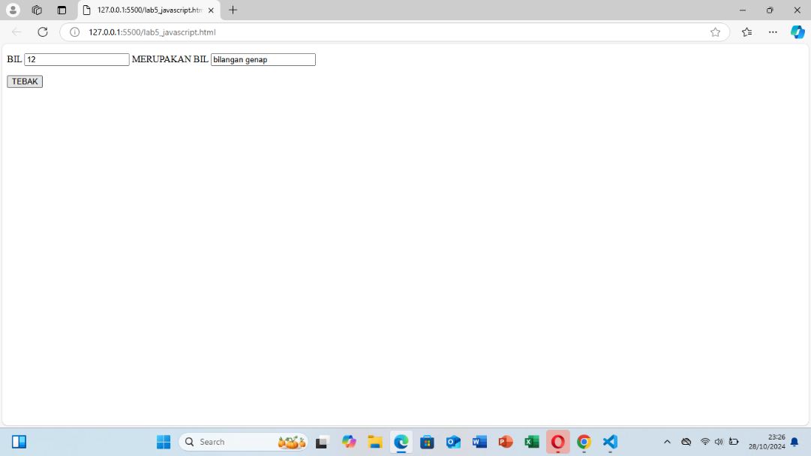

form button

<html>

<head>

<title>objek document</title>

</head>

<body>

<script language = "javascript"> function ubahWarnaLB(warna) {

document.bgColor = warna;

}

function ubahWarnaLD(warna) { document.fgColor = warna;

}

</script>

<h1>test</h1>

<form>

<input type="button" value="Latar Belakang Hijau" onclick="ubahWarnaLB('GREEN')">

<input type="button" value="Latar Belakang Putih" onclick="ubahWarnaLB('WHITE')">

<input type="button" value="Teks Kuning" onclick="ubahWarnaLD('YELLOW')">

<input type="button" value="Teks Biru" onclick="ubahWarnaLD('BLUE')">

</form>

<script language = "javascript">

document.write("Dimodifikasi terakhir pada" + document.lastModified);

</script>

</body>

</html>

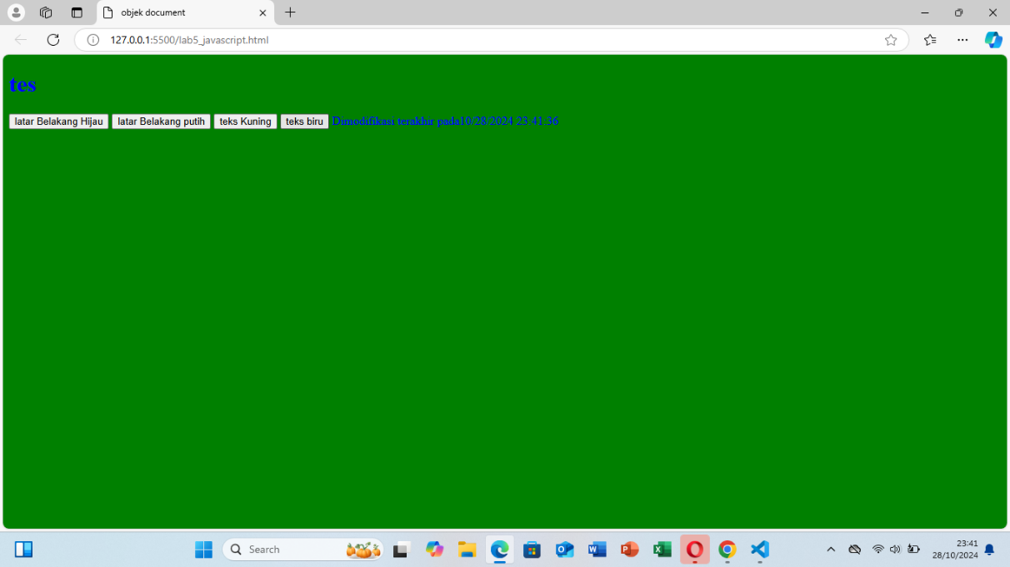

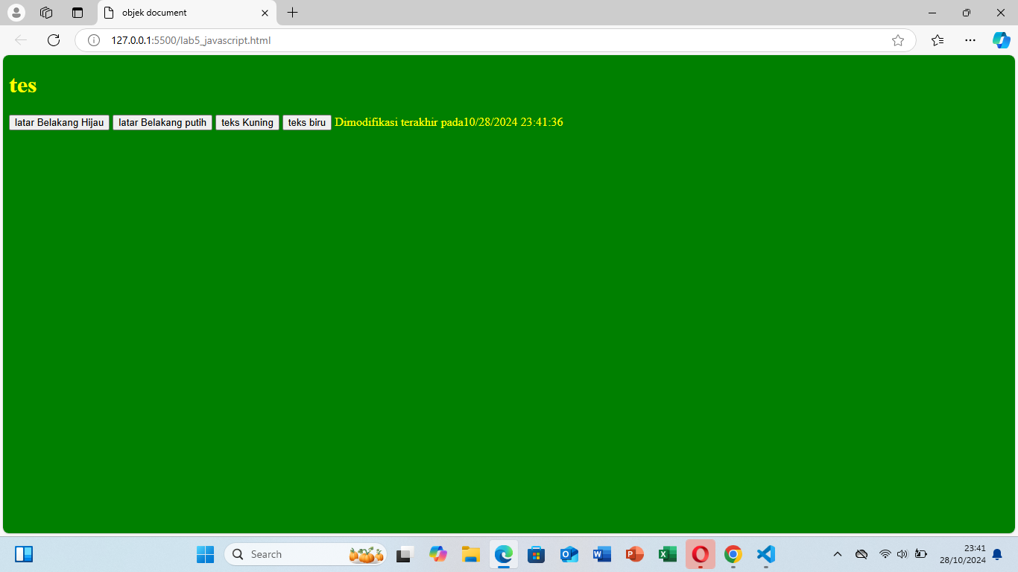

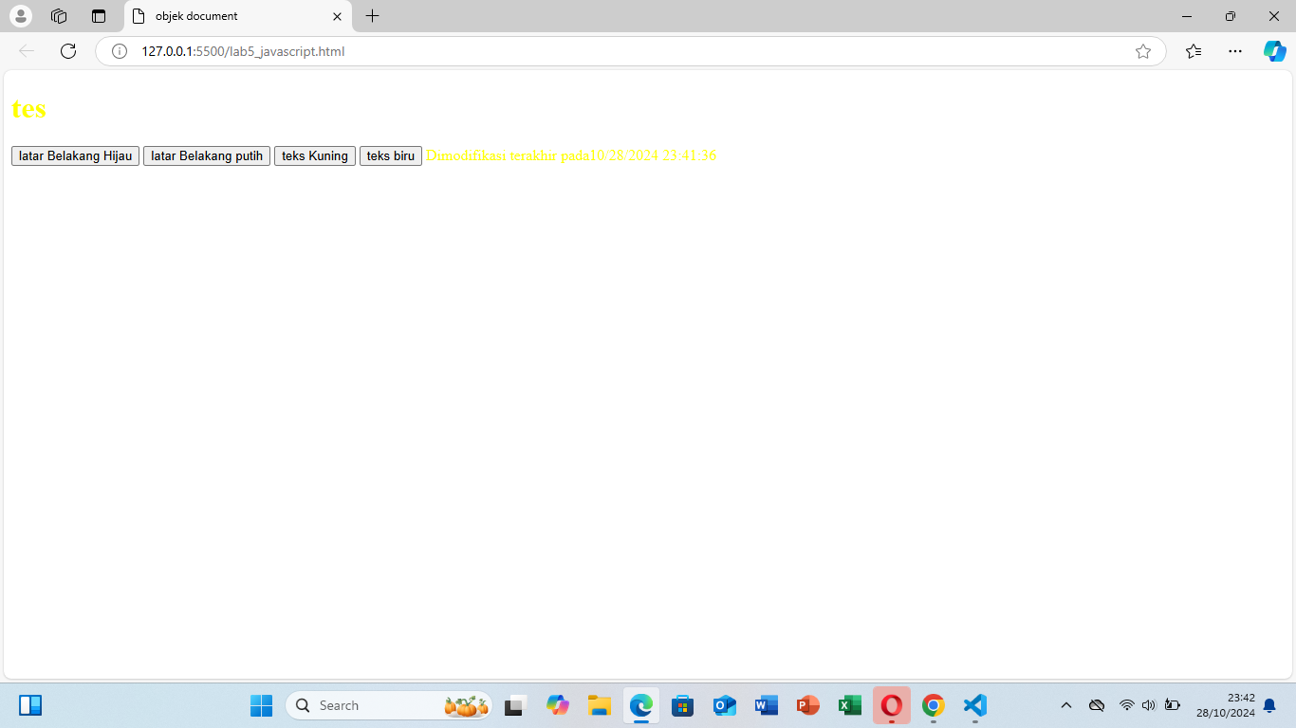

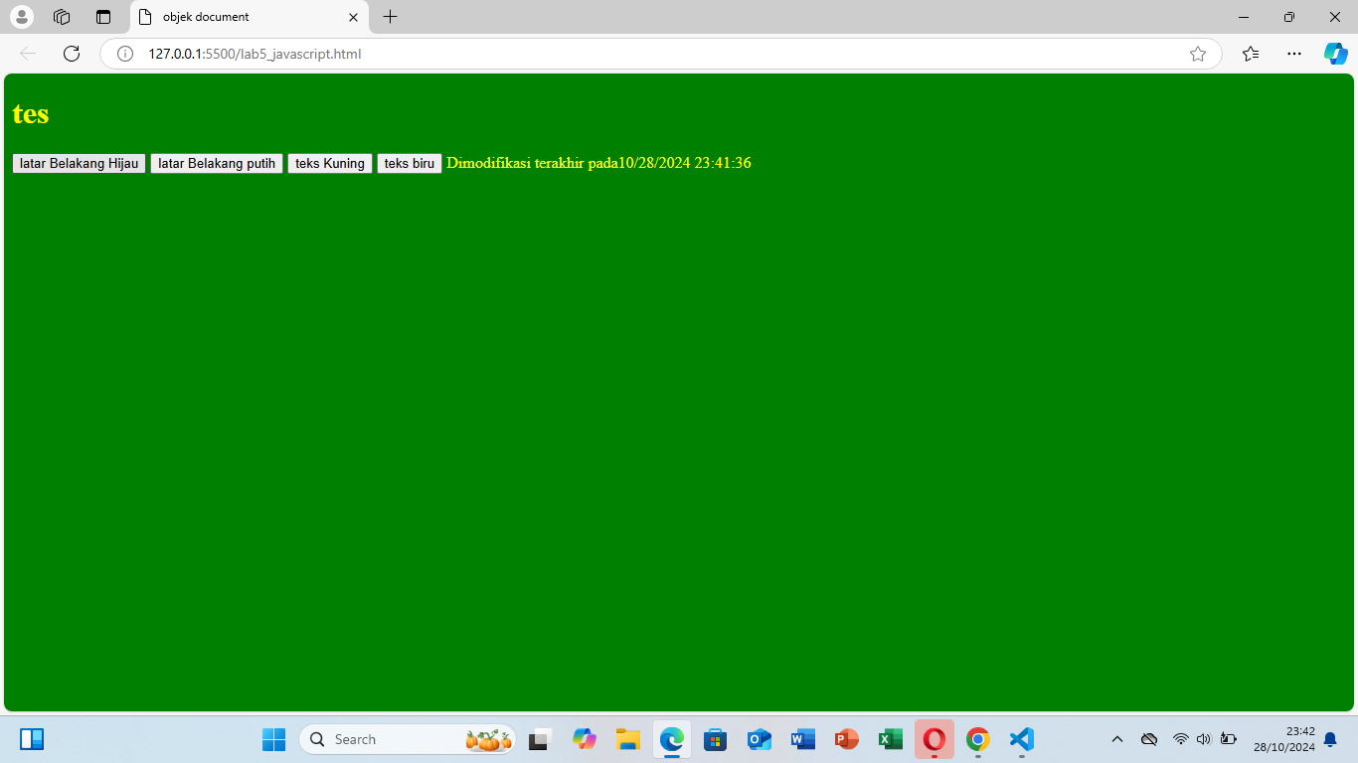

html dom

<!--file : daftar menu.html-->

<html>

<head>

<title>Daftar Menu</title>

<script>

function hitung(ele) {

var total = document.getElementById('total').value; total = (total ? parseInt(total) : 0);

var harga = 0;

if (ele.checked) { harga = ele.value;

total += parseInt(harga);

} else {

harga = ele.value; if (total > 0)

total -= parseInt(harga);

}

document.getElementById('total').value = total;

}

</script>

</head>

<body>

<h1>Daftar Menu Makanan</h1>

<label><input type="checkbox" value="5000" id="menu1" onclick="hitung(this);" /> Ayam Goreng Rp. 5.000</label><br />

<label><input type="checkbox" value="500" id="menu2" onclick="hitung(this);" /> Tempe Goreng Rp. 500</label><br />

<label><input type="checkbox" value="2500" id="menu3" onclick="hitung(this);" /> Telor Dadar Rp. 2.500</label><hr />

<strong>Total Bayar: Rp. <input id="total" type="text"/></strong>

</body>

</html>

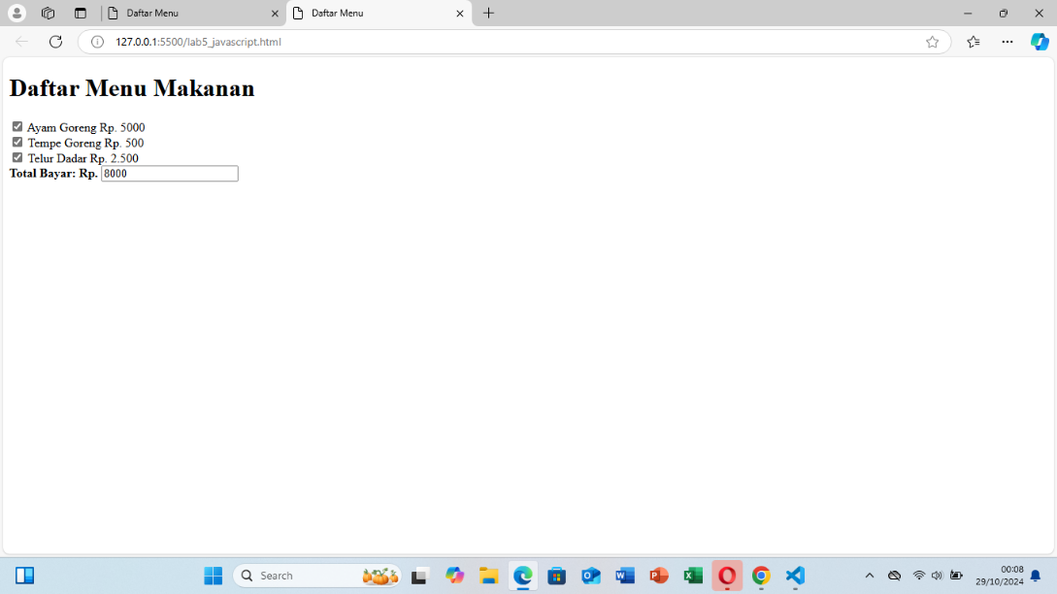

Pertanyaan dan tugas:

script pertanyaan dan tugas validasi form

<!DOCTYPE html>

<html lang="id">

<head>

<meta charset="UTF-8">

<meta name="viewport" content="width=device-width, initial-scale=1.0">

<title>Validasi Form Bilangan Ganjil atau Genap</title>

<style>

.error { color: red; }

</style>

<script language="javascript"> function cekBilangan() {

// Ambil nilai dari input T1

var val1 = document.forms["kirim"]["T1"].value; var hasil = document.forms["kirim"]["T2"];

var errorMessage = document.getElementById("errorMessage");

// Bersihkan pesan kesalahan

errorMessage.textContent = "";

// Pastikan input tidak kosong if (val1 === "") {

errorMessage.textContent = "Harap masukkan bilangan."; hasil.value = ""; // Kosongkan hasil

return false;

}

// Pastikan input adalah angka if (isNaN(val1)) {

errorMessage.textContent = "Input harus berupa angka."; hasil.value = ""; // Kosongkan hasil

return false;

}

// Pastikan angka adalah bilangan bulat

if (!Number.isInteger(parseFloat(val1))) {

errorMessage.textContent = "Harap masukkan bilangan bulat."; hasil.value = ""; // Kosongkan hasil

return false;

}

// Tentukan apakah bilangan genap atau ganjil if (val1 % 2 == 0) {

hasil.value = "Bilangan Genap";

} else {

hasil.value = "Bilangan Ganjil";

}

return true;

}

</script>

</head>

<body>

<h1>Cek Bilangan Ganjil atau Genap</h1>

<form name="kirim" onsubmit="return cekBilangan()">

<p>

Masukkan Bilangan: <input type="text" name="T1" size="20">

</p>

<p>

Hasil: <input type="text" name="T2" size="20" readonly>

</p>

<p class="error" id="errorMessage"></p>

<p>

<input type="button" value="Cek Bilangan" onclick="cekBilangan()">

</p>

</form>

</body>

</html>

