Use Case Diagram:
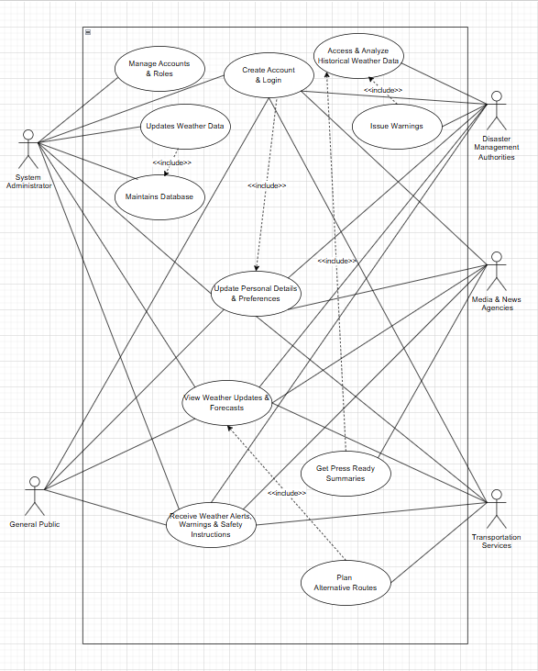

Description:
The use case diagram represents the functional overview of the Weather Forecasting Management System and illustrates the interactions between the system and its key stakeholders. The System Administrator manages user accounts, updates weather data, and maintains the system database to ensure reliable operation. The General Public can view weather updates, forecasts, and receive alerts, warnings, and safety instructions for daily planning. Disaster Management Authorities access and analyze historical weather data and issue warnings during critical situations. Media and News Agencies obtain press-ready summaries to disseminate accurate weather information to the public. Transportation Services use weather forecasts to plan alternative and safer routes.
Overall, the diagram shows how authenticated users interact with the system to access weather information, manage emergencies, and support informed decision-making.

3.2 User Story Table
Table-1
As A/An | I want to | So that | Acceptance Criteria
System Administrator | Create an account | I can access personalized features | Registration form available; fields validated; account created successfully.
 | Login / logout | I can securely access the system | Valid credentials allow login; invalid ones show error; session ends on logout.
 | Reset my password | I can regain access if I forget it. | “Forgot Password” option works; reset link or OTP sent; password updated.
 | Edit my profile | My information stays updated. | Admin can modify name, email, preferences; changes saved.
 | Search for a location | I can view weather data for that place. | Search bar works; location suggestions shown; forecast loads accurately.
 | Manage user accounts | Forecasts remain accurate. | Weather data update panel works; system refreshes data globally.
 | Monitor alert delivery | System errors can be identified. | Alert logs visible; system highlights failed alerts.
 | Backup and restore features | Data safety is ensured. | Automatic/manual backup options; restore functionality operational.
General Public | Create an account | I can access personalized features | Registration form available; fields validated; account created successfully.
 | Login / logout | I can securely access the system | Valid credentials allow login; invalid ones show error; session ends on logout.
 | Reset my password | I can regain access if I forget it. | “Forgot Password” option works; reset link or OTP sent; password updated.
 | Edit my profile | My information stays updated. | General public can modify name, email, preferences; changes saved.
 | Search for a location | I can view weather data for that place. | Search bar works; location suggestions shown; forecast loads accurately.
 | View real-time weather updates | I can plan my day. | Dashboard shows temperature, humidity, wind, precipitation, etc.
 | Check hourly and daily forecasts | I can plan ahead. | Hourly and multi-day forecasts visible; charts/tables displayed properly.
 | Receive severe weather alerts | I stay safe. | Alerts automatically delivered through user’s chosen notification method.
Disaster Management Authority | Create an account | I can access personalized features | Registration form available; fields validated; account created successfully.
 | Login / logout | I can securely access the system | Valid credentials allow login; invalid ones show error; session ends on logout.
 | Reset my password | I can regain access if I forget it. | “Forgot Password” option works; reset link or OTP sent; password updated.
 | Edit my profile | My information stays updated. | Disaster Management Authority can modify name, email, preferences; changes saved.
 | Search for a location | I can view weather data for that place. | Search bar works; location suggestions shown; forecast loads accurately.
 | Issue emergency warnings | The public is informed quickly. | Alert creation panel available; alerts broadcast instantly.
 | Monitor emergency response operations | I can coordinate properly. | Weather severity dashboards and alert logs available.
Media & News Agencies | Create an account | I can access personalized features | Registration form available; fields validated; account created successfully.
 | Login / logout | I can securely access the system | Valid credentials allow login; invalid ones show error; session ends on logout.
 | Reset my password | I can regain access if I forget it. | “Forgot Password” option works; reset link or OTP sent; password updated.
 | Edit my profile | My information stays updated. | Media & News Agencies can modify name, email, preferences; changes saved.
 | Search for a location | I can view weather data for that place. | Search bar works; location suggestions shown; forecast loads accurately.
 | Access to verified forecasts | I can broadcast accurate updates. | Media portal shows real-time verified data.
 | Download reports | I can use them in news broadcasts. | System generates PDF/summary; charts export correctly.
Transportation Services | Create an account | I can access personalized features | Registration form available; fields validated; account created successfully.
 | Login / logout | I can securely access the system | Valid credentials allow login; invalid ones show error; session ends on logout.
 | Reset my password | I can regain access if I forget it. | “Forgot Password” option works; reset link or OTP sent; password updated.
 | Edit my profile | My information stays updated. | Transportation Services can modify name, email, preferences; changes saved.
 | Search for a location | I can view weather data for that place. | Search bar works; location suggestions shown; forecast loads accurately.
 | Access route-based weather insights | I can choose safer routes. | System shows weather hazards along route; suggests alternatives.
 | Access optimized routes | Travel risks are minimized. | System generates alternate routes considering weather hazards.

