# Exploring Router and VLAN security, setting up access lists using Cisco Packet tracer.
- Configure the router and apply ACL rules as follows:-
- 192.168.1.2 deny
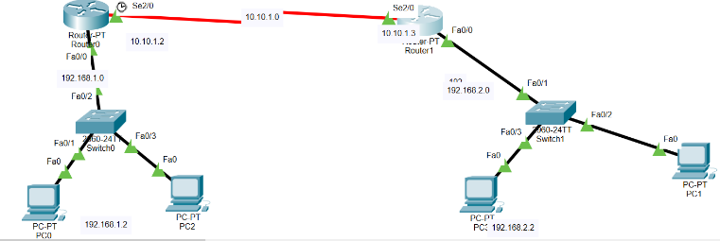
- Permit any

- Configure the router and apply ACL rules as follows:-
- Deny the host 192.168.1.1 with the network 192.168.2.0
- Deny the host 192.168.1.2 with the network 192.168.2.0
- Deny the host 192.168.3.0 with the network 192.168.2.0
- Permit all the remaining traffic
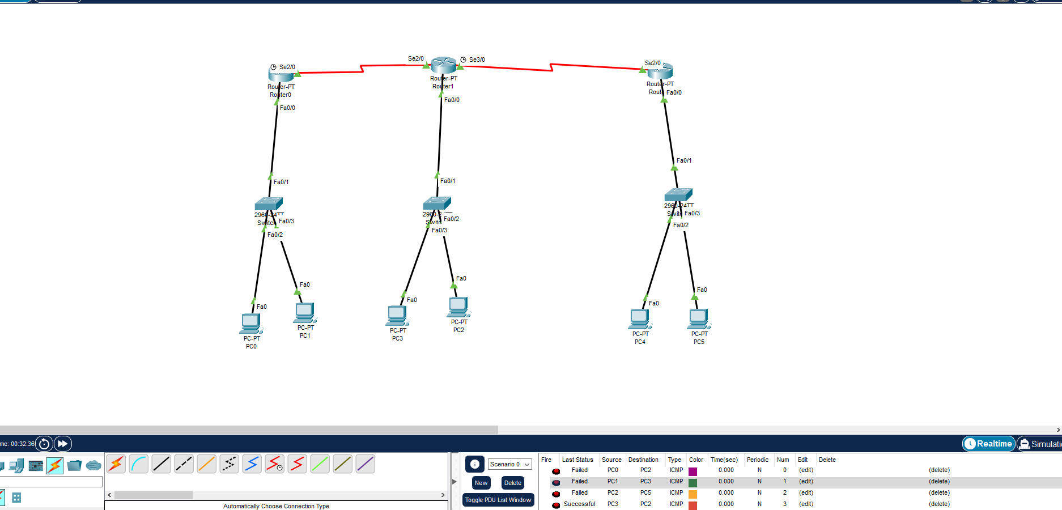

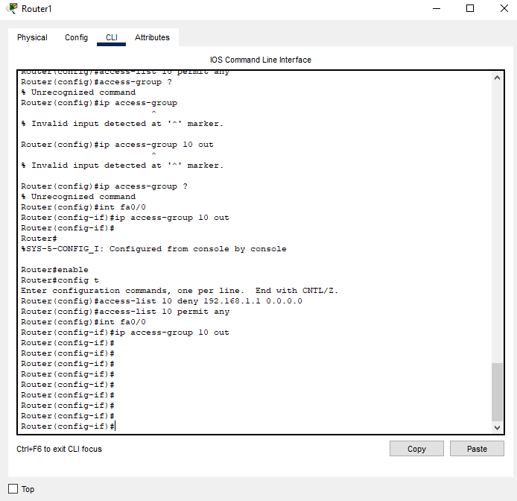
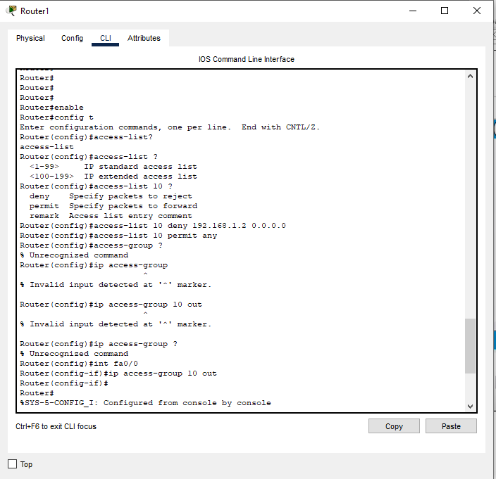
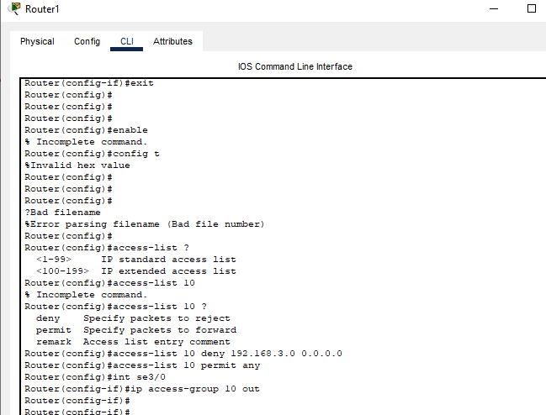

Device Name | Interface Name | IP Address
Router 0 | Serial 0/0/0 | 202.70.91.253/30
 | Serial 0/0/1 | 202.70.91.249/30
 | Gig 0/0 | 202.70.91.1/28
Router 1 | Serial 0/0/0 | 202.70.91.254/30
 | Serial 0/0/1 | 202.70.91.241/30
 | Gig 0/0 | 202.70.91.17/25
Router 2 | Serial 0/0/0 | 202.70.91.250/30
 | Serial 0/0/1 | 202.70.91.242/30
 | Gig 0/0 | 202.70.91.145/26
 | Gig 0/1 | 202.70.91.209/28
Server 0-3 | Server port | 202.70.91.2-4/28
Laptop 0 | Client port | 202.70.91.5/28
PC3 | Client port | 202.70.91.18/25
Laptop 2-3 | Client port | 202.70.91.19-20/25
PC1 | Client port | 202.70.91.146/26
PC2 | Client port | 202.70.91.147/26
Laptop-1 | Client port | 202.70.91.148/26
PC4 | Client port | 202.70.91.210/29
Laptop-4 | Client port | 202.70.91.211/29
PC5 | Client port | 202.70.91.212/29
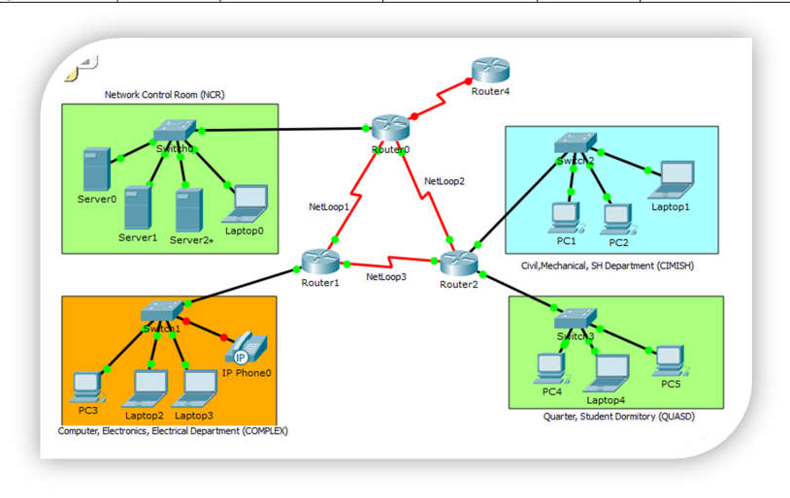

On Router-0, create the following ACL  Enable. vbbbbb vb conf ter  ip access-list standard 10 deny 202.70.91.16 0.0.0.127  deny 202.70.91.208 0.0.0.7  permit any ctrl+Z  wr | On Router-1, create the following ACL  enable conf ter  ip access-list standard complex deny host 202.70.91.150 permit any  ctrl+z wr
On Router-0, create the following ACL | After creating those ACLs, now test the connectivity as
enable | per the requirements (the ACL has not yet been applied)
conf ter
ip access-list standard 20 | Ping test from pc3 to server 0
deny 202.70.91.0 0.0.0.15 | PC>ping 202.70.91.2
deny 202.70.91.16 0.0.0.127 | Pinging 202.70.91.2 with 32 bytes of data:
deny 202.70.91.128 0.0.0.63 | Reply from 202.70.91.2: bytes=32 time=10ms TTL=126
permit any | Reply from 202.70.91.2: bytes=32 time=1ms TTL=126
exit | Reply from 202.70.91.2: bytes=32 time=1ms TTL=126
ip access-list standard cimish | Reply from 202.70.91.2: bytes=32 time=1ms TTL=12
deny host 202.70.91.146
deny 202.70.91.0 0.0.0.127
permit any ctrl+z
wr
Ping test from pc1 to server0  PC>ping 202.70.91.2  Pinging 202.70.91.2 with 32 bytes of data:  Reply from 202.70.91.2: bytes=32 time=2ms TTL=126 Reply from 202.70.91.2: bytes=32 time=1ms TTL=126 Reply from 202.70.91.2: bytes=32 time=1ms TTL=126 Reply from 202.70.91.2: bytes=32 time=1ms TTL=126 | Ping test from pc4 to server0  PC>ping 202.70.91.2  Pinging 202.70.91.2 with 32 bytes of data:  Reply from 202.70.91.2: bytes=32 time=2ms TTL=126 Reply from 202.70.91.2: bytes=32 time=1ms TTL=126 Reply from 202.70.91.2: bytes=32 time=1ms TTL=126 Reply from 202.70.91.2: bytes=32 time=1ms TTL=126
Ping test from pc3 to pc4  PC>ping 202.70.91.210  Pinging 202.70.91.210 with 32 bytes of data:  Reply from 202.70.91.210: bytes=32 time=1ms TTL=126 Reply from 202.70.91.210: bytes=32 time=1ms TTL=126 Reply from 202.70.91.210: bytes=32 time=1ms TTL=126 Reply from 202.70.91.210: bytes=32 time=1ms TTL=126 | Ping test from pc1 to pc3  PC>ping 202.70.91.18  Pinging 202.70.91.18 with 32 bytes of data:  Reply from 202.70.91.18: bytes=32 time=2ms TTL=126 Reply from 202.70.91.18: bytes=32 time=1ms TTL=126 Reply from 202.70.91.18: bytes=32 time=2ms TTL=126 Reply from 202.70.91.18: bytes=32 time=1ms TTL=126

Now apply the ACL in to the corresponding interfaces with inbound and outbound settings.
On router 0, in configuration mode, issue the following acl
int gig 0/0
ip access-group 10 out

On router-1, in configuration mode, issue the following acl
int gig 0/0
ip access-group complex out

On router-2, in configuration mode, issue the following acl
int gig 0/0
ip access-group cimish in exit
int gig 0/1
ip access-group 20 out ctrl+z
wr

