DISEASE DETECTION SYSTEM USING MACHINE LEARNING

Project Report

Submitted By
Name | CMS-ID
Amir Khan | 023-24-0166
Simran | 023-24-0192
Sajid Ali | 023-24-0169

1. Introduction
Healthcare is one of the most important sectors where technology can help improve decision-making and early diagnosis. Many diseases share similar symptoms, making it difficult for individuals to identify possible illnesses without professional consultation.
The Disease Detection System is a Machine Learning-based application that predicts potential diseases based on symptoms entered by the user. The system uses supervised and unsupervised learning techniques to analyze symptom patterns and provide disease predictions along with health advice.
The project demonstrates the practical application of Artificial Intelligence and Machine Learning in the healthcare domain.

2. Problem Statement
People often ignore symptoms or are unable to identify possible diseases at an early stage. Access to medical professionals may also be limited in some situations.
The problem addressed by this project is:
“How can Machine Learning be used to predict possible diseases from user-provided symptoms and provide preliminary health guidance?”

3. Objectives
The main objectives of the project are:
- To collect symptom data and create a disease prediction dataset.
- To train a Machine Learning model for disease classification.
- To predict possible diseases based on user symptoms.
- To provide health advice based on prediction results.
- To visualize disease patterns using Machine Learning techniques.
- To demonstrate supervised and unsupervised learning concepts in a real-world application.

4. Project Overview
The Disease Detection System allows users to:
- Enter symptoms through a web interface.
- Process symptom information using Machine Learning algorithms.
- Predict possible diseases.
- Display prediction confidence scores.
- Provide medical guidance and recommendations.
- Visualize disease clusters and classification results.
The system combines:
- Decision Tree Classification
- K-Means Clustering
- Principal Component Analysis (PCA)
- Data Visualization Techniques

5. System Features

Functional Features
- Symptom-based disease prediction
- Disease probability calculation
- Health advice generation
- Risk severity estimation
- Disease clustering
- Dataset generation
- Performance evaluation
- Interactive web interface

Machine Learning Features
- Supervised Learning
- Unsupervised Learning
- Classification
- Clustering
- Data Visualization

6. Technology Stack

Programming Language
- Python

Frontend
- HTML
- CSS
- JavaScript

Backend
- Python HTTP Server

Libraries Used
- NumPy
- Pandas
- Scikit-Learn
- Matplotlib

Machine Learning Algorithms
- Decision Tree Classifier
- K-Means Clustering
- PCA (Principal Component Analysis)

7. System Architecture
User Interface (HTML/CSS/JS)
↓
Python Backend Server
↓
Machine Learning Engine
↓
Disease Prediction Module
↓
Result Generation
↓
Advice & Severity Analysis

8. Dataset Design
The project uses symptom-based records.

Symptoms Included
- Fever
- Headache
- Vomiting
- Chills
- Cough
- Fatigue
- Body Pain
- Rash
- Sore Throat

Diseases Included
- Malaria
- Dengue
- Viral Fever
- Flu
- Common Cold
- Typhoid
- Healthy

9. Machine Learning Methodology

9.1 Supervised Learning
A Decision Tree Classifier is trained using symptom data.

Steps
- Dataset creation
- Data preprocessing
- Training/Test split
- Model training
- Prediction
- Accuracy evaluation

9.2 Unsupervised Learning
K-Means Clustering groups similar disease patterns.

Purpose
- Discover hidden symptom relationships
- Visualize disease groups
- Analyze patient similarity

9.3 PCA Visualization
Principal Component Analysis is used to reduce dimensions and visualize disease clusters in a two-dimensional space.

10. System Workflow
- User selects symptoms.
- Input is converted into feature vectors.
- Trained model processes the input.
- Disease probabilities are calculated.
- Most likely disease is selected.
- Severity level is determined.
- Health advice is displayed.
- Results are shown to the user.

11. Output Screens

Screen 1
Home Page
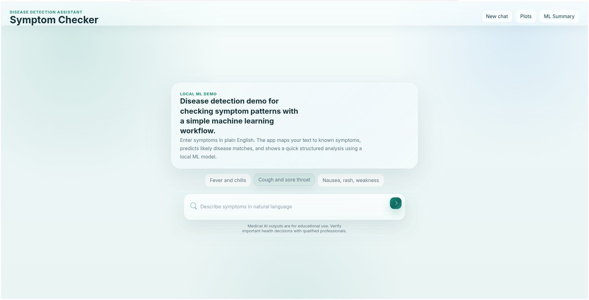

Screen 2
Symptom Selection Page
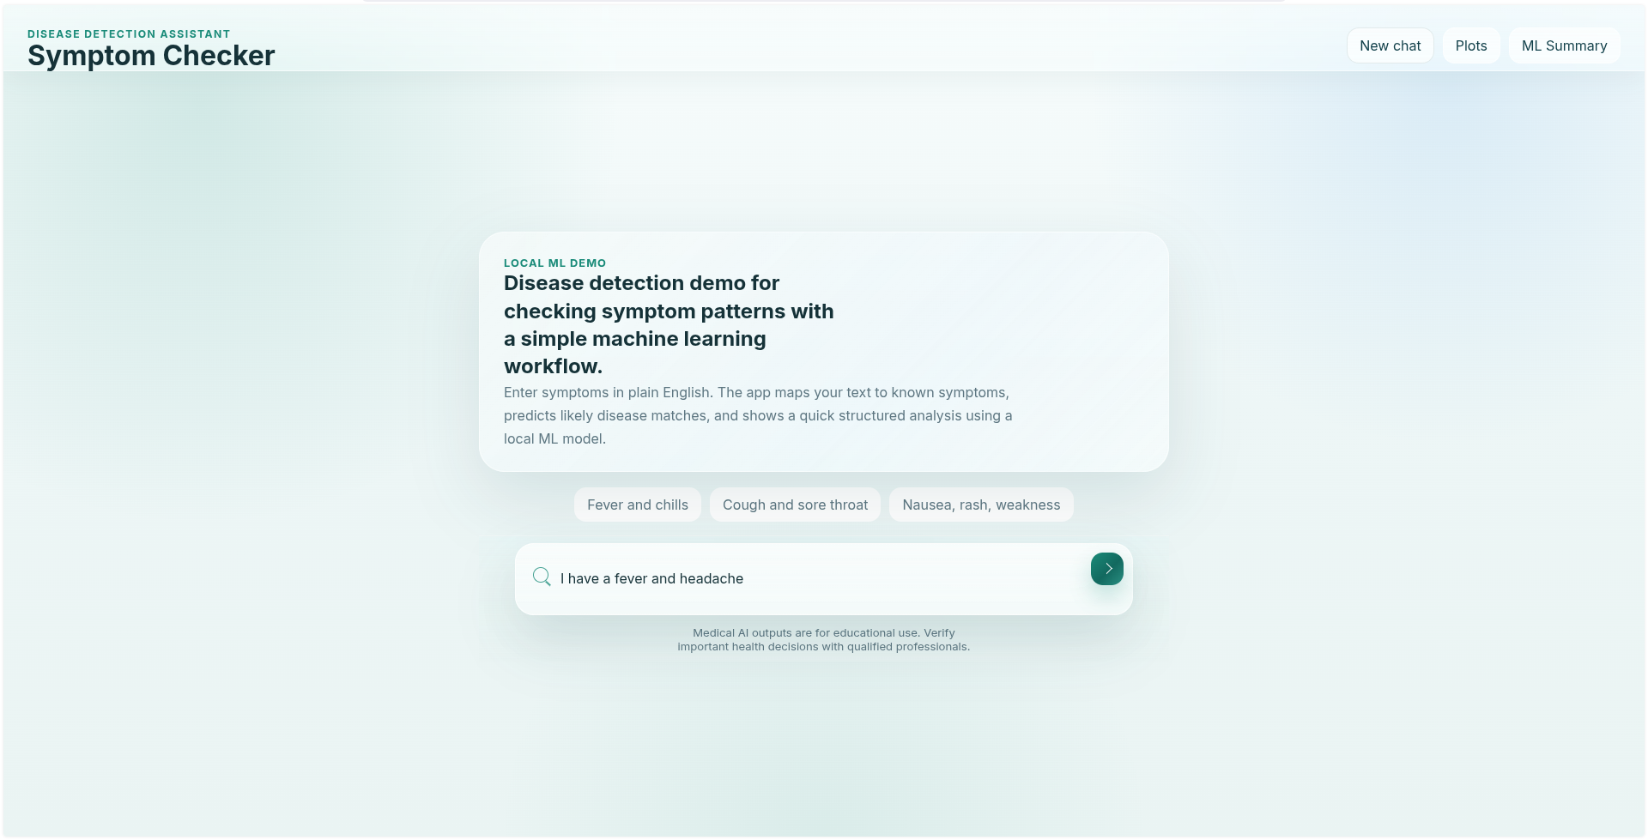

Screen 3
Disease Prediction Result
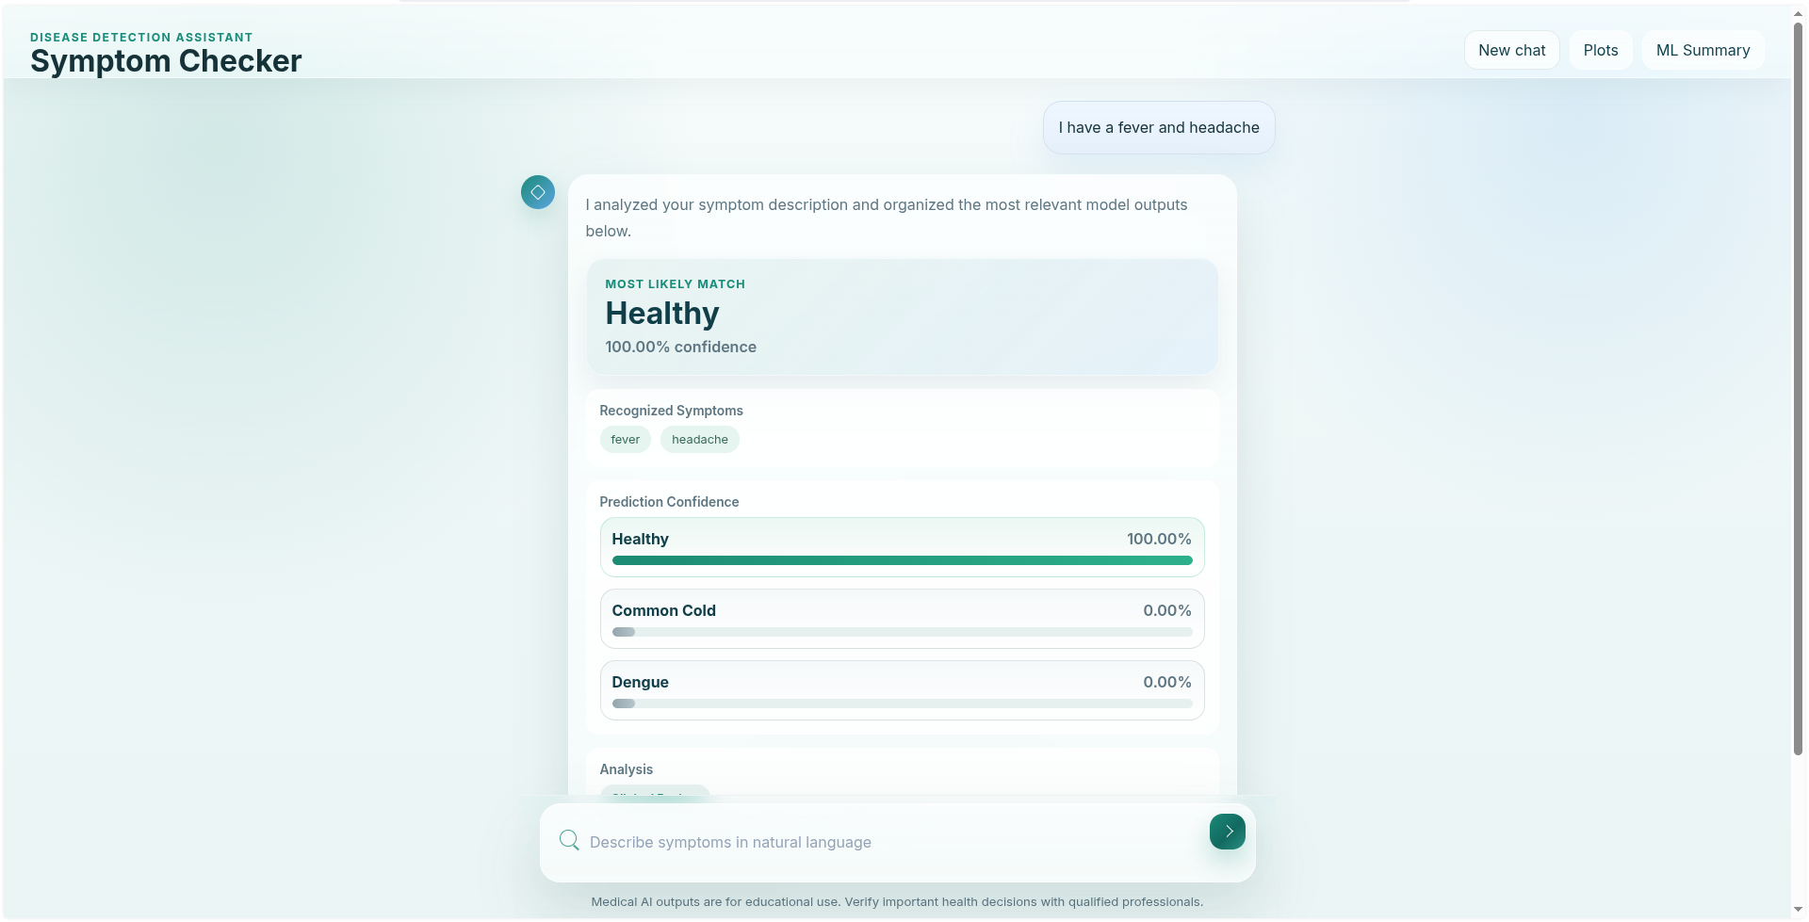

Screen 4
Cluster Visualization
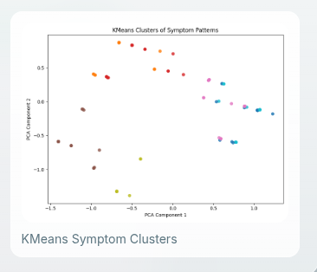

Screen 5
Confusion Matrix
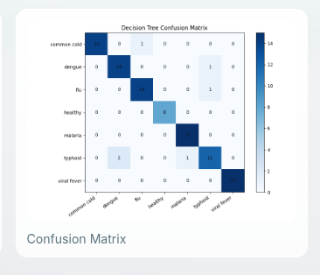

12. Performance Analysis
The project evaluates the Machine Learning model using:
- Accuracy Score
- Confusion Matrix
- Classification Results
- Cluster Analysis
These metrics help determine how effectively the system predicts diseases from symptoms.

13. Advantages
- Fast disease prediction
- User-friendly interface
- Supports healthcare awareness
- Demonstrates Machine Learning concepts
- Easy to extend with new diseases
- Useful educational project

14. Limitations
- Uses a limited dataset
- Cannot replace professional medical diagnosis
- Prediction accuracy depends on dataset quality
- Requires additional real-world medical data for production use

15. Future Enhancements
Future versions may include:
- Larger medical datasets
- Deep Learning models
- Real-time hospital integration
- Patient history management
- Mobile application support
- Cloud deployment
- Doctor recommendation system
- Multi-language support

16. Conclusion
The Disease Detection System successfully demonstrates the use of Machine Learning techniques for symptom-based disease prediction. By utilizing Decision Tree Classification, K-Means Clustering, and PCA visualization, the system provides disease predictions, health recommendations, and analytical insights.
The project highlights how Artificial Intelligence can assist in healthcare applications and serves as a practical example of Machine Learning implementation in disease diagnosis systems.

References
- Scikit-Learn Documentation
- NumPy Documentation
- Pandas Documentation
- Matplotlib Documentation
- Machine Learning Research Articles
- Healthcare Data Analysis Resources
Submitted By:
- Amir Khan
- Simran
- Sajid Ali

