First textbox to enter regular expression

And get first 10 random strings match this regular expression

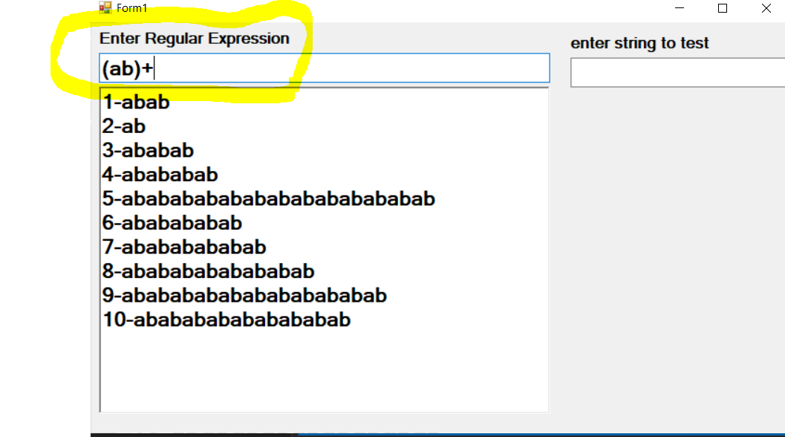

Second textbox to enter string

And check if this string match regular expression or not

