**Assumption for this model**

In this specific model, I’m assuming the spinning object is on the same plane that is determined by the vertical axis and the spinning axis of the object.

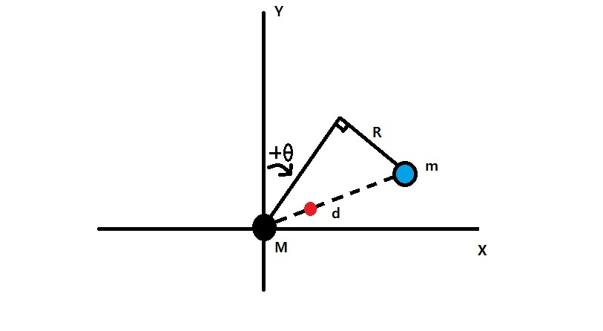

**Definitions**

X: the horizontal axis

Y: the vertical axis

Black ball: the main body of the quadcopter

M: the mass of the quadcopter

Blue ball: the spinning object

m: the mass of the spinning object

Red ball: the location of the overall center of mass

R: the radius of the spinning object

d: the distance between the quadcopter and the spinning object

θ: the pitching angle

g: the gravity constant (not shown on the figure)

Q: the ratio between the thrust and the gravity (not shown on the figure)

**Deriving the moment of inertia**



We need to derive the moment of inertia first so that we can use it to describe its rotational motion later.

The rotating center will be the overall center of mass, which is the red ball position as it’s mentioned in the definition section earlier.

By the definition of the moment of inertia

$I=M({d1)}^{2}+m{(d2)}^{2}$ (1)

We also defined earlier that

$$d=d1+d2$$

By the definition of the center of mass location

$d1=\frac{md}{M+m}$ (2)

$d2=\frac{Md}{M+m}$ (3)

Plug (2) and (3) into (1), we will get

|  |
| --- |
| **<<** The Moment of Inertia **>> $$I=\frac{Mm}{M+m}d^{2}$$** |

**Deriving the net force**

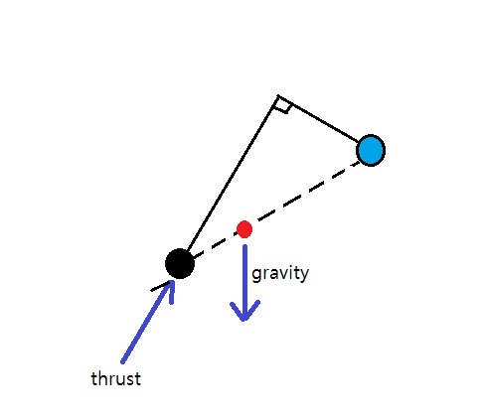

There are two major forces --- gravity and thrust.

$$Fnet=Fgravity+Fthrust$$

$$Fnet=\left[\begin{matrix}0 \\ -1 \\ 0\end{matrix}\right]\left(M+m\right)g+\left[\begin{matrix}\sin{θ} \\ \cos{θ} \\ 0\end{matrix}\right]\left(M+m\right)gQ$$

Simplify the equation to get

|  |
| --- |
| **<<** The Net Force **>> $$Fnet=\left[\begin{matrix}Q\sin{θ} \\ Q\cos{θ}-1 \\ 0\end{matrix}\right]\left(M+m\right)g$$** |

**Deriving the net torque**

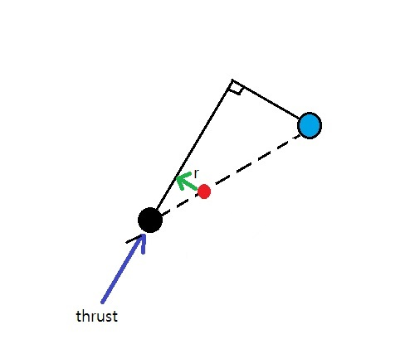

Again, we still consider two major forces, the gravity and the thrust.

However, the gravity is applied right on the center of mass, so it won’t introduce any torque into the system.

So the only force that generates torque is the thrust.

Suppose “r” in the figure is the direction vector that is orthogonal to the spinning axis(this is the axis for the spinning object not the rotating axis for the torque we are deriving), by the definition of torque

$Torquenet=r ×thrust$ ( r cross product with the thrust)

$Torquenet=r ×thrust$

$Torquenet=\left\{\left[\begin{matrix}\cos{θ} \\ -\sin{θ} \\ 0\end{matrix}\right]\frac{Rm}{M+m}\right\} ×\left\{\left[\begin{matrix}\sin{θ} \\ \cos{θ} \\ 0\end{matrix}\right](M+m)g\right\}$

|  |
| --- |
| **<<** The Net Torque **>> $$Torquenet=\left[\begin{matrix}0 \\ 0 \\ 1\end{matrix}\right]RQmg$$** |

**Deriving the accelerations**

Knowing the net force and the net torque, we can go further to derive the translational and rotational accelerations of the entire object.

Using the relationships

$$Fnet=a\left(M+m\right)$$

And

$$Torquenet=αI$$

Plug in the previously derived net force, net torque and moment of inertia, we will get

|  |
| --- |
| **<<** The Translational Acceleration **>>**  a= |

|  |
| --- |
| **<<** The Rotational Acceleration **>>**  α= $\left[\begin{matrix}0 \\ 0 \\ 1\end{matrix}\right]\frac{RQg(M+m)}{Md^{2}}$ |