Meta Title: Merge PDF and PDF: Combine Files for Free Online
Meta Description: Need to merge pdf and pdf files? Discover how to combine PDF files for free online with our easy-to-follow guide. Start merging now!
URL Slug: merge-pdf-and-pdf-combine-files-for-free-online

Merge PDFs for free - Combine PDF files online
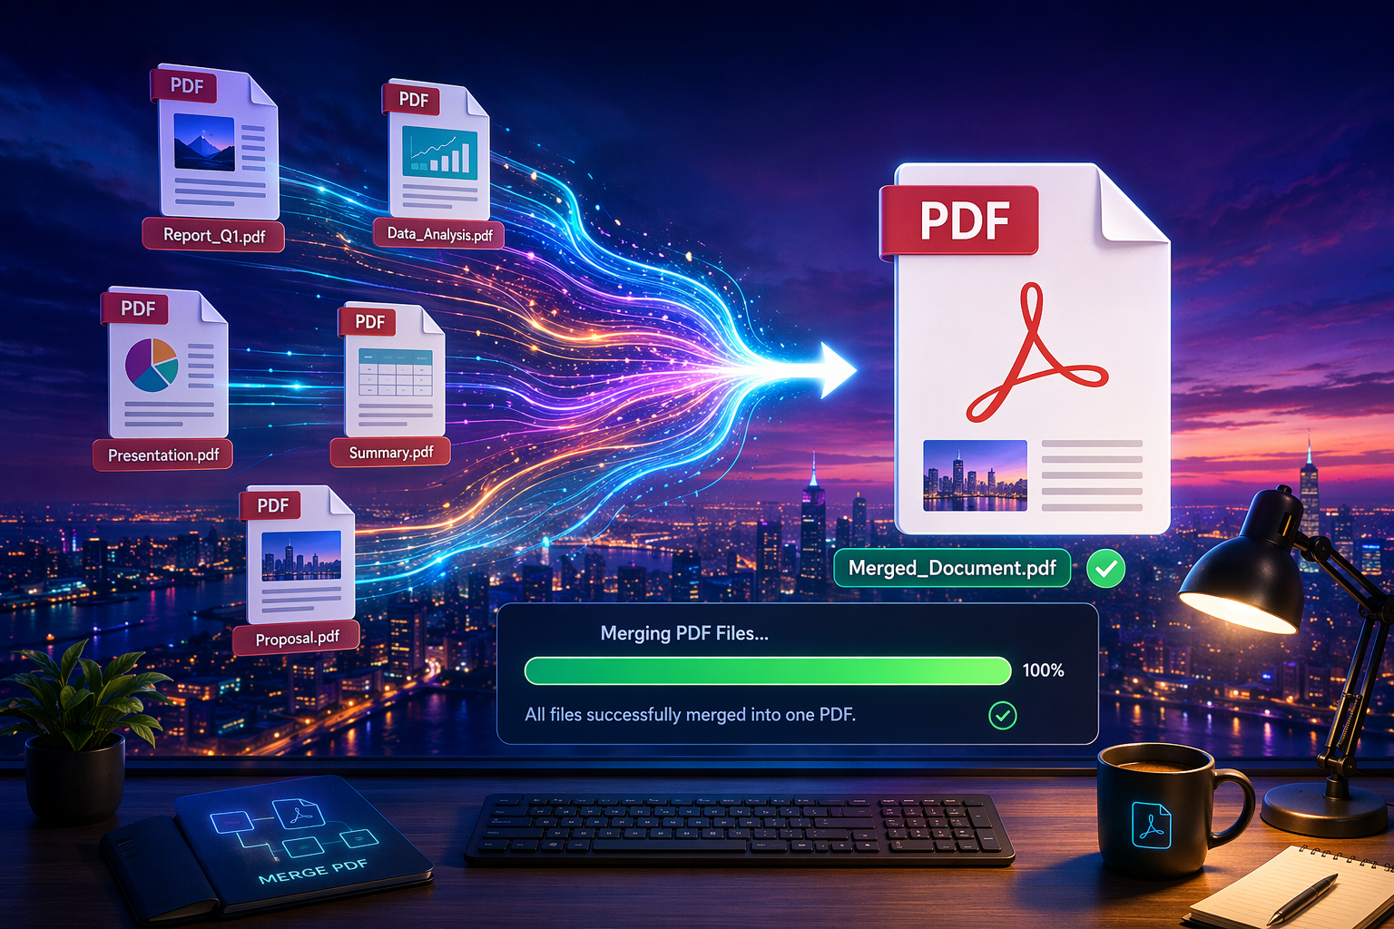

Key Highlights
- A good merge pdf tool lets you join files in a browser with quick pdf merging and very little setup.
- Many best tools work on Windows, Mac, Linux, and mobile, so you can merge on almost any device.
- Some options, including ToolifyPDF, offer a pdf combiner with no registration and a simple interface.
- File sizes, privacy handling, and speed vary, so checking limits matters before upload.
- Several tools also act as a pdf editor with reorder, split, and image files support.
- Beginners often want simplicity, while advanced users may need more features and higher limits.

Introduction
Need to join reports, forms, or scans into one file fast? A free online pdf merger makes that easy. Instead of installing a full pdf editor, you can use a browser-based pdf combiner to upload, arrange, and download a single file in minutes. This guide keeps things simple. You will see which tools are easiest to use, what privacy trade-offs to watch for, and how to choose the option that fits your everyday document workflow.

The Easiest Ways to Merge PDFs for Free Online
If you want to combine pdf documents without installing software, a browser-based pdf merge tool is usually the fastest path. You upload files, reorder them, click merge, and save the result. That works well on Windows, macOS, and most mobile devices too.
Still, not every merge pdf tool is the same. Some focus on simplicity, others add cloud access, page tools, or desktop options. The next sections compare the best tools, along with ease of use, limits, and privacy considerations.

1. ToolifyPDF – Fast, Secure PDF Merging Without Registration
ToolifyPDF is one of the best tools if you want quick pdf merging without extra steps. It runs in your browser, works across devices, and does not ask you to create an account before using the pdf merger. That makes it a strong fit for quick jobs and everyday document tasks.
Just upload your files, arrange them, and download the combined result. The interface is simple, processing is fast, and the service is completely free. Because it is browser-based, you avoid software installs while still getting a practical pdf combiner for routine use. You can try it here: https://www.toolifypdf.online
It is especially useful when you want speed and convenience, but you should still be cautious with highly confidential documents on any online platform.
- Completely free with no registration required
- Fast browser-based processing with a simple interface
- Multiple PDF tools in one place for broader workflow needs

2. Merge2PDF – Combine PDFs Instantly on Any Device
Merge2PDF is built for convenience. If you need a pdf merge tool that opens in a browser and works with your internet connection on desktop, tablet, or phone, it fits the job. That also means you can merge PDFs on Windows without using Adobe Acrobat.
The layout is easy to follow. You upload files, place them in order, start the process, and then download the finished file. For beginners, that simplicity is a real advantage. You do not need a full pdf editor just to join a few files.
Before using it, check its limits. Some online tools restrict file sizes or the number of files in the free version.
- Works through a browser on many devices
- Simple upload, arrange, and download process
- Limits may apply to size or file count

3. Smallpdf – User-Friendly PDF Combiner with Cloud Support
Smallpdf is a well-known pdf combiner for users who like a clean interface. Its biggest draw is cloud support, letting you import files from Google Drive or Dropbox instead of only from local storage. That helps if your documents already live online.
From a usability standpoint, it is easy to learn. You add files, arrange them, and export the merged result. The platform also offers advanced features beyond a basic pdf merger, which may appeal if you handle document tasks often.
The free version is useful for light work, but some advanced features sit behind a paid plan. That matters if you need frequent access or more flexibility.
- Google Drive and Dropbox support
- Clean interface for fast combining
- Extra tools available, though some require payment

4. ILovePDF – Reliable PDF Merging and Additional Tools
ILovePDF is popular because it does more than merging. If you want a pdf merge tool plus pdf split options and other document helpers, it offers a wide range of features in one place. That makes it useful for people with repeat tasks.
Using it feels straightforward. You add files, place them in order, and export one combined file. Depending on the plan, limits may affect the number of pages or the number of files you can process comfortably in one go.
It is also known for accessibility through browser-based use, and some users look to it when they want extension-style convenience.
- Reliable for merging and other PDF tasks
- Easy ordering before export
- Useful if you need more than a basic merger

5. PDF24 Tools – Merge PDF Documents Free on Windows & Mac
PDF24 Tools stands out because it gives you both web-based and desktop choices. If you want flexibility on Windows or Mac, this can be a smart pick. You can use it in a browser for convenience or look at desktop-style options when privacy matters more.
That privacy angle is important. Some processing methods can avoid sending files away from your device, which reduces concerns about remote servers. For users handling more sensitive material, that can be a deciding factor.
Beyond merging, it includes extra pdf tools that help with everyday work. That wider toolkit makes it more than a simple pdf editor substitute.
- Web and desktop flexibility
- Better privacy potential for local handling
- Extra PDF utilities for broader tasks
Text Table: Quick Comparison of Popular Tools
Tool | Best For | Registration | Cloud Support | Privacy Note
ToolifyPDF | Fast everyday merging | No | Not highlighted | Browser-based, good for routine files
Merge2PDF | Simple cross-device use | Not specified | Not highlighted | Check file limits and privacy terms
Smallpdf | Cloud-based workflows | Not always required | Google Drive, Dropbox | Review free plan limits
ILovePDF | Extra PDF features | Not always required | Supported on platform workflows | Check page and task limits
PDF24 Tools | Web and desktop flexibility | Not specified | Not central feature | Local options may improve privacy

How to Combine PDF Files Without Installing Software
For most people, the easiest method is a browser-based pdf merger. Open the tool, use the drop feature to upload files, reorder them, merge them, and save the result. The whole workflow usually takes only a minute or two.
That speed is why online tools are so popular. You do not need setup, updates, or extra storage space. A good pdf combiner works directly in your browser, which is perfect for quick school, work, or home tasks.

Using Browser-Based PDF Tools for Quick Merges
Here is the basic process most tools follow. First, open your chosen merge pdf tool in a browser. Then upload files with the drop feature or a file picker. Many tools place the main action near the top right corner so it is easy to spot.
Next, check the order before you continue. A good interface lets you drag items into place. Once everything looks right, click the merge button and wait for the tool to create your single file.
This method is popular because it is simple and fast.
- Open the tool in your browser
- Upload or drag your files into the workspace
- Reorder items before processing
- Click merge, then download the result

Rearranging Pages and Organizing PDFs Before Combining
Order matters more than many people expect. If you merge files without checking sequence, the final document can feel confusing or incomplete. That is why many users choose a pdf merger that lets them reorder files before processing.
Some platforms go further and act more like a light pdf editor, giving you options to move pages or adjust structure during the workflow. Adobe notes that order can be changed before merging, and signed-in users may get more page controls afterward depending on the tool.
When organizing, keep these points in mind:
- Put the first file at the top because it usually appears first
- Check the number of pages in long files before combining
- Remove anything unnecessary before export if the tool allows it

Security and Privacy: Is It Safe to Merge PDFs Online?
Online merging can be safe for everyday files, but you should still read the privacy policy before uploading anything important. Reputable services explain how files move through their servers and when they are deleted.
That said, highly sensitive documents deserve extra caution. If a contract, legal record, or financial file is very private, a desktop option or a tool that keeps processing local may be the safer choice. Next, let’s look at practical safeguards.

Handling Sensitive Documents with Online PDF Freeware
Start with the developer’s privacy policy. It should clearly explain upload handling, storage time, and deletion practices. If that information is hard to find, think twice before using the service for confidential documents.
A browser-based tool is fine for many routine tasks, but not every file belongs online. If you are dealing with highly private records, browser convenience should not outweigh security. In those cases, a local desktop tool may be a better fit than an online pdf editor.
Use online freeware carefully. Choose known platforms, avoid shared public networks, and keep originals until you verify the result. That small caution can prevent bigger issues later.

Quality Control – Does Combining PDFs Affect File Quality?
In many cases, merging alone should not cause quality loss. PDF format is built to preserve layout and formatting across devices, and Adobe specifically notes that formatting is retained when files are combined. So a normal merged pdf file should look like the originals.
Problems usually show up when another feature changes the file. A pdf compressor, watermarking rule, or conversion step may affect appearance more than merging itself. That is why it helps to know the range of features a tool applies during export.
Watch for these quality factors:
- Compression settings that reduce clarity
- Watermarks in limited free plan tools
- Output checks before you delete your source files

Conclusion
In conclusion, merging PDFs has never been easier thanks to the variety of online tools available. Whether you choose ToolifyPDF for its fast and secure merging capabilities without any registration, or explore other user-friendly options like Smallpdf or ILovePDF, you're guaranteed a smooth experience. Remember that merging not only streamlines your documents but also enhances organization and accessibility. As you combine your PDFs, ensure you prioritize security and quality to maintain the integrity of your files. If you're looking for a reliable solution, don't hesitate to try out ToolifyPDF today—it's completely free and designed for your convenience!

Frequently Asked Questions

Can I merge all PDFs into one file without Adobe Acrobat?
Yes. You can use a merge pdf tool in your browser instead of Adobe Acrobat. A browser-based pdf combiner lets you upload files, place them in order, and download one combined file without installing software.

Which free online PDF merger supports larger file sizes?
Support for larger file sizes depends on the platform and its free version limits. Adobe allows up to 100 files and a combined total of 1,500 pages in its tool, while other best tools may set smaller size or task limits.

What steps should I follow to merge PDF documents securely?
Choose a trusted pdf merger, read its privacy policy, and use a secure internet connection. Avoid uploading confidential documents unless you understand how the service handles files on its servers and when those files are deleted.
FAQ Schema (JSON-LD) { "@context": "https://schema.org", "@type": "FAQPage", "mainEntity": [ { "@type": "Question", "name": "Can I merge all PDFs into one file without Adobe Acrobat?", "acceptedAnswer": { "@type": "Answer", "text": "Yes. You can use a browser-based merge PDF tool to upload files, arrange them, and download one combined file without installing Adobe Acrobat." } }, { "@type": "Question", "name": "Which free online PDF merger supports larger file sizes?", "acceptedAnswer": { "@type": "Answer", "text": "Limits vary by tool. Adobe states its merge tool can combine up to 100 files and up to 1,500 pages total, while other free versions may allow less." } }, { "@type": "Question", "name": "What steps should I follow to merge PDF documents securely?", "acceptedAnswer": { "@type": "Answer", "text": "Use a trusted PDF merger, review the privacy policy, upload over a secure connection, and avoid placing highly sensitive documents on online services unless you understand their file handling and deletion practices." } } ] }
Article Schema (JSON-LD) { "@context": "https://schema.org", "@type": "Article", "headline": "Merge PDFs for Free - Combine PDF Files Online With the Best Free Tools", "description": "A practical guide to merging PDF files for free online, comparing popular tools, explaining safe browser-based steps, and helping readers choose the right option.", "mainEntityOfPage": { "@type": "WebPage", "@id": "/merge-pdfs-for-free-combine-pdf-files-online" }, "author": { "@type": "Organization", "name": "ToolifyPDF" }, "publisher": { "@type": "Organization", "name": "ToolifyPDF", "url": "https://www.toolifypdf.online" }, "articleSection": [ "Key Highlights", "Introduction", "The Easiest Ways to Merge PDFs for Free Online", "How to Combine PDF Files Without Installing Software", "Security and Privacy", "Frequently Asked Questions" ], "inLanguage": "en-US" }
Suggested Internal Links
- Merge PDF tool: https://www.toolifypdf.online
- Split PDF tool: https://www.toolifypdf.online
- Compress PDF tool: https://www.toolifypdf.online
- Reorder or organize PDF-related tool page: https://www.toolifypdf.online
Suggested External References
- Adobe Acrobat Merge PDF information
- Smallpdf merge tool page
- ILovePDF merge tool page
- PDF24 Tools merge PDF page

combine pdfs into one

combine pdf to pdf

