Meta Title: Understanding PDF: Your Ultimate Guide to PDF Files
Meta Description: Dive into our ultimate guide on pdf files! Discover everything you need to know about pdf, its features, and how to use it effectively in 2026.
URL Slug: understanding-pdf-your-ultimate-guide-to-pdf-files

Understanding PDF: Your Complete Guide to PDF Files
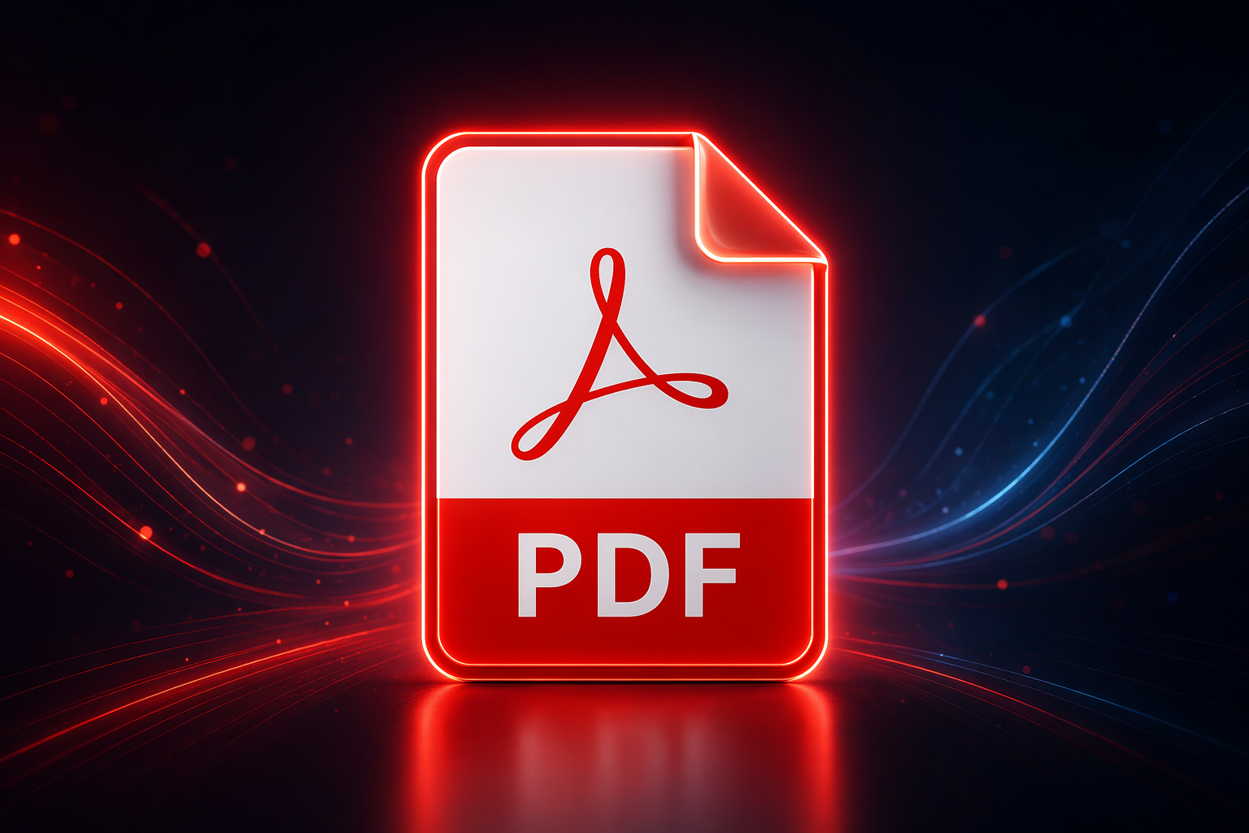

Key Highlights
- PDF stands for portable document format, a file type built to keep pages consistent across devices.
- A PDF file preserves text, images, fonts, and layout better than many editable formats.
- The pdf format works with a pdf viewer in modern browsers, phones, and desktop systems.
- PDF supports security features like passwords, permissions, and digital signatures.
- It is an open standard maintained through ISO, which helped global adoption.
- PDF tools can open, merge, convert, compress, and organize files while managing file size.

Introduction
You probably open a pdf file almost every day without thinking much about the file format behind it. Yet PDF remains one of the most important document format choices for sharing reports, forms, manuals, scans, and contracts. Why? It keeps pages looking the way the sender intended. This guide explains what PDF is, where it came from, how it works, and why it still matters in 2026. From basics to practical use, you will get a clear picture fast.

What Is a PDF File? Understanding the Basics
A PDF document is a portable document format file created to display content the same way on different systems. Adobe introduced this file format in 1993, and it later became an open standard. In simple terms, it packages text, images, fonts, and layout into one dependable file.
You will see PDF used for sharing polished files that should not shift around when opened elsewhere. A pdf creator can also reduce file size, preserve formatting, and keep a document easier to print, store, or send. The next sections break down its structure and daily uses.

Core Characteristics and Structure of PDFs
At its core, the pdf format is a fixed-layout file type. That means the page is designed to appear consistently, no matter which operating system or app opens it. The contents of the pdf can include text, vector graphics, raster images, links, forms, and even embedded attachments.
Another defining feature is that fonts can travel with the document. This helps prevent spacing problems and missing character issues. A PDF may also include metadata, layers, form fields, and annotations, which makes it useful for reviewing or collecting information without changing the main page design.
Inside the file, PDF uses structured objects, streams, and cross-reference data so a viewer can quickly find what it needs. That design supports efficient access, incremental updates, and reliable display. In short, PDF is built to preserve appearance while still supporting practical document features.

Common Uses for PDF Files in Everyday Life
I

pdf editor pdf convertor
n everyday life, a pdf document acts as a bridge between paper documents and electronic documents. You can share one file and expect it to look nearly the same on a work laptop, home printer, or phone. That reliability explains why PDF is used so widely.
You will often open one with a pdf reader when the sender wants you to view, print, sign, or archive something. Common examples include school handouts, invoices, forms, instruction manuals, and scanned records. PDF is also common when people need pages to stay fixed.
Typical uses include:
- Contracts and forms that need signatures or comments
- E-books, reports, and manuals with stable page layout
- Scanned paper documents stored for search or sharing
- Presentations and handouts sent for printing

The History and Development of the PDF Format
PDF began as Adobe’s answer to a simple but hard problem: how do you send a document anywhere and keep its appearance intact? That idea came from the Camelot Project, started by Adobe co-founder John Warnock in 1991. The first Adobe PDF release followed in 1993.
Over time, PDF moved from a company-controlled format to an open standard under ISO in 2008. That shift mattered because it encouraged wider software support and shared governance. Today, technical communities and industry groups continue helping shape PDF standards and long-term use.

Adobe’s Role and the Origins of PDF
The story starts with the Camelot Project. In 1991, John Warnock proposed a way to capture documents from any application, send them anywhere, and let others view and print them on any machine. That was a major challenge at a time when software and hardware differences often broke document formatting.
Adobe turned that idea into the pdf format and released it in 1993. Early on, Adobe PDF was closely tied to publishing and print workflows. Adobe Acrobat and related tools helped people create, view, and manage these files, which gave the format practical reach.
For years, Adobe controlled the specification. Even so, the company also made the PDF specification available free of charge in the early period. That helped the format spread. Eventually, PDF grew beyond one company’s ecosystem and became a widely trusted document standard.

Milestones in Standardization and Global Adoption
PDF adoption grew because it solved a universal problem. Businesses, publishers, schools, and governments needed a dependable way to exchange documents. A big turning point came in 2008, when the pdf format became an ISO open standard. That move helped broaden trust and compatibility.
Today, PDF standards are maintained through ISO committees, with the PDF Association serving an important role in the standards community. PDF 2.0 later replaced older Adobe-led specifications and removed proprietary technologies from normative references. That made the standard cleaner and more future-focused.
Year | Milestone
1991 | The Camelot Project began at Adobe
1993 | PDF was first released publicly
2008 | PDF 1.7 became ISO 32000-1, an open standard
2017 | ISO published PDF 2.0 as ISO 32000-2
2020 | Updated PDF 2.0 edition added clarifications and corrections
2023 | The PDF Association made ISO 32000-2 available for free download

Key Features and Benefits of PDF Files
PDF became popular because it solves several document problems at once. This document format keeps layout stable, supports printing, works across platforms, and can hold text, graphics, forms, and metadata in one file. That makes sharing easier and more predictable for you.
Another big advantage is pdf security. Files can include a password, permissions, encryption, and digital signatures. Some tools also support comments, forms, attachments, and accessibility features. In the next sections, you will see how compatibility and security features make PDF practical for everyday work.

Cross-Platform Compatibility and Consistency
One of the biggest strengths of the pdf format is consistency. A file created on Windows can be opened on macOS, Linux, Android, or other systems with very similar results. That matters when documents must look right on different screens, printers, and mobile devices.
You usually do not need special setup to read one. Modern browsers and many web browsers already include built-in PDF viewing. Phones and tablets also support PDF through system apps or browser tools, so opening a file is often as simple as tapping it.
This cross-platform strength helps you:
- View the same layout on different devices and operating system environments
- Open files directly in browsers without extra plugins in many cases
- Share print-ready pages confidently across desktop and mobile devices

Security, Permissions, and Digital Signatures in PDFs
PDF security includes several layers. A file may use encryption so the contents cannot be opened without the right password. There can also be a user password for access and an owner password tied to editing or printing restrictions. This makes PDF useful for sensitive material.
Still, you should know the limits. Permission controls depend on the reader software honoring them, and some free tools may ignore certain restrictions. So while a password can protect opening a file, editing and copying limits are not always a guarantee after distribution.
Digital signatures add stronger trust for approval workflows. They help confirm authenticity and show whether a file changed after signing. PDF also supports secure authentication features and advanced signature profiles used in formal processes. For many teams, that makes PDF practical for reviews, forms, and signed records.

Managing and Editing PDF Files
Working with a pdf document is easier than many people think. You can open it in a pdf reader, review it in a pdf viewer, or create one from common office apps and print features. Many systems already support PDF without extra setup, which keeps the format convenient.
Editing is more limited than in a word processor, but it is still possible. Depending on the tool, you can merge files, annotate pages, convert formats, or scan paper into searchable PDF. The next two sections explain how to view files and handle common editing tasks.

Opening, Reading, and Viewing PDFs Across Devices
If you want to open and read a PDF file on your computer or phone, start with what is already built in. Many devices handle PDFs through a browser, system app, or default viewer. On macOS, Preview is a common option. On Android, browser-based viewing and mobile apps are widely used.
For basic reading, a free pdf reader is often enough. Adobe Acrobat Reader is widely known for viewing, printing, sharing, signing, and handling comments. Modern browsers also work for quick reading, especially when you just need to open a download and check the contents.
Good basic viewing options include:
- Built-in browser support in Chrome, Firefox, and Safari
- Preview on macOS for viewing and annotation
- Adobe Acrobat Reader for reading, printing, and sharing across devices

Tools for Editing, Converting, and Merging PDFs (Including Online Solutions)
There are different ways to manage a PDF document beyond simple viewing. Many office apps can export to the PDF format, and some systems let you print directly to PDF through a virtual printer. Google Docs and Microsoft Word can both help you save a Word document as PDF.
Online tools can also merge, convert, or compress files, though you should be careful with sensitive documents. For scanned files, optical character recognition (OCR) can turn image-based pages into searchable text. That is especially helpful when old paper records need to become usable digital files.
Common tasks supported by PDF tools include:
- Converting Microsoft Word documents, images, or scans into PDF
- Merging multiple files into one organized document
- Using OCR to make scanned pages searchable
When it comes to merging several PDF files or organizing pages into a single document, browser-based solutions can be particularly convenient. Many users look for accessible tools that let them combine PDFs quickly without installing extra software. In these situations, web platforms—such as ToolifyPDF’s merge page—offer a straightforward way to upload, arrange, and merge PDF files directly from your browser. This can be useful for assembling reports, collecting receipts, or preparing documents for sharing. Alongside ToolifyPDF, there are other online PDF editors and converters that provide similar features, allowing users to handle a variety of file formats, compress large PDFs, or apply OCR. However, it is important to review the privacy policies of online services before uploading confidential or sensitive documents, as not all tools guarantee the same levels of data protection. By choosing the right tool for the job, whether desktop-based or online, you can simplify PDF management and streamline your document workflow.

Conclusion
In conclusion, understanding PDF files is essential in today's digital landscape. Their versatility and reliability make them the go-to format for sharing documents across various platforms while maintaining formatting integrity. With features like security settings, cross-platform compatibility, and ease of editing, PDFs cater to both personal and professional needs. Whether you're managing business documents or organizing personal files, knowing how to effectively use and manipulate PDF documents will enhance your efficiency. Don't hesitate to explore various tools available for working with PDFs, such as ToolifyPDF, which can simplify many tasks related to PDF management. For a more tailored experience, consider reaching out for a free trial to discover how these tools can elevate your document handling process.

Frequently Asked Questions

How do I convert a Word or image file to PDF?
You can convert a word document by using export or save features in Microsoft Word, or by printing to the pdf format through a virtual printer. Images such as PNG can also be converted with a pdf creator, office app, browser-based tool, or scan workflow.

Are free online PDF tools safe to use?
They can be useful, but caution matters. If a pdf document contains sensitive data, think carefully before uploading it through a browser tool. Check whether the service discusses pdf security, file handling, and downloads. Password protection and local software may be safer for confidential documents.

What is the difference between PDF and other document formats?
The pdf format is mainly built for fixed presentation, while Microsoft Word documents and Google Docs are built for editing. PDF is a standard format for stable sharing and printing because layout stays consistent. It also supports zooming and graphics without the same kind of loss of quality seen in flat images.
https://web.archive.org/web/20230130032548/https://www.adobe.com/acrobat/about-adobe-pdf.html
https://web.archive.org/web/20101206175751/http://www.iso.org/iso/iso_catalogue/catalogue_tc/catalogue_detail.htm
https://web.archive.org/web/20101206175751/http://www.iso.org/iso/iso_catalogue/catalogue_tc/catalogue_detail.htm
https://web.archive.org/web/20251002171800/https://www.techradar.com/features/30-years-of-pdf-the-file-that-changed-the-world
https://web.archive.org/web/20071213004627/http://www.theinquirer.net/gb/inquirer/news/2007/12/05/pdf-approved-iso-32000

