Smart Parking Garage
Assignment 5 Strategy Pattern
Project author Amir Kabdilmalik
Astana IT University
This extension adds interchangeable pricing and bay allocation algorithms to the existing Smart Parking Garage. The Facade workflow, original behavior, durable records and reverse compensation remain in place. The final project passes 105 JUnit test invocations and builds an executable Java 17 JAR.

Preserved Facade workflow
ParkingFacade coordinates A admission, B reservation and C billing. B failure revokes A. C failure releases B before revoking A. Manual cancellation of a paid operation first refunds C. Persisted pauses, idempotent stage retries, overdue checks, offline sensors and garage capacity checks remain available through the original menu options.

Two families with distinct logic
Family | Algorithm | Behavior
Pricing | HourlyPricing | Linear price at 500 KZT per whole hour.
Pricing | CappedPricing | Daily ceiling of 3000 KZT.
Pricing | DemandPricing | Two hour grace period before sensor based surcharges.
Allocation | FirstFreeAllocation | Smallest eligible bay identifier.
Allocation | NearLiftAllocation | Minimum distance from bay 2, where the lift is located.
Allocation | LeastUsedAllocation | Fewest historical reservations among eligible bays.
At 8 hours with occupancy 0.8, prices are 4000, 3000 and 5200 KZT. With free bays 1, 2, 3 and past use counts 5, 2, 0, allocation results are bay 1, bay 2 and bay 3. The differing results come from different algorithms.

Contexts and automatic selection
PricingStrategy.amountFor(int) and AllocationStrategy.choose(SpaceAvailability) each define one method. PricingPolicy and SpaceSensorGrid each accept their strategy through a constructor, expose setStrategy(), then delegate the work. Neither context uses if, switch or instanceof to dispatch on concrete strategy types.
Selector | Priority | Rule
PricingSelector | 1 | At least 6 hours selects capped pricing.
PricingSelector | 2 | Before 06:00 or from 22:00 selects capped pricing.
PricingSelector | 3 | Occupancy at least 0.8 selects demand pricing.
PricingSelector | 4 | Otherwise select hourly pricing.
AllocationSelector | 1 | Near lift preference selects near lift allocation.
AllocationSelector | 2 | 08:00 inclusive to 18:00 exclusive selects least used allocation.
AllocationSelector | 3 | Otherwise select first free allocation.
Manual modes override these automatic rules. Time is evaluated in Asia/Almaty using an injected Clock. Main calls prepareStrategies(hours) before each new operation with the actual requested duration. Configuration is session scoped; programmatic callers follow the same configure, prepare, facade sequence.

Isolation from external change
DemandPricing reads OccupancySource, a project owned interface. The simulation can change its reading during execution. Unit tests inject a fixed FakeOccupancySource. Replacing a real sensor provider requires a new implementation of this boundary, leaving the price calculation contract unchanged.

Persisted decisions during recovery
BillingRepository writes a PriceQuote containing workflow ID, hours and amount before saving a payment. A retry reuses the original quote after a strategy swap, changed sensor reading or process restart. A quote is only a pricing decision, not a charge. Legacy Assignment 4 payments keep their original CSV format and hourly semantics. Existing reservations are reused by ID before any new allocation runs.
Least used allocation reads usage counts prepared by ReservationManager from persisted reservations, including released records. SpaceAvailability makes defensive copies and excludes occupied or blocked bays. Offline or full sensors retain the original errors and compensation behavior.

Pricing class diagram
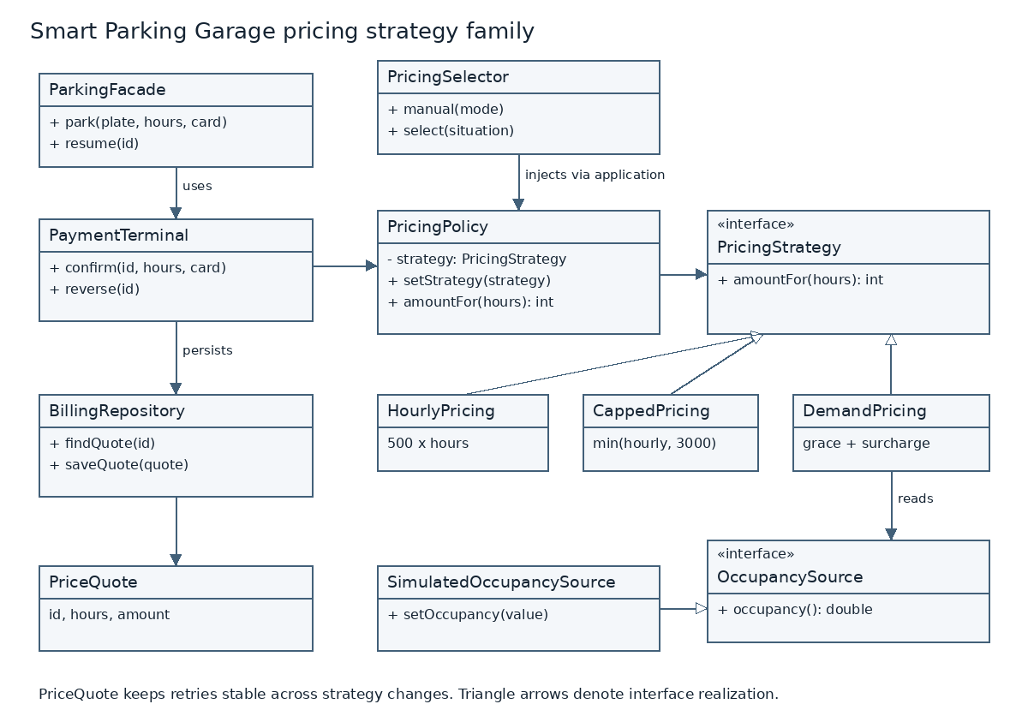
PricingPolicy is the context. The three concrete algorithms implement PricingStrategy. PricingSelector supplies a strategy through the composition root. DemandPricing depends on the OccupancySource boundary. PaymentTerminal retains responsibility for payment lifecycle behavior; the price algorithm only computes an amount.

Extension without changing the context
A new PricingStrategy implementation can be passed to the existing constructor or setStrategy(). The context needs no edit. Tests inject an unregistered implementation to verify this property. A new menu name or automatic choice requires an intentional selector rule or composition update.
The complete one sentence responsibility table for every production type, nested Snapshot record and test helper is in README. Each description is at most 25 words and excludes the prohibited conjunctions.

Allocation class diagram
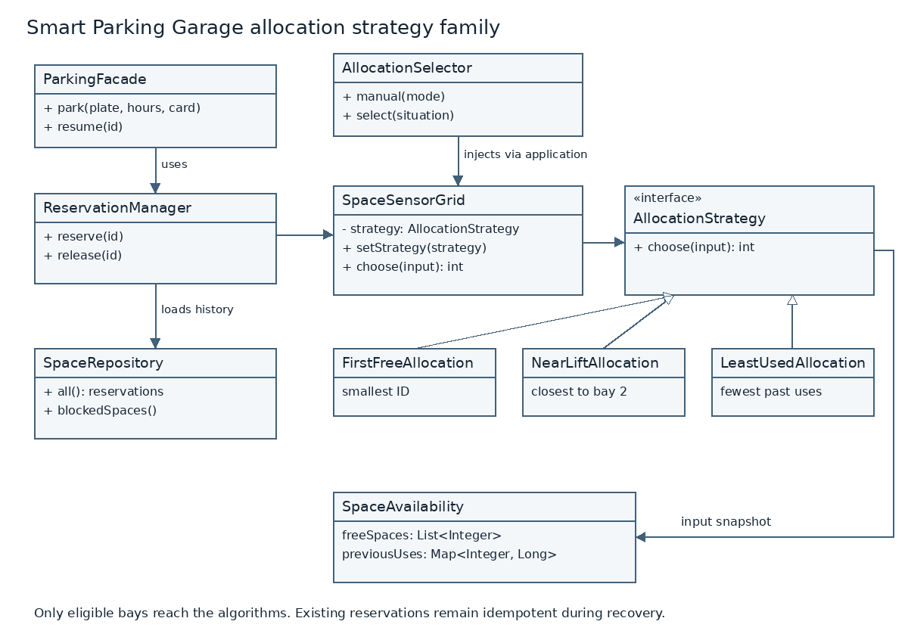
SpaceSensorGrid is the allocation context. FirstFreeAllocation orders eligible bays by identifier. NearLiftAllocation orders them by distance to bay 2. LeastUsedAllocation orders them by historical usage. Ties use the smaller identifier. A missing history entry means zero prior uses.

Facade with Strategy
Facade controls the larger operation and its recovery. Strategy changes a replaceable calculation inside a subsystem. Neither family bypasses the facade, changes the order of subsystem commits, or lets an allocation algorithm reserve a blocked bay. The original facades and lifecycle objects remain responsible for workflow consistency.

Why this is Strategy
The design varies two algorithms while keeping the surrounding workflow stable. PricingPolicy stores a PricingStrategy reference, receives it through its constructor, replaces it through setStrategy(), then delegates amountFor(). SpaceSensorGrid follows the same composition model for AllocationStrategy. Each family has three concrete implementations with different decision logic. A caller can apply every implementation to the same immutable input without changing the context class.
The client deliberately selects an algorithm to meet an external requirement: a price cap, live occupancy, proximity to the lift, or balanced bay usage. PricingSelector and AllocationSelector isolate that selection policy. Contexts contain no conditional dispatch based on concrete algorithm types. A new implementation can be passed directly to either context without editing its existing code; StrategyTest demonstrates this using previously unregistered implementations. Adding a new menu label or automatic rule remains an explicit change to the selector or composition setup.
State addresses changes in an object's lifecycle, where behavior follows transitions such as NEW to PAID or RESERVED to RELEASED. Those existing entity statuses remain in this project, but the tariff implementations never transition the parking workflow or decide which algorithm follows them. A completed payment can retain its original quote even after the client changes the active tariff. The selected algorithm therefore represents a calculation policy, rather than a lifecycle phase.
Template Method normally fixes an algorithm skeleton in a superclass and allows subclasses to override individual steps. Here no algorithm inherits a context skeleton. Separate objects implement a common interface, and the context delegates the complete operation to the selected object. This composition permits a runtime swap on the same context instance. Facade serves a separate purpose: ParkingFacade still coordinates gate admission, bay reservation, billing and recovery behind a simplified client API.

Demonstration
Option 13 shows all algorithms on the same input, manual override, automatic rules and runtime replacement on the same context instance. Option 14 configures live garage choices; option 1 then executes the original parking facade. Options 3 and 4 still demonstrate both rollback depths. Options 5 to 9 retain pause, restart and recovery behavior.
The demonstration also runs directly using java -cp dist/smart-parking-garage-1.0.0.jar parking.app.StrategyDemo. Its verified output is retained in STRATEGY_DEMO.txt.

Verification and refactoring history
Test group | Invocations | Result
Original Assignment 4 tests | 32 | Passed unchanged
Unchanged PricingContractTest | 16 | Passed on both commits
Additional StrategyTest | 57 | Passed
Final suite | 105 | No failures, errors or skipped tests
The before commit contains one PricingPolicy class with a switch for the three tariff variants. The after commit extracts the interfaces, algorithms, selectors and runtime delegation. The same 16 pricing contract invocations and original 32 tests pass before and after. PricingContractTest is byte identical across the two commits.
Before commit 4a8187a83db4de021efacf2b3fe8854716e9aeb4
After commit 80c1ac664c854073a4a03225aed63f08180d8ce6
README links to patch views of these exact commits. docs/repository-history.bundle contains their real ancestry together with the original project history. Hosted GitHub URLs require pushing this history to the student repository. No remote push or course submission is included.

Measured coverage
JaCoCo reports 100% line coverage for pricing, allocation, gate, space, billing, facade and store packages. The six required subsystem and strategy packages each pass a separate 80% threshold. The app package has 27.8% line coverage and is outside that threshold; the executable console was also exercised through real standard input. Line coverage does not imply complete branch or behavior coverage.

Verified executable behavior
The rebuilt JAR passed checks for the default 1000 KZT two hour booking, both compensation orders, strategy demonstration, configured capped pricing with bay 2, persisted results after reopening, invalid mode handling and a real pause followed by process restart and resume. Logs, JUnit XML, coverage and CLI transcripts are included under docs.

Defense preparation
The Russian defense guide explains the pattern roles, each selector priority, the persisted quote, and the distinction from State and Template Method. Worked exercises show adding a first hour free tariff, changing the occupancy threshold and swapping the sensor source. The Russian class guide explains new classes and changed methods.

