SOFTWARE DESIGN PATTERNS / ASSIGNMENT 5

SMART PARKING
GARAGE
STRATEGY PATTERN • UML • UNIT TESTS • GIT REFACTORING
  - Technical project report and defense notes
Student: Ali Ilyubayev | Group: SE-2532 | Year: 2026
Implementation: Java 17+, Maven, JUnit 5. Domain: multi-level parking garage. Example currency: KZT.

Project abstract
This project demonstrates runtime replacement of algorithms in two independent operations: pricing a parking stay and choosing a suitable free garage space. Six concrete strategies implement two small interfaces. Two contexts delegate without type-based branching, while separate selectors implement automatic business rules. A simulated occupancy sensor is hidden behind an interface; a fake source enables deterministic tests. The project includes a runnable demonstration, UML, and preserved Git refactoring history.

Quick facts
Area | Delivered implementation
Pricing strategies | Hourly; daily cap; occupancy-driven demand
Allocation strategies | Nearest entrance; lowest level; least crowded level
Automatic selection | PricingSelector; AllocationSelector
Runtime swapping | PricingContext.setStrategy(); AllocationContext.setStrategy()
Quality evidence | 30 JUnit test methods; 32 independently checked invocations; 3 preserved regression checks
Git history | before-strategy and after-strategy tags; unchanged regression test source

Source: Assignment 5, “Strategy Pattern: Interchangeable Algorithms, Runtime Selection, Clean Classes.” Business prices and garage data are illustrative.

1. Assignment requirements and implementation
Requirement from assignment | Where it is satisfied
Two families; interface with 1–2 methods; 3 distinct classes each | PricingStrategy with HourlyPricing / DailyCapPricing / DemandPricing; SpotAllocationStrategy with NearestEntrance / LowestLevel / LeastCrowdedLevel
One context per family; constructor; setStrategy; pure delegation | PricingContext and AllocationContext; no branch on concrete types
Separate automatic selector | PricingSelector and AllocationSelector; explicit prioritized rules
Refactor bad pricing implementation with Git; preserve tests | a01eb84 before; 1c04bcf after; PricingBehaviorRegressionTest unchanged
Isolate sensor data; test with fake | OccupancySource; SimulatedOccupancySource; FakeOccupancySource
JUnit 5, each strategy, selector rules, parameterized check | Six JUnit test classes; 32 checks in offline harness
Main demo with identical inputs, manual/auto choice, runtime change | SmartParkingDemo.main()
README: SRP table, comparison, links | README.md; docs/DEFENSE_GUIDE.md; docs/COMMITS.md

2. Architecture overview
The architecture divides the garage into shared request/space data, a sensor boundary, a pricing strategy family, and a space-allocation strategy family. Every concrete strategy implements one interface. Contexts depend on interfaces rather than concrete algorithms. Each selector owns policy rules; it returns a strategy object to the caller.
- Interface = shared method contract; concrete strategy = independent algorithm implementation.
- Context = holds the active strategy, forwards requests, replaces strategy through setStrategy().
- Selector = chooses a strategy from membership, stay duration, occupancy, or accessibility.
- OccupancySource = abstraction separating pricing from an external sensor implementation.
The full editable UML source is docs/uml/smart-parking-garage.puml. The project ZIP includes a high-resolution full-project PNG plus larger diagrams for both families.
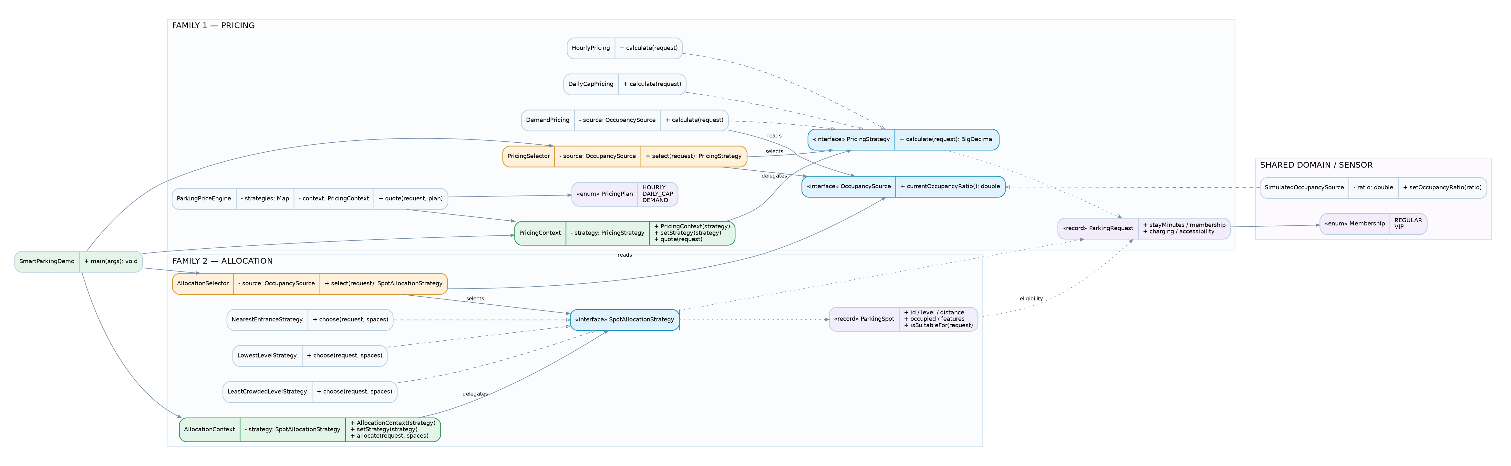
Figure 1. Full class UML overview. Open the included PNG for detail.

3. Pricing Strategy family
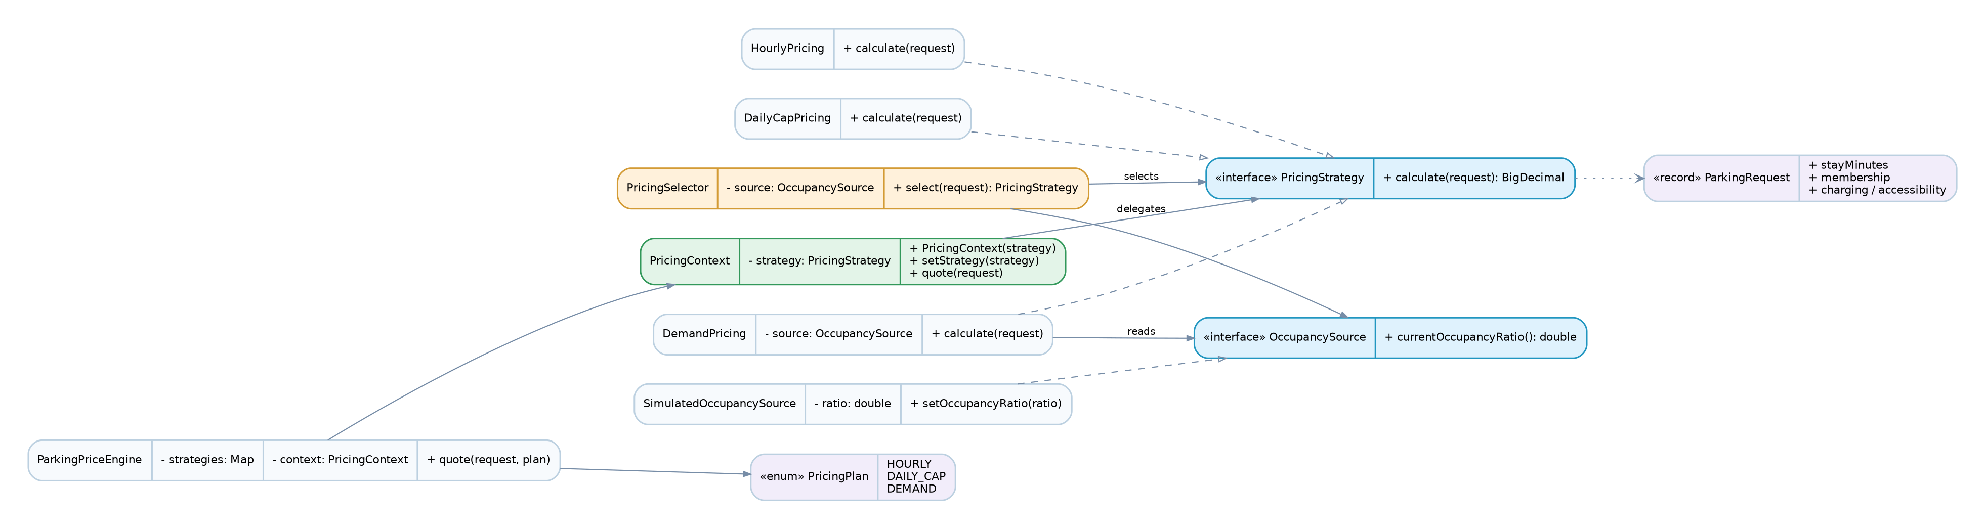
Figure 2. Pricing UML with interface implementations, context, selector, sensor boundary.
Concrete pricing algorithm | Formula / step | Example
HourlyPricing | ceil(minutes / 60) × 500 | 61 min = 1,000 KZT
DailyCapPricing | For each 24h block: min(ceil(blockMinutes / 60) × 500, 3,000) | 26 h = 3,000 + 1,000 = 4,000 KZT
DemandPricing | (600 + ceil(minutes / 30) × 250) × occupancy multiplier | 60 min, 90% used = 1,650 KZT

Demand occupancy multiplier: below 70% = 1.0; 70% up to below 85% = 1.2; at least 85% = 1.5. Money amounts are represented with BigDecimal.

PricingSelector decision order
- VIP plus stay ≥ 180 minutes → DailyCapPricing.
- Otherwise occupancy ≥ 85% → DemandPricing.
- Otherwise stay ≥ 360 minutes → DailyCapPricing.
- Otherwise → HourlyPricing.
This priority order ensures that eligible VIP long stays retain the cap even under high congestion. The pricing context has no conditional choice logic; the selector owns the choice.

4. Parking-space allocation family
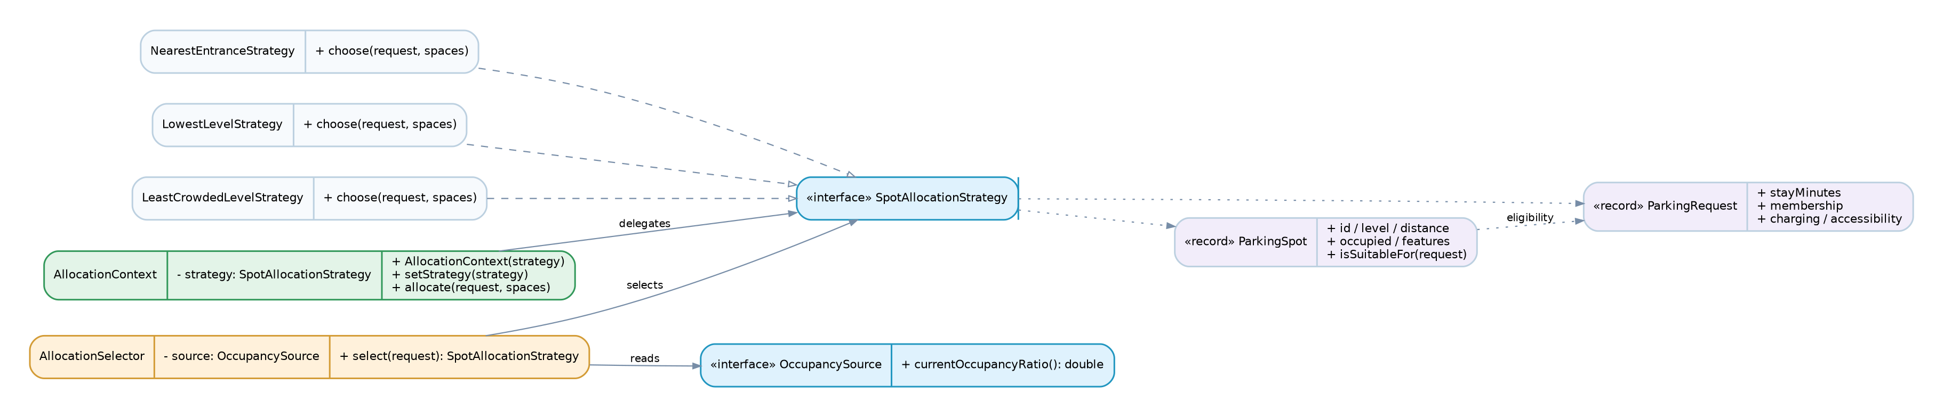
Figure 3. Allocation UML with the second interface, strategies, context, selector.
Concrete allocation algorithm | Decision criterion
NearestEntranceStrategy | Shortest distance among currently free, feature-compatible spaces.
LowestLevelStrategy | Smallest level number, then shortest distance, then spot ID.
LeastCrowdedLevelStrategy | Highest free-space fraction on a floor, then level, distance, spot ID.

Every allocation algorithm first excludes occupied spaces. Electric charging is required when electricCharging=true; accessibility is required when accessibleSpace=true. When no suitable free space exists, the result is Optional.empty(), not a fictitious reservation.

AllocationSelector decision order
- Accessible parking requested → NearestEntranceStrategy.
- Otherwise occupancy ≥ 80% → LeastCrowdedLevelStrategy.
- Otherwise VIP → NearestEntranceStrategy.
- Otherwise → LowestLevelStrategy.
Concrete example: floor 0 is heavily occupied while floor 2 is empty. LowestLevelStrategy still prefers floor 0; LeastCrowdedLevelStrategy spreads arrivals toward floor 2. This difference illustrates truly distinct algorithms.

5. Production class responsibilities
One-sentence responsibilities are also provided in the README; each respects the assignment’s word limit and wording rule.
Class / interface | One responsibility
Membership | Represents supported membership tiers.
ParkingRequest | Holds immutable inputs for one customer stay.
ParkingSpot | Represents one garage space with suitability metadata.
OccupancySource | Defines the occupancy-reading contract.
SimulatedOccupancySource | Supplies adjustable simulated occupancy readings.
PricingPlan | Names supported manual pricing plans.
PricingStrategy | Defines the interchangeable price-calculation contract.
HourlyPricing | Computes fees from started hours.
DailyCapPricing | Computes a capped price per daily block.
DemandPricing | Computes occupancy-sensitive prices from half-hour units.
PricingContext | Delegates fee calculation to its active strategy.
PricingSelector | Chooses a pricing policy from current conditions.
ParkingPriceEngine | Translates manual plan choices into strategy objects.
SpotAllocationStrategy | Defines the interchangeable space-selection contract.
NearestEntranceStrategy | Finds the suitable space with minimal walking distance.
LowestLevelStrategy | Finds a suitable space on the lowest garage level.
LeastCrowdedLevelStrategy | Finds a suitable space on the floor with most spare capacity.
AllocationContext | Delegates space choice to its active strategy.
AllocationSelector | Chooses a space-selection policy from current conditions.
SmartParkingDemo | Demonstrates both strategy families using a console scenario.

6. Unit testing and change isolation
JUnit 5 class | What it verifies
PricingBehaviorRegressionTest | The same three pricing outcomes before and after refactoring.
PricingStrategiesTest | Individual pricing algorithms, demand tiers, shared nonnegative rule via @ParameterizedTest.
PricingSelectorTest | Every automatic pricing rule, priority, boundary.
AllocationStrategiesTest | Every space algorithm, equipment filters, unavailable-space behavior.
AllocationSelectorTest | Every automatic allocation rule, including conflicting priority scenarios.
ContextsAndSourcesTest | Runtime switching, source replacement, input validation.
FakeOccupancySource | Stable readings, allowing tests without connecting to a sensor.

The project contains 30 JUnit test methods. One parameterized method yields three cases, producing 32 test invocations. The authoring environment did not have Maven/JUnit binaries or a reachable dependency server. We compiled the production application with javac, ran the main demo, then verified all test assertion paths using a temporary offline Java assertion/annotation harness: 32 checks, 0 failures. Actual mvn test must still be run on a machine with Maven dependencies.

Before/after regression
The before-strategy tag contains the original ParkingPriceEngine with a large if/else block. The after-strategy tag extracts each pricing algorithm into its own class and makes the stable engine delegate through PricingContext. The three original regression tests ran successfully on both snapshots without changing the original test source.
Git snapshot | Revision prefix | Verified assertion checks
BEFORE | a01eb84 | 3 passed / 0 failed
AFTER | 1c04bcf | 32 passed / 0 failed

7. Why this is Strategy, not State or Template Method
Strategy is appropriate because the parking garage must switch among independent algorithms for a single operation. Every pricing implementation receives the same request and returns a BigDecimal, while every space-selection implementation receives the same request and list of spaces, returning an Optional<ParkingSpot>. Each family has a stable interface. The context stores an object implementing that interface, delegates work to it, and permits explicit runtime replacement. A caller can choose an algorithm manually or let a selector decide. This reduces coupling and keeps new algorithm implementations separate from the context.
State is different: State pattern objects normally model lifecycle conditions of an owner, often with transitions as the owner changes behavior. The parking strategies represent business policies rather than stages in a garage lifecycle. An individual strategy does not cause the context to transition to another internal stage. The caller or selector chooses the next policy.
Template Method is different: it defines a fixed sequence of steps in a base class, leaving selected steps for subclasses to override. Smart Parking Garage does not use such an inheritance hierarchy. Each strategy independently fulfills an interface; the shared behavior is delegation through composition, not a fixed inherited algorithm.
Open/Closed Principle: an extra concrete strategy can be written against the existing interface and injected into the current context without editing its implementation. A new automatic business condition may require a focused change inside the selector, the designated location for selection policy.

8. Live defense plan
- Run java edu.aitu.parking.app.SmartParkingDemo or mvn exec:java.
- Point out the three pricing outputs for the same 120-minute request plus the additional 9-hour example.
- Show the different space assignments for nearest, lowest level, least crowded level.
- Change simulated occupancy to 92%; describe automatic pricing and allocation strategy changes.
- Explain the two context constructors, setStrategy(), delegation, and the two selector methods.
- Show the before/after tags in git log; demonstrate the unchanged regression tests.
- Open the UML source; explain interface implementation arrows and context dependencies.

9. Representative defense questions
Teacher question | Concise answer
Why two families? | Price calculation and spot allocation have different contracts.
Where may if/switch select strategies? | Inside selector classes, never inside the contexts.
How does sensor isolation work? | DemandPricing depends on OccupancySource; tests inject FakeOccupancySource.
How is runtime swapping shown? | setStrategy() changes the implementation in the same context instance.
What about a full garage? | No eligible spot yields Optional.empty().
How can you add a new algorithm? | Implement the existing strategy interface; inject the new object.

