Smart home project report
Assignment 6 Observer and Visitor Patterns
Topic 7 Smart home
Amir Kabdilmalik | SE-2532 | Student ID 250671
This project simulates device updates in a small home. Observer distributes typed notifications to five listeners. Visitor performs five operations on a Home and Room tree. A security listener connects the patterns by auditing only the room that generated an event and publishing the result as a new report.
The deliverable contains Java 17 source code, an executable JAR, 39 JUnit test methods, real extension commits, UML pictures, and a detailed study guide. The console simulation uses no real hardware or third-party production library.

Requirements covered by the code
Requirement | Project evidence
Subjects and listeners | Three DeviceSource objects; MobileApp, EnergyTracker, SecurityAlarm, AutomationRules, AuditLog
Typed immutable events | Own generic interfaces, four event records, per-type subscriptions, defensive collection copies
Observer chain | DeviceSource → EnergyTracker → MobileApp and AuditLog
Composite and Visitors | Home → Room → five device types; Visitor<R> and five concrete operations
Related subtree integration | Device update → room security audit → SecurityReport
Concurrency | Three producer tasks; configurable executor; atomic state and concurrent collections
Tests and trade offs | 39 test methods; exact 4000-event stress case; separate operation and element commits

Before submission, run the official JUnit suite on your machine, preserve the Git bundle history, and submit your own repository link. The included commits were created in one preparation session; they do not establish two weeks of development. The assignment also requires a live defense.

Observer notifications in simple words
A subject sends notifications. An observer receives them. A device source publishes one event without knowing the details of the mobile display, power tracking, security rules, automation, or logging. Listeners can subscribe and unsubscribe while the program is running.
Listener | What it does
MobileApp | Counts each received event type with AtomicLong counters.
EnergyTracker | Calculates updated room power and republishes aggregate EnergySummary events.
SecurityAlarm | Runs a new security audit on the event room and publishes a SecurityReport.
AutomationRules | Recommends 22 C when the changed thermostat is heating above 26 C.
AuditLog | Stores the immutable events it receives in a ConcurrentLinkedQueue.

Generic contracts and event categories
Observer<E extends HomeEvent> defines onEvent(event). Subject<E extends HomeEvent> defines subscribe, unsubscribe, and publish. EventType separates DEVICE_STATE, ENERGY_SUMMARY, SECURITY_REPORT, and AUTOMATION_COMMAND subscriptions. These are the project’s own interfaces, not java.util.Observable.

Why push delivery was chosen
DeviceStateChanged carries the source ID, source-local version, changed device ID, and immutable Room snapshot. This is push delivery: the listener receives the exact state that caused the notification. Pulling state later could return a newer update from another thread. Records plus copied child lists make the event safe to share.

Subscriptions changed inside a callback
ThreadSafeSubject eagerly creates one CopyOnWriteArrayList for each event category. Publishing uses its captured subscriber array. A callback can add or remove observers without damaging that iteration. A newly added observer receives later snapshots. An observer removed during publication may still receive a callback already captured by another thread.
Duplicate subscriptions are ignored by addIfAbsent. No whole-subject lock surrounds callback execution. A listener RuntimeException is passed to the injected nonthrowing error sink, and later listeners still receive the event. Main uses a concurrent error queue and reports any failure visibly.

The Composite tree and Visitor operations
Composite describes a tree made of groups and individual items. Home contains Rooms; each Room contains Devices. These are three levels and two container types. Lamp, Thermostat, Camera, SmartLock, and SmokeDetector are leaves. Every node implements Element and can accept a visitor.
Visitor | Result | Rule
PowerUseVisitor | Double | Sum current power in watts.
SecurityAuditVisitor | List<String> | Accumulate insecure cameras, unlocked doors, and smoke alerts.
DeviceFilterVisitor | List<Element> | Return devices matching an injected yes or no predicate.
JsonExportVisitor | String | Write nested JSON manually with escaped strings.
InventoryVisitor | Map<String, Integer> | Accumulate the number of devices of each type.

Double dispatch
Element e = new Lamp("l", "Lamp", true, 10);
Double watts = e.accept(new PowerUseVisitor());
First Java selects Lamp.accept using the real element type. Inside Lamp.accept, this has the concrete type Lamp, so visitor.visit(this) selects the visit(Lamp) overload. The real visitor then provides the operation. These two selections are double dispatch. Calling visitor.visit(e) directly cannot work with an Element variable because there is no visit(Element) overload.

Traversal belongs to the visitor
Each visitor decides how to walk Home.rooms and Room.devices. Element records hold data, validate construction, and dispatch; they contain no power, audit, or export rules. Visitor-owned traversal also lets JSON open and close each child array in the correct place.
PowerUseVisitor is stateless and reusable. SecurityAuditVisitor and InventoryVisitor hold state across one traversal and require a fresh instance for an independent run. SecurityAlarm receives a factory through its constructor to create a new audit per event.

UML diagram of notifications and wiring
This is the Observer panel of the complete class diagram. The next page supplies the Composite and Visitor panel. Together they show all 33 production types; the security visitor is repeated here as an integration reference.
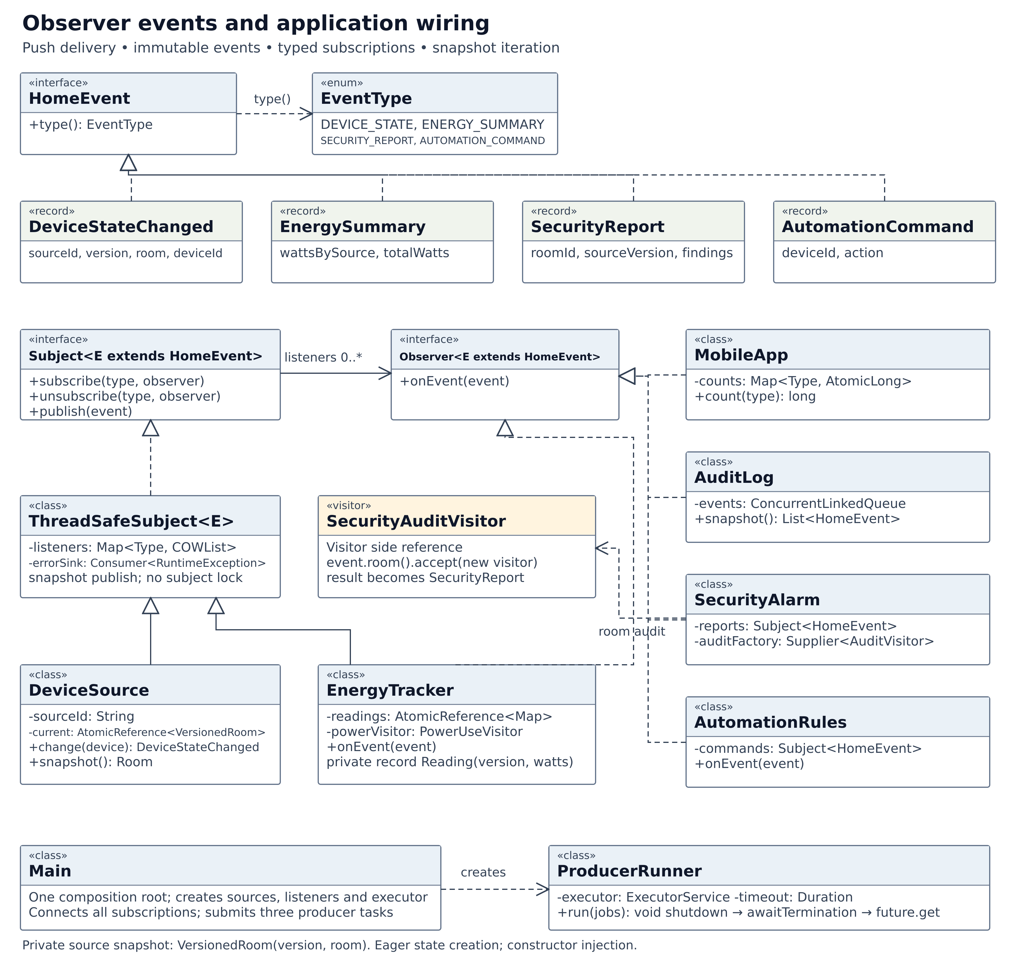
Figure 1 Observer interfaces, immutable events, five listeners, data sources, composition root, and executor lifetime. The combined Smart_home_UML.png and editable SVG are included separately for zooming.

UML diagram of the tree and operations
Filled diamonds show that Home contains Rooms and Room contains Devices. Hollow triangles point to parent interfaces or classes. Dashed hollow triangles show interface realization; ordinary dashed arrows show dependencies. Some constructor dependencies are shown as typed fields to reduce crossing lines.
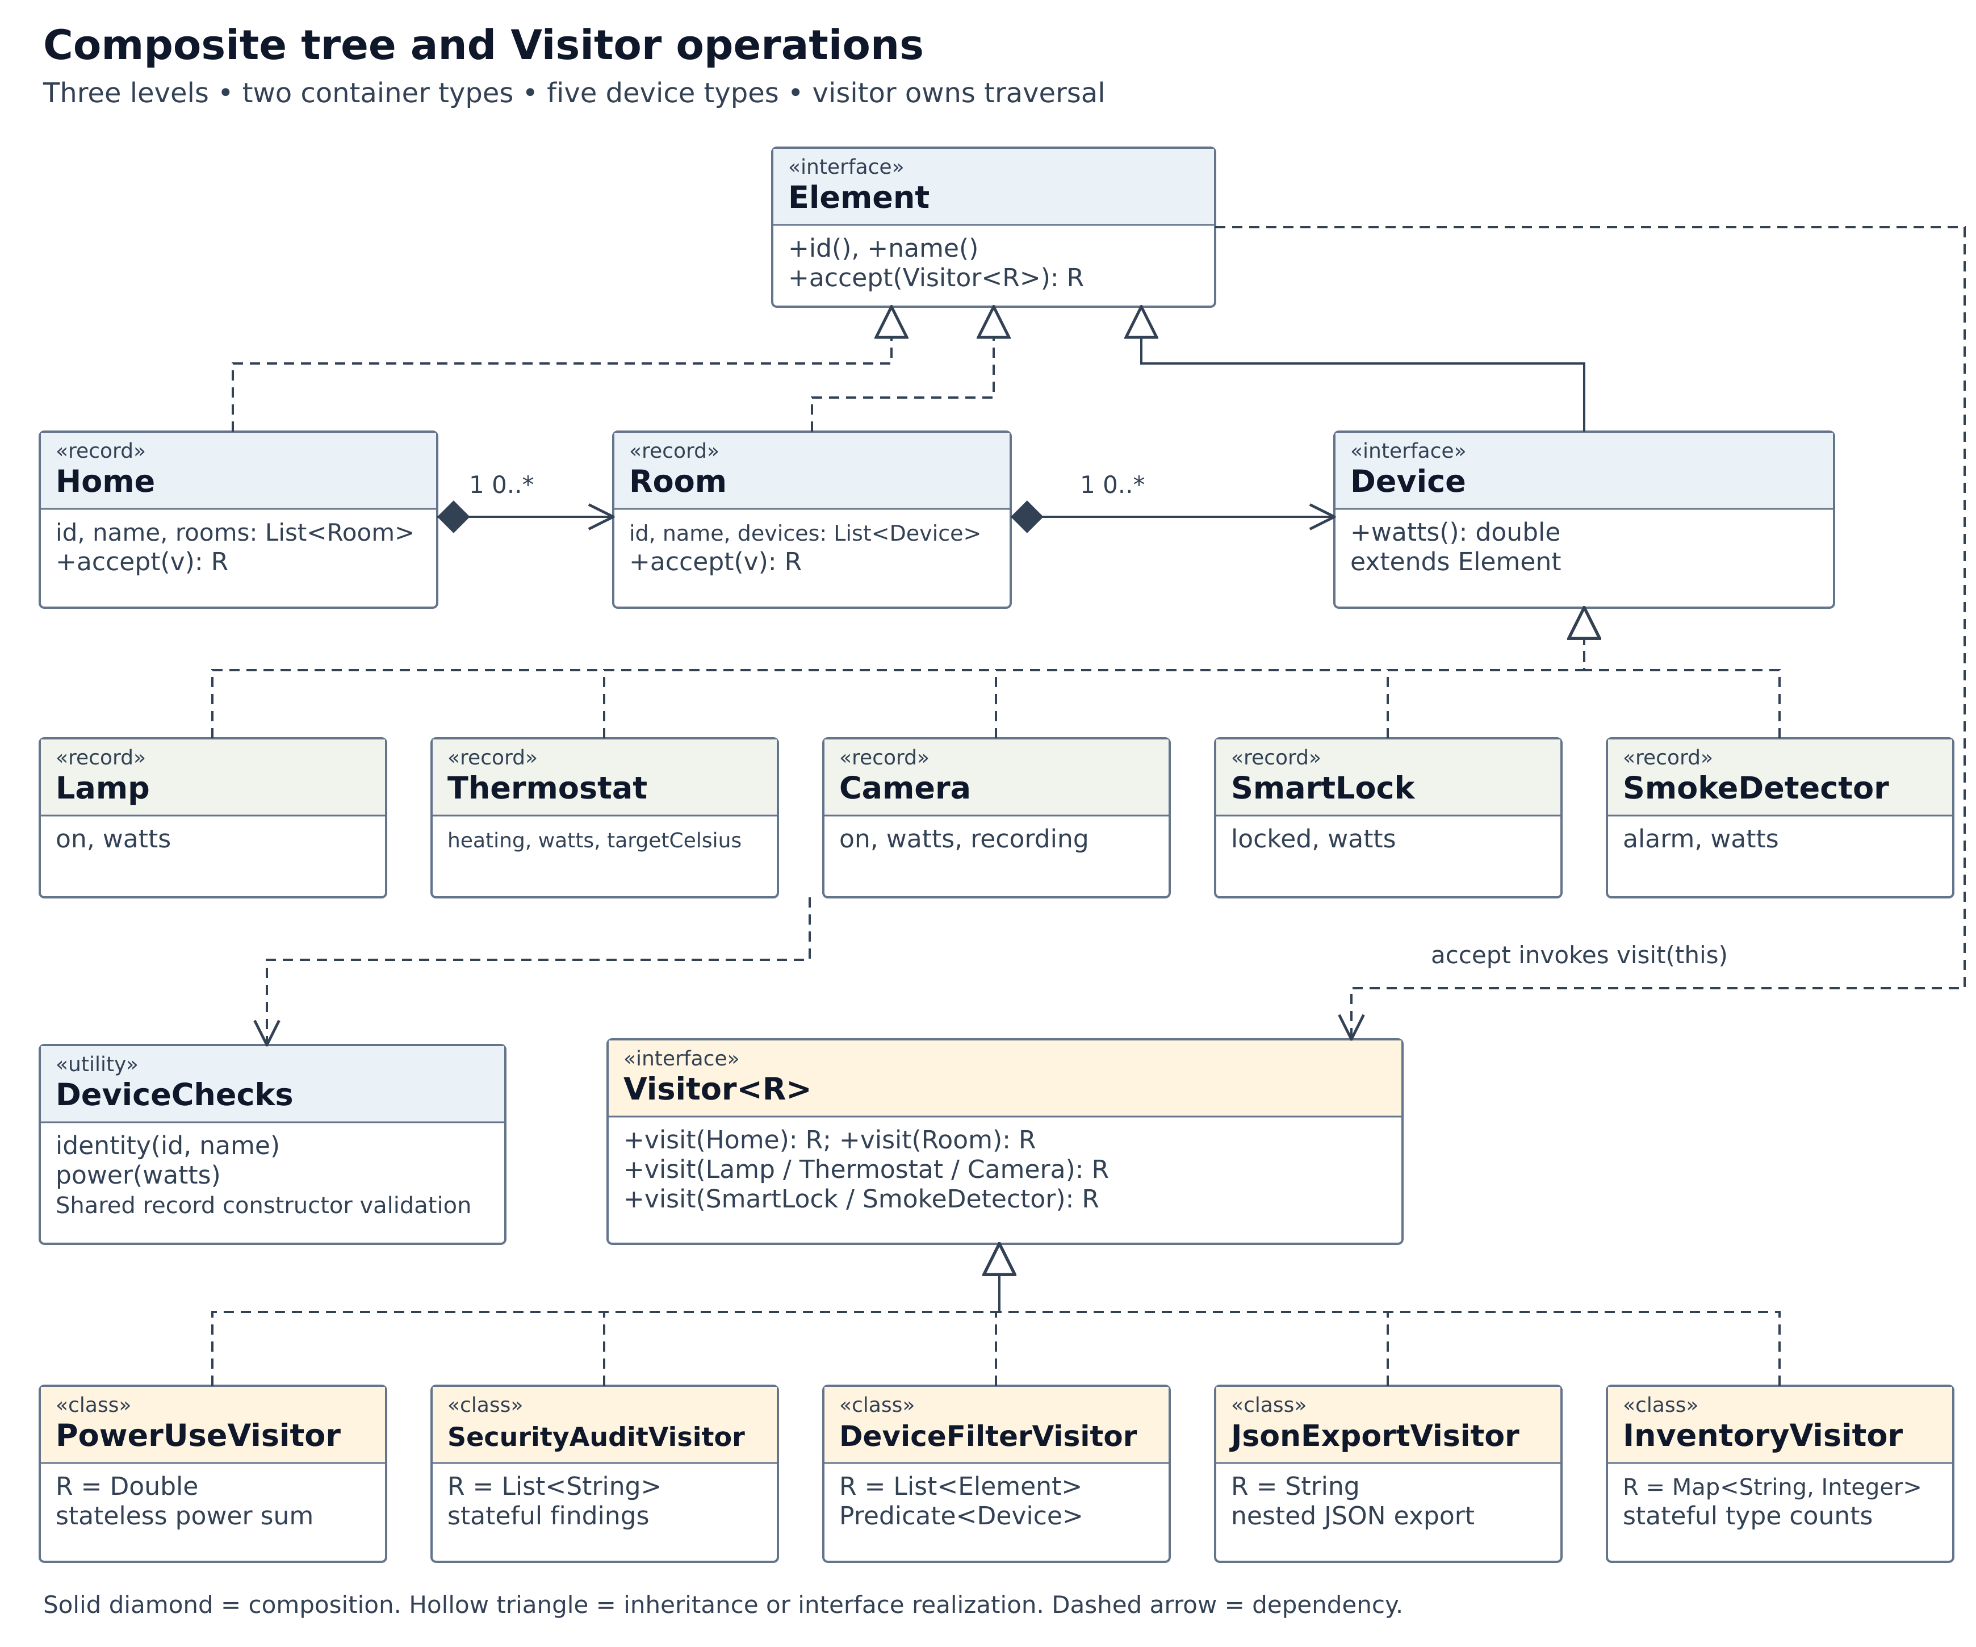
Figure 2 Two containers, five device leaves, the generic Visitor contract, five concrete operations, and shared constructor validation.
Each device also stores an ID and name through its record fields and Element contract. The picture abbreviates repeated members. DeviceChecks validates data records; its representative dependency is drawn once.

Integration and safe concurrent execution

A device event becomes a room report
When the entrance source publishes an unlocked door, SecurityAlarm receives the immutable room snapshot. It calls changed.room().accept(auditFactory.get()). Only that room’s devices are visited. The resulting findings become a new SecurityReport that MobileApp and AuditLog receive through Observer. A test proves that a known problem in another room is absent from this report.

Shared state and its protection
Shared data | Protection
Subscribers | CopyOnWriteArrayList per event type; immutable registry map
Room and source version | AtomicReference to an immutable VersionedRoom snapshot
Aggregate power readings | AtomicReference to an immutable map of versioned readings
Mobile counts | AtomicLong counters
Logs and failures | ConcurrentLinkedQueue
Stateful visitors | One fresh visitor confined to each operation

AtomicReference uses compare-and-set updates: if another thread changed the reference first, the update is retried from the newer snapshot. The update function only constructs values. Publishing happens once after a successful update, so a retry cannot duplicate the event.
Each source has a unique ID and owns one room. EnergyTracker compares source-local versions, so an older event cannot overwrite a newer reading. Every summary is calculated from one immutable map. Concurrent callback delivery has no global order; a previously calculated summary can arrive late. Final power therefore uses source snapshots after the workers finish.

Graceful shutdown
ProducerRunner receives an ExecutorService and timeout through its constructor. It submits three finite jobs, calls shutdown, waits for termination, and inspects Future results. Synchronous callbacks finish before a producer task completes. The normal run drains all accepted updates and leaves no executor threads. A timeout cancels unfinished work and throws a visible failure; lossless processing is not claimed after cancellation.

The classes and Clean Code structure
The implementation contains 33 production types. Each group below has one reason to exist. The separate explanation file describes every class individually with examples.
Files | Responsibility
Observer, Subject, ThreadSafeSubject | Generic event contracts and the reusable subscriber registry.
HomeEvent, EventType | Common event contract and notification categories.
DeviceStateChanged, EnergySummary, SecurityReport, AutomationCommand | Immutable event values with defensively copied collections.
DeviceSource | Own a room snapshot, replace a device atomically, publish updates.
MobileApp, EnergyTracker, SecurityAlarm, AutomationRules, AuditLog | Five independent listeners; EnergyTracker also acts as a subject.
Element, Device, Home, Room | Common element contracts and two tree container records.
Lamp, Thermostat, Camera, SmartLock, SmokeDetector | Five immutable leaf records containing device data.
Visitor, PowerUseVisitor, SecurityAuditVisitor, DeviceFilterVisitor, JsonExportVisitor, InventoryVisitor | Generic dispatch contract and five separate operations.
DeviceChecks | Shared identity and numeric validation for records.
Main, ProducerRunner | Composition root and explicit executor lifetime management.

Main creates and connects all application services. Required collaborators are passed through constructors. Service state is initialized eagerly; there are no service locators, setter injection, or lazy singleton services. A fresh audit visitor is an operation created for each request, not delayed initialization of a shared service.
Names describe domain responsibilities. Record validation is shared through DeviceChecks. Production code uses Java standard APIs only. JUnit is the sole test dependency. The project uses no event-bus library and no renamed weather, editor, or shape lecture example.

Verification and hand calculated results
JUnit class | Tests | Coverage
ObserverTest | 9 | Typed delivery, duplicates, runtime subscription changes, failures and immutability
VisitorTest | 12 | Power, stateful audit, filtering, nesting, escaping and dispatch
IntegrationTest | 7 | Related room only, republished reports, aggregation, versions and automation
ConcurrencyTest | 5 | Exact stress counts, concurrent unsubscribe, aggregation and shutdown
InventoryVisitorTest | 2 | New visitor and empty tree
SmokeDetectorTest | 4 | New device supported by all five visitors
Total | 39 | More than the required 15 test methods

Independent expected values
Fixture | Calculation | Expected
Test living room | 10 + 1000 + 8 + 2 | 1020 W
Test bedroom | 0 + 0 + 0 + 1 | 1 W
Whole test home | 1020 + 1 | 1021 W
Default demo home | 0 + 1000 + 8 + 2 + 6 + 1 | 1017 W
Registry stress test | 4 threads × 1000 events | 4000 callbacks

The test home has eight devices and three expected security findings. The demo home has six devices, including a smoke detector. They are different fixtures. Watts measure instantaneous power; energy in kWh would require a time interval.

What was executed
Production code compiled with Java 17 and -Xlint:all. The JAR passed runs with 3, 4, and 6 executor threads; counts were exact, JSON was parsed independently, and every process exited with zero listener failures. The standalone JDK-only checker passed 11 checks, including exactly 4000 stress deliveries.
All 39 test bodies passed a temporary local assertion compatibility harness. That is not the official JUnit engine. Its dependency could not be downloaded in the preparation environment, so mvn clean test must still be run on the student’s machine before claiming an official JUnit pass.

The two Visitor trade off commits

A new operation without changing elements
The commit tagged new-visitor adds InventoryVisitor and its tests. It changes exactly three files: InventoryVisitor.java, InventoryVisitorTest.java, and README.md. No existing element or Visitor interface changes. The operation can be applied directly to any existing element.

A new element changes every operation
The separate commit tagged new-element introduces SmokeDetector. It changes exactly ten files. Java requires all visitors to implement the new overload, making the extension cost visible at compile time.
- SmokeDetector.java adds the new leaf record.
- Visitor.java adds visit(SmokeDetector).
- PowerUseVisitor.java adds standby power.
- SecurityAuditVisitor.java adds smoke findings.
- DeviceFilterVisitor.java supports the new leaf.
- JsonExportVisitor.java writes detector fields.
- InventoryVisitor.java counts detectors.
- Main.java constructs the detector and displays inventory.
- SmokeDetectorTest.java verifies all affected operations.
- README.md records the trade-off and changed files.
Visitor works well when object types stay stable while new operations are frequent. If device classes changed constantly and many visitors already existed, updating every visitor could become too expensive. A data-driven model or a different design might then be preferable.
git show --stat new-visitor
git show --name-only new-element
The source archive includes a Git bundle preserving the real commits and tags. Copying source files into a new repository without restoring the bundle would lose this proof. The included commit dates are real and are not spread over two weeks.

Running the project and preparing the defense

Start the demo
Extract the archive and enter its smart-home directory. Java 17 can run the included executable JAR. Windows users may also use run.cmd.
java -jar dist/smart-home.jar 3 100
The arguments are executor threads and updates per producer. The default simulation alternates thermostat targets, lock state, and lamp state. It creates 300 device updates, 300 summaries, 300 reports, and 50 recommendations, giving 950 audit records.

Build and run the official tests
mvn clean test
mvn package
java -jar target/smart-home-1.0.0.jar
Use JDK 17 and Maven 3.9 or newer. Maven obtains JUnit and build plugins on its first run. A separate check without external libraries is available:
java --class-path dist/smart-home.jar validation/VerifyMain.java

Restore the proof commits
From the extracted archive’s top-level directory, restore the supplied Git bundle into a new working folder:
git clone Smart_home_history.bundle smart-home-with-history
cd smart-home-with-history
git log --oneline --decorate --all

Explain and change the code yourself
For the defense, be ready to trace a Lamp through double dispatch, demonstrate unsubscribe during concurrent publication, explain the 4000-event stress count, and show which files change for a new visitor versus a new device. Practice adding a visitor and rerunning the tests. The included DEFENSE_GUIDE.md supplies questions and short exercises.
The remaining submission tasks are to run the official JUnit suite, maintain genuine development history during the required period, create and submit your own GitHub repository link, and complete the live defense. The assignment gives 50 points for code and 50 for the defense. No remote repository was created or pushed during preparation.
Assignment source Assignment 6 Observer and Visitor Patterns supplied course brief

