**Final Year Project Guidelines**



***Department of Artificial Intelligence***

***FACULTY OF SMART AGRICULTURE***

**THE UNIVERSITY OF *AGRICULTURE*, D.I.KHAN**

**TABLE OF CONTENTS**

|  |  |  |
| --- | --- | --- |
| **Sr. #** | **Content** | **Page** |
| **1.** | **Sequence of Project Report Contents** | **3** |
| **2** | **Final Project Report -General Instructions** | **4** |
| **3** | **FYP Report Sample and Guidelines** | **6** |

1. **SEQUENCE OF PROJECT REPORT CONTENT**

The project report contents should be arranged according to the order mentioned below.

1. Title Page
2. Abstract
3. Final Approval Certificate
4. Declaration
5. Plagiarism Certificate
6. Turnitin Originality Report
7. Dedication (optional)
8. Acknowledgement (optional)
9. Table of Contents
10. List of Figures
11. List of Tables
12. List of acronyms (optional)
13. Chapter 1 (Introduction)
14. Chapter 2 (Background/Existing Work)
15. Chapter 3 (System Requirement Specification)
16. Chapter 4 (System Modeling and Design)
17. Chapter 5 (System Testing and Validation)
18. Chapter 6 (Conclusion)
19. Appendices
20. References

**FINAL PROJECT REPORT GENERAL INSTRUCTIONS**

* 1. Formatting
     1. Report should contain minimum 8000 words and maximum 10000 words (excluding the word count of initial pages, table of contents, list of figures, list of tables, chapters’ title pages and references)
     2. Use A4 size page with top, bottom, and right margin as 1 inch and left margin as 1.25 inches. Strictly follow margins throughout the report. No blank spaces will be left on either side.
     3. Use only one side of the page for printing.
     4. Times New Roman font style should be in entire report.
     5. A separator page containing the chapter (or appendix) number 18 pt size (bold) and chapter name in 22 pt size (bold) should be placed before start of each chapter (or appendix). This page should not contain page number.
     6. Headings / sub headings should be from 16 pt size to 12 pt size in bold depending upon level of heading.
     7. Body text should be in 12 pt size.
     8. Body text should be justified on both right and left side.
     9. The sections should be numbered with chapter number e.g 1.1, 1.2, and so on. The subsections should be numbered with the number of their parent sections e.g 2.1.1, 2.1.2 and so on.
     10. Only section numbers should be used/referred in the text. No bullets or other para number will be used.
     11. Figure and table: For caption use Arial Narrow, size 10. Provide table title at the top and figure title below the figure. Figures and tables should be numbered with chapter number as prefix, such as, 2.1, 2.2, 2.3 etc.
     12. Figures must be referred in the text, before they appear in the report.
     13. Figures and Tables should be referred with their number in text.
     14. **References:** List all the books, journals, research articles, web sites you referred for the Project and place the list under Bibliography or References at end of your report. The list should be numbered. Insert the number of reference material that you learnt, copied, or referred with the text in your report. For example a book on Java is placed at number 2 in your reference list and you are mentioning features of Java from that book in your report. You must insert [2] after writing the features of Java in your report. General reference like Wikipedia should not be used.
     15. **Roman Numbering:** The first few pages from dedication to List of Tables should be separately numbered in roman numbering as (i), (ii), (iii) and so on. The normal numbering (1, 2, 3, ….) will start from first page of chapter 1
  2. Plagiarism Check
     1. Two weeks before the final presentation, students will submit the printed copy of their project report, plagiarism form and soft copy of report to the focal person in the department.
     2. Focal person will check the plagiarism before within one week after submission.
     3. After Plagiarism check, the focal person will forward the plagiarism reports along with the hardcopies of FYP reports to Project Coordinator. The plagiarism report will also be forwarded to Supervisors and Group leader.
     4. Depending on the Plagiarism report Coordinator will allow the students to appear for final presentation
     5. If students clear the defense then the hard copy of FYP report will be forwarded to HOD.
     6. HoD will counter check the report and will forward the final version (before binding) to the Dean for the signature over “Final Approval Certificate”.
  3. Hard Binding
     1. The finally approved report will be hard bound in BLACK color for BSCS and in NAVY BLUE color for MCS. SILVER text will be embossed. It will contain the text of title page of your report.
     2. Degree title along with batch number, Project title and year of completion will be written on spine of the hard binding.

|  |  |  |
| --- | --- | --- |
| **BSCS-21** | **Title of Your Project** | **2025** |

* + 1. There should be two blank pages; one in the beginning of hard bind and one at the end of hard bind.
    2. Three hard bound copies will be submitted to the Project Coordinator. These copies will be distributed to Department, Library and Supervisor.
    3. Certificate with original signatures will be attached in first hard bound copy and its photocopy will be attached in other two copies.
    4. A CD will be attached at the end of hard binding containing certificate with original signatures. The CD should contain Proposal, Progress, Final Documentations along with Presentations, Project Source Code, Project Setup (if applicable), User manual (if applicable) and Supporting Tutorials (if applicable).

**FYP Report Sample**

**Font style:** Time New Roman,**Font size:** 18 Caps, Bold & Center aligned

**PROJECT NAME**



**Font style**: Time New Roman**, Font size**: 16 Bold&Center aligned

Do not use Ms/Mr/Sir , can use Dr./Prof./Engr.

**Student Name 1**

**Font style**: Time New Roman, **Font size**: 14 Italic, &Center aligned

**Student Name 2**

**Student Name 3**

###### Supervised By

**Supervisor Name**

###### Submitted for the partial fulfillment of BS Computer Science degree to the Faculty of Smart Agriculture

##### DEPARTMENT OF ARTIFICIAL INTELLIGENCE

**THE UNIVERSITY OF AGRICULTURE, D.I.KHAN**

**May, 2024**

**Font style**: Time New Roman, **Font size**: 14 Bold, Center aligned, **Date** must be at last line of the page. It should be month of submission of your report.

**Font style:** Time New Roman, **Font size:** 16 Bold, Caps &, Center aligned

**ABSTRACT**

First paragraph should start with brief **overview and the purpose of developed project** then it should have few statements about the **existing systems and the identified gap/problem**. After that it should have few statements about the **effectiveness/significance** of the work done in this project.

Second paragraph should mention the **main features/scope** of the developed system, the **proposed methodology/solution** and the **tools** which have been used for the development of the project.

Third paragraph should briefly discuss the system testing; including which **testing technique** has been used, on which system (hardware Specs) the developed system has been evaluated and what is the **overall result** of testing or **what has been achieved**.

Fourth paragraph should mentioned the **limitations of the developed project** and the possible improvements or enhancements that can be made in this project, as **future work**, to overcome these limitations.



***General Rules:***

* ***No of Pages:*** *Only one (at extreme condition it may have 2 pages)*
* ***No of Paragraphs:*** *3-4*
* ***No of Words:*** *Minimum 250 words*

**Font style**: Time New Roman/Arial,**Font size**: 16 Bold, Caps &, Center aligned

C**ERTIFICATE**

**Font style**: Time New Roman**, Font size:** 14, Center aligned

Dated:

**Final Approval**

It is certified that project report titled ‘**Title of your project**’ submitted by **Name of Student1**, **Name of Student2** and **Name of Student3** for the partial fulfillment of the requirement of **“Bachelor’s/Master’s Degree in Computer Science”** is approved.

**Font style**: Time New Roman,**Font size:** 14 Bold, Caps &, Center aligned

**COMMITEE**

Dr.

Dean Faculty of Smart Agriculture: Signature:

Dr.

HoD Computer Science: Signature:

Mr.

Head Project Committee: Signature:

Supervisor Name

Supervisor: Signature:

**DECLARATION**

**Font style**: Time New Roman/Arial,**Font size**: 16 Bold, Caps &, Center aligned

We hereby declare that our dissertation is entirely our work and genuine / original. We understand that in case of discovery of any PLAGIARISM at any stage, our group will be assigned an F (FAIL) grade and it may result in withdrawal of our Bachelor’s degree.

Group members:

Name Signature

Name of Student 1

Name of Student 2

Name of Student 3

**Font style**: Time New Roman/Arial,**Font size:** 16 Bold, Caps &, Center aligned

**PLAIGRISM CERTIFICATE**

This is to certify that the project entitled “**Title of your project**”, which is being submitted here with for the award of the “**Degree of Bachelor’s in Computer Science**”. This is the result of the original work by **Name of Student1, Name of Student2** and **Name of Student3** under my supervision and guidance. The work embodied in this project has not been done earlier for the basis of award of any degree or compatible certificate or similar tile of this for any other diploma/examining body or university to the best of my knowledge and belief.

**Turnitin Originality Report** Processed on

ID:

Word Count:

|  |  |  |
| --- | --- | --- |
| Similarity Index |  |  |
| % |  |
| Similarity by Source |  |
| Internet Sources: % |  |
| Publications: % |  |  |
| Student Papers: % |  |  |
| Date: |  | Supervisor Name (Supervisor) |

**Font style**: Time New Roman/Arial,**Font size:** 16 Bold, Caps and , Center aligned

**TURNITIN ORIGINALITY REPORT**

Group based Online Streaming Application using Android Mobiles [BSCS] by **Name of Student1, Name of Student2** and **Name of Student3**

From **Supervisor Name**

Processed on

ID:

Word Count:

Similarity Index %

Similarity by Source Internet Sources:

%

Publications:

%

Student Papers:

%

**SOURCES:**

**1.**

**2.**

**3.**

**4.**

**5.**

**6.**



**ACKNOWLEDGMENT**

**Font style**: Time New Roman,**Font size:** 16 Bold, Caps and , Center aligned.

##### (Optional)

Students may acknowledge the persons who supported them in the project work but should be very brief and precise.



**Font style**: Time New Romanl,**Font size:** 16 Bold, Caps&, Center aligned.

**TABLE OF CONTENTS**

Chapter Page

CHAPTER 1: INTRODUCTION 1

* 1. Project Domain: 2
  2. Problem Identification: 2
     1. Proposed Solution: 2
     2. Objectives 2
     3. Scope of the Project 2
  3. Effectiveness / Usefulness of the System 3
  4. Resource Requirement 3
     1. Hardware Requirement 3
     2. Software Requirement 3
     3. Data Requirement 3
  5. Report Organization 3

CHAPTER 2: BACKGROUND AND EXISTING SYSTEMS 4

* 1. Related Literature Review 5
  2. Related Systems/Applications 5
  3. Identified Problem from Existing Work 6
  4. Selected Boundary for Proposed Solution 6

CHAPTER 3: SYSTEM REQUIREMENT AND SPECIFICATIONS 7

* 1. System Specification 8
  2. System Modules 8
     1. Name of first Module 8
     2. Name of second Module 8
  3. Functional Requirements/Software Features 9
     1. Feature 1 9
  4. Non-Functional Requirements 9
     1. Usability 9

CHAPTER 4: SYSTEM MODELING AND DESIGN 10

* 1. System Design and Analysis 11
  2. Use Case Diagrams 11
  3. Full Dress Use Case/Detailed Use Case 12
     1. Arm/disarm systems - full dress Use case 13
  4. Activity diagram: 13
  5. Data Flow Diagram: 14
  6. System Sequence Diagram 16
  7. Sequence Diagram 17
  8. Design Class Diagram 18
  9. Architectural diagrams 19
     1. Interface Design 20
     2. Component Level design 20
     3. Deployment 21

CHAPTER 5: SYSTEM TESTING AND VALIDATION 22

* 1. System testing 23
  2. Testing Techniques 23
     1. Name of testing technique 1 23
     2. Name of testing technique 2 23
  3. Test Cases 23
     1. Test Case1: Name of Test Case 24
  4. Non –functional requirements 25

CHAPTER 6: CONCLUSION 27

* 1. Conclusion 28
  2. Limitations and Future Work 28

APPENDIX – I 29

REFERENCES 30

**Font style**: Time New Roman,**Font size**: 16 Bold, Caps &, Center aligned.

**LIST OF FIGURES**

Figure Caption Page No.

* 1. : Main Use Case Diagram 12
  2. : Activity Diagram 14
  3. : DFD Level 0 15
  4. : DFD Level 1 16

5.5: System Sequence Diagram 17

* 1. : Sequence Diagram 18
  2. : Class Diagram 19
  3. : Interface Design Diagram 20

4-9: Component Level Design 20

4.10: Deployment Diagram 21

**Captions should be exactly same as in text**

**Font style**: Time New Roman,**Font size**: 16 Bold, Caps &, Center aligned.

**LIST OF TABLES**

Table Caption Page No.

* 1. : Summary of Reviewed Literature 5
  2. : Summary of Existing System 5

4.3: Full Dress Use Case for Arm/disarm systems 13

* 1. : Test Case1 24
  2. : List of Common Non Functional Requirements 26

**Captions should be exactly same as in text**

# Chapter 1 INTRODUCTION

Start with some general statements to establish the background of the work, highlighting the recent trend and significance of the work done. Then discuss about the overall achievements and lacking of existing work for the selected domain and problem. After that add few statements emphasizing the need or motivation for the developed system.

Start a new paragraph providing brief overview of your system and mentioning how your system will contribute with the recent trends. Provide comparison of your developed system with existing systems.

### Project Domain:

Provide at least one paragraph (comprising of at least 5-6 lines) about the domain of you project and the problem that you’re planning to solve. Project domain must match with your project’s title such as domains may include image processing, artificial intelligence, IOT, data mining, web mining, and information security etc. (these mentioned domains are just examples you need to add according to your project).

### Problem Identification:

Provide a paragraph (minimum 6-7 lines) to clearly mention the problem that is required to be solved or to be improved (if a solution to that problem already exists). You may start by mentioning the work that has been done so far by others (in few statements) and then you may specify the issues, problems or limitations of existing systems that you want to cover or improve in this project.

#### Proposed Solution:

Write a paragraph (minimum 6-7 lines) on the overview of your project.

#### Objectives

In Bullets highlight the objectives (what you want to achieve). Each bullet should start with “To” e.g.

To design a system that……. To develop a system that….. To improve…..

To reduce……..

To increase….

To validate the developed system…..

#### Scope of the Project

Provide a paragraph (minimum 6-7 lines) that clearly describes the boundary of your system detailing the functionalities your system provides. You may also describe the environment in which the system will be used.

### Effectiveness / Usefulness of the System

Write a paragraph (minimum 6-7 lines) detailing the usefulness or application of your develop project. You may start this paragraph by highlighting the contribution of your system with respect to other existing systems and then you can emphasize on the usefulness or the application of your project.

### Resource Requirement

Write few lines to describe this section

#### Hardware Requirement

Write a Paragraph mentioning the specs of hardware, required for the development and execution of the developed system. In addition to this paragraph, you may add a table listing all specs of required hardware (The table must be refer in the paragraph).

#### Software Requirement

Write a paragraph detailing the software (tools or languages) required for the development of the project. In addition to this paragraph, you may add a table listing all required tools or languages (The table must be refer in the paragraph).

#### Data Requirement

Machine Learning based project needs some datasets to train or test the model. The requirement or details of such datasets can be mentioned here. It is only for machine learning based projects.

### Report Organization

Write a paragraph about the organization of your project. In how many chapters this report is organized and what each chapter is detailing. Write one-two sentence about each chapter.

**Chapter 2** **BACKGROUND AND EXISTING**

**SYSTEMS**

First paragraph of the chapter should be consisting of brief introduction of the problem (proposed system) which is under our consideration. The paragraph should not be more than 3 to 4 lines.

Second paragraph should consist of chapter composition and organization like in this chapter we have discussed the related systems and their applications along with their limitations …. These statements should be according to the content discussed in this chapter.

### Related Literature Review

In this section, we have to discuss at least three papers. There should be one paragraph for each paper containing overview of the paper, findings of the paper and limitations those we have observed in this paper.

At the end of all these paragraphs (after the discussion of all papers), we have to insert a table for their summarization. The sample table is as given below:

Table 2.1: Summary of Reviewed Literature

|  |  |  |  |  |
| --- | --- | --- | --- | --- |
| Year | Authors | Contribution | Techniques | Limitations |
|  |  |  |  |  |
|  |  |  |  |  |
|  |  |  |  |  |

### Related Systems/Applications

This section should consist of literature survey related to the problem. In this, we should discuss the existing systems those are already made or proposed by other researchers along with their functionalities and pros and cons. After discussion of each system we have to discuss its features and limitations as:

Paragraph 1 // discussion about system 1, including its features and limitations Paragraph 2 // discussion about system 2, including its features and limitations

Table 2.2: Summary of Existing System

|  |  |  |  |  |  |
| --- | --- | --- | --- | --- | --- |
| Year | System | Contribution | Tool/Technologies | Limitations | Applications |
|  |  |  |  |  |  |
|  |  |  |  |  |  |
|  |  |  |  |  |  |

### Identified Problem from Existing Work

In this section, we should discuss and elaborate the problems identified from existing systems/ existing work. These identified problems (limitations) can be with respect to technology, functional requirements or non-functional requirements. At the end of this paragraph, we can discuss how we can improve the existing systems in just 2 or 3 lines so that we can set the scope of our project from these identified problems (research gaps). While writing this paragraph we have to remember one thing; Identified problem must be written based on work discussed above.

### Selected Boundary for Proposed Solution

In this section, we should define the boundary of our proposed solution in 2 paragraphs.

First paragraph should consists of functionalities those we will implement in our proposed system in 3 to 4 lines along their need (with reference to the section 2.3)

In the second paragraph, we should discuss the all those functionalities which will not be implemented in our system due to some reasons. In this way, we will completely define the scope of our proposed project.

**Chapter 3**

**SYSTEM REQUIREMENT AND SPECIFICATIONS**

In first paragraph, we have to discuss about the composition of this chapter such as this chapter is about the modules/software requirements and non-functional requirements of the system. Start by writing a few lines about this chapter.

Second paragraph should consist of the chapter organization like in first section; we have discussed the system specifications.



**Note:** *Every system has different modules/requirements and non- functional requirements so do not try to copy-paste the examples given in the template. They*

*may go wrong in the case of your project.*

### System Specification

Write a paragraph about system specifications. Briefly explain what kind of specifications you are going to explain in this chapter.

### System Modules

Write a few lines about what system modules are. Tell briefly about the modules of your project. If possible, also state the rational for designing your system into the said modules. Then write a line telling that each module is described as following. After that, write each module as a second level heading. For example

#### Name of first Module

Describe the module under this heading

#### Name of second Module

Describe the module under this heading



*General Guidelines:*

* *The concept of module comes from modular programming paradigm which advocates that software should be composed of separate, interchangeable components called modules by breaking down program functions into modules, each of which accomplishes one function and contains everything necessary to accomplish this.*
* *A module is a separate unit of software or hardware. Typical characteristics of modular components include [portability](https://searchstorage.techtarget.com/definition/portability), which allows them to be used in a variety of systems, and [interoperability](https://searchapparchitecture.techtarget.com/definition/interoperability), which allows them to function with the components of other systems. The term was first used in architecture.*

### Functional Requirements/Software Features

Write a few lines of functional requirements. Your functional requirements should be aligned to your project scope and objectives. Briefly describe overall features/functional requirements. After that describe each feature/functional requirement as second level heading. For example

#### Feature 1

Describe briefly the functional requirement or feature.

### Non-Functional Requirements

Start by explaining non-functional requirements. Briefly explain the NFR’s of your system. Then describe each NFR as a second level heading. Do not write each NFR randomly, there should be a rational for each NFR and it should be measurable.

#### Usability

For example if one of your non-functional requirements is usability, tell what usability is. Why it is required for your system. Tell how would you measure usability?

For example “if a computer illiterate person learns to use this software in two attempts this software is said to be usable” (it may not be exactly this in case of your project)



*General Guidelines:*

* *Functional requirements describe ways a product must behave or any requirement which specifies what the system should do whereas nonfunctional requirements, also known as quality attributes, describe the general software characteristics or any requirement which specifies how the system performs a certain function or quality attributes*
* *There are many kinds of non-functional requirements (quality attributes) such as Speed, Size, Usability (ease of use), Reliability, Robustness, and Portability. Each system can fulfill only number of such quality attributes. So please only discuss only those non-functional requirements those are relevant to your system.*

**Chapter 4**

**SYSTEM MODELING AND DESIGN**

Start by adding few paragraphs in the beginning that describe why system design and analysis is required. Then briefly write about the system under discussion and provide an overview of specific system design and analysis diagrams used in the **project under discussion**. After that you may provide the organization of this chapter.



**Note:** *Every diagram is to be developed for every system. It depends on the nature of software system and the level of analysis required, on the basis of which it is decided which model is to be built and which not. For every diagram, write a paragraph under the heading to illustrate the figure*

### System Design and Analysis

Describe the different analysis and design models you have used.

### Use Case Diagrams

Write a few lines about use case diagram and its significance to be drawn for your project. These few lines will contain the explanation about the diagram that was drawn and refer the diagram in the paragraph using the following syntax (as shown in Figure 4.1).



*General Guidelines:*

* *Use-Case diagram can be skipped if there is no user interaction with the system. The diagrams should be clear and preferable tools to draw the diagrams are i. Rational Rose, ii. MS. Visio etc.*
* *(Figure and table: For caption use Arial Narrow, size 10. Provide table title at the top and figure title below the figure. Figures and tables should be numbered with chapter number as prefix, such as, 4.1, 4.2, 4.3 etc.) Add to general instructions.*

Use case diagrams are must as they depict the functionalities performed with the interaction of user. They help seeing the system from user’s perspectives. However use case diagram can be skipped only and only if there is not interaction of user with the system.

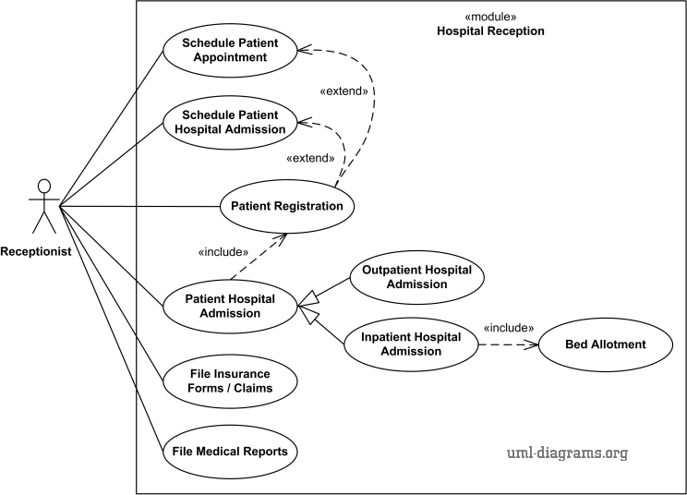

Figure 4.1: Main Use Case Diagram

### Full Dress Use Case/Detailed Use Case

Write a few lines about the importance of full dress use cases. Mention the use cases you have chosen to be full dressed. Give the **rationale** for selecting these use-cases for detailing.



*General Guidelines:*

* *However, not all use cases are needed to be shown in detail.*
* *Full dress use cases are not meant to be developed for every use case.*
* *Full dress use case /detailed use cases are developed only for those use cases which are complex and need explanation.*
* *Use cases like sign up/ login do not need to be full dressed.*

After that you need to write full dressed use case for each use case mentioned in use case diagram. For example as in figure 4.1, there are eight use cases, so each use case can be shown as a separate full dress use case. A simple template for full dress use case is as follows:

#### Arm/disarm systems - full dress Use case

Write the overview of this particular full dress use case. The student has to refer the table in the description too. A template for the full dress use case is provided as Table 4.1.

Table 4.3: Full Dress Use Case for Arm/disarm systems

|  |  |
| --- | --- |
| **Use Case Selection** | **Comment** |
| **Use Case name** | Starts with a verb. |
| **Scope** | The System under design. |
| **Level** | User goal or “subfunction”. |
| **Primary Actor** | Calls on the system to deliver its services |
| **Stakeholders and Interests** | Who cares about this use case, and what do they want? |
| **Pre-conditions** | What must be true on start and worth telling the reader? |
| **Success Guarantee** | What must be true on successful completion and worth telling the reader? |
| **Main Success Scenario** | A typical unconditional Happy path scenario of success. |
| **Extensions** | Alternate scenarios of success or failure. |
| **Special Requirements** | Related Nonfunctional requirements. |

### Activity diagram:

Write a few lines about activity diagram. Clearly mention the perspective for which you are drawing an activity diagram. Explain your activity diagram and refer the figure. An example of an activity diagram is shown in Figure 4.2.



*General Guidelines:*

*Activity diagram is basically a flowchart to represent the flow from one activity to another activity. Activity diagram can be used for –*

* *Modeling work flow by using activities.*
* *Modeling business requirements.*
* *High level understanding of the system’s functionalities.*
* *Investigating business requirements at a later stage.*

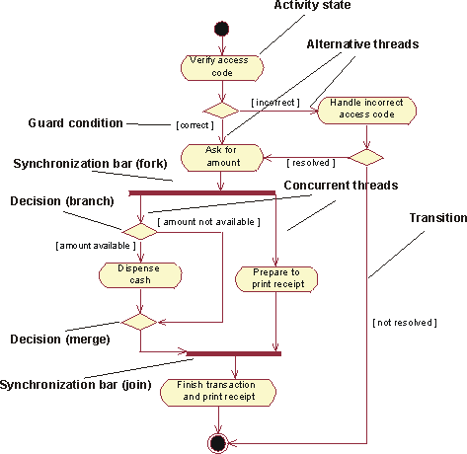

Figure 4.2: Activity Diagram

### Data Flow Diagram:

Start by telling about DFD’s. Mention the significance of developing DFD for your project. Explain your DFD and refer the figure(s) here. An example of level 0 DFD is shown in Figure 4.3.



*General Guidelines:*

* *A data-flow diagram is a way of representing a flow of a data of a process*

*or a system.*

* *Provides information about the outputs and inputs of each entity and the process itself.*
* *It has no control flow, there are no decision rules and no loops.*
* *There are different levels of DFD, for FYP report Level 0 and level 1 are MUST. Level 2 is optional. Further detailed level may not be required.*
* *DFD is developed only if there is some data involved. If there is any input data which your software receives, apply some process over it, and then shows the output.*

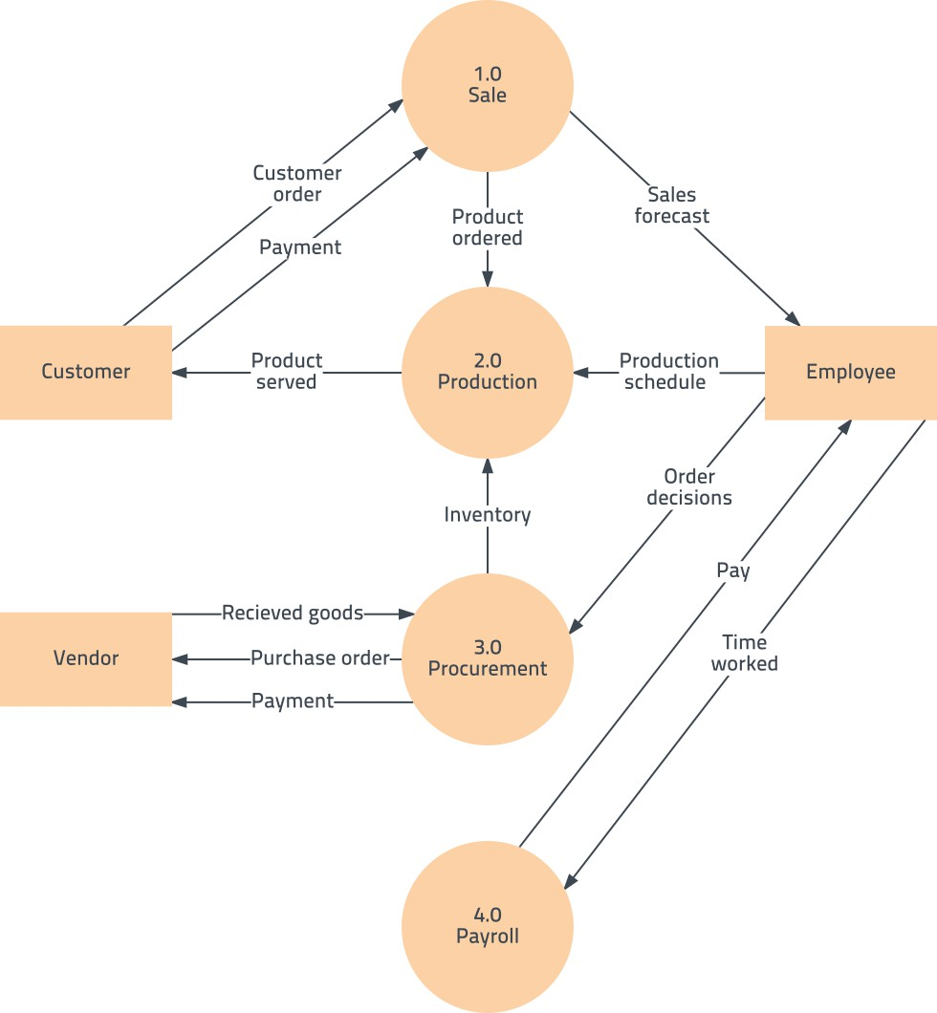

Figure 4.3: DFD Level 0

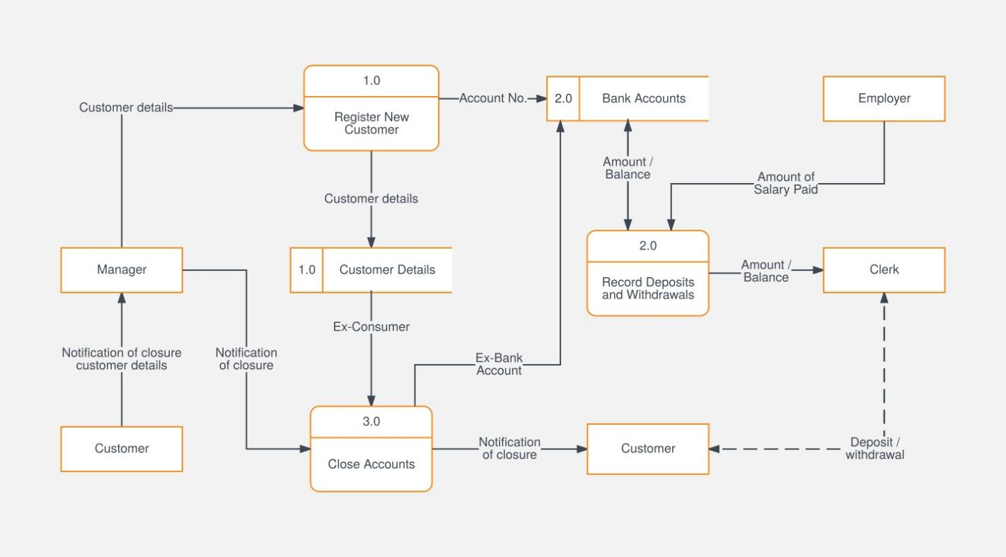

Figure 4.4: DFD Level 1

### System Sequence Diagram

Introduce SSD and write about your urge of drawing SSD with respect to your project. Clearly mention the scenarios/use cases for which you are developing SSD. Explain your SSD and refer the figure(s) here. An example of an SSD is shown in Figure 4.5.



*General Guidelines:*

* *A System Sequence Diagram is an artifact that illustrates input and output events related to the system under discussion.*
* *System Sequence Diagrams are typically associated with use-case realization in the logical view of system development. (These are basically the diagrammatic view of the full dress uses cases.)*
* *SSDs are derived from use case.*

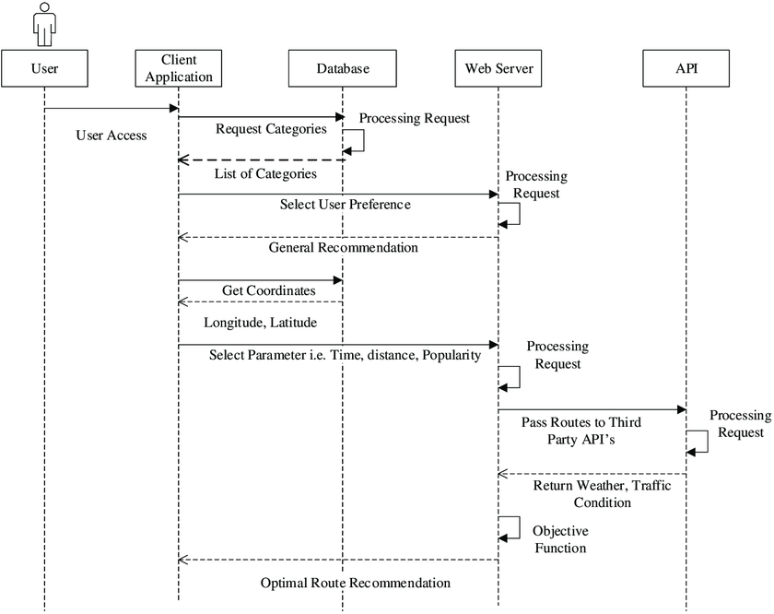

Figure 5.5: System Sequence Diagram

### Sequence Diagram

Write a few lines about SD. Clearly tell the events for which you are developing SD. Explain your SD and refer the figure(s) here. An example of an SD is shown in Figure 4.6.



*General Guidelines:*

* *A System Sequence Diagram is an artifact that illustrates input and output events related to the system under discussion.*
* *System Sequence Diagrams are typically associated with use-case realization in the logical view of system development. (These are basically the diagrammatic view of the full dress uses cases.)*
* *SSDs are derived from use case.*

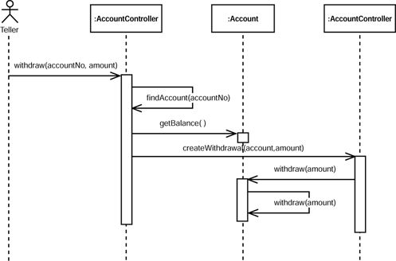

Figure 4.6: Sequence Diagram

### Design Class Diagram

Start by writing about the DCD. Discuss the important classes that are to be used in your project. Explain your Class diagram and refer the figure(s) here. An example of a class diagram is shown in Figure 4.7.



*General Guidelines:*

* *Class diagram is a must in FYP report. However if there are no classes involved (for example if the project merely involves networking) the design class diagram is not applicable.*
* *It is developed in accordance with the software classes of your system. However it may show the interaction of different instances.*

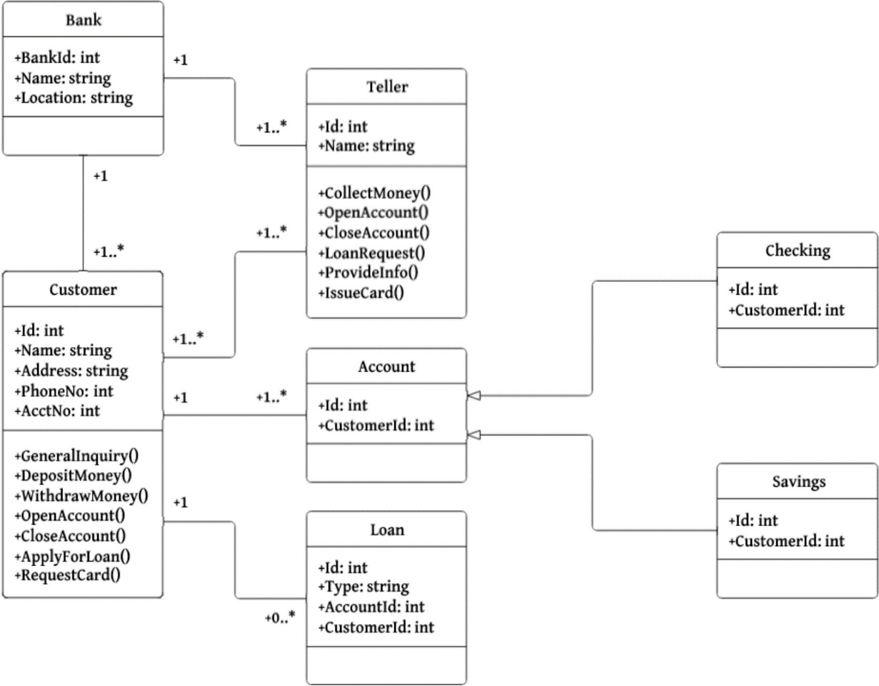

Figure 4.7: Class Diagram

### Architectural diagrams

Write a little about architecture diagrams. Tell which architecture diagram you are following and give the reason.

**4.8.1 Interface design (Needs Further discussion)**



*General Guidelines:*

* *Architecture serves as a blueprint for a system. It provides an abstraction to manage the system complexity and establish a communication and coordination mechanism among components*
* *These (or any of these) diagrams are to be built only where a diagrammatic illustration is necessary.*
* *The further diagrams in the architecture diagram can be interface design, component design and deployment diagram. If necessary these can be added to the project. Provide rationale for each diagram.*

#### Interface Design

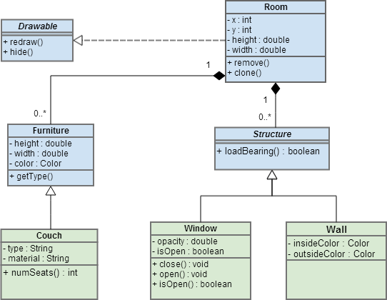

Figure 4.8: Interface Design Diagram

#### Component Level design

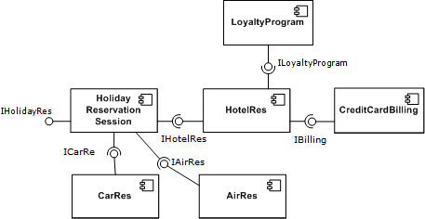

Figure 4-9: Component Level Design

#### Deployment

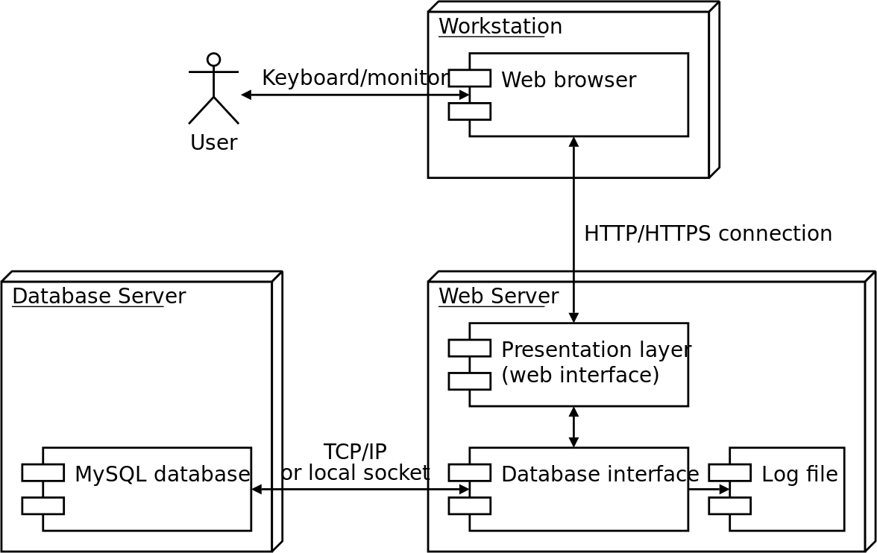

Figure 4.10: Deployment Diagram

**Chapter 5**

**SYSTEM TESTING AND VALIDATION**

Write paragraph to describe this chapter and provide the organization of this chapter.

### System testing

Tell briefly about system testing. What is the importance of testing a software? Write about the overview of testing techniques you applied. Write another paragraph to discuss the overall analysis of testing results. Analysis should match the objectives.

### Testing Techniques

Write few lines mentioning testing techniques in general and describing this section including which types of testing techniques **you are using to test** the developed project (The testing techniques maybe White Box, Black box, Unit Testing, Integration Testing etc.). After this write about each testing technique, that you are using, in sub heading as follow:

#### Name of testing technique 1

Write few paragraphs to include the following content

* + - * Define the testing technique1
      * Mention the rational for using that particular testing technique
      * Mention how you carried out the test
      * Discuss the results of test

#### Name of testing technique 2

Write few paragraphs to include the following content

* + - * Define the testing technique2
      * Mention the rational for using that particular testing technique
      * Mention how you carried out the test
      * Discuss the results of test

### Test Cases

Write few lines about test cases in general and then describe this section including how many test cases you have designed to test different functionalities of the developed project. After this write about each test case, that you designed, in sub heading as follow:



*General Guidelines:*

* *Test cases are important to mention.*
* *Your test cases should be aligned to your prioritized requirements*
* *You do not test each and every functionality of the system. Test cases (case/functionality to be tested according to the requirements or risks/priorities.*
* *Each test case is written as a third level heading.*

#### Test Case1: Name of Test Case

Write few lines about the feature for which you have designed this test case. Refer the respected table (e.g. table 5.1) in the paragraph.

Table 5.4: Test Case1

|  |  |  |  |
| --- | --- | --- | --- |
| **GENERAL INFORMATION** | | | |
| **Test Stage:** | Unit Functionality Integration System Interface  Performance Regression Acceptance Pilot  Specify the testing stage for this test case. | | |
| **Test Date:** | mm/dd/yy | **System Date, if applicable:** | mm/dd/yy |
| **Tester:** | Specify the name(s) of who is testing this case scenario. | **Test Case Number:** | Specify a unique test number assigned to the test case. |
| **Test Case Description:** | Provide a brief description of what functionality the case will test. | | |
| **Results:** | Pass Fail | **Incident Number, if applicable:** | Specify the unique identifier assigned to the incident. |
| **INTRODUCTION** | | | |
| **Requirement(s) to be tested:** | Identify the requirements to be tested and include the requirement number and description from the Requirements Traceability Matrix. | | |
| **Roles and Responsibilities:** | Describe each project team member and stakeholder involved in the test, and identify their associated responsibility for ensuring the test is executed appropriately. | | |
| **Set Up Procedures:** | Describe the sequence of actions necessary to prepare for execution of the test. | | |
| **Stop Procedures:** | Describe the sequence of actions necessary to terminate the test. | | |
| **ENVIRONMENTAL NEEDS** | | | |
| **Hardware:** | Identify the qualities and configurations of the hardware required to execute the test case. | | |
| **Software:** | Identify system and application software required to execute the test case. Specify any software that the test case will interact with. | | |
| **Procedural Requirements:** | Describe any constraints on the test procedures necessary to execute the test case. | | |

|  |  |
| --- | --- |
| **TEST** | |
| **Test Items and Features:** | Identify and describe the items and features that will be exercised by the test case. Group the test cases into logically related scenarios that test related items and features. For each item or feature, a reference to its associated requirement source should be included. |
| **Input Specifications:** | Define each input required to execute the test case, and reference any required relationships between inputs. |
| **Procedural Steps:** | Describe the sequences of actions necessary to prepare and execute the test case. Provide detailed test procedures for each test case; explain precisely how each test case will be executed. |
| **Expected Results of Case:** | Describe the outcome anticipated from the test case. Specify the criteria to be used to determine whether the item has passed or failed. |
| **ACTUAL RESULTS** | |
| **Output Specifications:** | Define all of the outputs and features required of the test case and provide expected values. While executing the test, record and describe the visually observable outputs as they occur. Produce tangible evidence of the output such as a screen print. At the conclusion, describe the actual outcome.  Indicate whether the test passed or failed, and identify any discrepancies between the expected results and the actual results. |

### Non –functional requirements

Write few lines about the non-functional requirements in general and then describe this section. After this write about each non-functional requirement of your system under sub headings. Some of the common non-functional requirements along with the measurement criteria are listed in table 5.2.



*General Guidelines:*

* *Nonfunctional requirements should not be stated as “software is very useful” “software is efficient” “software was tested and is accurate” NO.*
* *Follow proper metrics for measuring nonfunctional requirements*
* *Clearly explain the purpose of this table*

Table 5.5: List of Common Non Functional Requirements

|  |  |
| --- | --- |
| **Property** | **Measure** |
| Speed | Processed transactions/second User/event response time Screen refresh time |
| Size | Mbytes  Number of ROM chips |
| Ease of use | Training time  Number of help frames |
| Reliability | Mean time to failure Probability of unavailability Rate of failure occurrence Availability |
| Robustness | Time to restart after failure Percentage of events causing failure  Probability of data corruption on failure |
| Portability | Percentage of target dependent statements Number of target systems |

## Chapter 6 CONCLUSION

Write a paragraph to describe this chapter; what does this chapter contain and how it is organized. This chapter usually has two sections/paragraphs. In the first section, you will write concluding remarks, and in the second section future works will be discussed.

### Conclusion

Write a paragraph that should include the following points

* + - Overview of your project
    - Synthesis of key features of your project.
    - Results/Achievements of the developed system



*General Rules:*

* *State your conclusions in clear, simple language.*
* *Do not simply reiterate your results or the discussion.*
* *Reminds the reader of the strengths of your main argument(s) and reiterates the most important evidence supporting those argument(s).*

### Limitations and Future Work

In this section, you will write about the limitations of your developed project and how these limitations can be overcome as a future work.



*General Guidelines:*

* *Recommendations are often included with a report’s conclusion, [although](http://www.who.int/about/copyright/en/) they serve different purposes.*
* *Recommendations suggest actions to be taken in response to the findings of a*

*report.*

* *Report structure should lead up to the recommendations and provide justification for them.*

# APPENDIX – I



***Appendices should be inserted as Appendix – I, Appendix – II, and so on. These should include extra information (conversions tables, Source codes, long tables, proofs, definitions of terms, or any material that would help in understanding contents of the report/thesis), software installation guide and user manual of the system etc.***

# REFERENCES



***Note:*** *The list of books, articles and other sources should be listed at the end of report. All references must be used/ cited in the text. The general format is as follows:*

**Book**

1. W.K. Chen. *Linear Networks and Systems*. Belmont, CA: Wadsworth, 1993, pp. 123-35.

**Book Chapters**

1. J.E. Bourne. “Synthetic structureof industrial plastics,” *in Plastics*, 2nd ed., vol. 3. J.Peters, Ed. New York:McGraw-Hill, 1964,pp. 15-67.

**Article in a Journal**

1. G. Pevere. “Infrared Nation.” *The International Journal of Infrared Design*, vol. 33, pp. 56- 99, Jan. 1979.

**Articles from Conference Proceedings (Published)**

1. D.B. Payne and H.G. Gunhold. “Digital Sundials ang broadband technology,” in *Proc.* IOOC- ECOC, 1986,PP. 557-998.

**Papers Presented at Conferences (Published)**

1. B. Brandli and M. Dick. “Engineering names and concepts,” presented at the 2nd Int. Conf. Engineering Education, Frankfurt, Germany, 1999.

31