**Structured Query Language (SQL)**

**1. Create, Use and Drop Database**

1.1 Create a Database

1.2 Use a Database

1.3 Drop a Database

**2. Constraints in SQL Database**

2.1 Not Null Constraints

2.2 Default Constraints

2.3 Unique Constraints

2.4 Primary Key Constraints

**3. Create a Stored Recorded in Table**

3.1 Create a Table

3.2 Stored Record in Table

**4. Select and Distinct Statement**

4.1 Select a Single Column from Table

4.2 Select a Multiple Column from Table

4.3 Select Entire Columns from Table

4.4 Select Distinct

**5. Where Clause**

5.1 Simple Conditions

5.2 And Conditions

5.3 OR Conditions

5.4 Not Conditions

5.5 Like Conditions

5.6 Between Condition

**6. Function**

6.1 Min()

6.2 Max()

6.3 Count()

6.4 Sum()

6.5 Avg()

6.6 String LTRIM()

6.7 String Lower()

6.8 String Upper()

6.9 Reverse()

6.10 String Substring()

**7. Order By**

7.1 Ascending Order

7.2 Descending Order

**8. Top Clause**

**9. Group By**

**10. Having Clause**

**11. Update Statement**

**12. Delete Statement**

**13. Truncate Statement**

**14. Join Statement**

14.1 Inner Join

14.2 Left Join

14.3 Right Join

14.4 Full Join

14.5 Update using Join

**15. Union and Intersection Operator**

15.1 Union Operator

15.2 Union All Operator

15.3 Except Operator

15.4 Intersect Operator

**16. Create View and Drop View**

16.1 Create View

16.2 Drop View

**17. Alter Table**

17.1 Add Column

17.2 Drop Column

**18. Merge Statement**

**19. Table Valued Function**

**20. Temporary Table**

**21. Case Statement**

**22. IIF() Function**

**23. Stored Procedure**

1. **Create, Use and Drop the Database**
2. **Create a Database**

**Syntax:**

create database [databasename];

**Example:**



Here we create a database with the name of the company

1. **Use a Database**

**Syntax:**

Use [databasename];

**Example:**



Here we use a company database.

1. **Drop a Database**

**Syntax:**

Drop database [databasename];

**Example:**



Here we delete a company database.

1. **Constraints in SQL Database**

Constraints are used to specify rules for data in table

1. **Not Null Constraints**

Not Null constraints ensure that a column cannot have a Null value

**Example:**



For example, if we specify no null constraints on *e_salary* columns then it’s meant no null value should be in that column.

1. **Default Constraints**

Default constraints set a default value for cols when no value is specified

**Example:**



For example, if we specify default value 25 in *e_age* columns then it’s meant all the values in that column will be 25

1. **Unique Constraints**

Unique constraints ensure that all values in cols are different.

**Example:**



For example, if we specify unique constraints in the *e_name* column then it’s meant all the values in that column will be unique

1. **Primary Key Constraints**

* Primary key constraint uniquely identifiers each record in a table.
* It is also a combination of *not null + unique*
* **Note:** in table no more than one primary key

**Example:**



For example, if we assign a primary key on the e_id column then it means all the values in that column are unique and not null.

1. **Create and Store Record in Table**
2. **Create a Table**

**Syntax:**

1. **Stored Record in a Table**

**Syntax:**

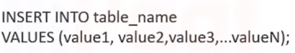

1. **Select and Distinct Statement Syntax**

**Syntax:**

1. **Select a Single Column from Table**

Here we select the **name** column from the company table that we create and store the value inside that.



1. **Select a Multiple Column from Table**

Here we select the **name, age, department** columns from the company table that we create and store the value inside that.



1. **Select Entire Columns from Table**

Here we select the **all** columns from the company table that we create and store the value inside that.



1. **Select Distinct Syntax**

Select Distinct (unique value) is used to select only distinct values from our column.

**For example,** in the gender column, we have multiple male and female records, and we want only unique



1. **Where Clause**

Let’s filter records with where clause

Where Clause is used to extract records that satisfy a condition

For example: age >60 , Occupation = Data Scientist

1. **Simple Conditions**

**Syntax:**

**Example:**

1. Age >= 22



1. Gender = male



1. salary >= 7200



1. **And Conditions**

AND operator displays records if all the conditions separated by AND are TRUE

For example: age >60 **AND** Occupation = Data Scientist

Let’s impose multiple conditions with AND

**Syntax:**

1. Age >= 22 AND salary >= 7200



1. Age <= 20 AND salary >= 5000 AND Gender = female



1. **OR Conditions**

OR operator displays records if any of the conditions separated by OR are TRUE

For example: age >60 **OR** Occupation = Data Scientist

Let’s impose multiple conditions with OR

**Syntax:**

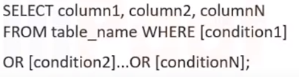

1. e_dept = 'Data Scientist' or e_dept = 'Data Analysis'



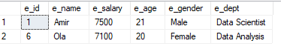

1. **Not Conditions**

Nor operator displays records if the condition is **NOT** True

For example: Occupation = Data Scientist >> then display except Data Scientist

Let’s impose records where the condition is NOT TRUE

**Syntax:**

1. Not e_dept = 'Data Scientist' (show all except this)



1. **Like Conditions**

Like operator is used to extract records where a particular pattern is present

For example: pattern John will display Johnathon and Johny etc

**Wild Card Character**





**Syntax:**

1. Extract name with K letter



1. Extract department only who have data in pattern



1. Select all employee who age in 20



1. **Between Conditions**

Between operator is used to select values within in given age

For example, salary range between 5000 and 6000

Note: here 5000 and 6000 are inclusive

**Syntax:**

1. Age between 19 to 22



1. **Functions**

Number Function and String Function

1. **Min()**

Give the smallest value

**Syntax:**

**Example**





1. **Max()**

Give the largest value

**Syntax:**

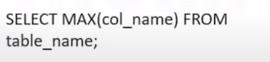

**Example**





1. **Count()**

Return the number of rows that match specific criteria.

**Syntax:**

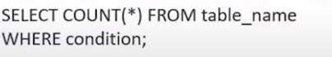

**Example**





1. **sum()**

return the sum of selected numeric column

**Syntax:**

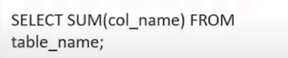

**Example**





1. **Avg()**

return the Average of selected numeric column

**Syntax:**

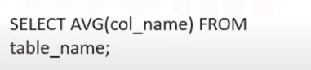

**Example**





1. **String LTRIM()**

Removes blank on the left side of the character expression

**Example**



1. **String LOWER()**

Convert all characters to lower case letters

**Syntax**

**Example**



1. **lower ()**

Convert all characters to lower case letters

**Syntax**

**Example**



1. **Upper ()**

Convert all characters to upper case letters

**Syntax**

**Example**



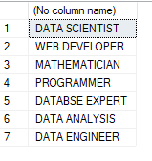

1. **Reverse ()**

Reverse all case letter into reverse

**Syntax**

**Example**



1. **String SUBSTRING ()**

Given a substring from the original strings

**Syntax**

**Example:**



1. **Order By**

Order by is used to sort the data in ascending or descending order.

**Example of Ascending order (By Default)**



**Example of Descending order**



1. **Top Clause**

Top is used to fetch the TOP N records

**Example**



1. **Group By**

Group by is used to get aggregate result with respect to a group

**Example**



**10. Having Clause**

Having clause is used in combination with group by to impose conditions on groups

**Example:**



**11. Update Statement**

The update is used to modify the existing records in a table

**Example:** (update the age of amir)



**12. Delete Statement**

The Delete statement is used to delete existing records in the table

**Example:** (delete the row of Nader)



**13. Truncate Statement**

Truncate statement deletes all the data inside the table

**Example** (delete all records of employee)





1. **Join**

By using join we can join multiple tables on the basis of different types which we will discuss now.

1. **Inner Join**

Inner Join returns records that have matching values in both tables. It is also known as simple join.

**Example**

1. **Left Join**

Left Join returns records all the records from the left table, and the matched records from the right table

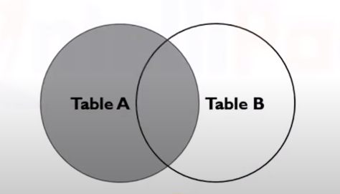

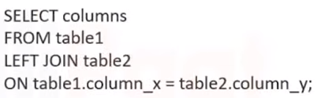

**Example**

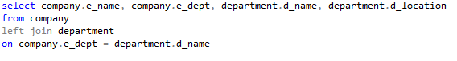

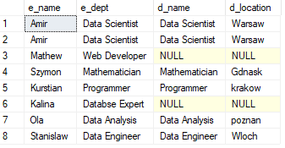

1. **Right Join**

Right join return s all the records from the right table, and the matched records from the left table.

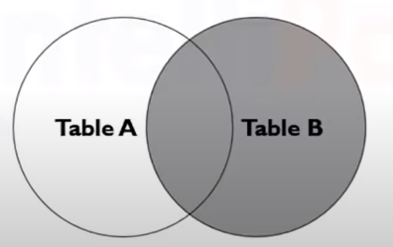

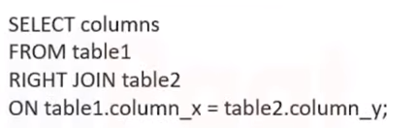

**Example**

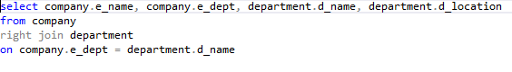

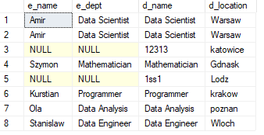

1. **Full Join**

It returns all rows from the left table and the right table with Null values in place where join condition is not met

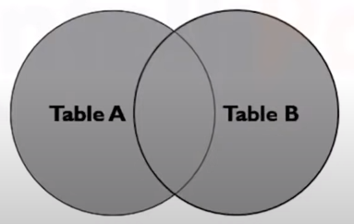

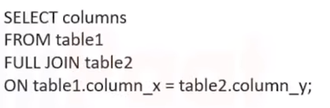

**Example**

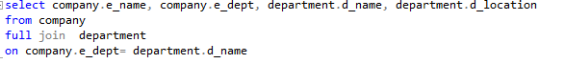

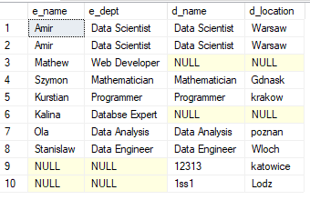

1. **Update using join**

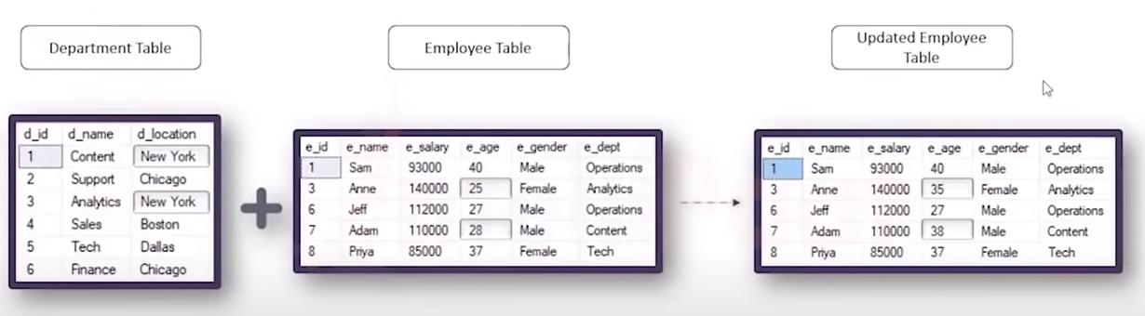

**Example:** update the company age where department location is warsaw

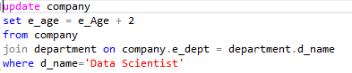

**15. Union and Intersection operator**

We will use these two tables for union and intersection operation

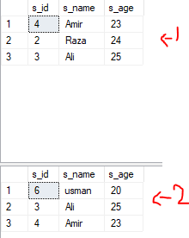

1. **Union operator**

Union operator is used to combine the result-set of two or more SELECT statement

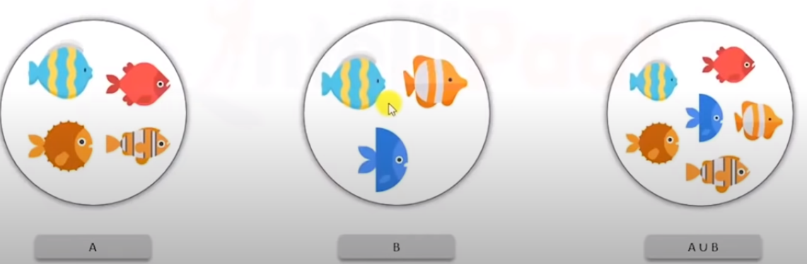

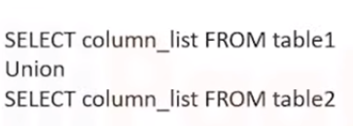

**Example:**



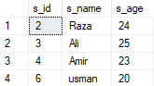

1. **Union All operator**

Union operator gives all the rows from both the tables including the duplicate

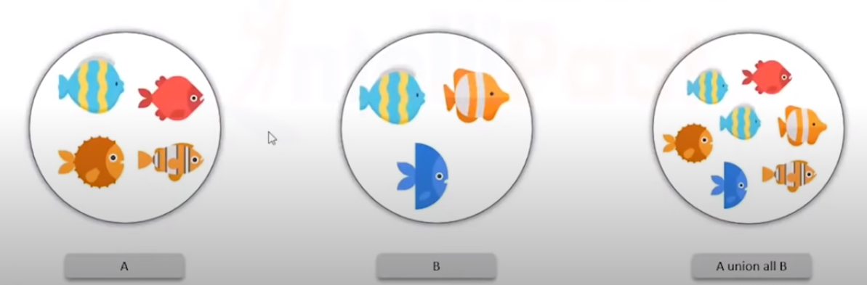

**Example:**



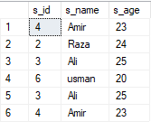

1. **Except Operator**

Except Operator combines two select statements and returns unique records from the left query which is not part of the right query.

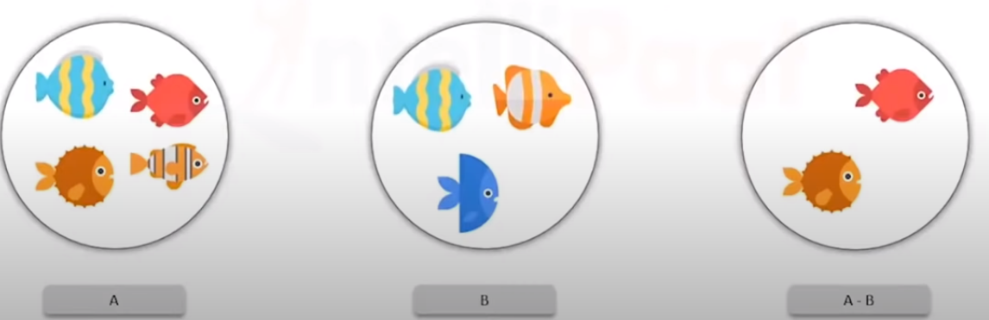

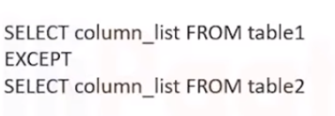

**Example:**





1. **Intersect Operator**

Intersect Operator helps to combine two select statements and returns the records which are common to both the select statements.

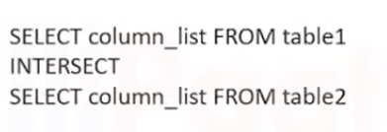

**Example:**



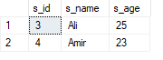

**16. Create View & Drop View**

1. **Create View**

View is a virtual table based on the result of an sql statement.

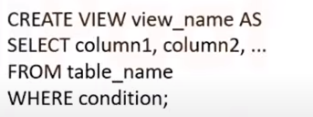

**Example:**





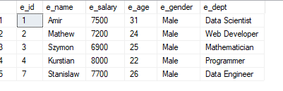

1. **Drop View**



**Example**



We drop male student view that we created

**15. Alter Table**

Alter table statement is used to add, delete or modify columns in a table

1. **Add Column**

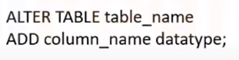

**Example**

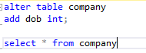

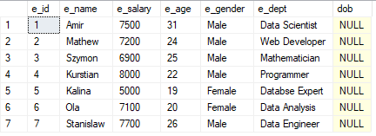

1. **Drop Column**

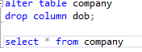

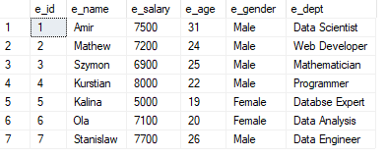

**18. Merge**

Merge is the combination of Insert, delete and update statements.

**Example**

**19. Table Valued Function**

Table valued function returns a table

**Example**

**20. Temporary Table**

Temporary Table are created in tempDB and delete as the session is terminated.

**Example**

**21. Case Statement**

Case Statement helps in multi way decision making.

**Example**

**22. IIF() Function**

IIF() function is an alternative for the case statement.



**Example**

**23. Stored Procedure**

Stored procedure is a prepared sql code which can be saved and reused.



**END😊**