Dataset: 20140920-OT1-dynamics
MIFlowCyt-Compliant Items

Requirement | Please Include Requested Information
1.1. Purpose | To measure ppERK response of TCR stimulated mouse CD8+ T-cells to SRC and MEK inhibition.
1.2. Keywords | SRC, MEK, MAP-Kinase, CD8, T-Cell
1.3. Experiment variables | Dasatinib (DOSE), 5 minutes, followed by  1 nM SIINFEKL pre-treated RMA-S cells (10 RMA-S, to 1 OT-1 cell), 10 minutes
1.4. Organization name and address | Memorial Sloan Kettering Cancer Center, New York, NY, 10065, USA
1.5. Primary contact name and email address | Grégoire Altan-Bonnet  gregoire.altan-bonnet@nih.gov
1.6. Date or time period of experiment | September 2014
1.7. Conclusions | Applied Dasatinib dose has significantly changed ppERK response vs. untreated control.
1.8. Quality control measures | -Biological replicate experiments were performed  -Stimulating antigen, SIINFEKL, dose was optimized by separate titration experiments  -Dasatinib doses were optimized by separate titration experiments  -Temperature of signaling experiment controlled  -Ratio of antigen presenting cells (APCs) to measured OT-1 cells was optimized by titration experiments.  -Antibody labeling concentrations were standardized  -Labeling of phospho-proteins was standardized and temperature controlled  -More details may be found in Vogel et al. Nat. Comm. 7, 12428 (2016)
2.1.1.1. (2.1.2.1., 2.1.3.1.) Sample description | Primary mouse T lymphocytes (OT-1), activated ex vivo and cultured for up to 10 days. OT-1 cells were activated by peptide (SIINFEKL) treated and irradiated (3,000 RAD) primary antigen presenting cells (APCs) from a B6 mouse.  Cell cultures were maintained by Ficoll-Paque gradient centrifugation and administration of exogenous IL-2 (1 nM) every other day. All cells were cultured at 37 °C and 5% CO2 in RPMI-1640 supplemented with 10% fetal bovine serum, 10 ug/mL penicillin and streptomycin, 2 mM glutamine, 10 mM HEPES (pH 7.0), 1 mM sodium pyruvate, 0.1 mM non-essential amino acids and 50 uM beta-mercaptoethanol prepared by MSKCC core media preparation facility.
2.1.1.2. Biological sample source description | -ppERK abundance measured in primary mouse T lymphocytes.  -RMA-S TAP-deficient T-cell lymphoma cell line was used as APCs for signaling experiments.  -APCs for primary OT-1 cell culture prepared from primary mouse splenocytes and lymphocytes.
2.1.1.3. Biological sample source organism description | -APCs prepared for primary OT-1 cell culture were harvested from C57BL/6N (B6; Taconic Farms) mice.  -ppERK measured in T lymphocytes were harvested from OT-1 TCR transgenic RAG2 -/- (Taconic Farms) mice.  Mice were bred, maintained, and euthanized at Memorial Sloan Kettering Cancer Center (MSKCC) in compliance with our animal protocol. The animal protocol was reviewed and approved by the Institutional Animal Care and Use Committee (IACUC) of the Memorial Sloan Kettering Cancer Center (New York NY). The protocol number is 05-12-031 (last renewal data: 23rd December 2013).
2.1.2.2. Environmental sample location | Not applicable
2.3. Sample treatment description | The ppERK response to SRC and MEK inhibition was measured using primary OT-1 T-lymphocytes activated with RMA-S APCs.  RMA-S cells were suspended in culture with 1 nM SIINFEKL peptide for 2 h at 37 °C, 5% CO2, and on a rotator to guarantee mixing.  -OT-1 cells were labeled with an amine-reactive dye, CTV, according to the manufacture’s protocol (Molecular Probes) for in silico identification. Cells were allowed to rest for one hour after CTV staining, and then distributed them in a 96-well v-bottom plate. Cells were then incubated with unique doses of either SRC or MEK inhibitor at a temperature of 37 °C for 5 minutes. After which, we added the peptide pulsed RMA-S cells (10 RMA-S to 1 OT-1 T cell) and pelleted mixture of cells by centrifugation for 10 s at 460 rcf at room temperature. The RMA-S and OT-1 cell pellet was then incubated at a temperature of 37 °C for 10 minutes. Followed by 15 minutes of chemical fixing with 2% PFA on ice and then permeabilization with ice cold 90% MeOH. Samples were kept at a temperature of -20 °C until labeling for flow cytometry.
2.4. Fluorescence reagent(s) description | Cells were labelled with primary antibodies against doubly phosphorylated ERK 1/2 (pT202, pY204; clone E10; 1:300 dilution), phosphorylated MEK 1/2 (p-S221; clone 166F8; 1:100 dilution), phosphorylated STAT5 (p-Y694; clone C11C5; 1:200 dilution)—purchased from Cell Signaling Technology (Beverly, Massachusetts)—and polyclonal goat anti-STAT5 (catalogue number sc-835-G; 1:200 dilution) purchased from Santa Cruz Biotechnology (Santa Cruz, California). Secondary antibodies tagged with fluorescent molecules include PE conjugated donkey anti-mouse (catalogue number 715-116-151), APC conjugated donkey anti-mouse (catalogue number 715-136-151), FITC conjugated donkey anti-rabbit (catalogue number 711-097- 003), and Alexa Fluor 647 conjugated donkey anti-goat (catalogue number 705-605-147) were all purchased from Jackson ImmunoResearch (West Grove, Pennsylvania; used at 1:200 dilution). In addition, Brilliant Violet 421 donkey anti-rabbit polyclonal antibody was purchased from BioLegend (San Diego, California; catalogue number 406410; used at 1:200 dilution). Surface markers CD8a (clone 53–6.7; used at 1:200 dilution) and CD4 (clone RM4-5; used at 1:300 dilution) tagged to fluorescent molecules were purchased from Tonbo biosciences (San Diego, California).
3.1. Instrument manufacturer | BD Biosciences
3.2. Instrument model | LSRII
3.3. Instrument configuration and settings | Parameter voltages:  FSC: 450  SSC: 225  FITC (pMEK): 550  A-700 (CD8): 550  PE (ppERK): 425  Pacific Blue (CTV): 250  Laser settings:  LASER1ASF 1.08  LASER1DELAY 0.00  LASER1NAME Blue  LASER2ASF 1.00  LASER2DELAY 99.99  LASER2NAME Red  LASER3ASF 1.27  LASER3DELAY 66.41  LASER3NAME UV  LASER4ASF 1.05  LASER4DELAY 130.04  LASER4NAME Green  LASER5ASF 1.06  LASER5DELAY 34.67  LASER5NAME Violet
4.1. List-mode data files | All data for this experiment can be found in  https://github.com/AmirErez/BimodalLogspaceCytA/tree/master/Data/20140920-OT1-dynamics  In particular, the list-mode file  Specimen_005_E5_E05.fcs  and accompanying compensation single stain controls.
4.2. Compensation description | Compensation samples were prepared the same way as the sample cells. See compensation plots below.
4.3. Data transformation details | Explained in main article
4.4.1. Gate description | See figures below for detailed visual description.  Cells were gated for CD8+CTV+ with extremely high FSC outliers excluded.
4.4.2. Gate statistics | See figures below
4.4.3. Gate boundaries | See figures below

Gating strategy:

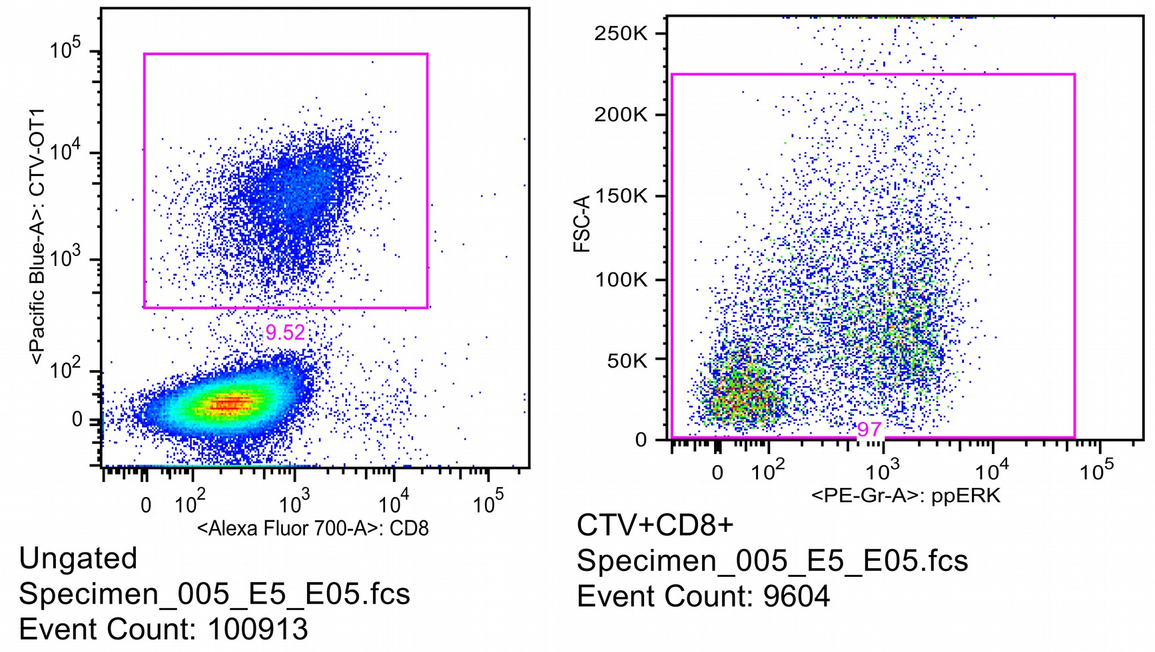

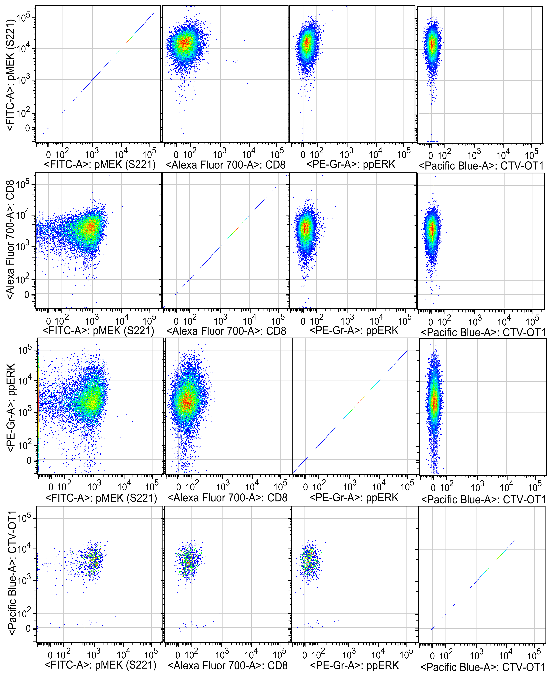
Compensation (spillover matrix): single stain on vertical axis, spilled-into channels in horizontal axis. This plot was produced with FlowJo 9.9 (OSX, default settings).

