Dataset: FeinermanScience2008
Previously published in Feinerman et al. Science Vol. 321, Issue 5892, pp. 1081-1084 (2008).
MIFlowCyt-Compliant Items

Requirement | Please Include Requested Information
1.1. Purpose | To measure variability and robustness in T Cell activation
1.2. Keywords | ERK, MAP-Kinase, CD8, T-Cell, activation, SHP-1
1.3. Experiment variables | ppERK dose-response for different CD8 and SHP-1 levels in individual OT-1 T cell blasts
1.4. Organization name and address | Memorial Sloan Kettering Cancer Center, New York, NY, 10065, USA
1.5. Primary contact name and email address | Gregoire Altan-Bonnet  gregoire.altan-bonnet@nih.gov
1.6. Date or time period of experiment | July 2007
1.7. Conclusions | Good agreement between theory and
1.8. Quality control measures
2.1.1.1. (2.1.2.1., 2.1.3.1.) Sample description | OT-1 T cell cultures were prepared as follows. C57Bl/6N splenocytes were pulsed for 2hr with 100nM SIINFEKL peptide, then irradiated (3000RAD), washed once and used as stimulator/feeder cells. OT-1 cells were harvested from axillary, brachial and inguinal lymph nodes as well as spleen (splenocytes were treated with ACK lysis buffer to remove red blood cells), and mixed with SIINFEKL-pulsed B6 splenocytes in complete RPMI. After two days, cells were expanded by diluting 2 fold into medium containing 100 pM IL-2. After four days, the cells were again expanded by 2 fold dilution into medium with IL-2. After one more day of culture, cells were harvested and spun through a 1.09 density Ficoll- Paque Plus gradient (GE Healthcare) to remove dead cells. Live cells were recovered, washed twice in complete medium and resuspended at 1 million/ml in complete medium with 100pM IL-2. Cells were used for experiments between 6 and 8 days after primary stimulation.
2.1.1.2. Biological sample source description
2.1.1.3. Biological sample source organism description | Splenocytes and lymphocytes were isolated from C57Bl/6N mice (Taconic Farms, Rockville, MD, USA) or H-2b OT-1 TCR transgenic mice (NIAID contract colony, Taconic Farms) on a Rag-2-/- background (S1) and used to prepare cultures of primary cells (see below). All mice were bred and maintained in accordance with the protocol (MSKCC#05-12-031) approved by the institutional animal care and use committee (IACUC) of Memorial Sloan-Kettering Cancer Center.
2.1.2.2. Environmental sample location | There were no environmental samples
2.3. Sample treatment description | The ppERK response to SRC and MEK inhibition was measured using primary OT-1 T-lymphocytes activated with RMA-S APCs. RMA-S cells were suspended in culture with 1 nM SIINFEKL peptide for 2 h at 37 °C, 5% CO2, and on a rotator to guarantee mixing. During this time we labelled OT-1 cells with an amine-reactive dye, CTV, according to the manufacture’s protocol (Molecular Probes). This fluorescent tag was used to identify OT-1 cells in silico. We rested the OT-1 cells one hour after CTV staining, and then distributed them in a 96-well v-bottom plate. Each well was given various doses of SRC inhibitor and MEK inhibitor and kept at 37 °C for 5 min. Following the 5 min exposure to the inhibitors, we added the peptide pulsed RMA-S (10 RMA-S to 1 OT-1 T cell) and pelleted by centrifugation for 10 s at 460 rcf at room temperature. This step guaranteed that both cell types, OT-1 and RMA-S, came into contact. The cells were allowed to activate for 10 min, followed by fixing on ice in 2% PFA, and then permeabilized and stored in 90% MeOH at 20 °C.APCs were pulsed with serial dilutions of OVA or variant peptides for 2 hr at 37°C, then washed with T cell medium at the time of harvest, and resuspended with anti-CD8α (53-6.72)-Fab-coated T cells in their conditioned media in a V-bottom 96-well plate (Corning). Fab-coating was performed 10 min before cell use by incubating T cells with 10 μg/ml of Fab fragment. T:APC cell contacts were synchronized using a quick centrifugal spin (10s at 400g). Plates containing T:APC conjugates were placed on a water bath at 37°C and incubated for 5 min. Supernatants were then discarded, T:APC conjugates disrupted by vortexing, and cells resuspended in ice-cold 4% paraformaldehyde for 15 min. Cells were then permeabilized with ice-cold 90% methanol for 15 min on ice, and washed twice with FACS buffer.
2.4. Fluorescence reagent(s) description | Cells were then stained with rabbit-anti-endogenous protein (e.g., to SHP-1) and mouse- anti-ppERK (0.2μg/ml) for 30 min at room temperature. Secondary antibodies [anti-rat(FITC) + anti- rabbit(PE) + (anti-mouse(APC)] were then used at 2 μg/ml for 30min. Cells were loaded in FACS buffer containing 1 μg/ml DAPI and fluorescence acquired on a LSRII instrument (BDBioscience, San Diego, CA, USA), after compensation of fluorescence bleed-through between channels (see SOM#8 for an example of FACS data analysis).
3.1. Instrument manufacturer | BD Biosciences
3.2. Instrument model | LSRII (Marcel van den Brink Lab, MSKCC)
3.3. Instrument configuration and settings | Parameter voltages:  FSC:  SSC:  FITC (pMEK):  A-700 (CD8):  PE (ppERK):  Pacific Blue (CTV):
4.1. List-mode data files | All data for this experiment can be found in  https://github.com/AmirErez/BimodalLogspaceCytA/tree/master/Data/FeinermanScience2008
4.2. Compensation description | Compensation samples were prepared the same way as the sample cells.
4.3. Data transformation details | Explained in main article
4.4.1. Gate description | See figures below for detailed visual description.  Cells were gated for lymphocyte FSC-SSC, then CD8+DAPI-.
4.4.2. Gate statistics | See figures below
4.4.3. Gate boundaries | See figures below

Gating strategy:
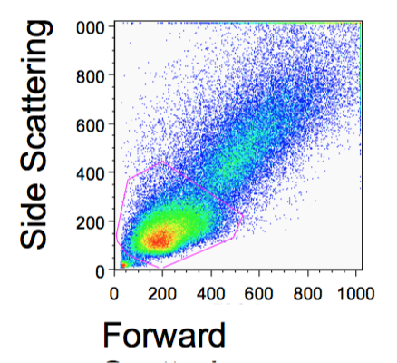
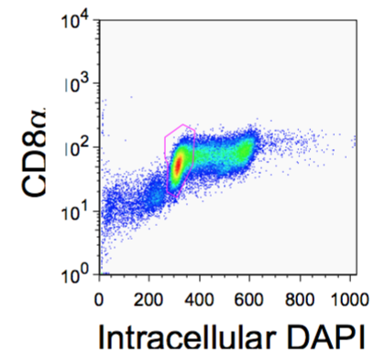

Compensation (spillover matrix): single stain on vertical axis, spilled-into channels in horizontal axis. This plot was produced with FlowJo 9.9 (OSX, default settings).

