|  |  |  |  |  |  |  |  |
| --- | --- | --- | --- | --- | --- | --- | --- |
|  | Load rate | TSS in | TSS out | Copper in | Copper out | Zinc in | Zinc out |
| Mean | 7.79 | 60.05 | 19.07 | 139.54 | 34.64 | 1054.09 | 199.94 |
| SD | 6.16 | 66.42 | 19.37 | 544.54 | 68.02 | 3911.30 | 386.50 |
| CV | 0.79 | 1.11 | 1.02 | 3.90 | 1.96 | 3.71 | 1.93 |
| Normality | Rejected | Rejected | Rejected | Rejected | Rejected | Rejected | Rejected |

Descriptive statistics of the seven studied variables, and their normality status based on the Shapiro Test

A brief descriptive analysis of the studied variables is summarized in the above table, including their mean, standard deviation, coefficient of variation and normality status. It should be mentioned that the normality has been assessed in a 95% confidence level using Shapiro test. For this test the null hypothesis is that there is no statistically significant difference between the variable’s distribution and normal distribution. Having p-value less than 0.05 in the given confidence level would lead us to reject the null hypothesis, and accept the alternative hypothesis of existence of a statistically significant difference with the normal distribution. In the other hand, the probability of committing to type I error in the rejection of the normality of variable is less than 5% in this case.

The result of the normality test would suggest the need of an adequate treatment of the data, before using them in a model. One of the possible treatment would be using a transformation based on the condition of the variables

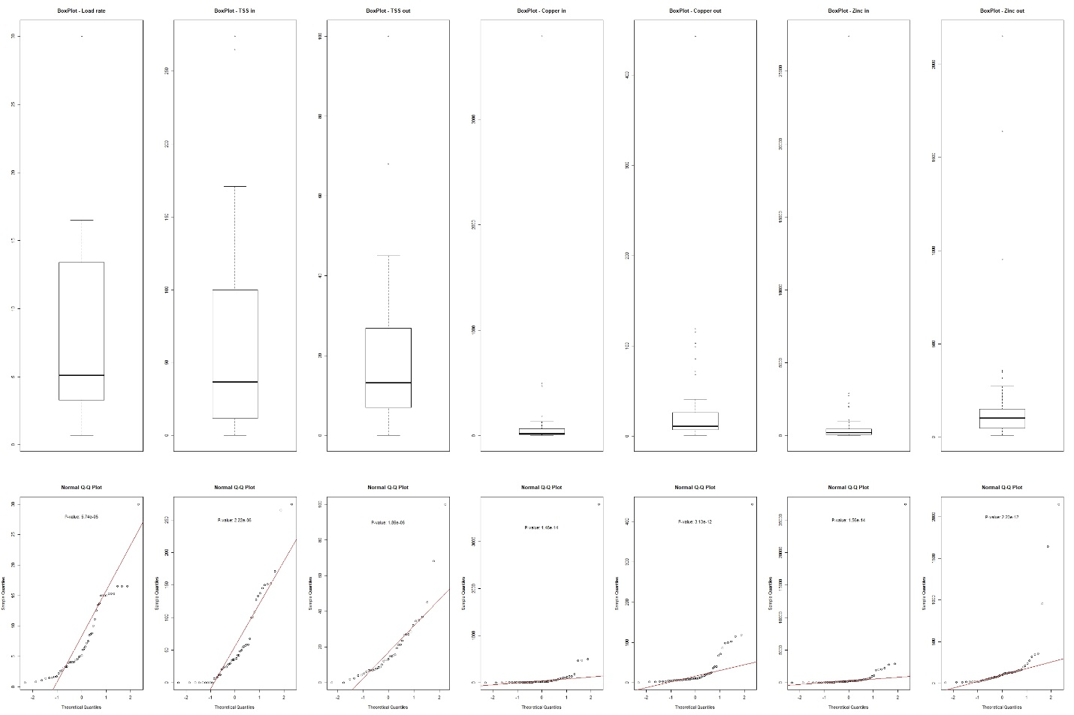

Boxplots and QQ Normal plots for the seven studied variables. The p-values on the QQ plots are showing the result of the Shapiro normality test.