<https://medium.com/flutter-community/flutter-firebase-realtime-database-crud-operations-using-provider-c242a01f6a10>

<https://github.com/mohamedHassanKa/ProductAppCourse>

<https://github.com/mohamedHassanKa/shop>

<https://github.com/mohamedHassanKa/Flutter_Product_Manager>

<https://github.com/mohamedHassanKa/circular_bottom_navigation>



<https://github.com/GeekyAnts/flutter-carousel>

<https://github.com/GeekyAnts/flutter-web-admin-dashbaord>

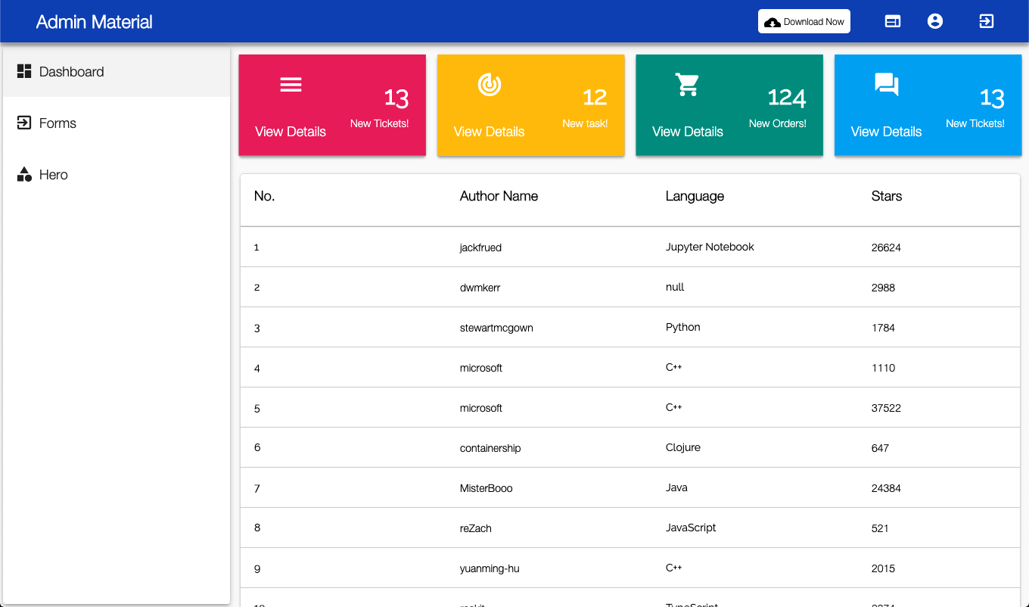

<https://medium.com/flutter-community/flutter-on-desktop-a-real-competitor-to-electron-4f049ea6b061>

# Flutter — Firebase FireStore CRUD Operations Using Provider

## Introduction

In this article, I will be showing how to set up and build a CRUD app using Firebase and a state management package called Provider.

We will build an app where you can add different types of products and show these products in the main view.