Facilities

**Library:** 

in any educational and research institution the Library department hold a key position being the major source of the inflow of knowledge. For this purpose, the library department incorporated about 2000 textbooks regarding course content, Islamic related, novels, magazines.   
Library’s environment, which attracts users and clientele spend time and study in relaxing and conducive environment. Study carrels and reading halls provide excellent environment for individual and group study.

**Sports :** 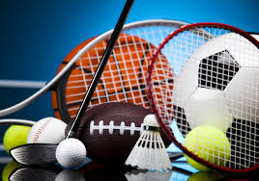

“Healthy Minds Live in Healthy Bodies”

Sports are a significant and most thrilling activity at the college. These sports activities are a way to soften tough and grilling academic rigor. Sports In charge arranges competitions to channel boundless energies of students. It provides opportunities for sports enthusiasts to share their interests and participate in events like sports week.

The following sports facilities are available at college:

* Volley ball Court
* Table Tennis
* Badminton
* Cricket

**Health Care: **

To meet the physical, mental and social challenges the college has a medical center along with a medical officer to provide the first aid and to fulfill the emergency requirements. Also the Harley hospital is very near to the campus on 2 to 3 minutes’ drive.

**Laboratories:** 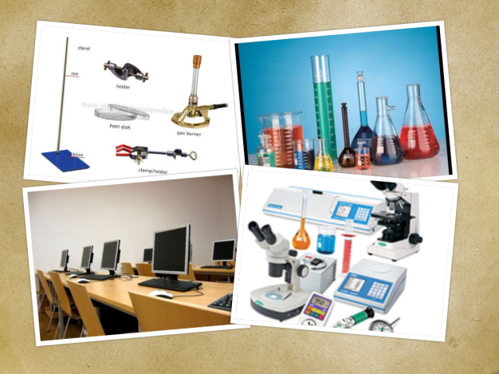

Proper labs with latest instruments are available for the practical work

The following labs are available at college:

Bio Lab

Computer Lab

Physics Lab

Chemistry Lab