Alibaba System

Procurement

April 2018

Contents

1. Project Objective 1

2. Background 3

3. Business Requirements 3

3.1 Item Catalogue 3

3.2 Quotation Request **Error! Bookmark not defined.**

4. General Notes **Error! Bookmark not defined.**

# Project Objective

The objective of this initiative is to implement an online catalogue system which can be used by THE COMPANY departments for obtaining quotations.

# Background

As of now, the quotation process is carried-out manually by the departments involving offline requests. THE COMPANY team intends to automate this process further adopting an online catalogue system similar to Amazon/ Alibaba style ordering experience.

# Business Requirements

E-catalogue system for THE COMPANY is required to address below requirements broadly but not limited to:

* Items catalogue
* Quotations Request

# Items Catalogue – Key Requirements

|  |  |
| --- | --- |
| **Sr. No.** | **Key Requirements** |
| 1 | Pre-qualified vendors should be able to upload their products / services (contracted and non-contracted) in the system along with the prices and other relevant details |
| 2 | Procurement team should have the option to review the details and approve the same before the details will be uploaded in the system for public view |
| 3 | The items / suppliers need to be linked to groups / categories |
| 4 | The Buyer will have the option of searching by product name, category or supplier |
| 5 | The Buyer will have the option of selecting specific products and add the same in the basket. In the time of check-out there will be 2 options as per below:   * + 1 – initiate PO / PR in Oracle (THE COMPANY ordering system) based on the prices available in the website   + 2 – request the supplier/s for revise quotation |

# Quotation Request – Key Requirements

|  |  |
| --- | --- |
| **Sr. No.** | **Key Requirements** |
| 1 | The Buyer will have the ability to send RFQ to suppliers based on categories   * + The quotations to be received through the system and initiate PO / PR in oracle based on the same |
| 2 | The Buyer will have the option of selecting specific products and add the same in the basket. In the time of check-out there will be available an option for requesting the supplier/s for revise quotation |
| 3 | Messaging facilities (quotations request / negotiations) |

# General Notes

* The login credentials should be generated by Procurement Department and these will be sent to the respective supplier / THE COMPANY user
* Option to login only. No option to create account
* Categories / groups will have a maximum of 3 tiers and will be dropdown
* The Buyer will have the following options:
  + Search for items / services based on
    - Contracted / non-contracted
    - Categories (see below sample pic)
  + Compare prices / specifications of various items
  + Select items / services available in the system and add the same to the shopping cart
  + On Check-out, the following options should be available:
    - Print details of the selected items (prices, supplier name …etc)
    - Push the order to Oracle (THE COMPANY ordering system)
    - Request for best price (for non-contracted items / services only)
    - Save to favorites

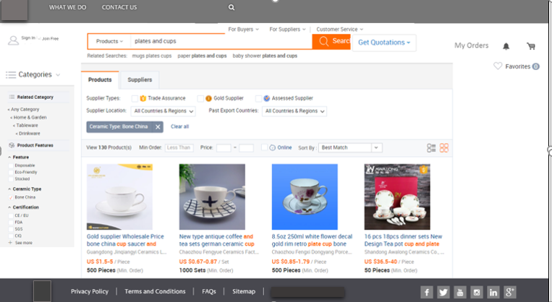

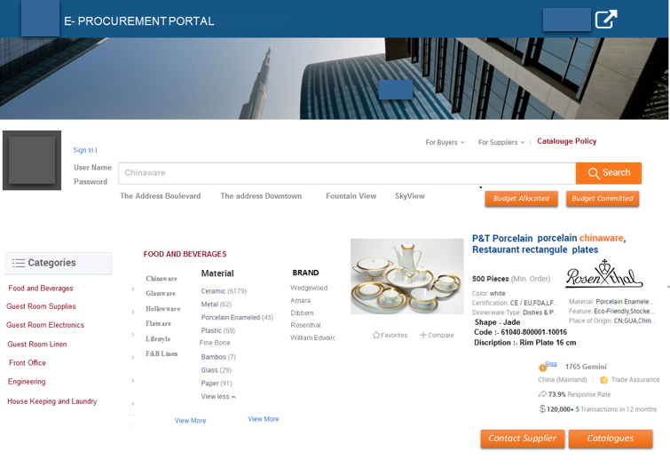

* + Search for suppliers based on
    - Contracted / non-contracted
    - Categories
  + Request for quotations to all suppliers registered under the specific category (see below sample)

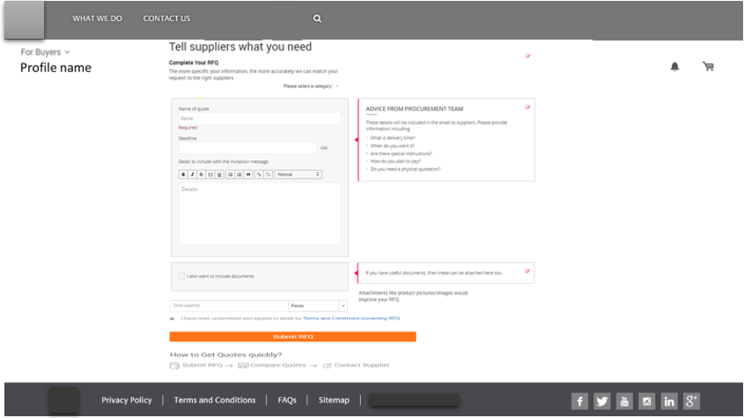

* Buyer screen should include the following:
  + Notifications
  + RFQ Issued (will contain all the request for quotations sent to suppliers)
  + RFQ Received (will contain all quotations submitted by suppliers based on buyer request)
  + Confirmed Orders (will contain all the confirmed orders – sent to Oracle for PO)
  + Analytics Dashboard based on the user activity
* Supplier screen should include the following:
  + Notifications
  + RFQ Received (will contain all request for quotations received from buyers)
  + RFQ Submitted (will contain all the quotations submitted to buyers)