**Idea: -** Sentiment Analysis of Product rating Through Social Network Sites.

**Schedule:-**

First we need of schedule of project in the form of chain.

20 days for Initialization

45 days for Requirements

45 days for Designing

35 days for Construction

1 Month for Integration

15 Days for Release

20 Days Buffer time

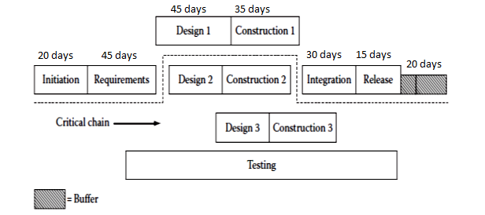

**Cost Estimation:-**

|  |  |  |  |  |
| --- | --- | --- | --- | --- |
| **Software Phase** | **Processes** | **Roles** | **Man hrs,Days** | **Cost** |
| Requirment Engg | Elicitation | Requirment Gathering | 10 days | $80,000 |
|  | Use cases | Abstract view | 10 days | $20,000 |
|  | Technology | Use for software Development eg sql server,asp.net | 20 days | $10,000 |
|  | Non functional req | Increase the performance and security | 5days | $60,000 |
| Analysis and Design | High level Design | Make Activity and Sequence Diagram(Architectural view) | 30 Days | $50,000 |
|  | Interface Design | Interface view | 15 Days | $50,000 |
| Code | LOC | Line of code count | 30 Days | $100,000 |
| Testing And Maintaince | Test case | Design Test Case for testing | 10 days | $40,000 |
|  | Maintaince | Change in Furture (Architecture) | 20 days | $80,000 |
| **Total** | | | | **$490,000** |