HOME ABOUT COLLEGE ADMISSION ACADEMICS FACULTY FACILITIES CONTACT

HOME

Slide show of pictures

Dr. A.Q Khan Message

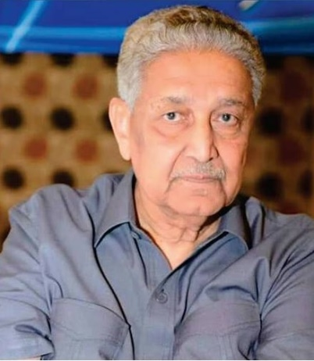"The aim of education should be to teach us rather how to think, than what to think — rather to improve our minds, so as to enable us to think for ourselves, than to load the memory with thoughts of other men."

**Dr. A.Q. Khan**



Director message

"Our educational setups are customized physical infrastructures equipped with latest computers. We strive to provide quality education and highly qualified faculty. Our programs are rich and designed to give students a hands-on experience. We warm-heartedly welcome the new entrants in Dr. A.Q. Khan College. Come, join us and experience a new world of learning and exposure”.

**M. Adnan Mukhtar**

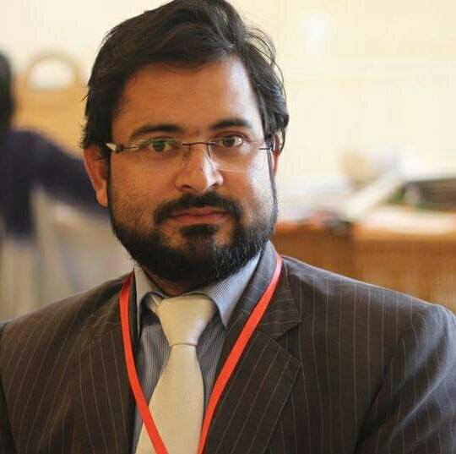

Principal message

"Welcome to the Dr. A.Q. Khan College, a highly developed education network known across the country for academic excellence. Our students are members of an institution, which is proud of a heritage that is developed by its cultural and economic diversity."

**Rashid Minhas**

Our Aim

It is our aim to make our college the best educational institute in the country. Our strategy to achieve this aim is to ensure that theory and practice go hand in hand. And we aim for all this to take place in a college environment that is safe and friendly, and at the same time disciplined, as envisaged by the Quaid-e-Azam. Because we feel that along with studies it is equally important to develop the good values of character, decency, honesty and consideration for one another.

Collaborations

Dr. A. Q. Khan College of Science and Information Technology have strong collaborations with various private and public sector organizations.

Such collaborations provide a good exposure to our students and not just the exposure it provides them opportunities to work as well.

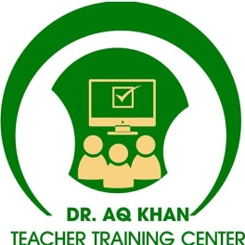

News and Events

College Educational Trip will be on 23rd January.

Funfair is going to be held in the mid of February.

Pre board will be scheduled in the month of March.

About College

**Introduction**

**Dr. A.Q. Khan Colleges of Science and Technology, under the umbrella of the Dr. Abdul Qadeer Khan, aspire to economically offer world class education in an innovative and technology-enabled environment. Our vision is to establish a House of Wisdom at the national level with a distinctive approach to cater to the current and future educational needs of the country and, at the same time, freeing our students from rote learning and tuition needs. We are focused on developing creative and confident students who will be capable of meeting any challenge in their lives. Our teaching methodology makes us unique. We will accomplish our mission by fulfilling the social responsibility of bringing a positive change in the society in terms of quality education, intellectual development and introducing good values.**

**Facts and History **

1. **Established in 2016**
2. **Current student’s Enrollment**
3. **Departments 04**
4. **2,000 Library Books**
5. **Fully equipped laboratories**

**Vision and Strategy **

The college vision is to provide a nurturing academic environment where students are transformed into creative and confident individuals who will become the leaders of tomorrow. Moderated online discussion forums will be available to support students during and after college hours

**Visitors Information **

The visitors, guests and prospective candidates are welcome to visit the college. If you are planning to visit the college, you can visit between 0900 Hrs to 1600 Hrs from Monday to Friday. The visit will give an overview of college and provide you information about culture, facilities and academic programs of the college. The prospective candidates may contact Student Affairs Center for detailed information and guidance.

For Admission Information and Career Counseling please visit  
  
Branch Manager (Student Affairs)  
Dr. A.Q Khan College of Science and Information Technology

Lane no. 2, Harley Street Rawalpindi

Phone051-5176166

Mobile: 0313-5344611

College Map

Admissions

Undergraduate Programs 

* Bachelors in Computer Science

Intermediate or equivalent with Mathematics, with minimum 50% marks from an accredited educational institution

* Bachelors in Commerce

Intermediate or equivalent with minimum 50% marks from an accredited educational institution.

Intermediate Level Programs 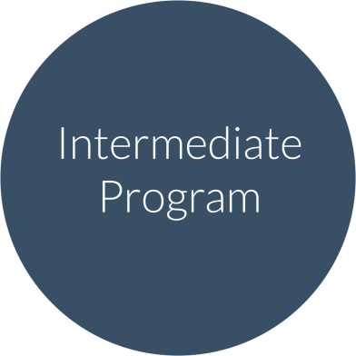

* FSc. Pre-Medical

Matriculation or equivalent with Biology, with minimum 60% marks from an accredited education institution

* FSc. Pre-Engineering

Matriculation or equivalent with Mathematics, with minimum 60% marks from an accredited education institution

* Intermediate in Computer Science

Matriculation or equivalent with minimum 50% marks from an accredited educational institution

* Intermediate in Commerce

Matriculation or equivalent with minimum 50% marks from an accredited educational institution

How to Apply 

Visit the admission office to complete all the formalities

Dr. A.Q Khan College of Science and Information Technology

Lane no. 2, Harley Street Rawalpindi

Phone051-5176166

Mobile: 0313-5344611

Scholarships 

* Academic Excellence Scholarship

Academics

**Intermediate Level**

**HSSC-I**

|  |  |  |  |
| --- | --- | --- | --- |
| **Pre-Eng (HSSC-I)** | **Pre-Medical (HSSC-I)** | **I.COM-I** | **ICS-I** |
| Mathematics | Biology | Pricipal of Accounting | Mathematics |
| Chemistry | Chemistry | Principal of Commerce | Computer |
| Physics | Physics | Principal of Economics | Physics |
| English | English | English | English |
| Urdu | Urdu | Urdu | Urdu |
| Islamite | Islamite | Islamite | Islamite |
| --- | --- | Business Mathematics | --- |

**HSSC-II**

|  |  |  |  |
| --- | --- | --- | --- |
| **Pre-Eng (HSSC-II)** | **Pre-Medical (HSSC-II)** | **I.COM-II** | **ICS-II** |
| Mathematics | Biology | Principle of Accounting | Mathematics |
| Chemistry | Chemistry | Banking | Computer |
| Physics | Physics | Commercial Geography | Physics |
| English | English | English | English |
| Urdu | Urdu | Urdu | Urdu |
| Pak Studies | Pak Studies | Pak Studies | Pak Studies |
| --- | --- | Business Statistics | --- |

**UNDER GRADUATE LEVEL**

|  |  |  |  |  |  |  |  |
| --- | --- | --- | --- | --- | --- | --- | --- |
| **BSc-I** | **BSc-II** | **B.Com-I** | **B.Com-II** |  |  |  |  |
| Gen- Math(Calculus) | Gen- Math(Method) | Business Mathematics and Statistics | Advanced Financial Accounting |  |  |  |  |
| Computer | Computer | Computer application in Business | Auditing |  |  |  |  |
| Physics | Physics | Economics | Business Communication & Report Writing |  |  |  |  |
| Islamite | English | Financial Accounting | Business Law |  |  |  |  |
| --- | --- | Functional English | Business Taxation |  |  |  |  |
| --- | --- | Introduction to Business | Cost Accounting |  |  |  |  |
| --- | --- | Money Banking and Finance | Economics of Pakistan |  |  |  |  |
| --- | --- | Islamic Studies | Pakistan Studies |  |  |  |  |

Faculty

Following is the list of Faculty and Staff members of our college

Image

Kkkkkkkkkkkk Mrs. Tabbasum Taj

Branch Manager of girls campus

Mrs. Naheed

Branch Manager of boys campus

Zubair Jadoon

Admin officer

Asim Raza

Accountant

Mr. shafqat

Lecturer

MS (Biochemistry)

Mr. Zain

Lecturer

MS (Statistics)

Mr. Ahmed

Lecturer

BS (Computer Science)

Mr. Bilal

Lecturer

BS (Maths)

Mrs. Ayesha

Lecturer

M-Phil (English)

Ms. Atika

Lecturer

MS (computer Science)

Mrs. Rizwana

Lecturer

MBA

Mr. Usman

Lecturer

M-phil (Urdu)

Mr. Ahsan

Lecturer

MSC (Physics)

Mr. Asif

Lecturer

MS (physics)