House Price Analytics & Prediction
Project Report
Prepared by: Amir Muaviya Khan
AICTE | IBM SkillsBuild Data Analytics with AI Internship 2026
Conducted by BharatCares in association with AICTE
October 2026

1. Introduction
Buying and selling a house is one of the biggest financial decisions most people make, and setting the right price is difficult. A price that is too high delays the sale, and a price that is too low loses money. This project uses data analytics to understand what drives house prices and to build a model that can predict the sale price of a house from its features.
The project follows the business-intelligence flow taught in the internship: data, then information, then insight, then decision, then action. The aim is not the most complex analysis, but clear findings that lead to useful business decisions.

1.1 Problem Statement
A real-estate business wants to (a) understand which factors drive house prices, (b) track the key numbers (KPIs) that describe the market, and (c) predict the sale price of a house so it can price properties correctly and decide where to invest.

1.2 Objectives
- Clean the raw housing data and make it ready for analysis.
- Calculate four key KPIs that summarise the market.
- Explore trends, rankings, drivers and outliers using charts.
- Build and compare prediction models for the sale price.
- Convert the findings into risks, opportunities and recommended actions.

2. Dataset Description
The project uses the "House Prices - Advanced Regression Techniques" dataset from Kaggle (train.csv). It contains 1,460 house sales in 81 columns covering lot size, building quality, size, rooms, garage, basement, neighbourhood, year built and the final sale price.
Dataset link: https://www.kaggle.com/competitions/house-prices-advanced-regression-techniques
Column group | Examples
Target | SalePrice (price the house sold for)
Size | GrLivArea, TotalBsmtSF, 1stFlrSF, 2ndFlrSF, LotArea
Quality & condition | OverallQual, OverallCond, ExterQual, KitchenQual
Age | YearBuilt, YearRemodAdd, YrSold
Rooms & facilities | BedroomAbvGr, FullBath, GarageCars, Fireplaces
Location | Neighborhood, MSZoning, LotConfig

3. Methodology
The work was done in Python using a Jupyter notebook with the pandas, NumPy, Matplotlib, Seaborn and scikit-learn libraries. The steps were:
- Load the data and inspect its structure.
- Clean missing values and remove duplicates.
- Create new features (TotalSF, HouseAge, TotalBath, PricePerSqFt).
- Calculate KPIs.
- Explore the data with eight charts.
- Train and compare three prediction models.
- Draw insights, risks, opportunities and actions.

3.1 Data Cleaning
Before cleaning, 19 columns contained a total of 7,829 missing cells. After cleaning, 0 remain. The main rules were:
- Blank means "not present": in columns such as PoolQC, Alley, Fence, FireplaceQu, GarageType and the basement columns, a blank means the house has no such feature. These were filled with "None" instead of being treated as errors.
- LotFrontage was filled with the median of the same neighbourhood, since similar lots are found in the same area.
- MasVnrArea was filled with 0, and GarageYrBlt (no garage) with the year the house was built.
- The single missing Electrical value was filled with the most common value.
- No duplicate rows were found. The Id column was dropped because it carries no information.

3.2 Feature Engineering
New feature | Meaning
TotalSF | Basement + 1st floor + 2nd floor area
HouseAge | Year sold minus year built
TotalBath | Full baths + 0.5 x half baths (including basement)
PricePerSqFt | Sale price divided by living area (used for the KPI only)

4. Key Performance Indicators
Four KPIs summarise the market at a glance:
KPI | Value | What it tells us
Average sale price | $180,921 | Typical price level
Median sale price | $163,000 | Middle price; ignores luxury sales
Average price per sq. ft. | $120.6 | Price relative to size
Priciest neighbourhood (10+ sales) | NoRidge ($335,295) | Best-performing area
The average ($180,921) is higher than the median ($163,000) because a few very expensive houses pull the average up. For pricing decisions the median is therefore the safer reference.

5. Exploratory Data Analysis

5.1 Price distribution
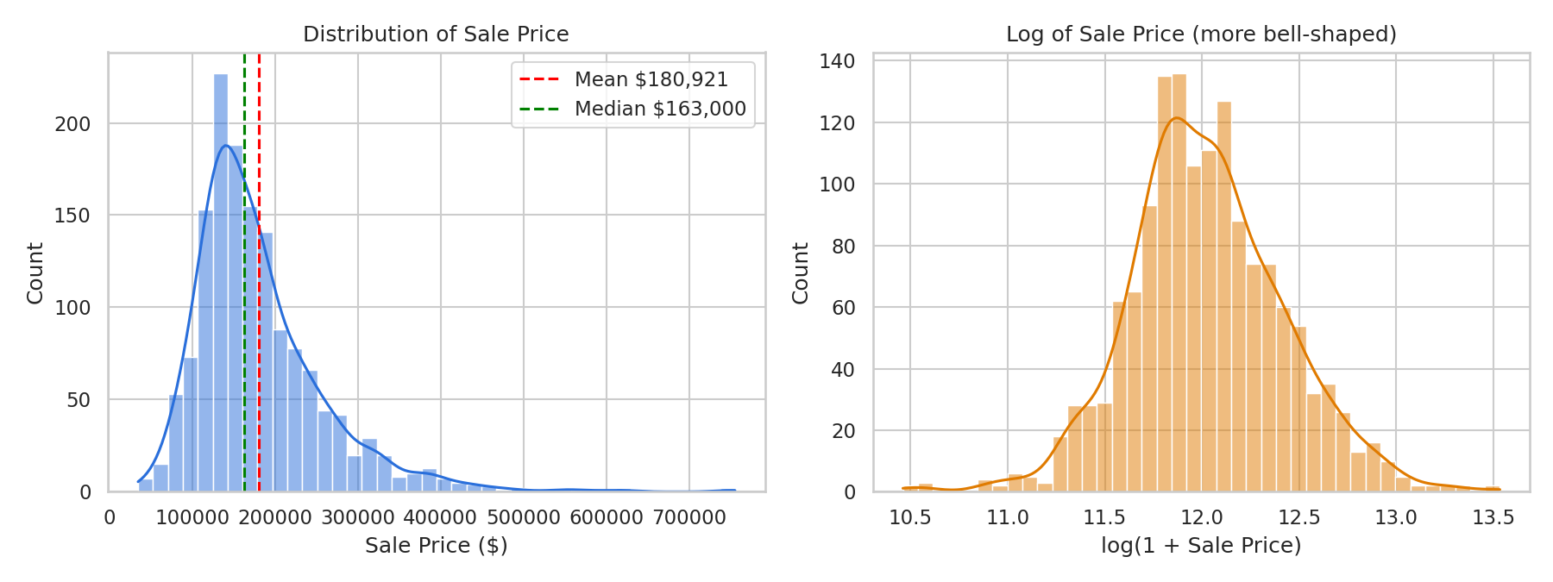
Figure 1: Distribution of sale price (left) and its log (right)
Prices range from $34,900 to $755,000 and are right-skewed (skewness 1.88). Most houses sell for less than the average, and a small number of luxury homes stretch the tail. Taking the log of the price makes the shape close to a bell curve, which helps the prediction models.

5.2 Neighbourhood ranking
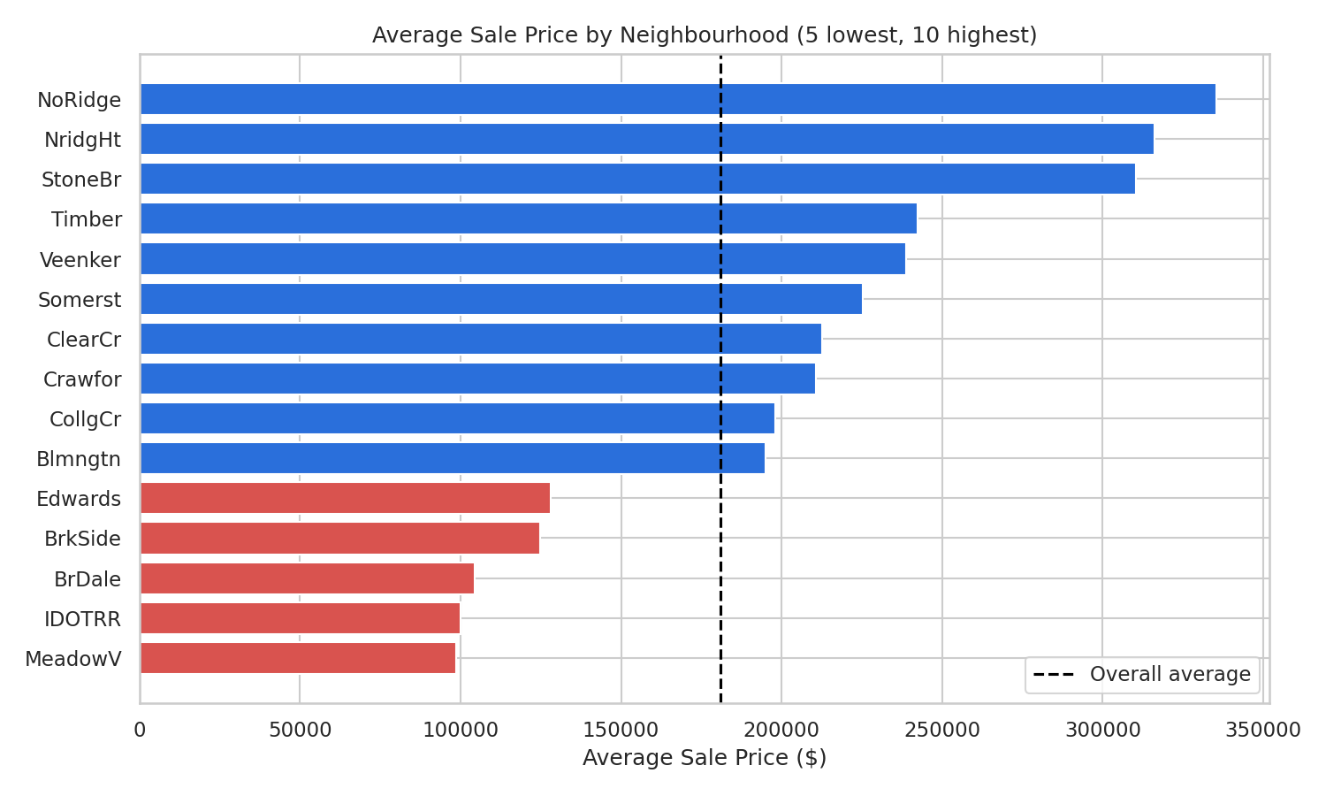
Figure 2: Average sale price by neighbourhood
Location has a large effect. The three most expensive neighbourhoods are NoRidge ($335,295), NridgHt ($316,271), StoneBr ($310,499). The three cheapest are MeadowV ($98,576), IDOTRR ($100,124), BrDale ($104,494). The most expensive area costs more than three times as much as the cheapest.

5.3 Build quality
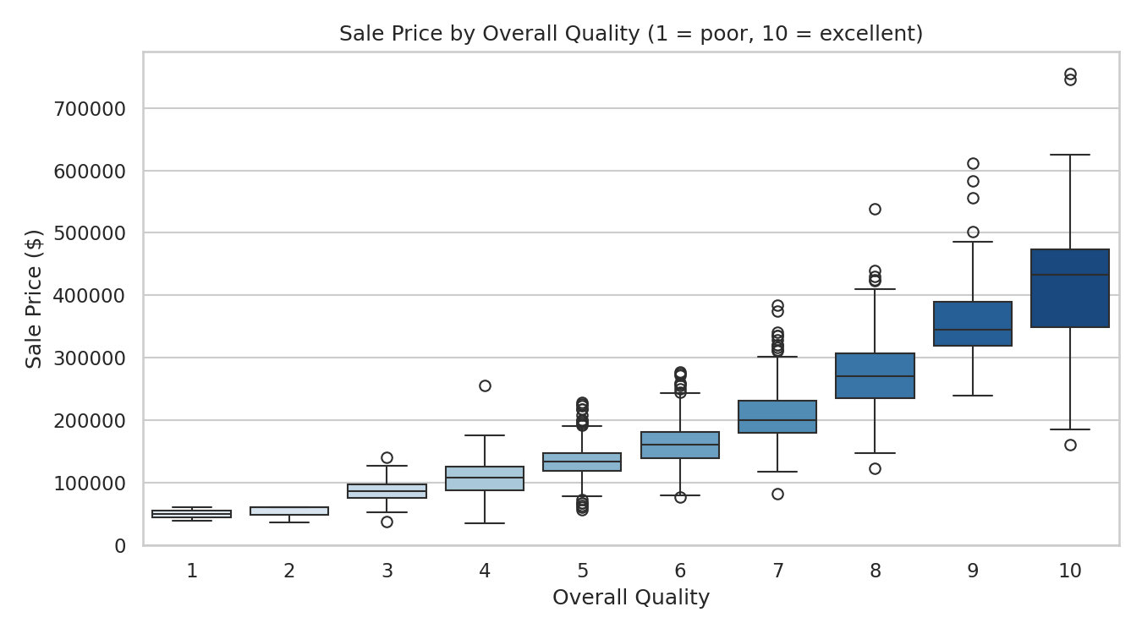
Figure 3: Sale price by overall quality rating
Price rises steadily with quality. Houses rated 8 sell for an average of $274,736, which is 2.1 times the $133,523 average of houses rated 5.

5.4 Size and outliers
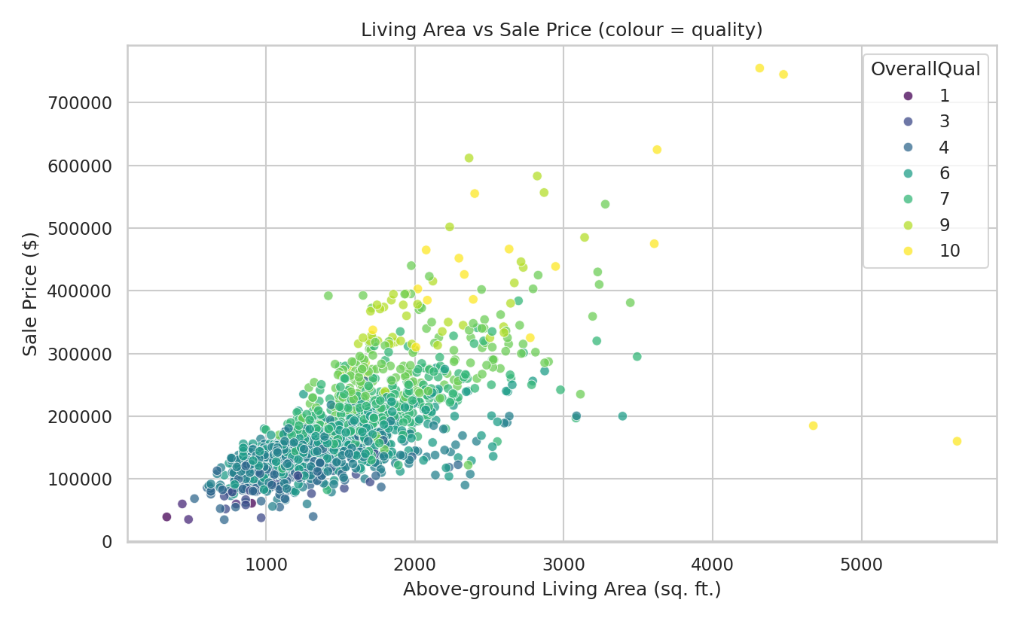
Figure 4: Living area against sale price, coloured by quality
Larger houses cost more (correlation 0.71). The colour shows that, for the same size, higher-quality houses sell for more. 2 very large houses (over 4,000 sq. ft.) sold for under $300,000, which is unusual and worth checking before they are used in valuations.

5.5 Correlation with price
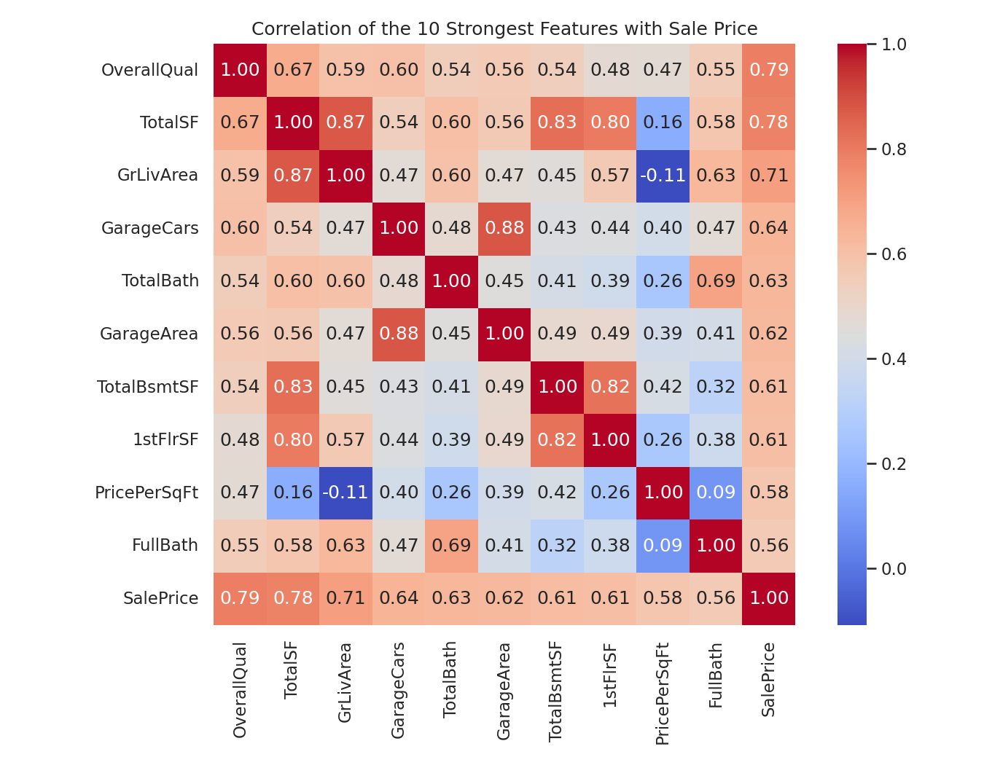
Figure 5: Correlation of the ten strongest features with sale price
The features most strongly linked to price are OverallQual (0.79), TotalSF (0.78), GrLivArea (0.71), GarageCars (0.64), TotalBath (0.63). This confirms that quality and size are the main drivers. Note that correlation shows an association, not proof of cause.

5.6 House age
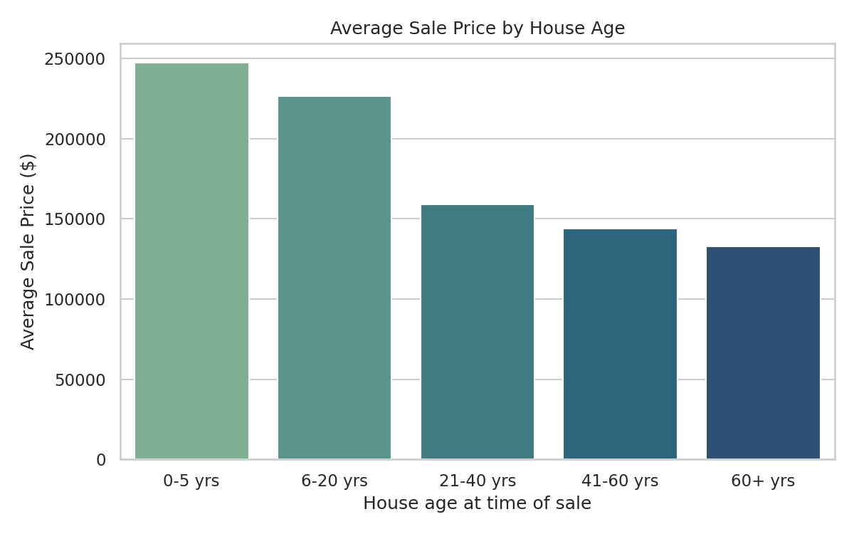
Figure 6: Average sale price by house age at the time of sale
Newer houses sell for more. Homes up to 5 years old average $247,235, compared with $132,956 for homes older than 60 years.

6. Prediction Model
The goal is to predict SalePrice from the other columns. Text columns were converted to numbers (one-hot encoding), and the data was split into 80% for training and 20% for testing. The log of the price was used as the target and predictions were converted back to dollars for scoring. PricePerSqFt was excluded from the model because it is calculated from the price itself and would leak the answer.
Three models were trained and compared on the unseen test data:
Model | R2 score | MAE ($) | RMSE ($)
Ridge Regression | 0.918 | 16,155 | 25,112
Gradient Boosting | 0.890 | 16,246 | 29,064
Random Forest | 0.878 | 17,467 | 30,601
R2 shows how much of the price variation the model explains (1.0 is perfect). MAE is the average error in dollars; RMSE penalises large errors more.
Ridge Regression performed best, with an R2 of 0.92 on the test data and an average error of about $16,155 per house. In 5-fold cross-validation the score was 0.85, which is a more cautious estimate of how it will behave on new houses.
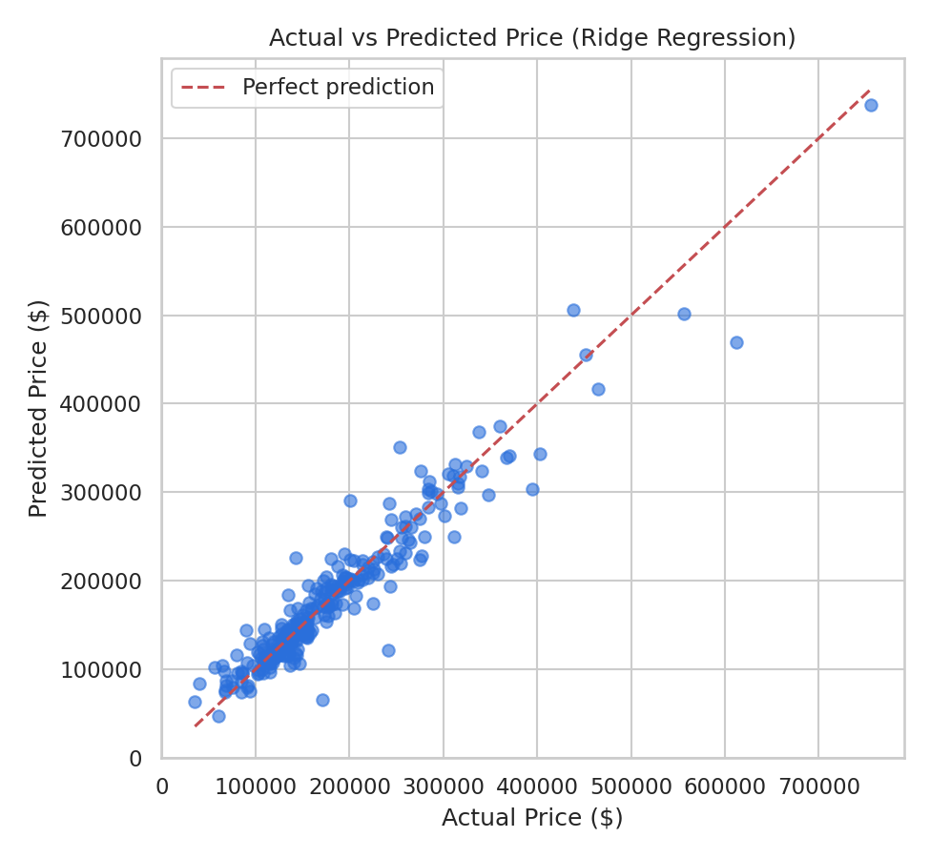
Figure 7: Actual against predicted prices; points near the red line are accurate
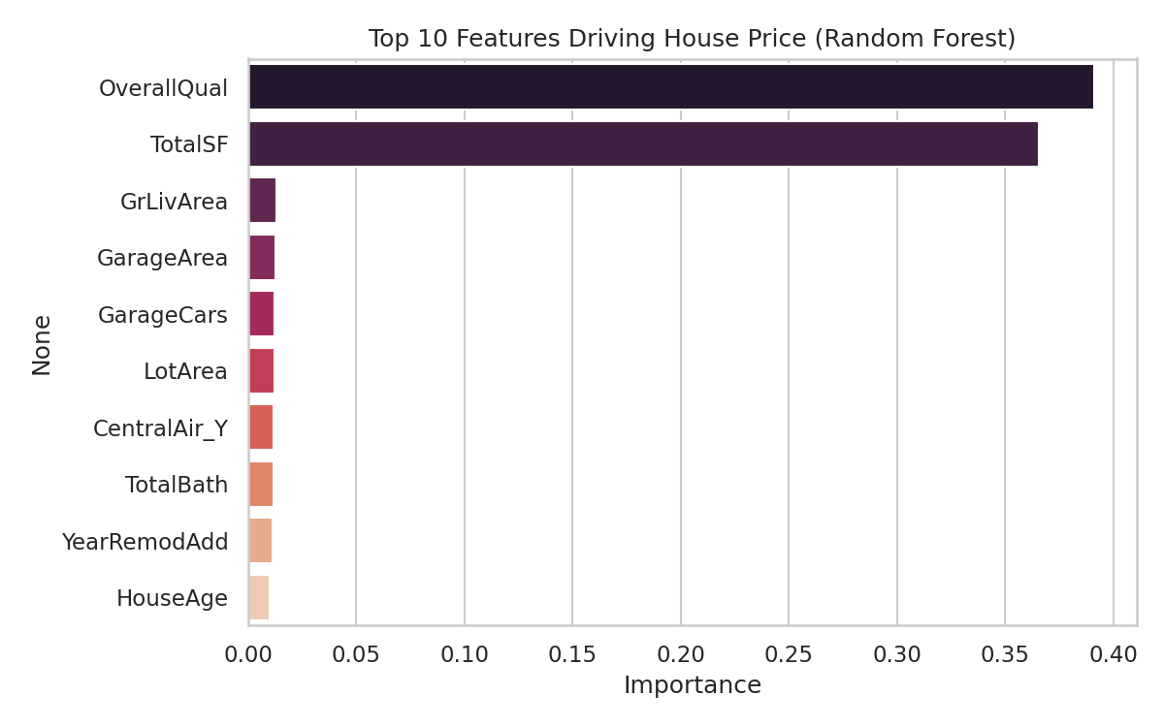
Figure 8: Top features used by the Random Forest model
The model relies mostly on OverallQual, TotalSF, GrLivArea, in line with the EDA findings.

7. Insights, Risks, Opportunities and Actions

Insights
- Quality drives price: houses with quality 8 sell for 2.1 times the price of quality 5.
- Size and quality dominate the model: OverallQual, TotalSF, GrLivArea.
- Location matters: NoRidge averages $335,295 against $98,576 in MeadowV.
- Newer houses (0-5 years) average $247,235, against $132,956 for houses over 60 years old.

Risks
- Skewed prices (skewness 1.88) make the average misleading; the median ($163,000) is safer.
- 2 very large houses sold unusually cheaply; unchecked, such sales distort valuations.
- The model is wrong by about $16,155 per house on average, so it should guide pricing, not replace human judgement.

Opportunities
- Invest in high-value areas such as NoRidge and NridgHt.
- Raising overall quality through renovation gives the largest price uplift.

Recommended Actions
- Price listings using the Ridge Regression model and cross-check against the neighbourhood median.
- Prioritise renovation of kitchens, finishes and overall build quality before selling.
- Focus acquisitions on high-value neighbourhoods and review outlier sales before they enter valuations.

8. Limitations
- The data covers one city over a few years and does not include market trends, interest rates or the economy.
- The model finds patterns, not causes: it shows what is associated with higher prices, not why.
- The test score (0.92) is higher than the cross-validated score (0.85), so real-world accuracy may be somewhat lower.

9. Conclusion
House prices in this dataset are driven mainly by overall quality, total size, garage capacity and neighbourhood. The Ridge Regression model explains about 92% of price variation on unseen houses, giving the business a data-backed way to price properties, spot unusual sales and choose where to invest. The model should be retrained regularly with new sales data.

10. Tools and References
- Python 3, pandas, NumPy, Matplotlib, Seaborn, scikit-learn, Jupyter Notebook
- Dataset: https://www.kaggle.com/competitions/house-prices-advanced-regression-techniques
- Code: AmirMuaviyaKhan_HousePrice.ipynb (submitted with this report)

