**Amirmohammad Khosravi Esfezar**

**S.N.: 810198386**

**Checkers Game Report**

Definition: Implementing Minmax algorithm on checkers game and have two agents to use it against each other.

**Testing game with different depths for each agent:**

1. **White 1 and Red 1:**

Each agent is fast but not accurate. They move fast but don’t choose the best move. Game doesn’t have winner with these depths and two agents start doing the same move over and over at the end. Finally the board will be like (swapping between boards below):

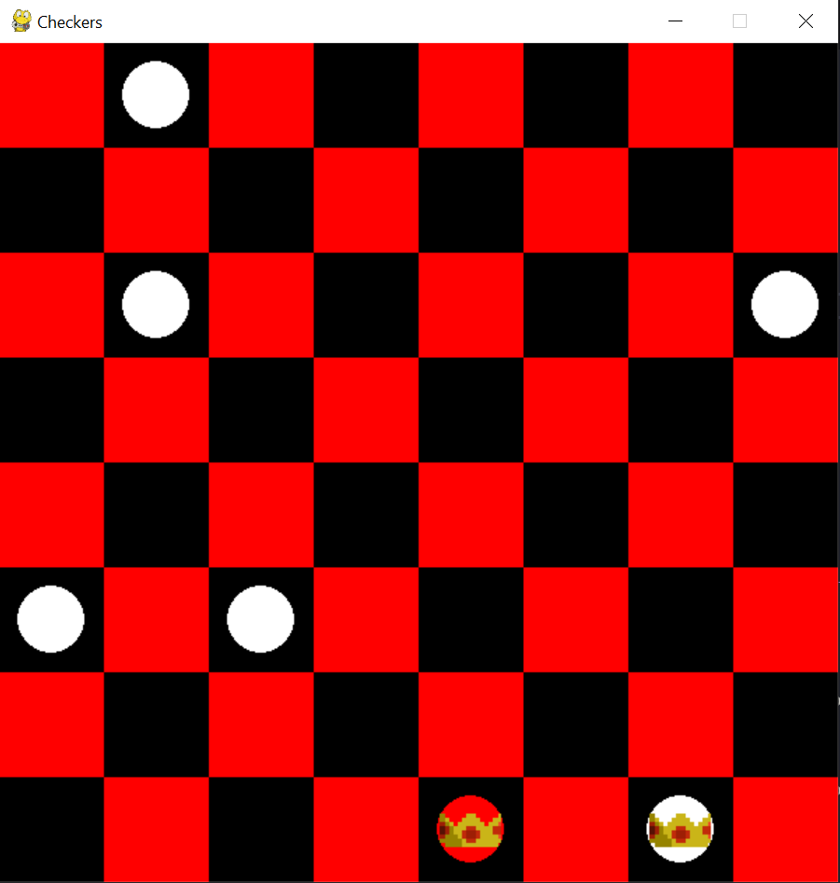 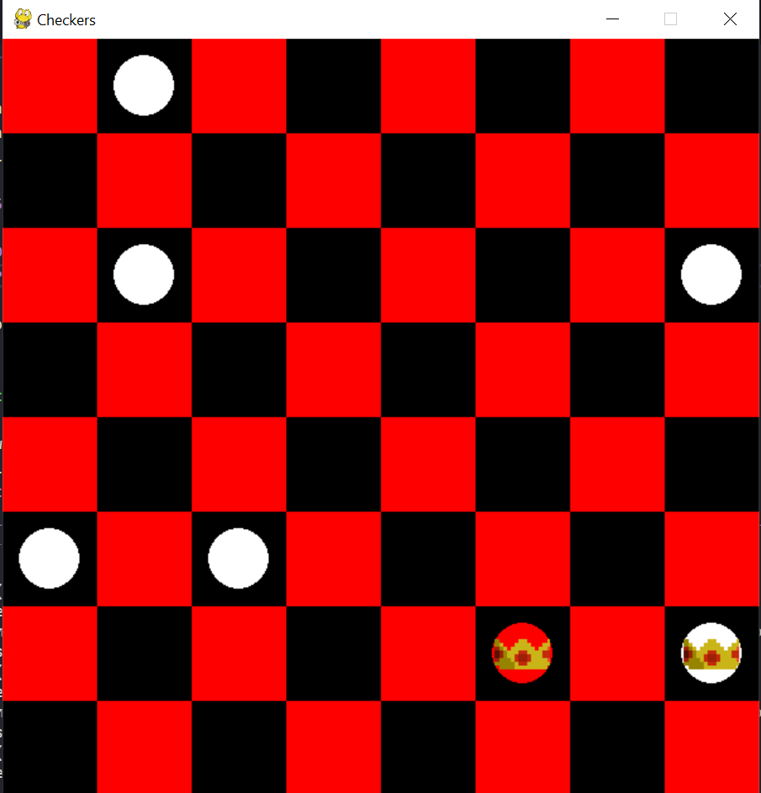

1. **White 5 and Red 2:**

White moves slower than red because it’s searching more possible moves and checks deeper and its search tree is bigger than Red ones. White plays better and choose better moves (as we can see at the end white has more kings). Again the game doesn’t have winner and two agent do the same move over and over at the end (cause with these depths these moves are the best). The board will be like (two agent moves like below. The board switches between states below):

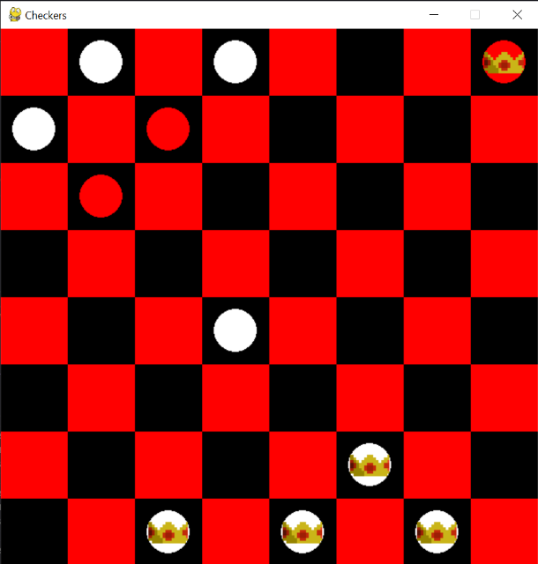 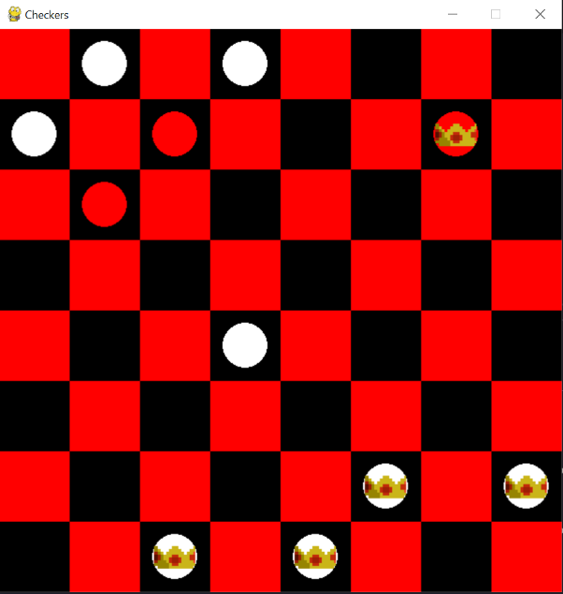

1. **White 2 and Red 5:**

Red moves slower than red because it’s searching more possible moves and checks deeper and its search tree is bigger than White ones. Red plays better and choose better moves (as we can see at the end, they have same number of kings but position of Red is better and closer to win). Again the game doesn’t have winner and two agent do the same move over and over at the end (cause with these depths these moves are the best). The board will be like (two agent moves like below. The board switches between states below):

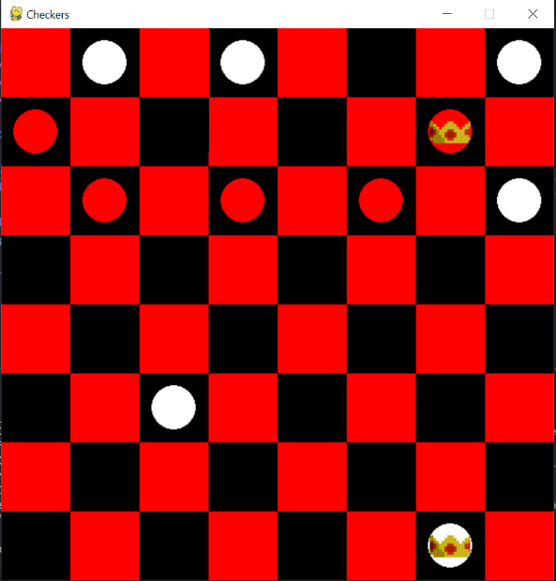 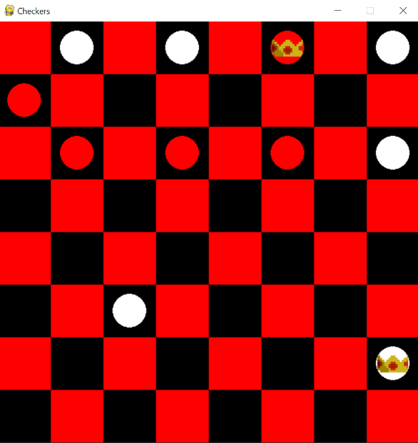

1. **White 5 and Red 5:**

both move slowly because they search more possible moves and check deeper and their search tree is large. Red plays better and choose better moves (as we can see at the end, it has more kings. Maybe because Red do the first move). The game doesn’t have winner and two agent do the same move over and over at the end (cause with these depths these moves are the best). The board will be like (two agent moves like below. The board switches between states below):

