**Object Oriented Electronic Modeling – CA#2 Report**

Amir Abbas Moumeni Zadeh – Mahdis Mirzaei

In this Projects we were supposed to Implimennt a Hardware Circuit in Gate Level and Simulate in C++ envirement.

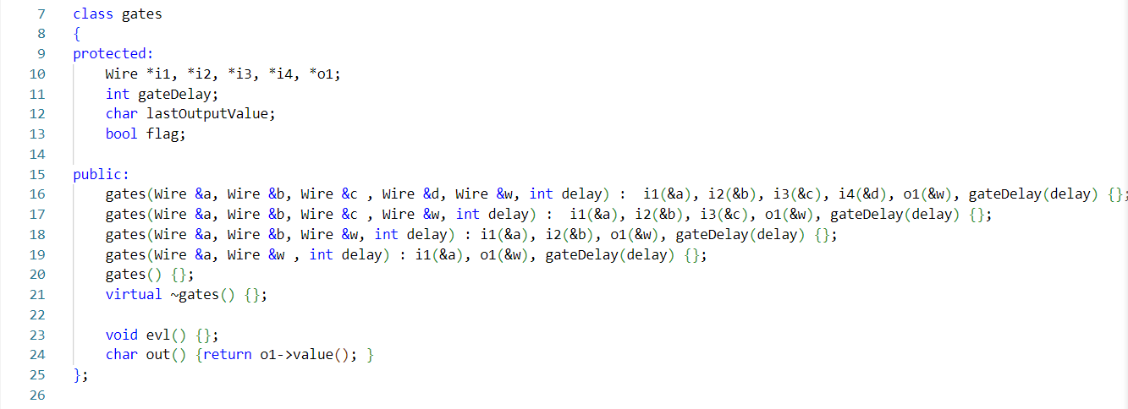First we need to develop a *Wire* class which is going to be used as inputs and outputs to our gates. After that we need to develop a top *Gate* class and inherit all other gates such as *AND, OR, XOR* and etc from that.

Class Gate

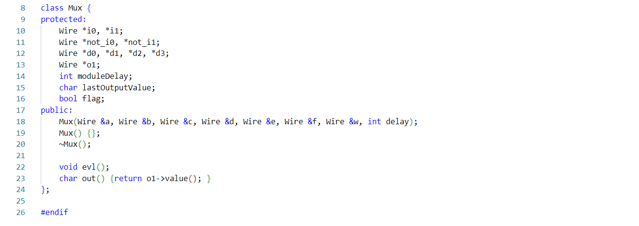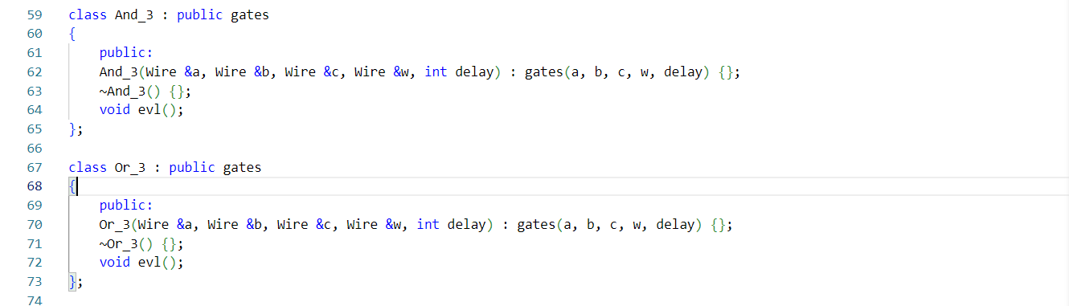Class *Gate* contains: three type of constructors for 3, 2, 1 input gates , a distructor, and two attributes one for evaluation and one for reading gate output.

Then the *Mux* class developed which is our final module to be implimented with designed gates.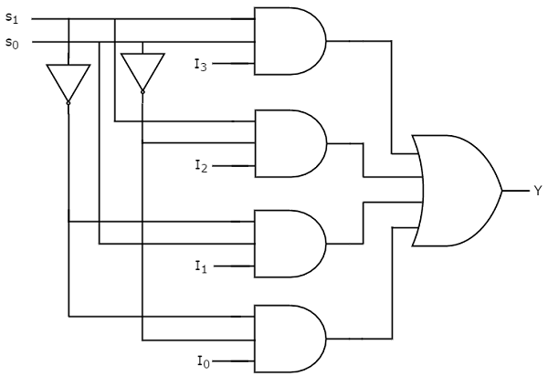

We need four 3-input *AND gates, a 3-input OR* gate and two *Not* gates. Also we need 9 wires for interconnections between gates.

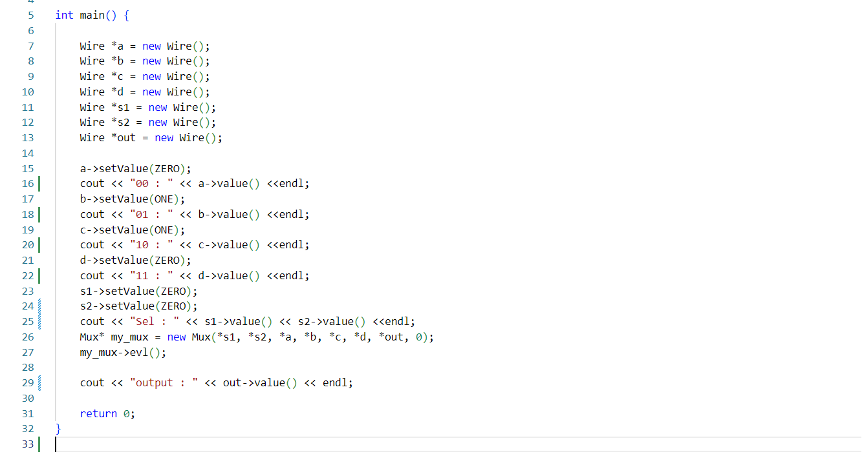After developing *Mux* circuit, we need to test it in the main function.

** its also possible to get inputs from terminal but we fixed them on our testbench.

