Acorn-SVD V7
Detailed Experimental Results & Scientific Analysis
  - PGD vs. spectrally certified PGD on two neural-recording sessions
Experiment: 24 successful training runs | 2 sessions × 2 training budgets × 2 methods × 3 seeds
Training radii: absolute L2 epsilon = 6 and 12 | Evaluation radii: 1, 3, 6
Primary source: terminal-exported V7 run_config.json, summary.json and 24 seed-level results.json records
Prepared: 22 October 2026

Principal finding
The spectral certificate has almost no predictive advantage at training epsilon 6, but at epsilon 12 it prevents an extreme loss of adversarial robustness on C-CO12. The PGD@3 R2 change is +0.6731 (positive for all three seeds), while training perturbation norms remain nearly identical (10.3621 vs 10.3456). On C-CO0, the analogous PGD@3 improvement is +0.1459, but both models remain substantially below zero. On C-CO12, robustness gains are accompanied by losses under neuron dropout and nested neuron removal.

Evidence and limits
The 24 raw model records and two run configurations were parsed and checked for unique session/epsilon/arm/seed combinations. Descriptive means, sample standard deviations and seed-paired differences were independently recomputed from the supplied records. No new training, checkpoint analysis or external validation is claimed. Three seeds across only two sessions are insufficient to establish population-level generality or causal attribution.

Reading guide
Sections 1–3 describe the experiment and principal results; Sections 4–7 detail certificate behavior, decoder sensitivity, per-target outcomes and robustness trade-offs. Sections 8–9 discuss limitations and report-ready conclusions. Appendices provide per-seed measurements, extended metrics and reproducibility fingerprints. Supplementary CSV tables preserve the complete source-supplied records.

1. Experimental design and data integrity
V7 tests two learning procedures: the standard adversarial PGD arm (spectral mode none), and pgd_cert, a PGD variant with a spectral certificate/restriction intended to retain a positive protected spectral gap and control mode exchange. This report describes observed diagnostics; it does not claim exact preservation of every singular vector or universal certification for all possible attacks.
Design element | Setting
Sessions | C-CO12 and C-CO0
Seeds | 42, 43, 44, matched by arm and training epsilon
Training | 3000 iterations; 10-step L2 PGD; alpha = 0.2 × train epsilon
Encoder | offset36-model-more-dropout; 64 hidden units, 64-dimensional output; learning rate 0.0003; batch 2048; temperature 0.4
Decoder | Linear → LayerNorm → ReLU → Dropout → Linear; hidden 64; dropout 0.4; learning rate 0.001; 2500 epochs
Spectral | gamma 0.9; k_min=1; k_max=8; centered spectral windows
Evaluation | L2 PGD, absolute radii 1/3/6, 20 steps, 3 restarts; plus geometric and naturalistic perturbations
Parallelism | Four independently scheduled GPU workers (within each session job cohort)
Metrics | R2 decoding accuracy; neuron-removal robustness; spectrum/mode diagnostics; decoder sensitivity; timing

Data geometry
Session | Train X | Validation X | Median window L2 | Gap p10/p50/p90 | Evaluated windows
C-CO12 | 18,384 × 86 | 4,543 × 86 | 37.393 | 1.626 / 2.477 / 3.883 | 4508
C-CO0 | 2,608 × 71 | 615 × 71 | 26.648 | 1.432 / 3.082 / 4.870 | 580

Each target Y has six columns. The absolute training epsilon of 12 corresponds to roughly 32.1% (C-CO12) versus 45.0% (C-CO0) of median centered-window norm; identical absolute radii are therefore not identical relative perturbation strengths across sessions.

2. Headline performance
All entries are mean ± sample SD over three seeds. “Clean” = valid_mean_r2 (validation score); evaluation PGD@1/3/6 is the attack-tested R2. Higher is better. Negative R2 is worse than predicting the validation-target mean.

C-CO12
Training ε | Method | Clean R2 | PGD@1 R2 | PGD@3 R2 | PGD@6 R2
6 | PGD | 0.675 ± 0.008 | 0.655 ± 0.008 | 0.575 ± 0.008 | 0.233 ± 0.010
6 | PGD-Cert | 0.671 ± 0.020 | 0.651 ± 0.019 | 0.573 ± 0.017 | 0.230 ± 0.002
12 | PGD | 0.699 ± 0.005 | 0.456 ± 0.055 | -0.082 ± 0.031 | -0.682 ± 0.117
12 | PGD-Cert | 0.694 ± 0.010 | 0.673 ± 0.010 | 0.591 ± 0.008 | 0.295 ± 0.030

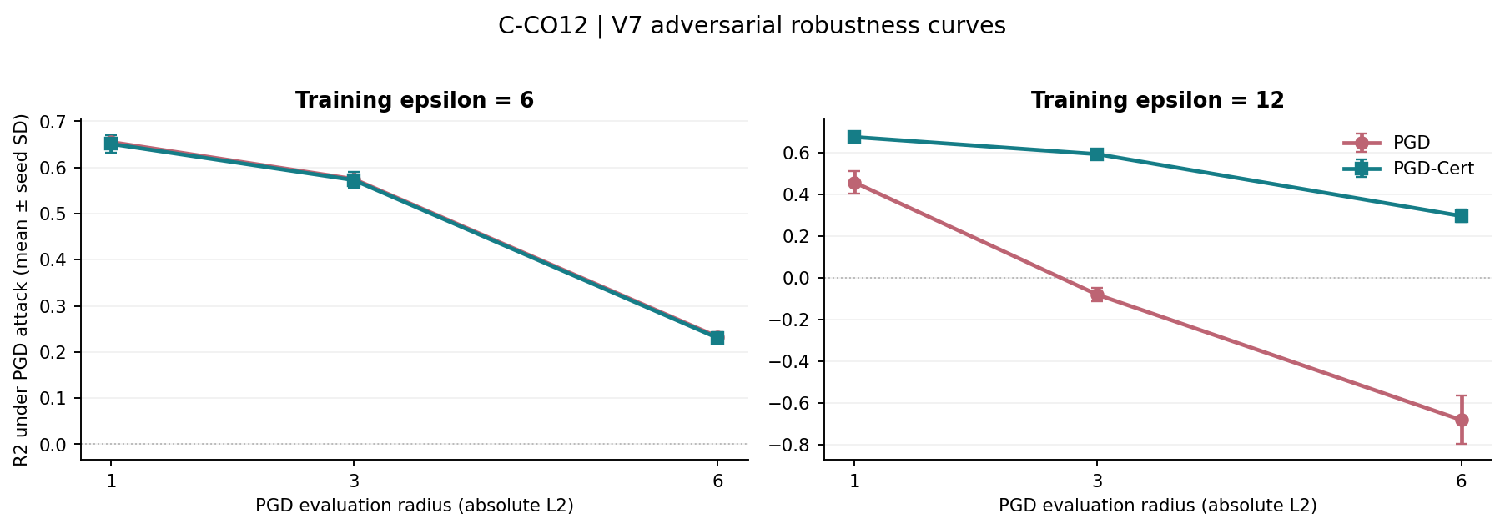
Figure. C-CO12: seed-aggregated PGD robustness under three evaluation radii. Error bars represent sample SD, not confidence limits.

C-CO0
Training ε | Method | Clean R2 | PGD@1 R2 | PGD@3 R2 | PGD@6 R2
6 | PGD | 0.681 ± 0.009 | 0.581 ± 0.013 | 0.178 ± 0.037 | -0.831 ± 0.036
6 | PGD-Cert | 0.685 ± 0.007 | 0.582 ± 0.013 | 0.180 ± 0.033 | -0.820 ± 0.010
12 | PGD | 0.696 ± 0.015 | -0.145 ± 0.069 | -1.125 ± 0.043 | -1.533 ± 0.029
12 | PGD-Cert | 0.711 ± 0.010 | -0.105 ± 0.053 | -0.979 ± 0.082 | -1.368 ± 0.113

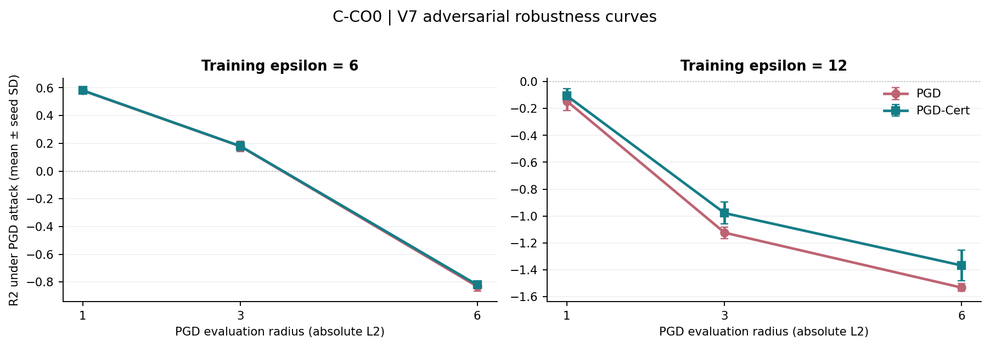
Figure. C-CO0: seed-aggregated PGD robustness under three evaluation radii. Error bars represent sample SD, not confidence limits.

3. Paired comparisons and the scale of the effect
Matched-seed differences are PGD-Cert minus PGD under the same session and training budget. Each mean is accompanied by the signs of the three seed-paired changes. Descriptive 95% Student-t intervals with two degrees of freedom are reported for two prespecified adversarial metrics; because n=3 and sessions are fixed, these intervals should not be interpreted as general population-level evidence.

C-CO12
Train ε | Metric | Δ mean R2 | Cert seed SD | Positive seeds | Paired Δ: 42 / 43 / 44
6 | Clean | -0.0044 | 0.0202 | 1/3 | +0.018 / -0.002 / -0.029
6 | PGD@3 | -0.0022 | 0.0172 | 1/3 | +0.014 / -0.002 / -0.018
6 | PGD@6 | -0.0025 | 0.0015 | 1/3 | -0.010 / -0.004 / +0.006
6 | Dropout-30% | -0.0015 | 0.0467 | 2/3 | +0.025 / +0.011 / -0.040
6 | Nested-50% | +0.0053 | 0.0522 | 2/3 | +0.037 / +0.014 / -0.035
12 | Clean | -0.0050 | 0.0098 | 1/3 | +0.008 / -0.005 / -0.017
12 | PGD@3 | +0.6731 | 0.0076 | 3/3 | +0.702 / +0.687 / +0.630
12 | PGD@6 | +0.9774 | 0.0301 | 3/3 | +1.076 / +0.988 / +0.868
12 | Dropout-30% | -0.1234 | 0.0178 | 0/3 | -0.142 / -0.110 / -0.118
12 | Nested-50% | -0.1710 | 0.0241 | 0/3 | -0.186 / -0.157 / -0.170

Train ε | Metric | Mean paired Δ | Descriptive 95% t interval, n=3
6 | PGD@3 | -0.0022 | [-0.0419, +0.0375]
6 | PGD@6 | -0.0025 | [-0.0233, +0.0183]
12 | PGD@3 | +0.6731 | [+0.5782, +0.7681]
12 | PGD@6 | +0.9774 | [+0.7189, +1.2359]

C-CO0
Train ε | Metric | Δ mean R2 | Cert seed SD | Positive seeds | Paired Δ: 42 / 43 / 44
6 | Clean | +0.0035 | 0.0075 | 3/3 | +0.004 / +0.001 / +0.006
6 | PGD@3 | +0.0013 | 0.0330 | 2/3 | -0.011 / +0.010 / +0.005
6 | PGD@6 | +0.0113 | 0.0104 | 2/3 | -0.020 / +0.000 / +0.054
6 | Dropout-30% | +0.0034 | 0.0394 | 2/3 | -0.016 / +0.004 / +0.022
6 | Nested-50% | +0.0114 | 0.0246 | 2/3 | -0.014 / +0.038 / +0.010
12 | Clean | +0.0148 | 0.0099 | 3/3 | +0.026 / +0.004 / +0.014
12 | PGD@3 | +0.1459 | 0.0817 | 3/3 | +0.071 / +0.090 / +0.277
12 | PGD@6 | +0.1650 | 0.1129 | 3/3 | +0.093 / +0.113 / +0.289
12 | Dropout-30% | -0.0167 | 0.0259 | 1/3 | +0.008 / -0.032 / -0.026
12 | Nested-50% | -0.0267 | 0.0152 | 0/3 | -0.014 / -0.027 / -0.039

Train ε | Metric | Mean paired Δ | Descriptive 95% t interval, n=3
6 | PGD@3 | +0.0013 | [-0.0262, +0.0287]
6 | PGD@6 | +0.0113 | [-0.0836, +0.1061]
12 | PGD@3 | +0.1459 | [-0.1367, +0.4286]
12 | PGD@6 | +0.1650 | [-0.1027, +0.4328]

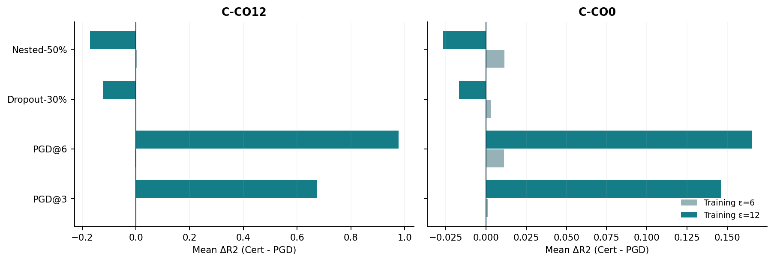
Figure. The spectral certificate favors PGD robustness more consistently at ε=12 than at ε=6; neuron-loss robustness can move in the opposite direction.

4. Spectral certificate: activation and observed diagnostics
The certificate is nearly inactive at ε=6 and becomes substantially more active at ε=12 on C-CO12. Its reported gap diagnostic remains near +0.10 while unrestricted PGD produces substantially negative minimum protected gaps. Reported collapse fractions reach zero for the certified arm; nevertheless, the mode-exchange diagnostic is small but nonzero at ε=12. Thus diagnostic preservation must be described precisely rather than as mathematically exact invariance of all spectral directions.

C-CO12
Train ε | Arm | Mean train L2 norm | Min retained gap | Collapse frac. | Mode exchange | Cert active | Budget retained
6 | PGD | 5.972 ± 0.004 | -1.032 ± 0.090 | 0.551% | 0.139% | — | —
6 | PGD-Cert | 5.958 ± 0.003 | 0.100 ± 0.000 | 0.000% | 0.000% | 0.93% | 99.76%
12 | PGD | 10.346 ± 0.022 | -3.282 ± 0.864 | 2.757% | 1.301% | — | —
12 | PGD-Cert | 10.362 ± 0.021 | 0.100 ± 0.000 | 0.000% | 0.031% | 32.34% | 88.54%

C-CO0
Train ε | Arm | Mean train L2 norm | Min retained gap | Collapse frac. | Mode exchange | Cert active | Budget retained
6 | PGD | 5.980 ± 0.009 | -3.041 ± 0.389 | 1.660% | 0.516% | — | —
6 | PGD-Cert | 5.941 ± 0.009 | 0.100 ± 0.000 | 0.000% | 0.000% | 2.29% | 99.34%
12 | PGD | 10.074 ± 0.052 | -5.708 ± 0.479 | 3.575% | 2.088% | — | —
12 | PGD-Cert | 9.971 ± 0.051 | 0.100 ± 0.000 | 0.000% | 0.052% | 5.94% | 98.19%

At ε=12, C-CO12 reaches norm 10.346 (PGD) versus 10.362 (PGD-Cert): a difference of only +0.0165. This rules out a trivial “smaller average attack norm” explanation for that session’s large robustness gap, but does not control every property of the attack (direction, per-window norm distributions, optimizer trajectory, and saturation may differ). For C-CO0 at ε=12, the norms differ by −0.1023, so matching is less exact.

5. Decoder sensitivity and spectral-mechanism indicators
The V7 output also measures sensitivity of the decoder to perturbed neural windows. At ε=12 on C-CO12, the learned PGD model exhibits a marked change in sensitivity compared with PGD-Cert. These are mechanistic correlates, not direct causal proofs, since model representations and learned decoders co-adapt during training.
Session | ε | Arm | Sensitivity norm | Tangent fraction | Active share | Top-unit share
C-CO12 | 6 | PGD | 0.218 ± 0.005 | 0.199 ± 0.002 | 0.470 ± 0.009 | 0.584 ± 0.005
C-CO12 | 6 | PGD-Cert | 0.210 ± 0.015 | 0.201 ± 0.004 | 0.469 ± 0.007 | 0.583 ± 0.004
C-CO12 | 12 | PGD | 0.900 ± 0.032 | 0.112 ± 0.001 | 0.030 ± 0.015 | 0.906 ± 0.044
C-CO12 | 12 | PGD-Cert | 0.224 ± 0.013 | 0.244 ± 0.002 | 0.464 ± 0.003 | 0.600 ± 0.005
C-CO0 | 6 | PGD | 0.518 ± 0.014 | 0.186 ± 0.006 | 0.704 ± 0.016 | 0.729 ± 0.013
C-CO0 | 6 | PGD-Cert | 0.516 ± 0.018 | 0.183 ± 0.008 | 0.707 ± 0.013 | 0.731 ± 0.012
C-CO0 | 12 | PGD | 2.140 ± 0.083 | 0.078 ± 0.008 | 0.073 ± 0.009 | 0.605 ± 0.038
C-CO0 | 12 | PGD-Cert | 2.240 ± 0.290 | 0.079 ± 0.010 | 0.049 ± 0.037 | 0.746 ± 0.130

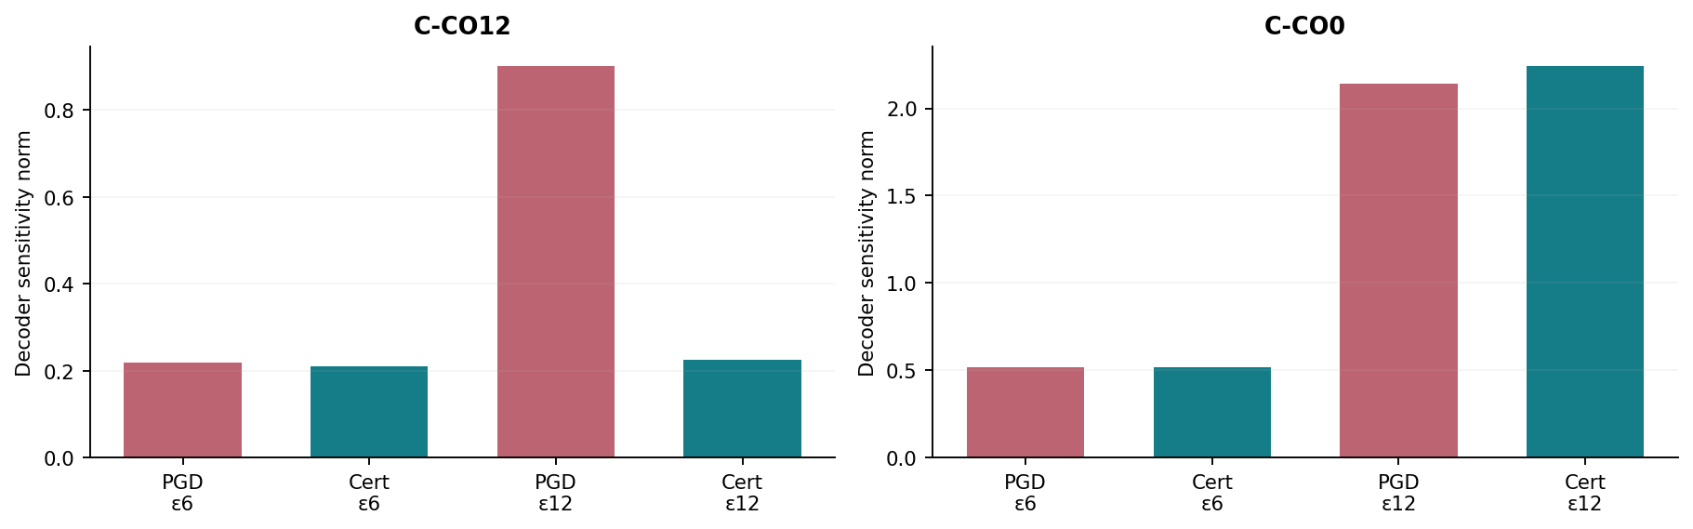
Figure. Decoder sensitivity norm by session and training arm; ε=12 creates a substantially different regime in the two sessions.
C-CO12 at ε=12: sensitivity norm is 0.9005 (PGD) vs 0.2244 (Cert); active share is 0.0298 vs 0.4637; top-unit share is 0.9065 vs 0.6004; tangent fraction is 0.1118 vs 0.2439. These synchronized shifts coincide with the robustness gap. In C-CO0, however, ε=12 sensitivities are 2.1403 (PGD) vs 2.2401 (Cert), so the same sensitivity-normalization mechanism does not generalize directly.

6. Naturalistic perturbation and neuron-removal trade-offs
The ε=12 certificate is not a free improvement. C-CO12: standard PGD has markedly higher performance under stochastic or nested neuron deletion, while PGD-Cert is substantially stronger under PGD evaluation. This suggests stressor-dependent specialization, not uniformly improved decoding.

C-CO12
Train ε | Arm | Poisson | Dropout-30% | Nested-50% | Gain-30% | Importance-drop-20%
6 | PGD | 0.664 ± 0.008 | 0.407 ± 0.016 | 0.233 ± 0.025 | 0.671 ± 0.009 | 0.105 ± 0.030
6 | PGD-Cert | 0.659 ± 0.016 | 0.406 ± 0.047 | 0.238 ± 0.052 | 0.667 ± 0.018 | 0.072 ± 0.193
12 | PGD | 0.569 ± 0.017 | 0.545 ± 0.002 | 0.447 ± 0.015 | 0.687 ± 0.005 | 0.310 ± 0.042
12 | PGD-Cert | 0.675 ± 0.009 | 0.421 ± 0.018 | 0.276 ± 0.024 | 0.684 ± 0.008 | 0.056 ± 0.049

C-CO0
Train ε | Arm | Poisson | Dropout-30% | Nested-50% | Gain-30% | Importance-drop-20%
6 | PGD | 0.614 ± 0.011 | 0.120 ± 0.051 | 0.140 ± 0.048 | 0.666 ± 0.017 | -0.328 ± 0.065
6 | PGD-Cert | 0.616 ± 0.008 | 0.123 ± 0.039 | 0.152 ± 0.025 | 0.668 ± 0.014 | -0.297 ± 0.090
12 | PGD | 0.369 ± 0.019 | 0.379 ± 0.011 | 0.328 ± 0.018 | 0.633 ± 0.010 | -0.034 ± 0.030
12 | PGD-Cert | 0.435 ± 0.022 | 0.362 ± 0.026 | 0.301 ± 0.015 | 0.652 ± 0.012 | -0.022 ± 0.056

7. Per-label decoding under adversarial attack
Each session has six behavioral output dimensions. Label identities are not supplied by the terminal output, so they are denoted L0–L5 and must not be interpreted as specific physical coordinates without the dataset schema. Reported means are averages of seed-level per-label R2 values.

C-CO12
Train ε | Method | L0 | L1 | L2 | L3 | L4 | L5
6 | PGD | 0.696 | 0.692 | 0.749 | 0.725 | 0.403 | 0.184
6 | PGD-Cert | 0.675 | 0.696 | 0.747 | 0.722 | 0.412 | 0.185
12 | PGD | 0.302 | 0.289 | 0.358 | 0.217 | -0.513 | -1.143
12 | PGD-Cert | 0.751 | 0.723 | 0.780 | 0.722 | 0.393 | 0.179

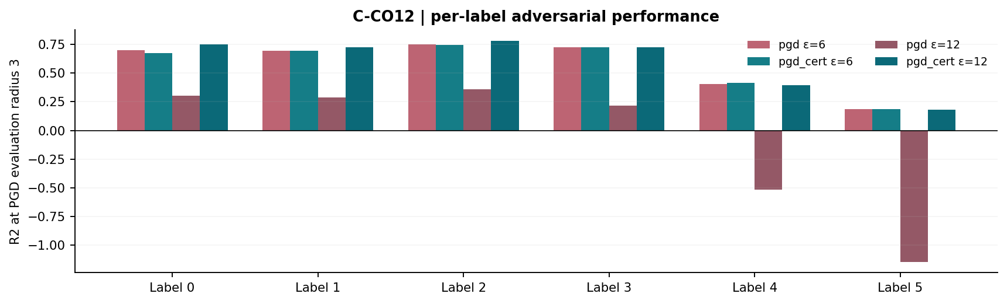
Figure. C-CO12: mean per-label R2 at PGD evaluation radius 3 (scores are not individually accompanied by error bars; consult full seed CSV).

C-CO0
Train ε | Method | L0 | L1 | L2 | L3 | L4 | L5
6 | PGD | 0.655 | 0.570 | 0.647 | 0.549 | -0.367 | -0.984
6 | PGD-Cert | 0.662 | 0.576 | 0.636 | 0.550 | -0.412 | -0.935
12 | PGD | -0.053 | -0.176 | 0.247 | 0.242 | -2.566 | -4.443
12 | PGD-Cert | 0.015 | -0.087 | 0.303 | 0.282 | -2.308 | -4.077

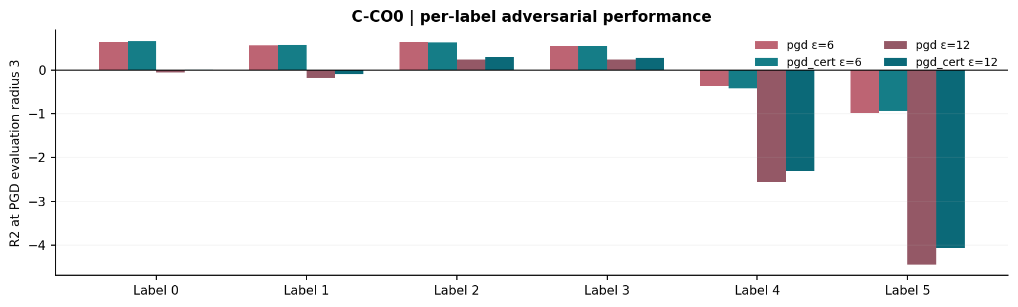
Figure. C-CO0: mean per-label R2 at PGD evaluation radius 3 (scores are not individually accompanied by error bars; consult full seed CSV).
The C-CO12 ε=12 deterioration of ordinary PGD is evident on multiple output dimensions, particularly L4 and L5; it is not attributable to a single anomalous label. C-CO0 retains severe negative attacked-R2 values on L4/L5 even under PGD-Cert, pointing to a persistent session-specific failure mode.

8. Computation, controls and reproducibility
Session | ε | Arm | Seconds/iteration | Total seconds/model | Mean achieved L2 / ε
C-CO12 | 6 | PGD | 0.200 ± 0.005 | 608.971 ± 14.841 | 0.995
C-CO12 | 6 | PGD-Cert | 0.283 ± 0.016 | 857.435 ± 46.858 | 0.993
C-CO12 | 12 | PGD | 0.203 ± 0.004 | 617.672 ± 11.149 | 0.862
C-CO12 | 12 | PGD-Cert | 0.292 ± 0.007 | 882.677 ± 20.436 | 0.864
C-CO0 | 6 | PGD | 0.196 ± 0.004 | 591.524 ± 12.698 | 0.997
C-CO0 | 6 | PGD-Cert | 0.278 ± 0.008 | 836.416 ± 24.843 | 0.990
C-CO0 | 12 | PGD | 0.196 ± 0.005 | 592.512 ± 13.803 | 0.839
C-CO0 | 12 | PGD-Cert | 0.284 ± 0.007 | 854.651 ± 22.169 | 0.831

Runtime overhead is substantial: relative to PGD, PGD-Cert takes approximately 1.4–1.5× the per-iteration time, depending on condition. Measured seconds are per model, not a summed wall-clock duration for four parallel workers.

Code provenance
C-CO12: runner v7-multigpu-independent-v1 | runner SHA256 0988318d9ba494df93d53a3b7f7dbaa7d8c688c109d3557c439df949a7d8c511
cebra/integrations/sklearn/cebra.py: eca3ac772e3622678eefc4d8eee5c277bd7a35e614acf5e43a6f0ddd78049ebe
cebra/solver/base.py: 1794228c2d2784ab7c43df08650b7718be39469187c6cead03f7edc35eff4bf8
cebra/solver/spectral_gap.py: 9b6c79d2d2379e16ce43a63bd81ffb668a110d6c12e034fcbdbdb4b187189546
C-CO0: runner v7-multigpu-independent-v1 | runner SHA256 0988318d9ba494df93d53a3b7f7dbaa7d8c688c109d3557c439df949a7d8c511
cebra/integrations/sklearn/cebra.py: eca3ac772e3622678eefc4d8eee5c277bd7a35e614acf5e43a6f0ddd78049ebe
cebra/solver/base.py: 1794228c2d2784ab7c43df08650b7718be39469187c6cead03f7edc35eff4bf8
cebra/solver/spectral_gap.py: 9b6c79d2d2379e16ce43a63bd81ffb668a110d6c12e034fcbdbdb4b187189546
The fork fingerprints are the same for both sessions. Repeated PGD ε=6 results reproduce the prior baseline reported for V5 to the precision shown in the terminal records. We have not independently rerun either the source code or the real-data experiments.

9. Interpretation, weaknesses and report-ready conclusions

Key conclusions
1. Certificate viability: at ε=6, PGD-Cert changes the protected-gap diagnostics markedly but changes attacked R2 very little on both sessions. This is evidence that spectral preservation alone does not guarantee performance gain.
2. High-budget regime: at ε=12 on C-CO12, unrestricted PGD becomes extremely attack-sensitive despite clean R2 around 0.70, whereas PGD-Cert maintains much stronger robustness. The seed-paired PGD@3 change is +0.6731 and the corresponding PGD@6 change is +0.9774, with nearly matched training perturbation norms.
3. Heterogeneity: on C-CO0 at ε=12, PGD-Cert improves PGD@3 by +0.1459 and PGD@6 by +0.1650 on average, but R2 remains negative in both cases. No claim of robust generalization across sessions is supported.
4. Specialized robustness: large adversarial gains on C-CO12 are accompanied by decreases of −0.1234 (Dropout-30%) and −0.1710 (Nested-50%) in R2. The direction and type of perturbation matter.
5. Mechanism: the large C-CO12 gain co-occurs with lower sensitivity norm, much greater active-unit sensitivity share, lower top-unit concentration, and cleaner gap diagnostics. Those associations warrant targeted intervention studies, not causal language.

Threats to interpretation
Only two independent recording sessions and three optimization seeds were evaluated; the output supplies no cross-session random-effects estimate or independent replication panel. The threat model uses finite-step PGD with three restarts and three evaluation radii; other attack strengths and adaptive strategies may change absolute scores. A positive retained-gap diagnostic should not be conflated with exact preservation of every singular direction, and small nonzero mode-exchange fractions at ε=12 require investigation. The finite-step training attack can be affected by gradient effects and optimizer dynamics at extreme epsilon; gradient masking is not ruled out by this report. Spectral diagnostic summaries may be measured on sampled training windows, not an exhaustive mathematical verification of all possible perturbations.
A particularly important check before claims about prevention of representation collapse is to characterize the PGD ε=12 training process (loss curves, learning trajectories, gradient magnitudes, encoder activation statistics, independently strengthened adaptive evaluation, and checkpoint behavior). This study contains no checkpoint files and so cannot resolve these possibilities.

Recommended reporting language
“We compare standard PGD adversarial training with an explicitly spectrally constrained PGD variant on two neural-recording sessions. At a moderate training radius, the certificate preserves favorable spectral diagnostics without consistently improving attacked decoding. At a high training radius, the certified variant substantially improves attacked R2 on one session, despite essentially identical average training perturbation norms, while reducing robustness to neuron removal. The effect is session- and corruption-dependent and motivates replication across additional sessions.”

Appendix A. Seed-level primary scores (all 24 runs)

C-CO12
Train ε | Seed | Arm | Clean | PGD@1 | PGD@3 | PGD@6 | Drop30 | Nest50 | Train L2
6 | 42 | PGD | 0.666 | 0.647 | 0.569 | 0.242 | 0.426 | 0.259 | 5.97
6 | 42 | Cert | 0.684 | 0.663 | 0.583 | 0.232 | 0.451 | 0.296 | 5.96
6 | 43 | PGD | 0.683 | 0.663 | 0.585 | 0.235 | 0.398 | 0.210 | 5.97
6 | 43 | Cert | 0.681 | 0.661 | 0.583 | 0.231 | 0.409 | 0.224 | 5.96
6 | 44 | PGD | 0.677 | 0.656 | 0.571 | 0.222 | 0.398 | 0.229 | 5.98
6 | 44 | Cert | 0.648 | 0.629 | 0.553 | 0.229 | 0.358 | 0.194 | 5.96
12 | 42 | PGD | 0.693 | 0.518 | -0.107 | -0.808 | 0.543 | 0.435 | 10.33
12 | 42 | Cert | 0.700 | 0.680 | 0.595 | 0.268 | 0.401 | 0.249 | 10.38
12 | 43 | PGD | 0.703 | 0.436 | -0.091 | -0.661 | 0.546 | 0.443 | 10.37
12 | 43 | Cert | 0.698 | 0.678 | 0.596 | 0.327 | 0.436 | 0.286 | 10.34
12 | 44 | PGD | 0.700 | 0.413 | -0.047 | -0.578 | 0.544 | 0.463 | 10.34
12 | 44 | Cert | 0.682 | 0.662 | 0.583 | 0.290 | 0.426 | 0.293 | 10.37

C-CO0
Train ε | Seed | Arm | Clean | PGD@1 | PGD@3 | PGD@6 | Drop30 | Nest50 | Train L2
6 | 42 | PGD | 0.688 | 0.594 | 0.207 | -0.795 | 0.177 | 0.194 | 5.97
6 | 42 | Cert | 0.691 | 0.594 | 0.196 | -0.815 | 0.161 | 0.180 | 5.94
6 | 43 | PGD | 0.685 | 0.581 | 0.191 | -0.833 | 0.078 | 0.102 | 5.98
6 | 43 | Cert | 0.686 | 0.583 | 0.201 | -0.832 | 0.082 | 0.140 | 5.94
6 | 44 | PGD | 0.671 | 0.567 | 0.136 | -0.867 | 0.105 | 0.125 | 5.99
6 | 44 | Cert | 0.677 | 0.568 | 0.142 | -0.813 | 0.127 | 0.135 | 5.95
12 | 42 | PGD | 0.680 | -0.149 | -1.078 | -1.507 | 0.382 | 0.326 | 10.02
12 | 42 | Cert | 0.705 | -0.099 | -1.007 | -1.413 | 0.391 | 0.312 | 9.93
12 | 43 | PGD | 0.700 | -0.212 | -1.132 | -1.564 | 0.387 | 0.310 | 10.08
12 | 43 | Cert | 0.704 | -0.161 | -1.042 | -1.451 | 0.355 | 0.284 | 9.96
12 | 44 | PGD | 0.708 | -0.073 | -1.163 | -1.528 | 0.366 | 0.346 | 10.12
12 | 44 | Cert | 0.722 | -0.054 | -0.887 | -1.239 | 0.340 | 0.307 | 10.03

Appendix B. Extended metrics: adversarial geometry and neuron dependence

C-CO12
ε | Arm | SVD-gap attack | Complement attack | Fixed tangent | SVD-tangent attack
6 | PGD | 0.627 ± 0.009 | 0.595 ± 0.008 | 0.644 ± 0.009 | 0.666 ± 0.008
6 | Cert | 0.624 ± 0.018 | 0.593 ± 0.017 | 0.640 ± 0.019 | 0.662 ± 0.020
12 | PGD | 0.177 ± 0.023 | -0.029 ± 0.025 | 0.429 ± 0.052 | 0.640 ± 0.012
12 | Cert | 0.645 ± 0.009 | 0.614 ± 0.008 | 0.659 ± 0.009 | 0.683 ± 0.010

ε | Arm | Top-unit attack energy | Top-unit signal | Decoder top-unit importance | Tangent attack energy
6 | PGD | 0.429 ± 0.003 | 0.369 ± 0.000 | 0.845 ± 0.020 | 0.248 ± 0.003
6 | Cert | 0.429 ± 0.003 | 0.369 ± 0.000 | 0.835 ± 0.028 | 0.248 ± 0.003
12 | PGD | 0.129 ± 0.001 | 0.369 ± 0.000 | 0.789 ± 0.035 | 0.101 ± 0.002
12 | Cert | 0.409 ± 0.004 | 0.369 ± 0.000 | 0.841 ± 0.018 | 0.270 ± 0.003

C-CO0
ε | Arm | SVD-gap attack | Complement attack | Fixed tangent | SVD-tangent attack
6 | PGD | 0.415 ± 0.019 | 0.264 ± 0.027 | 0.535 ± 0.022 | 0.638 ± 0.012
6 | Cert | 0.416 ± 0.010 | 0.264 ± 0.024 | 0.538 ± 0.021 | 0.641 ± 0.009
12 | PGD | -0.711 ± 0.047 | -1.054 ± 0.061 | 0.108 ± 0.006 | 0.496 ± 0.026
12 | Cert | -0.628 ± 0.071 | -0.930 ± 0.066 | 0.129 ± 0.013 | 0.517 ± 0.019

ε | Arm | Top-unit attack energy | Top-unit signal | Decoder top-unit importance | Tangent attack energy
6 | PGD | 0.631 ± 0.010 | 0.659 ± 0.000 | 0.961 ± 0.007 | 0.243 ± 0.001
6 | Cert | 0.631 ± 0.010 | 0.659 ± 0.000 | 0.966 ± 0.010 | 0.242 ± 0.000
12 | PGD | 0.157 ± 0.007 | 0.659 ± 0.000 | 0.910 ± 0.021 | 0.079 ± 0.011
12 | Cert | 0.168 ± 0.014 | 0.659 ± 0.000 | 0.923 ± 0.005 | 0.088 ± 0.013

Appendix C. Source scope and companion data
This report was calculated from the user-supplied terminal stdout dump. The complete run_config and summary objects are present, as are exactly 24 full seed-level JSON records. Records were parsed directly rather than transcribed manually. No additional source files, model checkpoints or original neural recordings were available for this stage. The CSV appendix containing complete records retains all available scalar fields and per-label vectors; the paired-difference CSV records all selected comparisons including per-seed signs and descriptive t intervals; the metric-summary CSV collects all numeric means and sample SD values.
Data-integrity checks: 24 unique key tuples; 12 per session; two arms × two training radii × three seeds; at least 102 source fields per run record; original trained methods are pgd and pgd_cert. Source terminal concluded TOTAL COMPLETED: 24/24.

