  - RESEARCH RESULTS / EXPERIMENTAL ANALYSIS

Acorn-SVD V5
84-run four-GPU experimental evaluation: spectral certificates, collapse-radius scaling, energy-matched PGD controls, and robustness curves
C-CO12 and C-CO0 | Seeds 42 / 43 / 44 | Training ε = 3, 6 | Evaluation ε = 1, 3, 6
Analysis date: 20 October 2026
Source: Acorn_SVD_V5_84runs_FULL_REPORT_DATA.zip (per-task JSON, run configurations, results, metrics, source code and log excerpts).

Executive findings
• All 84/84 planned model fits are recorded as successful: 24 + 18 for C-CO12 and 24 + 18 for C-CO0. Four independent GPU workers were used; this is task-level parallelism, not multi-GPU data parallelism within one model.
• Exact collapse-radius scaling preserves the protected singular structure in the sampled training diagnostics while using nearly the full nominal input-space budget. It does not produce a consistent decoding improvement over radial projection or unconstrained PGD.
• On C-CO12 at εtrain=6, radial has clean R²=0.6954 versus PGD=0.6753 (Δ=+0.0201); at the held-out εeval=6, PGD R²=0.2330 versus radial=0.1869. Collapse improves that strong-attack score to 0.2334 but drops clean R² to 0.6807.
• On C-CO0 at εtrain=6, SVD-Split gives clean R²=0.7071 versus PGD=0.6811 and higher severe-attack PGD R² at εeval=6 (−0.6802 versus −0.8315). The energy-matched-Split control, however, is stronger at εeval=3 (0.1781 versus 0.1632), so superiority is attack-radius dependent.
• The matched-energy controls did not achieve identical realized mean L2 norms (e.g., C-CO0, εtrain=6: Split=3.6774 and match-Split=4.0239). Consequently, directional effects cannot yet be interpreted as experimentally isolated causal effects.
• Sample size is three paired seeds per setting and only two recordings. The ± figures are across seeds. Results are descriptive, not a demonstration of population-level superiority or formal statistical significance.
All scores are R² (higher is better). Negative R² indicates predictions worse than the mean-label baseline for that evaluation split.

1. Experimental inventory and design
Cohort | Fits | Seeds | Train bins | Valid bins | Units | Median window ||Xc||F | Median gap
C-CO12_eps3 | 24 | 42, 43, 44 | 18384 | 4543 | 86 | 37.393 | 2.477
C-CO12_eps6 | 18 | 42, 43, 44 | 18384 | 4543 | 86 | 37.393 | 2.477
C-CO0_eps3 | 24 | 42, 43, 44 | 2608 | 615 | 71 | 26.648 | 3.082
C-CO0_eps6 | 18 | 42, 43, 44 | 2608 | 615 | 71 | 26.648 | 3.082

Protocol. The encoder uses CEBRA offset36-model-more-dropout, a 64-dimensional embedding, 64 hidden units, batch size 2048, temperature 0.4, 3,000 optimization iterations and learning rate 3e−4. Training calls encoder.fit(x_train, y_train), i.e. behavioral labels ARE passed to CEBRA. A two-layer decoder (Linear / LayerNorm / ReLU / Dropout / Linear; hidden size 64, dropout 0.4) is fitted for 2,500 epochs at learning rate 1e−3 to predict six continuous behavior columns.
Training attacks: PGD L2 with 10 steps, α=εtrain/5. Spectral controls use γ=0.9, a per-window dominant singular-rank search k∈[1,8], temporal centering enabled and mean preservation disabled. εtrain is an ABSOLUTE radius, not a fraction of the training window norm. Exact values 3 and 6 are ~8.0%/16.0% of C-CO12 median centered norm and ~11.3%/22.5% of C-CO0 median norm.
Held-out robustness: frozen encoder + decoder, 20-step targeted-label-loss (MSE-maximizing) window attacks, three restarts, PGD radii 1, 3, 6; at radius 3 the runner also evaluates SVD-gap, tangent, complement and fixed-radius tangent attacks. The worst individual restart is selected per window. Corruption tests include Poisson resampling, per-unit gain drift, independent random 10%/30% dropouts, nested 5–50% dropout levels, and structured top-20% activity/variance/importance ablations. Five random corruption draws are averaged.
Metric comparability: valid_mean_r2 is computed from encoder.transform over all validation time bins; r2_pgd, r2_clean and other attacked-window metrics use only fully valid offset-36 windows. Consequently raw values in these two families are not the same evaluation subset. Differences across models within a family are valid comparisons.

2. Models and interpretation of controls
Arm | Training perturbation | Interpretation
Clean | No adversarial perturbation | Unrestricted accuracy reference
PGD | Unrestricted L2 PGD | Adversarial robustness reference
Radial | Complement-space PGD + global shrink | Earlier conservative spectral certificate
Collapse | Complement-space PGD + exact along-direction collapse radius | Preserves complement direction; can retain a larger norm than radial
SVD-Split | Complement + tangent components with separate constraints | Mixed geometry / retained dominant-spectrum identity
PGD-Match-Split | PGD uses per-window norm from Split as its budget | Energy-control with unrestricted directions; realized energies must be checked
PGD-Match-Radial | PGD uses per-window norm from Radial as its budget | Energy-control with unrestricted directions; realized energies must be checked
Tangent | Perturb dominant-structure tangent space | Trade-off with unit-dropout and PGD robustness

From the bundled source: matched controls first generate a spectral perturbation to measure per-window norms, then run a separate unrestricted PGD step sequence with those norm budgets. Observed final norms may differ because a budget is an upper bound, not a requirement that final PGD reaches it.

3. Complete primary results by cohort

C-CO12 | training ε = 3 (absolute L2)
Arm | Clean R² | PGD@1 | PGD@3 | PGD@6 | Drop30 | Nested50 | Train ||δ||2
Clean | 0.684 ± 0.004 | 0.598 ± 0.009 | -0.015 ± 0.041 | -1.205 ± 0.039 | 0.527 ± 0.012 | 0.396 ± 0.016 | —
PGD | 0.677 ± 0.009 | 0.655 ± 0.009 | 0.564 ± 0.011 | 0.165 ± 0.039 | 0.434 ± 0.024 | 0.277 ± 0.030 | 2.997 ± 0.001
Radial | 0.698 ± 0.014 | 0.673 ± 0.014 | 0.569 ± 0.015 | 0.097 ± 0.021 | 0.422 ± 0.010 | 0.254 ± 0.010 | 2.799 ± 0.004
Collapse | 0.695 ± 0.005 | 0.671 ± 0.007 | 0.567 ± 0.015 | 0.109 ± 0.023 | 0.417 ± 0.010 | 0.242 ± 0.026 | 2.997 ± 0.000
SVD-Split | 0.690 ± 0.011 | 0.664 ± 0.010 | 0.559 ± 0.006 | 0.084 ± 0.013 | 0.438 ± 0.019 | 0.297 ± 0.014 | 2.392 ± 0.006
PGD-Match-Split | 0.684 ± 0.014 | 0.660 ± 0.013 | 0.561 ± 0.007 | 0.099 ± 0.040 | 0.444 ± 0.034 | 0.301 ± 0.038 | 2.468 ± 0.005
PGD-Match-Radial | 0.686 ± 0.008 | 0.662 ± 0.010 | 0.569 ± 0.018 | 0.158 ± 0.024 | 0.433 ± 0.026 | 0.275 ± 0.038 | 2.834 ± 0.003
Tangent | 0.691 ± 0.014 | 0.624 ± 0.016 | 0.176 ± 0.030 | -1.036 ± 0.034 | 0.529 ± 0.006 | 0.432 ± 0.033 | 1.179 ± 0.000

Values = mean ± sample standard deviation over three seeds. Main PGD column is evaluation radius 3. Train ||δ||2 is the observed mean L2 norm, not the nominal maximum.
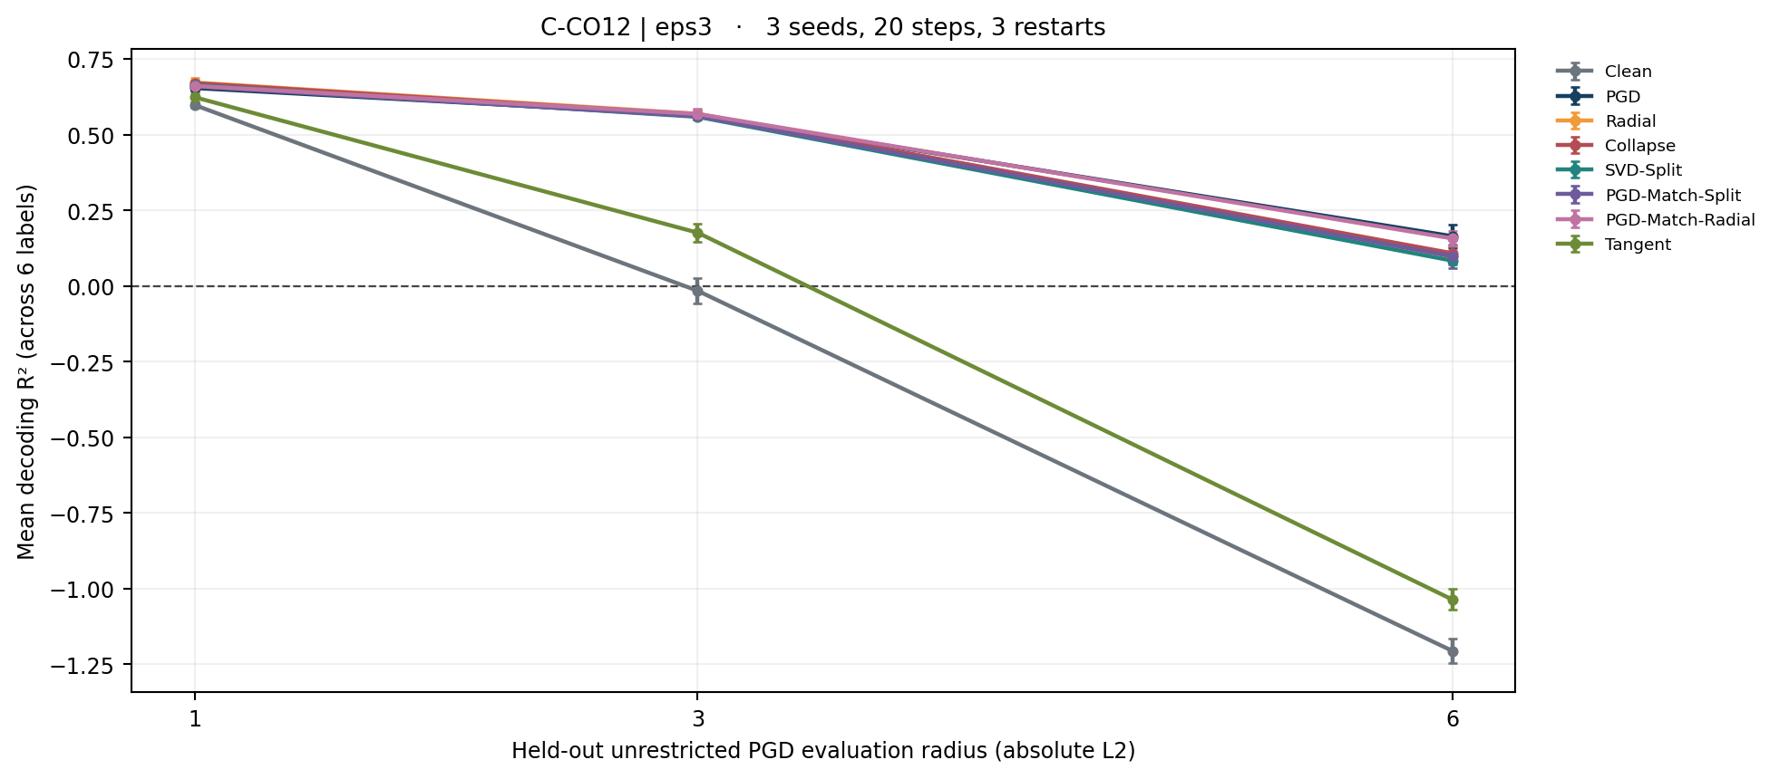
Figure 1. Held-out unrestricted PGD robustness curves for C-CO12_eps3. Error bars show sample SD across three seeds; attack settings are identical across arms.

C-CO12 | training ε = 6 (absolute L2)
Arm | Clean R² | PGD@1 | PGD@3 | PGD@6 | Drop30 | Nested50 | Train ||δ||2
PGD | 0.675 ± 0.008 | 0.655 ± 0.008 | 0.575 ± 0.008 | 0.233 ± 0.010 | 0.407 ± 0.016 | 0.233 ± 0.025 | 5.972 ± 0.004
Radial | 0.695 ± 0.006 | 0.674 ± 0.005 | 0.583 ± 0.006 | 0.187 ± 0.014 | 0.393 ± 0.003 | 0.198 ± 0.018 | 3.624 ± 0.009
Collapse | 0.681 ± 0.005 | 0.661 ± 0.005 | 0.580 ± 0.003 | 0.233 ± 0.001 | 0.395 ± 0.010 | 0.218 ± 0.014 | 5.976 ± 0.004
SVD-Split | 0.684 ± 0.004 | 0.661 ± 0.004 | 0.570 ± 0.004 | 0.178 ± 0.012 | 0.402 ± 0.014 | 0.221 ± 0.015 | 3.338 ± 0.007
PGD-Match-Split | 0.683 ± 0.013 | 0.662 ± 0.014 | 0.581 ± 0.014 | 0.229 ± 0.019 | 0.432 ± 0.019 | 0.283 ± 0.055 | 3.606 ± 0.010
PGD-Match-Radial | 0.682 ± 0.003 | 0.661 ± 0.004 | 0.578 ± 0.005 | 0.225 ± 0.020 | 0.432 ± 0.027 | 0.280 ± 0.051 | 3.815 ± 0.011

Values = mean ± sample standard deviation over three seeds. Main PGD column is evaluation radius 3. Train ||δ||2 is the observed mean L2 norm, not the nominal maximum.
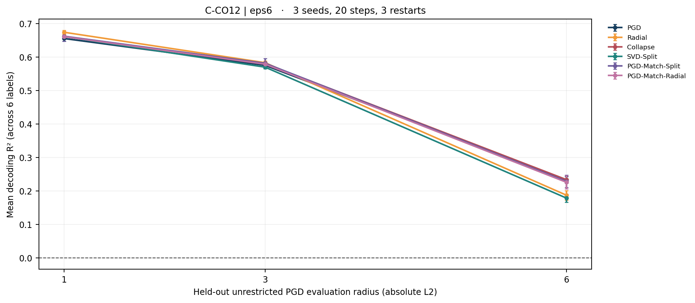
Figure 2. Held-out unrestricted PGD robustness curves for C-CO12_eps6. Error bars show sample SD across three seeds; attack settings are identical across arms.

C-CO0 | training ε = 3 (absolute L2)
Arm | Clean R² | PGD@1 | PGD@3 | PGD@6 | Drop30 | Nested50 | Train ||δ||2
Clean | 0.711 ± 0.002 | 0.200 ± 0.021 | -1.503 ± 0.032 | -1.925 ± 0.021 | 0.393 ± 0.022 | 0.331 ± 0.016 | —
PGD | 0.705 ± 0.009 | 0.584 ± 0.010 | 0.114 ± 0.018 | -0.876 ± 0.081 | 0.201 ± 0.010 | 0.238 ± 0.050 | 2.998 ± 0.000
Radial | 0.711 ± 0.010 | 0.588 ± 0.019 | 0.080 ± 0.038 | -0.915 ± 0.084 | 0.209 ± 0.037 | 0.236 ± 0.076 | 2.781 ± 0.005
Collapse | 0.707 ± 0.001 | 0.591 ± 0.010 | 0.110 ± 0.033 | -0.862 ± 0.075 | 0.198 ± 0.023 | 0.241 ± 0.069 | 2.998 ± 0.000
SVD-Split | 0.716 ± 0.005 | 0.597 ± 0.006 | 0.128 ± 0.021 | -0.854 ± 0.050 | 0.194 ± 0.027 | 0.269 ± 0.032 | 2.477 ± 0.007
PGD-Match-Split | 0.718 ± 0.003 | 0.603 ± 0.012 | 0.133 ± 0.036 | -0.895 ± 0.071 | 0.232 ± 0.021 | 0.284 ± 0.039 | 2.525 ± 0.004
PGD-Match-Radial | 0.716 ± 0.007 | 0.597 ± 0.012 | 0.122 ± 0.010 | -0.854 ± 0.016 | 0.229 ± 0.018 | 0.273 ± 0.008 | 2.818 ± 0.003
Tangent | 0.720 ± 0.012 | 0.454 ± 0.040 | -0.884 ± 0.032 | -1.795 ± 0.023 | 0.390 ± 0.048 | 0.337 ± 0.020 | 1.410 ± 0.000

Values = mean ± sample standard deviation over three seeds. Main PGD column is evaluation radius 3. Train ||δ||2 is the observed mean L2 norm, not the nominal maximum.
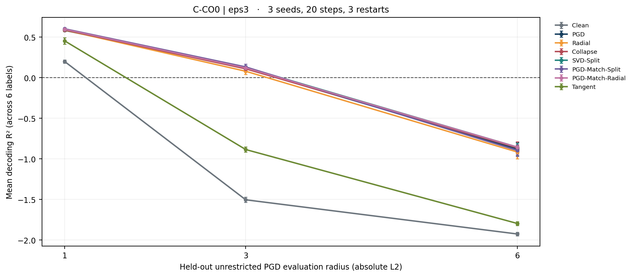
Figure 3. Held-out unrestricted PGD robustness curves for C-CO0_eps3. Error bars show sample SD across three seeds; attack settings are identical across arms.

C-CO0 | training ε = 6 (absolute L2)
Arm | Clean R² | PGD@1 | PGD@3 | PGD@6 | Drop30 | Nested50 | Train ||δ||2
PGD | 0.681 ± 0.009 | 0.581 ± 0.013 | 0.178 ± 0.037 | -0.831 ± 0.036 | 0.120 ± 0.051 | 0.140 ± 0.048 | 5.980 ± 0.009
Radial | 0.697 ± 0.007 | 0.571 ± 0.015 | 0.091 ± 0.077 | -0.890 ± 0.054 | 0.152 ± 0.029 | 0.189 ± 0.030 | 4.129 ± 0.013
Collapse | 0.667 ± 0.010 | 0.546 ± 0.011 | 0.114 ± 0.025 | -0.869 ± 0.039 | 0.131 ± 0.030 | 0.091 ± 0.057 | 5.977 ± 0.006
SVD-Split | 0.707 ± 0.002 | 0.595 ± 0.008 | 0.163 ± 0.007 | -0.680 ± 0.007 | 0.200 ± 0.035 | 0.244 ± 0.038 | 3.677 ± 0.009
PGD-Match-Split | 0.712 ± 0.007 | 0.607 ± 0.003 | 0.178 ± 0.022 | -0.757 ± 0.043 | 0.194 ± 0.029 | 0.224 ± 0.047 | 4.024 ± 0.008
PGD-Match-Radial | 0.705 ± 0.008 | 0.602 ± 0.016 | 0.187 ± 0.029 | -0.767 ± 0.009 | 0.191 ± 0.026 | 0.200 ± 0.017 | 4.373 ± 0.013

Values = mean ± sample standard deviation over three seeds. Main PGD column is evaluation radius 3. Train ||δ||2 is the observed mean L2 norm, not the nominal maximum.
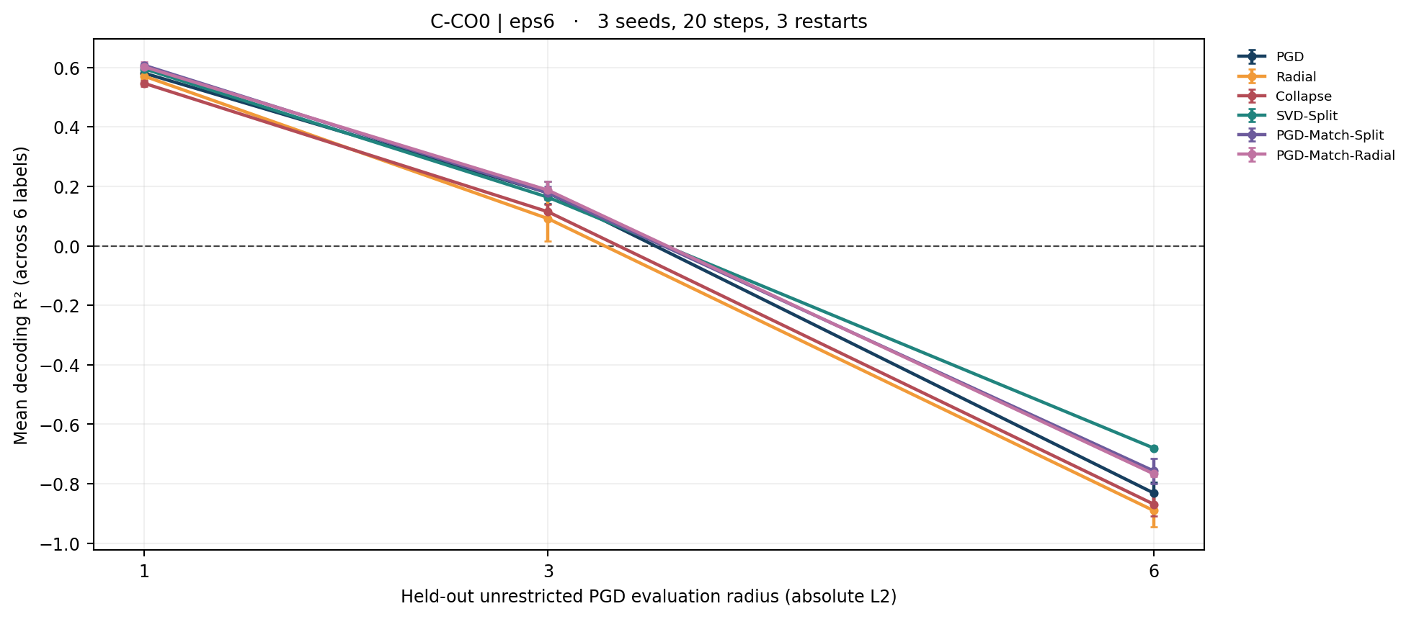
Figure 4. Held-out unrestricted PGD robustness curves for C-CO0_eps6. Error bars show sample SD across three seeds; attack settings are identical across arms.

4. Energy-matched comparisons (same seed, same recording)
Paired differences are calculated from each seed 42–44 before aggregation. A positive score difference favors the first arm. The 95% confidence intervals in the CSV supplement are t-based (df=2) and are highly unstable at n=3; no multiple-comparison inference is claimed.

C-CO12 | training ε = 3 (absolute L2)
Paired A–B | Δ clean R² | Δ PGD@3 | Δ PGD@6 | Δ Drop30 | Δ train norm
SVD-Split – PGD-Match-Split | +0.006 ± 0.009 | -0.002 ± 0.006 | -0.014 ± 0.053 | -0.006 ± 0.017 | -0.076 ± 0.001
Radial – PGD-Match-Radial | +0.012 ± 0.007 | +0.000 ± 0.004 | -0.060 ± 0.026 | -0.011 ± 0.017 | -0.035 ± 0.001
Collapse – Radial | -0.003 ± 0.019 | -0.003 ± 0.022 | +0.012 ± 0.014 | -0.005 ± 0.014 | +0.198 ± 0.003

C-CO12 | training ε = 6 (absolute L2)
Paired A–B | Δ clean R² | Δ PGD@3 | Δ PGD@6 | Δ Drop30 | Δ train norm
SVD-Split – PGD-Match-Split | +0.001 ± 0.017 | -0.012 ± 0.014 | -0.050 ± 0.029 | -0.030 ± 0.020 | -0.269 ± 0.007
Radial – PGD-Match-Radial | +0.014 ± 0.004 | +0.004 ± 0.001 | -0.039 ± 0.024 | -0.039 ± 0.030 | -0.191 ± 0.005
Collapse – Radial | -0.015 ± 0.007 | -0.002 ± 0.008 | +0.046 ± 0.014 | +0.002 ± 0.012 | +2.352 ± 0.013

C-CO0 | training ε = 3 (absolute L2)
Paired A–B | Δ clean R² | Δ PGD@3 | Δ PGD@6 | Δ Drop30 | Δ train norm
SVD-Split – PGD-Match-Split | -0.002 ± 0.005 | -0.005 ± 0.021 | +0.041 ± 0.052 | -0.037 ± 0.041 | -0.048 ± 0.002
Radial – PGD-Match-Radial | -0.005 ± 0.012 | -0.042 ± 0.036 | -0.061 ± 0.093 | -0.019 ± 0.028 | -0.037 ± 0.002
Collapse – Radial | -0.004 ± 0.010 | +0.030 ± 0.029 | +0.053 ± 0.079 | -0.011 ± 0.031 | +0.216 ± 0.005

C-CO0 | training ε = 6 (absolute L2)
Paired A–B | Δ clean R² | Δ PGD@3 | Δ PGD@6 | Δ Drop30 | Δ train norm
SVD-Split – PGD-Match-Split | -0.004 ± 0.009 | -0.015 ± 0.018 | +0.077 ± 0.036 | +0.006 ± 0.025 | -0.346 ± 0.002
Radial – PGD-Match-Radial | -0.008 ± 0.013 | -0.096 ± 0.093 | -0.124 ± 0.051 | -0.039 ± 0.008 | -0.244 ± 0.011
Collapse – Radial | -0.030 ± 0.015 | +0.023 ± 0.052 | +0.022 ± 0.027 | -0.021 ± 0.045 | +1.848 ± 0.015

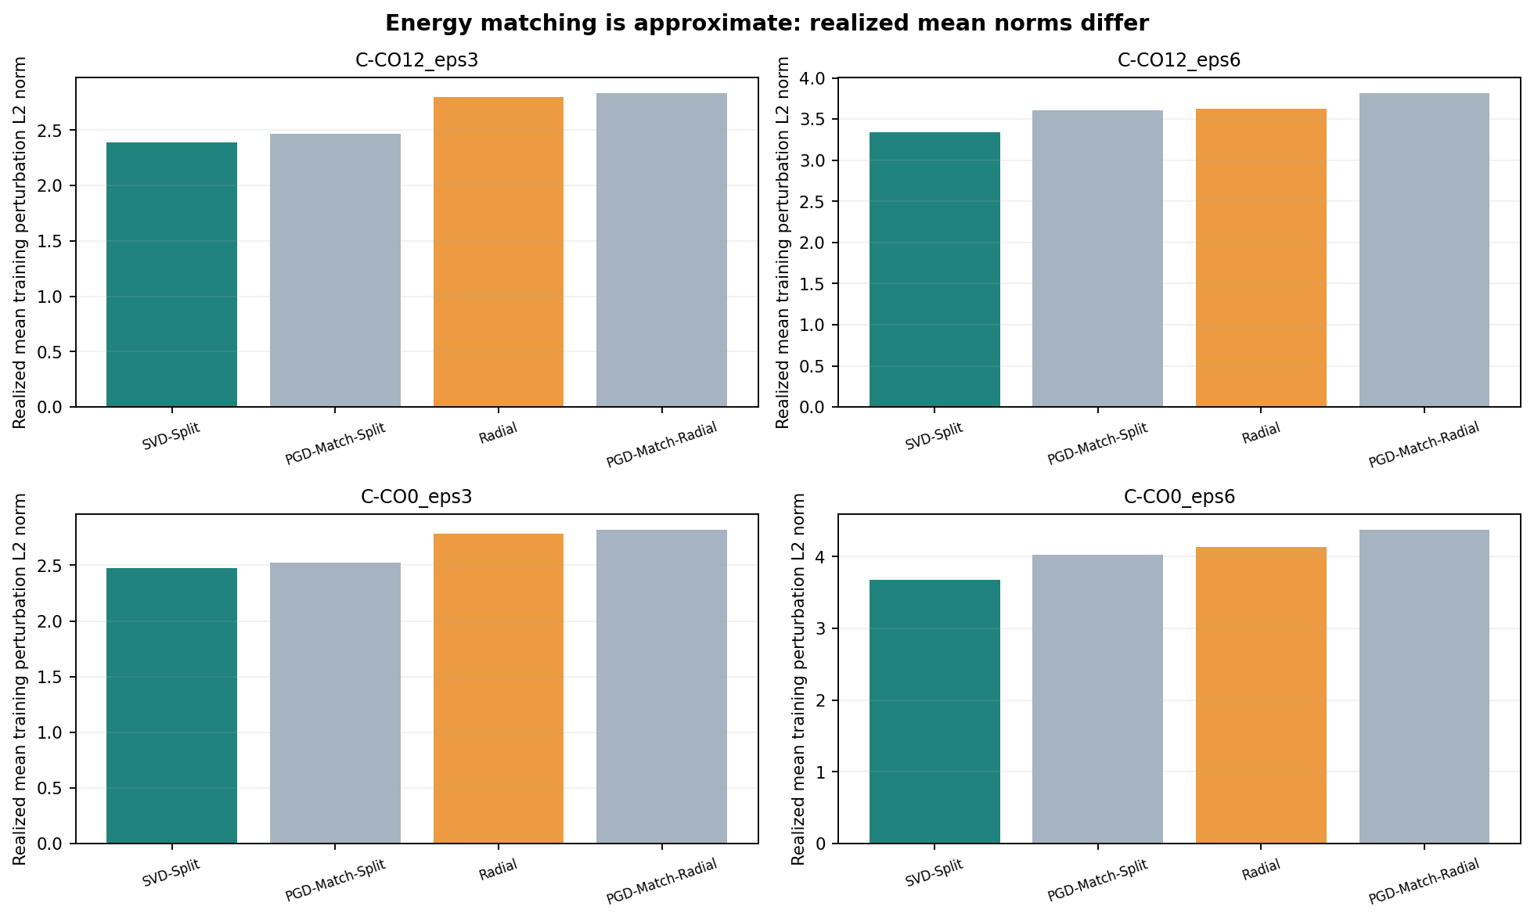
Figure 5. Realized mean training L2 norms: budget-matched PGD arms are systematically above the corresponding spectral arms; equality cannot be assumed.

5. Collapse-radius scaling versus radial certificate
Collapse uses the clean complement residual and scales the perturbation along its existing direction so that the complement spectral norm remains below a threshold based on s(k+1)+γ·gap. Radial scales the entire perturbation using the sufficient Weyl operator-norm bound γ·gap. This is a direction-preserving relaxation of a sufficient certificate, not a guarantee of better decoding.
Cohort | Collapse ||δ|| | Radial ||δ|| | Weyl gain¹ | Δ clean | Δ PGD@3 | Δ PGD@6
C-CO12_eps3 | 2.997 | 2.799 | 2.28 | -0.0025 | -0.0028 | 0.0115
C-CO12_eps6 | 5.976 | 3.624 | 2.75 | -0.0147 | -0.0025 | 0.0465
C-CO0_eps3 | 2.998 | 2.781 | 3.16 | -0.0040 | 0.0300 | 0.0526
C-CO0_eps6 | 5.977 | 4.129 | 3.37 | -0.0305 | 0.0230 | 0.0216

¹ train_adv_cert_weyl_gain comes directly from the fork implementation; it is not an improvement in R². Collapse has near-zero logged cert_active and near-unity cert_retained, because it uses its own feasibility construction; these numbers MUST NOT be interpreted as “no certificate applied.”

6. Spectral structure diagnostics

C-CO12 | training ε = 3 (absolute L2)
Arm | Active | Retained | Min gap kept | Max SV error | Mode exch. | Top-unit energy
PGD | — | — | 0.017 ± 0.082 | 0.079 ± 0.001 | 0.000 ± 0.000 | 0.406 ± 0.003
Radial | 0.332 ± 0.004 | 0.934 ± 0.001 | 0.531 ± 0.032 | 0.000 ± 0.000 | 0.000 ± 0.000 | 0.385 ± 0.003
Collapse | 0.000 ± 0.000 | 1.000 ± 0.000 | 0.225 ± 0.095 | 0.000 ± 0.000 | 0.000 ± 0.000 | 0.388 ± 0.002
SVD-Split | 0.997 ± 0.000 | 0.798 ± 0.002 | 0.708 ± 0.019 | 0.063 ± 0.004 | 0.000 ± 0.000 | 0.380 ± 0.002
PGD-Match-Split | 0.996 ± 0.000 | 0.824 ± 0.002 | 0.513 ± 0.029 | 0.066 ± 0.008 | 0.000 ± 0.000 | 0.398 ± 0.003
PGD-Match-Radial | 0.284 ± 0.004 | 0.946 ± 0.001 | 0.379 ± 0.069 | 0.079 ± 0.005 | 0.000 ± 0.000 | 0.403 ± 0.002
Tangent | — | — | 0.779 ± 0.007 | 0.069 ± 0.007 | 0.000 ± 0.000 | 0.363 ± 0.001

C-CO12 | training ε = 6 (absolute L2)
Arm | Active | Retained | Min gap kept | Max SV error | Mode exch. | Top-unit energy
PGD | — | — | -1.032 ± 0.090 | 0.170 ± 0.002 | 0.001 ± 0.000 | 0.429 ± 0.003
Radial | 0.934 ± 0.001 | 0.605 ± 0.002 | 0.533 ± 0.027 | 0.000 ± 0.000 | 0.000 ± 0.000 | 0.388 ± 0.003
Collapse | 0.003 ± 0.000 | 1.000 ± 0.000 | 0.100 ± 0.000 | 0.000 ± 0.000 | 0.000 ± 0.000 | 0.411 ± 0.003
SVD-Split | 1.000 ± 0.000 | 0.557 ± 0.001 | 0.679 ± 0.019 | 0.045 ± 0.004 | 0.000 ± 0.000 | 0.345 ± 0.002
PGD-Match-Split | 1.000 ± 0.000 | 0.603 ± 0.002 | 0.253 ± 0.027 | 0.117 ± 0.006 | 0.000 ± 0.000 | 0.404 ± 0.003
PGD-Match-Radial | 0.907 ± 0.003 | 0.639 ± 0.003 | 0.153 ± 0.045 | 0.134 ± 0.006 | 0.000 ± 0.000 | 0.405 ± 0.003

C-CO0 | training ε = 3 (absolute L2)
Arm | Active | Retained | Min gap kept | Max SV error | Mode exch. | Top-unit energy
PGD | — | — | -0.596 ± 0.043 | 0.124 ± 0.007 | 0.000 ± 0.000 | 0.620 ± 0.009
Radial | 0.266 ± 0.004 | 0.928 ± 0.002 | 0.564 ± 0.025 | 0.000 ± 0.000 | 0.000 ± 0.000 | 0.604 ± 0.006
Collapse | 0.000 ± 0.000 | 1.000 ± 0.000 | 0.100 ± 0.000 | 0.000 ± 0.000 | 0.000 ± 0.000 | 0.606 ± 0.006
SVD-Split | 0.992 ± 0.000 | 0.826 ± 0.002 | 0.715 ± 0.028 | 0.090 ± 0.008 | 0.000 ± 0.000 | 0.608 ± 0.005
PGD-Match-Split | 0.991 ± 0.000 | 0.843 ± 0.001 | 0.450 ± 0.050 | 0.094 ± 0.001 | 0.000 ± 0.000 | 0.616 ± 0.007
PGD-Match-Radial | 0.231 ± 0.003 | 0.941 ± 0.001 | 0.315 ± 0.049 | 0.121 ± 0.006 | 0.000 ± 0.000 | 0.621 ± 0.009
Tangent | — | — | 0.803 ± 0.010 | 0.082 ± 0.005 | 0.000 ± 0.000 | 0.530 ± 0.003

C-CO0 | training ε = 6 (absolute L2)
Arm | Active | Retained | Min gap kept | Max SV error | Mode exch. | Top-unit energy
PGD | — | — | -3.041 ± 0.389 | 0.266 ± 0.017 | 0.005 ± 0.000 | 0.631 ± 0.010
Radial | 0.781 ± 0.003 | 0.689 ± 0.002 | 0.434 ± 0.014 | 0.000 ± 0.000 | 0.000 ± 0.000 | 0.616 ± 0.008
Collapse | 0.012 ± 0.001 | 0.998 ± 0.000 | 0.100 ± 0.000 | 0.000 ± 0.000 | 0.000 ± 0.000 | 0.625 ± 0.008
SVD-Split | 1.000 ± 0.000 | 0.613 ± 0.002 | 0.624 ± 0.019 | 0.056 ± 0.001 | 0.000 ± 0.000 | 0.545 ± 0.007
PGD-Match-Split | 1.000 ± 0.000 | 0.672 ± 0.001 | 0.109 ± 0.070 | 0.194 ± 0.009 | 0.000 ± 0.000 | 0.634 ± 0.008
PGD-Match-Radial | 0.701 ± 0.004 | 0.730 ± 0.002 | 0.012 ± 0.040 | 0.221 ± 0.005 | 0.000 ± 0.000 | 0.641 ± 0.006

Spectral diagnostics summarize sampled training-window checks and do not constitute exhaustive proof over unseen windows, recording sessions or optimization trajectories. “SV error max” is a normalized top-k singular-value change; it is not generally zero for Split because its tangent component is designed to move the dominant subspace. Crucially, cert_active and cert_retained recorded for the PGD-Match controls describe the spectral precursor used to set each PGD budget; they DO NOT certify the final unrestricted matched-PGD attack.

7. Natural-corruption and structured unit-ablation scores

C-CO12 | training ε = 3 (absolute L2)
Arm | Poisson | Gain30 | Drop30 | Nested30 | Nested50 | Top20 | Var20 | Imp20
Clean | 0.618 ± 0.007 | 0.674 ± 0.003 | 0.527 ± 0.012 | 0.626 ± 0.003 | 0.396 ± 0.016 | 0.302 ± 0.044 | 0.125 ± 0.019 | 0.409 ± 0.055
PGD | 0.666 ± 0.008 | 0.674 ± 0.008 | 0.434 ± 0.024 | 0.612 ± 0.023 | 0.277 ± 0.030 | 0.103 ± 0.092 | 0.141 ± 0.099 | 0.227 ± 0.079
Radial | 0.684 ± 0.014 | 0.693 ± 0.013 | 0.422 ± 0.010 | 0.614 ± 0.018 | 0.254 ± 0.010 | 0.117 ± 0.056 | 0.147 ± 0.047 | 0.227 ± 0.030
Collapse | 0.683 ± 0.007 | 0.690 ± 0.006 | 0.417 ± 0.010 | 0.612 ± 0.011 | 0.242 ± 0.026 | 0.140 ± 0.037 | 0.168 ± 0.028 | 0.208 ± 0.073
SVD-Split | 0.674 ± 0.008 | 0.685 ± 0.010 | 0.438 ± 0.019 | 0.623 ± 0.011 | 0.297 ± 0.014 | 0.065 ± 0.020 | 0.140 ± 0.017 | 0.229 ± 0.046
PGD-Match-Split | 0.673 ± 0.012 | 0.681 ± 0.013 | 0.444 ± 0.034 | 0.624 ± 0.020 | 0.301 ± 0.038 | 0.068 ± 0.053 | 0.129 ± 0.092 | 0.126 ± 0.172
PGD-Match-Radial | 0.674 ± 0.009 | 0.681 ± 0.008 | 0.433 ± 0.026 | 0.620 ± 0.024 | 0.275 ± 0.038 | 0.100 ± 0.070 | 0.131 ± 0.065 | 0.223 ± 0.041
Tangent | 0.624 ± 0.012 | 0.683 ± 0.014 | 0.529 ± 0.006 | 0.648 ± 0.009 | 0.432 ± 0.033 | 0.278 ± 0.037 | 0.215 ± 0.031 | 0.250 ± 0.107

C-CO12 | training ε = 6 (absolute L2)
Arm | Poisson | Gain30 | Drop30 | Nested30 | Nested50 | Top20 | Var20 | Imp20
PGD | 0.664 ± 0.008 | 0.671 ± 0.009 | 0.407 ± 0.016 | 0.586 ± 0.003 | 0.233 ± 0.025 | 0.139 ± 0.041 | 0.140 ± 0.015 | 0.105 ± 0.030
Radial | 0.686 ± 0.005 | 0.690 ± 0.004 | 0.393 ± 0.003 | 0.602 ± 0.013 | 0.198 ± 0.018 | 0.157 ± 0.055 | 0.154 ± 0.042 | 0.204 ± 0.043
Collapse | 0.672 ± 0.006 | 0.675 ± 0.005 | 0.395 ± 0.010 | 0.588 ± 0.006 | 0.218 ± 0.014 | 0.176 ± 0.065 | 0.158 ± 0.082 | 0.204 ± 0.065
SVD-Split | 0.672 ± 0.002 | 0.679 ± 0.003 | 0.402 ± 0.014 | 0.601 ± 0.016 | 0.221 ± 0.015 | 0.091 ± 0.017 | 0.136 ± 0.032 | 0.156 ± 0.070
PGD-Match-Split | 0.674 ± 0.013 | 0.680 ± 0.015 | 0.432 ± 0.019 | 0.613 ± 0.027 | 0.283 ± 0.055 | 0.121 ± 0.014 | 0.127 ± 0.007 | 0.194 ± 0.043
PGD-Match-Radial | 0.672 ± 0.003 | 0.678 ± 0.004 | 0.432 ± 0.027 | 0.614 ± 0.023 | 0.280 ± 0.051 | 0.117 ± 0.032 | 0.122 ± 0.048 | 0.185 ± 0.051

C-CO0 | training ε = 3 (absolute L2)
Arm | Poisson | Gain30 | Drop30 | Nested30 | Nested50 | Top20 | Var20 | Imp20
Clean | 0.552 ± 0.007 | 0.659 ± 0.003 | 0.393 ± 0.022 | 0.555 ± 0.009 | 0.331 ± 0.016 | 0.272 ± 0.084 | 0.182 ± 0.106 | -0.040 ± 0.017
PGD | 0.642 ± 0.010 | 0.690 ± 0.013 | 0.201 ± 0.010 | 0.562 ± 0.013 | 0.238 ± 0.050 | 0.007 ± 0.148 | -0.122 ± 0.106 | -0.327 ± 0.056
Radial | 0.625 ± 0.011 | 0.688 ± 0.010 | 0.209 ± 0.037 | 0.549 ± 0.028 | 0.236 ± 0.076 | -0.055 ± 0.059 | -0.196 ± 0.048 | -0.244 ± 0.018
Collapse | 0.628 ± 0.002 | 0.686 ± 0.006 | 0.198 ± 0.023 | 0.561 ± 0.015 | 0.241 ± 0.069 | -0.112 ± 0.093 | -0.184 ± 0.046 | -0.256 ± 0.090
SVD-Split | 0.645 ± 0.006 | 0.693 ± 0.008 | 0.194 ± 0.027 | 0.564 ± 0.004 | 0.269 ± 0.032 | -0.051 ± 0.056 | -0.193 ± 0.031 | -0.189 ± 0.097
PGD-Match-Split | 0.650 ± 0.003 | 0.700 ± 0.005 | 0.232 ± 0.021 | 0.570 ± 0.017 | 0.284 ± 0.039 | -0.000 ± 0.070 | -0.122 ± 0.056 | -0.153 ± 0.012
PGD-Match-Radial | 0.654 ± 0.008 | 0.700 ± 0.013 | 0.229 ± 0.018 | 0.566 ± 0.012 | 0.273 ± 0.008 | 0.026 ± 0.082 | -0.097 ± 0.042 | -0.218 ± 0.043
Tangent | 0.600 ± 0.007 | 0.698 ± 0.013 | 0.390 ± 0.048 | 0.575 ± 0.024 | 0.337 ± 0.020 | 0.239 ± 0.037 | 0.173 ± 0.078 | 0.033 ± 0.014

C-CO0 | training ε = 6 (absolute L2)
Arm | Poisson | Gain30 | Drop30 | Nested30 | Nested50 | Top20 | Var20 | Imp20
PGD | 0.614 ± 0.011 | 0.666 ± 0.017 | 0.120 ± 0.051 | 0.514 ± 0.017 | 0.140 ± 0.048 | -0.124 ± 0.044 | -0.178 ± 0.053 | -0.328 ± 0.065
Radial | 0.609 ± 0.015 | 0.673 ± 0.014 | 0.152 ± 0.029 | 0.522 ± 0.038 | 0.189 ± 0.030 | -0.246 ± 0.058 | -0.249 ± 0.051 | -0.315 ± 0.090
Collapse | 0.592 ± 0.008 | 0.655 ± 0.012 | 0.131 ± 0.030 | 0.481 ± 0.030 | 0.091 ± 0.057 | -0.238 ± 0.084 | -0.201 ± 0.081 | -0.345 ± 0.140
SVD-Split | 0.642 ± 0.009 | 0.686 ± 0.008 | 0.200 ± 0.035 | 0.539 ± 0.019 | 0.244 ± 0.038 | -0.078 ± 0.071 | -0.135 ± 0.025 | -0.174 ± 0.056
PGD-Match-Split | 0.653 ± 0.012 | 0.697 ± 0.009 | 0.194 ± 0.029 | 0.566 ± 0.011 | 0.224 ± 0.047 | -0.151 ± 0.058 | -0.160 ± 0.023 | -0.274 ± 0.036
PGD-Match-Radial | 0.652 ± 0.009 | 0.691 ± 0.005 | 0.191 ± 0.026 | 0.542 ± 0.007 | 0.200 ± 0.017 | -0.093 ± 0.026 | -0.168 ± 0.005 | -0.293 ± 0.183

8. Concentration of adversarial energy on active neural units
The source computes the top 20% most active units within each training batch, then compares their share of squared attack energy to the share of squared temporally-centered clean neural signal. Consequently this is an activity-ranked, batch-aggregated energy statistic; it is not a label-relevance measure and does not independently establish causal neuron-importance concentration.
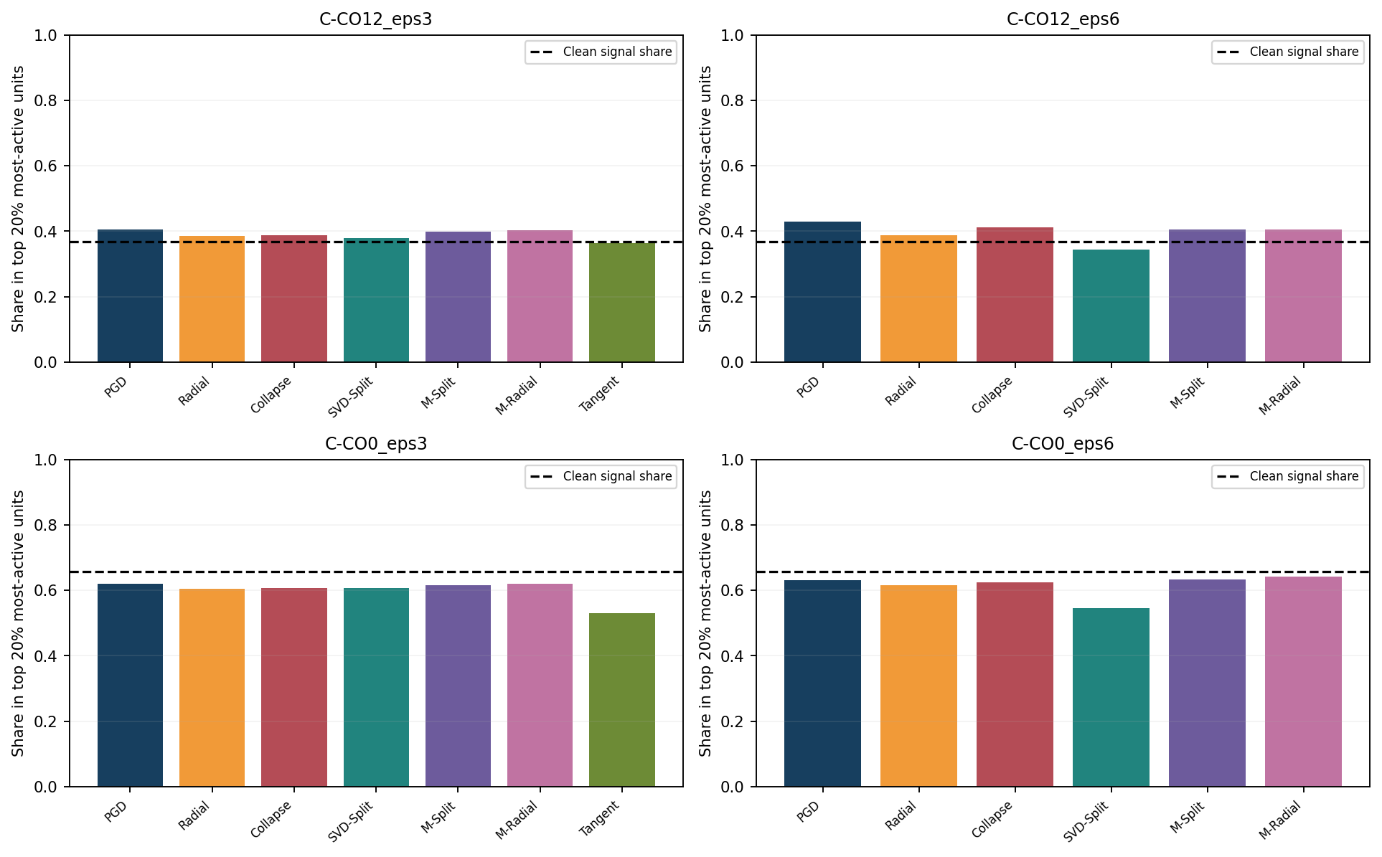
Figure 6. Top-20%-activity unit shares for perturbation energy; black dashed horizontal line = clean centered signal energy in the corresponding top units.
C-CO12_eps3: top-unit clean-signal energy share = 0.369; largest perturbation share = 0.406 (PGD); smallest = 0.363 (Tangent).
C-CO12_eps6: top-unit clean-signal energy share = 0.369; largest perturbation share = 0.429 (PGD); smallest = 0.345 (SVD-Split).
C-CO0_eps3: top-unit clean-signal energy share = 0.659; largest perturbation share = 0.621 (PGD-Match-Radial); smallest = 0.530 (Tangent).
C-CO0_eps6: top-unit clean-signal energy share = 0.659; largest perturbation share = 0.641 (PGD-Match-Radial); smallest = 0.545 (SVD-Split).

9. Computational cost and stability

C-CO12 | training ε = 3 (absolute L2)
Arm | Train sec/iter | Encoder sec | Decoder sec | Held-out attack sec | Total sec
Clean | 0.056 ± 0.002 | 167.8 ± 7.4 | 2.0 ± 0.6 | 4.9 ± 0.7 | 175.2 ± 8.6
PGD | 0.198 ± 0.010 | 594.5 ± 30.9 | 2.1 ± 0.6 | 5.3 ± 0.9 | 602.4 ± 32.4
Radial | 0.265 ± 0.017 | 796.4 ± 51.0 | 1.8 ± 0.2 | 5.0 ± 0.5 | 803.7 ± 50.9
Collapse | 0.264 ± 0.016 | 792.3 ± 48.7 | 1.8 ± 0.1 | 5.1 ± 0.3 | 799.7 ± 48.9
SVD-Split | 0.314 ± 0.007 | 942.3 ± 19.7 | 1.9 ± 0.1 | 5.2 ± 0.3 | 950.0 ± 19.8
PGD-Match-Split | 0.378 ± 0.015 | 1134.3 ± 46.2 | 1.8 ± 0.1 | 4.7 ± 0.2 | 1141.3 ± 46.5
PGD-Match-Radial | 0.338 ± 0.011 | 1013.7 ± 32.4 | 1.8 ± 0.1 | 4.9 ± 0.2 | 1020.8 ± 32.2
Tangent | 0.236 ± 0.009 | 708.6 ± 26.5 | 1.8 ± 0.1 | 4.9 ± 0.1 | 715.7 ± 26.6

C-CO12 | training ε = 6 (absolute L2)
Arm | Train sec/iter | Encoder sec | Decoder sec | Held-out attack sec | Total sec
PGD | 0.198 ± 0.003 | 594.8 ± 8.8 | 2.0 ± 0.1 | 5.2 ± 0.2 | 602.5 ± 9.0
Radial | 0.257 ± 0.011 | 770.2 ± 33.0 | 1.9 ± 0.2 | 5.1 ± 0.5 | 777.7 ± 33.6
Collapse | 0.263 ± 0.003 | 788.3 ± 7.5 | 1.9 ± 0.2 | 5.1 ± 0.4 | 795.7 ± 7.0
SVD-Split | 0.313 ± 0.033 | 938.1 ± 99.2 | 1.9 ± 0.1 | 5.0 ± 0.2 | 945.6 ± 99.2
PGD-Match-Split | 0.408 ± 0.036 | 1225.1 ± 107.8 | 1.8 ± 0.2 | 4.8 ± 0.3 | 1232.3 ± 108.2
PGD-Match-Radial | 0.347 ± 0.013 | 1040.5 ± 40.3 | 2.0 ± 0.1 | 5.1 ± 0.2 | 1048.1 ± 40.6

C-CO0 | training ε = 3 (absolute L2)
Arm | Train sec/iter | Encoder sec | Decoder sec | Held-out attack sec | Total sec
Clean | 0.053 ± 0.000 | 159.4 ± 0.4 | 1.8 ± 0.1 | 1.6 ± 0.1 | 163.1 ± 0.4
PGD | 0.192 ± 0.002 | 576.1 ± 6.8 | 1.8 ± 0.1 | 1.6 ± 0.1 | 579.7 ± 6.7
Radial | 0.255 ± 0.009 | 765.3 ± 27.9 | 1.8 ± 0.2 | 1.6 ± 0.1 | 769.1 ± 28.2
Collapse | 0.258 ± 0.013 | 772.9 ± 37.8 | 1.9 ± 0.1 | 1.6 ± 0.1 | 776.8 ± 37.9
SVD-Split | 0.315 ± 0.020 | 944.3 ± 59.9 | 1.9 ± 0.0 | 1.6 ± 0.0 | 948.1 ± 59.9
PGD-Match-Split | 0.395 ± 0.018 | 1185.2 ± 54.2 | 1.8 ± 0.1 | 1.6 ± 0.0 | 1188.9 ± 54.1
PGD-Match-Radial | 0.343 ± 0.010 | 1027.8 ± 28.6 | 1.8 ± 0.2 | 1.6 ± 0.1 | 1031.6 ± 28.9
Tangent | 0.239 ± 0.007 | 715.9 ± 22.2 | 1.7 ± 0.1 | 1.6 ± 0.1 | 719.6 ± 22.2

C-CO0 | training ε = 6 (absolute L2)
Arm | Train sec/iter | Encoder sec | Decoder sec | Held-out attack sec | Total sec
PGD | 0.196 ± 0.003 | 588.3 ± 8.0 | 1.8 ± 0.1 | 1.7 ± 0.0 | 592.1 ± 8.1
Radial | 0.247 ± 0.003 | 739.5 ± 8.3 | 2.0 ± 0.1 | 1.7 ± 0.1 | 743.5 ± 8.5
Collapse | 0.263 ± 0.008 | 788.5 ± 24.1 | 1.9 ± 0.1 | 1.7 ± 0.1 | 792.5 ± 24.2
SVD-Split | 0.327 ± 0.020 | 981.4 ± 60.0 | 1.9 ± 0.1 | 1.6 ± 0.0 | 985.3 ± 60.2
PGD-Match-Split | 0.416 ± 0.015 | 1249.0 ± 46.3 | 2.0 ± 0.1 | 1.7 ± 0.0 | 1253.0 ± 46.4
PGD-Match-Radial | 0.329 ± 0.008 | 986.0 ± 24.1 | 1.8 ± 0.2 | 1.6 ± 0.1 | 989.8 ± 24.3

Times are per independent model, not aggregate cluster makespan. Parallel execution makes wall-clock completion different from the sum of task times; clock variability and GPU contention can affect measured seconds/iteration.

10. Interpretation: what results support and what they do not

10.1 Geometry versus perturbation energy
The matched controls are the central V5 addition. They often narrow or reverse the difference between a spectral arm and an unrestricted PGD arm. On C-CO12 (εtrain=6), SVD-Split trails matched PGD at εeval=6 by 0.0502 R²; on C-CO0 (εtrain=6), Split exceeds matched PGD at εeval=6 by 0.0770 R², yet trails at εeval=3 by 0.0149. These mixed outcomes argue against one universally superior geometry.
Matched-energy training is an approximate control only: the matched PGD optimizer uses an energy budget derived from another attack but may stop at a different realized norm. The differences at εtrain=6 are especially notable. Additional strict per-window realized-norm matching or stratified analysis of the realized perturbation distributions is required to isolate geometry independent of energy.

10.2 Stronger-attack robustness is not monotonic across methods
All models undergo the same test at εeval=1/3/6, and their relative rankings vary with attack radius. For example on C-CO12, εtrain=6: Radial leads PGD at clean decoding and εeval=3, but PGD and Collapse are stronger at εeval=6. On C-CO0, εtrain=6: Split is below baseline PGD at radius 3 yet appreciably better at radius 6, although both scores are negative at radius 6. These are meaningful directional trade-offs, not evidence that robustness at all radii improves.

10.3 Robustness to neuron failure
C-CO0, εtrain=6 shows a large dropout difference between Split and ordinary PGD (0.2004 vs 0.1201 at 30% independent dropout; 0.2436 vs 0.1402 at nested 50%). The matched-Split control is much closer in dropout30 (0.1942), showing that part of this gain may reflect a change in perturbation intensity. Conversely on C-CO12, Tangent retains more random-dropout robustness but has poor adversarial PGD robustness; that branch alone does not support a general adversarial-robustness claim.

10.4 Collapse and spectral guarantees
In the sampled diagnostics, the projection-based Radial and Collapse subspace attacks report negligible changes to dominant singular values and no recorded 45° mode-exchange events. Collapse permits larger training norm than Radial, approaching the nominal budget. However numerical diagnostic success is a finite-sample check, and the method is not a formal certificate for the downstream nonlinear decoder R², domain shift or unsampled neural data.

10.5 Limits of the current data
• Only two recordings / sessions are tested, and repeated seeds on each fixed session are not independent recordings.
• Three seeds per model are insufficient for stable tail probabilities, broad generalization claims, or reliable hypothesis testing across many endpoints.
• The report does not infer biological causation from attack-energy alignment with the most-active neurons; neuron importance and activity are different quantities.
• The per-configuration R² means come from validation data for the exact two fixed sessions. The 6 label columns are averaged, which can mask label-specific trends; full per-label values are preserved in the CSV supplement.
• The source bundle contains runner, engine and selected integration code, logs excerpts and summaries, but not fitted encoder/decoder checkpoints or full RunAI service metadata. Exact re-evaluation would require rerunning training if checkpoints were not retained.
• Multiple PGD radii are evaluated, but each uses fixed 20-step attacks and 3 restarts; they are empirical lower bounds on worst-case predictive error, not certified robust accuracy.

11. Reproducibility and artifact manifest
Cohort | N | Runner version | ε unit | Main eval ε | Extra eval ε | Window scale
C-CO12_eps3 | 24 | v5-multigpu-independent-v1 | absolute | 3.0 | 1.0,6.0 | 37.393
C-CO12_eps6 | 18 | v5-multigpu-independent-v1 | absolute | 3.0 | 1.0,6.0 | 37.393
C-CO0_eps3 | 24 | v5-multigpu-independent-v1 | absolute | 3.0 | 1.0,6.0 | 26.648
C-CO0_eps6 | 18 | v5-multigpu-independent-v1 | absolute | 3.0 | 1.0,6.0 | 26.648

Source SHA-256 (fork):
cebra/solver/spectral_gap.py = fc70e1ce56cd90ab5223ec41e9a10d93f80e6a9d8ecf2650962f1cc0f2160df9
cebra/integrations/sklearn/cebra.py = 3447e8214cec9bd9fe507918b25db92e71ad95e16272439e7f81fab9424f0913
Runner SHA-256 = 116fbc177318c17c6bcf6f075374c44bfc0105758f43f350dc64893a0397937e. Source records are drawn from user-provided bundle; no outside datasets were accessed for this report.

Appendix A. Every seed: core numeric scores (84 rows)
Each row is one finished model fit. Columns: clean validation R², attacked-window PGD R² at radii 1/3/6, independent 30% neuron-loss R² and realized training perturbation mean L2 norm. All other metrics, per-label results and complete unrounded numeric records are in the CSV supplement.

C-CO12 | training ε = 3 (absolute L2)
Seed | Arm | Clean | PGD@1 | PGD@3 | PGD@6 | Drop30 | Train norm
42 | Clean | 0.6805 | 0.5897 | -0.0612 | -1.2376 | 0.5397 | —
42 | PGD | 0.6866 | 0.6643 | 0.5747 | 0.2006 | 0.4575 | 2.9960
42 | Radial | 0.7125 | 0.6875 | 0.5797 | 0.0893 | 0.4328 | 2.7990
42 | Collapse | 0.6890 | 0.6624 | 0.5518 | 0.0870 | 0.4125 | 2.9967
42 | SVD-Split | 0.7005 | 0.6734 | 0.5644 | 0.0743 | 0.4584 | 2.3902
42 | PGD-Match-Split | 0.6874 | 0.6639 | 0.5694 | 0.1234 | 0.4723 | 2.4664
42 | PGD-Match-Radial | 0.6918 | 0.6698 | 0.5826 | 0.1795 | 0.4542 | 2.8343
42 | Tangent | 0.6751 | 0.6062 | 0.1439 | -1.0722 | 0.5270 | 1.1788
43 | Clean | 0.6837 | 0.5988 | -0.0013 | -1.2169 | 0.5164 | —
43 | PGD | 0.6688 | 0.6465 | 0.5655 | 0.1708 | 0.4371 | 2.9975
43 | Radial | 0.6953 | 0.6710 | 0.5758 | 0.1210 | 0.4202 | 2.8025
43 | Collapse | 0.6978 | 0.6752 | 0.5816 | 0.1330 | 0.4285 | 2.9972
43 | SVD-Split | 0.6785 | 0.6536 | 0.5524 | 0.0793 | 0.4354 | 2.3987
43 | PGD-Match-Split | 0.6686 | 0.6459 | 0.5582 | 0.1200 | 0.4526 | 2.4739
43 | PGD-Match-Radial | 0.6876 | 0.6644 | 0.5765 | 0.1607 | 0.4410 | 2.8362
43 | Tangent | 0.7005 | 0.6348 | 0.1828 | -1.0040 | 0.5356 | 1.1787
44 | Clean | 0.6880 | 0.6067 | 0.0160 | -1.1615 | 0.5241 | —
44 | PGD | 0.6771 | 0.6528 | 0.5529 | 0.1232 | 0.4089 | 2.9972
44 | Radial | 0.6848 | 0.6593 | 0.5527 | 0.0809 | 0.4130 | 2.7953
44 | Collapse | 0.6983 | 0.6748 | 0.5665 | 0.1057 | 0.4098 | 2.9970
44 | SVD-Split | 0.6918 | 0.6656 | 0.5614 | 0.0988 | 0.4200 | 2.3869
44 | PGD-Match-Split | 0.6957 | 0.6701 | 0.5568 | 0.0521 | 0.4069 | 2.4632
44 | PGD-Match-Radial | 0.6772 | 0.6507 | 0.5481 | 0.1325 | 0.4049 | 2.8306
44 | Tangent | 0.6983 | 0.6319 | 0.2027 | -1.0309 | 0.5245 | 1.1787

C-CO12 | training ε = 6 (absolute L2)
Seed | Arm | Clean | PGD@1 | PGD@3 | PGD@6 | Drop30 | Train norm
42 | PGD | 0.6664 | 0.6468 | 0.5690 | 0.2418 | 0.4260 | 5.9697
42 | Radial | 0.7002 | 0.6789 | 0.5895 | 0.1971 | 0.3889 | 3.6274
42 | Collapse | 0.6778 | 0.6593 | 0.5786 | 0.2336 | 0.3978 | 5.9738
42 | SVD-Split | 0.6800 | 0.6581 | 0.5700 | 0.1668 | 0.4005 | 3.3355
42 | PGD-Match-Split | 0.6986 | 0.6787 | 0.5975 | 0.2500 | 0.4520 | 3.6126
42 | PGD-Match-Radial | 0.6853 | 0.6647 | 0.5839 | 0.2435 | 0.4627 | 3.8236
43 | PGD | 0.6826 | 0.6629 | 0.5845 | 0.2347 | 0.3983 | 5.9693
43 | Radial | 0.6890 | 0.6681 | 0.5794 | 0.1929 | 0.3935 | 3.6312
43 | Collapse | 0.6775 | 0.6580 | 0.5784 | 0.2339 | 0.4028 | 5.9741
43 | SVD-Split | 0.6885 | 0.6655 | 0.5737 | 0.1913 | 0.4164 | 3.3454
43 | PGD-Match-Split | 0.6750 | 0.6534 | 0.5756 | 0.2203 | 0.4290 | 3.6114
43 | PGD-Match-Radial | 0.6799 | 0.6588 | 0.5750 | 0.2045 | 0.4107 | 3.8195
44 | PGD | 0.6769 | 0.6556 | 0.5711 | 0.2224 | 0.3979 | 5.9765
44 | Radial | 0.6970 | 0.6744 | 0.5798 | 0.1708 | 0.3952 | 3.6141
44 | Collapse | 0.6867 | 0.6670 | 0.5843 | 0.2327 | 0.3838 | 5.9814
44 | SVD-Split | 0.6827 | 0.6579 | 0.5651 | 0.1767 | 0.3881 | 3.3324
44 | PGD-Match-Split | 0.6758 | 0.6538 | 0.5707 | 0.2153 | 0.4154 | 3.5954
44 | PGD-Match-Radial | 0.6796 | 0.6584 | 0.5763 | 0.2285 | 0.4214 | 3.8021

C-CO0 | training ε = 3 (absolute L2)
Seed | Arm | Clean | PGD@1 | PGD@3 | PGD@6 | Drop30 | Train norm
42 | Clean | 0.7120 | 0.2147 | -1.4710 | -1.9060 | 0.4148 | —
42 | PGD | 0.7070 | 0.5893 | 0.1348 | -0.8383 | 0.2022 | 2.9981
42 | Radial | 0.7182 | 0.5991 | 0.1113 | -0.8529 | 0.2487 | 2.7866
42 | Collapse | 0.7067 | 0.6001 | 0.1486 | -0.7767 | 0.2031 | 2.9976
42 | SVD-Split | 0.7121 | 0.6005 | 0.1415 | -0.8094 | 0.2052 | 2.4847
42 | PGD-Match-Split | 0.7194 | 0.6144 | 0.1708 | -0.8140 | 0.2471 | 2.5301
42 | PGD-Match-Radial | 0.7094 | 0.5908 | 0.1172 | -0.8473 | 0.2355 | 2.8211
42 | Tangent | 0.7212 | 0.4684 | -0.8718 | -1.7813 | 0.4365 | 1.4102
43 | Clean | 0.7090 | 0.2103 | -1.5054 | -1.9471 | 0.3937 | —
43 | PGD | 0.6942 | 0.5718 | 0.1028 | -0.8206 | 0.1901 | 2.9982
43 | Radial | 0.7000 | 0.5659 | 0.0375 | -1.0111 | 0.1740 | 2.7772
43 | Collapse | 0.7071 | 0.5804 | 0.0920 | -0.8942 | 0.1737 | 2.9977
43 | SVD-Split | 0.7150 | 0.5907 | 0.1046 | -0.9074 | 0.1639 | 2.4740
43 | PGD-Match-Split | 0.7151 | 0.5905 | 0.0988 | -0.9259 | 0.2392 | 2.5223
43 | PGD-Match-Radial | 0.7152 | 0.5900 | 0.1157 | -0.8430 | 0.2079 | 2.8152
43 | Tangent | 0.7318 | 0.4855 | -0.8606 | -1.8218 | 0.3934 | 1.4102
44 | Clean | 0.7113 | 0.1756 | -1.5340 | -1.9214 | 0.3709 | —
44 | PGD | 0.7126 | 0.5905 | 0.1053 | -0.9694 | 0.2098 | 2.9983
44 | Radial | 0.7163 | 0.5980 | 0.0911 | -0.8811 | 0.2056 | 2.7798
44 | Collapse | 0.7087 | 0.5914 | 0.0893 | -0.9164 | 0.2182 | 2.9977
44 | SVD-Split | 0.7215 | 0.5999 | 0.1390 | -0.8462 | 0.2136 | 2.4729
44 | PGD-Match-Split | 0.7201 | 0.6043 | 0.1301 | -0.9463 | 0.2083 | 2.5225
44 | PGD-Match-Radial | 0.7240 | 0.6116 | 0.1330 | -0.8729 | 0.2422 | 2.8184
44 | Tangent | 0.7074 | 0.4091 | -0.9209 | -1.7833 | 0.3409 | 1.4103

C-CO0 | training ε = 6 (absolute L2)
Seed | Arm | Clean | PGD@1 | PGD@3 | PGD@6 | Drop30 | Train norm
42 | PGD | 0.6877 | 0.5937 | 0.2074 | -0.7948 | 0.1765 | 5.9729
42 | Radial | 0.6921 | 0.5711 | 0.1434 | -0.8467 | 0.1403 | 4.1399
42 | Collapse | 0.6783 | 0.5563 | 0.1321 | -0.8560 | 0.1645 | 5.9715
42 | SVD-Split | 0.7088 | 0.6004 | 0.1700 | -0.6760 | 0.2171 | 3.6838
42 | PGD-Match-Split | 0.7038 | 0.6081 | 0.2028 | -0.7339 | 0.2258 | 4.0278
42 | PGD-Match-Radial | 0.7036 | 0.6125 | 0.2039 | -0.7706 | 0.1891 | 4.3723
43 | PGD | 0.6848 | 0.5810 | 0.1913 | -0.8325 | 0.0784 | 5.9768
43 | Radial | 0.6947 | 0.5554 | 0.0031 | -0.9505 | 0.1307 | 4.1153
43 | Collapse | 0.6594 | 0.5352 | 0.0857 | -0.9132 | 0.1081 | 5.9765
43 | SVD-Split | 0.7080 | 0.5865 | 0.1565 | -0.6763 | 0.1605 | 3.6668
43 | PGD-Match-Split | 0.7126 | 0.6031 | 0.1720 | -0.7308 | 0.1686 | 4.0151
43 | PGD-Match-Radial | 0.7141 | 0.6089 | 0.2040 | -0.7735 | 0.1660 | 4.3599
44 | PGD | 0.6709 | 0.5671 | 0.1361 | -0.8671 | 0.1053 | 5.9909
44 | Radial | 0.7045 | 0.5853 | 0.1277 | -0.8742 | 0.1846 | 4.1319
44 | Collapse | 0.6622 | 0.5476 | 0.1253 | -0.8374 | 0.1193 | 5.9841
44 | SVD-Split | 0.7045 | 0.5988 | 0.1632 | -0.6882 | 0.2235 | 3.6817
44 | PGD-Match-Split | 0.7183 | 0.6095 | 0.1596 | -0.8067 | 0.1881 | 4.0287
44 | PGD-Match-Radial | 0.6978 | 0.5840 | 0.1530 | -0.7567 | 0.2178 | 4.3854

Appendix B. Supplementary data files
The accompanying archive includes: (i) All84_RawResults.csv — one row per fit with all available scalar metrics and serialized six-label arrays; (ii) SeedPaired_Differences.csv — same-seed contrasts versus PGD and matched controls, with individual seed differences and exploratory 95% t intervals; (iii) PerLabel_Scores.csv — long-format R² values for each of the six behavior dimensions, each evaluation variant and each seed; and (iv) the original uploaded raw-data bundle as provided.
Source organization: C-CO12_eps3 (24 fits), C-CO12_eps6 (18 fits), C-CO0_eps3 (24 fits), C-CO0_eps6 (18 fits). A successful status and per-task JSON file were verified for each fit.

