Experiment 11 | Prospective validation of automatically calibrated adversarial budgets
  - Noise-aware adversarial training for CEBRA neural decoders
Full results and critical analysis | 10 unseen Perich sessions | 360 completed encoder-decoder evaluations | October 2026
Research progress report for supervisor review. Data source: frozen Exp11 per-run summaries, evaluation outputs and preregistered predictions captured on 24 October 2026. This is not a claim of external-dataset or formal equivalence validation.

Executive summary
Exp11 evaluates whether a session-specific adversarial-training budget, computed from training-set statistics before model fitting, can approach the performance of a strong previously selected fixed d-prime budget without new per-session epsilon sweeps. The study extends the initial nine-session experiments to ten prospectively selected, previously unseen Perich sessions. All 360 planned model runs finished successfully, with all 360 robustness JSON outputs and all checkpoint pairs present.
Main finding: In supervised CEBRA, difference-residual AUTO_BEH (DIFF/BEH) reproduces the robustness of fixed DIFF8 very closely: paired geometric-mean reference half-damage threshold ratio 0.994 (95% session-bootstrap CI 0.959–1.025), while mean clean decoding R2 differs by only -0.0017. Both outperform raw-L2 PGD6 in the noise-shaped threat metric by ~16–17%. Crucially, DIFF/BEH has zero operational floor failures versus three for DIFF8, although those three all come from a single challenging session and are not independent observations.
In time-only CEBRA, DIFF/AUTO_SIG similarly approaches fixed DIFF8: paired ratio 0.990 (95% CI 0.978–1.003) with clean R2 change -0.0032; both are ~14–15% more robust than PGD6 under noise-shaped attacks. No operational floor failures occurred in any of the 150 time-only models, so failure prediction cannot be validated in this mode.
The supervision-specific preregistered vulnerability score x_beh generalizes well descriptively: AUROC 0.954 (vs 0.820 for x_sig), 15/18 failures detected, 6 false alarms, and accuracy 95.7% (vs 91.4% for a no-failure predictor). However, the original decisions were correlated across seeds and many failures cluster in T-RT2. These data support practical budget transfer, not proof that AUTO_BEH matches a session-specific oracle or that two methods are statistically equivalent.

1. Research question and prospective design
The earlier Exp1–8 report established that covariance-aware d-prime training improves noise-shaped robustness but that a fixed large spatial (SP8) budget can overshoot in supervised CEBRA. Exp9–10 explored automatic epsilon selection and behavior-derived measures of vulnerability. Exp11 tests a locked rule on new sessions, without choosing the per-session epsilon by evaluating the newly trained decoder.
Preselection: 102 candidate Perich sessions meeting ≥10 channels and ≥2,000 training bins; the nine previous sessions excluded. A seed-2026 draw saved 20 ordered candidates and their data SHA256 hashes in DPRIME_EXP11_SESSIONS.json. The executed preregistered subset is the first 10 of those 20. The PREDICTIONS files were timestamped 23 October 2026 before the model runs. No separate new-animals or independent-dataset claim follows from this split.
Session | Neurons | Train bins | Validation bins
C-CO25 | 60 | 3,557 | 880
C-CO26 | 61 | 3,554 | 893
T-RT2 | 36 | 8,389 | 2,011
C-CO2 | 61 | 2,779 | 675
T-CO1 | 59 | 3,368 | 867
C-CO39 | 246 | 3,058 | 741
C-CO21 | 61 | 3,707 | 911
J-CO1 | 18 | 3,564 | 859
M-CO7 | 26 | 13,484 | 3,235
C-RT12 | 78 | 25,926 | 6,450

Factorial design: three random seeds (42/43/44) and two CEBRA modes. Supervised: 10 × 3 × 7 = 210 fits; time-only: 10 × 3 × 5 = 150 fits. Thus 360 independently fitted encoder-decoder pairs were evaluated, but the primary inferential replication unit for transfer is the session (n=10), rather than treating 30 seed runs as independent biological datasets.

2. Automatic budget selection and comparisons
Training employs a covariance-shaped constraint d′(delta) = sqrt(delta^T Sigma^-1 delta), with spatial noise covariance from Ledoit–Wolf estimation and a white temporal factor. The DIFF geometry uses first-difference residuals to attenuate slower signal components; SP uses whole residuals. A pool arm mixes the spatial covariance with an isotropic member. The method optimizes perturbations inside the d-prime ball via APGD within the adversarial CEBRA objective.
Frozen rules: AUTO_SIG uses epsilon = min[(2D)^(1/4), 0.24 epsilon_sig], where D is the number of neuron × time-bin input dimensions. AUTO_BEH uses epsilon = max[1, min((2D)^(1/4), 0.363 epsilon_beh)] from training behavioral labels, with a JND floor. The 0.363 and 0.24 coefficients were fixed from previous work; they are not tuned on the new sessions. AUTO_BEH is supervised-only. Both budget estimators are geometry-specific: eps_sig and eps_beh depend on the selected noise metric M, so the numerical epsilon differs across SP and DIFF. For pool arms, the reported nominal budget is not the only realized pool-member budget.
Supervised arms: PGD6 (raw L2), SP8, DIFF8, SP/AUTO_SIG, DIFF/AUTO_BEH, SP/AUTO_BEH and POOL/AUTO_BEH. Time-only: PGD6, DIFF8, DIFF/AUTO_SIG, SP/AUTO_SIG and POOL/AUTO_SIG. The fixed DIFF8 baseline is a strong earlier selected configuration; it is NOT an oracle optimized by a full epsilon sweep separately on each Exp11 session.

2.1 Frozen budgets by new session
Session | C | Blind cap | S DIFF/BEH | S SP/BEH | S SP/SIG | T DIFF/SIG | T SP/SIG
C-CO25 | 60 | 8.11 | 8.11 | 6.92 | 4.48 | 7.15 | 4.48
C-CO26 | 61 | 8.14 | 8.14 | 6.68 | 4.13 | 6.87 | 4.13
T-RT2 | 36 | 7.14 | 4.51 | 3.57 | 4.28 | 5.35 | 4.28
C-CO2 | 61 | 8.14 | 8.14 | 6.91 | 4.98 | 7.53 | 4.98
T-CO1 | 59 | 8.07 | 8.07 | 6.07 | 5.16 | 7.60 | 5.16
C-CO39 | 246 | 11.54 | 11.54 | 7.75 | 6.21 | 11.54 | 6.21
C-CO21 | 61 | 8.14 | 8.14 | 6.54 | 4.03 | 6.58 | 4.03
J-CO1 | 18 | 6.00 | 5.43 | 3.57 | 3.75 | 5.72 | 3.75
M-CO7 | 26 | 6.58 | 6.58 | 5.82 | 4.56 | 6.58 | 4.56
C-RT12 | 78 | 8.66 | 7.15 | 5.45 | 6.16 | 8.66 | 6.16

S = supervised; T = time-only. These are preregistered nominal d-prime training radii. PGD6 is in raw L2 units and is not numerically commensurate with these values; DIFF8 and SP8 always use d-prime epsilon = 8.

2.2 Training and evaluation settings
Component | Frozen configuration
Neural encoder | CEBRA offset36-model-more-dropout; 64-D embedding; 64 hidden units; 3,000 iterations; temperature 0.4; batch 2,048
Encoder supervision | Supervised CEBRA.fit(X_train, y_train), time_delta conditional, hybrid=False; time-only CEBRA.fit(X_train)
Decoder | 2-layer MLP; 2,500 training epochs; test metric is mean validation decoding R2
Adversarial training | Madry-style objective; 10 attack steps; d-prime APGD with 1 restart; no curriculum, guards or warm-up
Robustness evaluation | White-box full encoder+decoder attack, 20 APGD steps, d-prime budgets 0.5, 1, 2, 4, 8, 16; noise-shaped reference and isotropic threat geometries
Additional evaluation | 1024-window margin estimation, 100 steps; natural-noise decoding; held-out reference covariance estimated from complete training split
Compute / reproducibility | Four NVIDIA H200 GPUs; seeds 42/43/44; checkpoint, config, hash and evaluation records preserved for all 360 fits

The main robustness statistic epsilon_1/2 is the smallest attack budget (interpolated across the evaluation grid) that halves each model’s clean decoding R2. Higher is better. A reported value of exactly 0.500 represents the evaluation floor: the threshold may be at or below the smallest tested budget. We call this an operational floor failure rather than equating it with an unconstrained generalization or training failure.

3. Main results: supervised CEBRA (210/210 successful)
Arm | Clean R2 mean | Ref eps½ med. | Iso eps½ mean | Ref / PGD6 | Floor failures | Δ clean vs PGD6
PGD6 | 0.701 | 1.397 | 3.015 | 1.000 | 3/30 | —
DIFF8 | 0.703 | 2.018 | 2.018 | 1.174 | 3/30 | 0.0019
DIFF/BEH | 0.701 | 2.020 | 1.990 | 1.166 | 0/30 | 0.0002
POOL/BEH | 0.695 | 1.889 | 2.329 | 1.121 | 0/30 | -0.0058
SP/SIG | 0.700 | 1.814 | 1.517 | 1.109 | 0/30 | -0.0012
SP/BEH | 0.688 | 1.714 | 1.427 | 1.051 | 2/30 | -0.0132
SP8 | 0.686 | 1.203 | 1.033 | 0.699 | 10/30 | -0.0145

Arithmetic average of model-level clean R2 and isotropic thresholds; reference half-damage median shown for absolute scale; robustness ratios use matched (session, seed) geometric means, not a ratio of marginal medians.
Fixed DIFF8 has the largest aggregate reference ratio to PGD6 (1.1738), narrowly ahead of DIFF/BEH (1.1663). DIFF/BEH nevertheless records 25/30 wins over PGD6 and avoids all three floor failures seen under DIFF8, PGD6 and a total of 10 under SP8. Clean-decoding difference DIFF/BEH − DIFF8 is −0.00167 R2, and the natural-noise R2 mean is 0.613 vs 0.585 for DIFF8 (descriptive, not a separate significance claim). SP/BEH is not interchangeable with DIFF/BEH: its reference ratio to DIFF8 is 0.896 and its clean R2 drops by 0.0151.
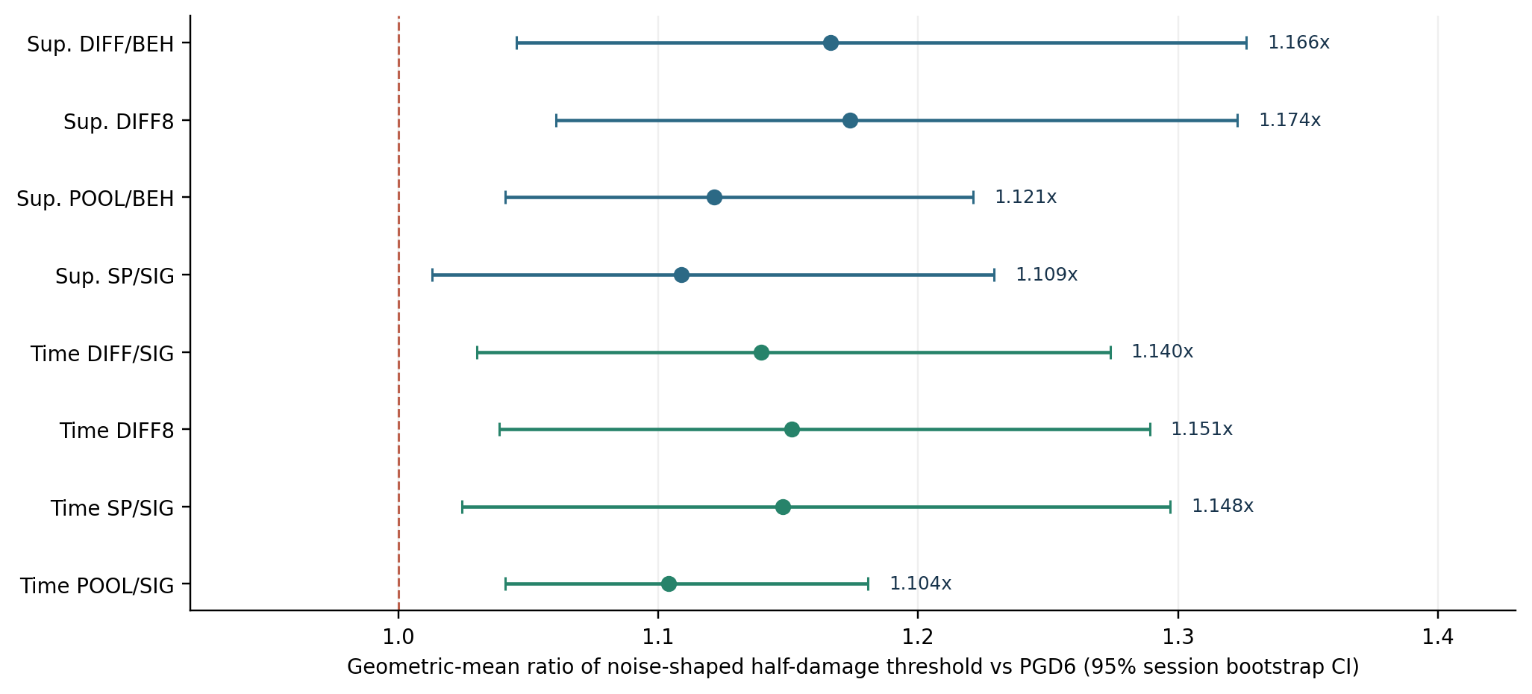
Figure 1. Paired noise-shaped robustness relative to raw-L2 PGD6, with cluster bootstrap confidence intervals across the ten sessions. Values above 1 mean a higher half-damage threshold.

3.1 Direct comparison with fixed DIFF8 (primary automatic-budget endpoint)
Across 30 matched session/seed pairs, DIFF/BEH versus DIFF8 yields a noise-shaped threshold ratio of 0.9936 (95% session-bootstrap CI [0.9589, 1.0246]), 16 wins / 30 paired runs, an isotropic threshold ratio of 0.9822, and mean Δ clean R2 of -0.00167. This is strong evidence for close performance against a robust fixed reference; the confidence interval spanning 1 does not establish formal equivalence without a prespecified equivalence margin and an appropriate equivalence test.
The most consequential difference is concentrated in T-RT2: DIFF8 reaches the 0.5 reference evaluation floor in all three seeds, whereas DIFF/BEH achieves approximately 0.532–0.542. This avoids the recorded floor, but the absolute robustness margin is small; a denser evaluation grid below 0.5 would clarify the effect size. The automatically selected DIFF budget on T-RT2 is 4.506, versus a fixed 8.000. Other sessions predominantly receive near-8 or capped higher budgets, which explains the very close aggregate performance.

3.2 Per-session reference robustness, supervised
Session | PGD6 | DIFF8 | DIFF/BEH | POOL/BEH | SP/SIG | SP/BEH | SP8
C-CO25 | 2.087 | 2.210 | 2.193 | 2.101 | 2.049 | 2.055 | 1.621
C-CO26 | 2.034 | 2.093 | 2.098 | 2.026 | 2.022 | 1.837 | 1.679
T-RT2 | 0.500 | 0.500 | 0.541 | 0.521 | 0.554 | 0.500 | 0.500
C-CO2 | 1.105 | 1.711 | 1.843 | 1.396 | 1.573 | 1.561 | 0.685
T-CO1 | 1.305 | 2.028 | 2.023 | 1.845 | 1.647 | 1.774 | 2.009
C-CO39 | 2.035 | 2.156 | 2.104 | 2.245 | 2.083 | 1.303 | 1.208
C-CO21 | 2.183 | 2.220 | 2.193 | 2.163 | 2.093 | 2.026 | 1.640
J-CO1 | 1.151 | 1.233 | 1.091 | 1.154 | 1.098 | 1.074 | 0.500
M-CO7 | 1.446 | 2.002 | 1.904 | 2.001 | 2.030 | 2.127 | 0.593
C-RT12 | 1.332 | 1.544 | 1.601 | 1.450 | 1.518 | 1.547 | 0.500

Median noise-shaped epsilon_1/2 across seeds 42–44; higher is more robust. A recorded 0.500 is a clipped lower evaluation bound.
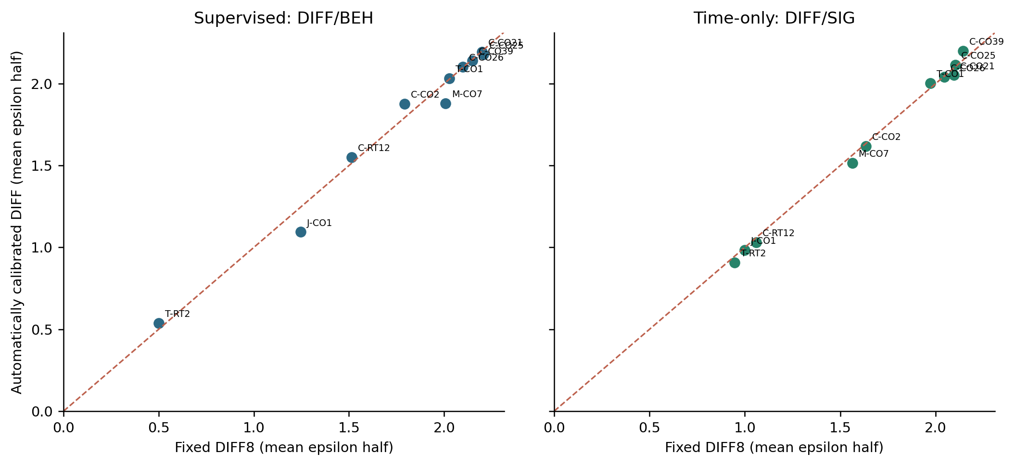
Figure 2. New-session comparison between the fixed difference-residual budget DIFF8 and the automatic difference-residual budget. Each dot is the mean over three seeds. The dashed diagonal indicates equality.

4. Main results: time-only CEBRA (150/150 successful)
Arm | Clean R2 mean | Ref eps½ med. | Iso eps½ mean | Ref / PGD6 | Floor failures | Δ clean vs PGD6
PGD6 | 0.603 | 1.266 | 3.137 | 1.000 | 0/30 | —
DIFF8 | 0.604 | 1.814 | 2.127 | 1.151 | 0/30 | 0.0011
DIFF/SIG | 0.601 | 1.872 | 2.129 | 1.140 | 0/30 | -0.0021
POOL/SIG | 0.606 | 1.605 | 2.767 | 1.104 | 0/30 | 0.0028
SP/SIG | 0.585 | 1.936 | 1.649 | 1.148 | 0/30 | -0.0178

The time-only DIFF/AUTO_SIG model reaches a geometric-mean reference ratio of 1.1397 relative to PGD6, compared with 1.1514 for fixed DIFF8. The paired DIFF/AUTO_SIG / DIFF8 ratio is 0.9899 (95% session bootstrap CI 0.9779–1.0026), with mean clean R2 difference -0.00324 and essentially equal isotropic ratio 1.0006. Unlike the supervised experiment, time-only did not produce operational floor failures in any arm; therefore the preregistered failure classifier cannot be evaluated for sensitivity or AUROC in this mode.
The SP/AUTO_SIG strategy has comparable average reference robustness to DIFF8 (paired ratio 0.997), but its isotropic robustness relative to DIFF8 is only 0.7925 and mean clean R2 is lower by 0.0189. POOL/AUTO_SIG trades some reference robustness (0.9589× vs DIFF8) for better isotropic robustness (1.2965× vs DIFF8), reinforcing the geometry-dependent Pareto trade-off.

4.1 Per-session reference robustness, time-only
Session | PGD6 | DIFF8 | DIFF/SIG | POOL/SIG | SP/SIG
C-CO25 | 2.062 | 2.100 | 2.091 | 2.090 | 2.051
C-CO26 | 2.023 | 2.045 | 2.043 | 2.069 | 2.030
T-RT2 | 0.675 | 0.940 | 0.902 | 0.754 | 0.920
C-CO2 | 1.091 | 1.593 | 1.559 | 1.359 | 1.508
T-CO1 | 1.308 | 2.012 | 2.005 | 1.771 | 1.995
C-CO39 | 2.097 | 2.144 | 2.222 | 2.393 | 2.015
C-CO21 | 2.120 | 2.103 | 2.062 | 2.102 | 2.044
J-CO1 | 1.072 | 1.043 | 0.998 | 1.062 | 1.012
M-CO7 | 1.231 | 1.563 | 1.477 | 1.462 | 1.883
C-RT12 | 1.028 | 1.049 | 1.033 | 1.040 | 1.117

5. Pre-registered decoder-vulnerability predictions
The prediction table was generated before model fitting and tied to each session/arm by a fixed vulnerability ratio, with no post-hoc threshold adjustment on Exp11. Supervised predictions use the behavior-normalized budget x_beh, with the Exp10-derived cutoff of approximately 0.5. The ratio is metric-specific; behavior labels are restricted to the supervised training split for AUTO_BEH budget selection. We distinguish the predictor’s association with floor failures from claims about the causal mechanism of those failures.
Supervised classifier metric | Final Exp11 result
Total runs / operational floor failures | 210 / 18 (8.6%)
Predicted failure cases | 21
Confusion matrix | TP 15, FP 6, FN 3, TN 186
AUROC for behavior ratio x_beh | 0.954
AUROC for signal ratio x_sig | 0.820
AUROC for nominal budget alone | 0.628
Accuracy / no-failure baseline | 95.7% / 91.4%
Precision / recall / specificity | 71.4% / 83.3% / 96.9%
Balanced accuracy | 90.1%

The true-positive cluster comprises large-budget SP8 failures and three baseline failures on T-RT2; six false positives all occur at J-CO1 (PGD6 and DIFF8, across three seeds) near x_beh ≈0.53. Three false negatives are SP8 on C-CO2 seed 44 and SP/BEH on T-RT2 seeds 43/44. The repeated predictions for the same session/arm over three seeds increase the apparent sample size, so the AUROC should be read as an out-of-session descriptive result; reliable confidence intervals require cluster-aware uncertainty treatment.
For time-only CEBRA, all 150 models have ref_half > 0.5, so AUROC and failure recall are mathematically undefined. Three warnings on PGD6/T-RT2 were false positives. The reported 98% accuracy is inferior to the 100% accuracy of the trivial all-negative classifier on this zero-event subset and must not be cited as a success in time-only failure prediction.

6. Robustness trade-offs, margins and interpretation
Evaluating both geometries prevents overstating success. Supervised DIFF/BEH improves noise-shaped robustness 1.166× relative to PGD6 but retains only 0.680× its isotropic half-damage threshold; fixed DIFF8 is similar (1.174× reference, 0.692× isotropic). Time-only DIFF/SIG likewise yields 1.140× reference and 0.684× isotropic compared with PGD6. Therefore the principal achievement is a calibration rule that transfers within a particular, scientifically motivated threat geometry, rather than domination against all perturbations.
Covariance pooling shifts the trade-off: supervised POOL/BEH is 1.121× PGD6 on the reference metric and 0.813× on isotropic; time-only POOL/SIG is 1.104× and 0.886×, respectively. The pool is an attractive alternative when isotropic resilience and clean decoding also matter, whereas DIFF is the clearest matched-geometry benchmark.

6.1 Additional evaluation: supervised
Arm | Ref natural-noise R2 | Ref DDN median | Iso natural-noise R2 | Iso DDN median
DIFF8 | 0.585 | 2.541 | 0.566 | 3.025
DIFF/BEH | 0.613 | 2.653 | 0.591 | 3.136
PGD6 | 0.567 | 2.251 | 0.639 | 4.490

Model-level averages of per-run natural-noise R2 and 100-step DDN decoding margins. These are corroborating secondary metrics; no formal statistical comparison is claimed.

6.2 Additional evaluation: time-only
Arm | Ref natural-noise R2 | Ref DDN median | Iso natural-noise R2 | Iso DDN median
DIFF8 | 0.492 | 3.203 | 0.455 | 4.352
DIFF/SIG | 0.488 | 3.179 | 0.465 | 4.430
PGD6 | 0.468 | 2.795 | 0.565 | 6.124

Model-level averages of per-run natural-noise R2 and 100-step DDN decoding margins. These are corroborating secondary metrics; no formal statistical comparison is claimed.

7. What the prospective experiment demonstrates — and does not
Supported: (i) the frozen, data-derived epsilon rule can approach a strong fixed d-prime setting without repeating a per-session manual epsilon search; (ii) difference-residual geometry remains safer than fixed SP8 for supervised CEBRA; (iii) the supervised behavior-ratio vulnerability score has good prospective discriminative performance at the individual-run level; (iv) trade-offs with isotropic threats persist rather than disappearing with adaptive calibration.
Not yet established: (i) statistical equivalence with DIFF8 under a prespecified tolerance; (ii) closeness to a genuinely session-specific best epsilon/Oracle selected by comprehensive grid search; (iii) superiority of AUTO_BEH to DIFF8 in average reference robustness (point estimates are 0.64% lower); (iv) extension to an independent data family or unseen animals, or broad physiological imperceptibility; (v) absence of gradient masking under all attack families. Exp11 white-box evaluation uses 20-step APGD, whereas stronger multi-restart stress tests were performed on prior checkpoints in Exp10-B, not proven separately for all new Exp11 models.
Important additional constraint: several sessions come from the same animals as other sessions in the study, and the entire prospective suite is from the Perich collection. Random seeds are repeated training stochasticity on the same session, not independent experimental units. The floor-failure criterion is coarse because epsilon=0.5 is the smallest attack radius and all arms use a common attack grid. The use of continuous offsets on integer spike-count inputs remains a threat-model abstraction.

8. Recommended next steps
1. Report Exp11 as a prospective fixed-baseline transfer test, with DIFF/BEH and DIFF/SIG as the automatic-budget protagonists and DIFF8 as the matched-geometry comparison. Preserve the frozen 0.363 / 0.24 rules unchanged for this result.
2. For a direct “near-best-manual-epsilon” claim, run a carefully scoped manual epsilon sweep on a subset of new sessions, compare each automatic budget against the oracle envelope and quantify regret. Label that envelope as an a posteriori upper bound, not a deployable fair baseline.
3. Measure equivalence with an agreed tolerance (for example, a scientific non-inferiority margin on epsilon_1/2 plus a clean R2 tolerance) before making formal equivalence claims. Expand to additional sessions if the margin-based confidence interval requires greater precision.
4. Refine the robustness grid below epsilon=0.5 on T-RT2 and J-CO1, and add an independent stronger-attack check on representative Exp11 checkpoints. Consider natural-noise augmentation as a matched-control arm if claims about the necessity of adversarial optimization are central.
5. Validate on a genuinely independent neural dataset / independent subjects, with labels isolated strictly to training where needed, and report results at animal and session hierarchical levels.

Appendix A. Complete per-session clean decoding (mean of three seeds)

Supervised
Session | PGD6 | DIFF8 | DIFF/BEH | POOL/BEH | SP/SIG | SP/BEH | SP8
C-CO25 | 0.770 | 0.772 | 0.773 | 0.757 | 0.760 | 0.759 | 0.741
C-CO26 | 0.764 | 0.760 | 0.770 | 0.761 | 0.764 | 0.749 | 0.742
T-RT2 | 0.399 | 0.410 | 0.410 | 0.405 | 0.404 | 0.395 | 0.390
C-CO2 | 0.736 | 0.734 | 0.742 | 0.706 | 0.751 | 0.714 | 0.750
T-CO1 | 0.771 | 0.765 | 0.763 | 0.763 | 0.753 | 0.744 | 0.755
C-CO39 | 0.715 | 0.717 | 0.689 | 0.699 | 0.714 | 0.675 | 0.682
C-CO21 | 0.790 | 0.783 | 0.779 | 0.771 | 0.780 | 0.764 | 0.760
J-CO1 | 0.703 | 0.706 | 0.686 | 0.709 | 0.689 | 0.691 | 0.704
M-CO7 | 0.742 | 0.742 | 0.752 | 0.740 | 0.743 | 0.742 | 0.731
C-RT12 | 0.621 | 0.639 | 0.647 | 0.639 | 0.639 | 0.645 | 0.609

Time-only
Session | PGD6 | DIFF8 | DIFF/SIG | POOL/SIG | SP/SIG
C-CO25 | 0.695 | 0.687 | 0.685 | 0.686 | 0.652
C-CO26 | 0.683 | 0.673 | 0.665 | 0.679 | 0.642
T-RT2 | 0.344 | 0.363 | 0.359 | 0.352 | 0.356
C-CO2 | 0.591 | 0.596 | 0.604 | 0.600 | 0.588
T-CO1 | 0.668 | 0.687 | 0.687 | 0.695 | 0.677
C-CO39 | 0.602 | 0.596 | 0.605 | 0.590 | 0.552
C-CO21 | 0.722 | 0.709 | 0.695 | 0.707 | 0.686
J-CO1 | 0.592 | 0.574 | 0.576 | 0.607 | 0.546
M-CO7 | 0.653 | 0.681 | 0.670 | 0.660 | 0.676
C-RT12 | 0.478 | 0.474 | 0.461 | 0.481 | 0.476

Appendix B. Reproducibility and audit trail
Output locations: DPRIME_EXP11_NEWSESS_SUPERVISED/ and DPRIME_EXP11_NEWSESS_TIMEONLY/; the frozen predictions are in each PREDICTIONS.csv; all 360 records are in the two summary.csv files; each run preserves a model pair, run_config.json, evaluation_config_v1.json and white-box robustness JSON. The present report is derived from a read-only full-results console extraction, supported by the completion log and source-file fingerprints.
Integrity checks: supervised 210 expected / 210 observed / 210 unique successful; time-only 150 / 150 / 150. Fifty supervised and time-only prediction entries belong to the first ten sessions; the original files additionally contain frozen entries for the remaining ten unused candidates. There were no missing prediction joins, no missing robustness JSON, no missing model checkpoint pairs and no right-censored thresholds above the largest attack budget.
Inference: Within each mode, paired ratios are computed for the same session and random seed. Geometric means and 10,000-resample percentile bootstrap intervals are computed on log ratios, resampling the ten sessions (not individual seed runs). The figures and tables use the printed run summary rather than regenerating evaluation attacks, so all numbers refer to the frozen Exp11 outputs.
Source note: Exact numerical values trace to the supplied Exp11 full-extraction log (Pasted text (7), 24 Oct 2026). Prior work is summarized only as historical context from the October 2026 “Measuring epsilon in the brain’s own units” progress report. Conclusions in this report explicitly distinguish a previously tuned strong fixed setting from an unmeasured new-session oracle.

