Exp13 - Noise-scale and clean controls for covariance-aware adversarial CEBRA
  - Full numerical evaluation and integration with Exp11/Exp12 | 10 unseen Perich sessions | 3 seeds | 540 unique model runs
Scientific status: completed experiments; analysis is observational across existing session-matched arms, not a newly preregistered hypothesis test.

Executive summary
Exp13 successfully trained and evaluated 120 additional models: 60 supervised and 60 time-only, each divided equally between a covariance-matched natural-noise-scale random-direction augmentation (GAUSS) and an unperturbed CLEAN control. Integrated with 360 Exp11 model re-evaluations and 60 Exp12 random-direction controls, the combined table contains 540 unique (mode, session, seed, arm) records. All Exp13 runs completed successfully; all 120 refined reference and isotropic evaluations report status "ok".
The central finding is a hierarchy, not a binary result. GAUSS improves substantially on CLEAN, demonstrating that noise-aware random augmentation is meaningful when applied at a natural-noise-scale radius. Yet the frozen DIFF8 adversarial arm and the corresponding AUTO method usually achieve greater reference-metric robustness. Crucially, GAUSS uses epsilon = sqrt(C*T), typically 25-94 d-prime units (not epsilon = 8); it is therefore a stronger-magnitude control than Exp12 RAND8, not an equal-epsilon test of direction alone.
Mode | Arm | Mean clean R² | Mean ref eps1/2 | Mean iso eps1/2
Supervised | CLEAN | 0.700 | 1.024 | 1.285
Supervised | GAUSS | 0.720 | 1.395 | 1.749
Supervised | D8 | 0.703 | 1.866 | 2.166
Supervised | AUTOBEH | 0.701 | 1.883 | 2.174
Time-only | CLEAN | 0.438 | 0.475 | 0.634
Time-only | GAUSS | 0.603 | 1.379 | 2.158
Time-only | D8 | 0.604 | 1.739 | 2.315
Time-only | AUTOSIG | 0.601 | 1.725 | 2.307

1. Experiment structure and integrity
All evaluations used the same 10 prospectively selected Perich sessions (C-CO2, C-CO21, C-CO25, C-CO26, C-CO39, C-RT12, J-CO1, M-CO7, T-CO1, T-RT2) and seeds 42/43/44. Exp11 supplies seven supervised and five time-only arms (360); Exp12 supplies one RAND8 control for each mode (60); Exp13 adds GAUSS and CLEAN for both modes (120). Across model records these form 300 supervised and 240 time-only outcomes.
Data group | Arms per session/seed | Models | Status
Exp11 supervised - reevaluated in Exp12 | 7 | 210 | 210/210 success
Exp11 time-only - reevaluated in Exp12 | 5 | 150 | 150/150 success
Exp12 RAND8 controls | 1 per mode | 60 | 60/60 success
Exp13 GAUSS + CLEAN | 2 per mode | 120 | 120/120 success
TOTAL | 18 mode-specific arms | 540 | 540/540 success

Data integrity checks: 120/120 Exp13 rows reconstructed from the untruncated terminal dump; 60 unique records per mode; no duplicate session/seed/arm tuples; 10 sessions and 3 seeds in each arm; all 120 reference and isotropic refinement status fields are "ok". The earlier 420 records were loaded from the existing detailed Exp12 CSV, not retyped.

2. Methodology and interpretation
Evaluation endpoint. The main adversarial robustness score is the refined reference-noise-metric epsilon at which decoder R² drops to half its clean value (refined reference eps1/2). Higher means greater robustness. The companion isotropic epsilon uses a different perturbation geometry and is not numerically interchangeable with the reference metric.
Matched comparisons. Arm A vs B matches the same session and random seed (30 matched instances). Our primary ratio is the median of 30 paired reference eps1/2 ratios. 95% percentile confidence intervals resample the 10 sessions as independent clusters with replacement, retaining all three matched seeds per chosen session (30,000 bootstrap replicates; fixed seed). Clean R² differences use mean paired differences with session-cluster bootstrap CIs. Session sign counts indicate how many of the 10 session-median ratios favor A.
GAUSS implementation. The Exp13 runner configures adv_dprime_optimizer="random" and the d-prime difference-residual covariance model, with epsilon = sqrt(C*T) (C channels, T window positions). The fork samples a Gaussian vector, normalizes it to a fixed-radius whitened sphere and maps it through the learned noise coloring. Hence the perturbations are covariance-shaped random directions with a fixed d-prime radius, not samples from a full Gaussian radial-amplitude distribution.
Budget comparability. DIFF8 is epsilon=8 and optimized adversarially; RAND8 is epsilon=8 without adversarial optimization; GAUSS is non-adversarial at natural noise scale (roughly 25.46-94.11 in the observed runs). GAUSS vs RAND8 changes amplitude, whereas DIFF8 vs GAUSS changes both amplitude and optimization. Conclusions about adversarial orientation are therefore best triangulated across all controls rather than attributed to a single controlled intervention.

3. Reference-metric robustness across all methods

Supervised CEBRA
Arm | Mean clean R² | Mean ref | Median ref | Mean iso | ref <0.5
DIFF/AUTO-BEH | 0.701 | 1.883 | 2.058 | 2.174 | 0/30
DIFF8 | 0.703 | 1.866 | 2.049 | 2.166 | 3/30
SP/AUTO-BEH | 0.688 | 1.662 | 1.822 | 1.466 | 2/30
SP/AUTO-SIG | 0.700 | 1.747 | 1.870 | 1.585 | 0/30
POOL/BEH | 0.695 | 1.803 | 1.931 | 2.530 | 0/30
PGD6 | 0.701 | 1.619 | 1.555 | 3.190 | 3/30
SP8 | 0.686 | 1.052 | 1.228 | 0.955 | 10/30
GAUSS | 0.720 | 1.395 | 1.445 | 1.749 | 3/30
RAND8 | 0.703 | 1.061 | 1.093 | 1.288 | 3/30
CLEAN | 0.700 | 1.024 | 1.041 | 1.285 | 3/30

Time-only CEBRA
Arm | Mean clean R² | Mean ref | Median ref | Mean iso | ref <0.5
DIFF/AUTO-SIG | 0.601 | 1.725 | 1.919 | 2.307 | 0/30
DIFF8 | 0.604 | 1.739 | 1.880 | 2.315 | 0/30
SP/AUTO-SIG | 0.585 | 1.698 | 1.957 | 1.747 | 0/30
POOL/SIG | 0.606 | 1.729 | 1.725 | 2.981 | 0/30
PGD6 | 0.603 | 1.547 | 1.414 | 3.315 | 0/30
GAUSS | 0.603 | 1.379 | 1.424 | 2.158 | 0/30
RAND8 | 0.444 | 0.499 | 0.516 | 0.691 | 15/30
CLEAN | 0.438 | 0.475 | 0.500 | 0.634 | 15/30

The observed values retain the geometry distinction: conventional PGD6 can have a higher isotropic threshold than DIFF8 despite lower robustness in the reference noise metric. No cross-metric scalar ranking is claimed.
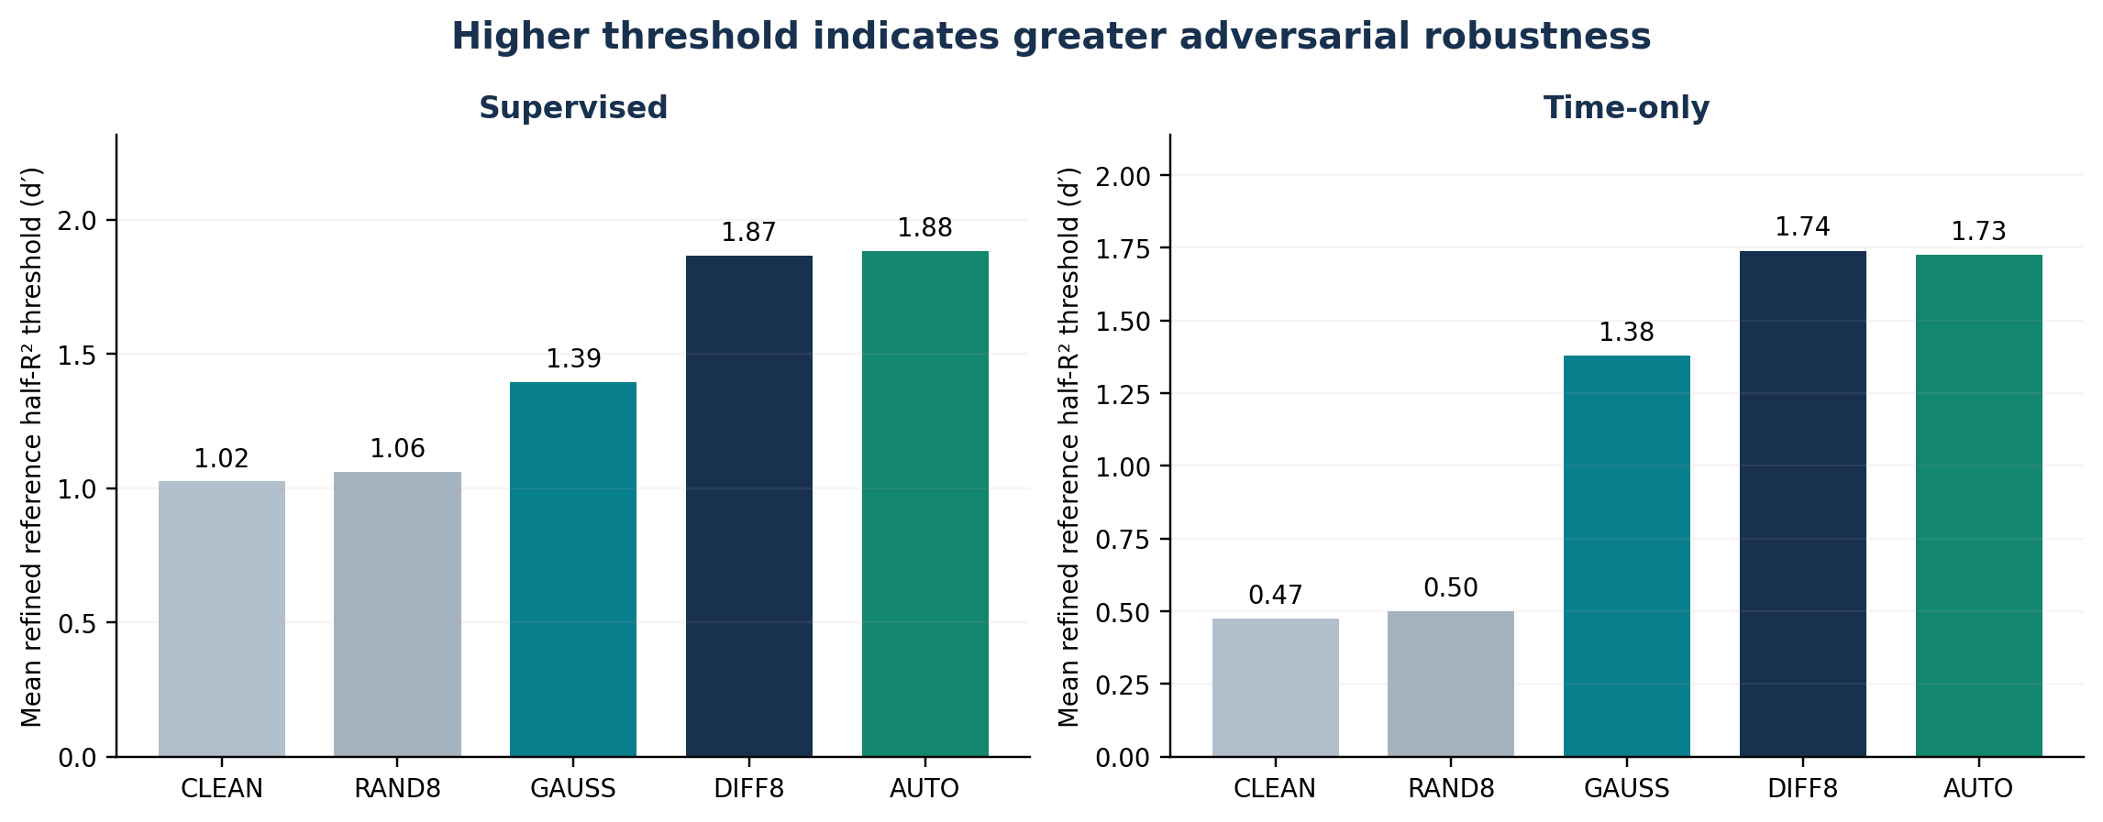
Figure 1. Across matched modes, GAUSS lies between CLEAN/RAND8 and DIFF8/AUTO for mean reference-metric robustness.

4. Paired comparisons and uncertainty
Table 3 reports median ratios of the 30 session/seed-matched refined reference thresholds, not ratios of group means. Bootstrap CIs account for the three seeds belonging to the same recording. For GAUSS and the adversarial methods, the confidence intervals describe between-session variation in this set of recordings; the dataset is not an independent external replication.

Supervised (30 matched model pairs per comparison)
Comparison (A / B) | Median ratio | 95% session CI | Run wins | Session wins | Delta clean R² (A-B)
GAUSS vs CLEAN | 1.330 | 1.293-1.471 | 30/30 | 10/10 | +0.021
DIFF8 vs GAUSS | 1.344 | 1.216-1.515 | 27/30 | 9/10 | -0.017
AUTO-BEH vs GAUSS | 1.319 | 1.244-1.444 | 30/30 | 10/10 | -0.019
GAUSS vs RAND8 | 1.299 | 1.250-1.396 | 30/30 | 10/10 | +0.017
GAUSS vs PGD6 | 0.839 | 0.789-1.085 | 6/30 | 2/10 | +0.019

Time-only (30 matched model pairs per comparison)
Comparison (A / B) | Median ratio | 95% session CI | Run wins | Session wins | Delta clean R² (A-B)
GAUSS vs CLEAN | 2.936 | 2.523-3.293 | 30/30 | 10/10 | +0.166
DIFF8 vs GAUSS | 1.228 | 1.154-1.354 | 29/30 | 10/10 | +0.000
AUTO-SIG vs GAUSS | 1.206 | 1.115-1.358 | 29/30 | 10/10 | -0.003
GAUSS vs RAND8 | 2.705 | 2.314-3.246 | 30/30 | 10/10 | +0.160
GAUSS vs PGD6 | 0.895 | 0.811-1.044 | 9/30 | 3/10 | +0.001

Interpretation: reference robustness for GAUSS exceeds CLEAN in all 30 pairs in both modes; DIFF8 exceeds GAUSS in 27/30 supervised and 29/30 time-only pairs; the two frozen AUTO variants exceed GAUSS in 30/30 supervised and 29/30 time-only pairs. These are paired win counts, not independent-sample trial counts.
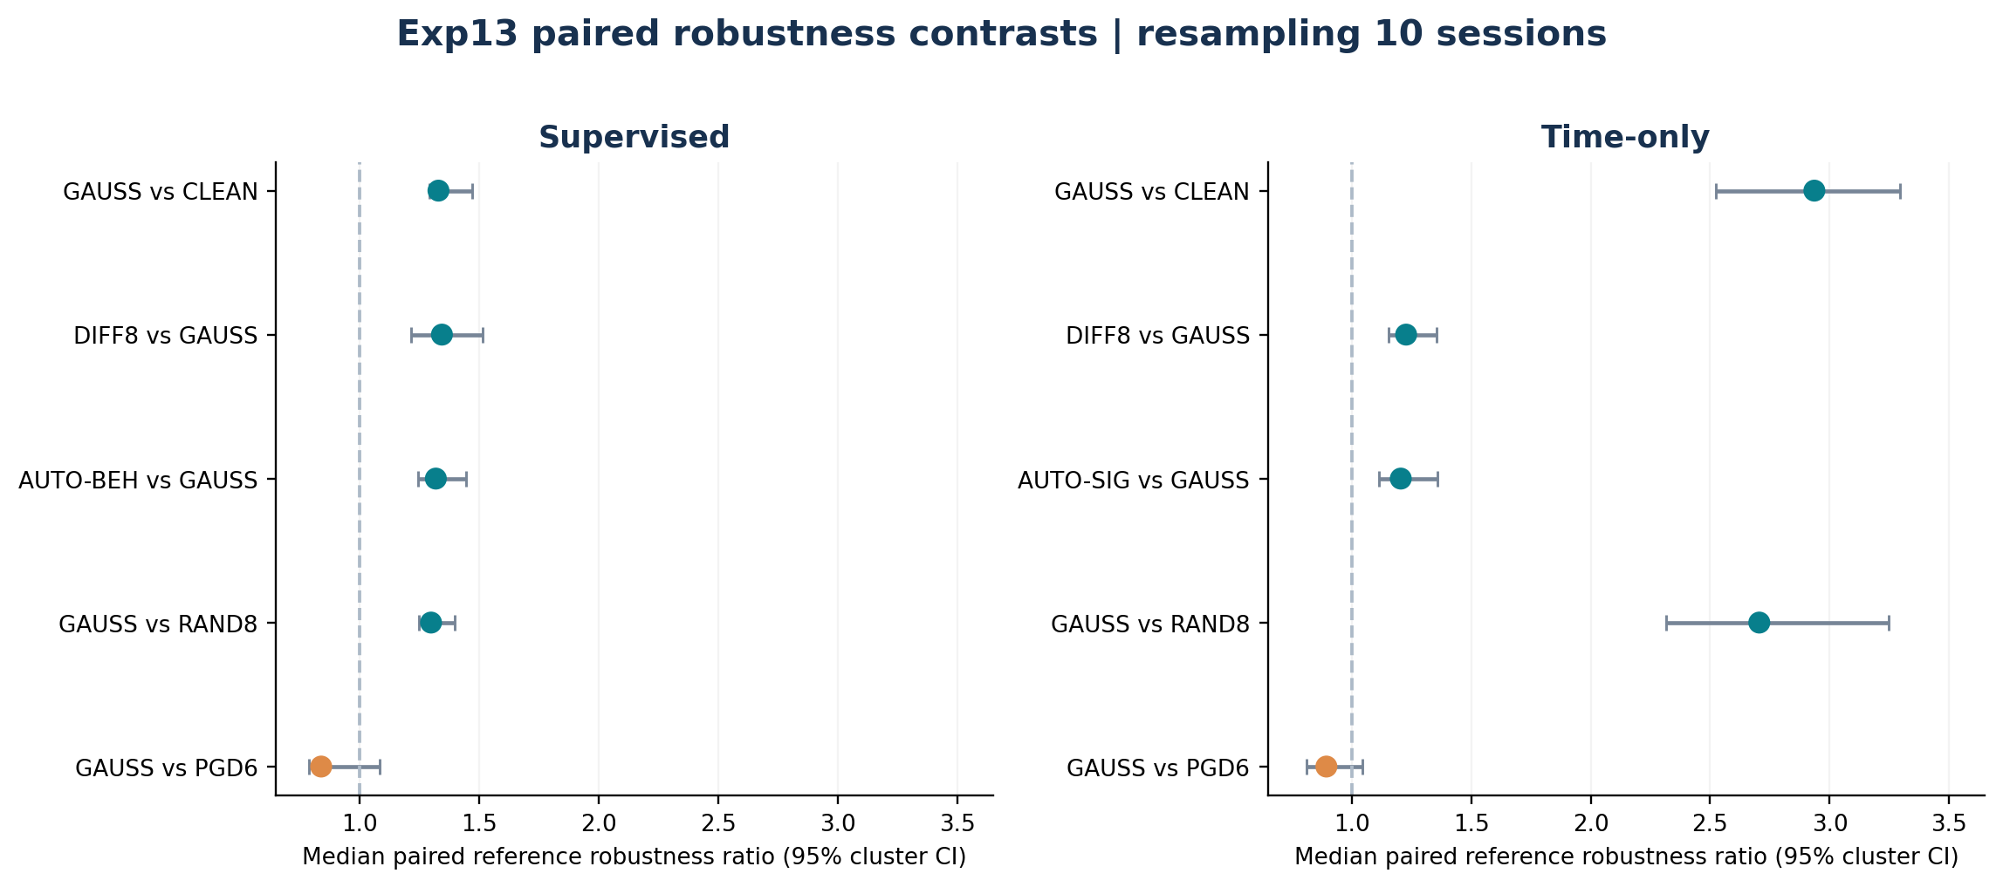
Figure 2. Median of paired ratios; horizontal bars show 95% session-cluster bootstrap percentile intervals. The null value is 1.

5. The hard-session exception and robustness sensitivity
T-RT2 is a decisive counterexample to any assertion that DIFF8 is superior on every recording. In supervised mode it has a very low clean decoding R² and the fixed DIFF8 arm reaches a refined reference threshold of only about 0.14; the natural-noise augmentation is around 0.47 and the frozen automatic behavior-budget arm around 0.56. This explains why the supervised DIFF8/GAUSS aggregate is sensitive to the choice of averaging functional.

Supervised T-RT2 (mean across seeds)
Arm | Clean R² | Refined ref eps1/2 | Refined iso eps1/2
CLEAN | 0.387 | 0.290 | 0.295
D8_RAND | 0.391 | 0.303 | 0.303
GAUSS | 0.430 | 0.470 | 0.484
PGD_L2_EPS6 | 0.399 | 0.308 | 0.219
D8 | 0.411 | 0.133 | 0.093
AUTOBEH | 0.410 | 0.559 | 0.495

Time-only T-RT2 (mean across seeds)
Arm | Clean R² | Refined ref eps1/2 | Refined iso eps1/2
CLEAN | 0.158 | 0.181 | 0.208
D8_RAND | 0.224 | 0.297 | 0.370
GAUSS | 0.339 | 0.770 | 0.945
PGD_L2_EPS6 | 0.344 | 0.725 | 1.280
D8 | 0.363 | 0.962 | 0.940
AUTOSIG | 0.359 | 0.934 | 0.997

Aggregation sensitivity: the supervised DIFF8/GAUSS median paired ratio is 1.344 (95% session bootstrap 1.216-1.515), whereas its geometric mean paired ratio is 1.183 (95% cluster bootstrap 0.840-1.461). The latter interval includes 1, because the large negative T-RT2 contrast receives more influence in the log-average than in the median. In other words, DIFF8 usually outperforms GAUSS, but across-session generalization of the exact superiority magnitude is sensitive to the summary statistic.
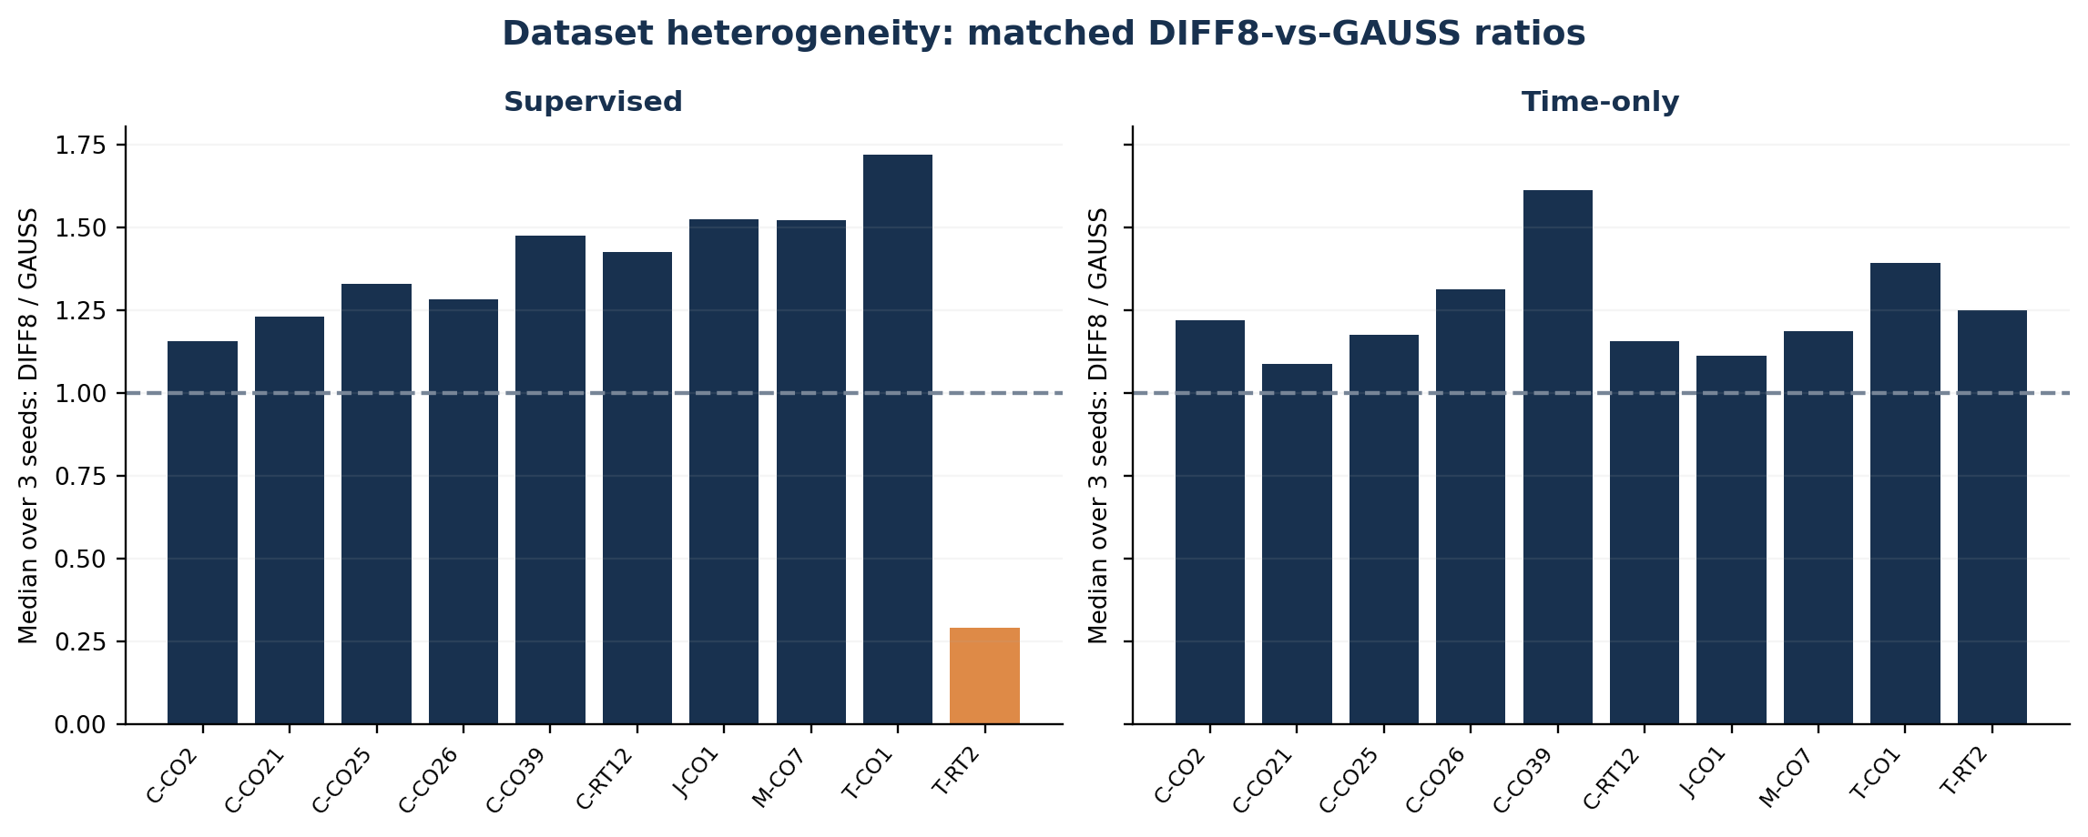
Figure 3. DIFF8/GAUSS within-session median paired ratios. The supervised T-RT2 reversal is visible.

6. What the GAUSS and CLEAN controls establish
Compared with CLEAN, covariance-aware natural-noise-scale random augmentation improves both clean decoding quality and adversarial robustness. In supervised mode, the paired mean clean R² increase is 0.0206 (95% session CI 0.0103 to 0.0303); GAUSS/CLEAN median paired reference robustness is 1.330x. In time-only mode, the gain in mean clean R² is 0.1656 (95% session CI 0.1495 to 0.1825), and the median paired robustness ratio is 2.936x. All 10 sessions show a favorable reference robustness median for GAUSS over CLEAN in both modes.
Conversely, the adversarial DIFF8 methods achieve larger reference thresholds than GAUSS on 9/10 supervised and 10/10 time-only sessions. The frozen automatic behavior and signal budgets are also more robust on essentially all matched settings. Thus Gaussian-shaped data augmentation is not an adequate substitute for direction-optimized adversarial training under this evaluation threat model, even when the injected random direction is at a much larger natural-noise radius.

Training-loss response: supporting, not decisive evidence
The official exp13_report.txt provides median training loss-gain values: supervised DIFF8=0.568, RAND8=0.001, GAUSS=0.010; time-only DIFF8=0.453, RAND8=0.005, GAUSS=-0.023. The small or negative median for random perturbations is consistent with their directions being substantially less effective at increasing the attack training objective than optimized adversarial directions. These diagnostics are implementation-specific and are not, by themselves, a formal measure of optimization quality or proof of a causal mechanism.

Noise-scale interpretation
Exp13 GAUSS draws a fixed-norm random perturbation (d-prime epsilon = sqrt(C*T)), not variable-radius Gaussian samples. Inspection of the Exp13 runner and Acorn-dprime training.py confirms that the "GAUSS" arm uses the random optimizer in difference-residual covariance geometry. Consequently the phrase "covariance-matched Gaussian augmentation" is an approximation in whitened high-dimensional direction, not an exact characterization of the radial law. A stricter matched-noise control could compare the same target d-prime budget with both random and adversarial orientation or use Gaussian radial sampling directly.

7. Behavioral scaling and failure prediction
The original Exp11 supervised preregistered vulnerability rule was retained; the Exp13 combined official summary reports 15 true positives, 6 false positives, 3 false negatives, 186 true negatives and AUC=0.954 for x_beh, versus AUC=0.820 for x_sig, over the 210 Exp11 supervised evaluation records. These are retained Exp11 findings, not 120 new independent validation samples. At the refined threshold epsilon1/2<0.5, there are 18/210 such observations in supervised Exp11; Exp13 controls add further low-robustness outcomes (GAUSS 3/30 supervised and 0/30 time-only; CLEAN 3/30 supervised and 15/30 time-only).
Mean reference kappa (refined epsilon1/2 / behavior-reference epsilon) is 0.103 for supervised GAUSS, versus 0.136 for DIFF8 and 0.138 for AUTO-BEH. The corresponding time-only values are 0.104, 0.129 and 0.127. The cross-session relationship remains descriptive; shared-scale effects and within-session variation must be separated before a theoretical scaling claim is made.

8. Limitations and claims appropriate for a manuscript
One dataset family. All 540 outcomes use the same 10 Perich sessions, with 3 seeds each; Exp13 enlarges method coverage, not the number of independent biological recordings or the number of external datasets.
Training-budget mismatch. GAUSS uses natural-noise-scale epsilon=sqrt(C*T), whereas DIFF8 and RAND8 use epsilon=8. Results support a multi-control hierarchy but do not isolate direction at identical energy for GAUSS vs DIFF8.
Paired dependence. The 30 seed pairs are nested within 10 sessions. Intervals use session-cluster resampling; sign-test results at 10-session level and bootstrap intervals should not be treated as 30 independent replications.
Metric specificity. The primary improvements are in the Ledoit-Wolf/reference d-prime metric; isotropic stress-test rankings can differ and must be shown separately.
Half-R² criterion. The term "failure" refers to a measured half-R² robustness threshold; it does not demonstrate a constant-output decoder or collapsed embedding. The evaluation-refinement procedure is finite-resolution.
Post-hoc contrasts. Contrasts and CIs in this report were computed after observing Exp13. They are exploratory unless included in a prospective analysis plan; no adjustment for comparing many arms was performed.
Text-based reconstruction. Exp13 per-model CSV numbers were reconstructed from terminal printouts rounded to six decimal places; source JSON/summary_v2.csv remains authoritative for full-precision replication.

Recommendations and next independent experiment
- Freeze Acorn-dprime, the existing epsilon-selection rule and evaluator; avoid any retuning on these 10 sessions.
- For a new dataset, preregister predictions and both robust and clean decoding endpoints before fitting; use one genuinely external recording family.
- Retain GAUSS, CLEAN and RAND8 as complementary controls, while describing the natural-noise-scale budget and fixed-radius sampling accurately.
- Report paired reference and isotropic robustness, clean R², per-session outcomes, and uncertainty over recordings rather than over seeds.
- Treat a decoder-collapse theorem as separate theoretical work: current experiments establish performance and vulnerability criteria, not a necessary mathematical collapse condition.

9. Reproducibility and files
Source inputs: the user-provided complete Exp13 terminal results (all 120 detailed lines, official summary and paired comparisons), the prior Exp12 all-420 model CSV, and the supplied Exp13_bundle.zip runner/training source for control-design verification. Exp13 ran on four H200 GPUs, with 10 sessions and seeds 42-44. All comparisons were recomputed from per-run rows rather than inferred from rounded summary tables.
Companion outputs: Exp13_All_120_Models_Detailed_Results.csv (23 terminal-export fields); Exp11_to_Exp13_All_540_Models_Detailed_Results.csv (consistent 29-column integrated schema, with provenance); Exp13_Paired_Comparisons_with_Session_Bootstrap.csv (10 matched contrasts, effect sizes and session-cluster confidence bounds).
Overall conclusion: natural-noise-scale covariance-aware random perturbations meaningfully strengthen both supervised and time-only CEBRA compared with clean training; however, optimized adversarial training with the original fixed or automatic budgets generally provides superior reference-metric robustness. The hard supervised T-RT2 session is a meaningful exception requiring explicit sensitivity analysis, not an inconvenient point to remove.

