Exp12 | Refined Robustness & Random-Direction Controls
  - Full research report • Ten held-out Perich sessions • 420 successful jobs
Prepared for supervisor review | Analysis date: 24 October 2026

Executive summary
Exp12 reassessed the 360 frozen CEBRA models from Exp11 with a refined white-box robustness threshold estimator and trained 60 matched random-direction controls (30 supervised, 30 time-only). All 420 jobs completed successfully across ten previously held-out Perich sessions and three seeds (42, 43, 44). The original checkpoint weights were reused for re-evaluation; the only newly trained models were the random-direction controls.
Primary result: behaviour-calibrated d-prime training (DIFF/AUTO_BEH) remains close to a strong fixed-budget baseline (DIFF8). The refined paired geometric robustness ratio is 1.133 (95% session-bootstrap interval 0.951–1.539); without the difficult T-RT2 session, the ratio is 0.980. Hence, the results support near-baseline performance without per-session epsilon tuning, not a general claim of statistical superiority. The refined measurement also resolves three DIFF8 thresholds below the previous 0.5 floor on T-RT2, while DIFF/AUTO_BEH remains above 0.5 on all seeds.
Independent control result: replacing adversarial directions with random directions on the same d-prime sphere markedly degrades reference robustness. RAND/DIFF8 is 0.632 (supervised) and 0.289 (time-only), with very small measured attack-loss gains in the random controls. This supports the importance of directional adversarial optimization over matched random-direction perturbations.
Validation scope | Completed | Errors
Exp11 supervised checkpoints re-evaluated | 210 / 210 | 0
Exp11 time-only checkpoints re-evaluated | 150 / 150 | 0
New supervised random controls | 30 / 30 | 0
New time-only random controls | 30 / 30 | 0
TOTAL | 420 / 420 | 0

Main interpretive caution: only ten sessions are independent clusters; three seeds per session should not be treated as 30 independent biological samples. Bootstrap intervals below resample sessions.

1. Motivation and research questions
The Exp11 hypothesis was that epsilon can be calibrated from training data before model fitting, approximating a strong manually selected epsilon without a fresh per-session search. Exp12 tests two possible weaknesses in that inference: (i) epsilon-at-half-clean-R² may be distorted by the coarse evaluation grid and the lower bound 0.5; and (ii) robustness might arise from covariance-shaped augmentation rather than gradient-directed adversarial optimization.
- RQ1: Does a refined measurement of reference epsilon at half-clean R² preserve the comparison between automatic and fixed epsilon policies?
- RQ2: Does adaptive epsilon remain competitive after recovering thresholds below the old evaluation floor?
- RQ3: Does adversarial direction outperform a matched random-direction perturbation under the same d-prime geometry and nominal epsilon?
- RQ4: How stable is kappa = refined reference epsilon at half-clean R² / reference behaviour distance across methods and sessions?

2. Data and experimental design
Ten Perich sessions selected prospectively from a frozen candidate list (selection seed 2026) after excluding nine previously studied sessions: C-CO25, C-CO26, T-RT2, C-CO2, T-CO1, C-CO39, C-CO21, J-CO1, M-CO7, C-RT12. Each uses seeds 42, 43 and 44. The full dataset remains within the Perich family; this is out-of-session rather than out-of-dataset validation.
Supervised: seven Exp11 strategies × 10 sessions × 3 seeds = 210 existing models. Time-only: five strategies × 10 × 3 = 150 existing models. Exp12 additionally trains one DIFF8_RAND control for each session and seed in each mode (60 new models).
The documented CEBRA configuration uses offset36-model-more-dropout, latent dimension 64, hidden dimension 64, temperature 0.4, batch size 2048 and 3,000 encoder iterations, followed by a 2,500-epoch decoder; adversarial training uses ten attack steps. The covariance-aware Madry/APGD variants use a Ledoit-Wolf spatial estimate and white temporal model; the DIFF variants use difference residuals. The control changes the perturbation optimizer to random while retaining nominal d-prime budget 8 and the same geometry. The CPU/headnode extraction itself is non-training.
Exp12-v2 evaluates the original checkpoints with the same base epsilon grid {0.5, 1, 2, 4, 8, 16}, white-box 20-step attacks, and refinement level four around the half-clean threshold, including values below 0.5. Both reference noise-shaped and isotropic metrics are evaluated. Kappa is computed using training-split behavioural labels as a diagnostic; time-only representation training does not use those labels.
Definitions: Clean R² is the held-out decoder score without adversarial perturbation. Reference (or isotropic) epsilon at half-clean R² denotes the attack budget where robust R² reaches half the clean R². Larger is better. A “sub-0.5 failure” below means a refined reference threshold < 0.5; it is a measurement criterion, not a training failure. Kappa = epsilon_(1/2),refined / epsilon_beh,ref.

3. Final results by strategy

3.1 Supervised CEBRA (240 jobs including control)
Method | n | Mean clean R² | Median ref ε½ | Median iso ε½ | Ref <0.5 | Mean κ
PGD6 | 30 | 0.701 | 1.555 | 3.265 | 3 | 0.119
DIFF8 | 30 | 0.703 | 2.049 | 2.363 | 3 | 0.136
DIFF/AUTO_BEH | 30 | 0.701 | 2.058 | 2.379 | 0 | 0.138
SP/AUTO_SIG | 30 | 0.700 | 1.870 | 1.774 | 0 | 0.129
SP/AUTO_BEH | 30 | 0.688 | 1.822 | 1.574 | 2 | 0.125
POOL/AUTO_BEH | 30 | 0.695 | 1.931 | 2.739 | 0 | 0.133
SP8 | 30 | 0.686 | 1.228 | 0.879 | 10 | 0.072
DIFF8_RAND | 30 | 0.703 | 1.093 | 1.287 | 3 | 0.078

DIFF/AUTO_BEH has mean clean R² 0.7012 and median refined reference epsilon 2.0577, close to DIFF8 (0.7028 and 2.0487). All 30 DIFF/AUTO_BEH runs have reference epsilon > 0.5; DIFF8 has three sub-0.5 thresholds, all in T-RT2. SP8 has ten sub-0.5 results, while SP/AUTO_SIG and pooled AUTO_BEH each have none. The isotropic outcome differs: ordinary PGD6 retains a much larger median isotropic threshold (3.265) than the DIFF variants (~2.36–2.38), demonstrating a geometry-dependent robustness trade-off.

3.2 Time-only CEBRA (180 jobs including control)
Method | n | Mean clean R² | Median ref ε½ | Median iso ε½ | Ref <0.5 | Mean κ
PGD6 | 30 | 0.603 | 1.414 | 3.488 | 0 | 0.115
DIFF8 | 30 | 0.604 | 1.880 | 2.405 | 0 | 0.129
DIFF/AUTO_SIG | 30 | 0.601 | 1.919 | 2.415 | 0 | 0.127
SP/AUTO_SIG | 30 | 0.585 | 1.957 | 1.806 | 0 | 0.127
POOL/AUTO_SIG | 30 | 0.606 | 1.725 | 3.078 | 0 | 0.127
DIFF8_RAND | 30 | 0.444 | 0.516 | 0.674 | 15 | 0.038

The label-free AUTO_SIG budget is competitive in time-only learning: DIFF/AUTO_SIG achieves median refined reference epsilon 1.919 compared with 1.880 for DIFF8, while clean R² is lower by 0.00324 on paired observations. No Exp11 time-only arm drops below reference epsilon 0.5; the new random control does so in 15/30 runs and also shows lower mean clean R² (0.444 vs 0.604 for DIFF8).

4. Paired inference and sensitivity
All paired comparisons match Session and Seed. The reported ratio is exp(mean(log[ε½(A)/ε½(B)])) across 30 pairs. Uncertainty is a percentile 95% bootstrap interval from 30,000 resamples of the ten session-level average log-ratios (fixed seed 2026). These intervals do not establish equivalence without a pre-specified equivalence margin.
Mode | Comparison | Ref ratio | 95% session CI | Wins | Iso ratio | Δ Clean R²
SUP | DIFF/AUTO_BEH / DIFF8 | 1.133 | [0.951, 1.539] | 16/30 | 1.160 | -0.0017
SUP | DIFF/AUTO_BEH / PGD6 | 1.213 | [1.073, 1.393] | 25/30 | 0.751 | +0.0002
SUP | DIFF8 / PGD6 | 1.070 | [0.849, 1.269] | 25/30 | 0.647 | +0.0019
SUP | DIFF8_RAND / DIFF8 | 0.632 | [0.508, 0.871] | 3/30 | 0.689 | +0.0003
TIME | DIFF/AUTO_SIG / DIFF8 | 0.987 | [0.973, 1.002] | 10/30 | 0.997 | -0.0032
TIME | DIFF/AUTO_SIG / PGD6 | 1.125 | [1.025, 1.243] | 22/30 | 0.700 | -0.0021
TIME | DIFF8 / PGD6 | 1.140 | [1.043, 1.257] | 24/30 | 0.702 | +0.0011
TIME | DIFF8_RAND / DIFF8 | 0.289 | [0.246, 0.331] | 0/30 | 0.304 | -0.1604

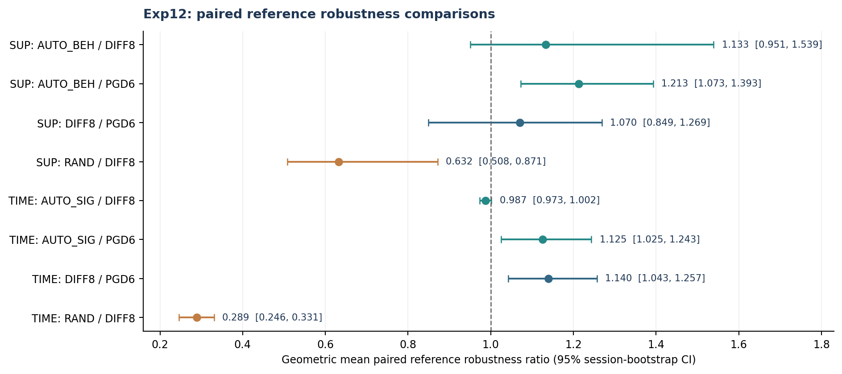
Figure 1. Session-bootstrap uncertainty for the primary within-session and within-seed comparisons.
The central supervised result is not robustly “AUTO_BEH outperforms DIFF8”: the all-session ratio is 1.133 but its interval includes 1; the median paired ratio is near unity. T-RT2 accounts for most of the increase because the refined threshold exposes values far below 0.5 in the fixed DIFF8 arm. Removing T-RT2 as a post-hoc sensitivity check yields ratio 0.980 (27 pairs), whereas T-RT2 alone yields 4.211 (three pairs). Accordingly, we interpret the automated rule as matching DIFF8 on most sessions while protecting one difficult session, rather than as uniformly dominating it.
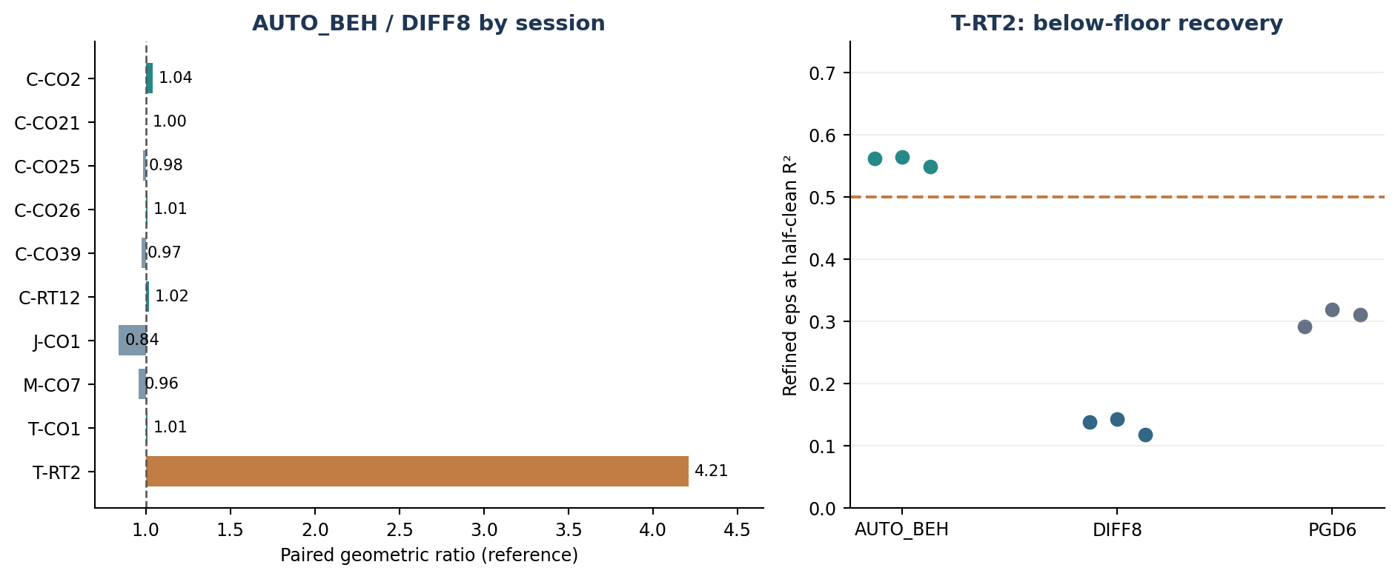
Figure 2. Most supervised sessions show similar robustness under AUTO_BEH and DIFF8; T-RT2 drives the large average difference.

5. Refined threshold estimation and the 0.5 floor
The original Exp11 grid began at epsilon 0.5. Under v1 reporting, models whose half-clean threshold was below the first grid point were recorded at 0.5. The v2 local refinement can recover sub-0.5 values, yielding valid “ok” statuses even for thresholds below 0.5. Thus the all-zero “below_floor” status count in the extraction is not a count of actual low-threshold models; use the numeric criterion refined epsilon < 0.5 instead.
Supervised model, T-RT2 | Median v1/grid ε½ | Median refined ε½ | Refined <0.5 count (of 3)
PGD6 | 0.500 | 0.311 | 3
DIFF8 | 0.500 | 0.138 | 3
DIFF/AUTO_BEH | 0.541 | 0.563 | 0
SP8 | 0.500 | 0.092 | 3

Across the 210 supervised original models, exactly 18 refined reference thresholds are <0.5, matching the number of v1 floor failures, but now with meaningful sub-floor magnitudes. This reinforces rather than overturns the session-level pathology. A better threshold estimator is not a stronger attack by itself; additional adaptive attacks and convergence tests would still be required to make a stronger robustness claim.

6. Matched random-direction control
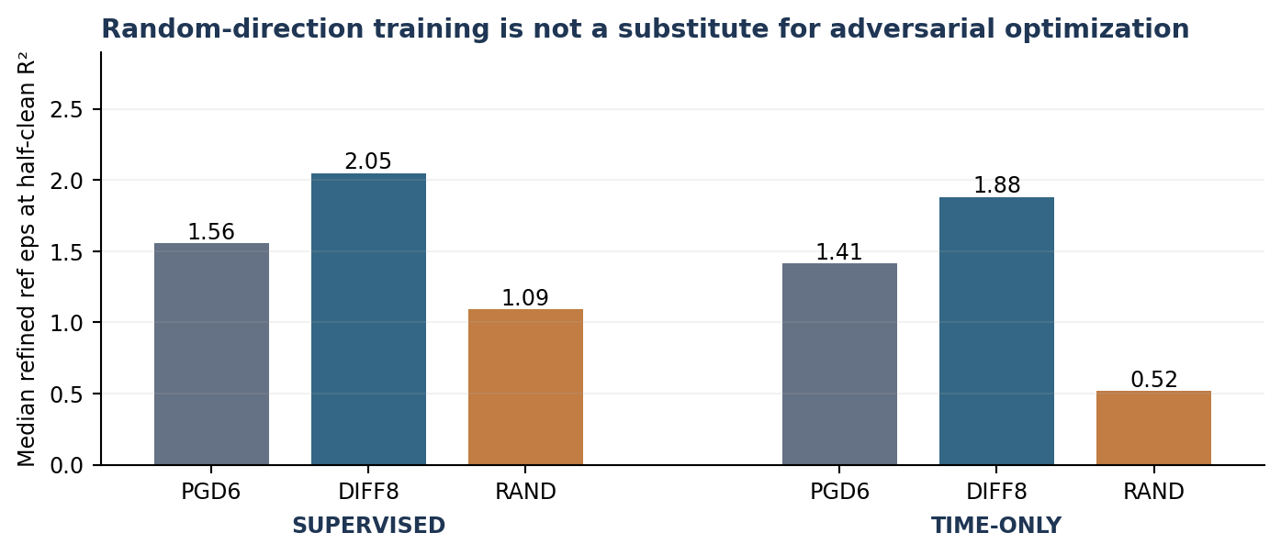
Figure 3. Median refined reference robustness: matched random-direction training has substantially lower robustness, particularly in time-only CEBRA.
With identical nominal d-prime epsilon = 8 and a matched noise-aware geometry, the RAND control replaces the adversarial direction with a random direction on the d-prime sphere. Supervised RAND/DIFF8 reference ratio = 0.632 (95% session-bootstrap CI 0.508–0.871; only 3/30 seed pairs and 1/10 sessions exceed DIFF8). Clean R² remains similar (mean paired change +0.00027). Thus the robustness reduction cannot be explained by a substantial loss of clean decoding in this mode.
Time-only RAND/DIFF8 reference ratio = 0.289 (95% interval 0.246–0.331; 0/30 seed pairs and 0/10 sessions exceed DIFF8). Clean R² falls by 0.1604 in the random control, so its robustness deficit coexists with major deterioration in representation quality. Median training attack-loss gains printed by the summary are approximately 0.568 vs 0.001 (supervised DIFF8 vs RAND) and 0.453 vs 0.005 (time-only). This supports that the control does not produce comparably adverse training perturbations.
The random-direction control rules out the narrower explanation that matched random perturbations on the same d-prime sphere suffice to reproduce the observed performance. It is not the same experiment as Gaussian augmentation with matched mean/covariance, nor does it prove that every noise-augmentation baseline is inferior.

7. Behaviour-distance normalization (κ)
The reference-scale quantity κ = refined ε½ / ε_beh,ref uses a behavioural distance computed from training labels in the evaluation metric. Mean κ for supervised DIFF8 is 0.1358 and DIFF/AUTO_BEH is 0.1378; corresponding time-only DIFF8 and DIFF/AUTO_SIG means are 0.1287 and 0.1272. The supervised DIFF8 κ coefficient of variation is approximately 0.334 and the time-only DIFF8 coefficient of variation is approximately 0.152 using the printed per-run values. The comparison is compatible with a shared characteristic robustness scale, with substantial session/model deviations.
Session | ε_beh,ref | SUP DIFF8 κ | SUP AUTO_BEH κ | TIME DIFF8 κ | TIME AUTO_SIG κ
C-CO2 | 16.19 | 0.113 | 0.118 | 0.106 | 0.105
C-CO21 | 15.23 | 0.164 | 0.163 | 0.144 | 0.140
C-CO25 | 15.98 | 0.156 | 0.156 | 0.140 | 0.138
C-CO26 | 15.39 | 0.145 | 0.146 | 0.137 | 0.136
C-CO39 | 18.33 | 0.128 | 0.120 | 0.125 | 0.131
C-RT12 | 12.82 | 0.131 | 0.135 | 0.084 | 0.082
J-CO1 | 7.59 | 0.179 | 0.153 | 0.142 | 0.132
M-CO7 | 12.08 | 0.166 | 0.161 | 0.141 | 0.135
T-CO1 | 13.23 | 0.157 | 0.156 | 0.153 | 0.152
T-RT2 | 8.11 | 0.017 | 0.069 | 0.118 | 0.115

An important interpretive limitation is that κ divides one distance in the reference geometry by another distance defined in the same geometry. Part of the stability may reflect shared metric scaling. Additionally, the κ values here are evaluated from measured robustness; to establish prospective prediction of robustness on a wholly new dataset, the factor itself must be frozen on a separate training cohort and evaluated without post-hoc recalibration.

8. Automated budget calibration: what is and is not demonstrated
DIFF/AUTO_BEH chooses a session-dependent budget using training behaviour with the previously frozen 0.363 coefficient and an upper cap (2D)^(1/4). In Exp11, seven of ten session budgets were cap-limited, making them close to an effectively dimension-dependent constant. Three sessions (T-RT2, J-CO1, C-RT12) were directly reduced by the behavioural term. Exp12 leaves these trained checkpoints and budgets unchanged. The strongest supported contribution is therefore a deployable, training-data-derived epsilon policy that tracks a strong fixed-budget reference, with material protection against an especially brittle session; the incremental contribution of the behavioural term beyond the cap needs additional ablation.
DIFF8 is a strong fixed manual baseline, not a demonstrated per-session epsilon oracle. Exp12 therefore does not establish equivalence to the best possible manually tuned epsilon for every session. Nor do the 95% cluster-bootstrap intervals constitute a formal equivalence test. The independent value of automated calibration is the absence of a fresh per-session epsilon sweep, rather than a guaranteed increase over every fixed setting.

9. Limitations, checks and recommended next experiments
- Measurement: although all 420 reference/isotropic refined status fields are “ok”, thresholds for 18 original supervised models lie below 0.5. Always evaluate failure counts from numeric refined thresholds, not the “below_floor” status label.
- Statistical power: 10 sessions (not 30 biologically independent samples) underlie the cluster-level intervals. Additional animal- or dataset-level holdouts are required.
- Attack strength: the v2 summaries document 20 white-box evaluation steps; stronger multi-restart or adaptive attack audits remain a separate check.
- Matched control: random-direction perturbations are weaker than adversarial perturbations, but a direct Gaussian/covariance-matched noise-augmentation arm has not yet been run.
- Generalization: the 10 new sessions are still Perich data. Transfer to a different species, brain region and behavioural task is untested.
- Kappa: the reported mean ratios are promising but insufficient to establish a universal neural robustness bound; session-level outliers, especially T-RT2, deserve investigation.
Recommended next steps: (i) freeze evaluation and method hyperparameters before using an external dataset; (ii) test an independently selected dataset with both budget-selection and κ predictions pre-registered; (iii) add a properly matched Gaussian-noise control if required by reviewers; (iv) establish equivalence margins in advance for automatic-vs-fixed epsilon comparisons; and (v) archive the source JSONs, checkpoint hashes and environment manifest with the final results.

10. Bottom line
Exp12 materially strengthens Exp11. A refined measurement reveals the depth of floor failures and sharpens the T-RT2 contrast while preserving near-fixed-baseline performance on most sessions. The random-direction control provides a second, distinct result: geometry alone without adversarial direction does not reproduce the robustness observed under DIFF8 training. The data support automatic epsilon calibration as a practical alternative to repeated manual tuning and support the importance of optimizing the adversarial direction. They do not establish universal superiority, a complete causal exclusion of all augmentation baselines, or an external-dataset generalization guarantee.

Appendix A — Session-level refined reference thresholds
For each session the table reports the median over three seeds. Full 420-run values, both geometries, kappa, original thresholds and training metrics are in the accompanying CSV.
Session | SUP PGD6 | SUP DIFF8 | SUP BEH | SUP RAND | TIME DIFF8 | TIME SIG | TIME RAND
C-CO2 | 1.173 | 1.822 | 1.910 | 1.191 | 1.712 | 1.694 | 0.598
C-CO21 | 2.432 | 2.492 | 2.487 | 1.543 | 2.199 | 2.130 | 0.618
C-CO25 | 2.202 | 2.496 | 2.494 | 1.505 | 2.240 | 2.205 | 0.541
C-CO26 | 2.096 | 2.231 | 2.254 | 1.433 | 2.110 | 2.098 | 0.570
C-CO39 | 2.081 | 2.337 | 2.201 | 1.097 | 2.290 | 2.407 | 0.391
C-RT12 | 1.479 | 1.678 | 1.727 | 0.915 | 1.081 | 1.056 | 0.383
J-CO1 | 1.292 | 1.363 | 1.160 | 0.707 | 1.077 | 0.999 | 0.354
M-CO7 | 1.612 | 2.004 | 1.945 | 1.089 | 1.708 | 1.631 | 0.697
T-CO1 | 1.513 | 2.076 | 2.065 | 0.781 | 2.026 | 2.013 | 0.638
T-RT2 | 0.311 | 0.138 | 0.563 | 0.300 | 0.958 | 0.930 | 0.284

Appendix B — Provenance and reproducibility notes
Source: the terminal export of Exp12 complete final results supplied by the researcher (420 per-model rows; four suite integrity checks; official exp12_summary.py text). The accompanying CSV was reconstructed from those printed per-model records, not guessed from aggregate tables. The analysis verified all 420 unique (suite, session, seed, experiment) records, zero error statuses, numerical consistency of κ with refined ε½ / ε_beh,ref, and expected group sizes (210 + 150 + 30 + 30).
Output CSV: Exp12_All_420_Models_Detailed_Results.csv. Its first 22 columns reproduce all fields from the individual-model terminal table; derived fields provide mode, run kind, numeric sub-0.5 flags, and recomputed κ for auditing. The CSV does not include raw intermediate points from every v2 refinement or checkpoints, which were not part of the terminal export.
This report uses descriptive summaries and cluster-bootstrap comparisons computed from the 420 extracted records. The research team should retain the original machine-generated summary_v2.csv, robust_eval_v2 JSON files, code version and checkpoint hashes for any formal submission.

