|  |
| --- |
| **EASC 106** |
| Earth Through Time |
| A Course Overview |

|  |
| --- |
| Jeffrey Leung |

Table of Contents

|  |  |  |  |
| --- | --- | --- | --- |
| **Page** |  |  | **Section** |
| *02* |  | 00 | Introduction to Earth History |
| *03* |  | 01 | Principles of Earth History |
| *09* |  | 02 | Minerals and Rocks |
|  |  | 03 | Geologic Time: |
| *15* |  |  | Stratigraphy |
| *18* |  |  | The Time Scale |
| *20* |  |  | Geochronology |
| *21* |  | 04 | Life on Earth and its Fossil Record:  Taxonomy of Earth |
| *23* |  |  | The Fossil Record |
| *26* |  | 05 | Biological Evolution |
| *31* |  | 06 | Sedimentary Environments |
| *35* |  | 07 | Seafloor Spreading |
|  |  | 08 | The Geologic Timeline: |
| *42* |  |  | The Hadean and Archean Eons |
| *43* |  |  | The Proterozoic Eon |
| *44* |  |  | The Paleozoic Era |
| *47* |  |  | The Mesozoic Era |
| *52* |  |  | The Cenozoic Era |
| *53* |  | 09 | Reefs through the Phanerozoic Eon |
| *55* |  | 10 | Human Evolution |
| *56* |  | 11 | Strata Diagrams |
| *57* |  | 12 | Glossary |

Introduction to Earth History

* **Geology:** Science of Earth’s structure, origin, history, physical/chemical processes, life forms
  + Used to:
    - Responsibly utilize natural resources
    - Understand the factors leading to current conditions
    - Preserve key habitats for life forms
* **Physical geology:** Study of geologic processes and Earth materials
  + E.g. Weathering, sedimentation, tectonic plate movement
* **Historical geology:** Origin of Earth and the changes in its physical/chemical/biological processes over time
* *Retrodiction:* Prediction of the past
* *Scientific methodology:* Investigation involving a process of empirical observation,  
  hypothesis creation, and testing
* Scientific theories of the Earth:
  + **Evolutionary theory:** Process by which biological species give rise to other species through genetic change and natural selection
    - Unifying idea of biology
  + **Plate tectonics theory:** Process by which the lithosphere is composed of separate pieces which float on the asthenosphere, a layer of magma
    - Unifying idea of geology
    - **Lithosphere:** Outer rigid layer of Earth consisting of the crust and upper mantle
      * **Crust:** Outermost layer of the Earth defined by density, composition, and seismic velocity

Principles of Earth History

* Geologic processes are labeled using numbers, with 1 being the oldest
* **Strata:** Earth material deposited as a layer on the Earth’s surface
  + Includes sedimentary rocks, volcanic ash, lava flows
* **Neptunism:** Theory that all rocks were created/precipitated at one time from a universal, mineral-filled ocean
* **Plutonism:** Theory that rocks undergo a cycle of melting from volcanic activity, erosion, formation into sedimentary rocks, etc.
  + Hutton’s view
    - Scottish geologist
    - 1700s
    - Father of modern geology
* **Uniformitarianism:** Theory that processes at work today were also at work in the geologic past
  + Created by Hutton
  + **Deep time:** Belief that the Earth is very old
  + Present is the ‘key’ to the past
  + Processes with little effect can add up to create greater effects
    - E.g. Erosion of an entire mountain
* Stratigraphic principles:
  + Nicolaus Steno:
    - Birth name: Niels Stensen
    - Danish physician
    - **Principle of Superposition:** In any undisturbed sequence of strata, the oldest rock unit is at the bottom, and the rock units are progressively younger above

Youngest

Oldest

1

2

3

* + - **Principle of Original Horizontality:** Sediments are almost always laid down on the Earth’s surface in horizontal layers
      * Exceptions include delta front sediments:

Delta front

Ocean

* + - **Principle of Original Lateral Continuity:** Layers extend in all directions until they thin out, end abruptly, or grade into another type of sediment

Sediment

River bank

Shoreline

.

.

.

.

.

.

.

.

.

.

-

-

-

-

-

-

-

* + - * Useful for correlation of once-connected / discrete areas:

.

.

.

.

.

.

.

.

.

.

.

.

.

.

.

.

.

.

.

_

_

_

_

_

_

_

_

_

_

_

_

_

_

_

_

_

_

_

_

_

_

_

_

_

_

_

_

_

_

_

_

_

* + Charles Lyell:
    - English geologist
    - 1800’s
    - Wrote *Principles of Geology*
    - **Principle of Cross Cutting Relationships:** Where one rock unit cuts across another rock unit, the other rock unit must be older to have been cut, and the cutting rock unit must be younger

1

**Dyke:** An igneous intrusion which cuts across layers

.

.

.

.

.

.

.

.

.

.

.

.

.

.

.

_

_

_

_

_

_

_

_

_

_

_

.

.

.

.

.

.

.

.

.

.

.

.

.

.

_

_

_

_

_

_

_

_

_

_

_

2

3

3

2

1

4

5

* + - **Principle of Included Fragments:** Fragments of rock found in another rock unit must be older than the unit they are included in

.

.

.

.

.

.

.

.

.

.

.

.

.

.

.

.

.

.

.

.

.

.

.

>

<

^

v

<

<

>

^

>

^

^

Eroded igneous fragments embedded in sandstone

<

v

>

Unconformity

_

_

_

_

_

_

_

_

_

_

_

.

.

.

.

.

.

.

.

.

.

.

.

.

.

.

.

>

<

^

<

>

^

.

.

.

.

.

.

.

.

.

Intrusion of magma into sandstone

1

2

1

2

3

* + - **Principle of Unconformities:** A surface of erosion separates much older rock below from much younger rock above

Much older rock unit

Surface of erosion unconformity  
**Hiatus:** Time gap of many years (millennia)

Much younger rock unit

* + William Smith:
    - English surveyor
    - 1800’s
    - Created the first geologic map
    - Did not know about evolution, but knew that organisms changed over time
    - **Principle of Biotic Succession:** Fossils appear in the rock record in a definite and determinable order
      * Smith could predict which layers of strata to expect above/below using the fossils found
  + Applying the geologic principles:
    - **Relative age dating:** Determining the order of past events relative to  
      each other
      * Outcrops or drill cores of rock can be examined
    - Examples of geologic events:
      * Deposition of sediments
      * Magma intrusions
      * Faulting
      * Folding (deformation) and tilting
      * Erosion
    - Most easily applied to un-deformed and undisturbed strata
    - Can only be applied to deformed strata after analysis of the upwards direction in the past, using:  
      * **Geopetal structures:** Features in the sedimentary rock which demonstrate an upwards direction
        + Footprints, tracks, and trails:

.

.

.

.

.

.

.

.

.

.

.

_

_

_

_

_

_

_

_

_

_

_

_

_

_

_

_

_

_

_

_

_

_

_

_

_

_

_

_

.

.

.

.

.

.

.

.

.

.

.

.

.

.

.

.

.

.

.

.

.

.

.

.

.

.

.

.

.

.

.

.

.

.

.

.

.

.

.

.

.

.

* + - * + Raindrop impressions:

.

.

.

.

.

.

.

.

.

.

.

.

.

.

.

.

.

.

.

.

.

.

.

.

.

.

.

.

.

.

.

.

.

.

.

.

_

_

_

_

_

_

_

_

_

_

_

_

_

_

_

_

_

_

* + - * + Mud cracks:

.

.

.

.

.

.

.

.

.

.

.

.

.

.

.

.

.

.

.

.

.

.

.

.

.

.

.

.

.

.

.

.

_

_

_

_

_

_

_

**_**

_

_

_

_

_

_

_

_

_

_

* + - * + Ripples:

Current

As sediments build up, layers fall away to the right

“Feathering out”  
of sediments at the base

Upwards

Fossil record

**Cross-bedding** or  
**current ripple lamination**  
( Current ripple lamination = < 5 cm)

* + - * Included fragments (always found at the base of the containing rock unit)
      * Fossils
      * Trace fossil: Evidence of the behaviour of an organism rather than  
        its body
        + Worm burrows:

Seafloor

U-shaped burrow

Seafloor

Tube burrow capped with a mud ball of fecal matter

Minerals and Rocks

* **Mineral:** Naturally occurring crystalline solid
  + **Crystalline:** Material which is made of atoms arranged in patterns
  + **Rock:** Aggregate of one or more types of minerals
* **Rock cycle:** Conceptual model to explain how rocks might be formed and altered

Sediments

**Extrusive/volcanic igneous rock**

**Intrusive/plutonic igneous rock**

Magma

**Metamorphic rock**

**Sedimentary rock**

Heat and pressure  
recrystallization

Deposition, burial, lithification  
(through compacting and cementing)

Weathering  
and erosion

Melting

Cooling and crystallization

Above Earth’s surface

Below Earth’s surface

* + **Weathering:** Breakdown of rock
  + **Erosion:** Transport of weathered material
  + **Lithification:** Process by which sediments are compacted and cemented into sedimentary rock
* Anatomy of the Earth:

Crust

Mantle

Outer core

Inner core

* + Core is metal (nickel and iron)
    - Solid inner core; liquid outer core
  + Mantle and crust are rock, and contains pockets of magma

Crust

Uppermost mantle

Asthenosphere

Lower mantle

Lithosphere

* + - **Tectonic plates:** Pieces of the lithosphere
    - **Asthenosphere:** Layer of ductile weak rock in the mantle which flows slowly beneath the lithosphere
      * Convection currents create the motion of the tectonic plates above
    - Magma is generated at:
      * Divergent plate boundaries:

New oceanic crust

Magma

Convection currents

* + - * + E.g. Mid-Atlantic ridge
      * Convergent plate boundaries (subduction):

Magma

Down into the lower mantle

* + - * + E.g. Pacific Ring of Fire (Andes, Cascades)
        + Magma uprising creates chains of volcanoes
      * Stationary mantle plumes:

Islands

Water

Mantle

Core

Plume

Crust

* + - * + E.g. Hawaii, Yellowstone, Ireland
        + As the plate moves, the plume stays at the “hot spot” and creates a continuous chain of volcanoes
    - Presence of magma can be explained easily using the theory of plate tectonics
* **Igneous (Rock):** Formed through the cooling/solidification of magma or lava, or from material ejected from a volcano  
  + **Intrusive/plutonic rocks (Plutons):** Igneous rocks which cooled from magma  
    (beneath the Earth’s surface)
    - Larger plutons:
      * Cool slowly over millennia
      * Large grain size (phaneritic)
      * *Examples of types:* Batholiths, stocks
      * *Examples of rocks:* Granite (light-coloured minerals),  
        gabbro (dark-coloured minerals)
    - Smaller plutons:
      * Cool relatively quickly
      * Small grain size (aphanitic)
      * *Examples of types:* Dikes, sills, laccoliths
    - Types of plutons:
      * **Batholith:** Irregularly-shaped intrusive rock measuring  
        > 100 km2 in diameter
      * **Stock:** Irregularly-shaped intrusive rock measuring  
        < 100 km2 in diameter
      * **Dike:** Thin sheet-like intrusive rock cutting across pre-existing rocks
      * **Sill:** Sheet-like intrusive rock parallel to the other strata
      * **Laccolith:** Dome-shaped intrusive rock parallel to the other strata, which also causes doming of other strata
      * **Volcanic neck:** Cylindrical intrusive rock from the solidification of magma in the pipe leading to a volcanic vent
        + E.g. Devil’s Tower, South Dakota
    - Pegmatite: Last-cooled area of an intrusive rock, containing large crystals
  + **Extrusive/volcanic rocks:** Igneous rocks which cooled from lava  
    (above the Earth’s surface)
    - E.g. Basalt, rhyolite, andesite, obsidian
    - **Volcanic glass:** Formed by lava cooling almost instantaneously
  + **Phaneritic texture:** Having large, coarse crystals
    - ‘Phaneros’ – visible
    - Rocks which have a low cooling rate are phaneritic because the crystals have enough time to form
  + **Aphanitic texture**: Having small, fine crystals
    - ‘Aphanos’ – hidden
    - Rocks which have a high cooling rate are aphanitic because the crystals do not have enough time to form
  + Poryphytic texture: Having both fine and coarse crystals
    - Created when partially-cooled intrusive rocks move above the Earth’s surface

|  |  |  |
| --- | --- | --- |
| **Cooling temperature:** | **Phaneritic:** | **Aphanitic** |
| High | Gabbro | Basalt |
| Low | Granite | Rhyolite |

* + - Temperature affects the minerals that form
    - Cooling rate affects the grain size of the minerals
  + Earth’s composition:
    - Rocks in the uppermost mantle: Phaneritic, green in colour (peridotite)
    - Rocks in the oceanic crust: Gabbro near the depths; basalt near the surface  
      Rocks in the continental crust: Granite
* **Sedimentary (Rock):** Formed through the deposition and lithification of sediments  
  during burial
  + **Siliclastic sediments:** Weathered, eroded rock
    - Form rocks such as:
      * Conglomerates (made of gravel)
      * Sandstone (made of sand)
      * Mudstone/shale (made of silt/clay)  
        (Shale breaks along thin, flat layers)
  + **Chemical sediments:** Precipitation of minerals from water
    - Form rocks such as:
      * Limestone
      * Evaporite (e.g. Halite – rock salt)
  + **Organic sediments:** Organic material such as shells
    - Form rocks such as chalk (made of dead plankton)
* **Metamorphic (Rock):** Formed through the recrystallization of pre-existing rocks at depth due to heat, pressure, and time
  + Examples:
    - *Gneiss:* Metamorphic rock characterized by bands of light and dark minerals
    - *Schist:* Metamorphic rock characterized by wavy layers
    - *Slate:* Metamorphic rock characterized by dullness and fine grains, with a tendency to split easily
    - *Marble:* Metamorphic rock consisting of recrystallized limestone

Geologic Time

Stratigraphy

* **Stratigraphic correlation:** Creating geochronological relationships between  
  different locations  
  + **Lithostratigraphy:** Correlation of strata based on lithology (rock type) and colour
    - **Stratigraphic columns:** Cross-sections of strata used to convey how strata  
      are related
    - **Formation:** A geologic rock unit which is mappable and identifiable
      * Fundamental unit of lithostratigraphy
    - Example:

.

.

.

.

.

.

.

.

.

.

.

.

.

.

.

.

.

.

.

.

.

.

.

.

.

.

.

.

.

.

.

.

.

.

.

.

.

.

.

.

.

.

.

.

.

.

.

.

.

.

.

.

.

.

.

.

.

.

.

.

.

.

.

.

.

.

.

.

.

.

_

_

_

_

_

_

_

_

_

.

.

.

.

.

.

.

.

.

.

.

.

.

.

.

.

.

.

.

.

.

.

.

_

_

_

_

_

_

_

_

_

_

_

_

_

_

_

_

_

_

_

_

.

.

.

.

_

_

_

_

_

_

_

_

_

_

_

_

_

_

_

_

_

_

_

_

_

_

_

_

_

_

_

_

_

_

_

_

.

.

.

.

.

.

.

.

.

.

.

.

.

.

.

.

.

.

.

.

.

.

.

.

.

.

.

.

.

.

.

.

.

.

.

.

.

* + **Boreholes:** Deep, thin, circular holes drilled in the ground into which geophysical tools are lowered to measure rock characteristics
    - Can allow measurement of rock type, porosity, pore substance, and permeability
    - Example:  
      *The Grand Canyon*

_

_

_

_

_

_

_

_

_

_

_

_

.

.

.

.

.

.

.

.

.

.

.

.

.

.

.

_

_

_

_

_

_

_

_

_

_

_

_

_

_

_

_

_

_

_

_

_

_

_

.

.

.

.

.

.

.

.

.

.

.

.

.

_

_

_

_

_

_

_

_

_

_

_

_

_

_

_

_

_

.

.

.

.

.

.

.

.

.

.

.

.

.

.

.

.

.

.

.

.

.

Kaibab Limestone

Toroweap Formation

Coconino Sandstone

Hermit Shale

Supai Formation

Redwall Limestone

Muav Limestone

Bright Angel Shale

Tapeats Sandstone

The Great Unconformity   
(nonconformity)   
(1.1 billion years of eroded rock)

Colorado  
River

Vishnu Schist

* + - * Shale weathers easily, so it forms a slope
      * Sandstone and limestone are resistant to erosion, so they form cliffs
  + **Biostratigraphy:** Correlation of strata based on guide fossils
    - **Biozone:** Interval of strata identified by its characteristic fossils
      * Fundamental unit of biostratigraphy
    - **Guide fossils:** Species that existed on Earth for only a short period of  
      geologic time and create fossils which are widespread geologically, abundant, easy to recognize, and easily preserved
      * Small marine organisms tend to be good guide fossils
      * E.g. Trilobites existed only in the Paleozoic Era
* **Unconformity:** A surface of erosion or non-deposition which separates much older rock below from much younger rock above
  + **Hiatus:** Great gap in time (centuries to many millennia)
  + **Nonconformity:** Deep-formed unconformity bedded by plutonic or metamorphic rock, which is uplifted and eroded at the surface

Strata/sediments

* + - Involves erosion of kilometers of overlying rock  
      (hiatus of hundreds to billions of years)
  + **Angular unconformity:** Unconformity bedded by deformed strata (folding, tilting, etc)

Strata/sediments

Strata

* + - Hiatus of many millennia
  + **Disconformity:** Unconformity bedded by strata which is undeformed, non-plutonic, and non-metamorphic  
    - Hiatus of centuries to millennia (relatively shorter than the hiatus of a nonconformity or an angular unconformity)
    - Tend to develop from sea level change
    - Common to marine strata

Geologic Time: The Time Scale

|  |  |  |  |  |  |  |
| --- | --- | --- | --- | --- | --- | --- |
| **Eon:** | **Era:** | **Period:** | **Epoch:** |  | **Years ago:** | **Notes:** |
| Phanerozoic | Cenozoic | Quaternary | Holocene |  | 11,800 |  |
| Pleistocene |  | 2.6 mil |  |
| Neogene | Pliocene |  |  | “Tertiary” in the past |
| Miocene |  | 23 mil |  |
| Paleogene | Oligocene |  |  | “Tertiary” in the past |
| Eocene |  |  |  |
| Paleocene |  | 65.5 mil |  |
| Mesozoic | Cretaceous |  |  |  |  |
| Jurassic |  |  |  |  |
| Triassic |  |  | 251 mil |  |
| Paleozoic | Permian |  |  |  |  |
| Pennsylvanian |  |  |  | “Carboniferous” outside of NA |
| Mississippian |  |  |  | “Carboniferous” outside of NA |
| Devonian |  |  |  |  |
| Silurian |  |  |  |  |
| Ordovician |  |  |  |  |
| Cambrian |  |  | 542 mil | First hard body parts (shells) |
| Proterozoic | Neo- | Ediacaran |  |  | 630 mil | First multi-cellular life |
|  |  |  |  |  |
|  |  |  |  |  |
| Meso- |  |  |  |  |  |
| Paleo- |  |  |  | 2.5 bil |  |
| Archean | Neo- |  |  |  |  |  |
| Meso- |  |  |  |  |  |
| Paleo- |  |  |  |  |  |
| Eo- |  |  |  | 4.0 bil | Oldest crustal rocks; First life on Earth (Bacterium) |
| Hadean |  |  |  |  | 4.6 bil |  |

* **Precambrian Era:** Span of time consisting of the Hadean, Archean, and Proterozoic Eons
  + **Ediacaran Period:** Span of time when multicellular life was first identified on Earth through impressions of large marine organisms in sandstone
* Prefixes and postfixes:
  + ‘eo’ Dawn of
  + ‘paleo’ Ancient
  + ‘meso’ Middle
  + ‘neo’ New
  + ‘zoic’ Life
  + ‘protero’ First
  + ‘phaneros’ Visible
* Geologic time scale as a single year:
  + January 1: Beginning of the Earth
  + November 18: End of the Precambrian
  + December 13: Appearance of dinosaurs
  + December 26: Extinction of dinosaurs
  + December 31:
    - 17:20pm: Oldest hominids evolve
    - 23:02pm: Homo Habilis evolves
    - 23:48pm: Homo Sapiens evolves
* **Phanerozoic time boundary:** Division between sections of geologic time, created based on the evolution of various species  
  + **Type section:** Strata boundary serving as a standard of reference
  + **Global Boundary Stratotype Section and Point (GSSP):** Internationally defined reference point marking the lower boundary of a geologic stage  
    - E.g. Brass marker (‘golden spike’) in Australia marks the lower boundary of the Ediacaran Period:

Ediacaran

2004

GSSP

Geochronology

* **Geochronology:** Absolute age dating of rock
* **Radioactive age dating:** Geochronology using radioactive decay of unstable isotopes
  + An unstable isotope decays into a stable isotope, radioactive particle(s), and heat
    - A ‘parent’ decays to a ‘daughter’
    - Top number of an isotope represents protons and neutrons;  
      bottom number of an isotope represents protons
  + E.g. → + (Alpha particle; helium particle without electrons) + heat  
     will decay further, and will eventually decay into .
* **Half-life:** Time required for half of a radioactive isotope to decay
  + Examples:
    - Carbon-14 has a half-life of 5730 years
    - Uranium-235 has a half-life of 710 million years
    - Uranium-238 has a half-life of 4.5 billion years
  + Formula: *t* =   
    where *t* = age of crystallization/recrystallization  
     *N* = Parents left at time *t*  
     *N*0 = Original parents at time t  
    - *Example: Zircon grains in granite are analyzed in a mass spectrometer, and a ratio of U238 to Pb206 is found to be 88 to 13.*  
      *N*0 = 88 + 13 = 101  
      *t* = = 0.89 billion years = 890 million years  
      *Therefore, the granite crystallized 890 million years ago.*
* The radiometric age of igneous rocks gives the age of crystallization of minerals (even of ash beds)
* The radiometric age of metamorphic rocks gives the age of recrystallization
* The radiometric age of sedimentary rocks gives the age of the source rock for the sediment,  
  not the age of deposition

Life on Earth and its Fossil Record

Taxonomy of Earth

* **Taxonomy:** Classification of life and organisms
* Linnaean classification system:
  + Binomial classification (i.e. named as *genus* *species*)
    - E.g. Homo Sapiens, Tyrannosaurus Rex
  + Categorization from broad to specific:  
    Domain; Kingdom; Phylum; Class; Order; Family; Genus; Species
    - E.g. Humans:  
      Eukarya; Animalia; Chordata; Mammalia; Primate; Hominidae; Homo; Sapiens
* Domains:
  + **Archaea:** Bacteria which can survive in harsh environments  
    (e.g. salty water, ocean floor geothermal vents)
  + **Bacteria:** All bacteria not in the Archaea domain
  + **Eukarya:** Multi-cellular (eukaryotic) organisms
    - **Eukaryotic:** Having membrane-bound organelles and a distinct nucleus
* Kingdoms:
  + Protozoa:
    - **Protista:** Single-celled protozoa (e.g. algae, plankton)
      * Base of the marine food chains
  + Metazoa:
    - Fungi, Plantae, and Animalia Kingdoms
    - **Animalia:** Invertebrate and vertebrate organisms
      * Examples of invertebrates: Coral, molluscs, echinoderms, arthropods
      * Examples of vertebrates: Reptiles, amphibians, fishes, birds, mammals
* **Species:** Group of organisms which can interbreed to produce fertile offspring
  + E.g. A male tiger and a female lion can breed to produce a tigon but the tigon cannot reproduce, so the tiger and the lion are different species
* Ecology of life forms:
  + **Habitat:** Ecosystem where an organism lives  
    - **Nonmarine (Continental):** Terrestrial or aquatic area
      * E.g. Forests, lakes
    - **Marginal marine:** Transitional area where a continent meets a marine area
      * E.g. Delta, brackish water where fresh river water meets ocean water, beaches, tidal floats
    - **Marine:** Seaward of the low tide mark; full salinity
      * **Pelagic:** Living above the seafloor
        + E.g. Fish
        + **Nektonic:** Swimming
        + **Planktonic:** Floating freely
      * **Benthic:** Living on/in the seafloor
        + E.g. Coral, marine worms
        + **Epifaunal:** Living on the surface of a sea/lake floor
        + **Infaunal:** Living under the surface of a sea/lake floor
    - **Neritic zone:** Shallower area of the ocean water before the continental shelf
    - **Oceanic zone:** Area of the ocean water which is 200m or deeper

**Neritic Zone**

**Oceanic Zone**

Shallow marine  
(Sunlight penetrates to seafloor)

Deep marine

Abyssal plain

Continental shelf

Continental  
slope

200m

3000-5000m

Continental rise

Abyssal zone

Bathyal zone

Sublittoral zone

Littoral zone  
(Intertidal)

**BENTHIC  
ENVIRONMENTS:**

**PELAGIC  
ENVIRONMENTS:**

* + - Oxygenation of a habitat**:**
      * **Oxic:** Well-oxygenated
      * **Dysoxic:** Poorly-oxygenated
      * **Anoxic:** Lacking oxygen
  + **Niche:** Role of an organism within its environment
    - Defined by nutrient requirements, environmental conditions, and   
      inter-species interactions
  + **Mode of life:** How an organism interacts with the food web
    - **Autotroph:** Synthesizes nutrients from raw resources
      * Also called primary producers
      * E.g. Photosynthesizers (plants, algae, phytoplankton, cyanobacteria)
    - **Chemotroph:** Derives nutrients from the breakdown of molecules in rocks
      * E.g. Archaebacteria at hydrothermal vents
    - **Heterotroph (Consumer)**: Derives nutrients from feeding on or causing the decay of other organisms
      * E.g. Decomposers, animals (herbivores, omnivores, carnivores), parasites, detrivores, deposit feeders (organisms which ingest sediment and filter out the microscopic plankton), suspension feeders (organisms which ingest water and filter out the microscopic plankton)

The Fossil Record

* **Fossil:** Evidence of life from during or before the Pleistocene epoch (> 11800 years old)
  + **Subfossil:** Evidence of life from the Holocene epoch (< 11800 years old)
  + **Body fossil:** Direct/altered remains or impressions of ancient organisms
    - E.g. Teeth, bones, wood, test (hard part of an organism), leaves
    - May be found ‘in situe’ (without transport from its original position) or weathered, eroded, and deposited with sediments
  + **Trace fossil (Ichnofossil):** Evidence of the behaviour of an organism rather than  
    its body
    - E.g. Tracks, trackways, trails, burrows, borings (burrows in hard substrate), nests, bite marks, coprolites (fossilized feces)
    - Found ‘in situe’ (without transport from its original position)
* **Fossilization:** The process through which dead organic material becomes a body fossil
  + After death, soft parts are consumed by scavengers and microbial decay, and hard parts become disarticulated and exposed, weathered, and eroded
  + The sooner the burial, the greater the chance of becoming a fossil
    - Greatest rates of deposition in marine and marginal marine environments
    - Burial does not guarantee decay of a fossil; acidic groundwater may dissolve the organic material
    - Fossils can remain buried, be uplifted/weathered/exposed at the surface, or be buried deeper and be destroyed through melting/metamorphosis
* Finding fossils:
  + Often a different colour and more resistant than the surrounding rock
  + Tend to be more abundant in sedimentary outcrops along cliffs, gullies, and arid areas
  + **Outcrop:** Exposed rock at the Earth’s surface
  + **Concretion:** Resistant chunk of rock due to included organic material altering nearby groundwater chemistry
* Methods of fossil preservation:
  + **Unaltered:** Original organic material
    - E.g. Teeth (made of phosphate)
  + **Recrystallization:** Metamorphosis of less stable material into a more stable form
    - E.g. Aragonite recrystallizes into calcite (Fossil looks chalky white)
  + **Replacement:** Molecular replacement by something other than calcite
    - E.g. Replacement by pyrite
    - E.g. Replacement of cellulose in wood by silica (quartz)
  + **Permineralization:** Infilling of pore spaces (in wood/bone) by silica
    - E.g. Petrified wood is created through replacement of cellulose and infilling of pore spaces
  + **Carbonization:** Deposition of thin carbon film
    - More common to soft parts such as leaves
  + **External mold:** Impression of the outer surface of organic material
  + **Internal mold (Steinkern):** Impression of an inner cavity of organic material
    - E.g. Sediment filling in the open space of a clam or gastropod
  + **Cast:** Filling in of an open space after organic material dissolves, filling in the space between external molds
    - Have the shape of the original organic material
  + **Exceptional preservation:** Area with excellent preservation of a wide variety of organisms
    - E.g. Tar pits of California; Burgess Shale in Field, BC
* Earth’s oldest fossils:
  + **Stromatolite:** Mound built by cyanobacteria  
    - 3.5 Ba (Archean Eon)
    - Trace fossil (No cyanobacteria body fossils were preserved)
    - Cyanobacteria (Blue-green algae):
      * Photosynthesizers
      * Lived in colonies in the intertidal zone
      * Built up mounds from sediment deposited during high tides
    - Significance:
      * Shows earliest evolution of life
      * Shows cyanobacteria released great amounts of oxygen into the atmosphere throughout the Precambrian, resulting in the possibility of complex life

Biological Evolution

* **Evolution:** Genetic change in an organism over time
  + Gradual environmental changes favour some traits over others
  + E.g. Horses underwent adaptations to a change in habitat (from forests to grasslands/plains) throughout the Cenozoic Era:
    - Toed feet to hooves (enabled faster running over flat, unobstructed plains)
    - 4x the size of a Neogene horse (enabled being able to see over the grass)
    - 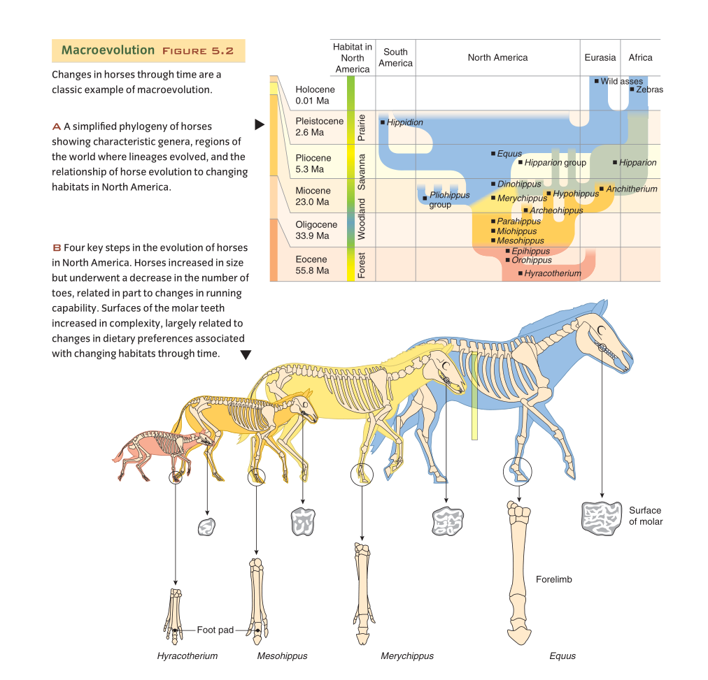Ever-growing molars with more hard enamel (enabled eating grasses made abrasive by quartz dust)
* **Natural selection:** Individuals with traits better suited to their environments have a greater chance to live to reproductive age and pass on their traits
  + Over many generations, the population has a tendency to contain more traits which are beneficial to survival
    - ‘Survival of the fittest’
  + As environments change, natural selection works on organisms to change and adapt
  + 1800s: Charles Darwin and Alfred Wallace bring the theory of natural selection to the main attention of the scientific community
  + Genetic variations and mutation create variations in traits, which accumulate over  
    many generations, leading to speciation
* Evidence to suggest common ancestry:
  + Embryology (early embryos of vertebrates have similar characteristics such as gill slits and tails)

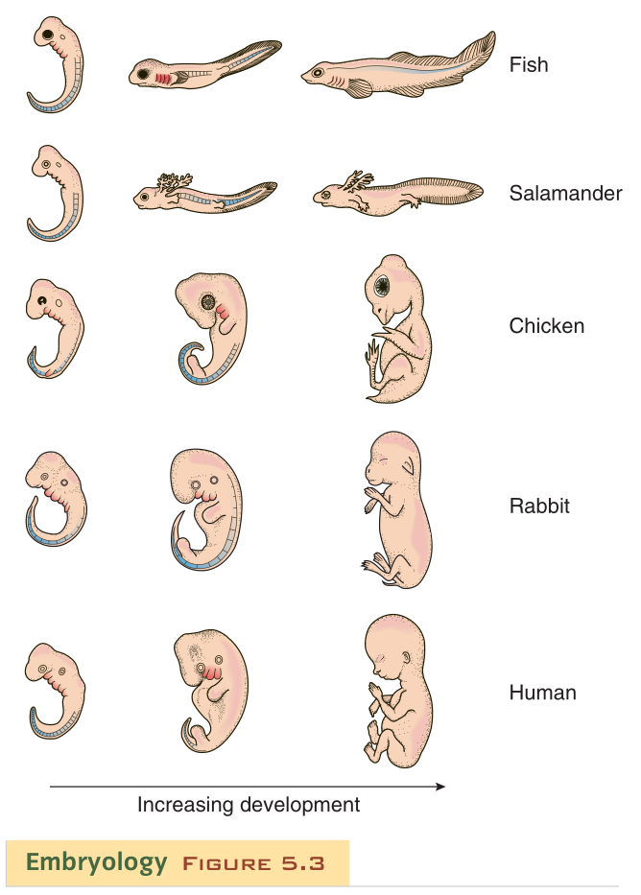

* + **Homologous structures:** Related parts of the body present in multiple distinct species which may or may not share a function
    - E.g. Forelimb bones of bats, birds, whales, and humans all share a similar structure, with the humerus, ulna, radius, and carpal bones
  + **Vestigial structures:** Body parts which no longer have a purpose
    - Must have been used by ancestors, but are useless to the current species
    - E.g. Humans have an appendix, a tailbone, and ear muscles;  
      whales have an unconnected pelvis bone
  + Microevolution shown by selective breeding in experiments and on domesticated animals
  + Fossil record
    - E.g. Evolution of horses throughout the Cenozoic Era and ammonoids
* **Speciation:** Rise of a new species from an ancestral species
  + Often begin from fringe populations, found on the outskirts of the main populations
    - E.g. Darwin’s finches

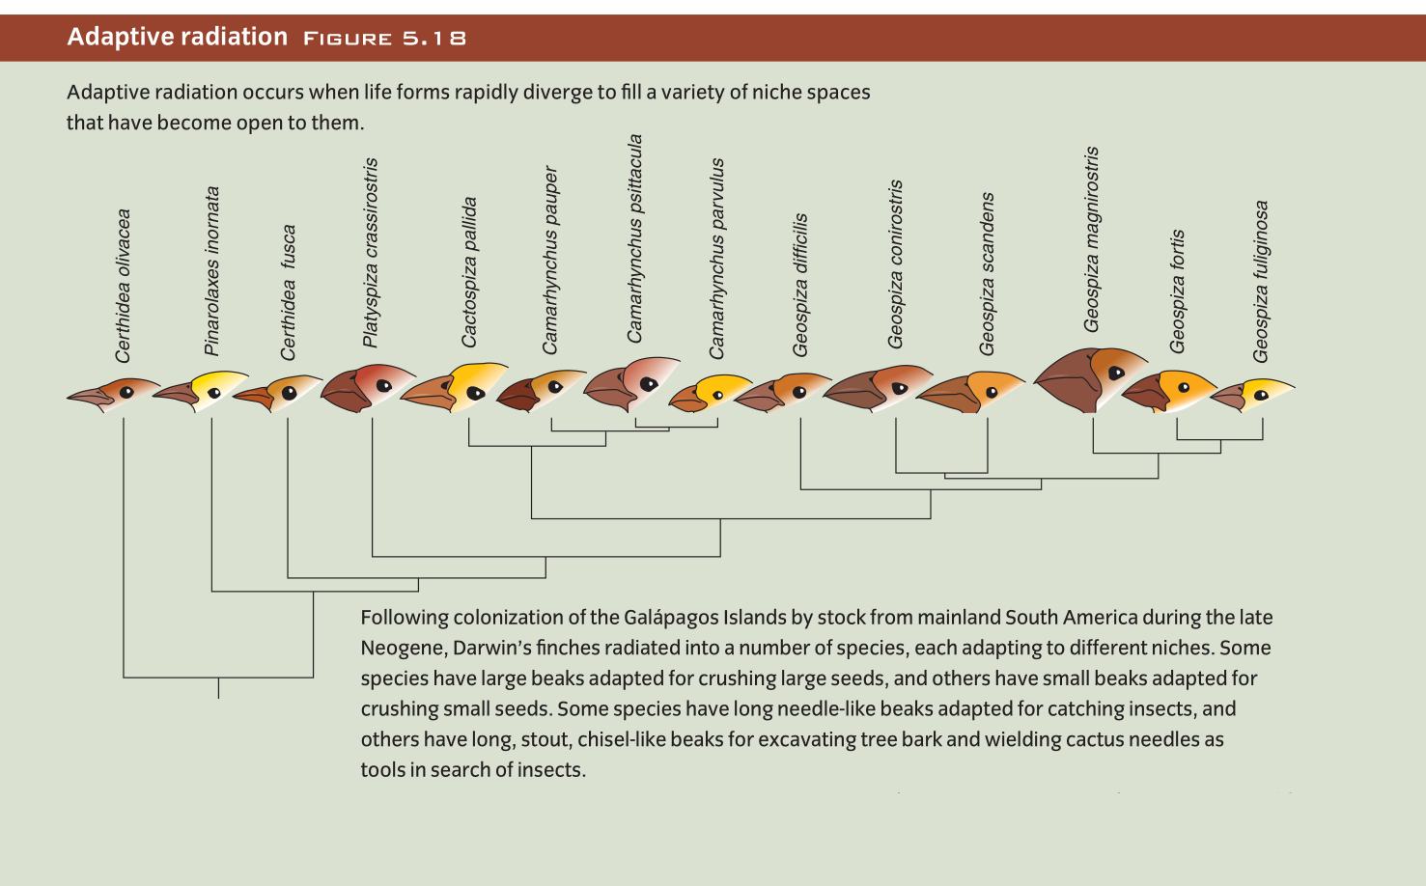

* **Dollo’s Law:** Genetic change cannot produce the exact same species more than once, be reversed, or be repeated
  + Known as the irreversibility of evolution
  + **Convergent evolution:** Similar traits and body forms amongst discrete species due to natural selection responding to similar ecological pressures
    - E.g. Wings of arthropods, birds, bats, pterosaurs
* **Adaptive radiation:** Quick evolution of a new species when new ecological opportunities arise
  + E.g. Darwin’s finches: Many different species evolved when some finches flew to the Galapagos Islands and their beaks became highly adapted to a specific diet
  + **Biotic turnover:** Adaptive radiation (quick evolution of new species) occurring in abundance following a mass extinction
    - Survivors evolve quickly due to the lack of competition in their environment
    - E.g. K-Pg (Cretaceous – Paleogene) extinction event:  
      An extinction of large marine reptiles, pterosaurs, and non-avian dinosaurs triggered the adaptive radiation of mammals and birds in the early Cenozoic Era
* **Living fossils:** Species which undergo little evolutionary change for millions of years
  + E.g. Lingula (brachiopod):

Shell

Burrow  
(infaunal)

Fleshy stalks  
(pedicule)

Geologic range:  
Cambrian to current

* **Extinction:** Annihilation of all individuals of a species
  + Typical duration of a species is 10 million years
  + **Mass extinction:** Time period when many species undergo extinction
    - Usually on the order of tens of thousands to millions of years
    - Exact causes are difficult to pinpoint
    - Can occur when an ecosystem collapses from:
      * Loss of a majority of the base of the food chain
        + I.e. Photosynthesizers – plants, algae, phytoplankton
      * Habitat loss
        + E.g. Falling sea level exposes the continental shelf, which is significantly productive
      * Climate change
        + E.g. From massive volcanism or an asteroid impact which creates ash in the atmosphere, blocking sunlight
    - 7 notable mass extinctions throughout the Phanerozoic Eon:

|  |  |
| --- | --- |
| **Era** | **Period** |
| Cenozoic | Quaternary |
| Neogene |
| Paleogene  K-Pg event |
| Meozoic | Cretaceous |
| Jurassic |
| Triassic  Permian mass extinction event |
| Paleozoic | Permian |
| Carboniferous |
| Devonian |
| Silurian |
| Ordovician  Mid-Cambrian |
| Cambrian |

Sedimentary Environments

* **Facie:** Feature of a sedimentary rock created by processes in the depositional environment
  + Processes:
    - Sedimentary features
      * E.g. Cross-bedding shows that a current was at work
    - High energy level creates sand/gravel; low energy creates settling of mud
  + *Biogenic structures:* Trace fossils which provide information about energy, salinity, etc.
  + Shallow marine facie:

.

.

.

.

.

.

.

.

.

.

.

.

_

_

_

_

_

_

_

_

_

_

.

.

.

.

.

.

.

_

Carbonates (Limestone)

Silt Clay

Mud

*Continental shelf*

Sand

*Coarser grains*

*Finer grains*

* + - Beach/near-shore facies:
      * High energy (waves breaking on the shore)
      * Deposition of sand/gravel
    - Offshore facies:
      * Medium energy
      * Deposition of mud
    - Far offshore facies:
      * Low energy
      * Precipitation of carbonates forming limestone
    - **Marine transgression (Onlap):** Sea level rise
      * Initiates a shift of environments in a landward direction

.

.

.

.

.

.

.

.

.

.

.

.

_

_

_

_

_

_

_

_

_

_

.

.

.

.

.

.

.

_

Time 1

Time 2

.

.

.

.

.

.

.

.

.

.

.

.

_

_

_

_

_

_

_

_

_

_

.

.

.

.

.

.

.

_

Sea level shift

* + - * **Fining-up sequence:** Rock facie which shows a shift of environments from near-shore to offshore as transgression occurs

_

_

_

_

_

_

_

_

_

_

_

.

.

.

.

.

.

.

.

.

.

.

.

.

.

.

* + - **Marine regression (Offlap):** Sea level fall
      * Initiates a shift of environments in a seaward direction

.

.

.

.

.

.

.

.

.

.

.

.

_

_

_

_

_

_

_

_

_

_

.

.

.

.

.

.

.

_

Time 2

.

.

.

.

.

.

.

.

.

.

.

.

_

_

_

_

_

_

_

_

_

_

.

.

.

.

.

.

.

_

Sea level shift

.

.

Time 1

* + - * **Coarsening-up sequence:** Rock facie which shows a shift of environments from offshore to near-shore as regression occurs

_

_

_

_

_

_

_

_

_

_

_

.

.

.

.

.

.

.

.

.

.

.

.

.

.

.

* **Walther’s Law:** In a conformable sequence without unconformities, a series of vertically stacked facies were adjacent in the depositional environment
  + Facies became stacked due to a shift in the environment, such as sea level change
  + Allows for the recognition of disconformities in a rock record
    - E.g. A coarsening-upwards sequence:  
        
        
      Sandstone and limestone are not laterally adjacent,  
      so there must be a hiatus between the layers.

.

.

.

.

.

.

.

.

.

.

.

.

.

.

.

* + Can be applied to any depositional environment
    - E.g. A winding river:

.

.

.

.

.

.

A

B

Flood plain B

Flood plain A

Cut bank

_

_

_

_

_

_

_

_

_

_

_

_

_

_

Channel bed

Point bar deposition

.

Sediment is moved from A to B.

_

_

_

_

_

_

_

_

_

_

.

.

.

.

.

.

.

.

.

.

.

.

.

.

.

Flood plain muds

Point bar sands

Channel bed gravel

Seafloor Spreading

* Spreading rates: 2.5 – 15 cm/year (full spreading)
* Stages of seafloor spreading:
  + **Rifting:** Process where heat below a continental plate (combined with gravity) bends and stretches the plate away from the heat source, creating faults

Continental crust

Faults from stretching

**Gravity**

**Heat**

Rift valley

**Gravity**

**Heat**

* + - Magma upwelling create basalt (in the fractures) and gabbro (below the upwelling), which form oceanic crust
  + Flooding of rift valleys by the ocean:
    - Rift valleys reach the edge of the continent; flooding creates a narrow seaway
    - **Triple junction:** Convergence of 3 rift systems (3 tectonic plates)
      * 2 arms will continue spreading and 1 will stop (a failed rift)
      * E.g. East African Rift System:

Red Sea

Africa

Saudi Arabia

Gulf of Aden

* + - Continued spreading can create a large ocean
      * E.g. Atlantic Ocean

200 million years ago, North America and Eurasia rifted apart from the supercontinent Pangaea.

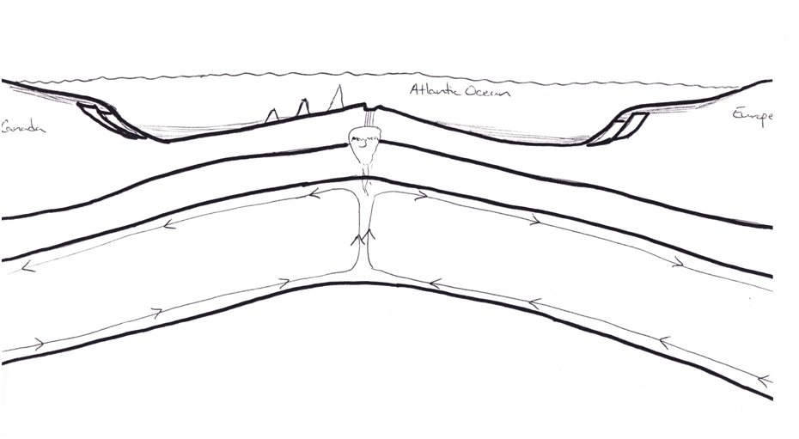

Continental shelf

Continental slope

Abyssal plain

Ridge axis

Eurasian plate

North American plate

Asthenosphere

Convection currents

Uppermost mantle

Continental crust

Oceanic crust

Lithosphere

Faults from  
initial rifting

* Supercontinents:
  + Pangaea:
    - Most recent
    - Assembled at the beginning of the Permian period
  + Rodinia:
    - First supercontinent
    - Assembled in the Neoproterozoic Era
* Evidence for seafloor spreading:
  + Radiometric age dating (e.g. Basalts are youngest at the ridge axis)
  + Deep-sea sediments thicken and are older with depth, and have basalt at their bases
  + Satellite data which gives precise measurements of spreading land masses
  + Paleomagnetism:
    - Earth’s magnetic field is caused by convection currents in the outer core
      * Orientation:
        + Can change and reverse over hundreds of thousands of years
        + **Normal polarity:** The current orientation of Earth’s  
          magnetic field
        + **Reverse polarity:** The opposite orientation of Earth’s current magnetic field
    - Variations cause magnetic anomalies
      * Positive magnetic anomaly: +
      * Negative magnetic anomaly: -
    - Tectonic plates show a symmetrical pattern of magnetic orientation on each side of the ridge axis:

+

+

+

+

+

+

-

-

-

-

-

-

* + - Shows that new crust is created at the ridge axis, and that crystallizing ocean crust locks in the magnetic field at the time of cooling
  + *Guyot:* Flat-topped underwater mountain which has risen above the water’s surface and has had its top eroded away by waves
* Tectonic boundaries:  
  + **Divergent plate boundary:** Area where tectonic plates move apart
    - Denoted by outward arrows or parallel lines::
    - Found at rift valleys and mid-ocean ridges
  + **Transform plate boundary:** Area where tectonic plates slide past each other
    - Denoted by parallel arrows or a single line:
    - Can cut through continental crust
      * E.g. San Andreas Fault
    - E.g. Offset mid-ocean ridges at the Mid-Atlantic Ridge  
      (East North American plate; West Eurasian plate):
  + **Convergent plate boundary:** Area where tectonic plates are pushed toward each other and meet
    - Denoted by inward arrows or arrows indicating the direction of subduction:
    - **Subduction zone:** Area where one tectonic plate is pushed underneath another
      * Subducting plate is oceanic crust (denser and thicker);  
        overriding plate is either continental or oceanic crust
      * **Deep-ocean trench:** Depressed area marking the beginning of a subduction zone

Subduction zone

Trench

* + - * **Accretionary wedge:** Sediments scraped from a subducting plate by an overriding plate
      * Not all subduction zones have trenches
      * Marianas Trench is 11 km deep
      * Water brought down by the subducting plate is heated and turns to  
        water vapour, which rises and melts rock to create magma
      * Subduction of an oceanic plate beneath a continental plate:
        + E.g. Cascades and Andes

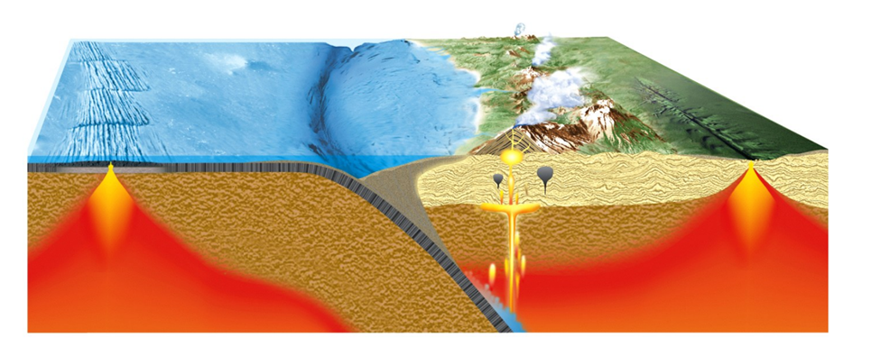

Mid-ocean ridge transform faults

Oceanic plate

Trench

Accretionary wedge

Volcanic arc

Rift valley

Continental plate

* + - * Subduction of an oceanic plate beneath an oceanic plate:
        + E.g. Japan, Philippines, Aleutian Islands

Magma

Island arc

* + - **Continental collision:** Meeting of two continental plates at a convergent  
      plate boundary
      * Neither plate can subduct; they buckle and rise
      * E.g. Himalayas
  + *Megathrust earthquakes:* Largest, most damaging earthquakes
    - Occur at subduction zones
    - Creates a tsunami if shallow enough
  + International tectonics:

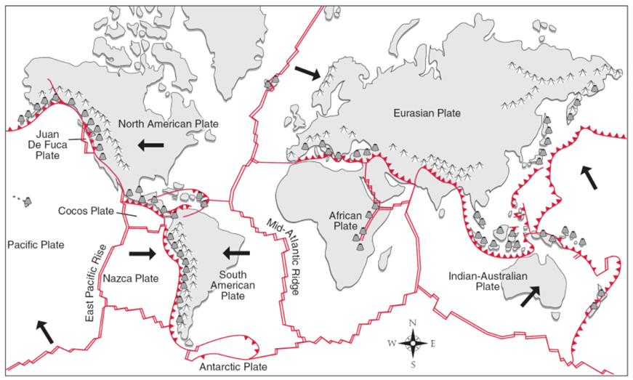

* + Local tectonics:
    - Juan de Fuca plate:
      * Offshore of Vancouver Island, Washington, Oregon, Northern California
      * Moves eastward due to spreading at the Juan de Fuca Ridge
        + **Cascadia Subduction Zone:** Area where the Juan de Fuca plate subducts beneath the North American plate

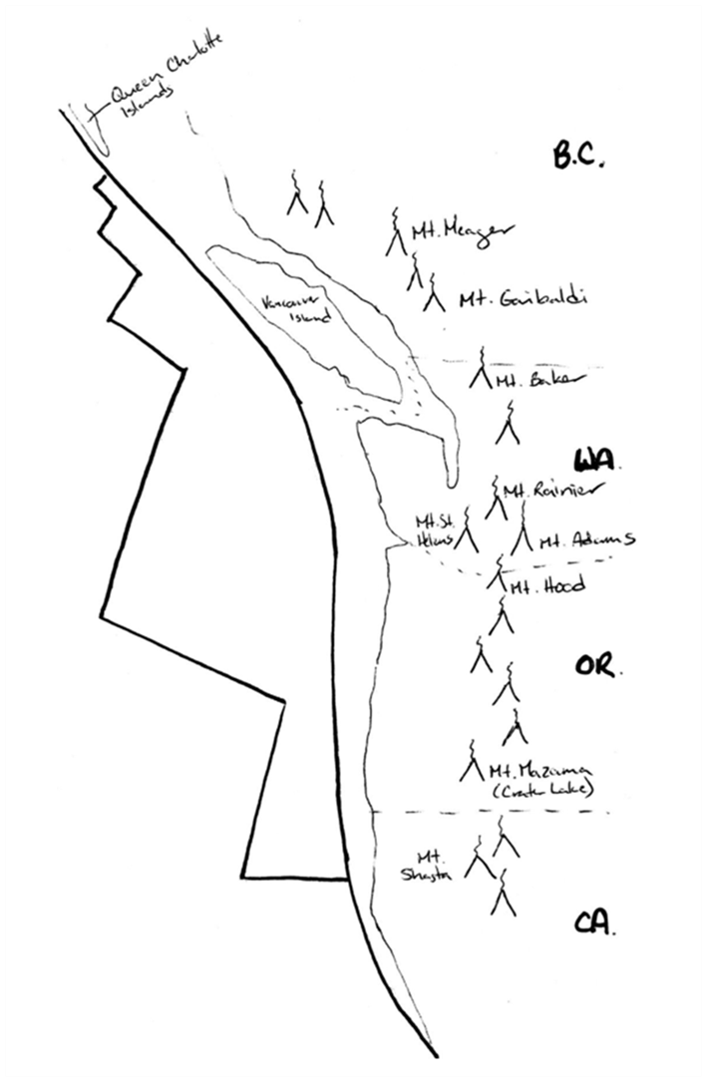

***Juan de Fuca plate***

***Pacific plate***

*Juan de Fuca ridge*

*Cascadia Subduction Zone  
(Convergent boundary)*

*Cascade Volcanic Arc*

*Queen Charlotte fault  
(Transform boundary)*

***North American plate***

*Transform faults*

*San Andreas Fault  
(Transform boundary)*

The Geologic Timeline

The Hadean and Archean Eons

* Earth forms from accretion of space dust and gas
  + 4.6 Ba
    - Calculated through radioisotopic dating of meteorites  
      (All material in the solar system was formed at the same time)
  + Condenses and superheats to create a molten ball
  + Densest material sinks to the centre to form the core;  
    less dense material forms the mantle and crust (with small continental crust segments)
* Moon is less dense than it should be
  + **Giant impact hypothesis:** Theory that 4.5 billion years ago, a Mars-sized planet impacted the Earth, causing lighter ejecta to be accreted into the Moon and heavier material to be absorbed into the Earth’s core
* Continental crust segments collide at subduction zones
  + Acosta Gneiss (oldest crustal rock) forms at 4.0 Ba
* 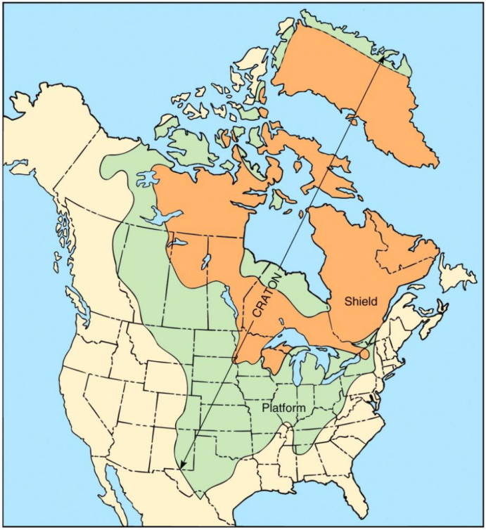**Craton:** Stable interior of a continent
  + Developed throughout the Archean and Proterozoic Eons
    - Precambrian ‘provinces’ (continental land segments) were accreted and sutured together to form large masses
  + **Shield:** Area of exposed, stable Precambrian rock
    - Made of granite and gneiss
  + **Platform:** Area where Precambrian rock is overlaid by Phanerozoic-age strata
  + **Orogenic belt:** Area with mountains which were created during the Phanerozoic Eon
* Archean atmosphere:
  + Created from outgassing as Earth melted and abundant volcanism
    - Volcanic gas is composed of water vapour, CO2, and nitrous gases
  + No oxygen:
    - Sourced from photosynthesis of cyanobacteria through the  
      Archean and Proterozoic Eons
      * Stromatolites from cyanobacteria are found at 3.5 Ba
    - Currently 20% oxygen
  + Oceans:
    - Absorb oxygen created by cyanobacteria to bond with ions, creating:
      * Chert:
        + Red rock
        + Created with silicon from weathered continental crust
        + Reaction: O + Si = SiO2
      * Magnetite/hematite:
        + Grey/silver metal
        + Created with iron from hydrothermal vents
        + Reaction: O + Fe = Fe3O4 or Fe2O3
    - **Banded iron formations:** Layers of red chert and grey iron oxides created by deposition of sediments bonded with oxygen
      * Abundant in the Archean and Proterozoic Eons
      * Major source of iron ore

The Proterozoic Eon

* **Rodinia:** Supercontinent assembled by Earth’s land masses during the Mesoproterozoic Era
  + First supercontinent
  + Rifted apart in the Neoproterozoic Era
  + **Laurentia:** Land mass in the Proterozoic Eon consisting of today’s North America  
    and Greenland
* **Snowball Earth:** Mega-freeze event around the globe during the Cryogenian Period  
  (just prior to the Ediacaran Period)
  + Most oceans and landmasses were covered in ice
  + Geologic record:

Carbonates (melting of ice)

GSSP (Located in the Ediacara Hills of Australia)

Glacial fill

*Cryogenian Period*

*Ediacaran Period*

* First metazoans found on all continents but Antarctica
  + Ediacaran Period
  + Widespread
  + Soft-bodied
  + Early Ediacaran biota found in:
    - Charnwood Forest, England
    - Mistaken Point, Newfoundland, Canada (565 Ma; oldest discovered metazoans)
      * **Lagerstätte:** Site of exceptional preservation of fossils and  
        great biologic diversity
  + Evolved most likely because the atmosphere and oceans reached a critical threshold to meet higher metabolic needs for larger cells (and therefore, for developing large life)

The Paleozoic Era

* First era of the Phanerozoic Eon
  + ‘phaneros’ – visible; ‘zoic’ – life
  + Rock record becomes more abundant with fossilized remains due to the evolution  
    of hard parts
* Bounded by the Precambrian-Cambrian Boundary at 542 Ma at the first appearance of complex trace fossils in the rock record
  + Not the first appearance of hard parts, which was at 535 Ma
  + Characterized by trace fossils more complex than simple vertical/horizontal burrows
    - Indicate more complex methods of feeding
    - E.g. *Treptichnus pedum:* Trace fossil created by a worm making repeated penetrations into sediment
  + GSSP is at Fortune Head, Newfoundland  
    (excellent accessibility and abundance of fossils from the end of the Precambrian)
* **Cambrian Explosion:** Period of adaptive radiation of complex metazoans  
  (multi-cellular animals), both soft-bodied and those that evolved hard parts
  + *Anomalacaris:* Advanced predator which appeared in the Cambrian Explosion
    - Up to 2m long
    - Consumed trilobites
  + Predators and competition drove prey to evolve:
    - Hard parts
    - Infaunal behaviour (burrowing)
      * Causes marine strata to become significantly bioturbated
      * *Cambrian Substrate Revolution:* Diversification of infaunal behaviour during the Cambrian
* Burgess Shale in Field, BC (Rocky Mountains):
  + World Heritage Site
  + Example of lagerstätte
* Geologic record of the shallow marine community 510 Ma (mid-Cambrian):

**Ordovician**

Burgess Shale 510 Ma

Cambrian Explosion 535 Ma

First complex trace fossils 542 Ma

**Cambrian**

**Precambrian**

Ediacaran Period – Soft-bodied metazoans

* + Paleozoic orogeny:
    - Rodinia rifts apart at the beginning of the Paleozoic Era
    - Pangaea forms at the end of the Paleozoic Era (251 Ma)
    - **Acadia Orogeny:** Suturing of Baltica (Europe) and the northeast margin of Laurentia to create the northern landmass of Laurasia
      * **Laurasia:** Landmass composed of Laurentia, Baltica, and parts of Asia
      * **Gondwana:** Landmass composed of Africa, South America, Antarctica, Australia, India
    - **Alleghenian Orogeny:** Suturing of Africa and Laurentia to bond Gondwana and Laurasia and create the Appalachian mountains
  + Epicontinental (epeiric) seas:
    - Flooding of a craton followed by regression of the water
    - **Cratonic sequence:** Unconformity-bound transgressive-regressive sequence (Sequence of strata where unconformities bound the top and bottom, and the deposition shows transgression then regression)

.

.

.

.

.

.

.

.

.

.

.

.

.

.

.

.

.

.

.

.

.

_

_

_

_

_

_

_

_

_

_

_

_

_

_

_

_

_

_

_

_

_

_

_

_

_

_

_

_

_

_

_

_

_

_

_

_

_

.

.

.

.

.

.

.

.

.

.

.

.

.

.

.

.

.

.

.

.

.

Unconformity

Unconformity (Erosion of the exposed craton)

Nearshore

Nearshore

Offshore

Offshore

Far offshore

Maximum transgression

* + - * 6 cratonic sequences throughout history
        + 4 in Paleozoic, 1 in Mesozoic, 1 in Cenozoic
        + Preserved as successions within the platform of the craton
* **Permian Mass Extinction Event:** Time period when many species became extinct during the Permian Period
  + Marine invertebrates experienced the worst losses
  + Extinction of trilobites
  + Reasons:
    - Creation of Pangaea caused a reduction in habitat  
      (e.g. continental shelves destroyed/raised above water;  
      vast polar and equatorial deserts created)
* **Siberian Traps:** Large region of volcanic rock in Siberia
  + 251 Ma:
    - Flood basalts poured out
    - Greenhouse gases created global warming and an acidic ocean
    - Ash blocked out the sun, causing the collapse of photosynthetic organisms

The Mesozoic Era

* Rifting of Pangaea:
  + 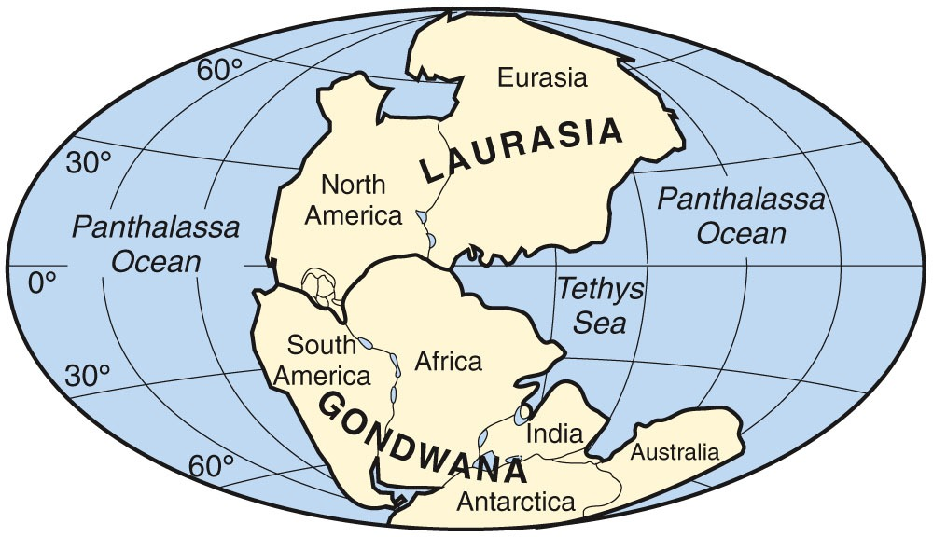251 Ma:
  + Separates throughout the Mesozoic and Cenozoic eras
  + Stages:
    - Rifting of Laurasia and Gondwana
    - Atlantic Ocean begins to open; Pantalassa Ocean becomes the Pacific Ocean
    - Rifting of Africa, South America, and India from Antarctica
      * India moves northward to connect with Eurasia in the Cenozoic Era
    - Rifting of South America and Africa
      * Fully opens Antarctic Ocean
      * Late Cretaceous Period
    - Rifting of Australia and Antarctica
      * Early Cenozoic Era
* Cordilleran Orogeny:
  + *Cordilleran Belt:* Geologic area consisting of the Cascades Volcanic Arc and the  
    Rocky Mountains
  + **Fold-and-thrust belt:** Mountainous hills and valleys by an orogenic belt created by pressure on a continental plate
  + **Foreland basin:** Valley by a fold-and-thrust belt created by folding of the tectonic plate

Pacific Ocean

Subduction zone

Island arcs

Fold-and-thrust belt

Foreland basin

Accreted  
island arc

Active  
volcanic arc

Fold-and-thrust belt

Foreland  
basin

*E.g. Rocky Mountains*

*E.g. Western Interior Seaway*

* + Process:
    - Accretion of island arcs causes stress in the plate due to compression,  
      resulting in faulting and folding of platform rocks
    - Adjacent to the fold-and-thrust belt, the land flexes downwards to create a foreland basin flooded by an epi-continental sea
    - E.g. In Alberta, the Rocky Mountains are a fold-and-thrust belt which was created when accretion at the Cascadia Subduction Zone placed pressure on the North American tectonic plate
* Age of reptiles:
  + Air: Pterosaurs, insects, the first birds
  + Land: Dinosaurs, crocodiles, lizards, snakes
  + Sea: Turtles, plesiosaurs, ichthyosaurs, mosasaurs, ammonoids
* Dinosaurs:
  + Evolved from small reptiles in the early Triassic
  + Underwent adaptive radiation
  + **Superorder Saurischia:** A member of the class Reptilia with the pelvis  
     of a lizard
    - 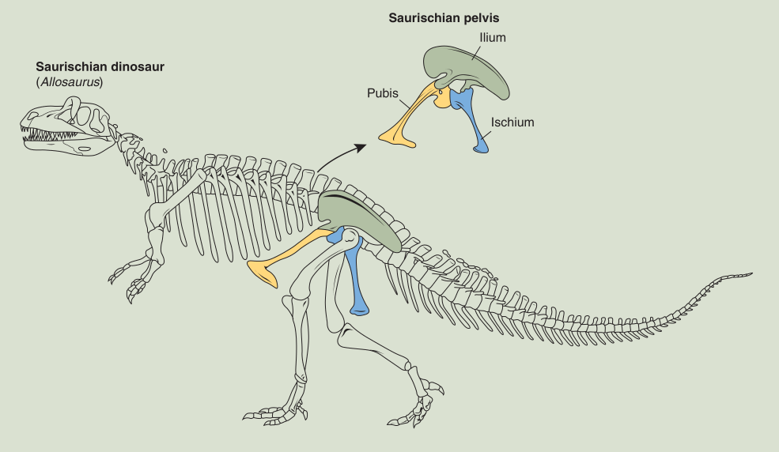Pubis and ischium are connected and extend downward
    - **Sauropods:** Larger quadrupedal Saurician herbivores
      * E.g. Brachiosaurus
    - **Theropods:** Smallerbipedal Saurician carnivores
      * E.g. Tyrannosaurus Rex
      * Included small feathered carnivores, from which birds evolved  
        - e.g. Archaeopteryx
        + First bird
        + ‘Missing link’ between modern birds and reptiles
  + **Superorder Ornithischia:** A member of the class Reptilia with the pelvis  
    of a bird
    - 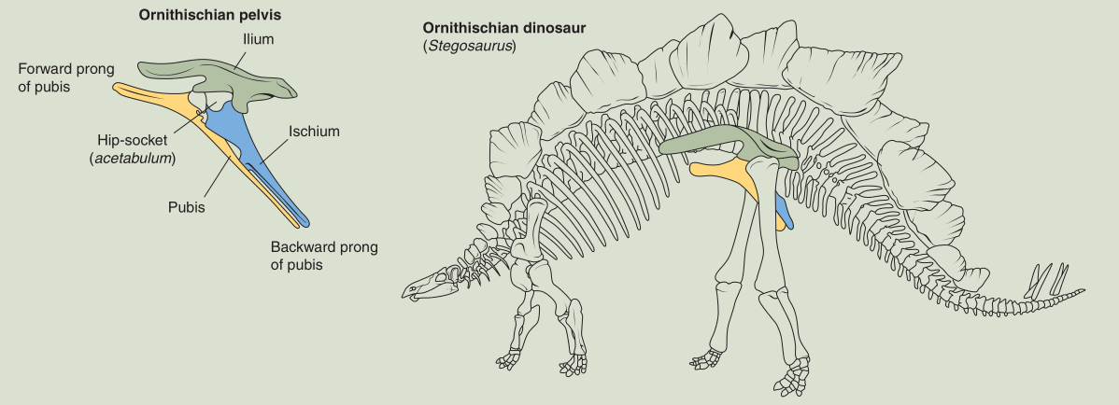Pubis and ischium are parallel and extend backwards
    - Herbivores
    - Bipedal/quadrupedal
    - E.g. Hadrosaurus, Stegosaurus, Triceratops, Ankylosaurus
  + 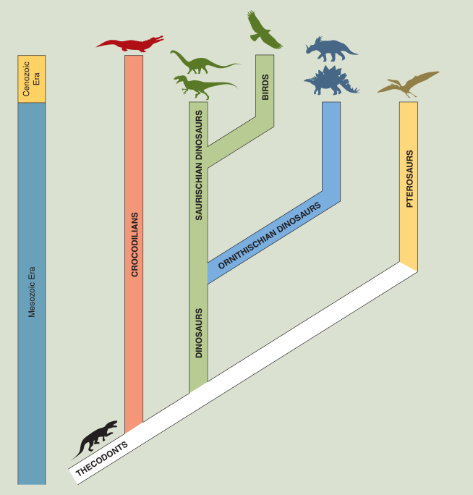Birds evolved off of and survived Saurichian dinosaurs
* **Cretaceous (K-Pg) Mass Extinction Event:** Extinction of many species, including dinosaurs, at the end of the Mesozoic Era
  + Second largest extinction on Earth
  + 65.5 Ma
  + Process:
    - 10km diameter asteroid impacts the seafloor just off the coast of the  
      Yucatan Peninsula in the Gulf of Mexico
    - Shockwave, mega tsunami, and firestorms from the impact
    - Debris is vaporized into the atmosphere and blocks sunlight for months
    - Photosynthetic organisms die and food chain collapses
      * Large reptiles went extinct quickly  
        (e.g. dinosaurs, pterosaurs, plesiosaurs, giant sea turtles)
      * All organisms suffered massive losses, but enough of the smaller animals survived the first year
  + Evidence:
    - Scientist analyzed boundary clay found worldwide at the K-Pg boundary and found great amounts of:
      * Iridium (30x normal levels)
      * Carbon soot spherules
        + Glass beads
        + Vaporized sea-floor sediments which cooled and fell to Earth
      * Tektites: Large, streamlined glass beads similar to bullets
      * **Shocked quartz:** Fractured quartz grains due to a shock wave
      * Tsunami deposits around the Gulf of Mexico

The Cenozoic Era

* Significant biotic turnover – The small surviving animals radiate quickly into new niches
* Paleogene Period:
  + Final phase of Pangaea rifting apart (rifting of Australia and Antarctica)
  + Circum-Antarctic current: Cold, dense water circulates around Antartica and chills it
  + Adaptive radiation of mammals along with the expansion of grasslands
    - E.g. Mammals such as horses begin to graze in grasslands
* Neogene Period:
  + India collides with the Eurasian Plate and the Himalayas are formed through  
    folding and thrusting
* Pleistocene Period (Ice Age):
  + Cycles of cooling (glacial episodes) and warming (interglacial episodes)
  + 4 glacial episodes:
    - Continental ice sheets covering Northern Europe and Canada, and extending down into Southern Europe and the U.S.
  + Glacial erosion exposes the Canadian Shield and Baltic Shield
  + Glacial scouring form Canada’s Great Lakes
  + Pleistocene extinction of mammals, mastodons, saber-toothed cats
* Holocene Period:
  + Current interglacial period
  + Carbon missions have augmented the atmosphere greatly (global warming)

Reefs through the Phanerozoic Eon

* **Reef:** Calcareous structure constructed by living organisms
  + Built with framework (e.g. coral) and cement (e.g. coralline algae)
    - **Coralline algae:** Algae which excretes hard material
  + Currently are found in a narrow belt within 30° North and South of the equator
    - Reef-building organisms require warm, clear water
  + Facies/areas:
    - **Reef core:** Main, central structure of the reef
      * Built upwards by marine organisms from the shallow seafloor to the ocean surface (to increase light intake)
      * Tidal inlet: Break in the reef core connecting the open water and the lagoon of the back reef
    - **Fore reef:** Collapsed parts of the reef core which have been broken and eroded by incoming waves
      * Steeply dipping layers of debris
      * **Reef front:** Face of the reef which takes the brunt of incoming waves
    - **Back reef:** Area between the reef core and the shoreline
      * Creates a lagoon
      * Carbonate sediment deposits
      * Reef front blocks ocean currents, so the waters are calm
      * Extreme biological diversity (and therefore excellent fossil material)

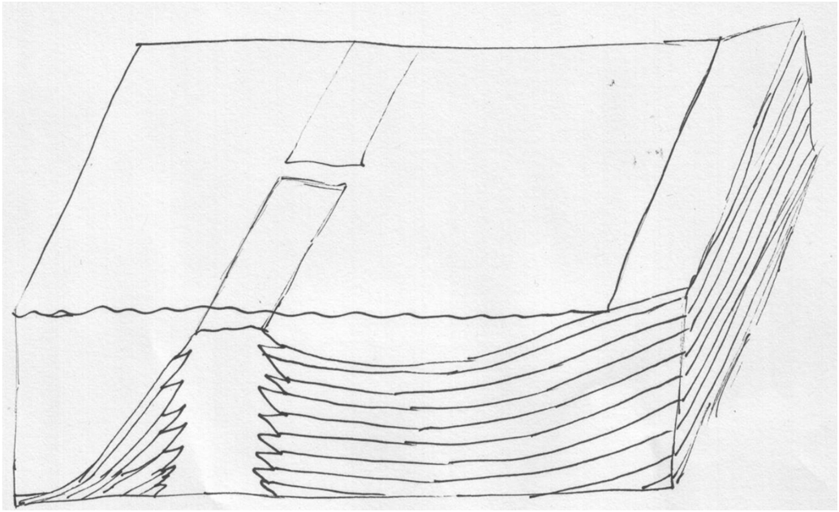

Reef front

**Fore reef**

**Reef core**

**Back reef**

Lagoon

Tidal inlet

Shoreline / Strand plain

* Paleozoic Era:
  + Cambrian Period:
    - Sponges (e.g. archaeocyathids)
  + Ordovician to Devonian Periods:
    - Tabulate coral (extinct at end of Permian Period)
    - Stromatoporoid algae
  + Mississippian to Permian Periods:
    - Rugose coral (extinct at end of Permian Period)
    - Stromatoporoid algae
* Mesozoic Era:
  + Scleratinian coral
  + Rudist bivalves
  + Coralline algae
* Cenozoic Era:
  + Scleratinian coral
  + Coralline algae

Human Evolution

* **Hominid:** Group of primates including humans and apes
  + Apes include chimpanzees, gorillas, and orangutans
  + Chimpanzees are our closest hominid relative (98.4% genetic similarity)
    - Split from a primate ancestor at 7 Ma
* 200,000 ya: Homo Sapiens evolves
  + Existed at the same time as Australopithecus (1.5 Ma overlap)
  + Existed at the same time as Homo neanderthalensis
    - Outcompeted and went extinct 30,000 ya
    - Less brain capacity, less erect stature, less manual dexterity, shorter maturity development timelines
* Began in Africa - best fossil specimens come from the East African Rift Valleys
  + E.g. Olduvai Gorge
* Volcanic ash beds allow for precise radioisotopic dating
* Hominids like Australopithecus left trackways in volcanic ash deposits;  
  (evidence of bipedal walking)

Strata Diagrams

Strata material:

.

.

.

.

.

.

.

.

.

.

.

.

.

.

.

Sandstone

_

Shale

_

_

_

_

_

_

_

_

_

Limestone

Igneous

>

>

>

<

^

^

v

<

v

^

_

Siltstone

_

_

_

_

_

_

_

_

_

.

.

.

.

.

.

.

.

.

.

.

.

.

Metamorphic

Plutonic

Surface of erosion / Unconformity:

Lithostratigraphy:

Direct horizontal correlation of strata:

Slanted (non-horizontal) correlation of strata:

Glossary

**Acadia Orogeny:** Suturing of Baltica (Europe) and the northeast margin of Laurentia to create the northern landmass of Laurasia

**Accretionary wedge:** Sediments scraped from a subducting plate by an overriding plate

**Adaptive radiation:** Quick evolution of a new species when new ecological opportunities arise

**Alleghenian Orogeny:** Suturing of Africa and Laurentia to bond Gondwana and Laurasia and create the Appalachian mountains

**Angular unconformity:** Unconformity bedded by deformed strata (folding, tilting, etc)

**Animalia (Kingdom):** Invertebrate and vertebrate organisms

**Anoxic (Habitat):** Lacking oxygen

**Aphanitic texture:** Having small, fine crystals

**Archaea (Domain):** Bacteria which can survive in harsh environments

**Asthenosphere:** Layer of ductile weak rock in the mantle which flows slowly beneath the lithosphere

**Autotroph (Organism):** Synthesizes nutrients from raw resources

**Back reef:** Area between the reef core and the shoreline

**Bacteria (Domain):** All bacteria not in the Archaea domain (see *Archaea* (*Domain*))

**Banded iron formations:** Layers of red chert and grey iron oxides created by deposition of sediments bonded with oxygen

**Batholith:** Irregularly-shaped intrusive rock measuring > 100 km2 in diameter

**Biostratigraphy:** Correlation of strata based on guide fossils

**Biotic turnover:** Adaptive radiation (quick evolution of new species) occurring in abundance following a mass extinction

**Biozone:** Interval of strata identified by its characteristic fossils

**Body fossil:** Direct/altered remains or impressions of ancient organisms

**Boreholes:** Deep, thin, circular holes drilled in the ground into which geophysical tools are lowered to measure rock characteristics

**Cambrian Explosion:** Period of adaptive radiation of complex metazoans (multicellular animals),  
both soft-bodied and those that evolved hard parts

**Carbonization (Fossil preservation):** Deposition of thin carbon film

**Cast (Fossil preservation):** Filling in of an open space after organic material dissolves, filling in the space between external molds

**Chemical sediments:** Precipitation of minerals from water

**Chemotroph (Organism):** Derives nutrients from the breakdown of molecules in rocks

**Coarsening-up sequence:** Rock facie which shows a shift of environments from offshore to near-shore as regression occurs

**Concretion:** Resistant chunk of rock due to included organic material altering nearby  
groundwater chemistry

**Continental collision:** Meeting of two continental plates at a convergent plate boundary

**Convergent evolution:** Similar traits and body forms amongst discrete species due to natural selection responding to similar ecological pressures

**Convergent plate boundary:** Area where tectonic plates are pushed toward each other and meet

**Coralline algae:** Algae which excretes hard material

**Craton:** Stable interior of a continent

**Cratonic sequence:** Unconformity-bound transgressive-regressive sequence (Sequence of strata where unconformities bound the top and bottom, and the deposition shows transgression then regression)

**Cross-bedding:** Feathered layers caused by waves collapsing built-up underwater sediments (> 5cm) (See *current ripple lamination*)

**Crystalline:** Material which is made of atoms arranged in patterns

**Current ripple lamination:** Feathered layers caused by waves collapsing built-up  
underwater sediments (< 5cm) (See *cross-bedding*)

**Crust:** Outermost layer of the Earth defined by density, composition, and seismic velocity

**Deep-ocean trench:** Depressed area marking the beginning of a subduction zone

**Deep time:** Belief that the Earth is very old

**Dike:** Thin sheet-like intrusive rock cutting across pre-existing rocks

**Disconformity:** Unconformity bedded by strata which is undeformed, non-plutonic, and  
non-metamorphic

**Divergent plate boundary:** Area where tectonic plates move apart

**Dollo’s Law:** Genetic change cannot produce the exact same species more than once, be reversed,  
or be repeated

**Dysoxic (Habitat):** Poorly-oxygenated

**Erosion:** Transport of weathered material **Evolutionary theory:** Process by which biological species give rise to other species through genetic change and natural selection

**Ediacaran Period:** Span of time when multi-cellular life was first identified on Earth through impressions of large marine organisms in sandstone

**Epifaunal (Organism):** Living on the surface of a sea/lake floor

**Eukaryotic (Organism):** Having membrane-bound organelles and a distinct nucleus

**Exceptional preservation (Fossil preservation):** Area with excellent preservation of a wide variety of organisms

**External mold (Fossil preservation):** Impression of the outer surface of organic material

**Extinction:** Annihilation of all individuals of a species

**Extrusive/volcanic rocks:** Igneous rocks which cooled from lava (above the Earth’s surface)  
**Evolution:** Genetic change in an organism over time

**Facie:** Feature of a sedimentary rock created by processes in the depositional environment

**Fining-up sequence:** Rock facie which shows a shift of environments from near-shore to offshore as transgression occurs

**Fold-and-thrust belt:** Mountainous hills and valleys by an orogenic belt created by pressure on a continental plate

**Fore reef:** Collapsed parts of the reef core which have been broken and eroded by incoming waves

**Foreland basin:** Valley by a fold-and-thrust belt created by folding of the tectonic plate

**Formation:** A geologic rock unit which is mappable and identifiable

**Fossil:** Evidence of life from during or before the Pleistocene epoch (> 11800 years old)

**Fossilization:** The process through which dead organic material becomes a body fossil

**Geochronology:** Absolute age dating of rock

**Geopetal structures:** Features in the sedimentary rock which demonstrate an upwards direction

**Geology:** Science of Earth’s structure, origin, history, physical/chemical processes, life forms

**Giant impact hypothesis:** Theory that 4.5 billion years ago, a Mars-sized planet impacted the Earth, causing lighter ejecta to be accreted into the Moon and heavier material to be absorbed into the Earth’s core

**Global Boundary Stratotype Section and Point (GSSP):** Internationally defined reference point marking the lower boundary of a geologic stage

**Gondwana:** Landmass composed of Africa, South America, Antarctica, Australia, India

**Guide fossils:** Species that existed on Earth for only a short period of geologic time and create fossils which are widespread geologically, abundant, easy to recognize, and easily preserved

**Habitat:** Ecosystem where an organism lives

**Half-life:** Time required for half of a radioactive isotope to decay

**Heterotroph (Consumer) (Organism):** Derives nutrients from feeding on or causing the decay of other organisms

**Hiatus:** Great gap in time (centuries to many millennia)

**Historical geology:** Origin of Earth and the changes in its physical/chemical/biological processes  
over time

**Homologous structures:** Related parts of the body present in multiple distinct species which may or may not share a function

**Hominid:** Group of primates including humans and apes

**Hutton, James:** Scottish geologist who believed in uniformitarianism

**Igneous (Rock):** Formed through the cooling/solidification of magma or lava, or from material ejected from a volcano

**Infaunal (Organism):** Living under the surface of a sea/lake floor

**Internal mold (Steinkern) (Fossil preservation):** Impression of an inner cavity of organic material

**Intrusive/plutonic rocks (Plutons):** Igneous rocks which cooled from magma  
(beneath the Earth’s surface)

**Laccolith:** Dome-shaped intrusive rock parallel to the other strata

**Lagerstätte:** Site of exceptional preservation of fossils and great biologic diversity

**Laurasia:** Landmass composed of Laurentia, Baltica, and parts of Asia

**Laurentia:** Land mass in the Proterozoic Eon consisting of today’s North America and Greenland

**Lithification:** Process by which sediments are compacted and cemented into sedimentary rock  
**Lithosphere:** Outer rigid layer of Earth consisting of the crust and upper mantle

**Lithostratigraphy:** Correlation of strata based on lithology (rock type) and colour

**Living fossils:** Species which undergo little evolutionary change for millions of years

**Lyell, Charles:** English geologist who coined the Principle of Cross Cutting Relationships, the Principle of Included Fragments, and the Principle of Unconformities

**Marine (Habitat):** Seaward of the low tide mark; full salinity

**Marine regression (Offlap):** Sea level fall

**Marine transgression (Onlap):** Sea level rise

**Marginal marine (Habitat):** Transitional area where a continent meets a marine area **Mass extinction:** Time period when many species undergo extinction

**Metamorphic (Rock):** Formed through the recrystallization of pre-existing rocks at depth due to heat, pressure, and time

**Mineral:** Naturally occurring crystalline solid

**Mode of life:** How an organism interacts with the food web

**Natural selection:** Individuals with traits better suited to their environments have a greater chance to live to reproductive age and pass on their traits

**Nektonic (Organism):** Swimming

**Neptunism:** Theory that all rocks were created/precipitated at one time from a universal,  
mineral-filled ocean

**Neritic zone:** Shallower area of the ocean water before the continental shelf

**Niche:** Role of an organism within its environment

**Nonconformity:** Deep-formed unconformity bedded by plutonic or metamorphic rock, which is uplifted and eroded at the surface

**Nonmarine (Continental) (Habitat):** Terrestrial or aquatic area

**Normal polarity:** The current orientation of Earth’s magnetic field

**Oceanic zone:** Area of the ocean water which is 200m or deeper

**Organic sediments:** Organic material such as shells

**Orogenic belt:** Area with mountains which were created during the Phanerozoic Eon

**Outcrop:** Exposed rock at the Earth’s surface

**Oxic (Habitat):** Well-oxygenated

**Pelagic (Organism):** Living above the seafloor

**Permian Mass Extinction Event:** Time period when many species became extinct during the Permian

**Permineralization (Fossil preservation):** Infilling of pore spaces (in wood/bone) by silica

**Phaneritic texture:** Having large, coarse crystals

**Phanerozoic time boundary:** Division between sections of geologic time, created based on the evolution of various species

**Physical geology:** Study of geologic processes and Earth materials  
**Planktonic (Organism):** Floating freely

**Plate tectonics theory:** Process by which the lithosphere is composed of separate pieces which float on the asthenosphere, a layer of magma

**Platform:** Area where Precambrian rock is overlaid by Phanerozoic-age strata

**Plutonism:** Theory that rocks undergo a cycle of melting from volcanic activity, erosion, formation into sedimentary rocks, etc.

**Precambrian Era:** Span of time consisting of the Hadean, Archean, and Proterozoic Eons

**Principle of Biotic Succession:** Fossils appear in the rock record in a definite and determinable order

**Principle of Cross Cutting Relationships:** Where one rock unit cuts across another rock unit, the other rock unit must be older to have been cut, and the cutting rock unit must be younger

**Principle of Included Fragments:** Fragments of rock found in another rock unit must be older than the unit they are included in

**Principle of Original Horizontality:** Sediments are almost always laid down on the Earth’s surface in horizontal layers

**Principle of Original Lateral Continuity:** Layers extend in all directions until they thin out, end abruptly, or grade into another type of sediment

**Principle of Superposition:** In any undisturbed sequence of strata, the oldest rock unit is at the bottom, and the rock units are progressively younger above

**Principle of Unconformities:** A surface of erosion separates much older rock below from  
much younger rock above

**Protista (Kingdom):** Single-celled protozoa (e.g. algae, plankton)

**Radioactive age dating:** Geochronology using radioactive decay of unstable isotopes

**Recrystallization (Fossil preservation):** Metamorphosis of less stable shell material into a   
more stable form

**Reef:** Calcareous structure constructed by living organisms

**Reef core:** Main, central structure of the reef

**Reef front:** Face of the reef which takes the brunt of incoming waves

**Relative age dating:** Determining the order of past events relative to each other

**Replacement (Fossil preservation):** Molecular replacement by something other than calcite

**Reverse polarity:** The opposite orientation of Earth’s current magnetic field

**Rifting:** Process where heat below a continental plate (combined with gravity) bends and stretches the plate away from the heat source, creating faults

**Rock:** Aggregate of one or more types of minerals

**Rock cycle:** Conceptual model to explain how rocks might be formed and altered

**Rodinia:** Supercontinent assembled by Earth’s land masses during the Mesoproterozoic Era

**Sauropods:** Larger quadrupedal Saurician herbivores

**Sedimentary (Rock):** Formed through the deposition and lithification of sediments during burial

**Shield:** Area of exposed, stable Precambrian rock

**Shocked quartz:** Fractured quartz grains due to a shock wave

**Siberian Traps:** Large region of volcanic rock in Siberia

**Siliclastic sediments:** Weathered, eroded rock

**Sill:** Sheet-like intrusive rock parallel to the other strata

**Snowball Earth:** Mega-freeze event around the globe during the Cryogenian Period

**Speciation:** Rise of a new species from an ancestral species

**Species:** Group of organisms which can interbreed to produce fertile offspring

**Steno, Nicolaus:** Danish physician who coined the Principle of Superposition, the Principle of Original Horizontality, and the Principle of Original Lateral Continuity

**Stock:** Irregularly-shaped intrusive rock measuring < 100 km2 in diameter  
**Strata:** Earth material deposited as a layer on the Earth’s surface

**Stratigraphic columns:** Cross-sections of strata used to convey how strata are related

**Stratigraphic correlation:** Creating geochronological relationships between different locations

**Stromatolite:** Mound built by cyanobacteria

**Subduction zone:** Area where one tectonic plate is pushed underneath another

**Subfossil:** Evidence of life from the Holocene epoch (< 11800 years old)

**Superorder Ornithischia:** A member of the class Reptilia with the pelvis of a bird

**Superorder Saurischia:** A member of the class Reptilia with the pelvis of a lizard

**Taxonomy:** Classification of life and organisms

**Tectonic plates:** Pieces of the lithosphere

**Theropods:** Smallerbipedal Saurician carnivores

**Trace fossil (Ichnofossil):** Evidence of the behaviour of an organism rather than its body

**Transform plate boundary:** Area where tectonic plates slide past each other

**Type section:** Strata boundary serving as a standard of reference

**Unconformity:** A surface of erosion or non-deposition which separates much older rock below from much younger rock above

**Unaltered (Fossil preservation):** Original organic material

**Uniformitarianism:** Theory that processes at work today were also at work in the geologic past

**Volcanic glass:** Extrusive igneous rock formed by lava cooling almost instantaneously

**Volcanic neck:** Cylindrical intrusive rock from the solidification of magma in the pipe leading to a volcanic vent

**Walther’s Law:** In a conformable sequence without unconformities, a series of vertically stacked facies were adjacent in the depositional environment

**Weathering:** Breakdown of rock