|  |
| --- |
| **ENGL 101** |
| Introduction to Fiction |
| A Course Overview |

|  |
| --- |
| Jeffrey Leung |

Table of Contents

|  |  |  |  |
| --- | --- | --- | --- |
| **Page** |  |  | **Section** |
| *02* |  | 01 | *Extremely Loud and Incredibly Close* By Jonathan Safran Foer |
| *07* |  | 02 | *Persepolis* By Marjane Satrapi |
| *12* |  | 03 | *Fight Club*  By Chuck Palahniuk |
| *16* |  | 04 | *Disgrace* By J.M. Coetzee |

*Extremely Loud and Incredibly Close*  
By Jonathan Safran Foer

* **Narrative:**
  + **Story**: Events of the narrative
  + **Discourse**: The way that the story is told
  + Events of September 11, 2001 as well as the Dresden bombing were global in their effects
  + Indirectly expressed:
    - *Oskar Schell*: “And also, there are so many times when you need to make a quick escape, but humans don’t have their own wings, or not yet, anyway, so what about a birdseed shirt?” (2)
    - *Oskar Schell*: “We were let out early, because of what happened” (14)
    - Oskar’s story is too traumatic for him to share it directly
      * Listening to his father’s messages hurts him
      * Has difficulty expressing his feelings and telling his story
      * Is able to heal as he tells it to the Blacks
    - Grandfather’s retelling of the Dresden bombing is about Anna, not the bombings
      * *Thomas Schell Sr.*: “it wasn’t the bombs and burning buildings” (17)
      * *Thomas Schell Sr.*: “I thought about my small victories and everything I’d seen destroyed … I’d lost the only person I could have spent my only life with.” (33)
      * Loss of his ability to speak because of the story being too wounding
        + *Thomas Schell Sr.*: “we would never talk about the past” (83)
        + Confusing narrative style
  + Meeting between Oskar’s grandparents is told differently from each side
    - Grandfather:
      * Unknown
      * Single meeting
      * Marriage proposal: “Help”
    - Grandmother:
      * Old friend who dated her sister
      * Marriage proposal: No children
  + *Grandmother to Oskar*: “I want to begin at the beginning, because that is what you deserve. I want to tell you everything, without leaving out a single detail. But wherei s the beginning? And what is everything?” (75)
  + Stories and letters are attempts toward connection
    - Grandfather to his son; grandmother to her grandson
    - *Grandmother*: “The letter was destroyed, but its final paragraph is inside of me.” (79)
* **Photography:**
  + Some pages interspersed throughout the novel consist of pictures  
    (e.g. pigeons flying, doorknobs, a white rectangle where Central park should be)
  + *Grandmother:* “[My husband] took pictures of everything … He took a picture of every doorknob in the apartment … I don’t know why that hurt me so much … He never took pictures of me, and we didn’t buy life insurance.” (175)
  + *Oskar:* “I did a few other searches, even though I knew they would only hurt me, because I couldn’t help it.” (42)
  + Originals vs. copies:
    - No distinction between the photos of Oskar took and the photos found online
    - *Postmodern condition:* Our world is made up of images; images are experiences
  + 9/11 and its effects expressed through a medium (in this case, images)
  + Photos show the reader what Oskar sees and provide empathetic context
  + *Readerly (lisible) text:* Literature in which the reader undergoes the experience and path laid out by the writer
  + *Writerly (scriptible) text:* Literature in which the reader is encouraged to be involved in imagining and creating the possibilities of the story
* **Typography:**
  + Connection between typography and the meaning of the text
    - *Grandmother on the letter from the prisoner:* “The words were very simple … I was left with the handwriting” (76)
  + Semiotics:
    - *Signifier:* Word with a meaning
    - *Signified/Referent:* Concept or meaning
    - E.g. Signifier – ‘grey’; signified: █
    - Relationship between signifier and signified may or may not be arbitrary
    - One signifier can refer to multiple signifieds
  + Expresses loss that conventional narrative has difficulty with:
    - Characters in the novel do not outwardly express loss
    - *Grandmother to grandfather:* “it hurts me when you do not want to hurt me … Let me see you cry” (180)
    - Arrangement of text is unique:
      * Gaps after grandmother’s periods at ends of sentences
      * White/blank pages (121 – 123) (135 – 141)
      * Letters burnt out of a book at Hiroshima (190)
  + Meaning placed on bodies:
    - Oskar’s bruises
    - Oskar’s colour fantasy (163)
    - Grandfather’s tattoos
  + *Grandmother about grandfather:* “He hid his face in the covers of his daybook, as if the covers were his hands….I pulled the book from him. It was wet with tears running down the pages, as if the book itself were crying” (180)
  + Reflection on idea of character and self
* **Trauma:**
  + Trauma narratives:
    - Confusing/disorienting
    - Vague
    - Disorganized
    - Fragmented
    - Involves telling one’s story
  + Grandfather:
    - Lost Anna and their baby, and his parents
    - Lost home and second family
    - Wounded
    - Put down animals
    - Lost ability to speak
  + Grandmother:
    - Lost family; lost her father to suicide
    - Lost home
    - Husband left
    - Dead son
  + Oskar:
    - Lost father and missing grandfather
    - No understanding of his father’s death
    - No goodbyes
    - No expression of love
    - *Oskar:* “Why didn’t he say goodbye? I gave myself a bruise. Why didn’t he say ‘I love you’?” (207)
  + Mourning/melancholy:
    - Described by Freud in *Mourning and Melancholia*
    - Both involving:
      * Loss of interest in the outside world
      * Loss of capacity to love
      * Inhibition of all activity
    - Mourning:
      * Loss acknowledged
      * Focused on memory of pain; distinguishes between past and present
    - Melancholy:
      * Loss is still struggled with
      * Focused on pain in the present
      * Felt as loss in the self
  + Temporally confused narrative:
    - Grandfather’s letters
    - Oskar’s story
    - Interweaving of the 3 stories
  + Internal emptiness:
    - *Grandmother:* “One morning I awoke and understood the hole in the middle of me.” (177)
    - *Grandfather:* “Nothing spaces—‘nonexistent territories in the apartment in which one could temporarily cease to exist.’ ” (110)
    - *Grandfather:* “she and I are no different, I’ve been writing Nothing, too.” (132)
    - *Oskar:* “That secret was a hole in the middle of me that every happy thing fell into.” (71)
    - Oskar plays Yorick in Hamlet, a skull
  + Aggression directed at the self (e.g. Oskar giving himself bruises)
  + Recovering:
    - Oskar meets the Blacks and tells his story repeatedly
    - Oskar and Mr. Black help each other re-engage in the world
    - *Mr. Black & Oskar:* “So you know what they did!” “They starved?” “They fed each other!” (164)
    - Writing letters
      * Grandmother to Oskar
      * Grandfather to unborn child
      * Oskar to whom?

*Persepolis*  
By Marjane Satrapi

* Graphic novels:
  + *Persepolis*:
    - Inspiration from *Maus* by Art Spiegelman
    - Black and white used as contrasts (chiaroscuro)
    - Influence of Persian art and western avant-garde art
    - Eyes used as seeing or bearing witness
  + Terms:
    - **Panel**: (Framed) segment of the comic
    - **Frame**: Border around a panel
      * Does not have to exist; panel can be integrated into the page
    - **Gutter**: Space between panels
    - **Captions**: Speech directly from the narrator, not connected to any character
    - **Speech balloons**: Speech from and connected to a character
* **Memory:**
  + Persepolis:
    - 500 BCE – 330 BCE
    - Ancient city of Persians
    - Destroyed by Alexander the Great
    - Metaphor for Marjane’s story:
      * Symbol of splendour, war, or ruin?
      * Desire for national belonging (Iran as a great civilization)
      * Ruined site of conflict
      * Story is excavating the past
  + Text is a way to memorialize Marjane’s past:
    - “One can forgive but one should never forget” (Introduction)
    - *Anoosh*: “Our family memory must not be lost. Even if it’s not easy for you, even if you don’t understand it all.”  
      *Marjane*: “Don’t worry, I’ll never forget” (60)
    - *Father:* “You’ve got to go now. Don’t forget who you are and where you come from” (152)
  + Personal memory in parallel with historical events; Marjane and Iran are both transitioning
    - Change in belief from Marxism to religion vs. change in the Iranian revolution
    - Rebellion of Marjane vs. war between Iran and Iraq
    - 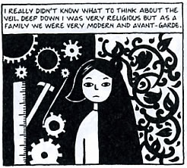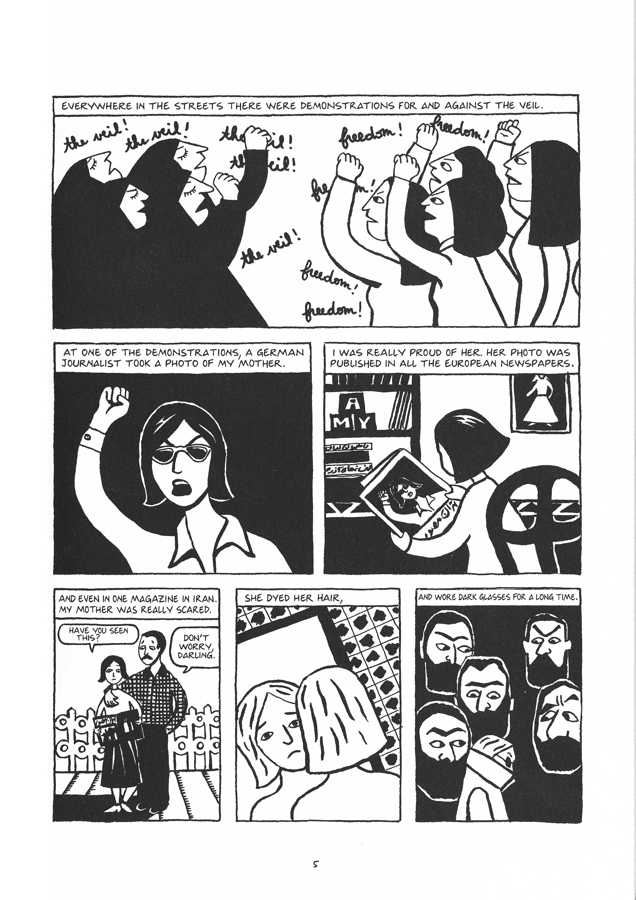Personal growth vs. political change (internal tension)
  + Looking for national belonging and trying to criticize the nation at the same time
  + Cigarettes as growing up:
    - Loss of innocence
    - Satirical
    - *Marjane:* “With this first cigarette, I kissed childhood goodbye” (117)
* **Family:**
  + Mother:
    - Politically active
    - Fighting for women’s independence
    - Dyes her hair and wears sunglasses after her photo is publicized (5)
    - Slaps Marjane and Mehri after they sneak out to protest on Black Friday
      * *Marjane:* “But in fact it was really our own who had attacked us” (39)
      * *Mother to Marjane:* “In this country you have to know everything better than anyone else if you’re going to survive” (113)
      * 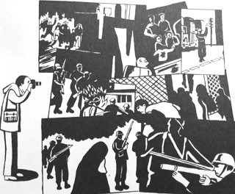Protection expressed as brutality
  + Father:
    - Takes pictures of the protests (29)
    - Outside the frame, as an observer
    - *Father:* “in this country you must stay within your social class” (37)
    - Warm/affectionate relationship with Marjane
    - Optimist (135)
  + Anoosh:
    - Idealized
    - Martyr
    - *Marjane:* “And I had a hero in my family … naturally I loved him immediately (54)
    - Foreshadows Marjane’s story (exile, then return to family)
  + Grandmother:
    - Teacher
      * Gives advice to Marjane
    - Moral centre
      * Admonishes Marjane when she condemns an innocent man
* 14 years old:
  + Independence:
    - Mother met father at 14 (113)
    - Cousin Peyman is 14 years old and takes Marjane to her first party (100)
  + Death:
    - Neda’s bracelet is a 14th birthday present
* **Bildungsroman** (Concept)**:** Coming of age novel
  + Individual’s growth and development within the context of a specific social order
  + Intellectual/psychological/moral growth of an individual
  + Search for meaning
  + Linear/chronological
* **Bildungsroman** (*Persepolis*):
  + Reconciliation of individuality with the demands of socialization?  
    (e.g. social connection with others, survival, feeling at home)
  + Intellectual freedom:
    - *Marjane:* “I needed to fit in, and for that I needed to educate myself (173)
    - Research into many philosophers
  + Social freedom:
    - Odd stages of physical growth
    - Change in style and dress
    - *Marjane:* “The harder I tried to assimilate, the more I had the feeling that I was distancing myself from my culture, betraying my parents and my origins, that I was playing a game by somebody else's rules” (193)
    - *Marjane:* “And when I got back that night, I remembered that line my grandmother told me ‘Always keep your dignity and be true to yourself!’” (195)
  + Sexual freedom:
    - Julie’s boyfriend (188)
    - Relationships with Enrique and Markus
  + *Marjane:* “I was a westerner in Iran, an Iranian in the west. I had no identity. I didn’t even know anymore why I was living” (272)
  + After overdosing:
    - ‘Resurrected’
    - Changes toward a female ideal: Truth, love, forgiveness, sacrifice
    - *Doctor:* “that dose should have been enough to finish off an elephant! .. even though I’m not a believer, aside from divine intervention, I can’t find any other explanation for your survival” (273)
  + Condemnation of the innocent man (287):
    - *Reza:* “what an instinct for survival” (287)
    - *Grandmother:* “I think that you’re a selfish bitch … Shame on you” (291)
  + Marriage as a compromise (317):
    - Leaves Iran and Reza at the same time
* **Orientalism** (Concept): Western conception of the Middle East
  + *Orientalism* (1978) by Edward Said brought this issue to the forefront
  + 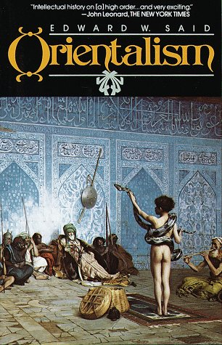Middle East seen as:
    - Idealized:
      * Decadent
      * Exotic
      * Mysterious
      * Timeless
    - Uncivilized:
      * Lazy
      * Irrational
      * Immature
      * Backward
    - Polar opposite of (and inferior to) the European culture
* **Orientalism** (*Persepolis*):
  + Marjane seen as a sexualized oriental
  + *Marjane*: “What? To you, true Austrians don’t go out with girls like me?   
    Is that it?” (220)
  + *Julie:* “Oh, you’re the pure, innocent virgin who does her homework. I’m not like that. I’ve been having sex for five years.” (182)
  + *Mother superior:* “It’s true what they say about Iranians. They have no education” (177)
  + Simplicity of a graphic novel used to connect the reader with the character(s)
  + Reversal - West seen as exoticized/idealized
    - Intellectual influences (e.g. Descartes, Marx)
    - Parties and popular culture
    - Austrians:
      * “Heidi”
      * Hairy armpits
      * Lederhosen (171)
    - *Marji on her friends:* “Much later, I learned that making themselves up and wanting to follow Western ways was an act of resistance on their part” (259)
  + 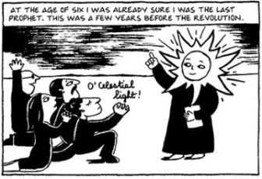Veil:
    - Marji born with light coming out of her head (6)
    - Beneath the veil (294) (305)
    - Rebellion:
      * Red socks
      * Letting strands of hair show
      * Marji’s idea for a freer outfit
    - *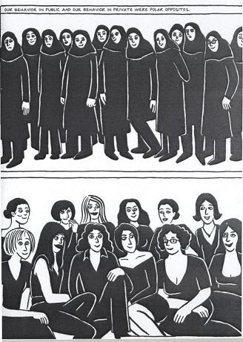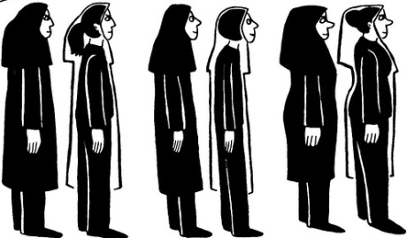Mayor’s deputy:* “Half of your characters are women without veils …. We can see their shapes and their hair! …. A Gordafarid in a chador is no longer a Gordafarid. You know that as well as I do.” (331)

*Fight Club*  
By Chuck Palahniuk

* **Postmodernism/Late capitalism:** Paradigm of generalized universal industrialization
  + Changes from:
    - Production to consumption
    - Industry economy to service & information economy
  + Globalization of labour, markets, and corporations
  + Simulacrum (e.g. Venetian Hotel in Las Vegas)
  + E.g. Gastown’s shipping buildings have been converted into apartment buildings
  + *Fight club*:
    - Consumption:
      * *Narrator:* “We all have the same Johanneshov armchair in the Strinne green stripe pattern. ….The Vild hall clock made of galvanized steel, oh, I had to have that. The Klipsk shelving unit, oh, yeah.” (43)
    - Service & information economy:
      * Narrator is a recall campaign co-ordinator (31)
      * Tyler and narrator work in the service industry as waiters
      * *Narrator:* “Too bad, but with more self-threading and rewinding projectors, the union didn’t need Tyler anymore.” (113)
    - Simulacrum:
      * *Narrator:* “This is how it is with insomnia. Everything is so far away, a copy of a copy of a copy.” (21)
      * Tyler lives on Paper Street (45), a street which exists only in maps/plans
* **Violence:**
  + Opening scene:
    - In the middle of events
    - *Narrator:* “Tyler gets me a job as a waiter, after that Tyler’s pushing a gun in my mouth and saying, the first step to eternal life is you have to die.” (11)
    - *Narrator:* “the gun, the explosion, the anarchy, is really about Marla Singer.” (14)
  + As a symptom of late capitalism:
    - *Narrator:* “If a new car built by my company leaves Chicago traveling west at 60 miles per hour, and the rear differential locks up, and the car crashes and burns with everyone trapped inside, does my company initiate a recall?” (30)
    - *Narrator:* “I know where all the skeletons are” (31)
  + Depersonalization:
    - *Tyler to the union president:* “I am trash and shit and crazy to you and this whole fucking world… but I am still your responsibility” (115)
    - *Narrator:* “Marla’s heart looked the way my face was. The crap and trash of the world. Post-consumer butt-wipe that no-one would ever go to the trouble to recycle.” (109)
    - *Narrator:* “At Tyler’s other job, at the Pressman Hotel, Tyler said he was nobody. Nobody cared if he lived or died, and that feeling was fucking mutual.” (113)
  + Cure and redemption:
    - *Narrator:* “Tyler gets me a job as a waiter, after that Tyler’s pushing a gun in my mouth and saying, the first step to eternal life is you have to die” (11)
    - *Narrator:* “Every evening, I died, and every evening, I was born. Resurrected.” (22)
* **Masculinity:**
  + Tyler is the ideal of masculinity
  + *Narrator:* “Chloe talked us into caves where we met our power animal. Mine was a penguin. Ice covered the floor of the cave and the penguin said, slide.” (20)
  + Big Bob:
    - Feminized body
    - Shares cancer support group with narrator named Remaining Men Together
      * Linked with:
        + Feminism
        + Globalization
        + Consumerism
    - *Narrator:* “Too much estrogen, and you get bitch tits.” (17)
    - *Narrator:* “Bob loves me because he thinks my testicles were removed, too” (17)
    - *Narrator:* “Shuffling his feet, knees-together invisible steps, Bob slid across the basement floor to heave himself on me…. His own gym, Big Bob owned a gym. He’d been married three times. He’d done product endorsement, and had I seen him on television, ever? The whole how-to program about expanding your chest was practically his invention.” (21)
  + Fight club:
    - Place for wounded men
    - Reclaiming power through active adoption of being a victim
    - Being masculine:
      * *Tyler:* “I want you to do me a favour. I want you to hit me as hard as you can” (52)
  + Narrator is pleased that people notice his wounds
    - Importance of others seeing the wounds
    - Lip scar on the back of the hand
    - *Narrator:* “My boss sends me home because of all the dried blood on my pants, and I am overjoyed. The hole punched through my cheek doesn’t ever heal. I’m going to work, and my punched-out eye sockets are two swollen-up black bagels around the little piss holes I have left to see through. Until today, it really pissed me off that I’d become this totally centered Zen Master and nobody had noticed.” (63)
  + Difference between fight club and the narrator’s support groups:
    - Associated with masculinity
    - Talking is not important
  + Marla:
    - Associations with power:
      * Cigarettes
      * Dildo “made of the same pink plastic as a million Barbie dolls” (61)
    - Brings forth the narrator’s fear of his femininity
* **Identity:**
  + Tyler as narrator’s figure of desire and ideal – “I want Tyler” (14)
  + Narrator and Tyler:
    - The operator “has to stand right there to change projectors at the exact second so the audience never sees the break when run reel starts and one reel ran out” (27)
    - *Tyler:* “There isn’t a me and a you, anymore … I think you’ve figured that out.” (164)
    - *Narrator and Tyler:* “Tyler is a projection. He’s a dissociative personality disorder. … Tyler Durden is my hallucination. ‘Fuck that shit’, Tyler says. ‘Maybe you’re my schizophrenic hallucination.’ (168).
  + Unconscious: Desires, thoughts, beliefs, and feelings which we are not aware of, yet shape our behaviour
  + Tyler is a projection of the narrator’s unconscious (e.g. anger and sexuality)
    - Created from societally unacceptable impulses that the narrator represses
    - Active when the narrator sleeps
      * *Tyler:* “I’m not sure if Tyler is my dream. Or if I am Tyler’s dream.” (138)
    - Spliced frames parallel unconscious messages
* **Limits:**
  + *Tyler:* “Recycling and speed limits are bullshit. They're like someone who quits smoking on his deathbed.” (125)
    - Recycling and speed limits represent capitalism
  + Capitalism’s waste and excess:
    - *Narrator:* “nuclear waste, buried gasoline tanks, landfilled toxic sludge” (124)
    - *Narrator:* “fourteen different flavours of fat-free salad dressing, and seven kinds of capers” (45)
    - *Tyler:* “Generations have been working in jobs they hate, just so they can buy what they don’t really need” (149)
  + *Tyler:* “Like fight club does with clerks and box boys, Project Mayhem will break up civilization so that we can make something better out of the world.” (125)
  + *Tyler:* “The liberator who destroys my property is fighting to save my spirit. The teacher who clears all possessions from my path will set me free” (110)
  + Limit-experiences: Shattering boundaries to undermine principles
    - *Narrator:* “Maybe self-improvement isn’t the answer … maybe self-destruction is the answer.” (49)
    - *Narrator:* “The mechanic wrestles the wheel toward the ditch, and I wrestle to fucking die” (146)
    - *Narrator:* “What happens at fight club doesn’t happen in words …. Fight club isn’t about words.” (51)
  + Inviting the transgression of limits:
    - *Tyler:* “Most of you … you’re here because someone broke the rules. Someone told you about fight club.” (54)
    - Narrator leaves the original rules in the photocopier
  + Ending:
    - *Narrator:* “This is like a total epiphany moment for me. I’m not killing myself, I yell. I’m killing Tyler.” (214-215)
      * Attempt to remove feelings which challenge limits

*Disgrace*  
By J.M. Coetzee

* Point of view:
  + **Free indirect discourse:** Moving between third person narrator and characters’ thoughts/words without clear distinguishing between different voices
* **Power:**
  + Apartheid:
    - Formalized in 1948; dismantled in 1994
    - Segregated South Africans into racial categories
  + David’s loss of power:
    - Seduction of women:  
      “If he looked at a woman in a certain way, with a certain intent, she would return his look, he could rely on that …. Then one day it all ended. Without warning his powers fled.” (7)
    - In his job:  
      “in this transformed, and, to his mind, emasculated institution of learning, he is more out of place than ever” (4)
    - As a racial elite:  
      *David:* “You people had it easier. I mean, whatever the rights and wrongs of the situation, at least you knew where you were.” (8-9)
  + David’s affair with Melanie:  
    - Ambiguity of her race:
      * “She is small and thin, with close-cropped black hair, wide, almost Chinese cheekbones, large dark eyes. Her outfits are always striking.”(11)
      * *David:* “Melàni: the dark one.” (18)
    - “That is where he ought to end it. But he does not. On Sunday morning he drives to the empty campus and lets himself into the department office. From the filing cabinet he extracts Melanie Isaac’s enrolment card and copies down her personal details: home address, Cape Town address, telephone number.” (18)
    - Melanie’s boyfriend described as the intruder
    - Confusion:
      * “What game is she playing? He should be wary, no doubt about that. But he should have been wary from the start.” (27)
      * “Melanie would not have taken such a step by herself, he is convinced. She is too innocent for that, too ignorant of her power.” (39)
  + David’s refusal to sincerely accept the charges:
    - *David:* “I do not wish to read Ms. Isaac’s statement. I accept it.” (49)
    - *David:* “Before the secular tribunal I pleaded guilty, a secular plea.” (58)
    - *Dr. Rassool:* “The issue goes beyond mere technicalities. Professor Lurie pleads guilty, but I ask myself, does he accept his guilt or is he simply going through the motions in the hope that the case will be buried under paper and forgotten? If he is simply going through the motions, I urge that we impose the severest penalty.”  (51)
    - Giving up power or maintaining power?
* **Animals:**
  + Often controlled and/or domesticated for human use
  + As metaphors:
    - David’s chosen totem would be a snake (2)
    - “The pentameter, whose cadence once served so well to oil the serpent’s words, now only estranges” (16)
    - “What should a predator expect when he intrudes into the vixen’s nest?” (10)
  + As commodities:
    - David gives a malachite heron to Soraya (5)
  + Parallels with women:
    - David views them as symbols/abstractions
    - David treats them as commodities (e.g. Soraya) to fulfill his desires
  + Lucy and dogs:
    - Lucy sees humans as no more privileged or superior
      * *Lucy:* “There is no higher life. There is only the life we lead, which we share with animals. That’s the example that people like Bev try to set. That’s the example that I try to follow. To share some of our human privilege with animals.” (74)
      * *Lucy:* “They do us the honor of treating us like gods, and we respond by treating them like things.” (78)
    - “The more dogs, the more deterrence.” (60)
    - Dogs are shot with Lucy’s own gun
  + Petrus and dogs:
    - *Petrus:* “ ’I am the gardener and the dog-man.’ He reflects for a moment. ‘The dog-man,’ he repeats, savoring the phrase.” (64)
    - Possible meanings for ‘dog-man’:
      * Inferior object to be controlled
        + *David:* “In the old days one could have had it out with Petrus…. to the extent of losing one’s temper and sending him packing and hiring someone in his place.” (116)
      * Other; foreign (e.g. speaks Xhosa)
  + David and dogs:
    - *David:* “As for animals, by all means let us be kind to them. But let us not lose perspective. We are of a different order of creation from the animals. Not higher, necessarily, just different. So if we are going to be kind, let it be out of simple generosity, not because we feel guilty or fear retribution.” (74)
    - Katy (female dog whom David feels connected to):
      * Parody of his womanizing
      * Cannot speak; David projects onto her
      * Similarly abandoned, old, and homeless
      * Non-judgemental
    - Disposes of the shelter dogs
      * “He had thought he would get used to it. But that is not what happens. The more killings he assists in, the more jittery he gets. One Sunday evening, driving home in Lucy's kombi, he actually has to stop at the roadside to recover himself. Tears flow down his face that he cannot stop; his hands shake.  
        He does not understand what is happening to him.” (142-3)
      * “A dog-man, Petrus once called himself. Well, now he has become a dog-man: a dog undertaker; a dog psychopomp; a *harijan*.” (146)
* **Disgrace:** Dishonor in general; ignominy; shame  
  + *Rosalind to David:* “I blame you and I blame her. The whole thing is disgraceful from beginning to end. Disgraceful and vulgar too.” (45)
  + *David to Lucy:* “[T] he road you are following is the wrong one. It will strip you of all honour.” (160)
  + “Lucy's secret; [David’s] disgrace.” (109)
  + *David to Mr. Isaacs:* “In my own terms, I am being punished for what happened between myself and your daughter. I am sunk into a state of disgrace from which it will not be easy to lift myself. It is not a punishment I have refused. I do not murmur against it. On the contrary, I am living it out from day to day, trying to accept disgrace as my state of being. Is it enough for God, do you think, that I live in disgrace without term?” (172)
  + David’s repentence:
    - “With careful ceremony he gets to his knees and touches his forehead to the floor.  
      Is that enough? he thinks. Will that do? If not, what more?  
       He meets the mother’s eyes, then the daughter’s, and again the current leaps, the current of desire.” (173)
  + Lucy’s choice:
    - Theological interpretation:
      * *David to Lucy:* “You are on the brink of a dangerous error” (160)
        + (Similarity between Lucy/Lucifer)
    - Reversal interpretation:
      * *Lucy and David:* “Yes, I agree, it is humiliating. But perhaps that is a good point to start from again. Perhaps that is what I must learn to accept. To start at ground level. With nothing…No cards, no weapons, no property, no rights, no dignity.”  
        “Like a dog.”  
        “Yes, like a dog.” (205)
    - Pessimistic interpretation:
      * Lucy must choose between the patronage and control of David or Petrus
    - Optimistic interpretation:
      * Lucy is living the way she wants to live
      * “She looks, suddenly, the picture of health” (218)
      * “Visitorship, visitation: a new footing, a new start.” (218)
* **Endings:**
  + “Bearing him in his arms like a lamb, [David] re-enters the surgery. ‘I thought you would be saving him for another week,’ says Bev Shaw. ‘Are you giving him up?’   
    ‘Yes, I am giving him up.’ ” (220)
    - David’s selfishness:
      * His control over Driepoot:  
        “**I** am giving him up” (220)
      * Finding redemption through the suffering of another
    - Love and grace:
      * “It is not ‘his’ in any sense; he has been careful not to give it a name (though Bev Shaw refers to it as Driepoot); nevertheless, he is sensible of a generous affection streaming out toward him from the dog. Arbitrarily, unconditionally, he has been adopted; the dog would die for him, he knows.” (215)
      * David takes care of the dying dogs which “he no longer has difficulty in calling by its proper name: love.” (219)
      * “Its period of grace is almost over” (215)
        + By putting Driepoot down earlier, David is saving him from the state of disgrace
        + In response to Driepoot loving David, David’s act of grace is to tend to the dying
        + “he saves the honour of corpses” (146)
  + David’s opera:
    - Charts his ethical development:
      * Initial identification with Byron:
        + “Mad, bad, and dangerous to know” (77)
        + “A once passionate and now less than passionate older man.” (180)
      * Teresa’s growing role from a young woman to a “peasant”, a “plain ordinary woman” (182)
      * Opera changes to be about the ability to empathize with another (Teresa)
      * “The dog is fascinated by the sound of the banjo …. Would he dare to do that: bring a dog into the piece[?]” (215)
    - Unfinished; a “work that will never be performed” (215), just like the ambiguity of Driepoot’s death and Lucy’s new life