# Calendar_DatePicker

We develop a QlikSense object Calendar done with jquery library and css. there are two variables, that are changed the value everytime you select a date.

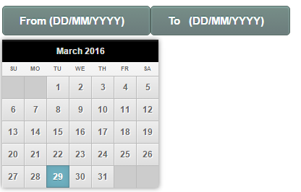

How to use:

1. For QlikSense Desktop: put the project into the directory Documents/Qlik/Sense/Extensions

2. For QlikSense Server (QMC): impoort the project in to the extension.

3. Set two variables, the first one to be used as 'From' i.e initial date, and the second variable to be used as 'To' i.e the final date

N.B: the 'To' should be greater than or equal to 'From' variable.