

Department of Computing

|  |  |
| --- | --- |
| Student ID |  |
| Module Title | Data In Action |
| Module Code | P18732_100301_2023-24_1 |
| Module Lecturer | Mandi Qi |
| Date of Submission |  |
| Actual Word Count |  |

Contents

1. Executive Summary
2. Data collection
   1. Value of Data in Forex Trading
   2. Data Sources
   3. Data Storage
3. Data analysis
4. Data Visualization
5. Data mining for competitors
6. References
7. Appendix
8. Individual logs

Executive Summary

In the dynamic landscape of trading, the abundance of raw data has become both a boon and a challenge for aspiring traders, whether individuals or brokers. The conventional presentation of historical data often falls short of providing actionable insights, necessitating a shift towards comprehensive data processing and extraction techniques. This report delves into the realm of data mining for trading, with a specific focus on the forex market, incorporating news and fundamental information, as well as generating novel insights through feature extraction from technical data.

Data Collection: Our primary data source for news and fundamental information is myfxbook, utilizing web scraping techniques to extract relevant data. This approach ensures a comprehensive collection of real-time, market-moving events that impact the forex market, offering a holistic view for traders.

Data Analysis: To make informed decisions, we employ machine learning algorithms, particularly focusing on time series analysis. By leveraging advanced models, we aim to discern patterns, trends, and potential market movements. This analytical framework empowers traders with predictive capabilities, enhancing their ability to act proactively in the face of market uncertainties.

Data Presentation (Visualization): The extracted insights are presented through a user-friendly interface, utilizing Python's Matplotlib and Plotly Express (px). These visualization tools are instrumental in transforming complex data into clear, actionable information, facilitating a more intuitive understanding of market dynamics.

Competitor Analysis: In addition to individual trading strategies, our report explores the competitive landscape by mining data from various providers. Through classification algorithms, we aim to categorize competitors into specific industries within the trading domain. This intelligence can aid traders in benchmarking their strategies against industry trends and competitor performance.

Conclusion:

By synthesizing news, fundamental, and technical data through advanced data mining techniques, this report advocates for a more nuanced and informed approach to trading. The integration of machine learning models, coupled with robust visualization tools, not only empowers traders with predictive capabilities but also facilitates a comprehensive understanding of the competitive landscape. As the forex market continues to evolve, leveraging data mining becomes imperative for staying ahead in the dynamic world of trading.

1. Data collection in Forex Trading
   1. Value of Data

Data collection is a critical process in the field of data mining for trading. It involves the gathering, measuring, and analysis of various types of information using a set of standard validated techniques. The main objective of data collection is to gather information-rich and reliable data, and analyze them to make critical business decisions. There are two main methods of data collection in research based on the information that is required, namely: Primary Data Collection and Secondary Data Collection. Primary data refers to data collected from first-hand experience directly from the main source, while secondary data refers to data that has been collected in the past. Primary data collection methods are generally regarded as the best kind of data in research. It is essential for organizations to collect data to research the demand, customer preferences, competitors, etc., before creating any new product. Even after the product is launched, many companies continue to collect their customers’ data to get feedback and identify ways to improve their overall customer experience. Data scientists play a crucial role in helping companies not only collect data but also organize it and derive results from it for shareholders to make decisions. (Duggal, N., 2023).

Figure 1 shows some categories of factors that have an effect on the market.

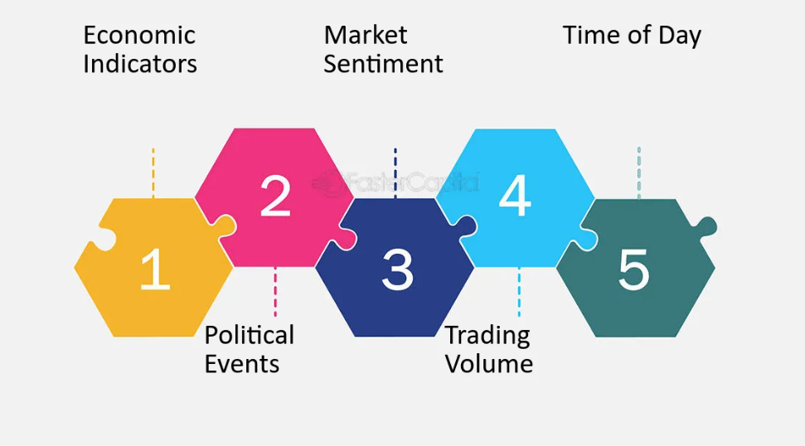

Figure (FasterCapital, 2023).

In the context of trading, fundamental data plays a crucial role in influencing trading decisions. Fundamental data includes economic indicators and news releases that can have a significant impact on the price of a currency. For example, when a major news release, such as non-farm payrolls, is announced, it can cause significant volatility in the EUR/USD currency pair, leading to sharp movements in the price. Fundamental data provides traders with insights into the underlying factors that drive the market and can help them anticipate future price movements. Traders rely on fundamental data to understand the economic conditions that may affect the value of a currency and make trading decisions based on this information. (Hayes, A., 2023; Kelly, L., 2023).

Figure 2 shows how the release of the US Bureau of Labor Statistics has an effect on the EUR/USD pair in the forex market on the 5th of July.

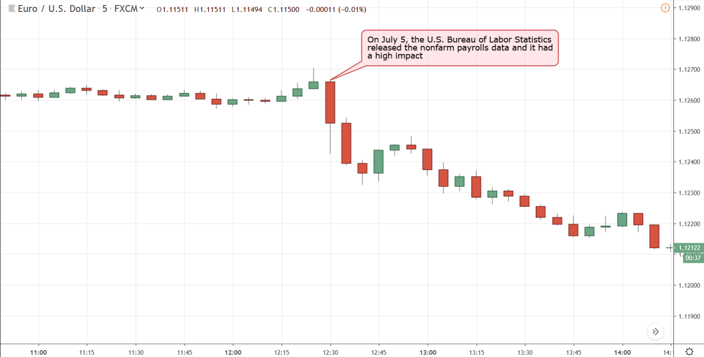

Figure (Tradeciety, 2023)

On the other hand, technical data plays a crucial role in informing trading decisions. Technical data includes indicators such as volume, RSI, MFI, Bollinger Bands, and others. Traders use technical data to analyze the historical price movements and the momentum of a currency, which can help them identify trends and make informed trading decisions. For example, a trader might use the RSI indicator to identify overbought or oversold conditions in the market and make a trading decision based on that information. Technical analysis, which utilizes various technical indicators, chart patterns, and statistical tools, is widely used by traders to forecast future price movements and identify potential entry and exit points for trades. It provides traders with a systematic approach to analyzing the market and can be used in conjunction with other forms of analysis, such as fundamental analysis, to make well-informed trading decisions. (Hayes, A., 2023; Kelly, L., 2023; Tuarob, S., Wettayakorn, P., Phetchai, P. et al., 2021).

Figure 3 shows some price action lines that depict the trend of the market.

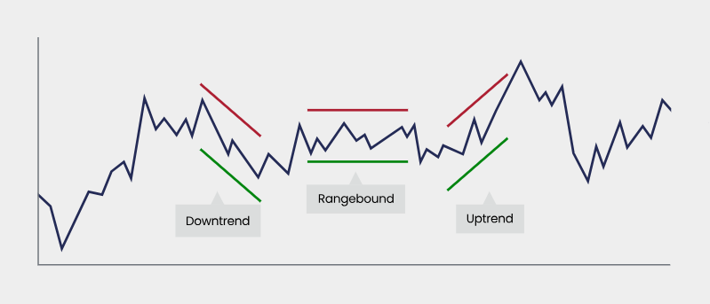

Figure (Forex., 2023)

* 1. Data Extraction:
  2. Data Storage:

Initial Storage: Utilize CSV files for initial data storage and analysis.

Transition to RDBMS: Consider transitioning to a robust solution like PostgreSQL to ensure data integrity and scalability

References

Duggal, N. (2023),” Effective Data Collection Methods: Techniques and Use Cases Explained”. Available at: https://www.simplilearn.com/data-collection-methods-article.(accessed 30 Nov 2023).

Twin, A. (2023),What Is Data Mining? How It Works, Benefits, Techniques, and Examples. Available at: https://www.investopedia.com/terms/d/datamining.asp.(accessed 30 Nov 2023).

Norm, H. (2023), Data Mining Shapes the New Age of Trading at: https://www.linkedin.com/pulse/data-mining-shapes-new-age-trading-norm-hart (accessed 30 Nov 2023).

Hayes, A. (2023). Understanding Trend Analysis and Trend Trading Strategies. at: https://www.investopedia.com/terms/t/trendanalysis.asp (accessed 30 Nov 2023).

Kelly, L. (2023). What is Trading Data? Definition, Uses, Datasets & Vendors. at: https://datarade.ai/data-categories/trading-data (accessed 30 Nov 2023).

Tuarob, S., Wettayakorn, P., Phetchai, P. et al. (2021), DAViS: a unified solution for data collection, analyzation, and visualization in real-time stock market prediction. Financ Innov 7, 56 .Available at: https://doi.org/10.1186/s40854-021-00269-7 (accessed 30 Nov 2023).

FasterCapital. (2023). Forex trading sessions: Optimal times for trading the Ngultrum .Available at: https://fastercapital.com/content/Forex-trading-sessions--Optimal-times-for-trading-the-Ngultrum.html (accessed 30 Nov 2023).

Tradeciety., (2023), THE MOST IMPORTANT FOREX NEWS .Available at: https://tradeciety.com/important-forex-news (accessed 30 Nov 2023).

Forex. (2023), Understanding technical analysis .Available at: https://www.forex.com/en-uk/trading-academy/courses/technical-analysis/uk-introduction/ (accessed 30 Nov 2023).