

Department of Computing

|  |  |
| --- | --- |
| Student ID |  |
| Module Title | Data In Action |
| Module Code | P18732_100301_2023-24_1 |
| Module Lecturer | Mandi Qi |
| Date of Submission |  |
| Actual Word Count |  |

Contents

1. Executive Summary
2. Data collection
   1. Value of Data in Forex Trading
   2. Data Extraction
      1. Fundamental data for analysis
      2. Technical data for analysis
   3. Data Storage
3. Data analysis
4. Data Visualization
5. Data mining for competitors
6. References
7. Individual logs
8. Appendix Code
   1. Select date
   2. Ads
   3. Complete header and details Scrapping
9. Executive Summary

In the dynamic landscape of trading, the abundance of raw data has become both a boon and a challenge for aspiring traders, whether individuals or brokers. The conventional presentation of historical data often falls short of providing actionable insights, necessitating a shift towards comprehensive data processing and extraction techniques. This report delves into the realm of data mining for trading, with a specific focus on the forex market, incorporating news and fundamental information, as well as generating novel insights through feature extraction from technical data.

Data Collection: Our primary data source for news and fundamental information is myfxbook, utilizing web scraping techniques to extract relevant data. This approach ensures a comprehensive collection of real-time, market-moving events that impact the forex market, offering a holistic view for traders.

Data Analysis: To make informed decisions, we employ machine learning algorithms, particularly focusing on time series analysis. By leveraging advanced models, we aim to discern patterns, trends, and potential market movements. This analytical framework empowers traders with predictive capabilities, enhancing their ability to act proactively in the face of market uncertainties.

Data Presentation (Visualization): The extracted insights are presented through a user-friendly interface, utilizing Python's Matplotlib and Plotly Express (px). These visualization tools are instrumental in transforming complex data into clear, actionable information, facilitating a more intuitive understanding of market dynamics.

Competitor Analysis: In addition to individual trading strategies, our report explores the competitive landscape by mining data from various providers. Through classification algorithms, we aim to categorize competitors into specific industries within the trading domain. This intelligence can aid traders in benchmarking their strategies against industry trends and competitor performance.

Conclusion:

By synthesizing news, fundamental, and technical data through advanced data mining techniques, this report advocates for a more nuanced and informed approach to trading. The integration of machine learning models, coupled with robust visualization tools, not only empowers traders with predictive capabilities but also facilitates a comprehensive understanding of the competitive landscape. As the forex market continues to evolve, leveraging data mining becomes imperative for staying ahead in the dynamic world of trading.

1. Data collection in Forex Trading
   1. Value of Data

Data collection is a critical process in the field of data mining for trading. It involves the gathering, measuring, and analysis of various types of information using a set of standard validated techniques. The main objective of data collection is to gather information-rich and reliable data and analyze them to make critical decisions. There are two main methods of data collection in research based on the information that is required, namely: Primary Data Collection and Secondary Data Collection. Primary data refers to data collected from first-hand experience directly from the main source, while secondary data refers to data that has been collected in the past. Primary data collection methods are generally regarded as the best kind of data in research. Organizations need to collect data to research the demand, customer preferences, competitors, etc., before creating any new product. Even after the product is launched, many companies continue to collect their customers’ data to get feedback and identify ways to improve their overall customer experience. Data scientists play a crucial role in helping companies not only collect data but also organize it and derive results from it for shareholders to make decisions. (Duggal, N., 2023).

Figure 1 shows some categories of factors that affect the market.

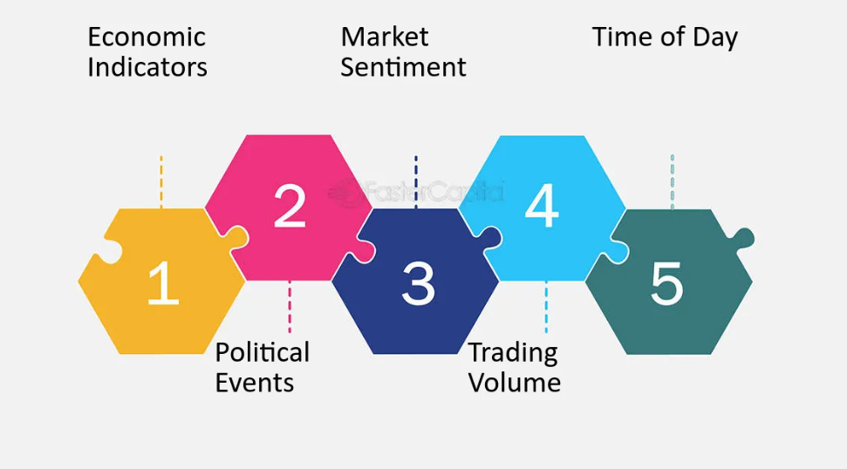

Figure (FasterCapital, 2023).

In the context of trading, fundamental data plays a crucial role in influencing trading decisions. Fundamental data includes economic indicators and news releases that can have a significant impact on the price of a currency. For example, when a major news release, such as non-farm payrolls, is announced, it can cause significant volatility in the EUR/USD currency pair, leading to sharp movements in the price. Fundamental data provides traders with insights into the underlying factors that drive the market and can help them anticipate future price movements. Traders rely on fundamental data to understand the economic conditions that may affect the value of a currency and make trading decisions based on this information. (Hayes, A., 2023; Kelly, L., 2023).

Figure 2 shows how the release of the US Bureau of Labor Statistics had an effect on the EUR/USD pair in the forex market on the 5th of July.

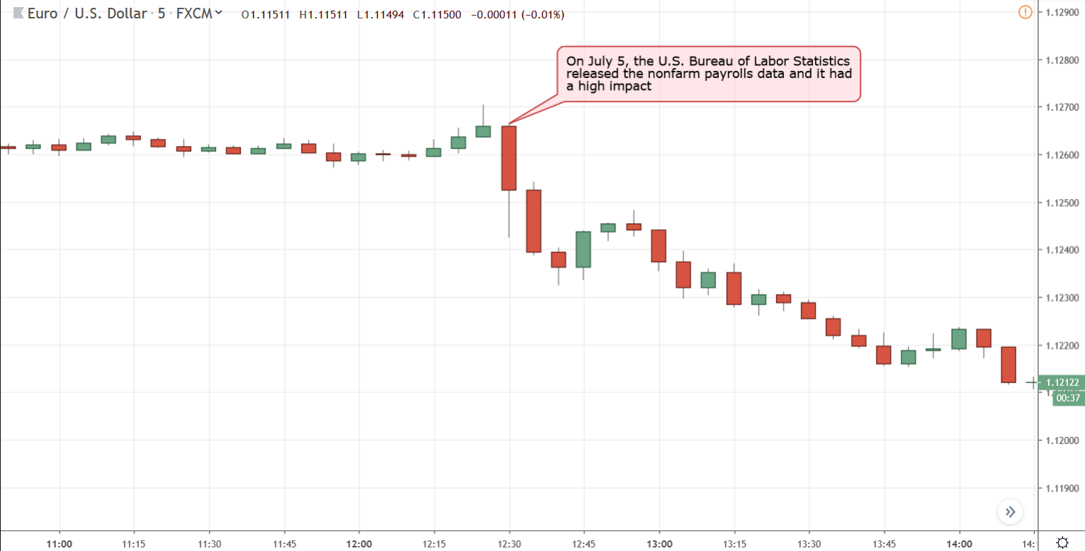

Figure (Tradeciety, 2023)

On the other hand, technical data plays a crucial role in informing trading decisions. Technical data includes indicators such as volume, RSI, MFI, Bollinger Bands, and others. Traders use technical data to analyze the historical price movements and the momentum of a currency, which can help them identify trends and make informed trading decisions. For example, a trader might use the RSI indicator to identify overbought or oversold conditions in the market and make a trading decision based on that information. Technical analysis, which utilizes various technical indicators, chart patterns, and statistical tools, is widely used by traders to forecast future price movements and identify potential entry and exit points for trades. It provides traders with a systematic approach to analyzing the market and can be used in conjunction with other forms of analysis, such as fundamental analysis, to make well-informed trading decisions. (Hayes, A., 2023; Kelly, L., 2023; Tuarob, S., Wettayakorn, P., Phetchai, P. et al., 2021).

Figure 3 shows some price action lines that depict the trend of the market.

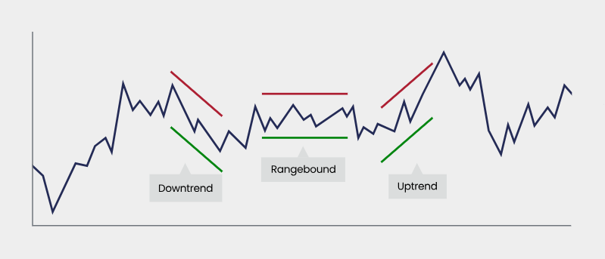

Figure (Forex., 2023)

* 1. Data Extraction:
     1. Fundamental data

In the process of collecting fundamental data, various data sources are available for scraping economic calendar news. However, they often show the same values. Therefore, there is no significant difference between collecting data from investing.uk.com or forexfactory.com. As a result, the decision was made to use myfxbook.com due to the absence of limitations in obtaining HTML from them, the reduced risk of our IP being banned, and the simplicity of the required functions.

The primary challenge stemmed from the limitations imposed by Myfxbook's landing page. This restriction manifested in the presentation of only the current week's header news, prompting the need for a more inclusive approach to gather all relevant information. To address this issue, the team opted for the implementation of Selenium, a powerful web scraping tool.

The initial step involved configuring the script to selectively choose the start and end dates for data extraction, focusing on the news headers. However, another obstacle surfaced during this phase. The website's calendar feature posed a constraint, limiting the date range to a maximum of three months (Figure 4). To circumvent the three-month limitation, a two-fold strategy was employed. First, a meticulously crafted list of dates was generated, providing the necessary flexibility for the scraping process. Additionally, a dedicated function was developed to convert standard date formats into the specific format mandated by Myfxbook. (Code related to pick date )

Figure 4 shows the 3-month limitation of selecting a date.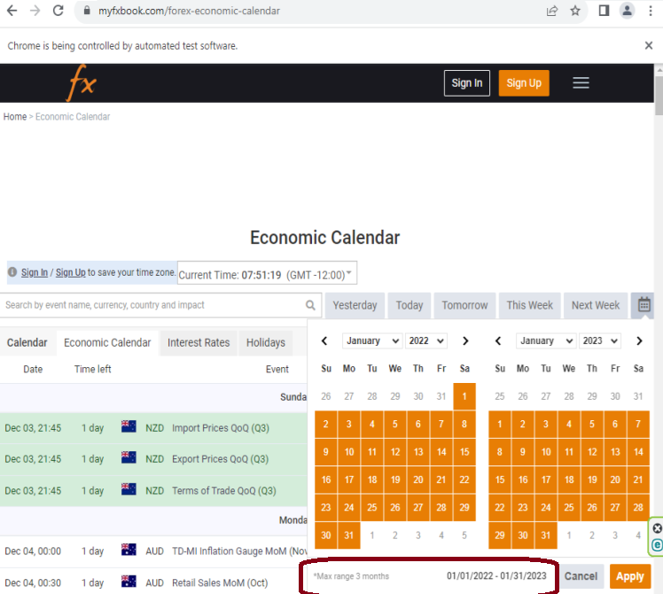

Figure

Another significant challenge involved dealing with advertisements that appeared during the scraping process. To mitigate this issue, we had to check the existence of ads before each page navigation (see Appendix), using the try-catch and click methods in the Selenium library. (Appendix Code relate to click on ads )

Figure 4 illustrates how advertisement pop-ups can prevent web scraping.

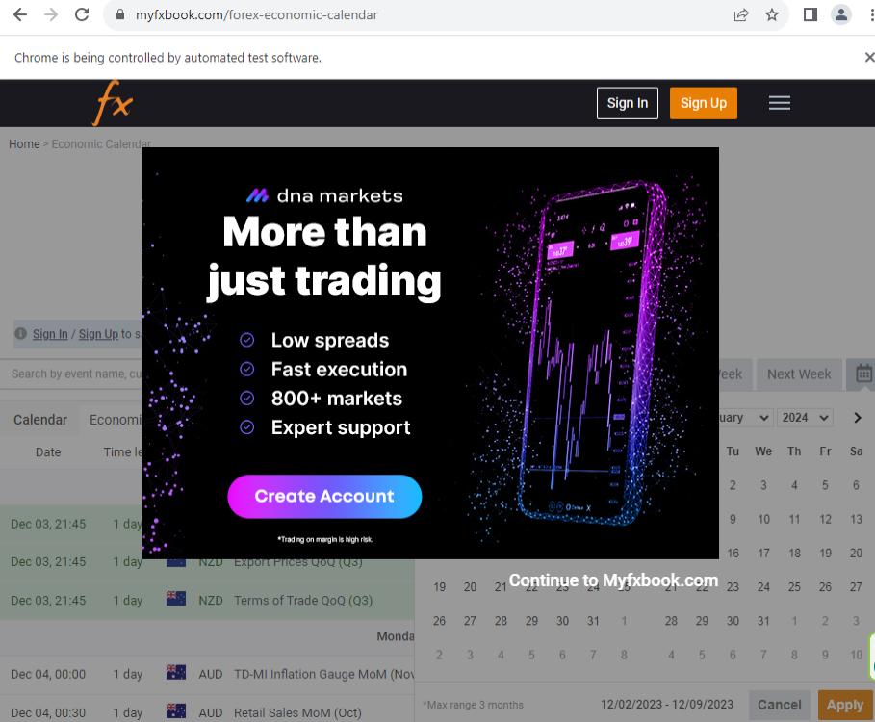

Figure

Furthermore, the challenge of data acquisition in the context of scraping Myfxbook arises from the absence of consolidated information on a single page. This necessitates additional steps following the initial capture of news headers. Addressing this obstacle requires a systematic approach wherein the process involves scraping all available headers and subsequently saving them. Subsequently, a thorough exploration of the reference links associated with each news entry becomes imperative. By navigating through these links, one can access comprehensive information, including historical data pertinent to the respective news items. (Appendix Code relate scrapping the heards)

To overcome this challenge, first and foremost, all headers are scraped and stored for reference. Subsequently, a meticulous examination of the associated reference links is conducted. This involves traversing through the linked pages to gather a more in-depth understanding of the news entries and to ensure access to historical data. By adopting this comprehensive approach, the data mining process becomes more effective and yields a more complete dataset for analysis in the context of trading. (Appendix Code related to details)

* 1. Technical data
  2. Data Storage:

Initial Storage: Utilize CSV files for initial data storage and analysis.

Transition to RDBMS: Consider transitioning to a robust solution like PostgreSQL to ensure data integrity and scalability

1. Data analysis
2. Data Visualization
3. Data mining for competitors
4. References

Duggal, N. (2023),” Effective Data Collection Methods: Techniques and Use Cases Explained”. Available at: <https://www.simplilearn.com/data-collection-methods-article> .(accessed 30 Nov 2023).

Twin, A. (2023), What Is Data Mining? How It Works, Benefits, Techniques, and Examples. Available at: <https://www.investopedia.com/terms/d/datamining.asp> .(accessed 30 Nov 2023).

Norm, H. (2023), Data Mining Shapes the New Age of Trading at: <https://www.linkedin.com/pulse/data-mining-shapes-new-age-trading-norm-hart> (accessed 30 Nov 2023).

Hayes, A. (2023). Understanding Trend Analysis and Trend Trading Strategies. at: <https://www.investopedia.com/terms/t/trendanalysis.asp> (accessed 30 Nov 2023).

Kelly, L. (2023). What is Trading Data? Definition, Uses, Datasets & Vendors. at: <https://datarade.ai/data-categories/trading-data> (accessed 30 Nov 2023).

Tuarob, S., Wettayakorn, P., Phetchai, P. et al. (2021), Davis: a unified solution for data collection, analysis, and visualization in real-time stock market prediction. Financ Innov 7, 56. Available at: <https://doi.org/10.1186/s40854-021-00269-7> (accessed 30 Nov 2023).

FasterCapital. (2023). Forex trading sessions: Optimal times for trading the Ngultrum.Available at: <https://fastercapital.com/content/Forex-trading-sessions--Optimal-times-for-trading-the-Ngultrum.html> (accessed 30 Nov 2023).

Tradeciety., (2023), THE MOST IMPORTANT FOREX NEWS.Available at: <https://tradeciety.com/important-forex-news> (accessed 30 Nov 2023).

Forex. (2023), Understanding technical analysis.Available at: <https://www.forex.com/en-uk/trading-academy/courses/technical-analysis/uk-introduction/> (accessed 30 Nov 2023).

1. Individual logs

November 15, 2023:

Our team convened for its inaugural meeting to deliberate on a suitable subject for our collaborative project. The meeting transpired in our communal space, conveniently located near the campus. After careful consideration, we reached a unanimous decision to delve into the realm of data mining for trading. This choice was motivated by Emmanuel's extensive expertise in banking and finance, coupled with my prior involvement in technical data analysis, specifically within the domain of time series data.

As the project initiator, I assumed the responsibility of initiating the data collection phase and crafting a structural framework for the forthcoming report. Concurrently, Emmanuel undertook the analysis, Colin dedicated efforts towards visualization, and [insert names] were entrusted with the task of delving into competitor data mining.

November 17, 2023:

Progressing to this date, my focus shifted towards extracting data from review websites' HTML. However, navigating the intricacies of web scraping regulations became imperative due to the possibility of IP address bans. Upon encountering the platform 'myfxbook,' I determined it to be a suitable source for data extraction.

November 20, 2023:

Advancing to this date, I commenced the meticulous process of scrutinizing HTML using Notepad++ to comprehend the employed tags and functions. After several hours, I manually extracted the initial complete HTML from myfxbook, subsequently automating the process to include tasks such as handling ads, selecting dates, and invoking functions. The culmination of this effort resulted in a repository on GitHub, housing Python code and comprehensive documentation to facilitate collaborative engagement and feedback.

November 25, 2023:

On this day, the initiation of data extraction from HTML occurred. I modularized the process by encapsulating each step into functions, utilizing Selenium to navigate HTML and extract desired values. Additionally, a record was created and appended to a data frame.

November 26, 2023:

Moving forward to this date, a comprehensive review of the work prompted the data to be saved initially in CSV format to facilitate the commencement of analysis and data visualization by other team members. However, recognizing the need for a more sophisticated data storage solution, the decision was made to transition to either Postgres or SQL Server.

November 27, 2023:

By this date, the data scraping phase was deemed complete, albeit with minor details requiring refinement. Subsequently, Emmanuel's currency selection for analysis would necessitate the addition of specific details to the application.

November 28, 2023:

Our progress was collectively assessed during a meeting on this date, revealing that we are ahead of schedule. This achievement aligns with our ambitious goal of concluding the project before the end of December.

**Self and peer assessment of group collaboration**

Me: Amir Shabani 100109012 , Member Emmanuel Patrick 10010 Member B.............................

Member C ............................. Member D ............................

Consider each member's contribution and effectiveness to the group task including your own.

Award 2 if the member contribution was outstanding and was effective member of the team.

Award 1 if the member was average within the team.

Award 0 if the member's contribution and effectiveness was poor, minimum effort applied.

|  |  |  |  |  |  |  |
| --- | --- | --- | --- | --- | --- | --- |
| **Area** | **Contribution, skill and effectiveness** | **Me** | **A** | **B** | **C** | **D** |
| Research | Established research tasks and components of a task |  |  |  |  |  |
|  | Effectively researched the problem |  |  |  |  |  |
|  | Developed strategies to explore assigned research tasks |  |  |  |  |  |
|  | Contributed individual part and group report writing effectively |  |  |  |  |  |
| Communication | Share information with others |  |  |  |  |  |
| Communication | Discussed and re-evaluate information with others |  |  |  |  |  |
|  | Presentation skills, able to communicate/teach the problem |  |  |  |  |  |
| Planning | Established resources and schedule to meet the task |  |  |  |  |  |
|  | Planned their time, did not waste others |  |  |  |  |  |
|  | Share information with others |  |  |  |  |  |
|  | Established role within the group and others within the group |  |  |  |  |  |
| **Total Weighting Factor /20** | | |  |  |  |  |

1. Appendix

Code related to pick date

############################################# click on calendar button

calendar_btn=driver.find_elements(by=By.XPATH, value='//button[@id="calendarCustomBtn"]')[0]

# calendar_btn=driver.find_element(By.XPATH, "//button[contains(text(), 'Click Me')]")

calendar_btn.click()

timesleep_for_datepicker=1

############################################# Select start Year

combo_box_start_year=driver.find_elements(by=By.XPATH, value='//select[@class="yearselect"]')[0]

# Create a new instance of the Select class

select_start_year = Select(combo_box_start_year)

time.sleep(timesleep_for_datepicker)

# Create a new instance of the Select class

select_start_year.select_by_value(str(start_year))

############################################# Select start Month

combo_box_start_month=driver.find_elements(by=By.XPATH, value='//select[@class="monthselect"]')[0]

# Create a new instance of the Select class

select_start_month = Select(combo_box_start_month)

time.sleep(timesleep_for_datepicker)

# Create a new instance of the Select class

select_start_month.select_by_visible_text(start_month)

############################################# Select first day of selected month

start_date_picker_value=f'//td[text()="{start_day}"]'

start_date_picker=driver.find_elements(by=By.XPATH, value=start_date_picker_value)[0]

# click on start date

start_date_picker.click()

time.sleep(timesleep_for_datepicker)

# wait 5 second

driver.implicitly_wait(5)

############################################# Select end Year

combo_box_end_year=driver.find_elements(by=By.XPATH, value='//select[@class="yearselect"]')[1]

# Create a new instance of the Select class

select_end_year = Select(combo_box_end_year)

time.sleep(timesleep_for_datepicker)

# Create a new instance of the Select class

select_end_year.select_by_value(str(end_year))

############################################# Select end Month

combo_box_end_month=driver.find_elements(by=By.XPATH, value='//select[@class="monthselect"]')[1]

# Create a new instance of the Select class

select_end_month = Select(combo_box_end_month)

time.sleep(timesleep_for_datepicker)

# Create a new instance of the Select class

select_end_month.select_by_visible_text(end_month)

############################################# Select last day of given duration month

end_date_picker_value=f'//td[text()="{end_day}"]'

end_date_picker=driver.find_elements(by=By.XPATH, value=end_date_picker_value)[-1]

time.sleep(timesleep_for_datepicker)

# click on start date

end_date_picker.click()

############################################## Click on apply

apply_btn=driver.find_elements(by=By.XPATH, value='//button[@type="button" and text()="Apply"]')[0]

apply_btn.click()

(Appendix Code relate to click on ads )

############################################# click on continue to MyFxBook (skip the add)

try:

    # continuetosite=driver.find_elements(by=By.XPATH, value='//a[@class="bold color-white" and @data-dismiss="modal"]')[0]

    continuetosite=driver.find_elements(by=By.XPATH, value='//*[@id="popupAdContainer"]'+

                                                            '//div[@class="continue-text"]'+

                                                            '/button[@class="no-padding hover-underline no-background no-border bold color-white"]')[0]

    continuetosite.click()

except:

    print("did not find ads(continuetosite)")