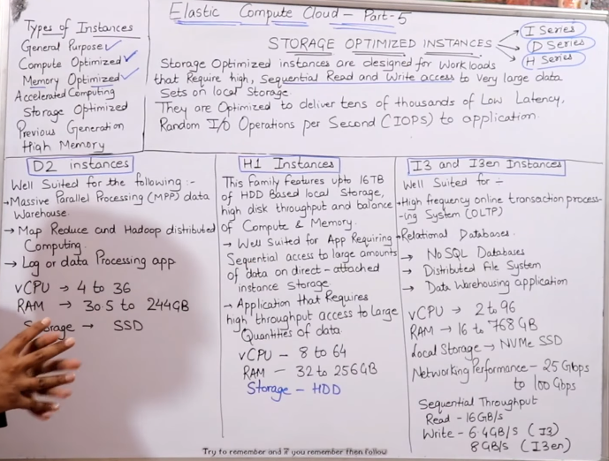

* Sequential read and write data (not parallel)- mean a user can only upload are download one file at a time.
* All three instances are for parallel processing, data warehouse, etc.

**Directly attached storage instances VS network attached instances.**

1. Network attached storages- connected to a server via a network (not directly)
2. Directly attached storages- attached to a server physically or directly

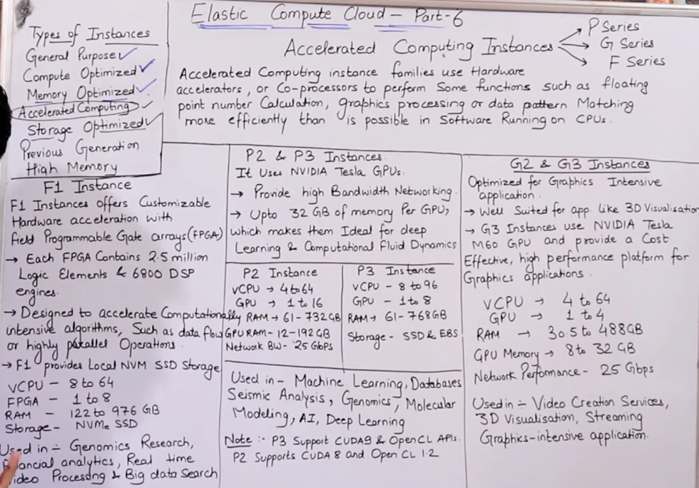

* Used for – live streaming, 3d gaming, where latest technology is used like ML, DL, AI
* Only F1 instance use FPGA (programmable logic gate arrays)

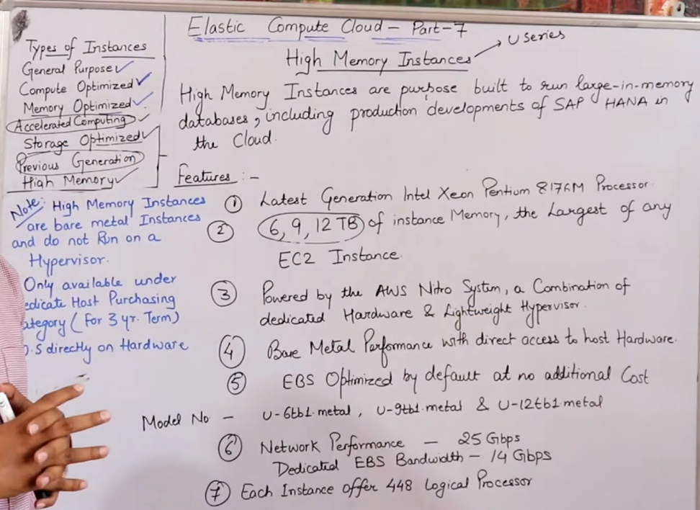

* For dedicated users only
* This instance runs on dedicated hosts only
* Can be purchased for at least 3 years only, not less than that
* Dedicated hosts are the only option available to use this instance (you need to purchase)
* No virtualization – can only be installed on hardware

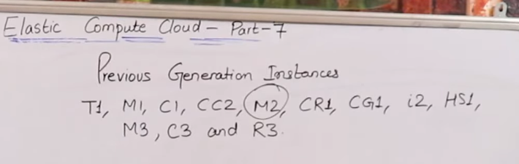

* Does previous generation instances got deleted – No
* Can we purchase previous generation instances – Yes